Chapter #1
What is Programming?
Programming is a collaboration between humans and computers.
PROGRAMMING IS EVERYWHERE
Programming is, quite literally, all around us. From the take-out we order, to the movies we stream, code enables everyday actions in our lives. Tech companies are no longer recognizable as just software companies — instead, they bring food to our door, help us get a taxi, influence outcomes in presidential elections, or act as a personal trainer.
When you’re walking down the street, where can you find technology in your environment? Click on the white circles.
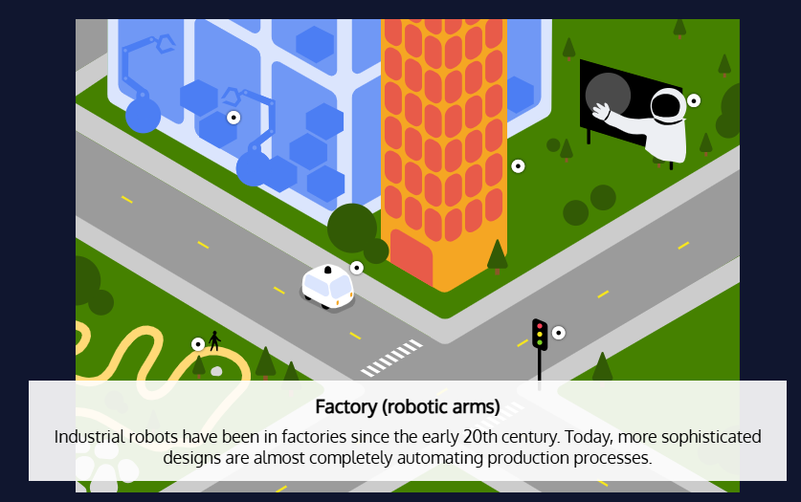
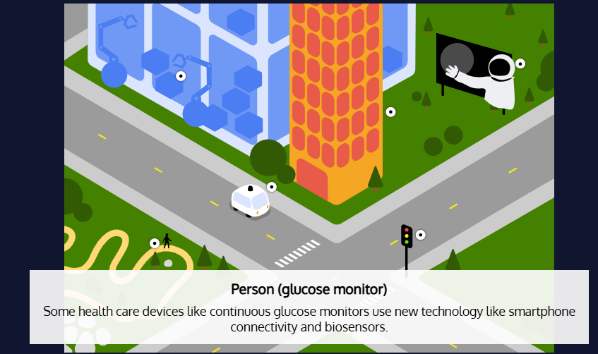
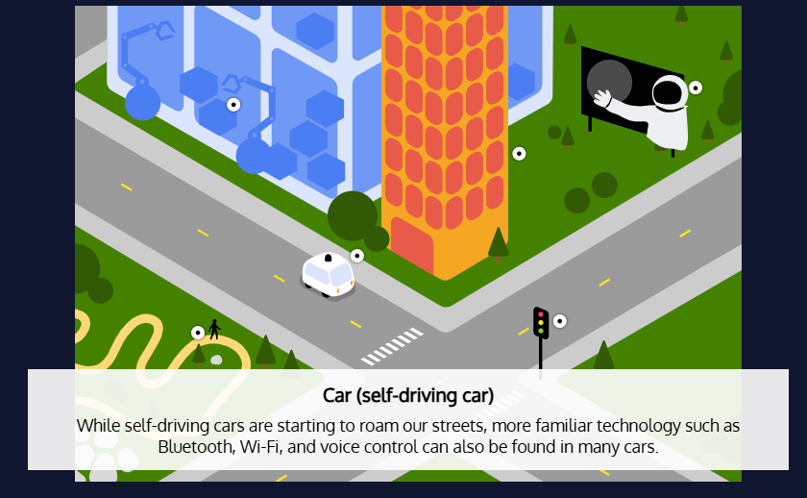
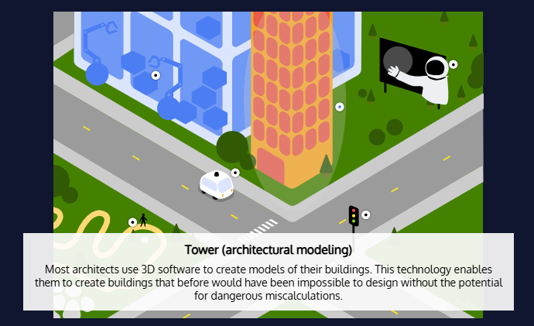
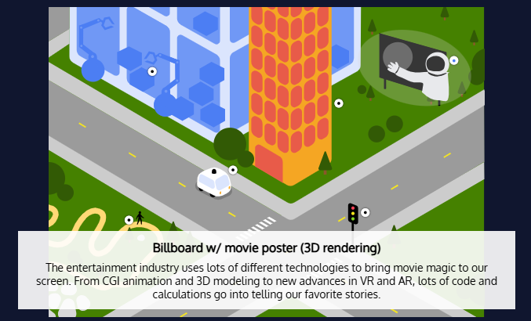
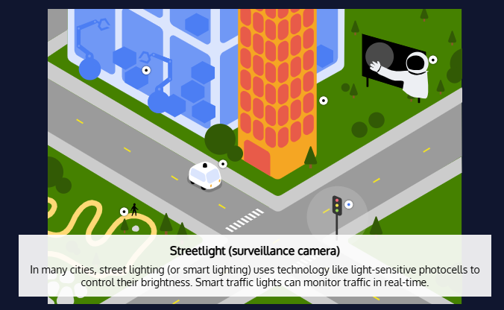

…AND PROGRAMMING IS FOR EVERYONE
For many years, only a few people have known how to code. However, that’s starting to change. The number of people learning to code is increasing year by year, with estimates around 31.1 million software developers worldwide, which doesn’t even account for the many OTHER careers that relate to programming.
Here at Codecademy, our mission is to make technical knowledge accessible and applicable. Technology plays a crucial role in our economy — but programming is no longer just for software engineers. Any person can benefit from learning to program — whether it’s learning HTML to improve your marketing emails or taking a SQL course to add a dose of analysis to your research role.
Even outside of the tech industry, learning to program is essential to participating in the world around you: it affects the products you buy, the legal policies you vote for, and the data you share online.
So, let’s dig into what programming is.
WHAT IS PROGRAMMING?
Put simply, programming is giving a set of instructions to a computer to execute. If you’ve ever cooked using a recipe before, you can think of yourself as the computer and the recipe’s author as a programmer. The recipe author provides you with a set of instructions that you read and then follow. The more complex the instructions, the more complex the result!
How good are you at giving instructions? Try and get Codey to draw a square!
PROGRAMMING AS COMMUNICATION, or CODING
“Ok, so now I know what programming is, but what’s coding? I’m here to learn how to code. Are they the same thing?”
While sometimes used interchangeably, programming and coding actually have different definitions.
- Programming is the mental process of thinking up instructions to give to a machine (like a computer).
- Coding is the process of transforming those ideas into a written language that a computer can understand.
Over the past century, humans have been trying to figure out how to best communicate with computers through different programming languages. Programming has evolved from punch cards with rows of numbers that a machine read, to drag-and-drop interfaces that increase programming speed, with lots of other methods in between.

