Task 1: Create relational database
Figure 1: creating database
Create database victorTest

Task 2: Create table and insert data.
Table 1: students table
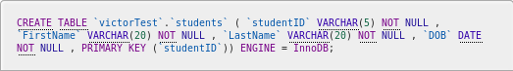Figure 2: creating students table
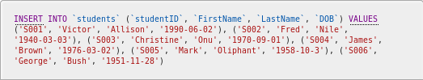Figure 3: inserting studens data
Table 2: courses table
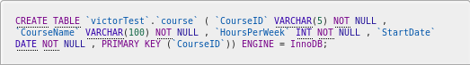Figure 4: creating courses table
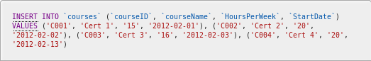Figure 5: inserting data into courses

Table 3: Enrolment Table
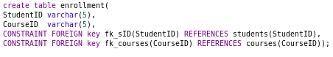Figure 6: creating enrolment table

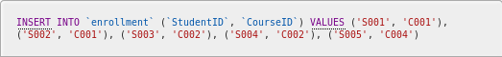Figure 7: inserting enrollment data

Task 3: Select data from database
- the select statement used is select * from students
Figure 8: students select statement

the results of execution
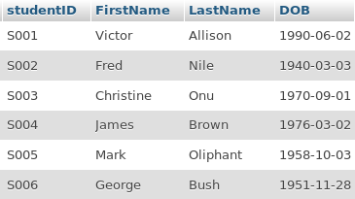Figure 9: results of execution

The results returned were the expected results

- SQL statements : SELECT FirstName ,LastName from students RIGHT JOIN enrollment on enrollment.StudentID=students.studentID where enrollment.CourseID='c001'
executio results
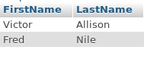

The results produced were the expected results

- SQL statement: select DISTINCT students.*, courses.* from students,courses RIGHT JOIN enrollment on enrollment.StudentID=studentID WHERE students.studentID='s001'

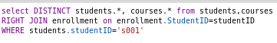

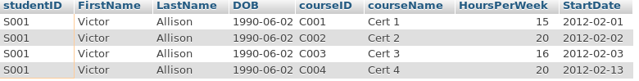
The execution produced the desired results

- SQL statement: SELECT * from courses ORDER by StartDate ASC


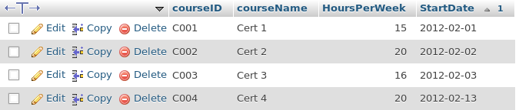
The execution produced the desired results

- SQL STATEMENT: SELECT COUNT(* ) from enrollment RIGHT JOIN courses on enrollment.CourseID=courses.courseID WHERE courses.courseName='Cert 1'

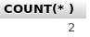

The execution produced the desired results

- SQL statement :select max(HoursPerWeek) from courses

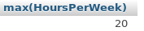Figure 10: execution results

The execution produced the desired results

- SQL Statement: select COUNT(*) from courses

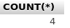

The execution produced the desired results

- sql statement: select * from students where FirstName LIKE 'Chris%'
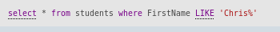

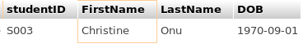

task 4: Modify table structure

sql statement: alter TABLE courses add CourseEndDat date

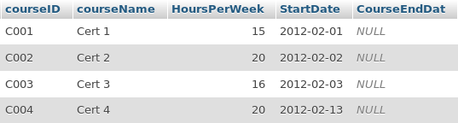

Task 5: Modify table data

- sql statement: UPDATE `students` SET `DOB` = '1940-06-06' WHERE `students`.`studentID` = 'S002'



Task 6: Written definitions
- DROP TABLE tableName

- EXPLAIN TABLE tableName
- DROP DATABASE databaseName

- Min is used to get the item with the minimum value in the list

- Max when used returns the maximum value in the list

- Sum returns the cumulative or sum of all numeric valuesa of a tuple

- avg is used to get the average of a tuple in a table, e.g average of HoursePerWeek in the courses table

- count counts the total number of returned values according to query

- count(*) will return total count of records in a table

- Group by: Groups rows that have same value into summary rows
- HAVING: Specifies that sql select statement should only return rows where the agregate values meet the specified condition

- ORDER BY: Used to sort the results by some certain row, either in ascending or descending order

- dates and times: Are sql data types used to store dates and time

- SQL data types: Are the allowed types which can be stored in sql tuples, include date, varchar, double , int e.t.c

- numbers: This are sql data types that show numerical value, e.g float, int, double, long

- text: A data type in sql used for strings of of long data

- SQL syntax: This is the allowed way by which sql queries may be written

- SELECT: indicates the tuples to retuen as part of our records

- FROM: Indicates the table or tables from which we want to draw our record

- WHERE: Gats a record or records whose certain tuple have a certain characteristic

- LIKE: It is used when a user would like to get records that show a particular pattern in a certain column, is used together with wild cards, e.g getting the cource that whose ID starts with c00

- DISTINCT: returns non dublicate records

- CREATE: used to create a new database or table

- ALTER TABLE: changes the current table layout, either its tuples or the constaints assigned to it

- INSERT INTO: Adds a new record to a table

- UPDATE: used to update a certain tuple value for a record displaying a certain condition

- DELETE: used to delete a certain record from our table
- DROP: used to either permanently remove a table, a column, a constraint or a databse

