**Dmytry Gordienko**

Summary

I develop and optimize layouts for adaptive sites, also maintain existing projects. I always make sure to check the results of my work for cross-browser compatibility, download speed and validity.

My list of completed projects includes 100+ sites performed at various levels of complexity. More information about some of them is available on my site (<http://odinokun.com>) and on my Github page (<https://github.com/Odinokun>)

Open for Front-end Developer Position

I am open for both full time and part time office employment (Kyiv, Ukraine), remote cooperation is also possible.

Skills

|  |  |
| --- | --- |
| * HTML5 with Pug (ex-Jade) * Css3 with Scss | * JS (native & Jquery) * React (beginner level) |

Tools that I use

|  |  |
| --- | --- |
| * Gulp and Webpack * Git and Github * Figma, Avocode, Adobe Photoshop, Adobe Illustrator |  |

Languages

|  |  |
| --- | --- |
| * Russian/Ukrainian (native) * English (beginner) |  |

Education

|  |  |
| --- | --- |
| * 2012 – law degree (KUTEL) * 2016 – Loftschool – Web Development for Advanced * 2018 – Loftschool – Complete JavaScript Course |  |

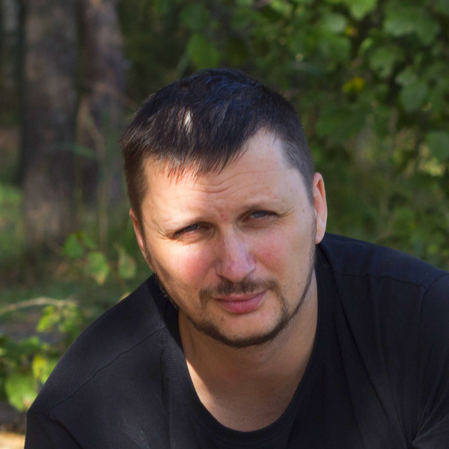

**Position:**

Front-end developer

**Employment:**

Full time, part time, freelance

**Location:**

Kyiv, Ukraine

**Date of birth:**

19-10-1978

**Experience:**

Freelance from 2014

**Website:**

http://odinokun.com

Contacts

**Email:**

odinokun@gmail.com

**Telegram:**

@odinokun

**LinkedIn:**

https://www.linkedin.com/in/

dmitry-gordienko

**Github:**

https://github.com/Odinokun

Languages

Spanish – C2

Chinese – A1

German – A2