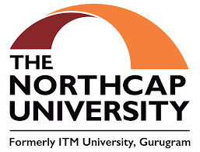

Grubble - Empowering Careers with Personalized Learning

**Course Code & Name: CSC301 - Seminar**

**Prepared by: Latika Mukhi (22CSU105)**

**Oditi Agarwal(22CSU125)**

**Instructor: Dr. Swati Gupta**

**Date: 10-04-2025**

**THE NORTHCAP UNIVERSITY**

**Gurugram, India**

**Abstract**

Grubble is an AI-powered learning and career development platform designed to personalize educational journeys and improve career outcomes. The platform addresses key issues faced by online learners such as lack of structured guidance, low motivation, and difficulty in tracking skill progression. Grubble curates courses from multiple e-learning platforms and builds personalized roadmaps based on user interests and existing skills. With integrated gamification, recruiter access, and a cloud-based certificate tracking system, Grubble empowers users to upskill efficiently while helping employers identify talent more effectively.

**Introduction**

In the digital age, the education landscape is evolving rapidly, with millions of learners shifting to online platforms. However, this transition has introduced new challenges such as lack of structured learning, overwhelming choices, and limited guidance. This report introduces "Grubble," an AI-powered platform that personalizes learning paths, tracks progress, and connects learners with recruiters through an integrated, gamified ecosystem.

Purpose and Objectives:  
The primary goal of this report is to document the development of Grubble and highlight how it addresses key challenges in online education. The objectives include:

* To analyze current gaps in online learning and recruitment.
* To present Grubble as a viable solution using AI and gamification.
* To describe the system design, implementation, and user feedback.

Scope and Limitations:  
The scope of this study is limited to the development of a minimum viable product (MVP) that aggregates courses, provides learning roadmaps, and offers recruiter access. Limitations include dependency on third-party APIs, the need for scalable infrastructure, and initial user adoption challenges.

**Related Work**

Existing platforms like Coursera, Udemy, and edX offer high-quality courses but lack personalized learning paths and a unified learner profile. LinkedIn Learning provides some level of tracking, but it is limited to its ecosystem. Other platforms focus on gamification but do not aggregate courses or offer recruiter integration. Grubble differentiates itself by combining these features into a single platform that is learner-centric and career-oriented.

**Tech Stack**

* **Frontend:** React.js, Tailwind CSS
* **Backend:** Node.js, Express.js
* **Database:** MongoDB
* **AI Recommendation Engine:** Python, scikit-learn, TensorFlow
* **Cloud Storage:** AWS S3 (for storing course completion certificates)
* **Authentication:** JWT-based Auth system
* **Other Tools:** Git, Postman, Figma (UI/UX design)

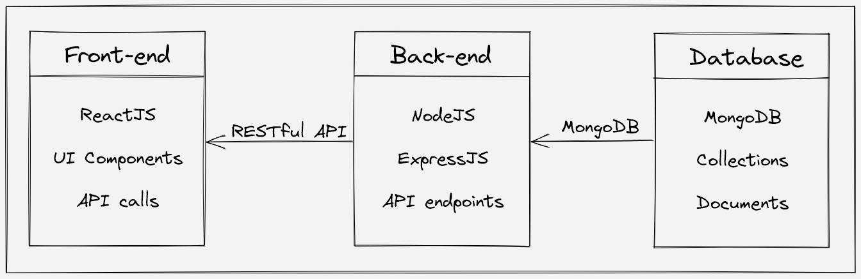

**System Architecture**

The career guidance and learning platform consists of three main components: the frontend, backend, and database. The platform follows a client-server architecture, where the frontend acts as the client, while the backend and database function as the server.

Frontend The frontend is built using React Native, a powerful framework for developing cross-platform mobile applications. It utilizes Tailwind CSS/NativeBase for a responsive and visually appealing UI, ensuring an intuitive experience for students and professionals. Redux/Zustand is used for efficient state management, enabling seamless interactions. The frontend communicates with the backend through RESTful API calls.

Backend The backend is developed using Node.js and Express.js, which provide a robust and scalable server-side architecture. It handles user authentication, course recommendations, career roadmap generation, recruiter access, and more. Additionally, an AI-driven roadmap generator powered by FastAPI (Python) personalizes learning paths based on user inputs. The backend efficiently processes and manages user data, learning progress, and payment transactions.

Database The platform integrates PostgreSQL for structured data storage, ensuring reliable and relational data management. MongoDB is used for storing certificates, learning progress, and other flexible data types. Redis is incorporated for caching, optimizing performance and reducing load times. Additionally, AWS S3/Firebase Storage is used for handling media files, such as certificates and course resources.

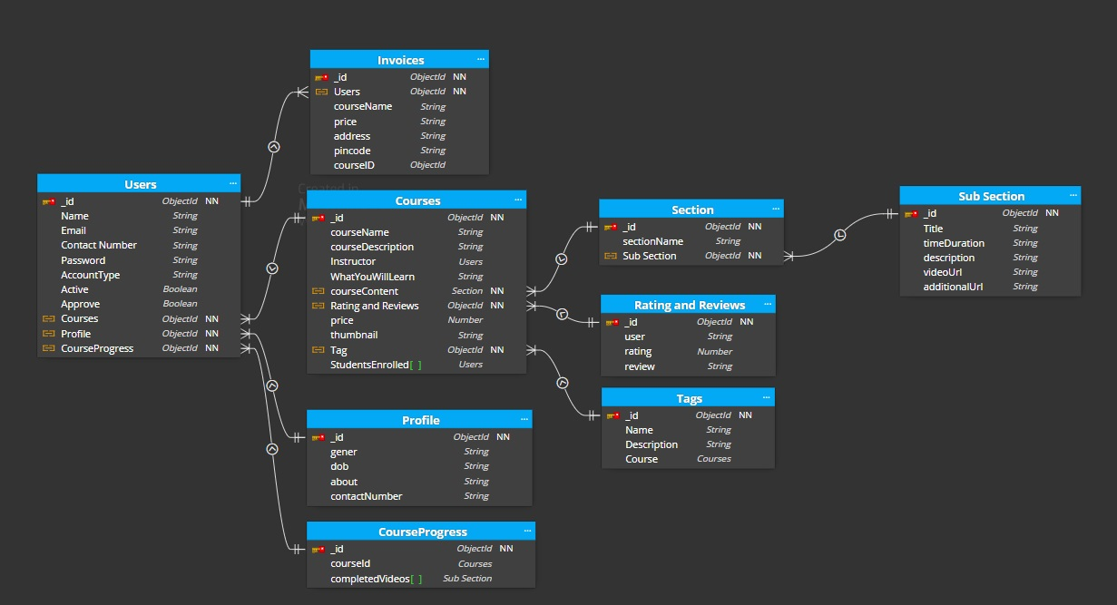

**Implementation**

1. **User Onboarding & Profiling:** Users input their skills, interests, and career goals. This data feeds into the AI engine.
2. **AI-Powered Roadmaps:** Based on user input, the platform generates a personalized learning path with course suggestions from platforms like Coursera, Udemy, etc.
3. **Course Aggregation:** APIs fetch and display relevant course data.
4. **Gamification:** Users earn badges, stars, and points for course completions, participation, and project submissions.
5. **Certificate Tracking:** Users upload course completion certificates, which are stored and displayed on their profile.
6. **Recruiter Access:** Recruiters can browse learner profiles based on skills and verified achievements.
7. **Survey Integration:** A user survey was conducted to validate the market need and pricing expectations.

**Methodology**

1. Planning: Identify learner challenges & define AIdriven
2. Solutions
3. Design: Architect AI recommendations, course aggregation & gamification.
4. Development: Build AI models, integrate course platforms & implement tracking.
5. Testing: Validate AI accuracy, UI/UX & course completion updates.
6. Deployment: Launch MVP with cloud-based scalability.
7. Maintenance: Improve AI, expand course options & enhance engagement.

**Results**

* Successfully built a functional MVP with personalized roadmap generation.
* Integrated multiple course providers through APIs.
* Implemented certificate upload and display features.
* Conducted a survey which confirmed high interest and willingness to pay among learners.
* Received positive feedback on UI/UX and roadmap clarity from beta testers.

**Screenshot**

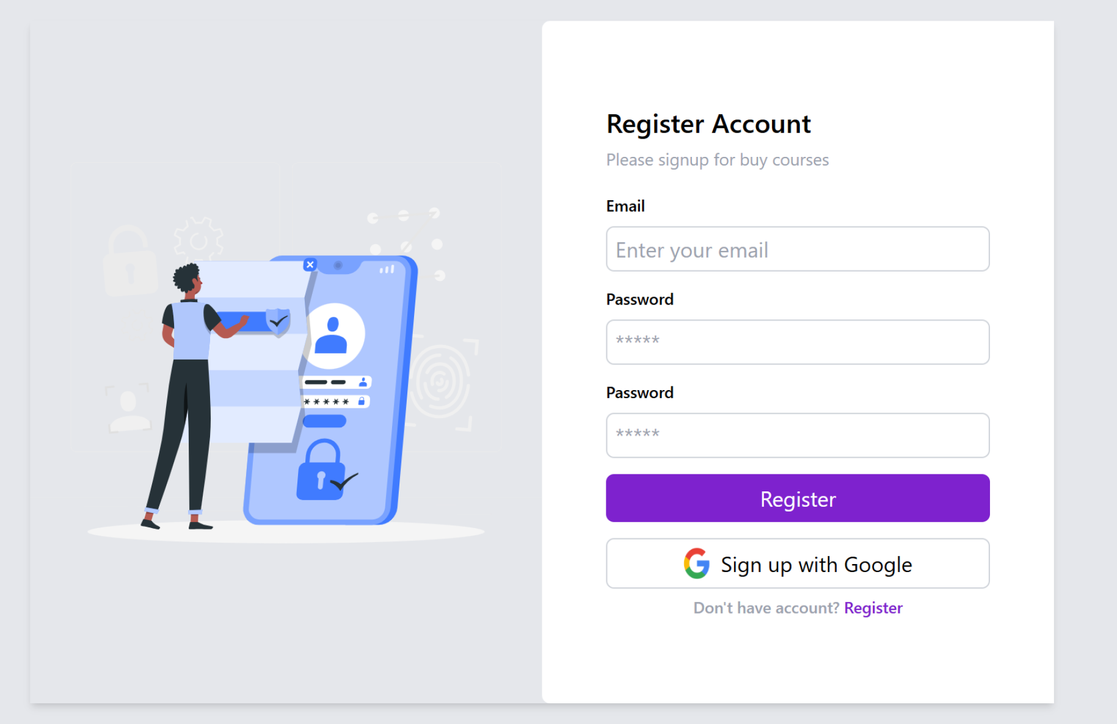

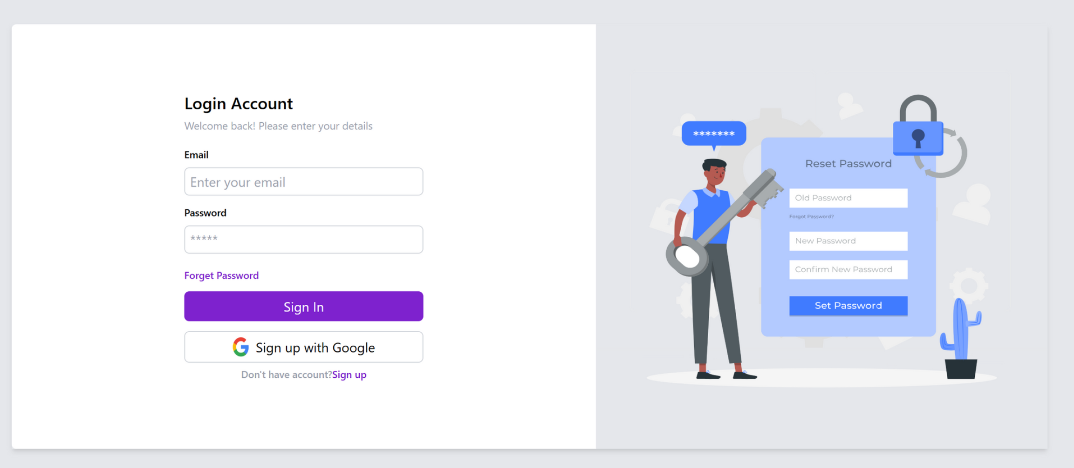

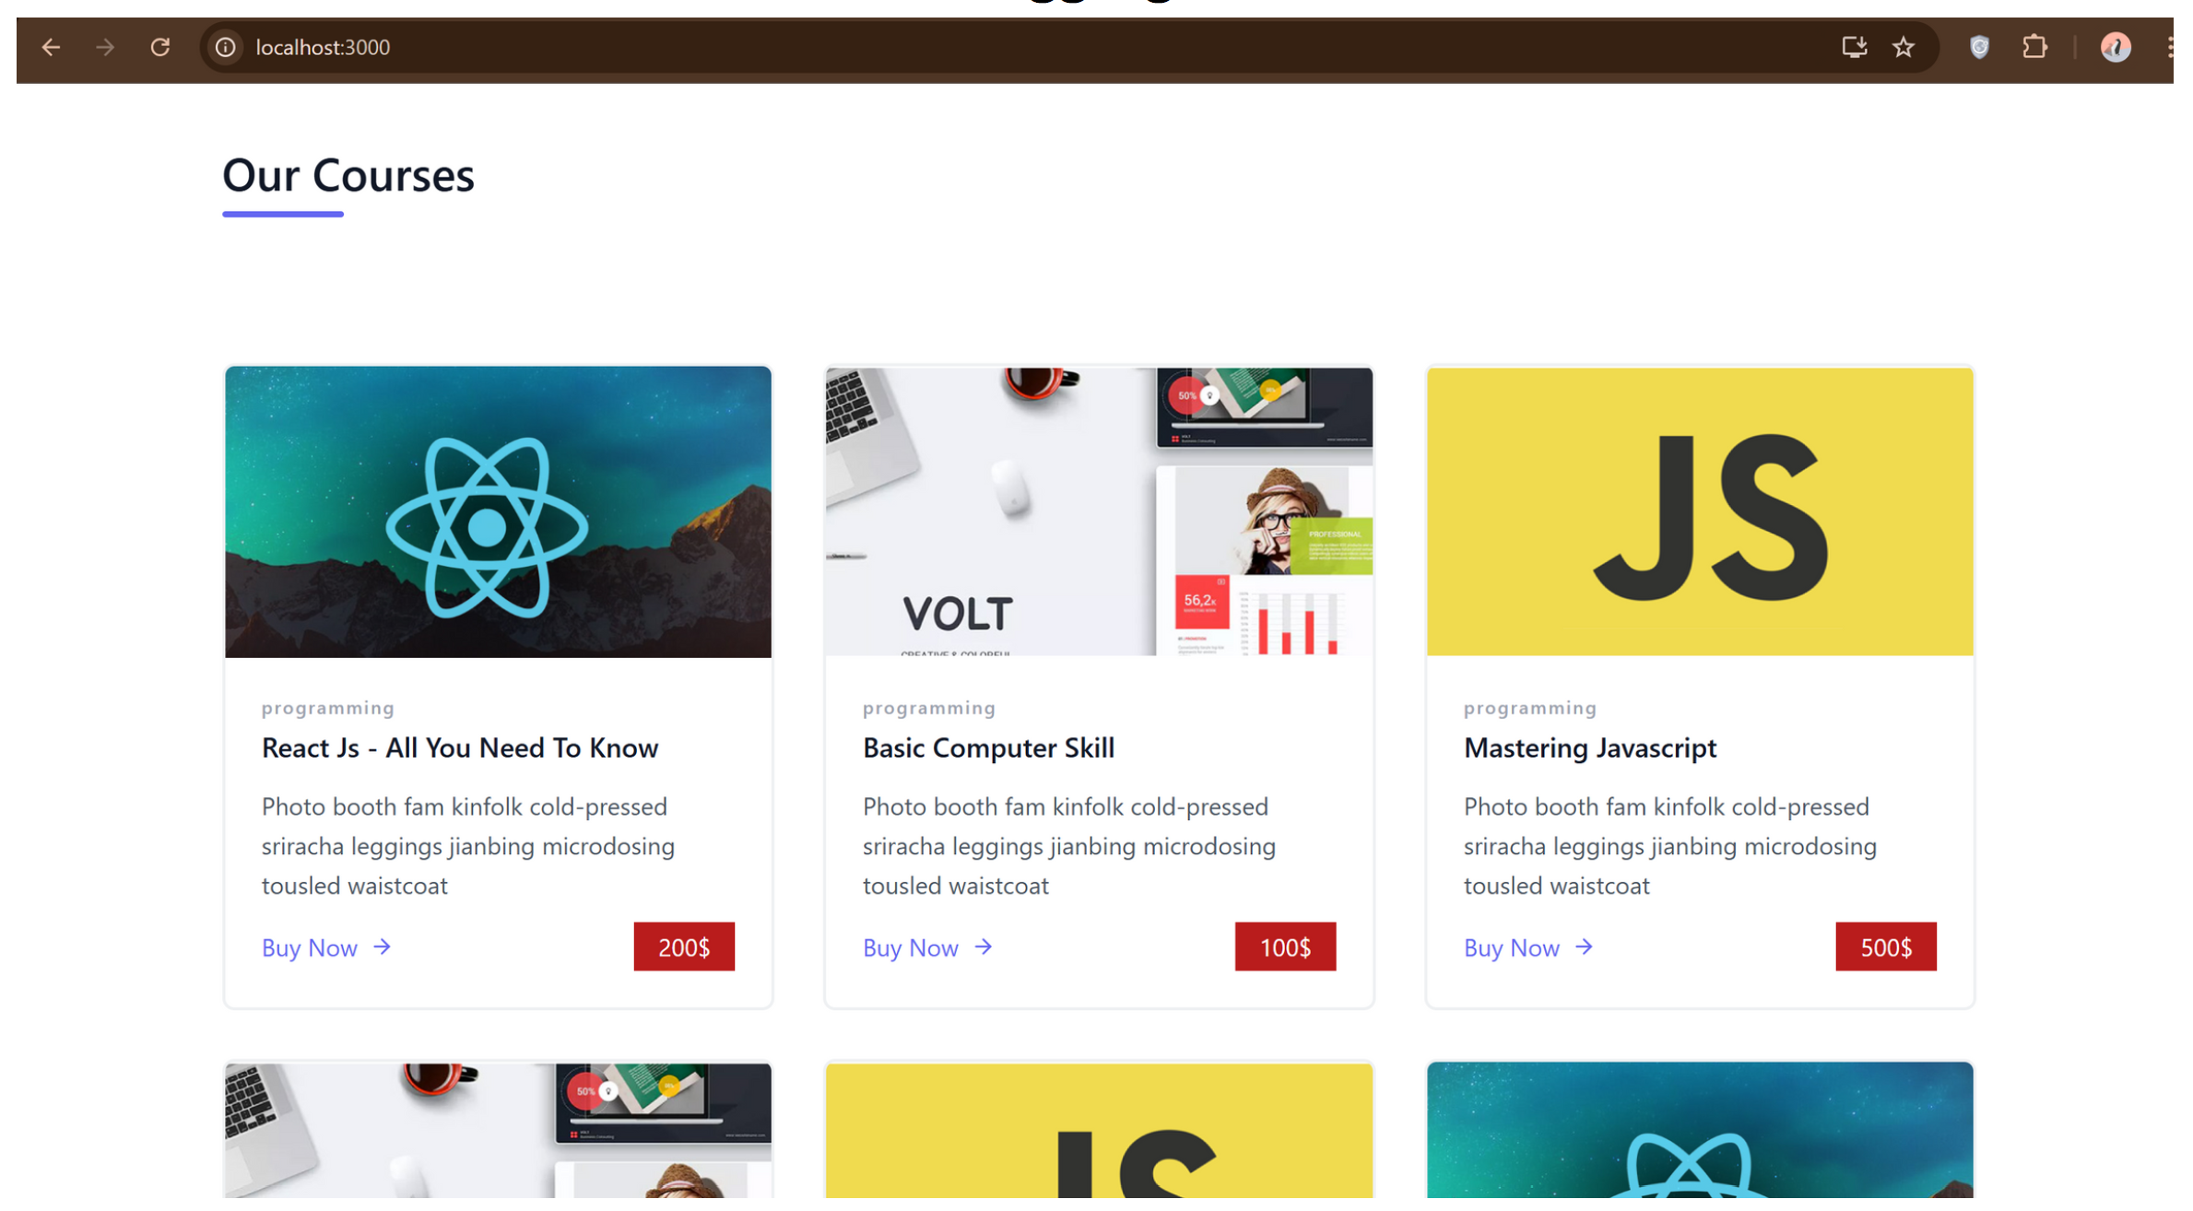

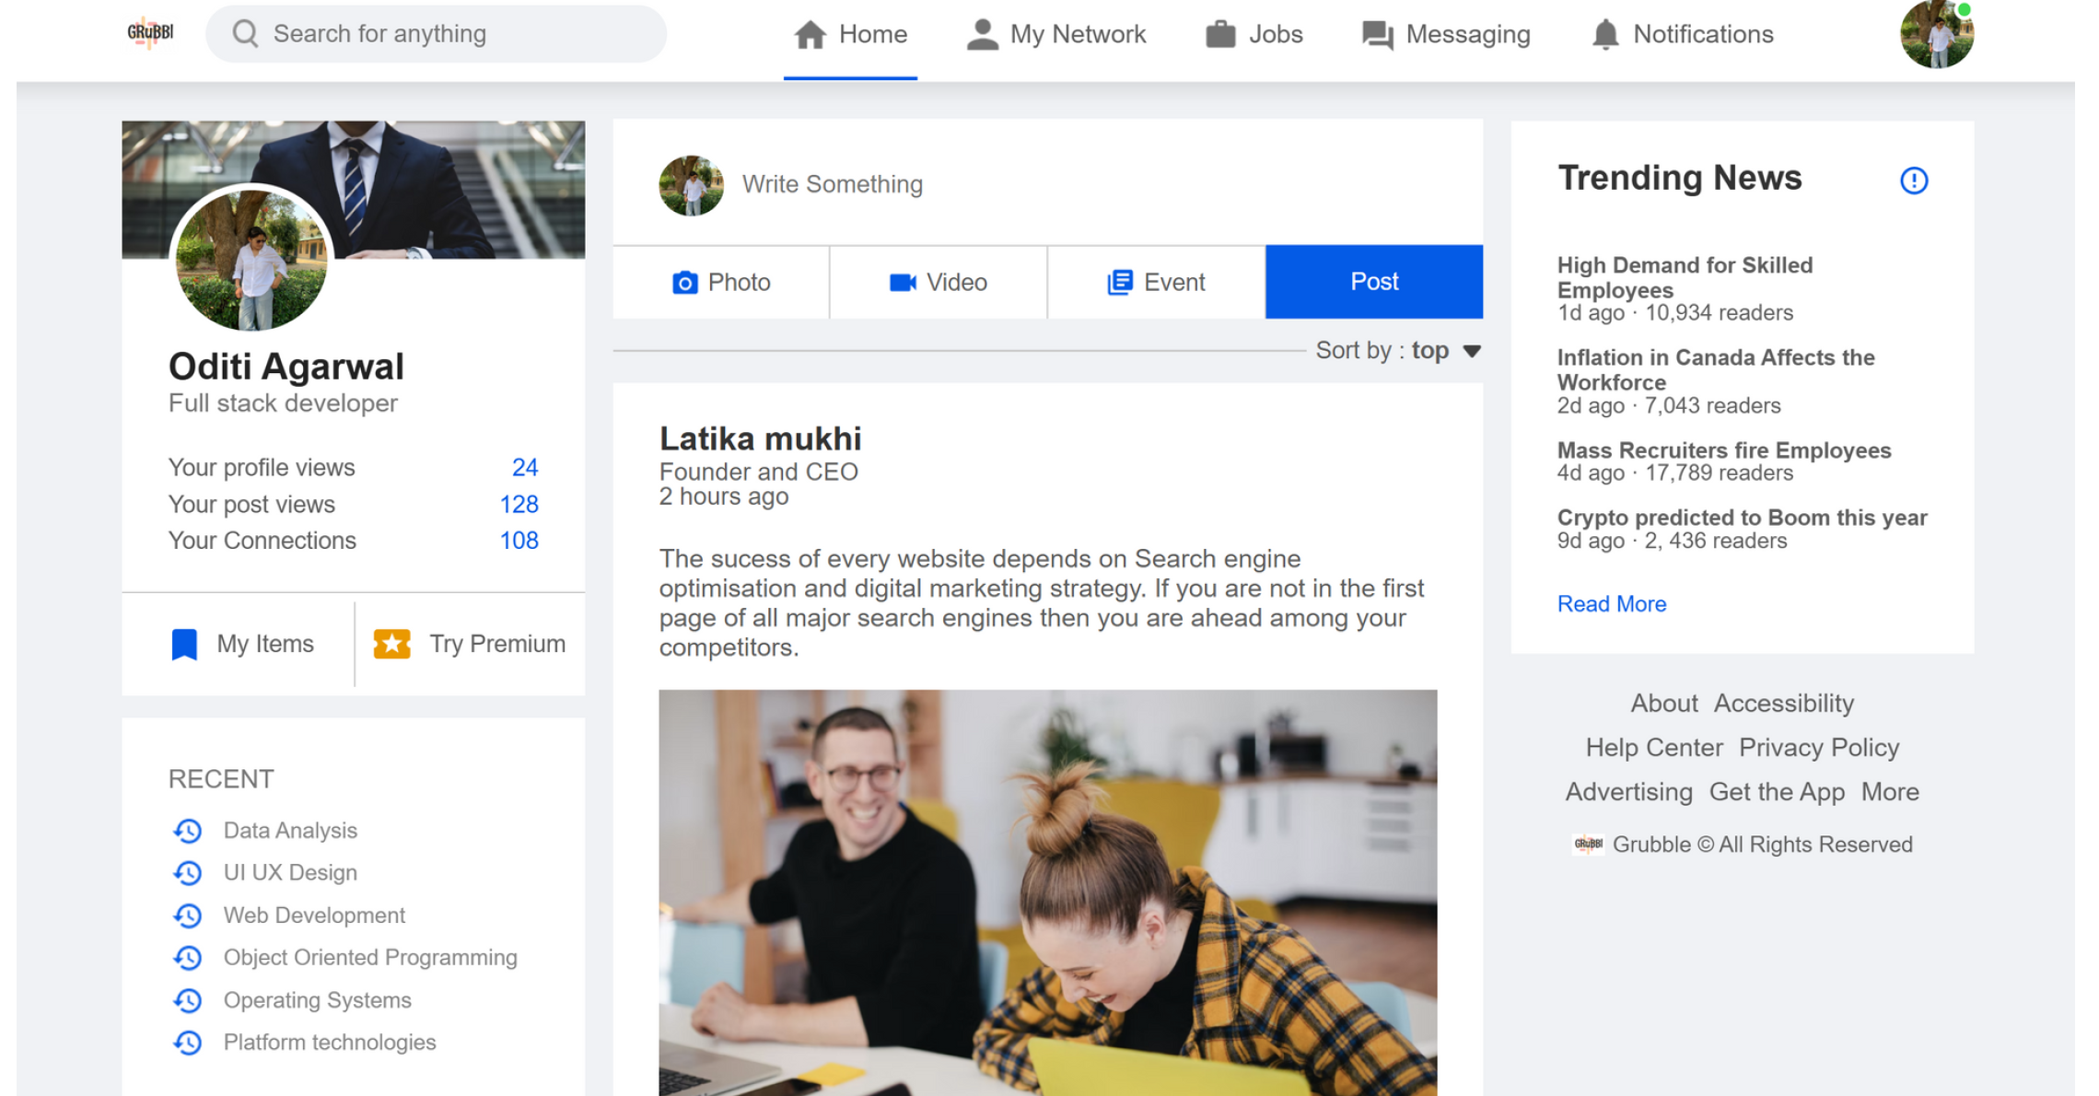

**Future Work**

* Introduce real-time mentorship features and discussion forums for peer collaboration.
* Integrate practical assessments and capstone projects to validate course outcomes.
* Expand to institutional partnerships for formal credit recognition.
* Localize the platform with language support for wider reach.
* Develop a mobile app to improve accessibility.

**Conclusion**

Grubble addresses critical gaps in the current digital learning ecosystem by combining AI, gamification, and community features. It provides a structured, engaging, and career-focused experience for learners while offering recruiters a better way to discover talent. With scalability in mind, Grubble has the potential to evolve into a comprehensive platform for global skill development and hiring.

In the future, Grubble can integrate advanced machine learning algorithms to further refine recommendations, support real-time mentoring features, and include in-app project-based assessments. This would not only enhance the personalization experience but also provide recruiters with deeper insights into practical competencies. Additionally, partnerships with academic institutions and global e-learning providers could strengthen the platform's credibility and outreach.

By continuously adapting to user feedback and technological advancements, Grubble aims to become a go-to platform for both learners and employers in the ever-evolving landscape of digital education and career development.

**References**

1. Coursera: www.coursera.org
2. Udemy: www.udemy.com
3. edX: www.edx.org
4. LinkedIn Learning: www.linkedin.com/learning
5. NorthCap University Internal Survey, 2025
6. Global E-learning Market Reports (Statista, 2024)
7. <https://www.futurelearn.com/>
8. <https://developers.google.com/machine-learning/recommendation>
9. https://medium.com/@sakshammathurr/course-recommendation-system-817f13928011