PressPilot Ambient Motion & Background System
  - Design AI Agent Handoff — Version 1

Scope
Create the cinematic background family only. Do not redesign the interface, rewrite copy, or move product controls.

1. Brand position
PressPilot is an install-ready WordPress website builder. The backgrounds should visualize a business brief becoming a complete website without making the product feel technical or intimidating.
- A business brief becomes a complete WordPress website.
- The website is built around the business and its brand.
- The website can be edited in WordPress and installed on any WordPress host.
- PressPilot works in 7 languages, including Arabic with full RTL support.
- Do not place generated text, invented wordmarks, or fake interface copy inside the background.

2. What the exploration established
- Near-black and deep navy foundation
- PressPilot emerald as the principal light color
- Restrained teal and cyan reflections
- Soft cinematic diffusion, fog, and depth
- Broad atmospheric light rather than thin neon lines
- The PressPilot AI star used as a subtle living energy source
- Slow, controlled movement
- Layered assets that can support parallax or parallel-scroll effects
Important
The old single green ribbon is only a temporary placeholder. Do not refine or reproduce it as the final system.

3. Current-page context
The current page relies on flat dark surfaces and temporary cyan/green gradients. The new system must add depth without reducing feature-copy, gallery, or pricing readability.
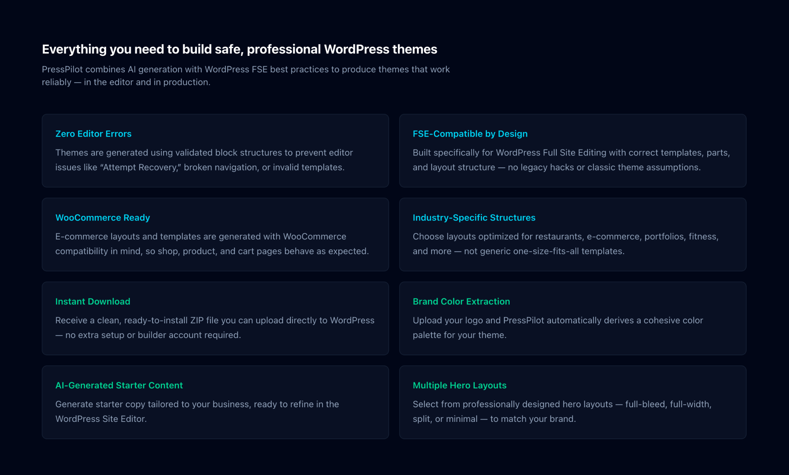
Current feature-section reference — background assets remain temporary.

4. Non-negotiable visual rules

Use
- Dark navy-black canvas
- PressPilot emerald light
- Soft volumetric haze
- Large blurred light fields
- Controlled depth and refraction
- Slow parallax between visual layers
- A restrained four-point AI star motif
- Large dark negative-space regions for copy and UI
- Smooth loops with no visible jump

Avoid
- Neon wires, fiber-optic strands, corrugated light rings, or electrical cables
- Cyberpunk tunnels or audio-visualizer shapes
- Repeated floating stars
- Plastic or chrome 3D stars
- Aggressive lens flares, oversaturated green, flashing, or camera shake
- Generated logos, wordmarks, or text embedded in footage

5. AI star behavior

Correct
- Preserve the four-point silhouette
- Soft emerald internal illumination
- Very small brightness change over time
- Slow breathing rhythm
- Stable exterior geometry
- One star as the focal source, not a repeated field

Incorrect
- Bright white starburst or five-point star
- Fast pulsing, spinning, or unrelated morphing
- Glossy plastic object or strong neon outline
- Multiple copies floating through the scene
Logo rule
Overlay the real PressPilot SVG separately in the UI or editor. Do not ask a video generator to preserve the wordmark.

6. Color and light direction
- Foundation: Near-black and deep navy.
- Primary energy: PressPilot emerald.
- Depth: Dark teal.
- Secondary reflection: Restrained cyan-green.
- Highlights: Soft white, used rarely.
Light must be broad and diffused with smooth falloff. Keep the strongest light near focal UI or CTA areas and maintain dark edges for readability.

7. Approved background scenarios

Scenario 1 — Creation Portal
Use for: Landing-page hero, Studio introduction, empty state, and initial generation.
Story: A business idea enters PressPilot and begins becoming a website.

Composition
- One large abstract four-point star or star-shaped aperture
- Broad emerald mist and liquid-light movement
- Dark copy-safe area
- Clear product-preview area
- Subtle particles moving toward the focal point

Motion
- Slow internal illumination
- Gentle atmospheric expansion and contraction
- Very restrained orbital drift
- Locked or almost locked camera

Scenario 2 — Intelligence Flow
Use for: How-it-works section, generation progress, business-brief processing, and content creation.
Story: Unstructured business information becomes a structured WordPress website.

Composition
- Small star-shaped source or energy anchor
- Horizontal or diagonal information flow
- Soft particles, mist, and translucent planes
- Geometric hints of website structure forming gradually
- Dark space for explanatory copy

Motion
- Directional but calm
- Particles organize into soft rectangular structures
- No laser streaks
- No technical dashboard graphics

Scenario 3 — Generative Landscape
Use for: Website gallery, preview sections, business categories, and Studio review.
Story: A spacious visual world containing many possible website directions.

Composition
- Layered translucent planes
- Distant soft star motifs
- Blurred emerald light fields
- Subtle architectural lines or grid fragments
- Strong depth separation

Motion
- Slow multi-layer parallax
- Background haze moves least
- Midground planes drift gently
- Foreground blur moves slightly more
- Website preview remains the focal point

Scenario 4 — Calm Brand Pulse
Use for: Pricing, final CTA, payment confirmation, completion, and download.
Story: The project is complete and ready to move forward.

Composition
- Dark edges
- Soft central emerald illumination
- Faint star or logo-inspired silhouette
- Minimal fog and particles
- Clear CTA-safe center

Motion
- Slow breathing light
- Gentle halo expansion
- Minimal circular drift
- No dramatic climax or flashing

8. Layered parallax package
Create the visuals as separable layers whenever possible:
1. Back layer — deep navy gradient and low-contrast haze
2. Mid layer — broad emerald ribbon or volumetric field
3. Focal layer — AI star, portal, or assembling structure
4. Front layer — blurred bokeh, bloom, or translucent plane
5. Static mask — dark copy-safe gradient
Suggested implementation movement later: back 8–12%, mid 16–22%, focal 22–30%, foreground 30–38%. Text and UI remain stationary or move only subtly.

9. Required output package
- 3840 × 2160, 16:9 master
- 10–12 second seamless loop
- 24 or 30 fps
- Silent; no audio track
- High-quality MP4 and WebM
- Static poster frame in PNG and WebP
- Layered still pack for parallax implementation

Adaptations after master approval
- 1080 × 1920 vertical
- 1080 × 1080 square
- 1200 × 628 landscape social
- 1920 × 1080 web/video
- Optional 4:5 feed crop

10. Independent prompts
A — CREATION PORTAL
Create a premium cinematic motion-graphics background for PressPilot, an install-ready WordPress website builder. Use a near-black and deep navy environment with soft emerald light, restrained teal reflections, volumetric fog, atmospheric refraction, and large blurred light fields. Build the composition around one abstract four-point AI star inspired by the supplied PressPilot icon. Preserve the four-point silhouette, but interpret it as a dimensional energy aperture rather than a hard logo.
The star should have a restrained living presence: slow internal illumination, extremely gentle breathing, stable exterior geometry, and a soft emerald halo. Add broad translucent atmospheric ribbons moving slowly through depth. Reserve a dark clean region for a large headline and a quieter region for a product UI preview. Use a locked camera with almost imperceptible drift. Create a seamless 10–12 second loop.
Avoid neon wires, electrical cables, fiber-optic strands, tunnels, spinning, flashing, repeated stars, plastic 3D surfaces, text, wordmarks, and excessive particles.

B — INTELLIGENCE FLOW
Create a dark premium cinematic motion background for PressPilot. Communicate a short business brief becoming a structured WordPress website. Use a near-black deep navy base, PressPilot emerald light, subtle teal, soft fog, and controlled depth.
Place one subtle four-point AI star as the source of the motion. From it, send calm horizontal streams of mist, small particles, and translucent information planes across the composition. Let the flow gradually organize into soft rectangular website structures without showing literal UI, readable text, or code. Keep the motion slow and elegant. Preserve large dark areas for copy. Create a seamless 10–12 second loop with a locked camera.
Avoid lasers, digital rain, fiber optics, bright lines, technical dashboards, glitch, fast motion, and logo distortion.

C — GENERATIVE LANDSCAPE
Create a spacious cinematic background for a PressPilot website gallery and preview experience. Use a near-black and deep navy environment with restrained emerald light fields, translucent floating planes, distant four-point star motifs, subtle architectural lines, and deep layered parallax.
The scene should suggest many possible website directions without showing literal websites or readable text. Background haze moves very slowly, midground planes drift gently, and foreground blur moves slightly more. Keep contrast low behind cards and website previews. The result must feel premium, calm, and dimensional. Create a seamless 10–12 second loop.
Avoid busy particles, hard neon geometry, cyberpunk styling, repeated logos, and strong light behind text.

D — CALM BRAND PULSE
Create a calm premium cinematic closing background for PressPilot pricing, completion, and final CTA states. Use near-black, deep navy, and soft emerald light. A subtle four-point star or logo-inspired silhouette should emerge through dark atmospheric mist with a restrained internal pulse.
Use darker edges and a softly illuminated center. Motion should be meditative: a slow breathing glow, minimal halo expansion, tiny particles, and almost imperceptible circular atmospheric movement. Keep the CTA area clear and readable. Create a seamless 10–12 second loop.
Avoid dramatic flares, bright central explosions, neon outlines, fast particles, aggressive pulses, and over-saturated green.

11. Universal negative prompt
NEGATIVE PROMPT
Cheap neon, glowing wires, corrugated cables, fiber-optic strands, electric ring, audio waveform, music visualizer, cyberpunk tunnel, gaming interface, rainbow colors, oversaturated green, flashing, strobing, fast rotation, camera shake, rapid zoom, chaotic particles, hard geometric edges, strong lens flare, glossy plastic star, five-point star, repeated stars, warped logo, changing logo geometry, generated text, letters, numbers, WordPress logo, people, devices, stock footage, cartoon appearance.

12. Production workflow
1. Build one static 16:9 keyframe for each scenario.
2. Review star geometry, light level, negative space, and brand color.
3. Approve the static frames before animation.
4. Animate only the approved visual properties.
5. Produce low-resolution motion tests.
6. Approve motion speed and loop behavior.
7. Render final 4K masters.
8. Create platform adaptations.
9. Deliver static fallbacks and separated parallax layers.

13. File naming
- PP-BG-01-Creation-Portal-16x9-v01
- PP-BG-02-Intelligence-Flow-16x9-v01
- PP-BG-03-Generative-Landscape-16x9-v01
- PP-BG-04-Calm-Brand-Pulse-16x9-v01
Use suffixes: -MASTER.mp4, -WEB.webm, -POSTER.webp, -STILL.png, and -LAYER-[BACK|MID|FOCAL|FRONT].png.

14. Quality gate
- The star remains a four-point PressPilot-style form
- Glow is restrained and emerald
- No neon-wire appearance
- No generated text or wordmark
- Motion is slow and intentional
- Loop has no obvious jump
- Copy-safe areas remain dark
- Preview areas remain quiet
- The four scenarios feel like one family
- Static poster works without motion
- Reduced-motion fallback is available
- Files are silent and web-ready

