Chapter Three
Methodology

3.1 Background
The financial institutions have seen a massive growth in the application of Information and computer technology (Alese et al., 2018). The number of operations that can be performed through online, mobile and USSD banking has continued to increase. It is now possible to create an account without leaving the comfort of your room. These IT services offered by financial institutions will not be possible without the feature to distinctly authenticate users.
Different methods of authentication have been discussed in the previous chapters. Likewise, Behavioral authentication has also been reviewed in the previous section. As explained in the previous chapter, one of the important components in behavioral biometrics authentication is the issue of modalities and features. This section will discuss the modalities used in this project and also discussed the features and the process of extracting those features. However, before proceeding to discuss the methodology and approach that will be used in this project, it is expedient to discuss briefly the transition of authentication methods.
Authentication involves two stages. The first is the process of user registration or user enrollment. In this stage the user is registered in the user database. The user information is saved alongside with other required data necessary to uniquely identify the user. For example, in password-based authentication, the user registered with username and password with other details needed. The information is saved in the database and that completes the registration or enrollment process. Most services include a validation step before completing the enrollment step.
The second stage is the verification or login process. In a password-based system, the user supplies the username and the password with which the user registered to get access to the service. The system checks the username as password and matches it against the one supplied during the enrollment stage. The system allows the user to access the requested resources if there is a match and return error otherwise.
This process is similar in biometric authentication. It also involves the enrollment process and the validation process. However, the enrollment process in most biometric authentication involves the user of biometrics hardware. For example, fingerprint biometric authentication needs a fingerprint scanner for both the authentication and the enrollment process. Likewise, Iris biometric and voice recognition requires an iris scanner and a sound recording device respectively (Solayappan & Latifi, 2006; Teo & Neo, 2017). Furthermore, Face recognition authentication requires a webcam or an image capturing device. Also, hand geometry recognition also requires a hardware device for enrollment and authentication process.
Also, in password-based authentication, the user can get access to any authorized service as far as the user session is still valid. This type of authentication, where the user only needs to log in the first time and no validation is needed to access resources/service after the first login, is known as passive authentication. Whereas an authentication process that checks the validity of the user at every time a resource access request is initiated is known as active or continuous authentication (Roth et al., 2013; Weiss et al., 2019). Most authentication methods that involve the use of specialized hardware for enrollment and verification are difficult to implement as continuous authentication.
Behavioral authentication on the other hand can capture the activities of the users for both enrollment and verification. This characteristic makes behavioral authentication suitable for continuous or active authentication. Like every authentication process, behavioral biometric authentication also includes the enrollment phase and the validation phase. In this work, the two phases will involve the use of a mobile application and a mobile application server. The following sections will discuss the workings of these two components.

3.2 The System Architecture
The system will include three main actors.

3.2.1 The User
The user is the actor that needs to be authenticated. The user will perform various forms of touch and typing related interactions on their mobile devices. The user will also interact with the banking functions. There will be two major banking operations that the user can interact with. These operations are:
- Transfer Operation:
This is transfer operations from one person to another. This is one of the most performed operations with mobile financial application (Airehrour et al., 2018; Alese et al., 2018). During transfer, the user sends money to another user’s account by specifying the user’s account information and the amount to be sent and then initiates the transfer. The financial system removes the specified amount along with service charges; then credits the account of the recipient/beneficiary with the exact amount specified during the transfer. This operation is very sensitive because one the transfer operation is completed, it cannot be undone, except through another transfer operation from the recipient/beneficiary.
Consequently, malicious users are more interested in having controls of this operation. To further secure these operations, financial applications usually include a two-factor/multi-level authentication before this operation can be approved (Alese et al., 2018). The user will usually need to supply a password/pin first, then a token is sent to the user’s phone. The user will need to enter the correct token sent to his/her phone before the operation will be approved.
The multi-level authentication can help secure user funds by making it difficult for malicious users to have access to the transfer operation. However, multi-level authentication does not prevent the user from performing transfer operations with the influence of social engineering attacks. However, anomaly detection features could help provide a form of warning when a user initiates an unusual transaction. The anomaly detection features is part of the features included in the biometric authentication metrics and will be discussed later in this document.

- Enquiry Operation
In this operation, the user will be able to check their account balance and also view their transaction history. The enquiry operation will also be part of the operation that will be secured through biometric authentication. Securing enquiry operation is important, even though it does not involve any monetary transaction in any way. It is important because a malicious user could gain more information about the user through account balance enquiry and transaction history.
This type of information can help malicious users to launch various social engineering attacks since they have access to real information about the user thereby making their malicious claims somewhat valid. Valid information about user transactions could be embedded in phishing emails and messages, thereby increasing the chances of a user falling victim of those attacks (Birlea, 2020; Lohani, 2019).
Aside from direct attack on the victim, having information about the user’s transactions could expose other users with whom the user has transacted with. Therefore, increasing the attacking space for malicious users (Airehrour et al., 2018; Birlea, 2020; Conteh & Schmick, 2016).

3.2.2 Mobile Device
The user mobile device acts as a data collection tool, through the device sensors. The user performs operations through the phones and the phone captures the user’s interactions for training purposes. The mobile devices need to contain some hardware sensor component in order for the device to be useful for data collection. There are three main hardware sensor components that are required in this work.
- Touch Sensor
This project will make use of android mobile devices. Most of these devices are touch based devices and already include touch sensors. This sensor will capture user touch and typing interaction. The data from this sensor will be collected and used for features extraction and subsequently training of the authentication model. This sensor also helps extract the needed data during the verification stage.
- Accelerometer Sensor
Accelerometer measures movement of the phone in any direction of the phone. It measures the horizontal, vertical and the depth direction of the phone. This sensor helps capture the moves of the user while using the phone. This will help capture specific user movement patterns while using the phone. The mobile device will also help to capture specific movement patterns for each user.
- Gyroscope Sensor
The gyroscope sensor measures the orientation of the device. It measures how much the phone is tilted and in what direction. The measures from the accelerometer sensor are combined with that of the gyroscope sensor to measure users orientation during phone usage.

3.2.3 The Mobile Application Server

The enrollment and verification process cannot be performed on the mobile devices because of the limited computing resources. However, the mobile device is used to collect relevant data. This data is then sent to a mobile application server for further processing. The machine learning training algorithm and the matching algorithm is performed on the server. Likewise, the bulk of the authentication process is performed on the server.
As mentioned earlier, there are two stages in the verification process. The enrollment stage and the verification stage.
Enrollment Stage
During this stage, a stream of interaction data is sent to the server by the mobile applications. These data will contain data measuring different types of interactions based on the accelerometer and the gyroscope sensor value. The information is matched with the supplied information during registration.
Therefore, the enrollment data will be a collection of basic personal data and device interaction data. The personal data that will be collected are:
- Fullname
- Email Address
- Phone Number
- Contact Address
- Gender
- Marital Information
- Date of Birth
The personal information will be saved in the database to generate a unique user identification number. This number will link all user’s interaction data; thereby uniquely separating each user’s phone interaction data.
Feature’s extraction process will be achieved using each user’s phone interaction data. The features are then trained using the machine learning algorithm which will be discussed in the later part of this document to generate an authentication model for each user.

Verification Stage
At this stage, the application server receives the interaction data from the user’s mobile device. The quantity of the interaction data received at this stage can be lesser than the quantity received during the enrollment. Similar to the enrollment stage, the interaction data is converted to a set of features. These set of features are passed through the model saved during the enrollment stage. The result from the model determines if the user is authenticated or not.
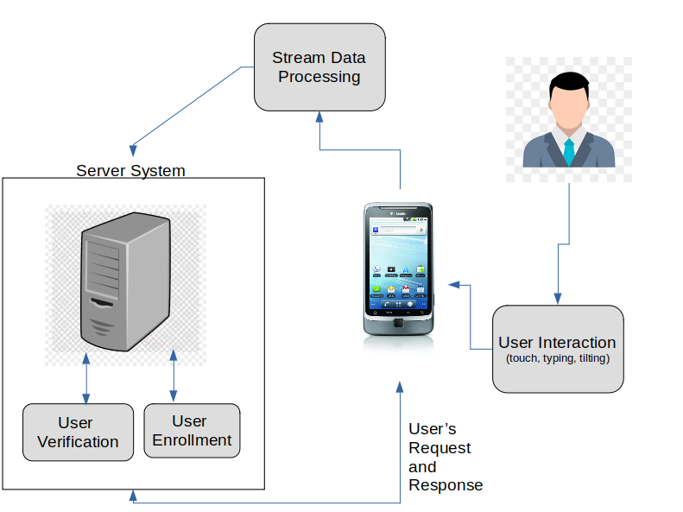
Figure 3.1 is a pictorial representation of the interaction of the three main actors.

3.3 Features Extraction Process
This section described the set of features that will be used in the work. The features are based on three categories:
- Touch Interaction
- Click Interaction
- Typing Pattern
- Tilting pattern
- Operation History
Touch Interaction
This is the touch interaction pattern made by the user. The interaction is recorded alongside with the delay between touch down and touch up. The touch interaction will include multi-touch interactions like, pinching and dragging.
Click Interaction
This is similar to the touch interaction activities, except that this measure is based on clicking on the provided functions buttons. Similar to the touch interaction, timing is also measured.
Touch Typing Pattern
These features still make use of the touch sensors, but specifically with the software keyboard present. This measures the typing speed of the users and the typing variation with respect to time.
Tilting Pattern
This is a measure of the movement and orientation of the device while being used by the user. This quantity is an aggregation of the measure from the gyroscope and the accelerometer sensor as explained in section 3.2.2.
Operation History
This is an anomaly detection feature. It makes use of the user’s transaction history and creates an average of the transaction made by the user monthly. These thus form anomaly detection features. The number of averages is based on the size of the user history since the average is done on a weekly interval to create a time-series like features.
Figure 3.2 shows how each of these features relates.

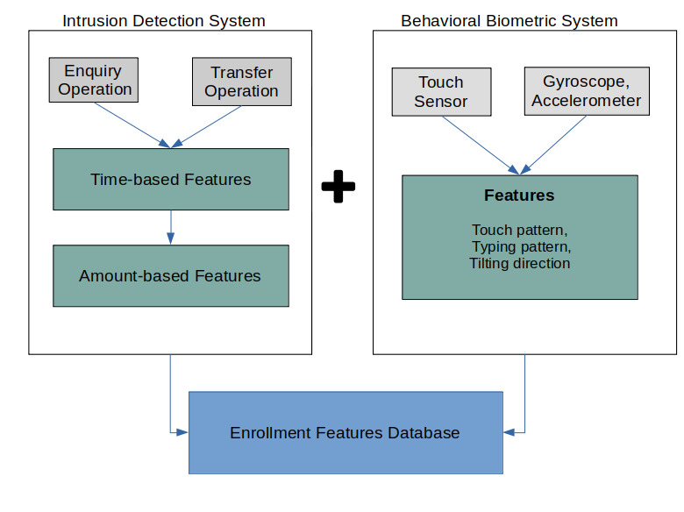
Figure 3.2 The feature extraction process diagram
According to figure 3.2, there are two types of features. The first type is the biometric authentication features. The biometric authentication features belong to the category of features seen mostly in literature. These features are measured directly from the user interaction pattern and as shown in the figure above, they are: touch pattern, typing pattern and tilting pattern.
The features are measured directly from the user's device through the mobile application software that can communicate with the mobile application server. The application server then saves the feature into the database as shown above.
The second category of feature is anomaly detection features. It measures the normal activities specific to the user by making use of the user’s transaction history. The transaction history is fetched from the transaction database. This will be a vector of features that contains the average of the weekly transaction volume by the user. The features form a set of a time-series data with a period of seven days.
The biometric authentication feature is then combined with the anomaly features to form the set of final biometric authentication features as shown in figure 3.2.

3.4 Data Gathering

The biometric authentication method in this work involves the use of supervised machine learning algorithms which require training data. The data to be used in the training process are the features data extracted from the user interaction as explained earlier.

Between forty and sixty users will be enrolled to participate in the study. Each user will interact with the mobile application that will be installed on their devices to capture their interaction pattern. This data will be sent to the application server for each of the enrolled. This data will thus serve as the training data for the machine learning algorithms.

3.5 The Machine Learning Algorithms
As stated above, this study will make use of supervised machine learning algorithms. Two algorithms will be used and compared in this study. These are:
- Artificial Neural Network (ANN)
- Support Vector Machine (SVM)

3.5.1 Artificial Neural Network (ANN)
Artificial Neural Network (ANN) is one of the machine learning algorithms that will be applied to train the user interaction data extracted from mobile devices. ANN can be used as a supervised machine learning algorithm. This means that the data can be used to train datasets that include labels. Unlike other machine learning algorithms like linear regression, ANN can be used to model non-linear. The ability to use ANN for non-linear data makes it applicable as a training algorithm for this type of data. ANN has been applied in related works that employ similar categories of data (Corpus et al., 2016; Ivutin et al., 2018).
ANN as the name implies is inspired by the biological neurons in the brain where a neuron is represented as a perceptron. Perceptrons are like simple computation models that represent what can be seen as a form of biological neuron. Like the biological neuron, it can have many inputs (biologically referred to as dendrites), a computation center (cell body) and a single output (axon) (Charniak, 2018). Figure 3.3 gives a graphical representation of a perceptron.

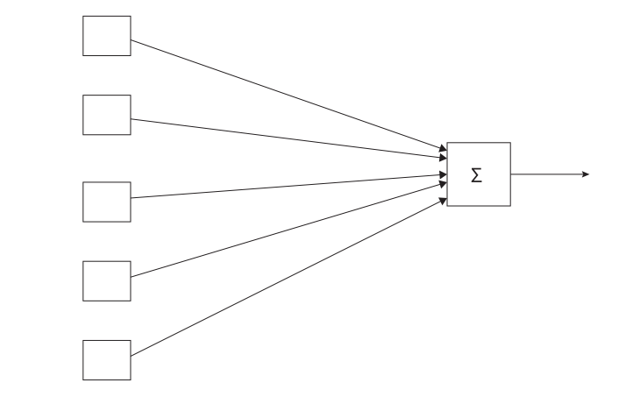
Figure 3.3 Graphical representation of a perceptron with 5 inputs
Each input in a perceptron has a weight w, attached to it. There for a perceptron of input size m, there will be w₁ …… w_{m.} The output from a perceptron is a binary, that is the output can either be 0 or 1. Furthermore, a perceptron contains as a bias value b. A perceptron is represented mathematically as shown below:
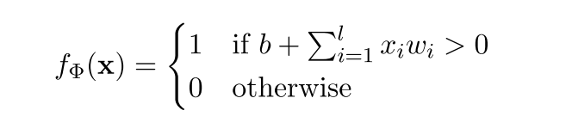
Where Φ is the set of parameters; in this case Φ={W,b}, where W=[w₁…….w_{m}]. X=[x₁……...x_{m}] is the set of all the inputs to the perceptron; b is the bias value.
The perceptron can thus be trained with a dataset to estimate the value of the parameters. The training process is achieved with the algorithm below.
- Initiate the parameters to zero, that is W and b
- Loop: for each training example with output
  - Let output of each training example be y_{k} and the input be x_{k}
  - if y_{k} – f(x_{k}) =0 skip
  - foreach weight w_{k}:
    - ∆w_{k} = (y_{k} – f(x_{k}) )x_{k}
    - Add ∆w_{k} to the weights.
The perceptron can only have one output, therefore in order to have multiple output, a multiple perceptron is used. The is represented graphically in figure 3.4
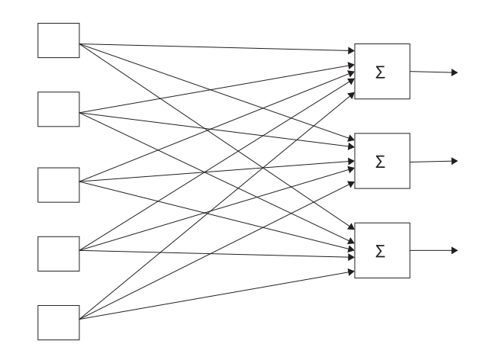
Figure 3.4 multilayer perceptron.
Each of the perceptrons still follows the same computation as described above. The training process is however different in this case. There is an additional loop over the new output, meaning each of the perceptrons is trained on the same set of input.
In a multi-layer neural network, figure 3.4 connects to another node, such that the output node now forms new input for the overall output node as shown in figure 3.5.

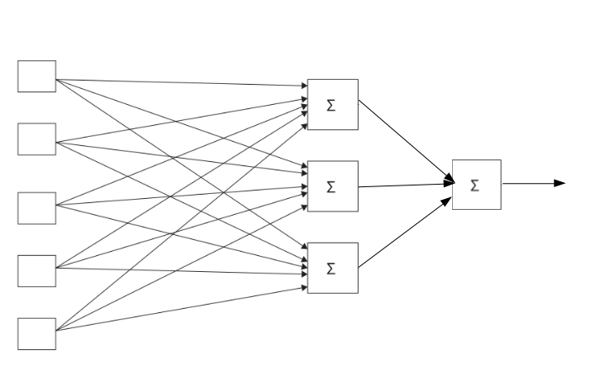
Figure 3.5 Artificial Neural Network with one hidden layer

ANN contains three types of layer. Input layer, hidden layer and the output layer. The hidden layer is the layer in the middle in figure 3.5. ANN can contain more than one hidden layer. However, in this work a neural network with two hidden layers will be used. The training in ANN is done using a backpropagation algorithm. This algorithm will update the weight in the graph by propagating the error value from the training data from the output node to the input nodes.

3.5.2 Support Vector Machine (SVM)
The purpose of a supervised machine learning algorithm is to find a line that separates different classes. It might be possible sometimes to find more than online that can separate data belonging to various classes. However, the best line will be the line that gives the maximum margin between the different classes (Daumé, 2017). Support Vector Machine (SVM) is a machine learning algorithm that helps to find a hyperplane that separates training data into different planes by favoring the separation with the largest margin between the planes. This process forms a constrained optimization problem as given in the equation below.
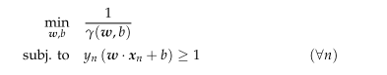
γ is the parameter that maximizes the margin, w is the coefficient of the input. The equation above, will work for linearly separable data. However, SVM can solve model non-linear data and this is done by optimizing the objective function given in the equation below:
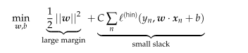
SVM is able to solve non-linear problems through use of kernels. Kernels are functions that help expand the spaces of the features, such that in that space, the features are linearly separable. SVM allows the use of various kernels. However, the Radial Basis Function (RBF) kernel will be used. RBF is chosen because of its capability to model non-linear data.

3.6 The General Training Process
Previous sections in this document already explained each of the different components for behavioral biometric authentication. Figure 3.6 gives a general overview of the training process while incorporating the training algorithms.
The data saved from the enrollment database is preprocessed and the features described in section 3.3 are extracted for training. The features set is trained using ANN and SVM algorithms described in section 3.5 to generate the machine learning authentication model, completing the enrolled process.
The verification process on the other hand selects fresh interaction data from the user’s device. This data is processed to generate preliminary features similar to that coming from the enrollment database from the enrollment step. The feature is then preprocessed to generate equivalent leaning features, which is then passed through the verification system.

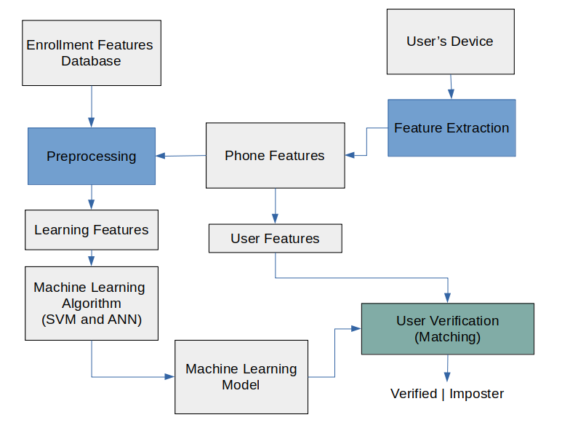
The verification system will generate a binary output that determines if the user trying to perform a particular operation is a legitimate user or an impostor. The verification system is like the prediction aspect of the two machine learning algorithms (ANN and SVM).

3.7 Performance Evaluation Metrics
The following metrics will be used during performance evaluation for both ANN and SVM. However, some definitions are needed before diving into the metrics.
True Positive (TP): This happens when a user is correctly matched.
True Negative (TN): This happens when an imposter is correctly matched as an imposter.
False Positive (FP): This is when an imposter is wrongly identified as a legitimate user.
False Negative (FN): This is when a legitimate user is identified as an imposter.

Therefore, the following is defined based on the definition above. This is a combination of the metrics described in (Eberz et al., 2017; Neal & Woodard, 2020)
- Accuracy: This is the measure of the number of correct matches made by the method. (TP+TN)/(TP+TN+FP+FN)
- False Acceptance Rate (FAR): This is the proportion of false positives to all other forms of negatives. FP/(FP+FN)
- False Rejection Rate (FRR): This is the ratio of false negative to all positives. FN/(TP+FN)
- True Negative Rate (TNR): This is the ratio of true negative to all negatives. TN/(TN+FP)
- True Positive Rate (TPR): This is the ratio of true positive to all positives. TP/(TP+FN)
The performance of ANN and SVM will be evaluated and compared based on the five metrics given above.

References

Airehrour, D., Nair, N. V., & Madanian, S. (2018). Social engineering attacks and countermeasures in the New Zealand Banking System: Advancing a user-reflective mitigation model. Information (Switzerland), 9(5). https://doi.org/10.3390/info9050110
Alese, B. K., Thompson, A. F., Alowolodu, O. D., & Oladele, B. (2018). Multilevel authentication system for stemming crime in online banking. Interdisciplinary Journal of Information, Knowledge, and Management, 13, 79–94. https://doi.org/10.28945/4063
Birlea, M. C. (2020). Phishing Attacks : Detection And Prevention. ArXiv.
Charniak, E. (2018). Introduction to Deep Learning. In Journal of Chemical Information and Modeling (Vol. 53, Issue 9).
Conteh, N. Y., & Schmick, P. J. (2016). Cybersecurity:risks, vulnerabilities and countermeasures to prevent social engineering attacks. International Journal of Advanced Computer Research, 6(23), 31–38. https://doi.org/10.19101/ijacr.2016.623006
Corpus, K. R., Gonzales, R. J. D. L., Morada, A. S., & Vea, L. A. (2016). Mobile user identification through authentication using keystroke dynamics and accelerometer biometrics. Proceedings - International Conference on Mobile Software Engineering and Systems, MOBILESoft 2016, 11–12. https://doi.org/10.1145/2897073.2897111
Daumé, H. (2017). A Course in Machine Learning. In Self-published (Vol. 101, Issue 2). http://www.csie.ntu.edu.tw/~cjlin/papers/guide/guide.pdf
Eberz, S., Rasmussen, K. B., Lenders, V., & Martinovic, I. (2017). Evaluating behavioral biometrics for continuous authentication: Challenges and metrics. ASIA CCS 2017 - Proceedings of the 2017 ACM Asia Conference on Computer and Communications Security, 386–399. https://doi.org/10.1145/3052973.3053032
Ivutin, A. N., Savenkov, P. A., & Veselova, A. V. (2018). Neural network for analysis of additional authentication behavioral biometrie characteristics. 2018 7th Mediterranean Conference on Embedded Computing, MECO 2018 - Including ECYPS 2018, Proceedings, 1–3. https://doi.org/10.1109/MECO.2018.8406032
Lohani, S. (2019). Social Engineering: Hacking into Humans. International Journal of Advanced Studies of Scientific Research, 4(1), 10.
Neal, T., & Woodard, D. (2020). Presentation Attacks in Mobile and Continuous Behavioral Biometric Systems. In Advanced Sciences and Technologies for Security Applications. https://doi.org/10.1007/978-3-030-39489-9_2
Roth, J., Liu, X., Ross, A., & Metaxas, D. (2013). Biometric authentication via keystroke sound. Proceedings - 2013 International Conference on Biometrics, ICB 2013. https://doi.org/10.1109/ICB.2013.6613015
Solayappan, N., & Latifi, S. (2006). A survey of unimodal biometric methods. Proceedings of The 2006 International Conference on Security and Management, SAM’06.
Teo, C. C., & Neo, H. F. (2017). Behavioral fingerprint authentication: The next future. ACM International Conference Proceeding Series, Part F1285, 1–5. https://doi.org/10.1145/3093293.3093296
Weiss, G. M., Yoneda, K., & Hayajneh, T. (2019). Smartphone and Smartwatch-Based Biometrics Using Activities of Daily Living. IEEE Access, 7, 133190–133202. https://doi.org/10.1109/ACCESS.2019.2940729

