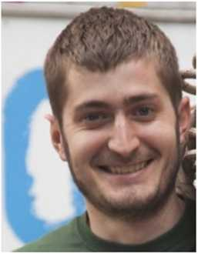
Denys Siumak
Front-end Developer

Address Ukraine, Kyiv  Phone +38(095) 599-66-00  E-mail denys_siumak@outlook.com  Date of birth 28 June 1990  www odoxar.github.io | Facebook facebook.com/odoxar  GitHub github.com/Odoxar  Linkedln linkedin.com/in/denys-siumak-757b47136/  Skype denisyumak

I am looking for interesting Job as a front-end developer, where I can improve my tech skills and learn and use new technologies.

Experience
2016-03 - 2016-09 | Freelance (MEPlife)  Adding responsive design to existing website. Adding Language options.
2017-02 - 2017-04 | Freelance (Martinika)  Developed responsive landing page with two version (ukr and eng).

Education
2007-09 – 2012-06 | Krementchuk Mykhailo Ostrohradskyi National University Speciality: "Land Use Planning and Cadastre". Degree: "M"

Courses
2016-01 - 2016-02 | HTML Academy
2016-05 - 2016-07 | Prometheus
2016-09 - 2016-10 | Ninja Frontend
2017-10 - 2018-03 | CyberBionic systematics

Certificates
2018-04 | CyberBionic systematics: WEB Frontend Developer, 2018
2016-07 | Prometheus - CS50, 2016
2012-06 | Krementchuk Mykhaiio Ostrohradskyi National University. Speciality: "Land Use Planning and Cadastre". Degree: "M"

Skills | Languages
  HTML5
  CSS3
  JavaScript
  jQuery
  Angular
  Ukrainian | native
  Russian | fluent
  English | Pre-Intermediate

