WORK INSTRUCTION
Performing Production Data Quality Assessment Using Python
Document ID | WI-DA-001 | Version | 1.0
Document Type | Work Instruction | Status | Portfolio Simulation
Document Owner | Data Analytics Manager | Intended User | Data Analysts
Related SOP | SOP-DQ-001 | Related Specification | SPEC-DQ-001

1. Purpose
This work instruction provides step-by-step instructions for performing the approved initial data quality assessment of manufacturing production datasets using Python. It supports consistent identification, documentation, and disposition of data-quality issues before production data proceed to downstream analysis.

2. Scope
This instruction applies to Data Analysts responsible for initial quality assessment of manufacturing production datasets using the approved Python validation workflow. It covers verification of the working dataset, execution of validation checks, review of results, issue documentation, and determination of dataset disposition.
This instruction does not authorize analysts to modify original source data, delete potential duplicate records, impute missing values, correct source values, or remove statistical anomalies without authorization under the applicable correction or exception process.

3. Prerequisites
- Authorized access to the approved Python/Jupyter analysis environment.
- Authorized access to the production-data project directory.
- An approved working copy of the production dataset.
- Current Production Data Dictionary and applicable validation requirements.
- Access to the validation record and issue-tracking outputs.
- Working knowledge of Python and pandas appropriate to the Data Analyst role.

4. Required Tools and Resources
Tool / Resource | Purpose
Approved Python environment | Executes the controlled validation workflow.
Jupyter Notebook | Runs the approved validation notebook.
pandas | Supports dataset loading and validation operations.
production_data_quality_assessment.ipynb | Approved portfolio-simulation validation notebook.
Production dataset - working copy | Dataset evaluated by the analyst.
Production Data Dictionary | Defines expected fields, types, units, domains, and applicable limits.
Validation requirements | Defines controlled checks and acceptance criteria.
Approved output directory | Stores validation evidence and release outputs.

5. Data Integrity Cautions
CAUTION - SOURCE DATA INTEGRITY
Do not perform validation or cleaning operations on the original source dataset. Perform the assessment using the authorized working copy. Do not overwrite the source file.

CAUTION - DATA MODIFICATION
Do not automatically delete duplicates, impute missing values, cap range violations, rename source fields, or alter values solely to make a validation check pass.

CAUTION - ANOMALY HANDLING
Do not treat statistical extremity alone as proof that a record is invalid. Preserve the observation and flag it for contextual review.

6. Procedure
Step 1. Verify the Working Dataset
Action: Confirm that the file provided for assessment is the authorized working copy. Verify the dataset identifier, filename, reporting period, and source against the applicable intake record.
Expected result: Dataset identity matches the intake information and the original source dataset remains unchanged.
If not met: Do not proceed. Resolve the discrepancy with the dataset owner or designated responsible person.
Step 2. Open the Approved Validation Notebook
Action: Open Jupyter Notebook in the approved Python environment and navigate to the approved production data quality assessment notebook.
Expected result: The notebook opens without an execution or access error.
If not met: Confirm the approved environment and file location. Escalate unresolved access or environment problems.
Step 3. Verify the Input File Path
Action: Confirm that the notebook input path references the authorized working copy, not the preserved source dataset.
Expected result: The configured path resolves to the intended working-copy file.
If not met: Correct the path only when the authorized file location has been verified. Do not substitute an unverified dataset.
Step 4. Load the Dataset
Action: Execute the dataset-loading section of the notebook.
Expected result: The dataset loads successfully and the notebook reports its row and column dimensions.
If not met: Review the error message. Verify the file path, format, permissions, and approved environment before escalating.
Step 5. Verify Required Structure
Action: Execute the required-field/schema check and compare the dataset structure with the current Production Data Dictionary.
Expected result: All required fields are present.
If not met: Record the applicable schema failure. Follow the severity and disposition requirements; do not fabricate or rename fields without authorization.
Note: The observed number of rows is descriptive unless an approved requirement defines an expected row count.
Step 6. Assess Missing Values
Action: Execute the completeness checks for required identifiers and required measurements.
Expected result: The workflow reports missing counts and applicable validation results for controlled fields.
If not met: Record failures by Rule ID and affected record. Do not independently impute or replace missing values.
Step 7. Identify Potential Duplicate Records
Action: Execute duplicate detection using the approved composite business key: Facility_ID + Batch_ID + Machine_ID + Timestamp.
Expected result: Potential duplicate groups are identified for review.
If not met: Document and investigate the affected records. Do not automatically delete either record.
Step 8. Validate Data Types
Action: Execute data-type validation and compare controlled fields with the expected types defined in the Production Data Dictionary.
Expected result: All evaluated values conform to the required data types.
If not met: Record the field, affected record, observed value, expected type, and Rule ID. Do not guess or silently coerce questionable source values.
Step 9. Validate Controlled Categories
Action: Execute categorical-domain validation for controlled fields such as Facility_ID, Product_Code, Shift_Code, Operator_Team, and Quality_Status.
Expected result: All evaluated categorical values belong to their approved domains.
If not met: Record invalid values and the applicable Rule ID. Do not independently map an invalid source value to an approved category.
Step 10. Validate Numeric Ranges
Action: Execute the configured hard-range validation for controlled numeric measurements.
Expected result: All evaluated numeric values fall within their applicable approved hard validity limits.
If not met: Record each violation. Do not cap, replace, delete, or otherwise alter the source value solely because it fails a range check.
Step 11. Validate Timestamps
Action: Execute timestamp parsing and format validation using the approved timestamp requirement.
Expected result: Required timestamps parse successfully in the approved format.
If not met: Record the affected record and observed value. Do not infer or reconstruct missing/invalid timestamps without authorized source information.
Step 12. Execute Cross-Field Business Rules
Action: Execute applicable relationship checks, including Defect_Count <= Units_Produced and Downtime_Min <= the reporting interval.
Expected result: All applicable cross-field relationships satisfy their controlled requirements.
If not met: Record each failed Rule ID and apply the specified severity. Critical failures place the dataset on HOLD pending investigation.
Step 13. Review Statistical Anomalies
Action: Execute the approved statistical-review check and review observations that exceed the configured review threshold.
Expected result: Potential statistical anomalies are reported separately from hard validation failures.
If not met: Preserve flagged observations and document them for contextual review. Do not automatically delete or fail a record solely because it is statistically unusual.
Step 14. Review the Validation Summary
Action: Review the rule-level validation summary after all applicable checks complete.
Expected result: The summary identifies each executed Rule ID, validation area, severity, failure/flag count, and result.
If not met: If expected rules are absent or execution is incomplete, do not proceed to disposition until the workflow is successfully completed.
Step 15. Review the Detailed Issue Log
Action: Review record-level validation issues and confirm that each issue includes sufficient traceability to the applicable Rule ID and affected record.
Expected result: Issues contain an Issue ID, Rule ID, Record ID, observed condition, expected requirement, severity, and status.
If not met: Do not close or suppress unresolved issues solely to obtain a releasable status.
Step 16. Determine Dataset Disposition
Action: Apply the controlled disposition logic after reviewing the validation summary and detailed issues.
Expected result: The dataset receives HOLD, REVIEW REQUIRED, or APPROVED status according to the applicable criteria.
If not met: Do not override the disposition logic without documented authorization under the applicable exception/change-control process.
Step 17. Preserve Validation Evidence
Action: Save the required validation summary, detailed issue report, release report, and related evidence to the approved output location using the applicable naming convention.
Expected result: All required evidence is present, readable, traceable to the assessed dataset, and retained without overwriting the original source data.
If not met: Do not consider the assessment complete until the required outputs are generated and stored successfully.

7. Dataset Disposition Criteria
Disposition | Condition | Required Response
HOLD | One or more unresolved Critical validation failures are present. | Do not release the dataset for downstream analysis. Investigate and resolve through the applicable process.
REVIEW REQUIRED | No unresolved Critical failures are present, but one or more Major issues require authorized review. | Obtain required review/resolution before release.
APPROVED | Applicable validation is complete and no unresolved Critical or Major issue prevents release. | Record approval and preserve required validation evidence.
REVIEW FLAG | A statistical or contextual condition requires review but does not itself constitute a hard validation failure. | Preserve the observation and complete the required contextual review.

8. Troubleshooting and Exception Handling
Condition | Required Response
Input file not found | Verify the filename and approved working-copy path. Do not substitute an unverified dataset.
Permission denied | Verify the approved location. Contact authorized support if access remains unavailable.
Required Python package unavailable | Confirm the approved environment. Do not independently alter a controlled environment unless authorized.
Notebook execution error | Capture the error. Determine whether it represents a documented validation condition; escalate unresolved execution errors.
Required column missing | Record the schema failure. Do not rename or fabricate fields without authorization.
Potential duplicates detected | Document and investigate. Do not auto-delete.
Required validation output missing | Do not consider the assessment complete. Verify workflow execution and output configuration.
Statistical anomaly identified | Preserve the observation and flag it for contextual review.
Critical validation failure | Record the failure and place the dataset on HOLD according to the applicable requirement.

9. Completion Criteria
The assessment is complete only when all of the following conditions are satisfied:
- All applicable validation checks have executed.
- Required validation outputs have been generated.
- Validation failures and review flags are documented.
- Critical and Major issues have been classified according to applicable requirements.
- Dataset disposition has been determined.
- Required evidence has been saved to the approved location.
- The original source dataset remains unchanged.

10. References
Document ID | Document Title
SOP-DQ-001 | Data Quality Validation Procedure
SPEC-DQ-001 | Production Data Quality Requirements
FORM-DQ-001 | Data Quality Validation Log
Reference | Production Data Dictionary

11. Revision History
Version | Date | Description of Change | Author
1.0 | 2026-08-19 | Initial portfolio release; added visual verification aids and corrected source/working-copy architecture. | Portfolio Author

12. Portfolio Disclaimer
This Work Instruction is a professional portfolio simulation. The company scenario, document identifiers, validation requirements, roles, data, and workflow are fictional and were created to demonstrate technical-writing, data-quality, instructional-design, and controlled-documentation capabilities. It is not an approved procedure for any real organization.

14. Visual Verification Aids
These figures are supporting aids for the portfolio simulation. The generated validation files remain the authoritative evidence.
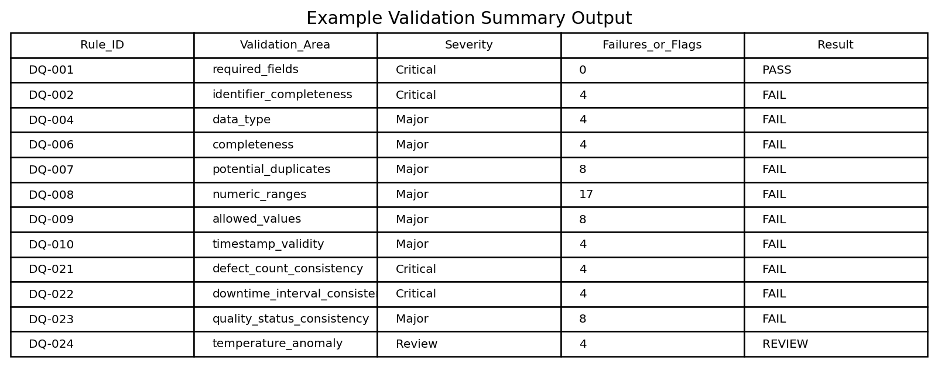
Figure 1. Example rule-level validation summary generated by the workflow.
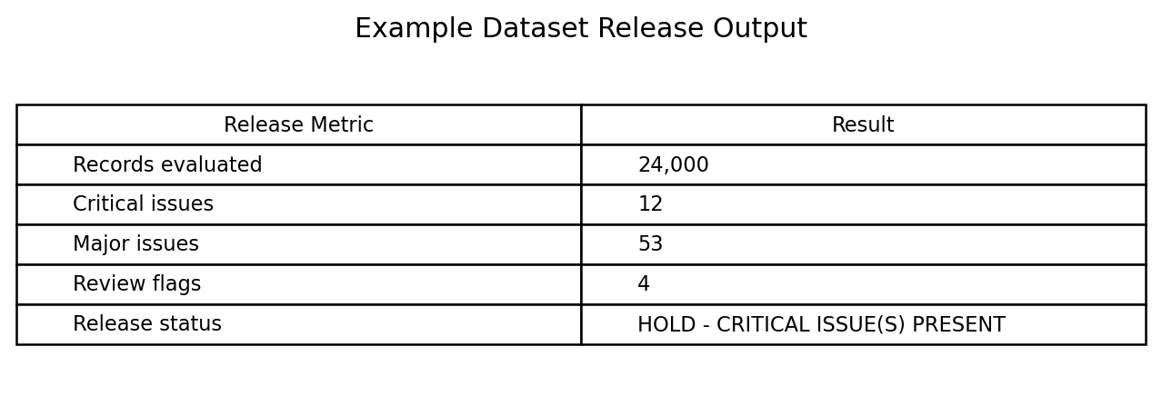
Figure 2. Example dataset release output.
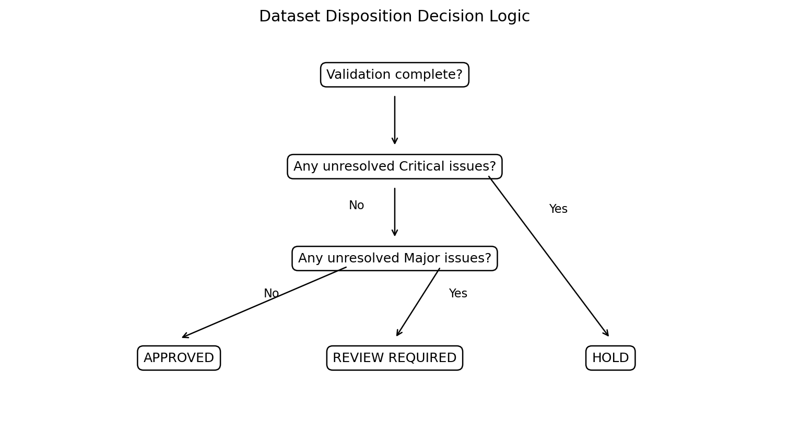
Figure 3. Dataset disposition decision logic.

