Step 2 - Process Discovery: Alpha, Heuristic and Inductive Miner
Each miner was run with PM4PY in its own program (step2_alpha_miner.py, step2_heuristic_miner.py, step2_inductive_miner.py) on two versions of the log: RAW, the log as given (events without a timestamp are dropped), and CLEAN, the log without the 22 cases flagged in Step 1. The clean log is not a correction (that is Step 5); it is used as a reference to show the effect of the errors.

1. Process variants and the timestamp errors that cause them
# | Variant (raw log, ordered by timestamp) | Cases | Step 1 error types in these cases | Example cases
1 | Register Claim -> Verify Documents -> Evaluate Claim -> Approve Claim -> Close Claim | 83 | none: 78, B: 5 | Case_1, Case_10, Case_100, Case_11, Case_12, Case_13
2 | Register Claim -> Verify Documents -> Approve Claim -> Evaluate Claim -> Close Claim | 12 | D: 7, C: 5 | Case_15, Case_29, Case_31, Case_32, Case_36, Case_4
3 | Register Claim -> Verify Documents -> Approve Claim -> Close Claim | 3 | A: 3 | Case_34, Case_70, Case_84
4 | Register Claim -> Evaluate Claim -> Approve Claim -> Close Claim | 1 | A: 1 | Case_28
5 | Verify Documents -> Evaluate Claim -> Approve Claim -> Close Claim | 1 | A: 1 | Case_77
Error types: A = Missing timestamp; B = Truncated timestamp (precision loss); C = Shifted timestamp (order inversion); D = Precedence violation (swapped timestamps or deviation). Type B (truncated) does not change the order, so it creates no new variant.

2. Metrics comparison
Metric | alpha (raw) | heuristic (raw) | inductive (raw) | alpha (clean) | heuristic (clean) | inductive (clean)
Cases | 100 | 100 | 100 | 78 | 78 | 78
Events | 495 | 495 | 495 | 390 | 390 | 390
Variants | 5 | 5 | 5 | 1 | 1 | 1
Places | 8 | 8 | 8 | 6 | 6 | 6
Transitions | 5 | 6 | 9 | 5 | 5 | 5
Silent (tau) transitions | 0 | 1 | 4 | 0 | 0 | 0
Arcs | 15 | 16 | 20 | 10 | 10 | 10
Perfectly fitting traces (%) | 0.0 | 84.0 | 100.0 | 100.0 | 100.0 | 100.0
Fitness (token replay) | 0.9351 | 0.976 | 1.0 | 1.0 | 1.0 | 1.0
Fitness (alignments) | - | 0.9683 | 1.0 | 1.0 | 1.0 | 1.0
Precision | 1.0 | 1.0 | 0.729 | 1.0 | 1.0 | 1.0
Generalization | 0.8995 | 0.7496 | 0.6467 | 0.8868 | 0.8868 | 0.8868
Simplicity | 0.7647 | 0.7778 | 0.7391 | 1.0 | 1.0 | 1.0
Sound (workflow net) | False | True | True | True | True | True
Fitness: how much of the log the model can replay. Precision: how little extra behaviour the model allows. Generalization: how well the model avoids overfitting to the observed traces. Simplicity: based on the arc degree of the net (1 = simplest). Alignment fitness is '-' when the net is not sound.

3.1 Alpha miner
Raw log:
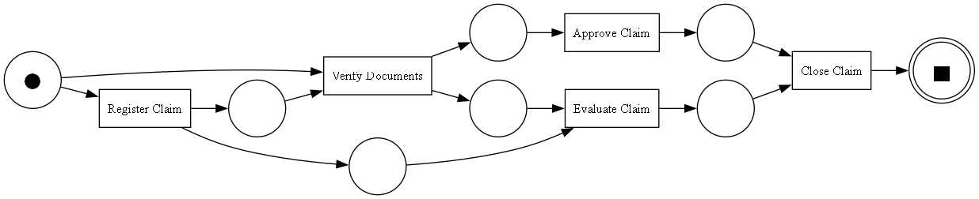
Clean log (reference):
The alpha miner only looks at directly-follows pairs and has no noise handling. Because Approve Claim follows Evaluate Claim in most cases but precedes it in the 12 type C/D cases, it sees both orders and concludes the two activities are parallel. The missing timestamps (type A) add direct start->Verify Documents and Register->Evaluate connections, leaving tokens behind. The result is not a sound workflow net and no raw trace fits perfectly. Its token-replay precision of 1.0 is not reliable here, because replay on an unsound net with remaining tokens overstates precision.

3.2 Heuristic miner
Raw log:
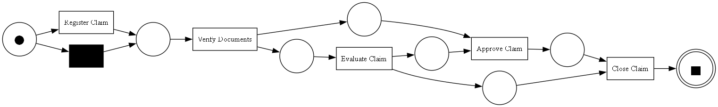
Clean log (reference):
The heuristic miner uses frequencies, so the frequent order Evaluate -> Approve keeps a strong dependency and the rare reversed order is mostly filtered out. It adds a silent transition to skip Register Claim (caused by the missing timestamp in Case_77) and an extra Evaluate -> Close place. The net is sound and fits most traces (84% perfectly), but the swapped/shifted cases do not replay.

3.3 Inductive miner
Raw log:
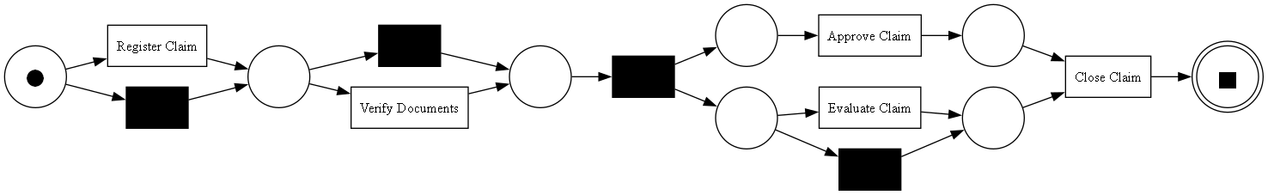
Clean log (reference):
The inductive miner (noise threshold 0) must reproduce every trace, so it guarantees a sound net with fitness 1.0. To do so it makes Register and Verify skippable, makes Evaluate optional and puts Approve and Evaluate in parallel. This over-generalises: the model now allows approving a claim without evaluating it, which is why precision drops to 0.73. Every timestamp error is 'absorbed' into the model as legal behaviour.

4. Conclusion
- On the clean log all three miners discover the same sequential model Register -> Verify -> Evaluate -> Approve -> Close, with fitness, precision and simplicity equal to 1. So the differences between the models are caused only by the timestamp errors.
- Alpha miner: most sensitive. One wrong order turns a sequence into concurrency and the net becomes unsound.
- Heuristic miner: most robust. Frequency thresholds keep the main flow and treat errors as noise, at the cost of not fitting the affected traces.
- Inductive miner: always sound and fitting, but it over-generalises by making the errors part of the model (lower precision).
- Conclusion: the timestamps must be corrected (Step 5) before the discovered model can be trusted.

