Experiment 1
Data Acquisition and Data Profiling using BI Tools

Aim
To acquire data from multiple sources and perform data profiling using Microsoft Power BI in order to assess data quality, understand data structure, identify anomalies, and prepare data for further analytical processing.

Tools / Software Required
- Microsoft Power BI Desktop
- Sample datasets: Sales_Data.csv, Employee_DB.xlsx, and a sample SQL database

Theory
Business Intelligence (BI)
Business Intelligence refers to a set of technologies, processes, and practices that enable organizations to collect, integrate, analyse, and present business information. BI helps transform raw data into meaningful, actionable insights that support better decision-making across an organization.

Key components of a BI system include:
- Data Sources: Databases (SQL/NoSQL), flat files, cloud stores, and APIs
- ETL Pipeline: Extract, Transform, Load processes that move data from source to destination
- Data Warehouse / Data Lake: Centralized repositories for structured or unstructured data
- BI & Reporting Tool: Microsoft Power BI for data connection, transformation, and visualization
- Analytics Layer: Descriptive, diagnostic, predictive, and prescriptive analytics

Data Acquisition
Data Acquisition is the process of collecting and importing data from various heterogeneous sources into a unified environment for processing. It is the first and foundational step in any BI pipeline. In Power BI, data is acquired through the Get Data option, which supports a wide range of connectors including flat files (CSV, XLSX), relational databases (SQL Server, MySQL), cloud sources (SharePoint, Azure), and web-based sources.

Data Profiling
Data Profiling is the process of examining data from an existing source and collecting statistics, summaries, and metadata about that data. It is a critical quality assurance step that reveals the structure, content, and quality of a dataset before further processing. Data profiling covers the following key dimensions:

- Completeness: Percentage of non-null values in each column.
- Uniqueness: Ratio of distinct to total values — detects duplicate records.
- Validity: Whether values conform to defined rules or expected formats.
- Consistency: Uniformity of values across related datasets.
- Accuracy: Correctness of values relative to real-world facts.
- Timeliness: Currency of data relative to the reporting period.

Data Profiling in Power BI — Power Query Editor
Microsoft Power BI provides built-in data profiling capabilities through the Power Query Editor. Under the View tab, three profiling features can be enabled:
- Column Quality: Displays the percentage of valid, error, and empty values per column.
- Column Distribution: Shows a histogram of value frequency along with the distinct and unique count for each column.
- Column Profile: Provides detailed statistics for a selected column including minimum, maximum, mean, median, standard deviation, and a full value distribution chart.

Conduct
Part A: Data Acquisition

Step 1: Launch Power BI Desktop and import the Sales.csv file.

Home > Get Data > Text/CSV
Browse to Sales_Data.csv > Load
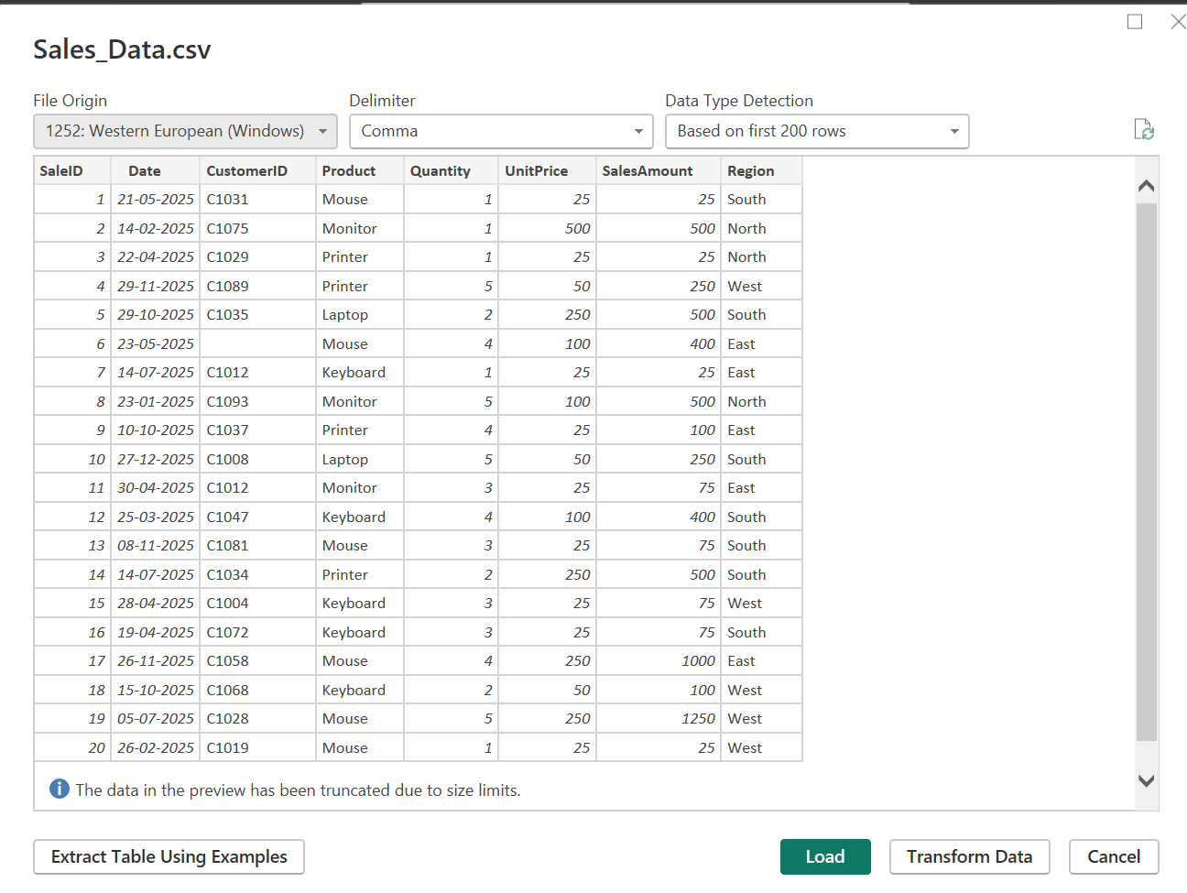

Step 2: Import the EmployeeDB.xlsx file.

Home > Get Data > Excel Workbook
Browse to Employee_DB.xlsx > Select the appropriate sheet > Load
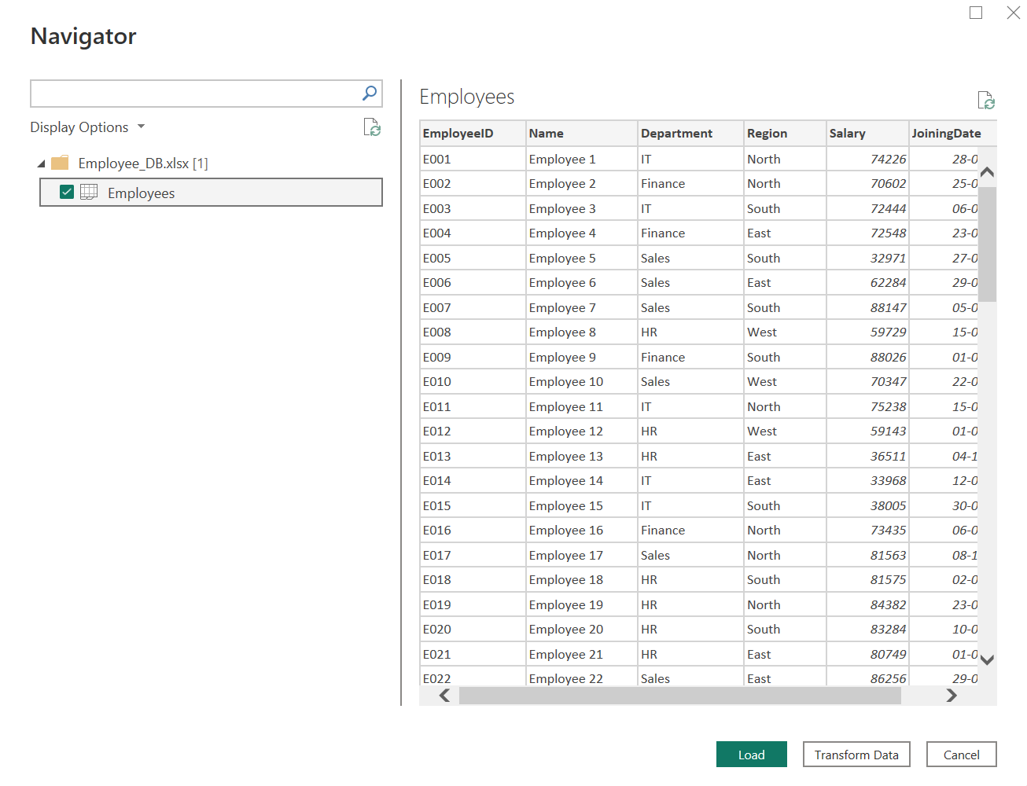

Step 3: Connect to the SQL database and import the Transactions table.

Home > Get Data > SQL Server
Enter server name and database credentials > Select Transactions table > Load
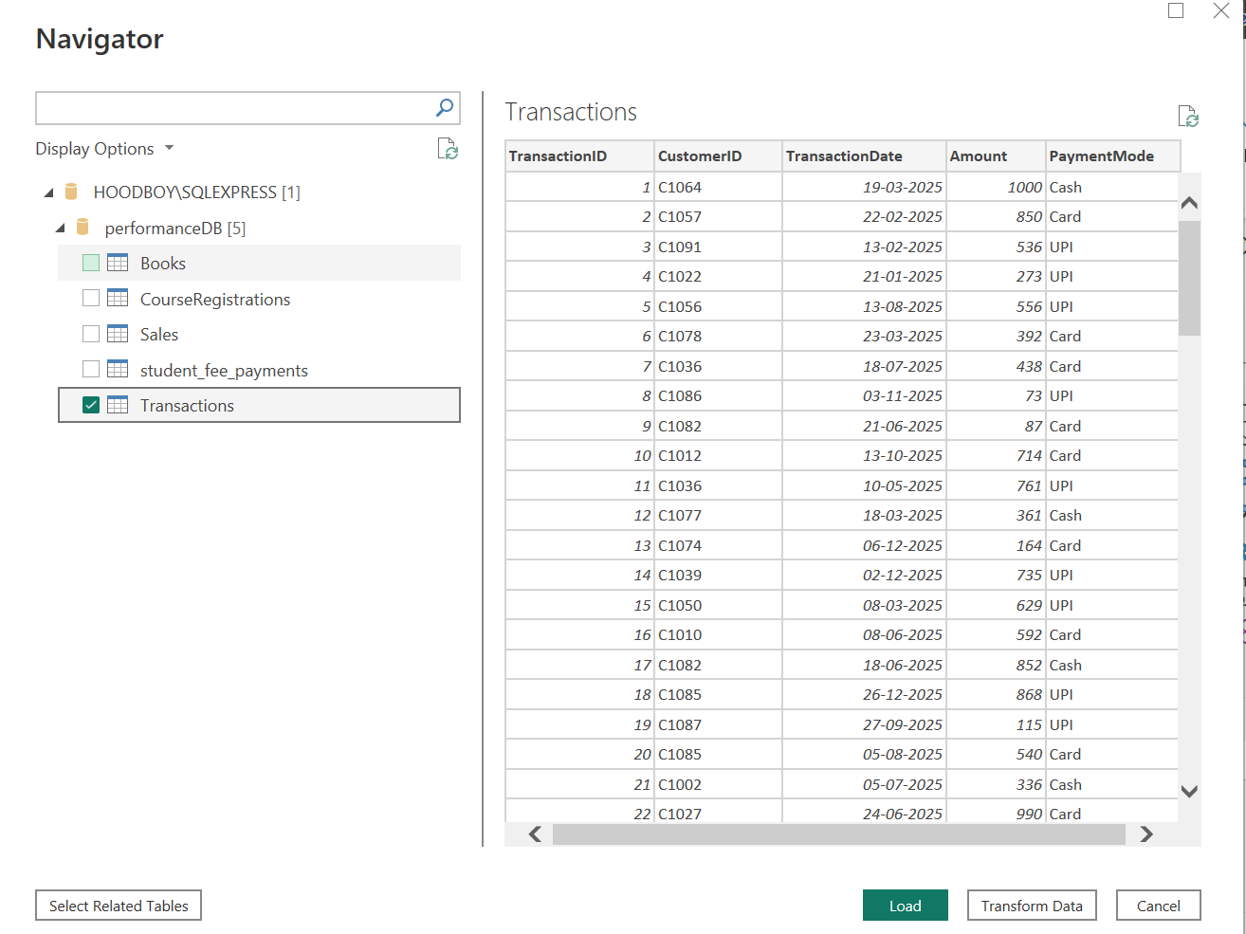

Verify that all three data sources appear in the Data pane on the right-hand side of the Power BI window.
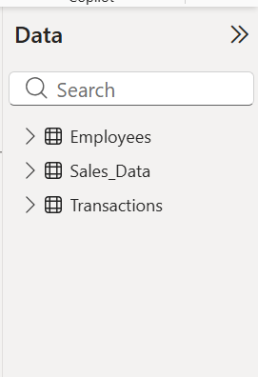
Part B: Data Profiling in Power Query Editor

Step 4: Open Power Query Editor.

Home > Transform Data under the query tab
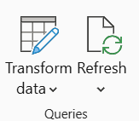

Step 5: Enable data profiling features.

View tab > tick: Column Quality
View tab > tick: Column Distribution
View tab > tick: Column Profile

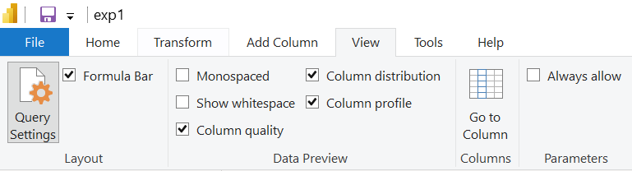

Select each column one at a time and observe the profiling statistics displayed below the data preview grid.

Step 6: Record profiling observations.
For each column in each dataset, note the following:
- Data type and total row count
- Null / empty percentage (from Column Quality)
- Distinct value count and unique value count (from Column Distribution)
- Minimum, maximum, mean, and standard deviation for numeric columns (from Column Profile)
- Any errors, mismatched data types, or unexpected values observed
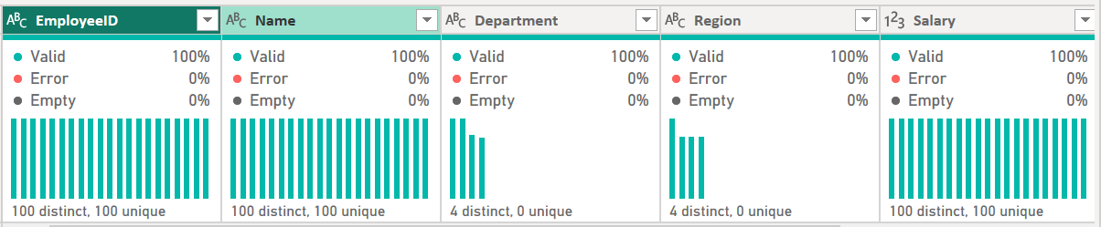
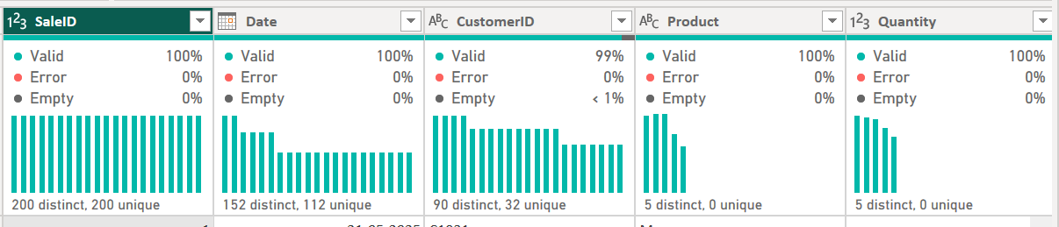

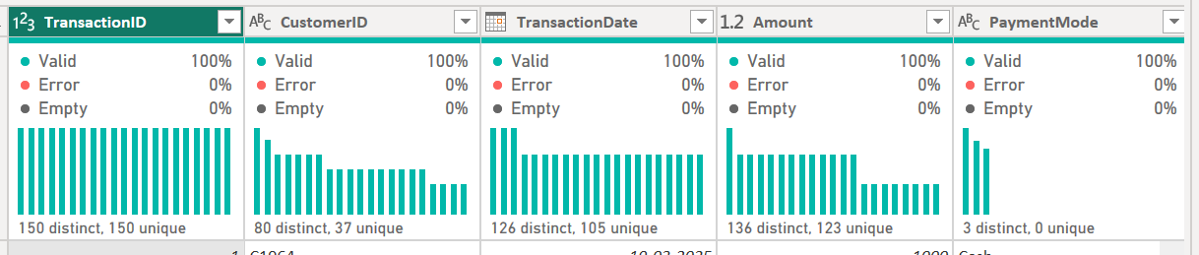

Part C: Identify and Document Data Quality Issues

Step 7: Based on the profiling results, identify data quality issues.
Look for the following common issues:
- High null percentage in important columns such as customer ID or date fields
- Columns with only one unique value — zero variance and no analytical value
- Numeric columns containing text values indicating a data type mismatch
- Date columns with future dates or dates outside the expected range
- Duplicate rows identified through a low uniqueness ratio

Document at least three data quality issues found and note the suggested remediation action for each.
I was able to;
Find duplicates on the tables, which was removed.
Blank rows were identified and removed.
Numeric columns having textual values were identified, which the datatype was changed and the textual values removed.

Result
Data from multiple heterogeneous sources (CSV, Excel, and SQL database) was successfully acquired and imported into Microsoft Power BI Desktop. Data profiling was performed using the Power Query Editor's built-in tools — Column Quality, Column Distribution, and Column Profile. Key data quality dimensions including completeness, uniqueness, and validity were assessed across all datasets, and data quality issues were identified and documented for remediation prior to analysis.

Learning Outcomes
After completing this experiment, I was able to:
- Explain the concept of Business Intelligence, its key components, and the role of data acquisition in a BI pipeline.
- Describe different data source types and the methods used to connect and import them into Power BI.
- Connect to multiple heterogeneous data sources and successfully import datasets using Power BI's Get Data feature.
- Apply data profiling techniques in Power Query Editor to assess data quality dimensions across real-world datasets.
- Interpret profiling statistics to identify data quality issues and propose suitable remediation strategies.

