**Network Security**

**Lab 3:** Port Security

**Teacher:** Khumar Shiraliyeva

**Student:** Omar Ahmadov

**Group:** 6424e

**Steps:**

1. Connect PC1 and PC2 to the FastEthernet0/1 and FastEthernet0/2 ports of the Switch.

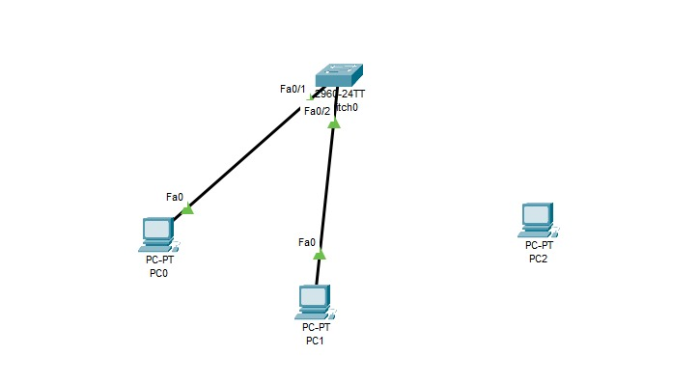

1. Assign static IP addresses from the same network to each PC (for example, 192.168.1.0/24).

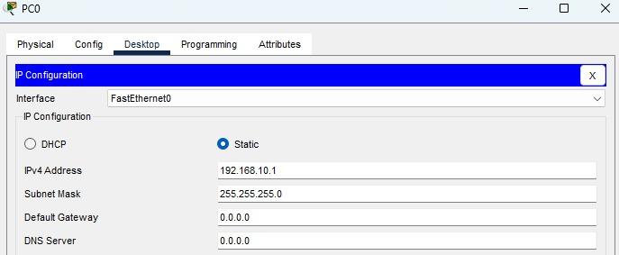

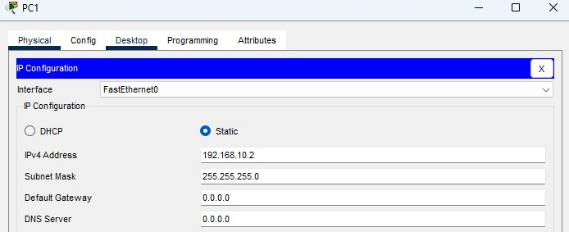

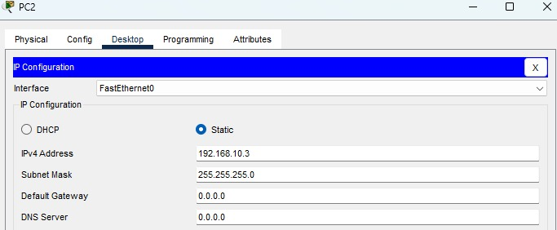

1. Configure switch port security.

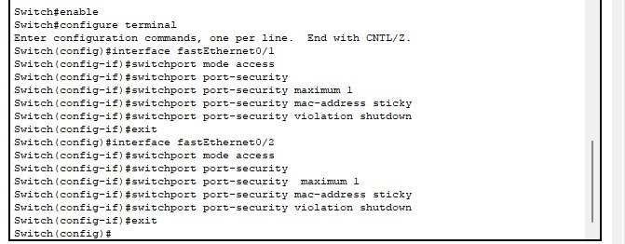

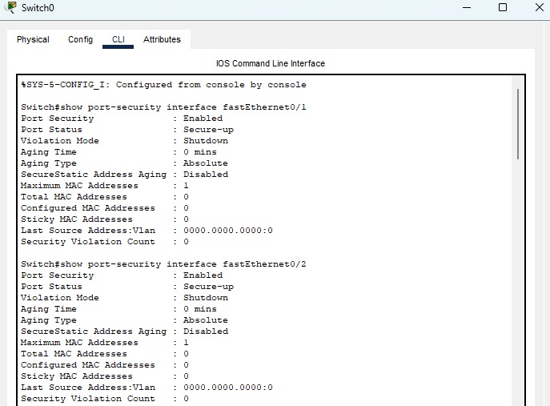

1. Perform normal ping tests with PC1 and PC2.

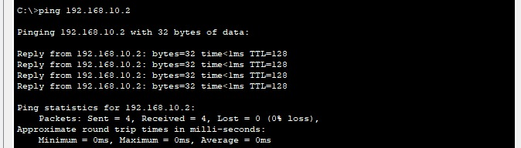

1. Connect PC3 and ping test.

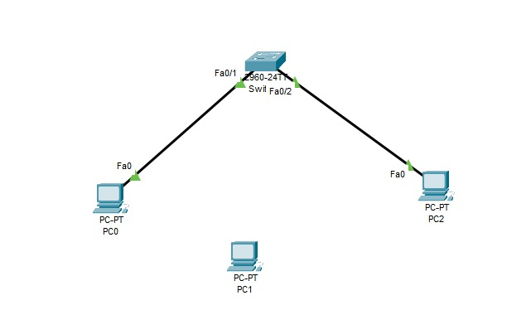

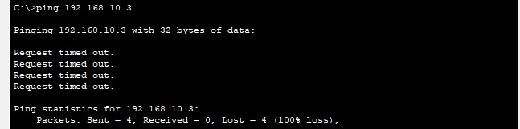

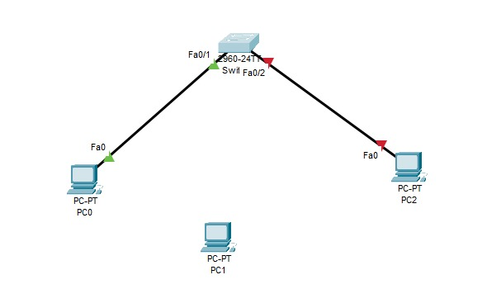

1. Restore the blocked port.

