**NETWORK SECURITY**

**Lab 2:** VLAN and Trunking

**Teacher:** Shiraliyeva Khumar

**Student:** Ahmadov Omar

**Group:** 6424e

1. Build the network: connect the HR and IT computers to the corresponding switch ports.

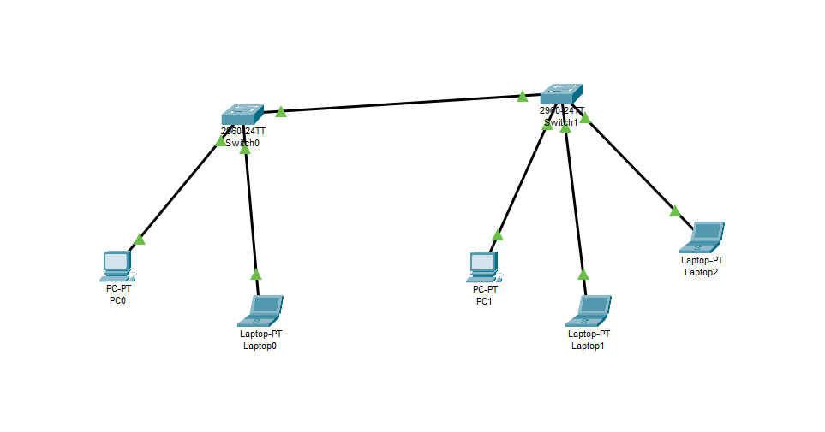

1. Create VLAN 10 and VLAN 20 on the switches, and assign the ports to the appropriate VLANs.
2. Configure a trunk port between the switches.

For Switch0:

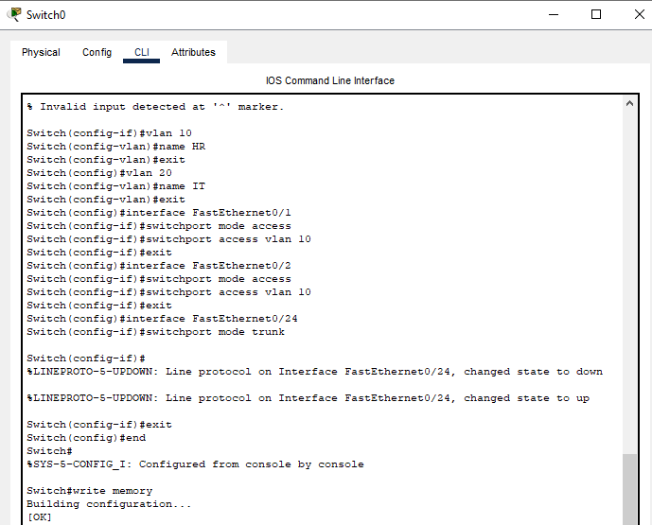

For Switch1:

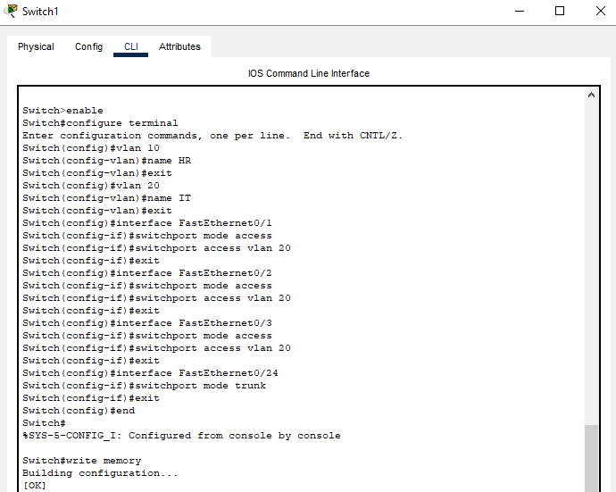

We assign IP addresses:

For HR:

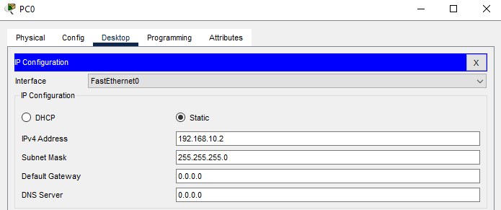

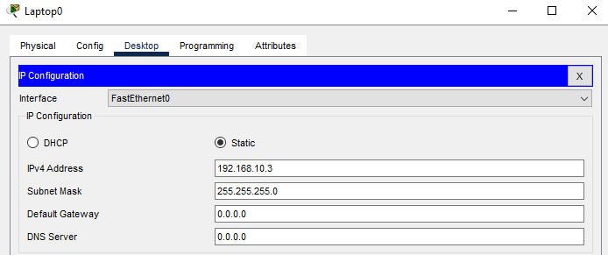

For IT:

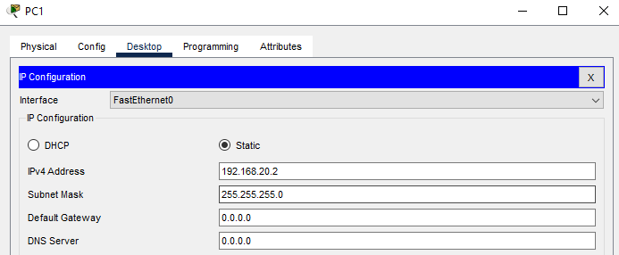

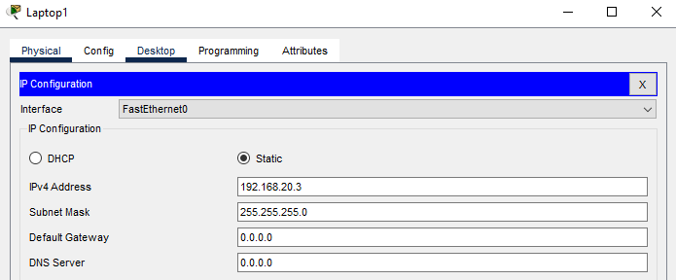

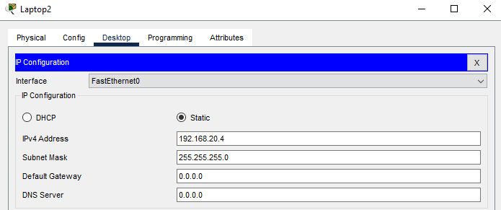

1. Perform a ping test within the same VLAN (HR → HR, IT → IT).

For HR 🡪 HR:

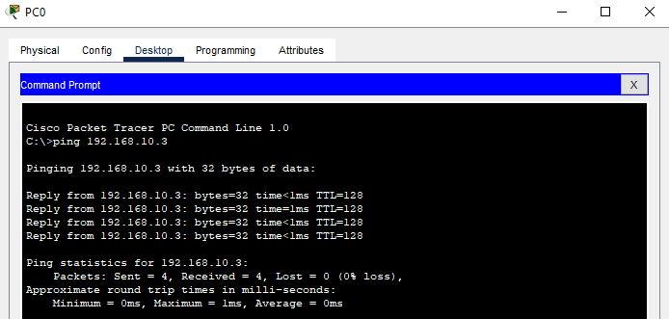

For IT 🡪 IT:

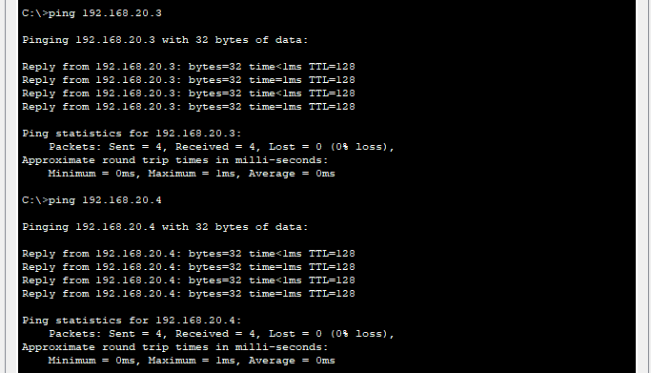

1. Verify the configuration using the show vlan brief command.

In Switch0:

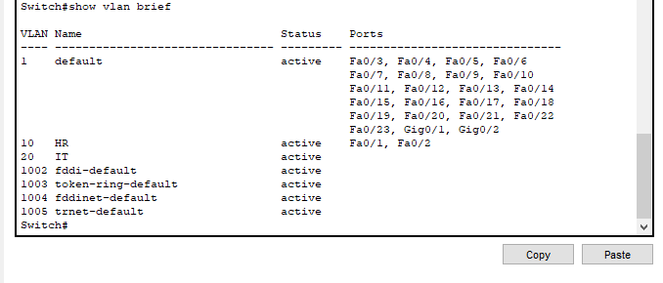

In Switch1:

