Detailed Use Cases:

|  |  |
| --- | --- |
| Use case name | Assigning-Employee-to-Shift |
| Textual Description | The HR manager assigns a specific employee to a specific shift. |
| List of Actor | HR Manager |
| Pre-Conditions | The HR manager is in the ShiftMenu, The shift must exist in the system; The employee has to have a constraint matching shift date and type; The employee must not be assigned to the shift |
| Post-Conditions | The shift has the employee assigned to it; the database includes a record which details the assignment |
| Main success scenario | 1. The HR manager chooses the shift through the ShiftMenu 2. The HR manager chooses to add to the shift employees of the type of the wanted employee 3. System validates number of already assigned employees of chosen type is less than set max number for this type 4. System shows available employees for chosen shift of chosen type 5. HR Manager chooses the employee out of the list of available employees 6. System checks new number of currently assigned to set max 7. HR Manager stops the assignment process |
| Alternative/Extensions | 3’) Number of assigned employees matches set number  4’) System notifies HR manager of the situation and offers to reset the number of employees for the shift or remove already assigned employee |
| 7’’) System stops the assignment process |

|  |  |
| --- | --- |
| Use case name | Carrying out transport |
| Textual Description | Creating and carrying out a transport. |
| List of Actor | Transport manager and Carrier |
| Pre-Conditions | There is an order for transportation. An available truck exists for the time of the transportation. A carrier with a suitable license for this truck and with a constraint for the shift time.  There are sources and destinations of transportation |
| Post-Conditions | In the completed transports archive the order exist.  The truck and driver will be available for other transports |
| Main success scenario | 1. Transport Manager create new transport. 2. Transport manager adds transport-orders to the transport. 3. Transport manager chooses truck for the transport. 4. Transport manager chooses carrier suitable for this transport. 5. The carrier updates the destination-document for each destination visited, the change is saved in the archive. 6. When the carrier finishes his ride the transport is marked as finished in the transport-document, the change is saved in the archive. |
| Alternative/Extensions | In case the truck enters overweight state an alert will be sent to the carrier and a redesign of the transport will be performed. The transport will end and start over. |

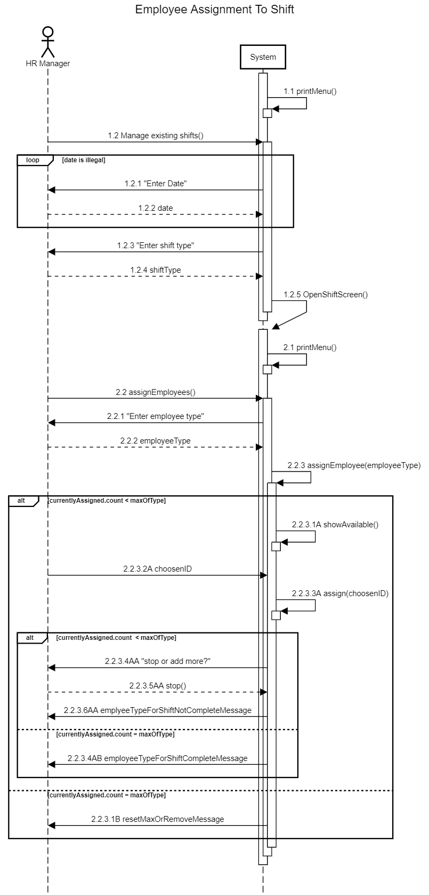

When assigning an employee to a shift   
the system will interact with the manager in order to produce identifying data for the shift and the employee.   
The system will assign and save the assignment in the system if conditions are met.

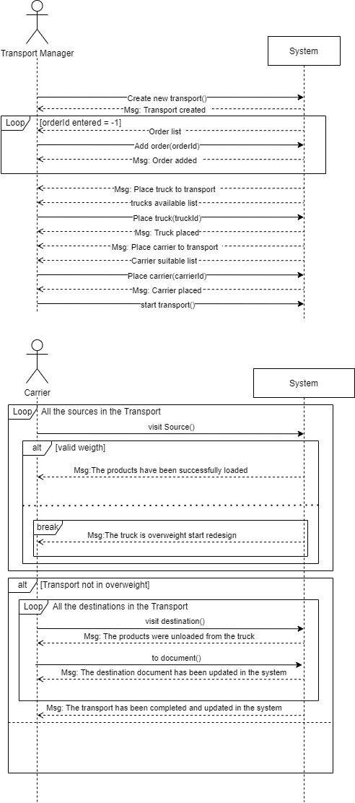

When assigning an employee to a shift   
the system will interact with the manager in order to produce identifying data for the shift and the employee.   
The system will assign and save the assignment in the system if conditions are met.

Opening the Employee-Management-Menu is a key process in most employee-management   
use-cases. Which is why it’s included here in great detail.  
Each Actor whishing to open an Employee-Management-Menu, be it the HR manager or the employee itself, would only need to input the ID of the wanted employee.   
The system will open the menu if the ID exists in the system, or print an error message if it does not.  
Since the system uses lazy-load way of work a Get request is sent to the DAO.

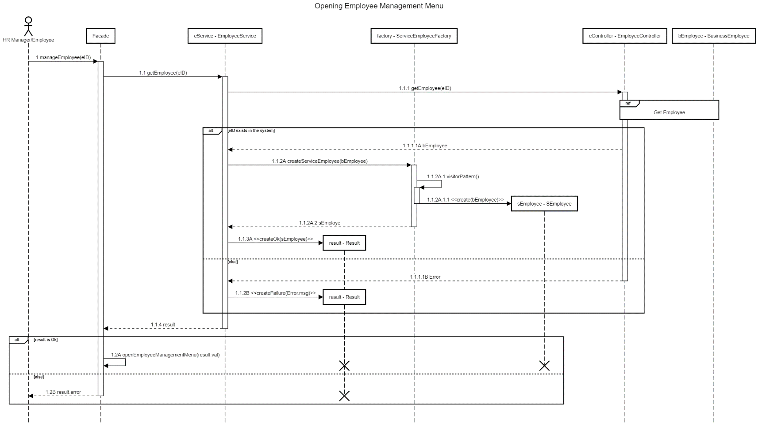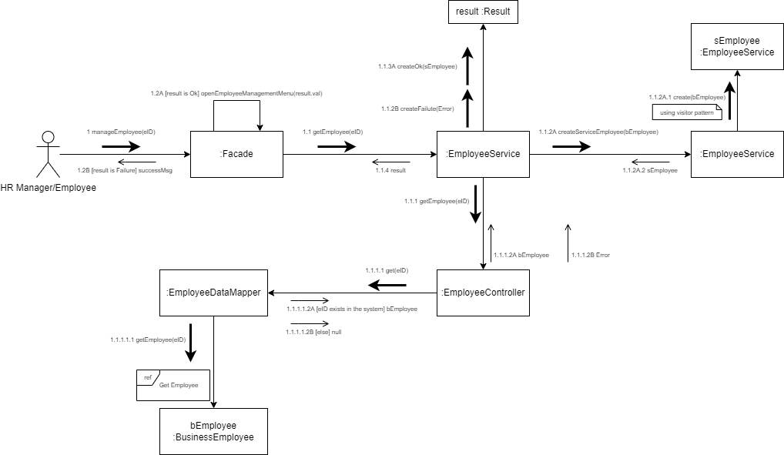

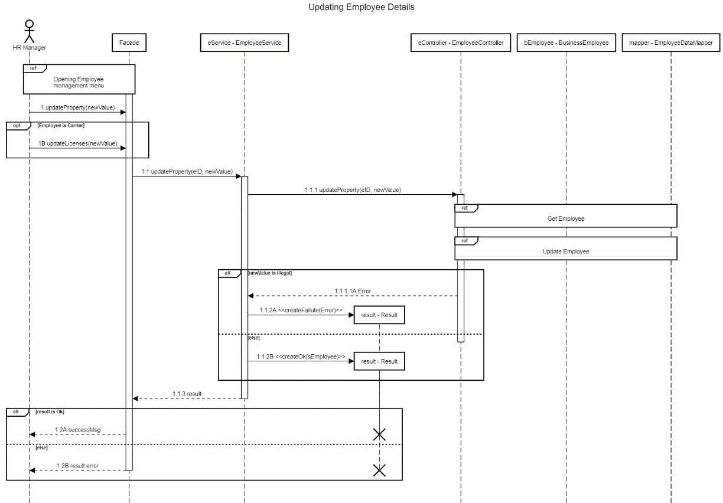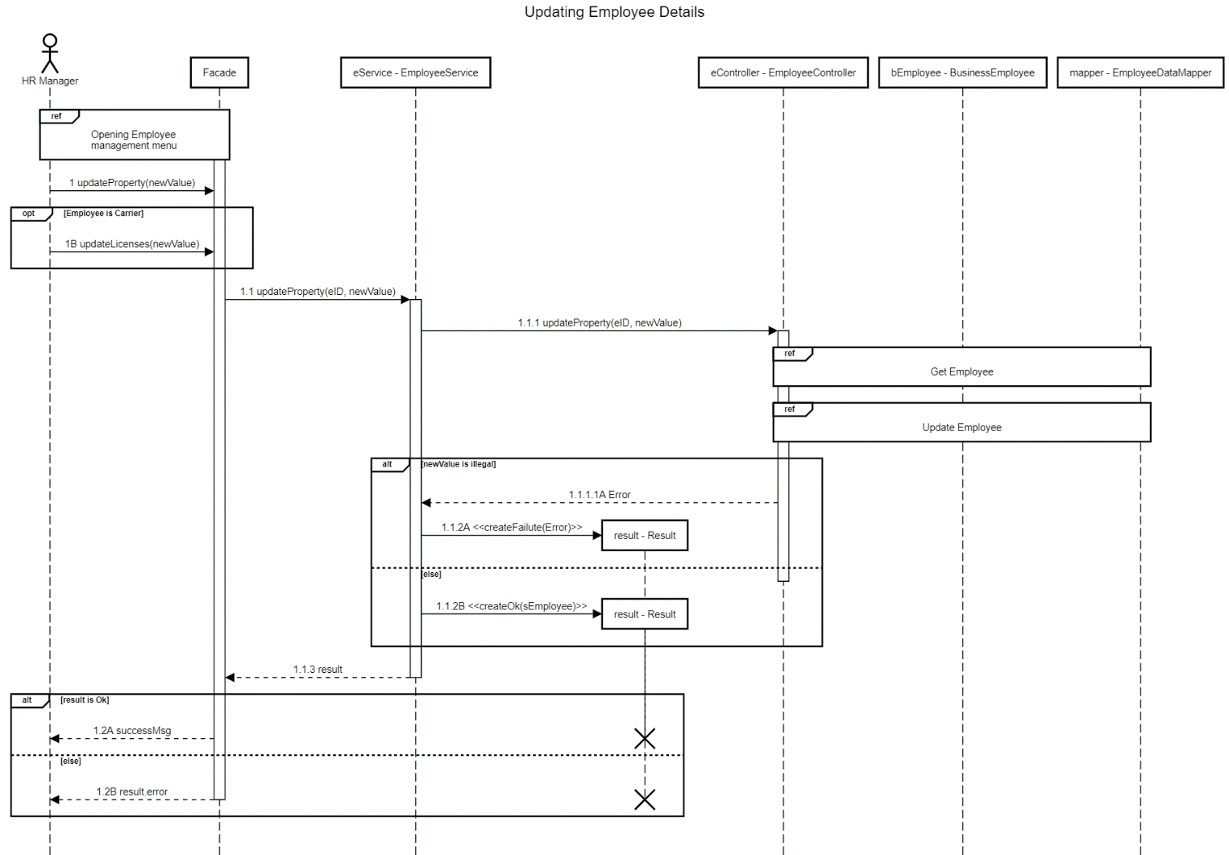When the HR manager requests to update an existing employee in the system he will first open the Employee-Management-Menu for that employee as shown above. After which he will choose which property to update and to what value. If the employee is a carrier the licenses for said carrier may also be updated.   
The process requires use of multiple DAO processes.

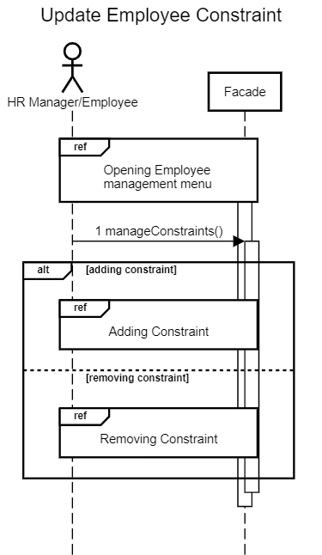In order to update employee constraints the HR manager or the employee itself will first have to open the Employee-Management-Menu and then choose whether to add or remove constraints.  
Both these processes run in a similar fashion – the user inputs the date and shift-type they can or can’t work and will be notified with process success. This process doesn’t fail unless an IO exception occurs when data is saved in the DB.

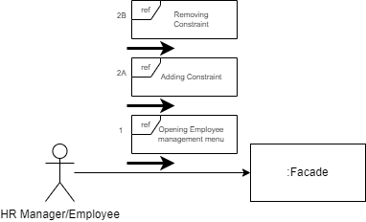

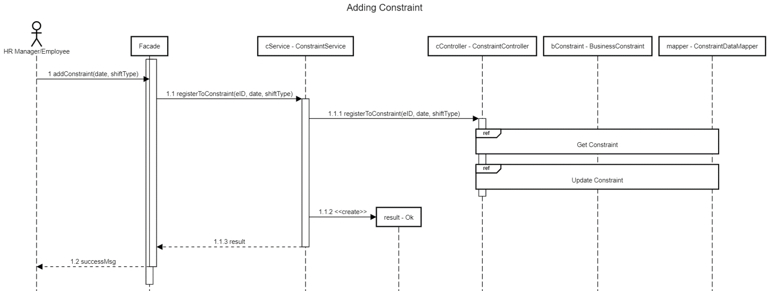

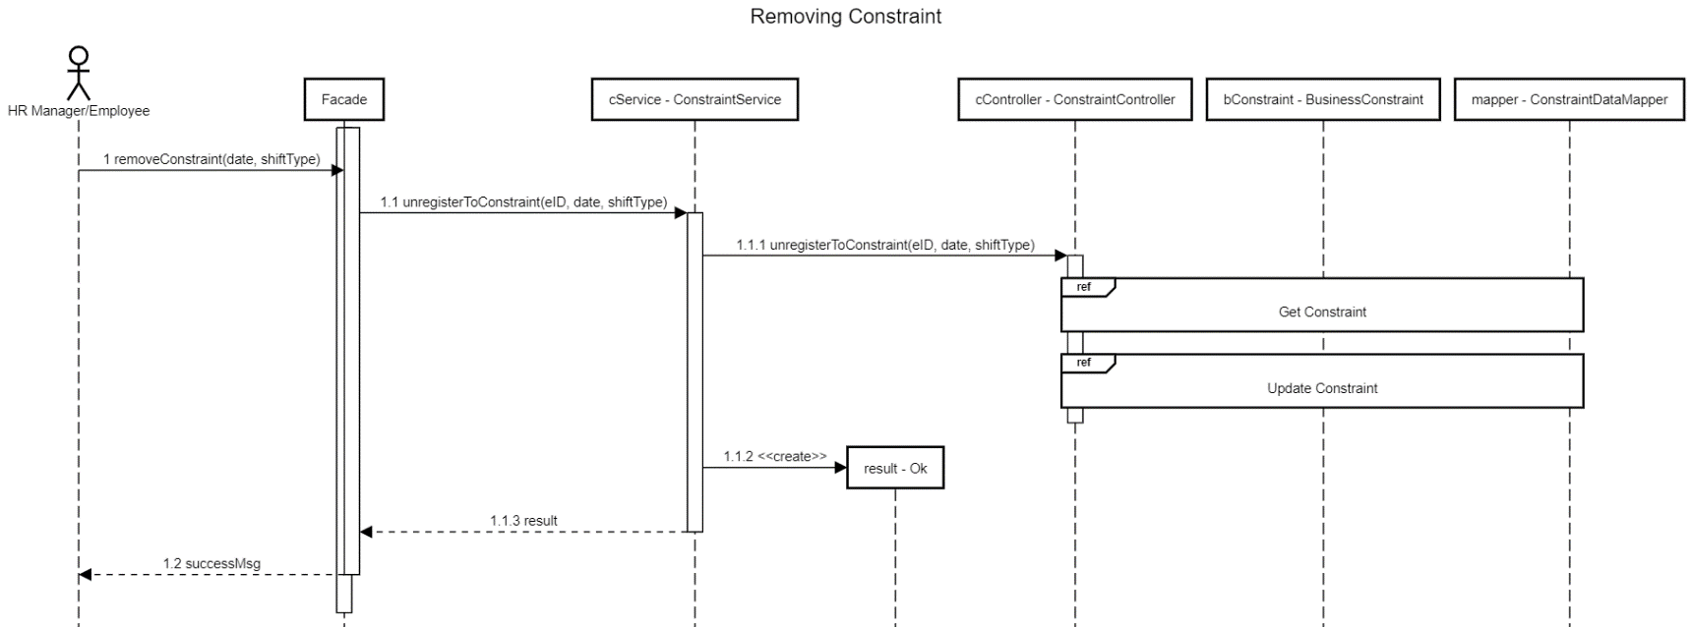

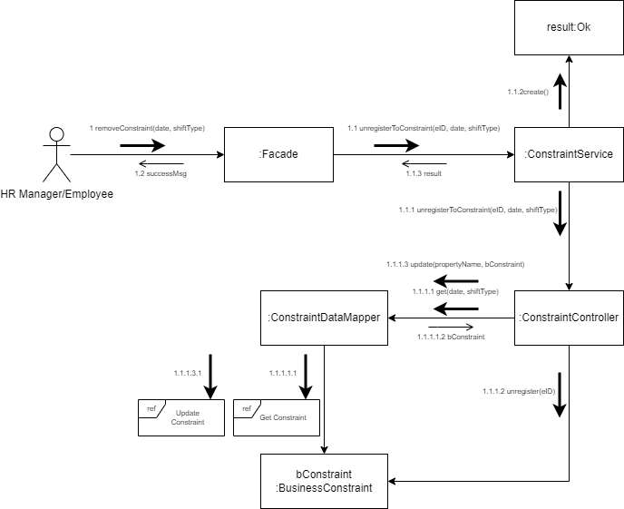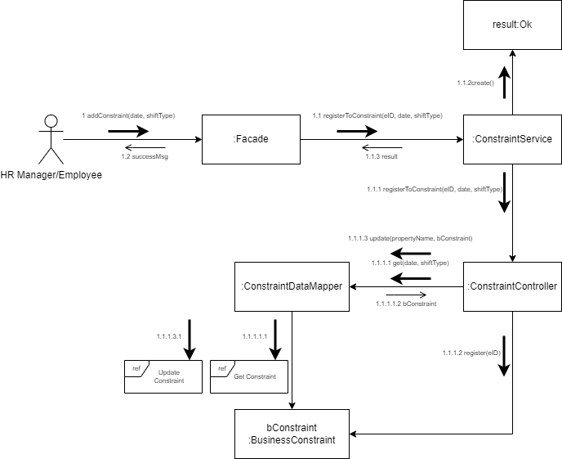

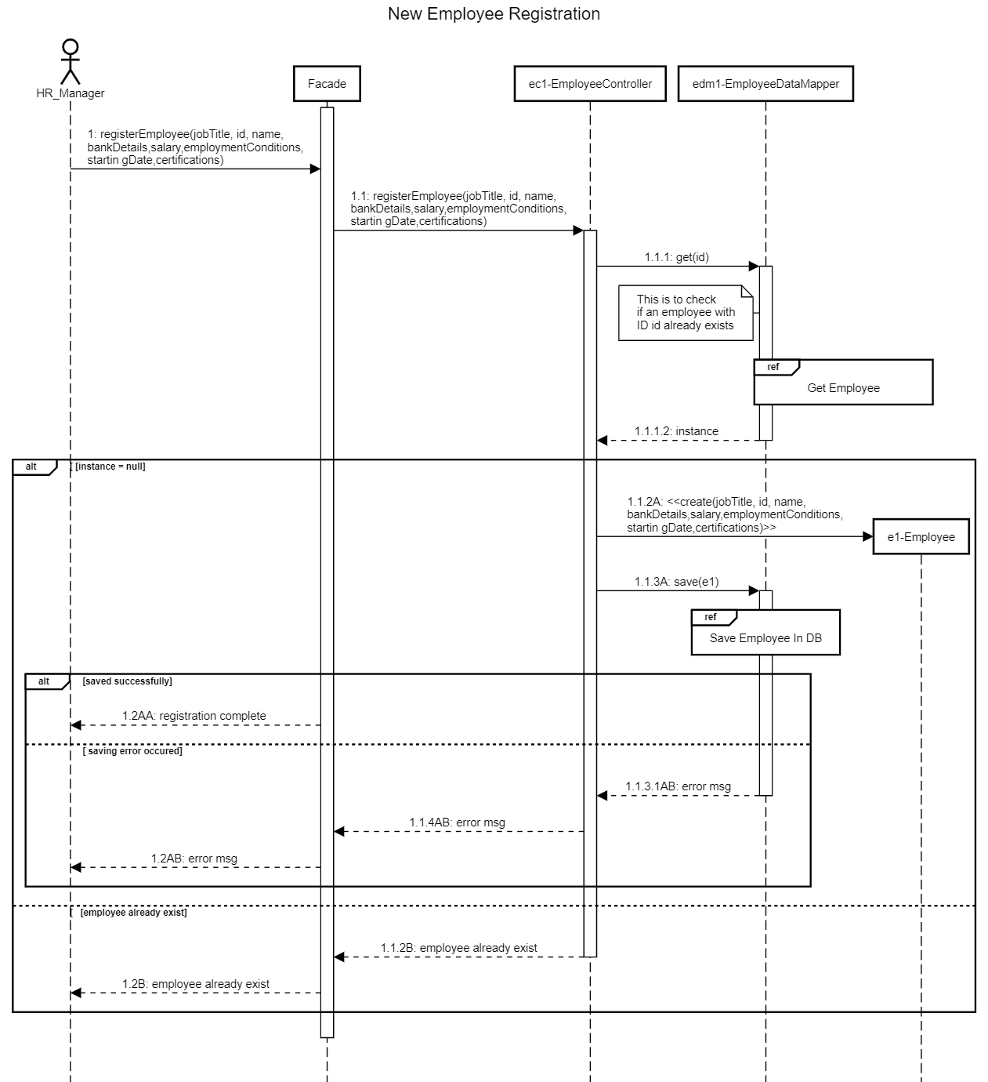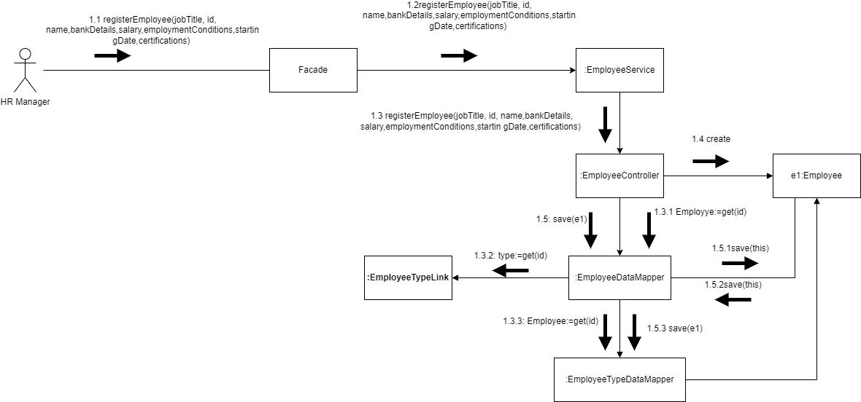In order to register a new employee into the system the HR manager will input all details through dialog with the system. If the given ID exists in the system the process will fail, else the new employee will be saved in the system and in the DB.

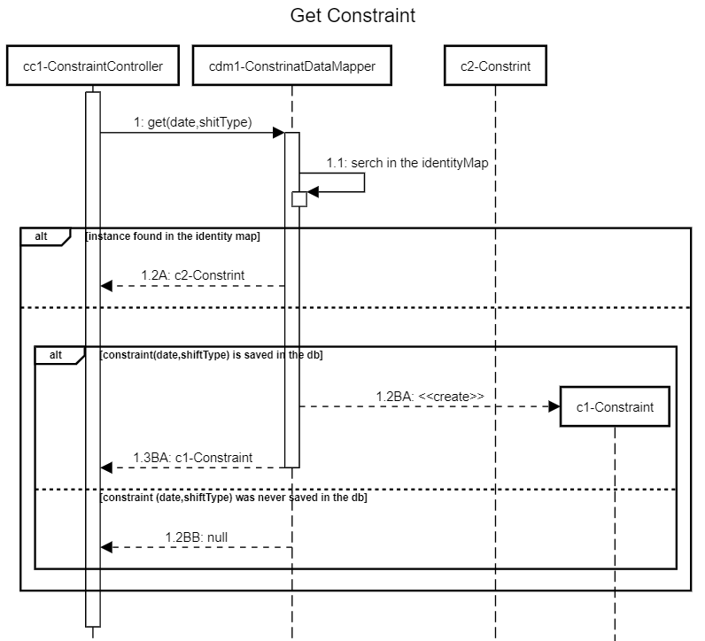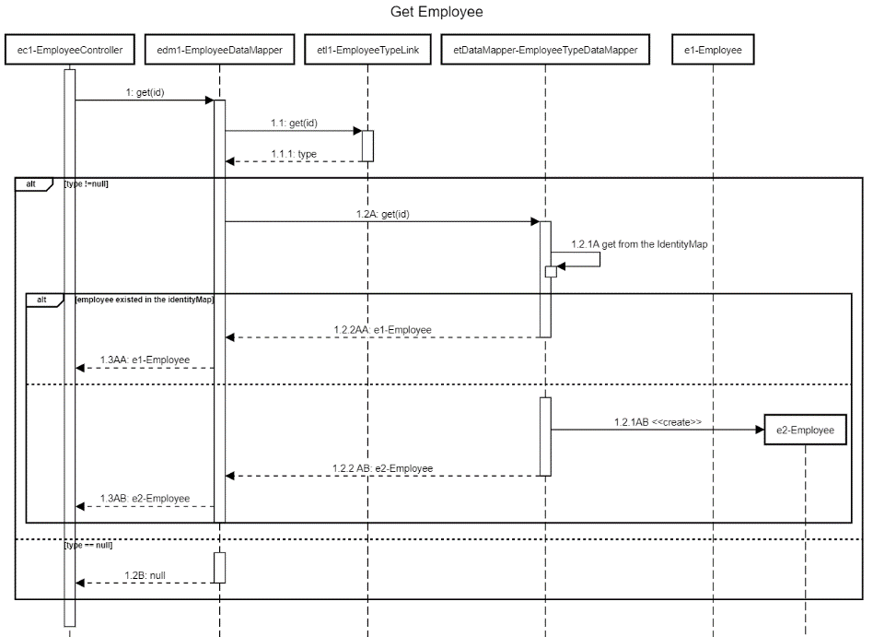DAO processes:

