**Software Design Document**

# Introduction

# Purpose

This software design document describes the architecture and system design of a medical file management system.

# Scope

The main purpose of this project is to create a medical file management system. The system will provide the ability to view and document the patient’s medical examination results, the focus is on hearing examinations.

The system supports:

* Documentation of various examinations.
* Fast and efficient search queries on the data.
* View analysis based on the stored data.
* Schedule appointments with patients and print the summary of the appointment

# Overview

Today the communication clinicians use an old, not properly developed system that cannot provide their needs. This community approached the university with a request for a system that can store big data and perform analysis on it. According to the experts that we interviewed the current system they use can only perform basic functions such as read and store data.

# Definitions and Acronyms

Describe of possible Risks:

* Submit wrong examination results and diagnose for a patient.
* Data breach of patients personally identifiable and medical information.
* The medical device – audiometer fails.

# System Overview

The outcome product of this project is a new improved medical file management system. The developer team will create a website that supports the newest technologies. The system will satisfy the communication clinician’s community requirements.

The main users of this system are the communication clinicians and the system managers.

Following are the communication clinician requirements:

* Review and edit patient medical file.
* Review and edit patient appointments details.
* Submit and edit hearing examination results.
* Perform analysis calculation based on stored examination results.
* Perform efficient search on the data.
* Print appointment summary and diagnosis.
* Simple integration with the “audiometer” - medical device.

Following are the system manager requirements:

* Permissions management – add. remove or edit communication clinician user.

The secondary users are the patients, following are their requirement:

* Secure personally identifiable and medical information.
* Provide a hard copy of an appointment that included details examination results and diagnosis.

# System Architecture

# Architectural Design

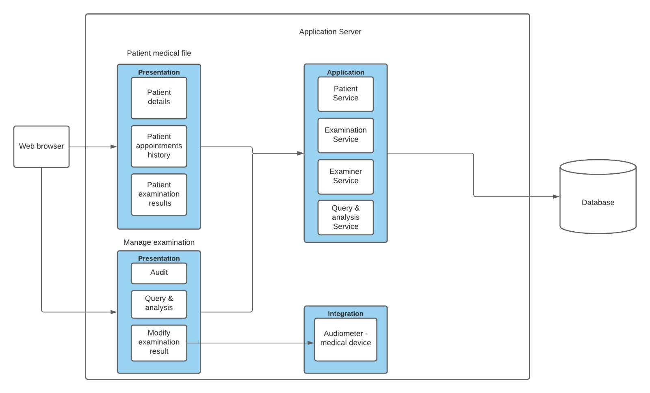

# Decomposition Description

# Design Rationale

The rationale for selection the architecture described in 3.1 section was to create an independent component for each subsystem this way the components will have a separate functionally and will reduce the resources cost. Using this architecture will improve the system modularity and makes it more flexible for changes as opposed to using a single component.

# Data Design

# Data Description

The information will be transformed into class objects entities and will be stored in a relational database including their relationships. In addition, for the analysis and efficient search we will use a secondary unstructured data base that will store the appointments details and examinations results as documents.

# Data Dictionary

Entities list:

1. **Company** – entity that represents the company of the main entities like : Examiner,Patient,Manager.
2. **Manager** – Entity that responsible of adding new examiner
3. **Secretary** – Entity that responsible of adding new patient.
4. **Examiner** – entity that responsible of modify appointment details (apt reason, modify examination details , summary and more), also the examiner can run queries on examination results and modify patient details
5. **Patient medical file** – entity that contains the patient and history of examination results , and appointments of the patient
6. **Patient** – Entity that contains the details of patient (fullname , id , address and more..)  
   the patient can view his medical file
7. **Appointment** – Entity that contains : appointment details , the patient , the examiner , and the examinations.
8. **Examination** – Entity that contains the type and the results of the examination
9. **Examination Result** – Entity that contains the values of examination result and which examination is related to.

# Component Design

1. View component of patient medical file : (**Access: [Examiner,Patient]**)  
   - Showing patient details  
   - Show history of appointments and examination details + results for each appointment
2. Create/Edit component of patient: (**Access: [Secretary]**)  
   - Add/Edit details of patient
3. Create component of examiner: (**Access: [Manager]**)  
   - Create new examiner and details  
   - Set examiner to the same company as manager
4. Integration component for audiometer: (**Access: [Examiner]**)  
   - Allow pulling examination result from audiometer.  
   - Allow edit the results manually
5. Querying component: (**Access: [Examiner]**)  
   - Allow search efficient & fast data on examination results  
   - Allow analyzing information on examination results.
6. Create/Edit component of appointment: (**Access: [Examiner]**)  
   - Allow to edit and create appointment details
7. Create/Edit component of examination: (**Access: [Examiner]**)  
   - Allow to edit and create examination details

# Human Interface Design

# Overview of User Interface

* Management of a patient medical file that include the patient information, examinations results, diagnosis, and appointments details.
* Management appointments between a patient and a communication clinician.
* Manually insert and edit examinations results as patient record.
* Graphic view of examination results.
* Extract the examination results from the audiometer device into the system.
* Perform calculation analysis on the data such as average function on the results of a specific examination type.
* Print or create a pdf file with the appointment summary and diagnosis details.
* Efficient search on the data such as run a query according to the appointment details –diagnosis, summary, patient cause of visit the clinic etc.
* Add additional data to the examination results and alert the user if the addition of data does not match to the examination type.
* Functional suitability- the system provides a graphic view of the hearing examination results.
* The graph view describes the signal volume that was tested for both patient’s ears.
  1. Screen Images & Screen Objects and Actions

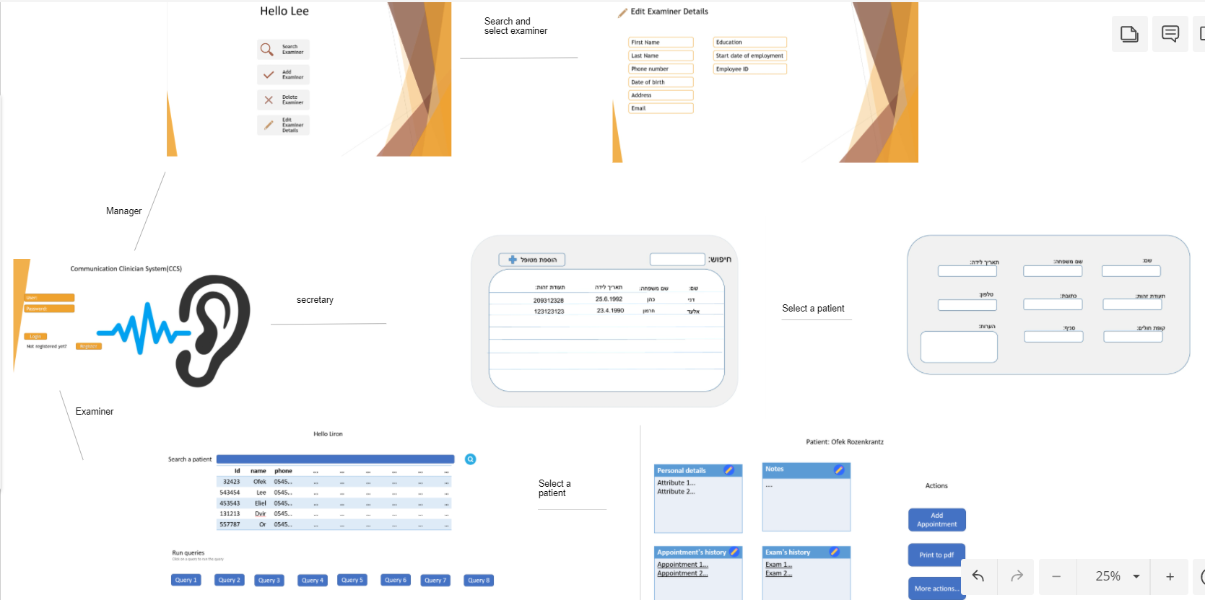Main screens:

# Requirements Matrix