**NAME: Ofentse Mogafe**

**MODULE: IT PROJECT MANAGEMENT**

**MODULE CODE: IPMA6212**

**ASSESSMENT: ASSIGNMENT 2**

**CAMPUS: VC WATERFALL**

Table of Contents

**QUESTION 1** 2

**QUESTION 2** 3

**QUESTION 3** 6

**QUESTION 4** 6

**QUESTION 5** 6

**REFERENCES** 7

# **QUESTION 1**

* 1. The need for this initiative was established through community surveys, interactions with local law enforcement, and crime data analysis. The initiative tackles a specific issue: the lack of a centralized platform for citizens to report suspicious activity, contact emergency services, and get timely safety updates. (Gisclard-Biondi, 2021)
  2. Progressive Web Applications (PWAs) are the technology trend that I am implementing. PWAs combine the greatest aspects of both web and mobile apps, including offline capabilities, quick loading times, and cross-platform compatibility. This trend will help the project's timelines by shortening the development time for separate Android and iOS apps, as PWAs can be viewed straight from a web browser. (Good, 2019)

Potential hazards of adopting PWAs include limited access to device hardware (such as GPS or cameras) compared to native applications, compatibility concerns with outdated web browsers, and the requirement for a stable internet connection for some functionality.   
  
PWAs will benefit consumers by offering a consistent experience across devices, allowing for offline access to vital information such as emergency contacts and safety recommendations, and decreasing the need for regular app updates. (Good, 2019)

* 1. The main outcomes for the project charter would be: (Aldridge, 2023)  
       
     1. Project Scope Statement: Clearly defines the project's objectives, deliverables, milestones, and financial restrictions.   
     2. Project Schedule: The project schedule outlines the timing for each phase of development, such as design, development, testing, and deployment.   
     3. Resource Plan: Identifying team members' roles and duties, credentials, and expected time commitments to the project.   
     4. Risk Management Plan: Identifying possible risks, assessing their effect, and developing mitigation methods to assure project success.   
     5. Stakeholder Communication Plan: Outline how stakeholders will be involved throughout the project, such as frequent status reports, feedback sessions, and decision-making procedures. (Aldridge, 2023)

# **QUESTION 2**

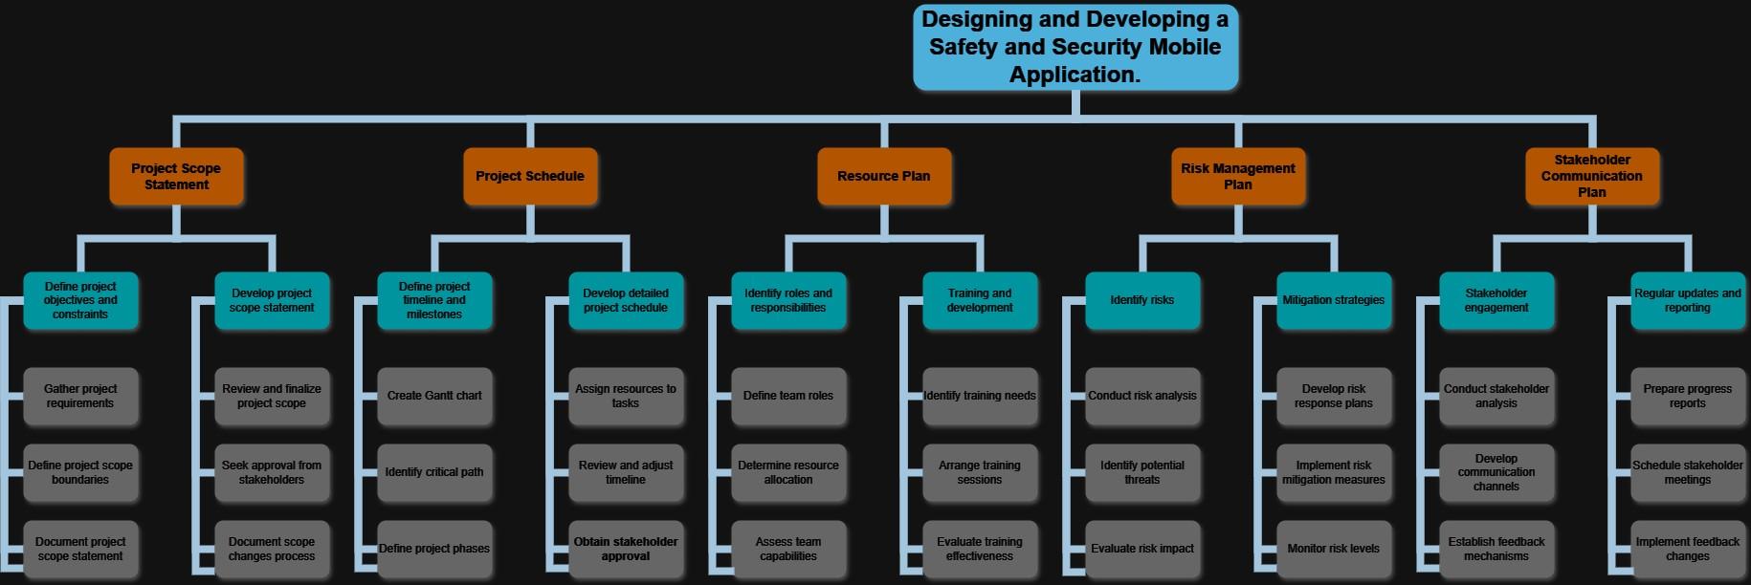

**Main Project:** (Peter, 2022)

Designing and Developing a Safety and Security Mobile Application.

**Deliverables:** (Peter, 2022)

* Project Scope Statement
* Project Schedule
* Resource Plan
* Risk Management Plan
* Stakeholder Communication Plan

**Sub-Tasks 1:** (Peter, 2022)

Define project objectives and constraints.

**Work Packages:**

Gather project requirements.

Define project scope boundaries.

Document project scope statement.

**Sub-Tasks 2:**

Develop project scope statement.

**Work Packages:**

Review and finalize project scope.

Seek approval from stakeholders.

Document scope changes process.

**Sub-Tasks 3:**

Define project timeline and milestones.

**Work Packages:**

Create Gantt chart.

Identify critical path.

Define project phases.

**Sub-Tasks 4:**

Develop detailed project schedule.

**Work Packages:**

Assign resources to tasks.

Review and adjust timeline.

Obtain stakeholder approval.

**Sub-Tasks 5:**

Identify roles and responsibilities.

**Work Packages:**

Define team roles.

Determine resource allocation.

Assess team capabilities.

**Sub-Tasks 6:**

Training and development.

**Work Packages:**

Identify training needs.

Arrange training sessions.

Evaluate training effectiveness.

**Sub-Tasks 7:**

Identity Risks.

**Work Packages:**

Define team roles.

Determine resource allocation.

Assess team capabilities.

**Sub-Tasks 8:**

Mitigation strategies.

**Work Packages:**

Develop risk response plans.

Implement risk mitigation measures.

Monitor risk levels.

**Sub-Tasks 9:**

Stakeholder engagement.

**Work Packages:**

Conduct stakeholder analysis.

Develop communication channels.

Establish feedback mechanisms.

**Sub-Tasks 10:**

Regular updates and reporting.

**Work Packages:** (Peter, 2022)

Prepare progress reports.

Schedule stakeholder meetings.

Implement feedback changes.

# **QUESTION 3**

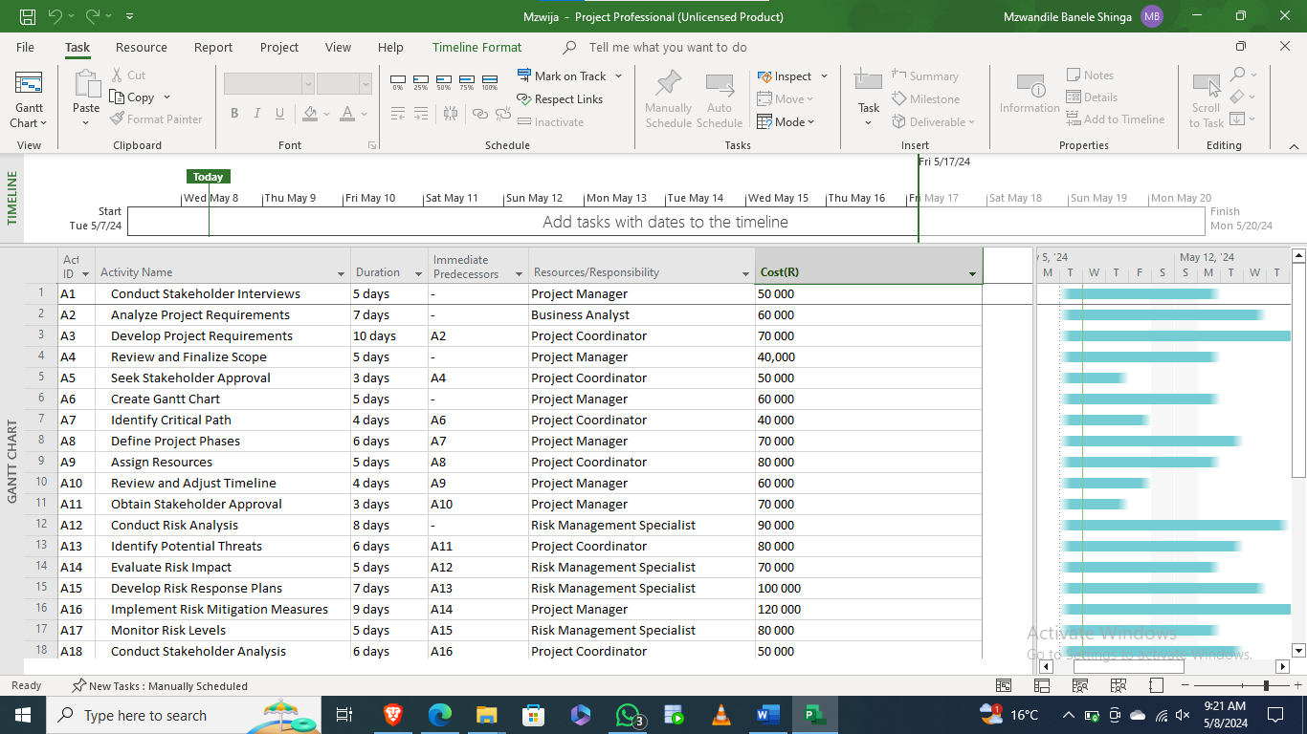

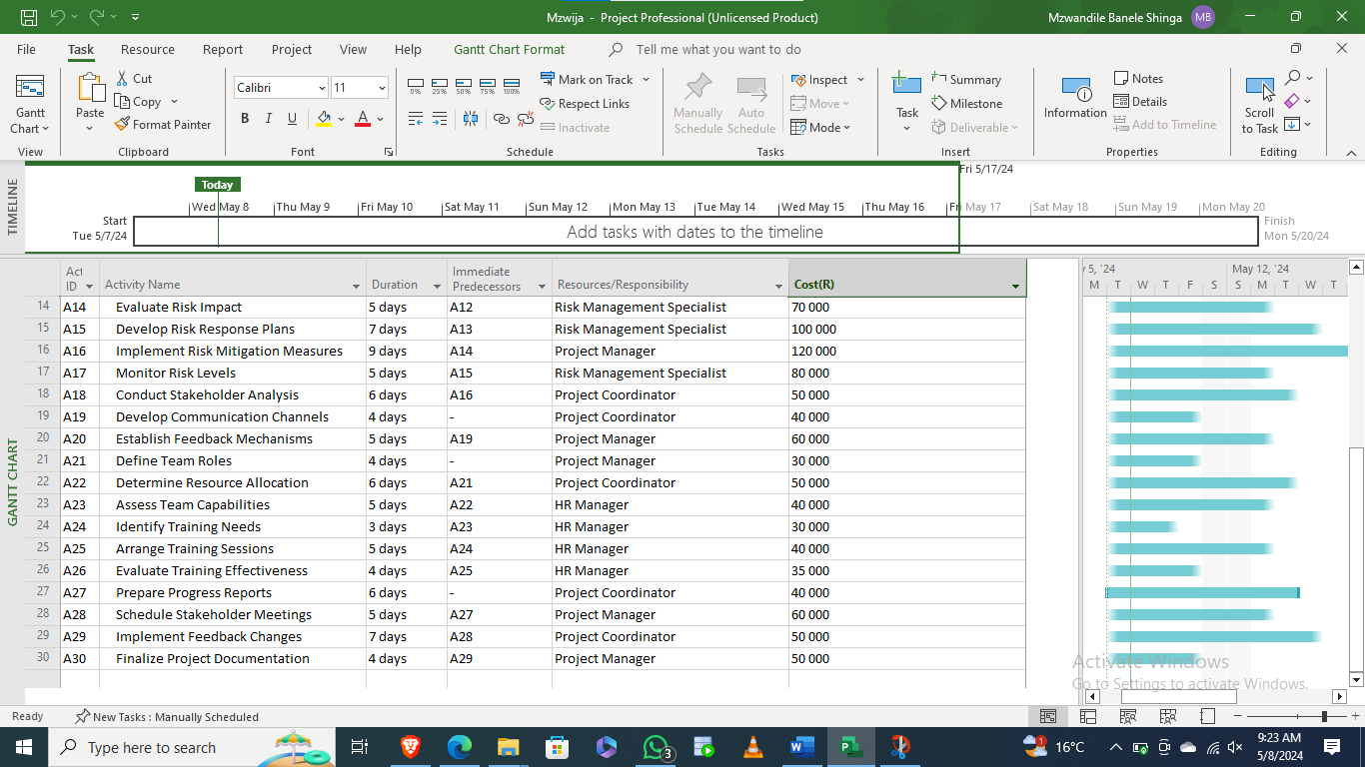

# **QUESTION 4**

# **QUESTION 5**

5.1

**APPENDIX B – PEER EVALUATION**

This peer evaluation form must be completed for each member of the group and returned to the lecturer before or on the submission date.

**GROUP NAME/NUMBER**:

**DATE:**

**Name of student being evaluated**:

|  |  |  |  |  |
| --- | --- | --- | --- | --- |
| **The student’s personal work** | **Never (0)** | **Seldom (1/2)** | **Frequently (1)** | **Always (2)** |
| 1. The student contributed good ideas that added value to the project and produced high-quality work. |  |  |  |  |
| 2. The student performed their tasks in line with what was expected of them. |  |  |  |  |
| 3. The student managed their own time well and met deadlines. |  |  |  |  |
| **The student’s work as part of a team (when relevant)** |  |  |  |  |
| 4. The student accepted responsibility for a fair portion of the tasks and was an enthusiastic member of my team. |  |  |  |  |
| 5. The student helped others to be successful and worked well with other members of the team. |  |  |  |  |

5.2

**NAME:**

**Self-Reflection Report**

**Introduction:**

The goal of the assignment project was to demonstrate my competence to oversee the design and development of a mobile application focused at solving community safety and security concerns. This included determining project needs, recognizing technical trends, developing a work breakdown structure, and commenting on personal and team relationships throughout the project.

**Skills Learnt:**

1. Industry-specific Practices: I gained knowledge about mobile app development procedures, including project management approaches such as PMBOK and Agile.   
   Understanding and translating user wants into app features was critical to properly addressing safety issues.
2. Interpersonal Communication Skills: Conducted brainstorming sessions with team members to create ideas and solutions for the app.   
   Feedback sessions helped to improve the app's design and functionality based on user and stakeholder feedback.
3. Management Skills:   
   Time management was critical to meeting project deadlines and milestones.   
   Crisis management abilities were put to the test when unanticipated complications developed during development, necessitating swift problem solutions.

**Role in the Team:**

Throughout the project, I assumed leadership duties, including supervising project progress, organizing team activities, and ensuring assignments were completed on time. My contributions to the team's performance included offering guidance, swiftly resolving issues, and encouraging collaboration. Dealing with problems and complaints entailed active listening, mediation, and finding mutually beneficial solutions.

**Research, Technology, and Presentation of Information:**

I did web research to acquire information on safety issues, technical advances in app development, and best practices for user experience. This material was gathered from trustworthy industry papers, academic journals, and online sources. Project management tools for task tracking were employed, as well as collaboration platforms for team communication and design applications for app prototype creation. Presenting information entailed producing reports, presentations, and documentation for stakeholders and team members.

**Personal Strengths and Weaknesses:**

I excelled in project planning, stakeholder communication, and issue solving. My key talents include attention to detail, excellent communication, leadership, flexibility, and innovation. Managing unforeseen setbacks, juggling different agendas, and dealing with sophisticated technological challenges were all tough for me. To address deficiencies, I intend to develop crisis management skills, prioritize duties more effectively, and seek mentoring or training in areas of difficulty.

**Stakeholder position:**

I had a positive connection with my team members, characterized by successful teamwork, mutual respect, and open communication. However, there were several cases when clearer communication channels may have increased efficiency and comprehension. To develop connections, I would encourage proactive communication, regular feedback sessions, and rapid resolution of difficulties.

**Impact:**  
My efforts assisted the team by accelerating project development, meeting stakeholder expectations, and providing high-quality mobile app solutions. Clients, stakeholders, and team members benefited from my knowledge, commitment, and adaptability to changing project needs.

**Conclusion:**

Overall, the assignment project gave useful information on project management, teamwork, and technology advances in app development. I have recognized areas for development and intend to continue honing my talents so that I may flourish in future initiatives. This experience has been enlightening, and I am excited to implement what I've learned in real-world circumstances.

# **REFERENCES**

* Gisclard-Biondi, H. 2021. “How to Determine Project Needs: The Right Way to Get Started.” *Appvizer.com*, 16 April 2021. (Online). Available at: [How to Determine Project Needs: The Right Way to Get Started (appvizer.com)](https://www.appvizer.com/magazine/operations/project-management/project-needs). (Accessed 16 April 2024)
* Good, L. 2019. “Project Identification.” *Project-Management.com*, 16 Feb. 2019, (Online). Available at: [Project Identification: What Is It & How to Do It Right (project-management.com)](https://project-management.com/project-identification/). (Accessed 16 April 2024)
* Aldridge, E. 2023. “What Is a Project Charter in Project Management?” *Project Management Academy Resources*, 14 Sept. 2023. (Online). Available at: [What is a Project Charter In Project Management? (projectmanagementacademy.net)](https://projectmanagementacademy.net/resources/blog/pmp-project-charter/). (Accessed 16 April 2024)
* Eby, K. 2016. “All about Work Breakdown Structures (WBS) | Smartsheet.” *Smartsheet*, 7 May 2024, (Online). Accessed at: <https://www.smartsheet.com/getting-started-work-breakdown-structures-wbs>. (Accessed 8 Nov. 2016)
* Q3.1
* Q3.2
* Q4.1
* Q4.2
* Q5.1
* Q5.2

# 

# 