expariment param 1
Data 2
features 2
Model training 3
visualization 3
*********************** Start of Project ************************* 3
data visualization 3
extracting features 7
histogram 7
feature selection 17
Train model with cross-validation 17
Test 20
%MATLAB 2019a
%this code loads an EEG structure extarcts feature out of the data and trains an LDA model
%to predict between two classes
clear all;
close all;

expariment param
load('motor_imagery_train_data.mat'); % trainig data
testFileName = 'motor_imagery_test_data.mat';
fs = P_C_S.samplingfrequency; %sampling frequency, Hz
dt = 1/fs; %time step [sec]
nTrials = size(P_C_S.data,1); % num of trails
trialLen = size(P_C_S.data,2); % num of sample
timeVec = dt:dt:trialLen/fs; %create time vec according to parameters
f = 0.5:0.1:40; % relevant freq range
window = 1.1; %window length in secs
windOverlap = 1; %window overlap length in secs
numOfWindows = floor((size(P_C_S.data,2)-window*fs)/...
(window*fs-floor(windOverlap*fs)))+1; %number of windows
miStart = 2.25; %motor imagery start in sec
miPeriod = timeVec(timeVec >= miStart); %motor imagery period
edgePrct = 90; %spectral edge percentaile
chans = cell2mat(P_C_S.channelname(1:2)); %channels in use
chans = str2num(chans);
chansName = ["C3" "C4"]; %channels names should corresponds to chans
nchans = length(chans); % num of channels
nclass = 2; %this project support two classes only
classes = P_C_S.attributename(3:end); %extract classes assuming rows 1,2 are artifact and remove
classes = string(classes);
clasRow = cellfun(@(x) find(ismember(P_C_S.attributename,x)), classes, 'un',false); %extartct classes rows
ntrialsPerClass = [sum(P_C_S.attribute(clasRow{1},:)==1),...
sum(P_C_S.attribute(clasRow{2},:)==1)];
% creating struct for all relevant parameters
Prmtr = struct('fs',fs,'time',timeVec,'freq',f,'nTrials',nTrials,'winLen',floor(window*fs),...
'winOvlp',floor(windOverlap*fs),'miPeriod',miPeriod,'nclass',nclass,'classes',classes, ...
'clasRow',cell2mat(clasRow),'ntrialsPerClass',ntrialsPerClass,...
'chans',chans,'chansName',chansName,'nchans',nchans,'edgePrct',edgePrct);
isTrainMode = 1; % if set to 1 than the script will ran a loop in order to
%check the best num of features to select using analyzeNumOfFeat function
%when is set to 0 a normal run will occur

Data
creating struct for all relevant data and arrange it
Data.allData = P_C_S.data;
Data.combLables = cell(1,nchans*nclass); %lables for channels*class combinations
Data.lables = strings(nTrials,1); %lable each trail for his class
k = 1;
for i = 1:nclass
currClass = classes(i);
Data.indexes.(classes{i}) = find(P_C_S.attribute(Prmtr.clasRow(i),:)==1); %finding the indexes for each class
Data.lables(Data.indexes.(classes{i})) = currClass; %lable each trail for his class
for j = 1:nchans
chanCls = char(currClass + chansName(j)); %creating combination name
Data.(chanCls) = Data.allData(Data.indexes.(classes{i}),:,chans(j)); %arrange data by combination
Data.combLables{1,k} = chanCls;
k = k+1;
end
end

features
%band power features 1st arr - band, 2nd arr - time range
Features.bandPower{1} = {[15,20],[3.5,6]};
Features.bandPower{2} = {[32,36],[4,6]};
Features.bandPower{3} = {[9,11],[5.5,6]};
Features.bandPower{4} = {[17,21],[1.2,2.7]};
nBandPowerFeat = length(Features.bandPower)*2; %bandpower and relative bandpower for each relevant range
Features.mVthrshld = 4; %threshold feature in muV
Features.diffBetween = ["C3","C4"]; % choose two elctrode to calc diff
generalFeat = 10; %number of general features should be 10!
%Total Power,Root Total Power,Slope,Intercept,Spectral Moment,Spectral Entropy
%Spectral Edge,Threshold Pass Count,Max Voltage,Min Voltage
nDifFeat = 1; %number of diffs between chanle features should be 1!
Features.nFeat = ((nBandPowerFeat+generalFeat)*nclass)+ nDifFeat; %num of total features feature selection method
Features.nFeatSelect = 8 ; %number of features to select for classification
Features.fsMethod = "ks"; %choose feature selection method between cna and ks
Features.distPrecision = 5; %only in case you run ks for feature selection

Model training
k = 5; %k fold parameter
results = cell(k,1);
trainErr = cell(k,1);
acc = zeros(k,1);

visualization
globalPos = [0.2,0.15,0.6,0.7]; %global position for figures
globTtlPos = [0.45,0.999]; %global title position
%first visualization
signalPerFig = 20; %signals per figuer
plotPerRow = 4; %plots per row
plotPerCol = signalPerFig/plotPerRow; %make sure signalPerFig divisible with plotPerRow
%histogram
xLim = [-4 4]; %x axis lims in sd
binWid = 0.2;
trnsp = 0.5; %bars transparency
binEdges = xLim(1):binWid:xLim(2);
Prmtr.Vis = struct('globalPos', globalPos,'globTtlPos',globTtlPos,...
'signalPerFig',signalPerFig,'plotPerRow',plotPerRow,'plotPerCol',plotPerCol,...
'xLim',xLim,'binEdges',binEdges,'trnsp',trnsp);

*********************** Start of Project *************************

data visualization
%visualization of the signal in Voltage[muV] for rand co-responding trails
for i = 1:nclass
signalVisualization(Data,i,Prmtr)
end
% calculating PWelch for all condition
for i = 1:nclass
for j = 1:length(Prmtr.chans)
currClass = Prmtr.classes(i);
chanCls = char(currClass + chansName(j));
Data.PWelch.(chanCls) = pwelch(Data.(chanCls)(:,(Prmtr.miPeriod*fs))',...
Prmtr.winLen,Prmtr.winOvlp,Prmtr.freq,Prmtr.fs);
end
end
%visualization PWelch
plotPwelch(Data,Prmtr)
%calculating spectrogram for all conditions
for i =1:length(Data.combLables) %looping all condition
for j = 1:size(Data.(Data.combLables{i}),1)
Data.spect.(Data.combLables{i})(j,:,:) = spectrogram(Data.(Data.combLables{i})(j,:)',...
Prmtr.winLen,Prmtr.winOvlp,Prmtr.freq,Prmtr.fs,'yaxis');
end
% convert the units to dB and average all spect for each cindition
Data.spect.(Data.combLables{i}) = squeeze(mean(10*log10(abs(Data.spect.(Data.combLables{i}))).^2));
end
%visualization spectogram
plotSpectogram(Data,Prmtr)
plotSpectDiff(Data,Prmtr)
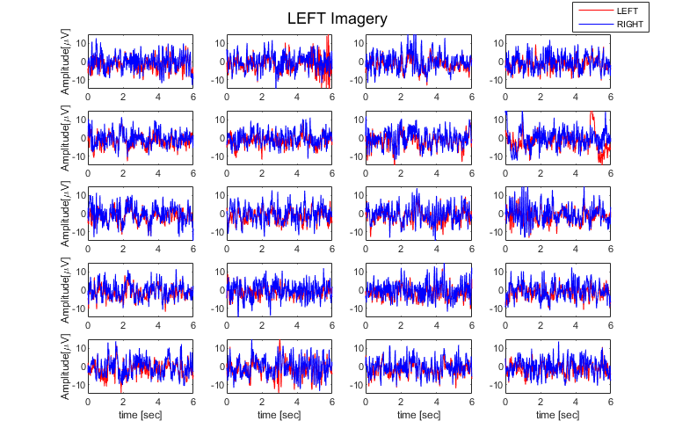
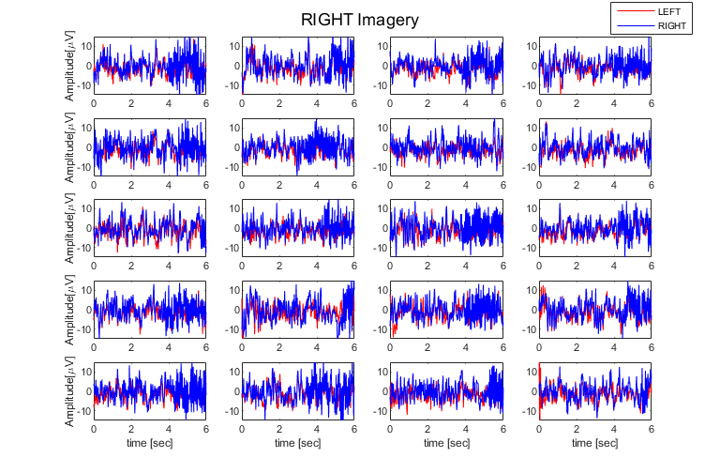
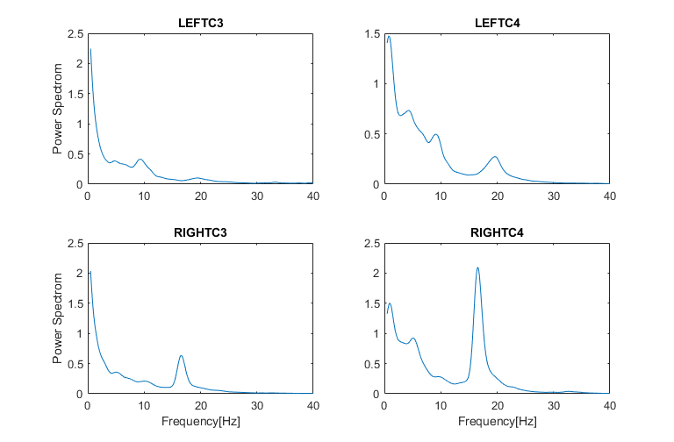
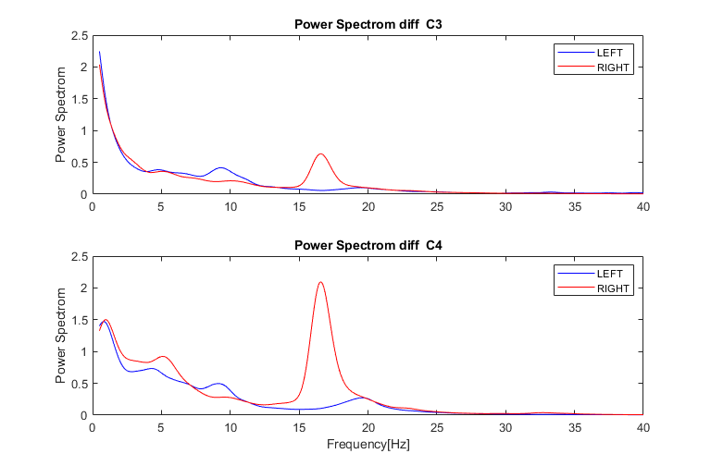
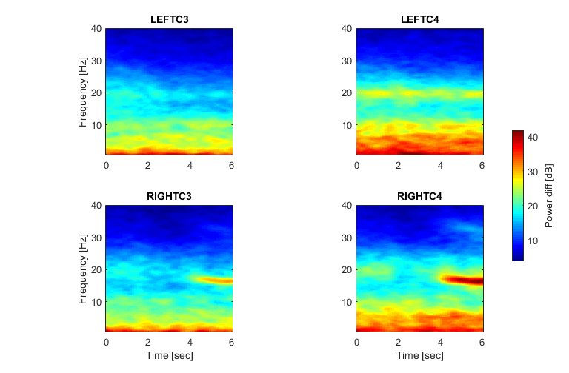
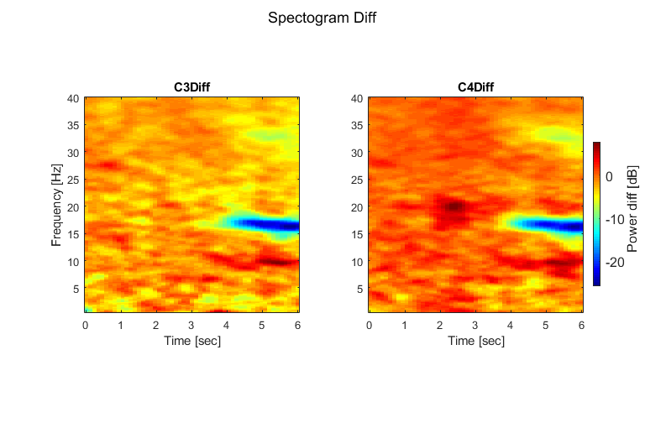

extracting features
Features.featMat = zeros(nTrials,Features.nFeat); %allocate space
fIdx = 1; % index for the co-responding feature to col
Features.featLables = cell(1,Features.nFeat); %allocate space to features name
Features = extractFeatures(Data.allData,Prmtr,Features,'featMat',fIdx); %calc and extract all features
[Features.featMat,meanTrain,SdTrain] = zscore(Features.featMat); % scale all features

histogram
makeFeaturesHist(Prmtr,Features,Data);
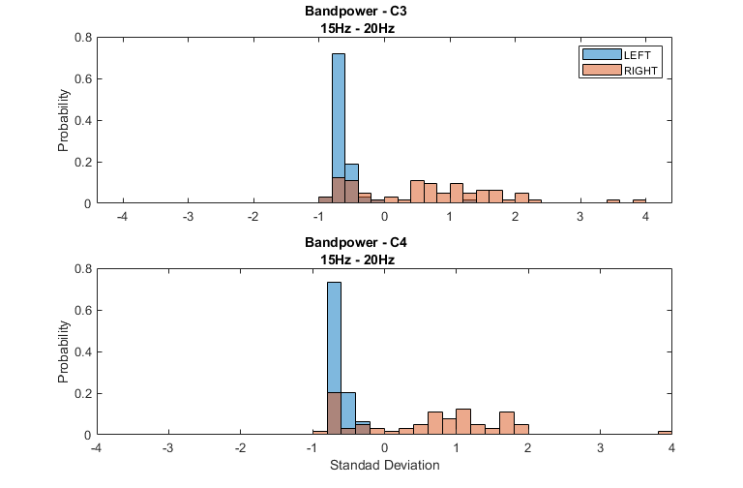
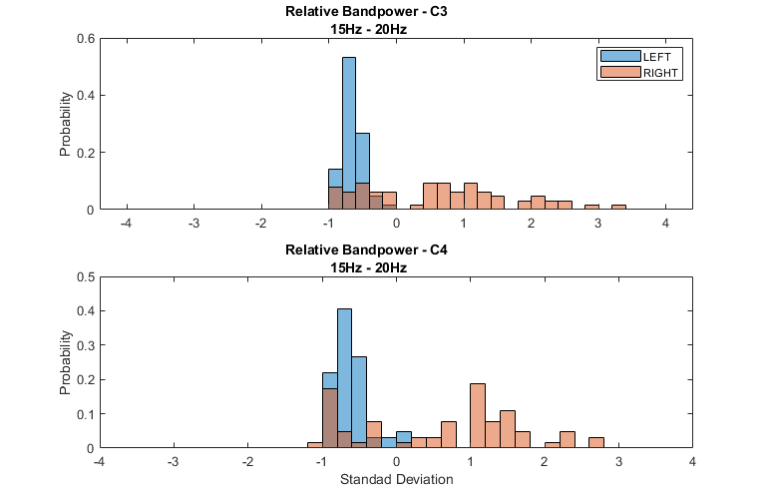
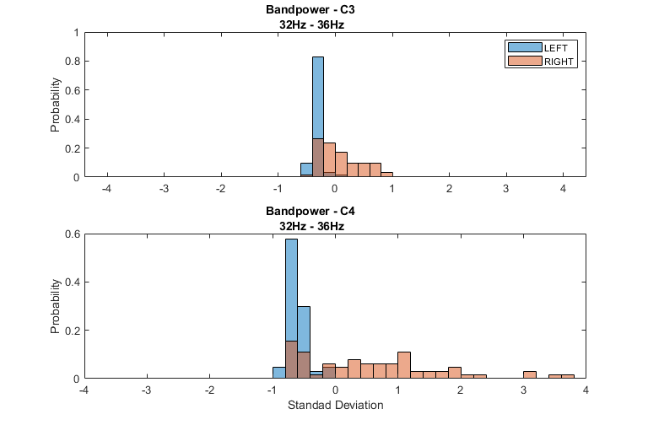
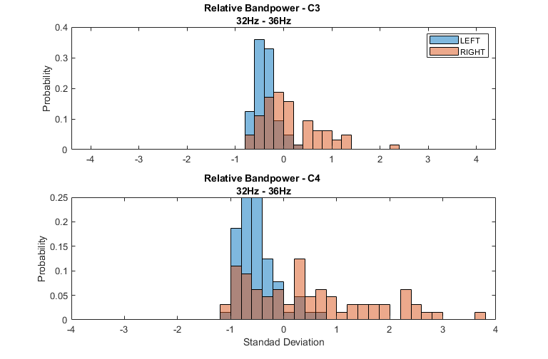
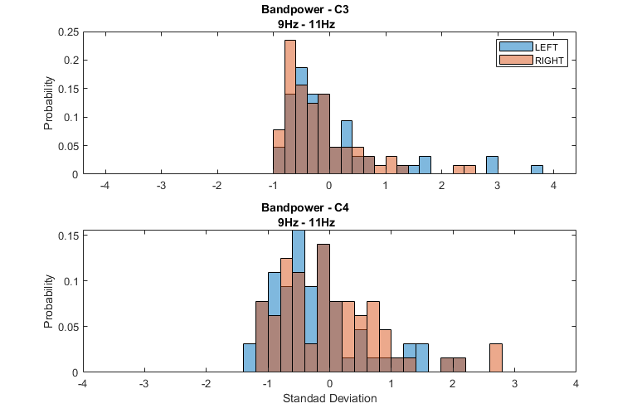
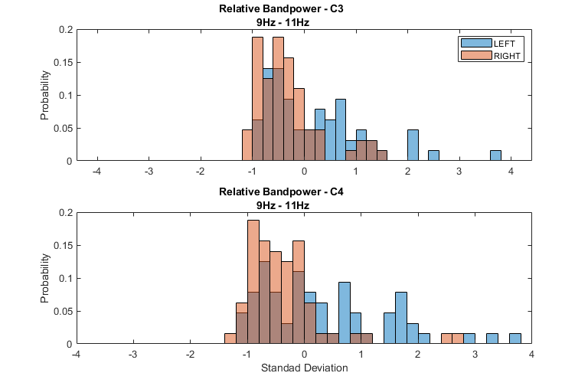
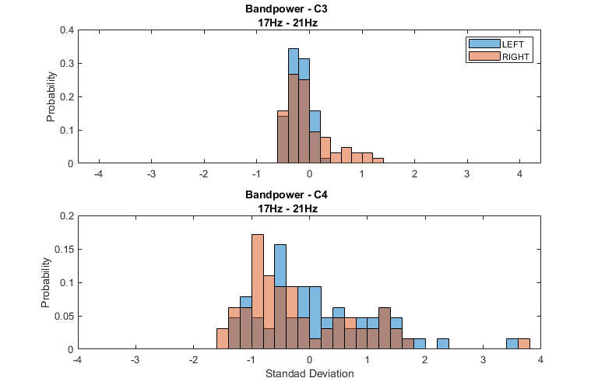
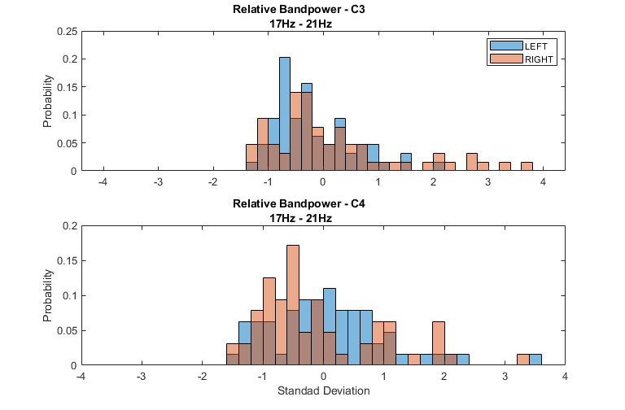
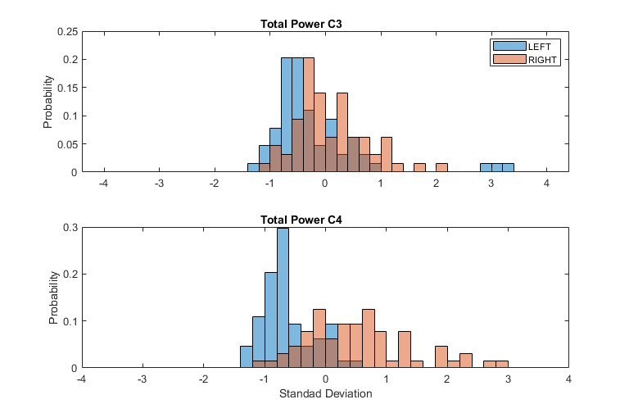
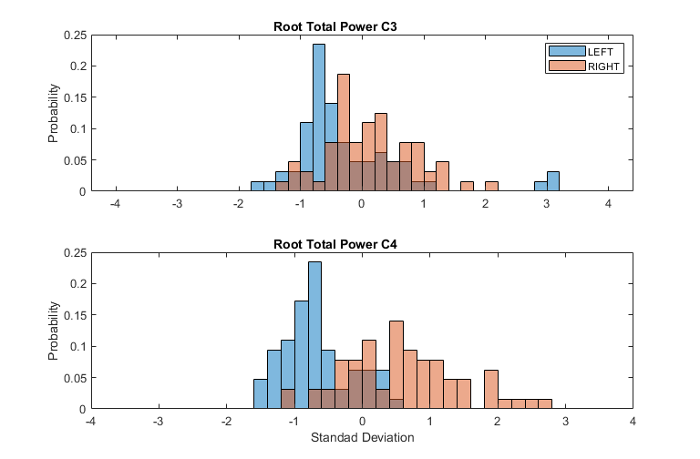
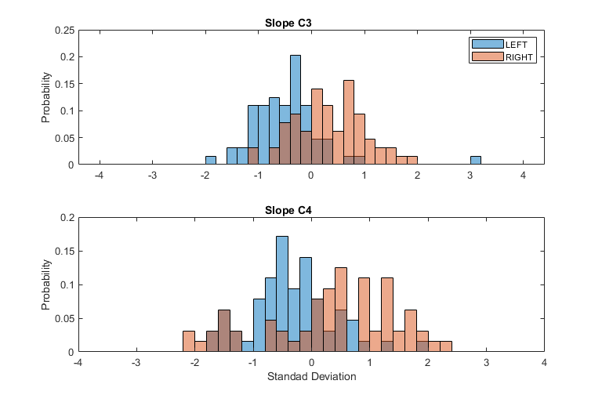
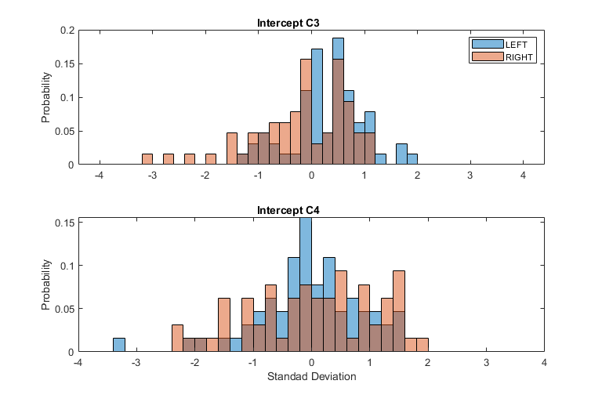
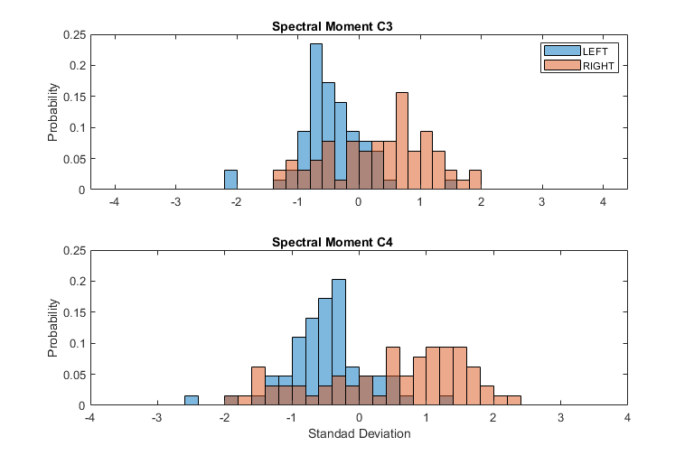
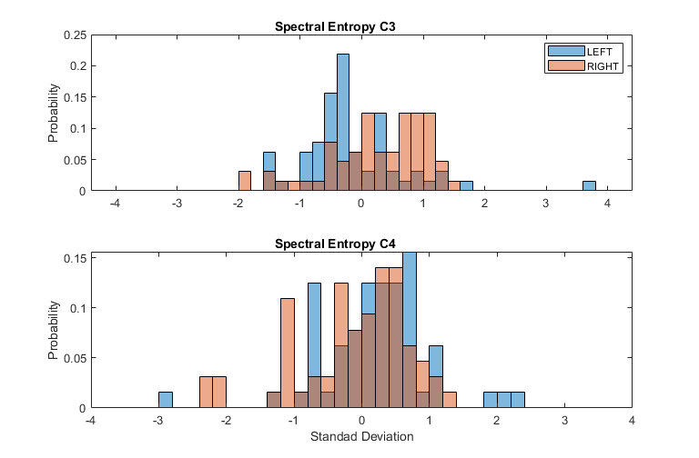
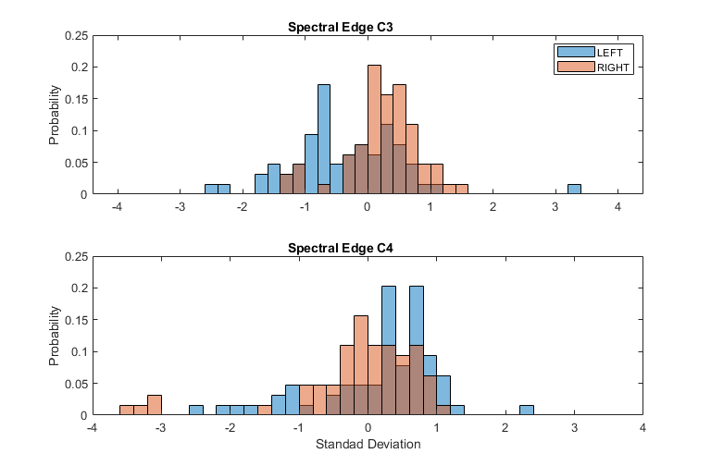
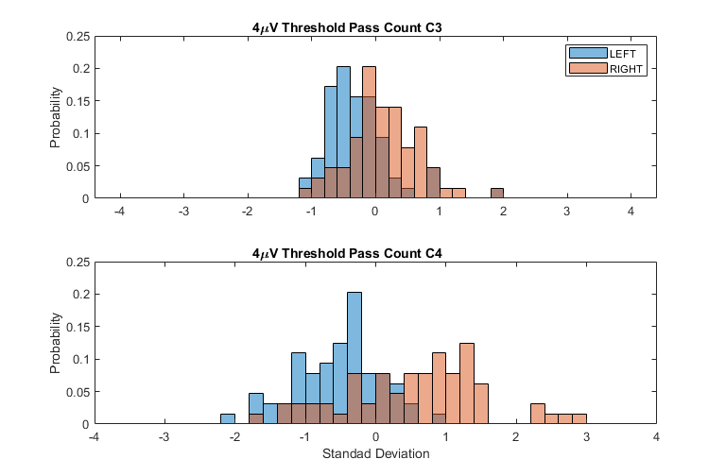
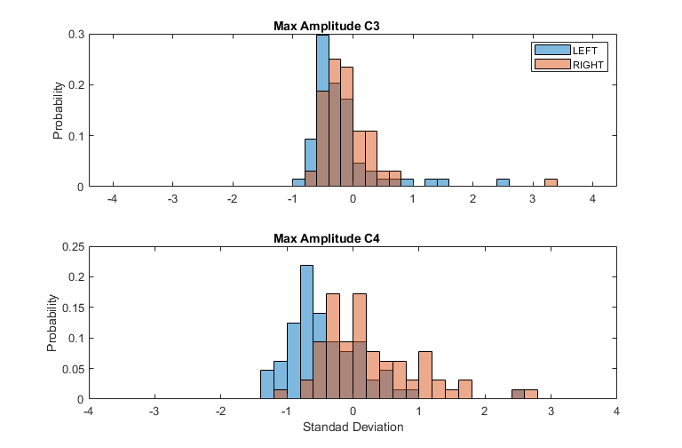
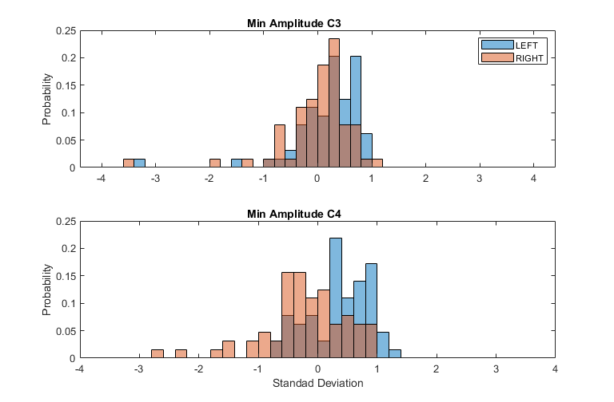
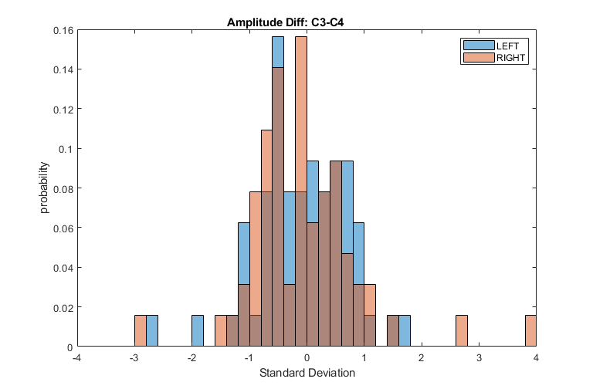

feature selection
if isTrainMode == 1 %if true than check best num of features by loop through all features
numOfIter = Features.nFeat;
f1 = zeros(numOfIter,1);
accAvg = zeros(numOfIter,1);
trAccAvg = zeros(numOfIter,1);
accSD = zeros(numOfIter,1);
trAccSD = zeros(numOfIter,1);
else
numOfIter = 1; %if false than train model once with nFeatSelect features
end
for iter = 1:numOfIter %in case that train mode is on this loop will finde the best num of features
%select only the nFeatSelect best features
if isTrainMode == 1
Features.nFeatSelect = iter;
end
[featIdx,selectMat,featOrder] = selectFeat(Features,Data.lables);

Train model with cross-validation
idxSegments = mod(randperm(nTrials),k)+1; %randomly split trails in to k groups
cmT = zeros(nclass,nclass); % allocate space for confusion matrix
for i = 1:k
% each test on 1 group and train on the else
validSet = logical(idxSegments == i)';
trainSet = logical(idxSegments ~= i)';
[results{i},trainErr{i}] =...
classify(selectMat(validSet,:),selectMat(trainSet,:),Data.lables(trainSet),'linear');
acc(i) = sum(results{i} == Data.lables(validSet)); %sum num of correct results
acc(i) = acc(i)/length(results{i})*100;
%build the confusion matrix
cm = confusionmat(Data.lables(validSet),results{i});
cmT = cmT + cm;
end
%calculate accuracy and f1
percision = cmT(1,1)/(cmT(1,1) + cmT(1,2));
recall = cmT(1,1)/(cmT(1,1) + cmT(2,1));
f1(iter) = 2*((percision*recall)/(percision+recall));
accAvg(iter) = mean(acc);
accSD(iter) = std(acc);
trainAcc = (1-cell2mat(trainErr))*100;
trAccAvg(iter) = mean(trainAcc);
trAccSD(iter) = std(trainAcc);
end
if isTrainMode == 1 %plots for checking best features number
disp(char("optimal number of features is: "+...
analyzeNumOfFeat(Prmtr,[f1,accAvg,accSD,trAccAvg,trAccSD],Features)));
else %in regular mode, print accuracy and confusion matrix
printAcc(accAvg,accSD,1);
printAcc(trAccAvg,trAccSD,0);
figure('Units','normalized','Position',globalPos)
cmChart = confusionchart(cmT,[classes(1) classes(2)]);
cmChart.Title = char(classes(1)+" "+classes(2)+" classification");
end
% plot PCA
plotPCA(Features.featMat,Data,Prmtr)
optimal number of features is: 28
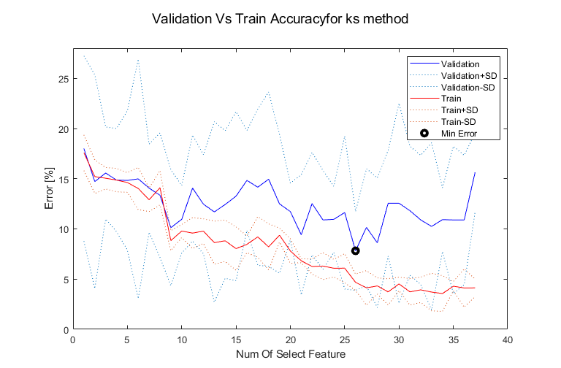
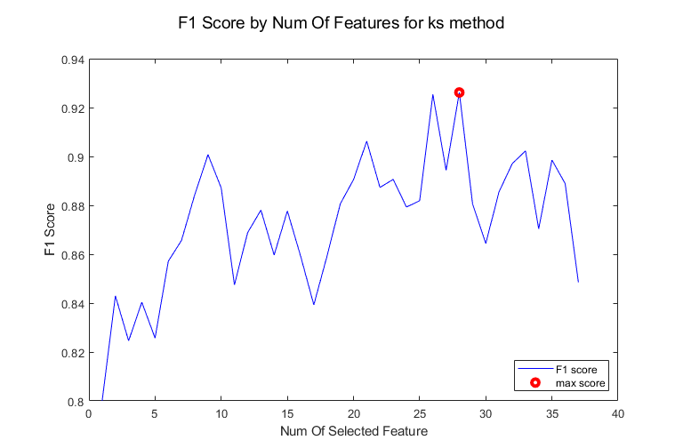
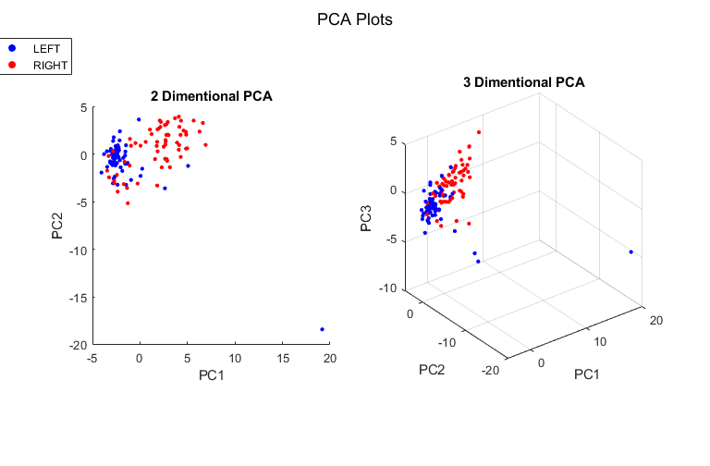

Test
%Load test data
load(testFileName)
testData = data(:,:,1:length(Prmtr.chans));
%Test feature extraction
Features.TestFeatMat = zeros(size(testData,1),Features.nFeat); %allocate space
Features = extractFeatures(testData,Prmtr,Features,'TestFeatMat',fIdx); %calc and extract all features
%Test feature selection
Features.TestFeatMat = Features.TestFeatMat(:,featIdx); %choosing the same features
Features.TestFeatMat = (Features.TestFeatMat - meanTrain(:,featIdx))./SdTrain(:,featIdx); % scale according to train data
%Test classifier - output is the classifier predictions for test data.
testPredict = classify(Features.TestFeatMat,selectMat,Data.lables,'linear');
Published with MATLAB® R2019a

