Abstract

A text analysis of UK House of Commons (HoC) parliamentary debates from 2010 to 2020 reveals that discussions relating immigration meaningfully increased following the general election in 2015 and leading to Brexit, during the progression of the European migration crisis. By performing a topic model analysis, it becomes evident that migration-related discussions in the HoC revolved around four central themes – social welfare, economic migration, refugees fleeing conflict and the humanitarian concerns of migration. The relative prevalence of these topics in party-specific contributions changed over the years in correlation with significant global and national events. Topic-related sentiments also help identify trends in migration-related debates in the HoC. While the UK’s fifth largest political parties exhibit positive sentiment toward the topic of economic migration, they are found to overwhelmingly present the humanitarian concerns of migration in a negative frame. These findings offer policymakers insight for generating actionable strategies for coalition building on issues related to immigration.

1. introduction

Like most world economies, the UK is facing a challenging period in the wake of the Coronavirus pandemic. During these already challenging times, immigration is likely to become a sensitive topic in policy making. Particularly so, given that the UK’s exit of the European Union, which is only now beginning to come into effect, was driven in part by the desire for immigration-related legislation made on UK’s terms.

There are many current debates on this issue. While many of those who voted “leave” were most concerned about the number of immigrants coming into Britain (Sapsted, 2020),[1] others argue that preventing the immigration of skilled workers is likely to hinder the country’s economic recovery due to gaps in currently-high-demand-jobs (Grierson, 2020). In fact, the COVID-19 outbreak has brought to attention just how much the UK’s healthcare and social care systems depend on workers who originally came from abroad (Sapsted, 2020). In any case, regardless of how circumstances develop in the UK and other countries, some people will still leave their homes in the search of a better future. Hence, debates on immigration will likely remain of core parliamentary importance.

As discussions in the House of Commons (HoC) are instrumental to the unfolding policies and pieces of legislation on immigration, understanding politicians’ contributions to these debates can provide valuable insights into how certain policies came into effect. This approach uses speech data to investigate sentiments and themes in the debates on immigration to explore how prominent issues are framed (Bara, Weale & Bicuelet, 2007). Our analysis applies these methods to investigate the attitudes in the HoC regarding the most prevalent topics of immigration.

To provide an overview of how discussions on immigration have developed in parliamentary debates, we focus our analysis on the time frame from the years leading up to the 2015 general election and the Brexit referendum until now, using these two historic moments as points of reference. The general election and Brexit referendum represent pivotal moments in the UK’s politics with potentially significant implications for debates on immigration. We believe that by looking at how different kinds of crises or national-level events might impact the prevalence of migration-related debates in parliament, how such topics are covered by different parties over time and what is parties’ sentiment toward specific topics of immigration can provide initial insight that can assist politicians and policy makers to generate an actionable strategy for coalition building for immigration related policies in the specific context of Covid-19 crisis.

2. Data

To understand how debates related to immigration are framed and perceived when discussed in British parliament, we used the HoC-related dataset from a database called ParlSpeech V2 by Christian Rauh and Jan Schwalbach (2020). This dataset is unique in its scope, covering all parliamentary debates from 1998 and up until 2020, resulting in 1,956,223 speeches (Rauh & Schwalbach, 2020, p. 10). Speeches represent individual contributions by members of parliament and were collected from the digital Commons Hansard, which contains the plenary protocols and documents from which speech texts and metadata are extracted. As a result, the corpus includes a range of covariates like *party* *affiliation* and *agenda,* which facilitate a detailed set of context and party-specific analyses. In our analysis, we make use of these metadata and leverage the Lexicoder 2015 sentiment dictionary, which was established to produce reliable estimates based on 2,858-word patterns relating to negative sentiment and 1,709-word patterns indicating positive sentiment (Young & Soroka, 2012). This sentiment dictionary is particularly relevant to our purposes as it was designed to analyse sentiment in political language of legislative speech [2] and has been applied specifically to migration discourse.[3]

2.1 Subset and method

Choosing a subset for analysis is a challenging task, and in our case, the decisions we took were related both to substantive and practical consideration of needing to narrow down a very large database to perform a more in-depth analysis. In a first step, we choose to focus on texts from 2010 to present day, leaving us with slightly fewer than 750,000 individual contributions. 2010 is a good starting point for our analysis because that was the year of the Tory manifesto and the general elections, which resulted in a win for the Conservative party. This allows a sufficient time frame that has observations both before our main events of interest—namely the 2015 General Election, the Syrian refugee crisis, and the Brexit Referendum—and after, from 2016 until 2020. In terms of content, we subset the corpus to those contributions that either contain a reference to keywords related to our topic of immigration, or that were made in response to agenda points that contain such keywords. The keywords we used were “I/immigra*”, “R/refuge*” and “A/asylum.” As a continuation of existent research, we expect parliamentary debates to be explicit in their language, meaning that if immigration is discussed, one of these keywords will show either in the agenda description or in the speech itself (Van Dijk, 2000). This would allow us to capture most of the substantive debates regarding immigration. As final steps of subsetting, we exclude speeches that were shorter than 10 words and select only the contributions of the five parties that made the most overall contributions. These were the Conservatives, Labour, Liberal Democrats, SNP and DUP. Subsetting in this way allows us to focus our analysis and remove noise from unrelated text. The downside of such subsetting is that we lose documents discuss immigration without mentioning the three key terms chosen in either agenda description or text.

The aforementioned steps yielded a final subset of 22,257 individual contributions, representing about 3% of the parliament’s overall debates during that period as well as about 6.25% of the overall time spend in debates. The five parties selected represent about 98% of the overall contributions made.

To offer a blueprint, our analysis consists of two main threads. First, we use a general subset of the HoC parliamentary debates described above. Second, we use a more targeted subset of text immediately surrounding selected keywords. Essentially, this subset contains bubbles of text in range of 20 words before and after a keyword. Importantly, if two keywords are presented within such a bubble, there would be no multiplication. We created this subset in order to pursue a deeper analysis of how these terms are used in context.

3. Descriptive | General Findings

Graphs that would go in this section:

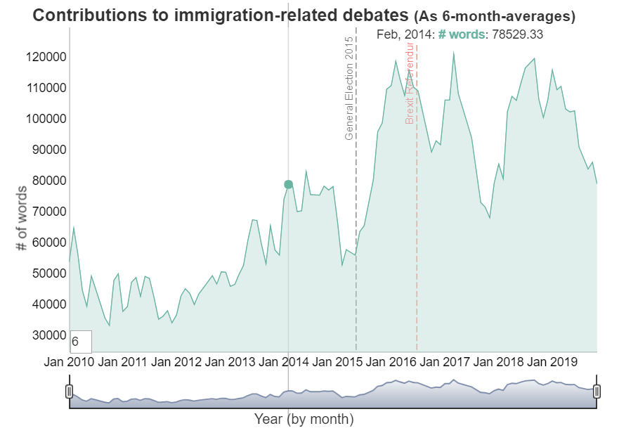

The first density plot depicts frequency (y) of individual contributions (regardless of their length) over time. Technically speaking, this equals the total count of documents for each month between 2010 and 2020. From this, one can infer the overall prevalence of immigration-related debates in the HoC between 2010 and 2020, irrespective of party. Evidently, following the general elections in 2015, there was a rapid increase in discussion about immigration, which is aligned with the progression of the vast immigration wave across the EU. The spikes and breaks are likely due to the different recess dates within the HoC.[4]

*Plot 2* depicts the number of unique agenda points dedicated towards immigration related matters. What becomes clear is that the overall number of agenda points devoted or somehow related to immigration has almost tripled between 2010 and 2020, with a nearly linear increase over the years.

*Plot 3*

Different from the previous plot that ignored the length of speakers’ contributions, this plot uses the sum of words used within debates as an indicator of the time spent on the respective debate. Considering that the HoC only has a limited time available to discuss agenda points, devoting more time towards a debate may indicate certain priorities. In this regard, plot 3 depicts the 6-month-average total amount of words spend on immigration-related debates. By looking at the 6-month averages, it is possible to observe whether debate-preferences prevailed over time or whether they only peaked for short periods.[5]

From January 2012 to November 2014, we observe a steady increase in time (averaged over 6-months) spent on debates related to immigration. This is likely due to the monthly spikes in both January and June of 2014. The second half of 2014 as well as the first half of 2015 saw less time being devoted to immigration related debates. This suggest that overall, the content of our subset did not increase in particular prevalence before the 2015 General Election.

However, between May 2015 and June 2016, hence the year following the general election and leading up to the Brexit referendum, there was a major increase in time spent on immigration-related debates. On average, the HoC spent almost twice as much time on immigration related debates during Sep 2015 - February 2016 when compared to the period of December 2014 - May 2015. Hence, debates seem to have gained in priority after the General election and leading up to the referendum.

Plot 4. Number of words spent on immigration related debates (by party) 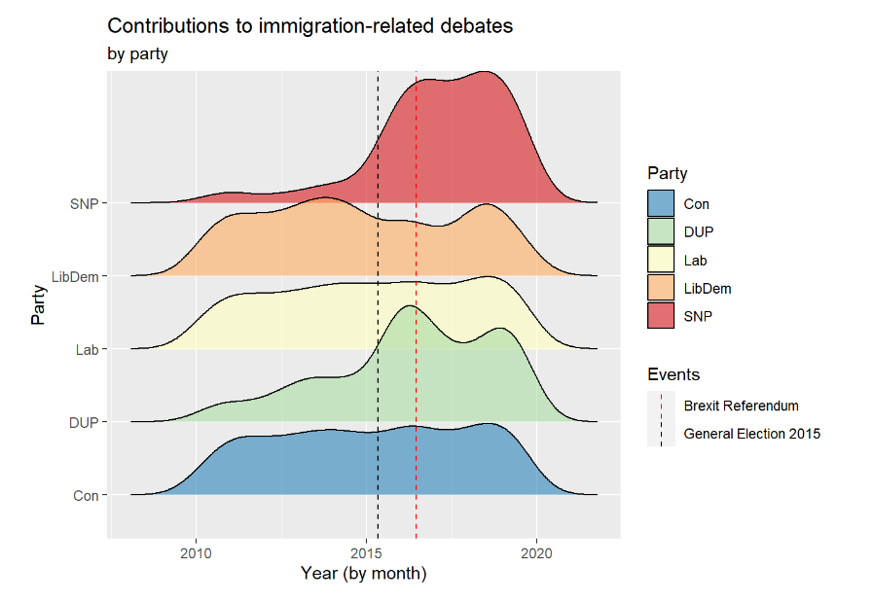

Zooming in further, this density plot gives us a sense of the frequency each party discussed immigration related issues every month during the time frame investigated. What it shows is that while the SNP and the DUP spoke more about immigration after Brexit, other parties has a more constant trend of engagement with immigration related speech. Importantly, the information that can be gathered from this graph is limited in that it does not tell us anything about substance of these speeches, but crudely how many words were used. Nevertheless, this descriptive visualization does help us get an initial sense about the prevalence of immigration related speech in each of the parties we are focusing on.

## 4. Sentiment

## We performed the sentiment analysis using the quanteda.sentiment package and applying the Lexicoder sentiment dictionary containing positive, neutral and negative expressions. The analysis essentially matches words with sentiment ratings from the dictionary to words in the various documents and then computes an average sentiment score for each document.

## Observing sentiment by party throughout the years presents several trends that are worth mentioning. Interestingly, the Conservative party exhibits an overall more positive sentiment that increases gradually over the years compared to the Labour party. Further, the Liberal democratic party (LibDem), the Scottish National Party (SNP) and the Democratic Unionist Party (DUP) exhibit a more fluctuating sentiment toward immigration related topics. Specifically, before the general election, both SNP and DUP had more negative sentiment toward immigration.

## There is a challenge of interpreting these party-sentiment trends because the sentiment score represents both sentiment towards the subject of these debates (e.g. for conservatives’ economic migration is usually less contested than humanitarian migration), and, it may also capture how parties perceive immigration. To disentangle these effects, that may be contradictory, further analysis is required. Nevertheless, from this analysis is possible to

Graph: Sentiment by party

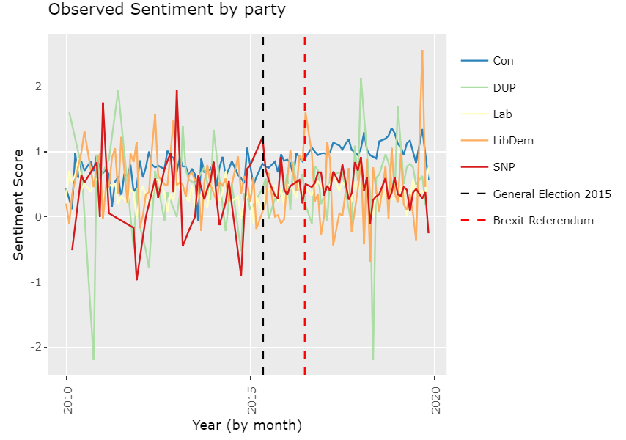

## 4.1. Sentiment in Keyword-specific context

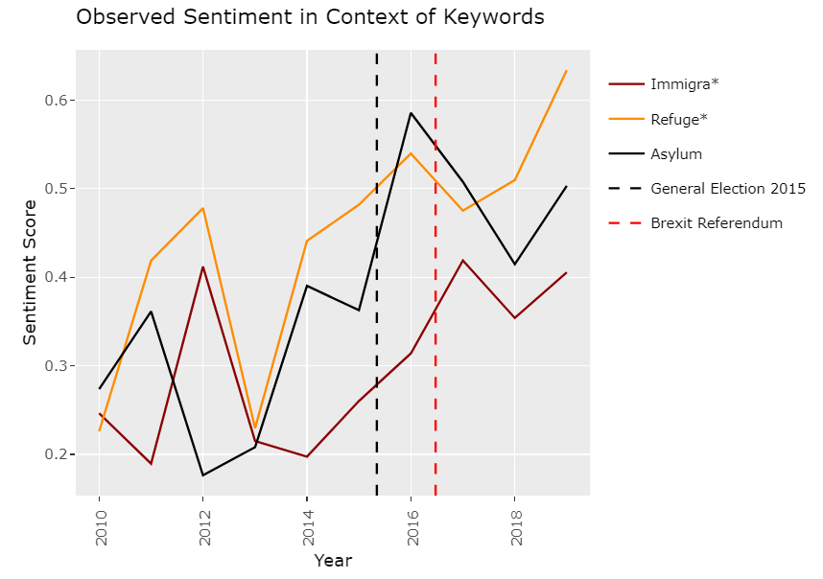

When breaking down the sentiment all parties had towards the key words, in the moments in which these words are explicitly mentioned, generally we can see that sentiment becomes more positive over time. Further, while sentiment is lowest toward sentences in which the word immigration is mentioned, it is the most positive when refugees are mentioned. The increase in positive sentiment in sentences mentioning asylum from the end of 2014 when the immigration crisis emerged and up to the months before Brexit support this argument of humanitarian concern explanation as well. A speculation as to why is that refugees are mostly those migrants who are at risk and need, meaning that the wish to save those people was more prevalent than the wish to keep borders close.

## To conclude, the sentiment analysis we performed here is limited in that we are not exploring sentiment in relation to a very concrete vote or debate but rather gathering various sentiments toward different discussion and averaging them together. Consequently, we can only interpret our findings in a broad manner. Nevertheless, this analysis provides the reader with a sense of the general affect parties had to immigration related debates.

## 6. Topical Analysis

In order to better understand developments in migration-related debates over time, the different party positions in these debates, and the sentiment associated with discourses of migration, it is important to distinguish these debates by the themes they discuss. To do this, we use the Structural Topic Model (STM).

- topics

Using the STM package in R, we model 6 topics from the content of migration-related documents and assign each document a theta score for each topic. These scores represent the proportions of prevalence of each topic for each document. Next, we test how exclusive and coherent these topics are. While 6 topics may seem few, we are modelling topics from a subset of parliamentary debates that use migration-related keywords. This already limits the extent of topics potentially covered by these debates. Our test also shows that 6 is a sufficient number for allocating exclusive and coherent topics.

-topics dataframe

We combine the topic scores of each document to our dataset of migration-related debates. Next, we attribute to each topic a name based on the first 3 FREX terms, the words that are more frequent and most exclusive to each topic. One topic, labelled “allowance, tax, dwp,” may refer to content on migration that related to social welfare. The topic named “eea, seasonal, visa” relates to the portion of debates that concern the economic dimensions of migration. “Iraq, Rohingya, Libya” describes the portion of debates that mainly concern refugees fleeing conflict. The topic “tb, Sikh, Auschwitz” seems to indicate a collection of less prevalent migration-related topics such as Tuberculosis, specific migrant communities, and the Holocaust. The title “unaccompanied, trafficked, detention” describes the most vulnerable populations of migrants and the humanitarian concerns of migration. Finally, the topic “vote, voting, motion” includes the procedural vocabulary of the House of Parliament.

-topic_by_party_plot

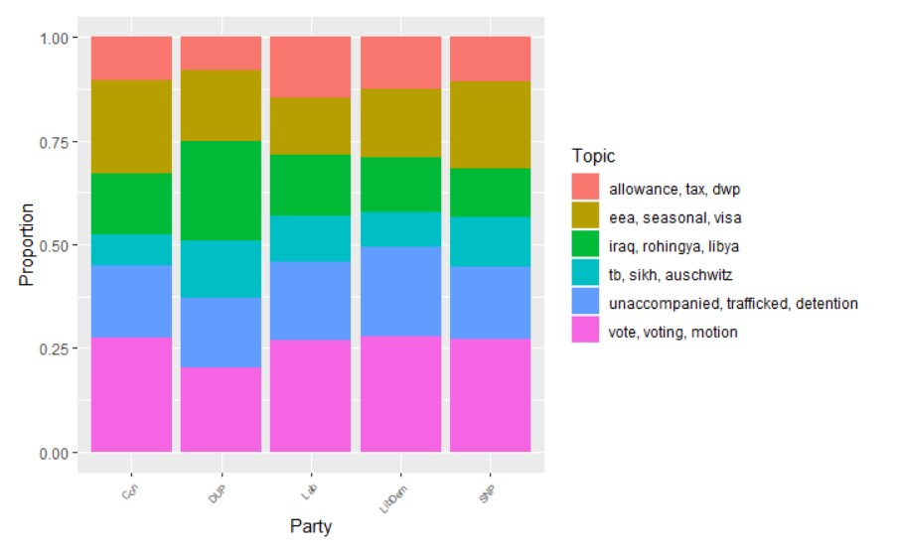

We plot the proportions of topics covered by each party over all the years of debate (2010-2020). This plot illustrates two main things. First, it demonstrates the relative prevalence of these six migration-related topics in parliamentary debates. From this we can see that aside from procedural vocabulary, the three most prevalent topics in these migration debates are economic migration, refugees fleeing conflict, and the humanitarian concerns of migration.

In addition, this plot compares how different parties discuss migration, in terms of these six topics. Here we see that the Conservatives discuss economic migration more than any other major party and to a greater extent than they discuss refugees fleeing conflict or the humanitarian concerns of migration. In comparison to the Conservatives, the Labour party discusses migration more often in the context of social welfare and humanitarian concerns.

-topics_by_time_plot

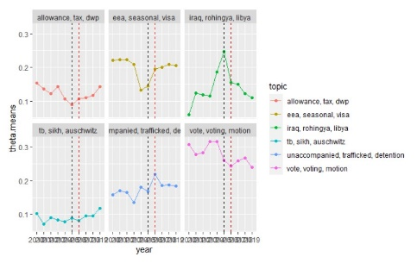

To explore the change in topic prevalence over time, we plot the yearly average prevalence of each topic between 2010 and 2020. For reference, the vertical, black, dashed line marks the 2015 election and the beginning of the so-called Syrian refugee crisis in Europe, while the red, dashed line represents the BREXIT referendum in 2016. This plot shows that while the topic of social welfare enjoys relatively little prevalence in migration-related debates, it was most prevalent in the earlier years of the decade and has begun regaining attention in recent years. We also find that the topic of economic migration experienced a sharp decline in attention after 2013 has only risen to prominence once again in post-BREXIT debates. The topic of refugees fleeing conflict first received attention in 2011 (in the context of civil war in Libya) before becoming nearly three-times more prevalent at the peak of the Syrian refugee crisis in 2015. The topic lost traction in 2016 after the BREXIT referendum shifted political attention to other concerns regarding migration. (why did humanitarian concerns peek in 2016? Also related to events connected to the Syrian refugee crisis and passage to Europe?)

-topic_by_party_and year

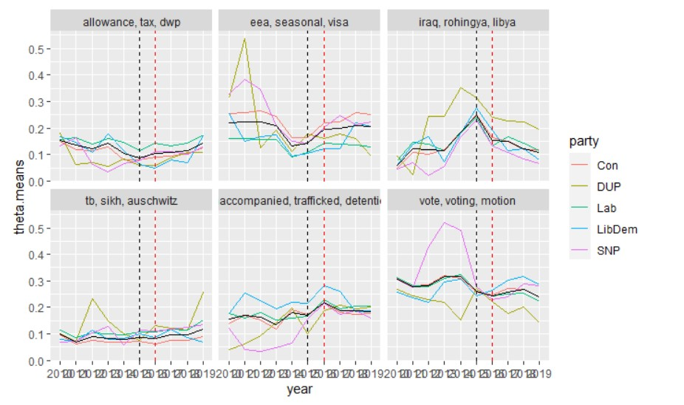

Next, we explore the prevalence of the topics by party over these ten years (2010-2020). In addition to showing party-specific trends in topical focus over time, this graph also shows that the topic coverage of parties converges in 2015 and 2016. Three explanations may shed light why we see this trend. The first relates to significant external developments that are relevant to UK national interests, such as the Syrian refugee crisis in Europe. As a result, certain topics related to migration enter the agenda as large-scale *national* issues that are relevant to all parties. Secondly, as usually occurs towards general election, all parties discuss broadly similar agenda points which are found in the core of the political discourse. Lastly, the Brexit referendum in 2016 drastically changed the context for many kinds of policies on a national level. This means that some topics of migration, such as economic migration, become important for the whole UK and all parties.

-topics-sentiment correlation

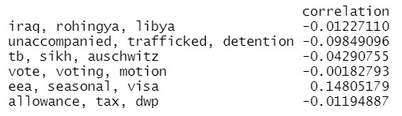

Another reason we apply a topic model to political debates on migration is to explore the general sentiments in parliament regarding these topics. To do this, we calculate the correlation of sentiment scores and topic scores for all documents in the subset. The result presents estimate of correlation between positive sentiment and each topic category. The topic of economic migration shows the strongest correlation with positive sentiment (0.148). This makes substantive sense, as many sectors of the UK economy benefit from migration. Discussion about economic migration in parliament would therefore enjoy a generally positive sentiment. In contrast, discussion related to the humanitarian concerns of migration show a strong, inverse correlated with positive sentiment (-0.098). This means that the increased prevalence of this topic in debate is paired with increasingly negative sentiment. Substantively speaking, this would indicate that members of parliament are generally concerned about the humanitarian risks of migration and wish to avoid or prevent them. The topic containing procedural vocabulary is correlated with neutral sentiment (-0.002). As these words contain no valuable content, this makes sense and affirms our understanding of these topic-sentiment correlation estimates. The topics of social welfare and refugees fleeing conflict both show slightly negative correlations with sentiment (both are -0.012), possibly indicating mixed stances on these topics in parliament that overall verge negative. While the topic titled “tb, sikh, Auschwitz” has a score of relatively strong negative sentiment correlation, it is difficult to make any conclusions on this because the topic is inconsistent and contains multiple subjects of debate.

Conclusions:

* What can we conclude from this?
* How does this answer our questions from our intro/framing? (What were they?)
* What are the challenges of interpreting sentiment (sentiment related to content, vs. sentiment related to attitudes towards specific content)? What are our recommendations for moving forward?

Reference

Grierson, J. (2020) https://www.theguardian.com/politics/2020/dec/15/post-brexit-key-worker-shortage-may-hamper-uk-economic-recovery

Heidenreich, T., Eberl, J. M., Lind, F., & Boomgaarden, H. (2020). Political migration discourses on social media: a comparative perspective on visibility and sentiment across political Facebook accounts in Europe. *Journal of Ethnic and Migration Studies*, *46*(7), 1261-1280.

Bara, J., Weale, A., & Bicquelet, A. (2007). Analysing parliamentary debate with computer assistance. *Swiss Political Science Review*, *13*(4), 577-605.

1. Sabsted, D. (2020, September 17). *Is Brexit Britain pro-immigration and what does it mean for business?* Relocate Global. <https://www.relocatemagazine.com/articles/enterprise-is-brexit-britain-pro-immigration-and-what-does-it-mean-for-business-dsapsted-au20>
2. <http://www.snsoroka.com/data-lexicoder/>
3. (Heidenreich et al., 2020) <https://www.tandfonline.com/doi/full/10.1080/1369183X.2019.1665990>
4. For example, in the months before January 2018, where there seem to be a decrease in debates, there were several holidays, including summer holiday, an external conference, November break and Christmas holiday. https://www.parliament.uk/about/faqs/house-of-commons-faqs/business-faq-page/recess-dates/list-of-previous-commons-recess-dates/
5. To give you an example, looking at the number of words on Dec 2011 indicates the monthly-average amount of words spend on immigration related debates during the second half of 2011.