304851504
Video Processing EX2 Solution
Section 1 – General Questions
1. The constant brightness constraint says that every point on an object in the real world always has the same brightness value regardless of the circumstances. When assuming this constraint we can compare the location of a real-world point in two images and determine the movement of this point between those frames. This assumption is not correct in the real world since there are light reflections that effect the brightness of every point in the real world and its brightness when looking from a certain direction.
2. Aperture problem – when looking on a small portion of moving object (looking from within a small hole) we can’t determine the exact direction of the movement of this object. Therefore, the object can move in many different directions that will look the same from the point of view of this small hole. We can mitigate the problem by analyzing the movement of an object by using aperture (windows) of different size or down sampling the image and use the analysis of different sampling rate images to determine the movement of the same scene.
3. To solve the optical flow problem, the Lucas-Kanade assumes that a neighborhood of a pixel moves in the same direction for all pixel.
4. Around object boundaries the Lucas-Kanade assumption is incorrect since there are moving pixels (of the object) and pixels of the surroundings which behave differently. Therefore, taking a small window around the object boundaries include pixels that not part of the moving object, and therefore moves differently.
5.To calculate the optical flow of the object’s boundaries we need to determine which pixel related to the object and which to its surroundings. Once we have that input, we can control the window size around of the Lucas Kanade algorithm around boundary pixels. Assume we are centered in pixel which is 2 pixels away from the boundary and we used 5X5 window, we can switch to a 3X3 window etc. if we are located at the last pixel of the object, we can take a one-sided window around it and neglect all pixels to the other side, assuming they are related to the surroundings and not the object itself.

Section 2 – 2.1 Optical Flow One Step
4. Results following the execution of the main_river.py script related to the one step Lukas Kande:
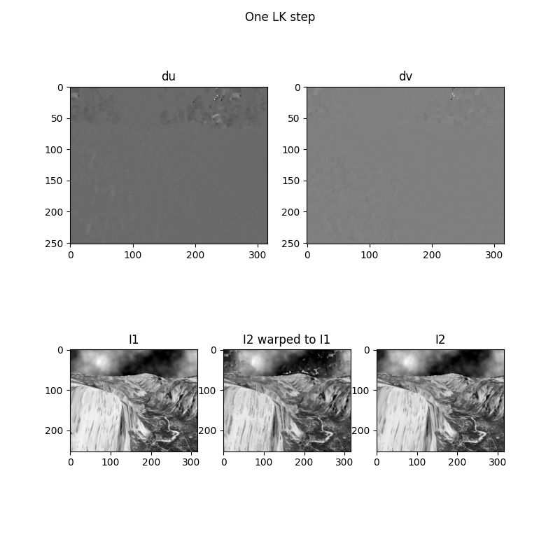

The du and dv images represent the estimated pixel displacements between I1 and I2, showing movement along the columns (x-axis) and rows (y-axis), respectively. In these visualizations, most areas appear gray, indicating little to no estimated motion variation—this is often due to uniform texture regions, where tracking precise motion is more difficult, leading to approximated or uncertain flow values.
A noticeable area of motion can be seen at the top of the du image, particularly around the dark cloud region. This area exhibits a clear shift to the right, reflecting the motion of the cloud between I1 and I2.
The warping of I2 to I1 has imperfect areas that can be seen as noise in some areas such as the cloud on the top of the image.
4.2. looking at the gifs it is shown that the result – I2 image warping is imperfect. A perfect result would be the same as the “1_original.gif”. In our results, most of the image is warped correctly – mostly the bottom part of the image. However, there are noisy regions showing as areas with different pixel color related to the objects color. It is the most visible in the area of the cloud, which supposed to be mainly dark but has noisy bright areas in the warped image.
Several factors could contribute to these imperfections:
1. The L-K algorithm is based on approximations such as considering only the first order Taylor approximation and not further orders.
2. The constant brightness assumption which might be correct most of the times but not always. This can be seen in the cloud’s region which as several types of grey and probably same scene point’s brightness is slightly different in I1 compared to I2 related to the cloud’s density.
3. The u,v calculation per window can have errors since this calculation can face singular matrix.
4. The L-K algorithm assumes that all the pixels in the window have the same optical flow, which not always correct.
All those points can cause imperfections.

