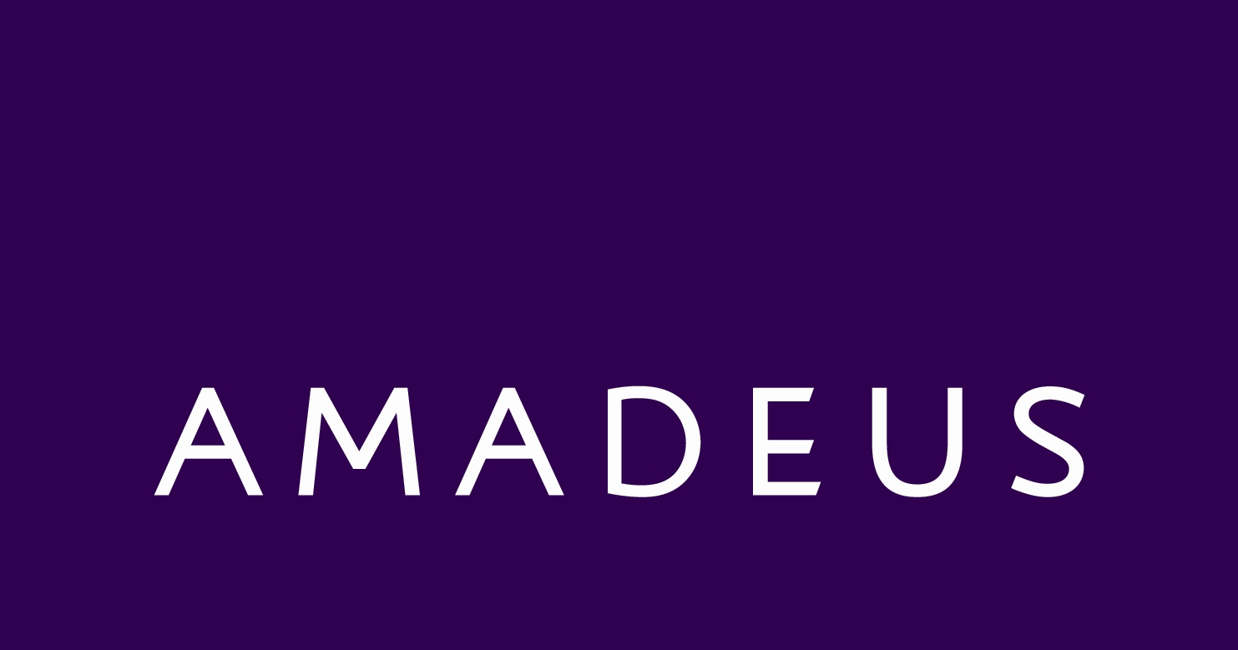



## The following frequently asked questions have been put together to assist local authorities prior to and during an inspection. The intention is to provide outline information with regards to the business their food safety management system and its practical application.

|  |  |
| --- | --- |
| Who are Amadeus? | Amadeus are a Trading Division of the NEC Group Ltd and provide the catering for all NEC Group home venues. This includes The National Exhibition Centre (NEC), LG Arena, International Convention Centre (ICC) and the National Indoor Arena (NIA). Amadeus also caters at External Fixed sites that include Cadburys World and Dudley Zoological gardens, as well as catering at a variety of external events at various venues and locations throughout the UK. The Amadeus Head office is based at the NEC Birmingham where all support departments are located.  Amadeus may also trade at venues as the ‘Oak Kitchen’ or ‘MADE’. |
| What provision is in place for the support of food safety to the outlets from head office? | Amadeus has a dedicated Food & Safety Support (FSS) team based centrally at the NEC. The team consists of a Senior Food & Safety Officer and a Food & Safety Officer dedicated to ensuring Amadeus comply with all current statutory obligations with regards to food safety and health & safety (H&S), this is also complimented by a wider NEC Group safety team.  All food businesses outlets are audited internally every 6 months to ensure compliance with all aspects of food safety and H&S. A pass rate of 80% is expected and 10% deductions are in place for non-conformances with statutory obligations. |
| What HACCP System would I expect to see on site? | The Food safety management/ HACCP system is an intranet based system with the focus on Catering Codes of Practice (CCOP). Supporting documentation on site will include “Daily Diaries” as well as goods received books. “Daily Daries” typically will contain opening checks, closing checks and temperature control recordings as well as cleaning records. A minimum requirement during any inspection would be that the manager for the area demonstrates how to access the system.  The intranet based system has been devised to ensure that it is fully interactive and easy to navigate. All venues will have a computer and up to date IT available and all members of the team will have access. The advantages of this type of system is that it remains live and kept up to date via head office. Communications for any changes or alerts are also sent out via the system. |
| What training is given to employees? | All employees, regardless of job role, will receive a minimum food safety awareness training based on an e-learning module that must be completed before they can start in position.  This training is also complimented by a full day induction where employees learn about the practical applications of food safety within our business including the taking of food temperatures and completion of daily diaries. Allergen awareness training is also completed via an e-learning module and again complimented at induction.  All employees in a supervisory role and higher will complete as a minimum level 3 food safety. As a business we have also invested in our executive chef team and trained up to level 4. |
| What control measures are in place for the control of and management of allergens? | Amadeus have invested heavily in a centralised IT system that enables the procurement team to load specifications including allergen information for all products, ingredients and component parts of recipes. These recipes are then created on the system.  A report is then generated for each area of the business and procedures trained as previously documented. |
| How are food complaints/ food poisoning allegations dealt with? | Within the intranet system, a purple tab has been created that will direct the employees to a food safety complaint questionnaire that should be completed whenever a complaint is made by a customer.  These forms are then forwarded straight to Amadeus FSS who investigate every complaint. |
| Does the sanitiser conform to  BS EN 1276:1997? | Yes, all sanitisers fully conform to BS EN 1276:1997 standard.  All chemicals are supplied via Zenith, no household products should be used on site |
| Is there a pest control management system in place? | A pest control management system will be in place for every venue.  Where Amadeus activities fall within a managed building often that building’s facilities management also manage pest control.  Pest control checks should be competed daily at all Amadeus venues and detail is contained within the “Daily Diary”. Where venue specific controls differ, details should be obtained on site and venue pest control folder should be available for inspection. |
| How does Amadeus apply the current E- coli approved code of practice to its businesses? | Amadeus have an E- coli CCOP which details all control procedures in place to prevent the risks posed by E- coli contamination. This CCOP has been devised with current Food Standards Agency guidance and existing controls within the FSMS. |
| How does Amadeus Manage its external and Event catering? | External events are expected to comply with the other Catering Codes of Practice for all control/storage/temperature control requirements. Food is delivered to the event safely and under temperature controlled conditions appropriate to the food being transported  **Pre event Planning**  The Food and Safety Support Team will inspect / audit most events.  **Design and Construction**  The stall, vehicle or temporary kitchen must be large enough for the type of catering being carried out (e.g. sufficient working surfaces for the separate preparation of raw and cooked products) so that cross contamination cannot occur.  All internal surfaces in a food preparation area must be washable and floors must have cleanable sheeting material over the structure.  **Pest Control**  Pest checks must be carried out daily before food production begins to ensure there is no evidence of a major pests infestation. These pest checks must be recorded in the” Daily Diary”. If a major problem is found at any point during the event, all contaminated food and food suspected to be contaminated must be discarded. All work surfaces and hand contact points must be sanitised before catering begins/re-commences. If catering within another managed building the venues pest control service would be asked to attend site. |