Generic Blank Game Design Document (GDD)

Your Game Logo

Here

***‘Catchy Game Tagline’*** - you

This page: Table of Contents and Team Member Listing

|  |  |  |
| --- | --- | --- |
| Table of Contents  [1 Game Overview](https://n-xovwktmtjsnaxyc2mwes2xu7pohqedmdm6zjw5q-2lu-script.googleusercontent.com/userCodeAppPanel)  [2 High Concept](https://n-xovwktmtjsnaxyc2mwes2xu7pohqedmdm6zjw5q-2lu-script.googleusercontent.com/userCodeAppPanel)  [3 Synopsis](https://n-xovwktmtjsnaxyc2mwes2xu7pohqedmdm6zjw5q-2lu-script.googleusercontent.com/userCodeAppPanel)  [4 Game Objectives](https://n-xovwktmtjsnaxyc2mwes2xu7pohqedmdm6zjw5q-2lu-script.googleusercontent.com/userCodeAppPanel)  [5 Game Rules](https://n-xovwktmtjsnaxyc2mwes2xu7pohqedmdm6zjw5q-2lu-script.googleusercontent.com/userCodeAppPanel)  [6 Game Play](https://n-xovwktmtjsnaxyc2mwes2xu7pohqedmdm6zjw5q-2lu-script.googleusercontent.com/userCodeAppPanel)  [6.1 Game Controls](https://n-xovwktmtjsnaxyc2mwes2xu7pohqedmdm6zjw5q-2lu-script.googleusercontent.com/userCodeAppPanel)  [6.2 Maps](https://n-xovwktmtjsnaxyc2mwes2xu7pohqedmdm6zjw5q-2lu-script.googleusercontent.com/userCodeAppPanel)  [7 Players](https://n-xovwktmtjsnaxyc2mwes2xu7pohqedmdm6zjw5q-2lu-script.googleusercontent.com/userCodeAppPanel)  [7.1 Characters](https://n-xovwktmtjsnaxyc2mwes2xu7pohqedmdm6zjw5q-2lu-script.googleusercontent.com/userCodeAppPanel)  [7.2 Metrics](https://n-xovwktmtjsnaxyc2mwes2xu7pohqedmdm6zjw5q-2lu-script.googleusercontent.com/userCodeAppPanel)  [7.3 States](https://n-xovwktmtjsnaxyc2mwes2xu7pohqedmdm6zjw5q-2lu-script.googleusercontent.com/userCodeAppPanel)  [7.4 Weapons](https://n-xovwktmtjsnaxyc2mwes2xu7pohqedmdm6zjw5q-2lu-script.googleusercontent.com/userCodeAppPanel)  [8 NPC](https://n-xovwktmtjsnaxyc2mwes2xu7pohqedmdm6zjw5q-2lu-script.googleusercontent.com/userCodeAppPanel)  [8.1 Enemies](https://n-xovwktmtjsnaxyc2mwes2xu7pohqedmdm6zjw5q-2lu-script.googleusercontent.com/userCodeAppPanel)  [8.1.1 Enemy States](https://n-xovwktmtjsnaxyc2mwes2xu7pohqedmdm6zjw5q-2lu-script.googleusercontent.com/userCodeAppPanel)  [8.1.2 Enemy Spawn Points](https://n-xovwktmtjsnaxyc2mwes2xu7pohqedmdm6zjw5q-2lu-script.googleusercontent.com/userCodeAppPanel)  [8.2 Allies / Companions](https://n-xovwktmtjsnaxyc2mwes2xu7pohqedmdm6zjw5q-2lu-script.googleusercontent.com/userCodeAppPanel)  [8.2.1 Ally States](https://n-xovwktmtjsnaxyc2mwes2xu7pohqedmdm6zjw5q-2lu-script.googleusercontent.com/userCodeAppPanel)  [8.2.2 Ally Spawn Points](https://n-xovwktmtjsnaxyc2mwes2xu7pohqedmdm6zjw5q-2lu-script.googleusercontent.com/userCodeAppPanel)  [9 Art](https://n-xovwktmtjsnaxyc2mwes2xu7pohqedmdm6zjw5q-2lu-script.googleusercontent.com/userCodeAppPanel)  [9.1 Setting](https://n-xovwktmtjsnaxyc2mwes2xu7pohqedmdm6zjw5q-2lu-script.googleusercontent.com/userCodeAppPanel)  [9.2 Level Design](https://n-xovwktmtjsnaxyc2mwes2xu7pohqedmdm6zjw5q-2lu-script.googleusercontent.com/userCodeAppPanel)  [9.3 Audio](https://n-xovwktmtjsnaxyc2mwes2xu7pohqedmdm6zjw5q-2lu-script.googleusercontent.com/userCodeAppPanel)  9.4 What you Developed   |  | | --- | |  | | Game Development Team Members    GAME DESIGNERS  Aaron Jensen  Thomas van Dyk  PROGRAMMERS  Aaron Jensen  Thomas van Dyk |
|  |  |

|  |
| --- |
|  |

# 1 Game Overview *

Title: Awesome Game Name

Platform: PC Standalone

Genre: Multiplayer Third Person Survival Shooter

Rating: (10+) ESRB

Target: Casual gamer

Release date: May, 2018

Publisher: San Diego State University

Description: Multiplayer Third person shooter where the player is placed in a town full of hostiles and must fight to survive. The player succeeds when all enemies are eliminated. The player can find different weapons and powerups around the town to assist with surviving the trial.

# 2 High Concept

This game plunges the players into a dangerous city where they must survive the onslaught. Make use of the scattered weapons and powerups to ensure your teams survival.

# 3 Synopsis

# 4 Game Objectives

The objective of the game is to destroy all enemies and survive.

# 5 Game Rules

The game level is an enclosed city where the player must evade the enemies and destroy them. The player has limited ammo and must move around to find more ammo. Different weapons and powerups can be found around the level that will help the player to survive.

# 6 Game Play

## 6.1 Game Controls

WASD controls movement. ENTER fires the weapon. SPACEBAR jumps. C crouches. LEFT SHIFT walks. ESC to return to menu from in game.

### 6.2 Maps

Single map, City setting

# 7 Players (optional)

## 7.1 Characters

Single Character that automatically spawns in at game start. Max 2 players.

## 7.2 Metrics

## 7.3 States

## 7.4 Weapons

# 8 NPC (optional)

## 8.1 Enemies

### 8.1.1 Enemy States

### 8.1.2 Enemy Spawn Points

## 8.2 Allies / Companions

### 8.2.1 Ally States

### 8.2.2 Ally Spawn Points

# 9 Art *

## 9.1 Setting

Hostile urban city somewhere in the world.

## 9.2 Level Design

Level is based in an urban setting. Major elements are buildings that the players and enemies can use for cover. Powerups, ammo, and weapons are scattered around the level. Players have set spawn locations. Enemies have set spawn locations.

Level 1:

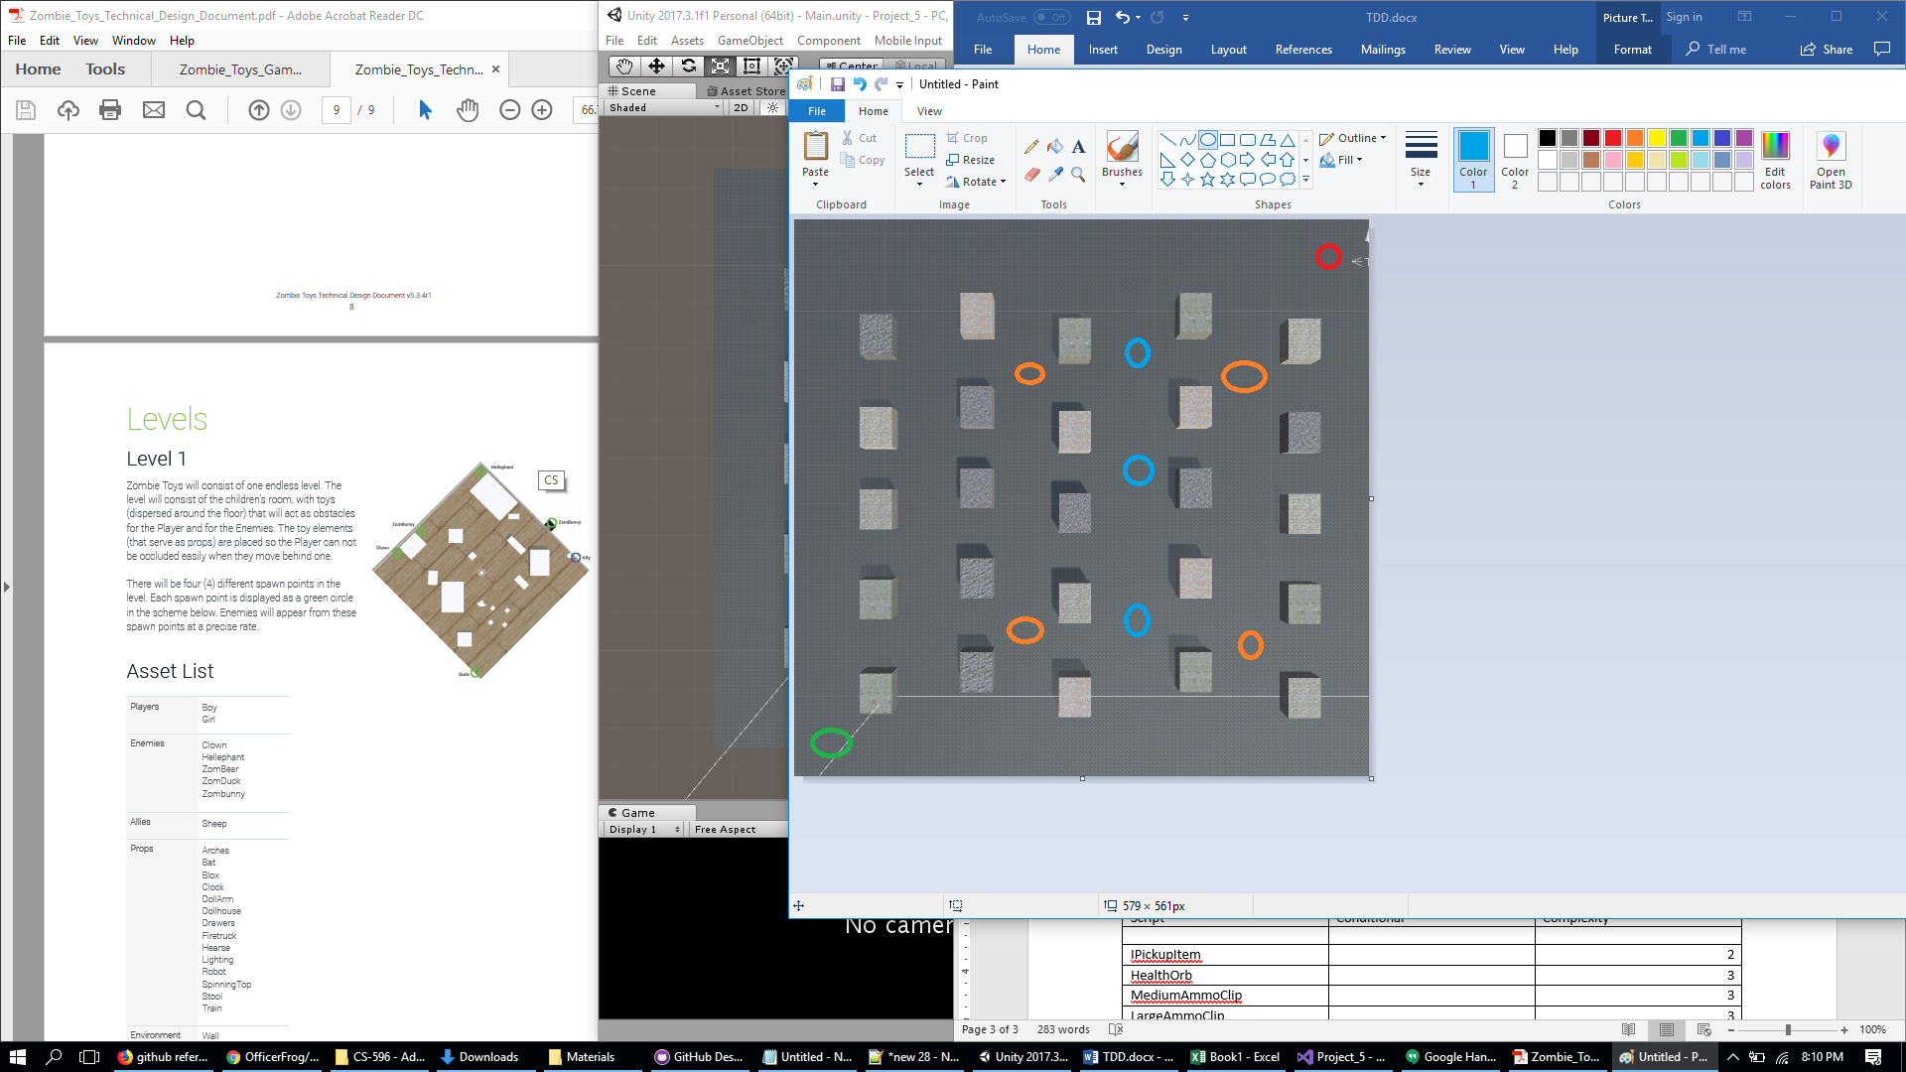

Green – Player spawn

Red – Enemy spawn

Orange – Ammo spawn

Blue – Health spawn

## 9.3 Audio

No audio implemented at this time.

9.4 What you Developed