Technical Design Document

**Contents**

Developers

Aaron Jensen

Thomas van Dyk

Game Overview

Technical Summary

Hardware

Software

Game Engine

Target Platform

Remote Collaboration

Level

Complexity Analysis

**Game Overview**

This is a third-person, multiplayer survival shooter game where the players are tasked with surviving against a group of enemies. Victory is achieved when all enemies are defeated. A player will lose if they are killed within battle. Ammo, Weapons, and powerups can be found scattered around the map to assist the players in completing the game.

**Technical Summary**

Two developers using the Unity game engine will complete development in approximately 2 months. The 3D assets will be acquired using the Unity asset store as there is no dedicated asset production member.

The game will be released for PC alone. The Minimum requirements are a stable internet connection and a computer with Windows OS.

**Hardware**

Development team is to use any available hardware that is already owned. Expected hardware is Windows PC and Mac.

**Software**

Unity Game engine for game development.

**Game Engine**

The Unity game engine will be used to meet the requirements set by Prof. Price and due to its ease of use in game development.

**Target Platform**

Windows will be the platform targeted.

**Remote Collaboration**

The members of the team do not have an office space to make use of so they will use github to maintain workflow. All changes are pushed to the github repository for the other members to pull and make changes to.

**Level 1**

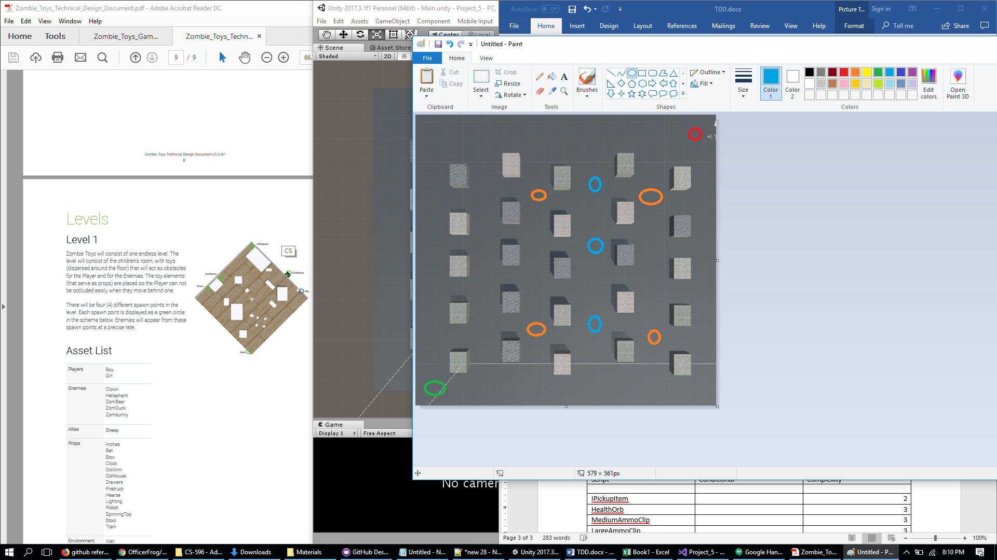

Green – Player spawn

Red – Enemy spawn

Orange – Ammo spawn

Blue – Health spawn

**Complexity Analysis**

|  |  |  |
| --- | --- | --- |
| **Script** | **Conditional** | **Complexity** |
| IPickupItem |  | 2 |
| HealthOrb |  | 3 |
| MediumAmmoClip |  | 3 |
| LargeAmmoClip |  | 3 |
| DismissibleObject |  | 5 |
| BasicPlayerController |  | 12 |
| PlayerController |  | 22 |
| EnemyController |  | 4 |
| Projectile |  | 8 |
| Bullet |  | 3 |
| Billboard |  | 2 |
| ButtonManager |  | 3 |
| EnemySpawner |  | 3 |
| Health |  | 11 |
| ObjectWIthExperience |  | 5 |