Ecopath with Ecosim version 6.0
User manual/help files guide
Version 1.0
12 September 2007
Authors: Villy Christensen, Carl J. Walters, Daniel Pauly and Robyn Forrest

1 Introduction 9
1.1 About Ecopath with Ecosim 9
1.2 On modelling 10
2 Introductory material: Ecopath 12
2.1 Mortality for a prey is consumption for a predator 12
2.2 The energy balance of a box 16
2.3 On the need for input parameters 17
2.4 Defining the system 18
2.5 Dealing with open system problems (species and fisheries that cross system boundaries) 19
2.6 Production 20
2.7 Consumption 21
2.8 Other mortality 23
2.9 Representation of multi-stanza life histories in Ecopath, Ecosim and Ecospace 24
3 Introductory material: Ecosim 28
3.1 An overview of Ecosim 28
3.2 Ecosim basic 28
3.3 Vulnerabilities in Ecosim 29
3.4 Dealing with dynamic instability in Ecosim/Ecospace 32
3.5 Predicting consumption 33
3.6 Foraging time and predation risk 34
3.7 Time series fitting in Ecosim: evaluating fisheries and environmental effects 35
3.8 Hints for fitting models to time series reference data 36
3.9 Effect of P/B (Z) and vulnerability for time series fitting 42
3.10 Predator satiation and handling time effects 44
3.11 Modeling switching behavior in Ecosim 46
3.12 Compensatory mechanisms 48
3.13 Using Ecosim to study compensation in recruitment relationships 49
3.14 Compensatory growth (overall P/B) 51
3.15 Compensatory natural mortality 51
3.16 Linking mediation and time forcing functions to trophic interaction rates 51
3.17 Primary production 53
3.18 Nutrient cycling and nutrient limitation in Ecosim 53
3.19 Density-dependent changes in catchability 55
3.20 Modelling effort dynamics 56
3.21 Using Ecosim for Stock Reduction Analysis 58
3.22 Hatchery populations in Ecosim 59
3.23 Parameter sensitivity 60
4 Introductory material: Ecospace 61
4.1 An overview of Ecospace 61
4.2 Representing seasonal migration in Ecospace 62
4.3 Advection in Ecospace 65
4.4 Fitness-driven dispersal behavior in Ecospace (by Bob Lessard) 67
4.5 Prediction of mixing rates 69
4.6 Predicting spatial fishing patterns 69
4.7 Numerical solutions 69
5 Ecopath with Ecosim 6: Getting started 71
5.1 How to obtain the Ecopath with Ecosim 6 software 71
5.2 Software support, copyright and liability 71
5.3 Installing and running Ecopath with Ecosim 71
5.4 Previous versions 71
5.5 Getting help 72
5.6 General features of the Graphic User Interface 72
5.7 File menu 76
5.8 View menu 77
5.9 Ecopath menu 77
5.10 Ecosim menu 78
5.11 Ecospace menu 78
5.12 Tools menu 78
5.13 Windows menu 80
5.14 Help menu 80
6 Using Ecopath. Part 1: Ecopath inputs 81
6.1 Introduction 81
6.2 Edit groups 81
6.3 Edit multi-stanza groups 83
6.4 Edit fleets 86
6.5 Ecopath input data 87
6.6 Basic input 87
6.7 Diet composition 90
6.8 Detritus fate 90
6.9 Other production 91
6.10 Fishery 92
6.11 Definition of fleets 92
6.12 Landings 93
6.13 Discards 94
6.14 Discard fate 94
6.15 Market price 94
6.16 Non-market price 95
7 Using Ecopath. Part 2: Parameterization and outputs 96
7.1 Notes on parameterizing an Ecopath model 96
7.2 Balancing a model 98
7.3 Basic estimates 102
7.4 Key indices 104
7.5 Mortalities 106
7.6 Mortality coefficients 107
7.7 Predation mortality 109
7.8 Consumption 110
7.9 Respiration 110
7.10 Niche overlap 112
7.11 Electivity 114
7.12 Search rates 114
7.13 Fishery 115
7.14 Tools 116
7.15 Flow diagram 116
7.16 EwE network analysis plugin 117
7.17 Trophic level decomposition 118
7.18 Summary of flow data 119
7.19 Flows and biomasses 120
7.20 Primary production required 121
7.21 Mixed trophic impact 123
7.22 Ascendancy 125
7.23 Flow from detritus 127
7.24 Cycles and pathways 127
7.25 Network analysis indices in Ecosim (by Sheila Heymans) 129
8 Using Ecosim. Part 1: Ecosim inputs 131
8.1 Getting started in Ecosim: The Ecosim menu 131
8.2 Ecosim parameters 133
8.3 Group info 134
8.4 Vulnerabilities (flow control: foraging arena parameter) 135
8.5 Time series 137
8.6 Import time series 141
8.7 Mediation 142
8.8 Apply mediation 148
8.9 Forcing function 150
8.10 Apply forcing function (consumer) 153
8.11 Apply forcing function (primary producer) 156
8.12 Egg production 156
8.13 Apply egg production 159
8.14 Fleet size dynamics 160
9 Ecosim. Part 2: Ecosim outputs 163
9.1 An Ecosim exercise 163
9.2 Biomass 164
9.3 Plots 168
9.4 Stock recruitment (S/R) plot (multi-stanza groups only) 171
9.5 Monte Carlo runs 172
9.6 Fishing policy search 176
9.7 Implementing policy optimization in Ecosim 179
9.8 Maximize portfolio utility (maximizing risk-averse log utility for economic and existence values) 185
9.9 Fit to time series 187
9.10 Equilibrium analysis 191
10 Ecospace. Part 1: Ecospace inputs 194
10.1 Getting started in Ecospace: The Ecospace menu 194
10.2 Ecospace parameters 196
10.3 Define Ecospace habitats 197
Figure 10.5 200
10.4 Basemap 200
10.5 Assign habitats 203
10.6 Dispersal 204
10.7 Ecospace fishery 207
11 Ecospace. Part 2: Ecospace outputs 209
11.1 Run Ecospace 209
12 Capabilities and limitations 212
13 Major Pitfalls in the Application of EwE 222
14 ACKNOWLEDGEMENTS 225
15 REFERENCES 225

ABSTRACT
Ecopath with Ecosim is designed for straightforward construction, parameterization and analysis of mass-balance trophic models of aquatic and terrestrial ecosystems. Focus is on using the models for fisheries management, and a suite of tools are included for this aim. This help system describes how to obtain, install and use the Ecopath software system written for personal computers using the Windows environment. Brief accounts are given of the theory behind the models developed using Ecopath with Ecosim.
The Ecopath mass-balance modeling system is built on an approach initially presented by J.J. Polovina for estimating biomass and food consumption of the elements (species or groups of species) of an aquatic ecosystem. Subsequently it was combined with various approaches from theoretical ecology, notably those proposed by R.E. Ulanowicz, for the analysis of flows between the elements of ecosystems. However, the system has been optimized for direct use in fisheries assessment as well as for addressing environmental questions through the inclusion of the temporal dynamic model, Ecosim, and the spatial dynamic model, Ecospace.
Since its initial development in the early 1980s, the mass-balance approach incorporated in the Ecopath software has been widely used for constructing food web models of marine and other ecosystems. This has led to a number of generalizations on the structure and functioning of such ecosystems, relevant to the issue of fisheries impacts. Some of these generalizations have revisited older themes, while others were new. Both sets of generalizations have impacted on the development of the Ecopath approach itself. Herein, the description of the average state of an ecosystem, using Ecopath proper, also serves to parameterize systems of coupled difference and differential equations, used to depict changes in biomasses and trophic interactions in time (Ecosim) and space (Ecospace).
The results of these simulations can then be used to modify the initial Ecopath parameterization, and the simulations rerun until external validation is achieved. This reconceptualization of the Ecopath approach as an iterative process, which helps address issues of structural uncertainty, does not, however, markedly increase its input requirements. Rather, it has become possible, through a semi-Bayesian resampling routine to explicitly consider the numerical uncertainty associated with these inputs.
Real ecosystems are more complicated than the mass-balance fluxes of biomass in Ecopath, however large the number of functional groups we include in our models. Real ecosystems also have dynamics far more complex than represented in Ecosim. The issue to consider, when evaluating the realism of simulation software, is, however, not how complex the software and the processes are that are represented therein. Rather, the question is which structure allows a representation of the basic features of an ecosystem, given a limited amount of inputs. On such criterion, it was obvious that a major deficiency of the Ecopath with Ecosim approach was its assumption of homogenous spatial behavior. This has been remedied through the development of Ecospace (Note that in Walters et al., 1999 Equation 13, the sign for the T' factor was reversed by mistake.), a dynamic, spatial version of Ecopath, incorporating all key elements of Ecosim.
The Ecopath with Ecosim software has been distributed to more than 3000 registered users in 124 countries, and more than 200 publications utilizing it have appeared in the scientific literature. See www.ecopath.org for an update.

Introduction

About Ecopath with Ecosim
EwE is an ecological software suite for personal computers that has been under development for more than a decade. The development is now centered at the University of British Columbia’s Fishery Centre, while applications are widespread throughout the world. The software has more than 2500 registered users in 124 countries, and more than two hundred publications based on the software have appeared, see www.ecopath.org. The approach is thoroughly documented in the scientific literature, and key references are mentioned below. EwE has three main components: Ecopath – a static, mass-balanced snapshot of the system; Ecosim – a time dynamic simulation module for policy exploration; and Ecospace – a spatial and temporal dynamic module primarily designed for exploring impact and placement of protected areas. The Ecopath software package can be used to
- Address ecological questions;
- Evaluate ecosystem effects of fishing;
- Explore management policy options;
- Evaluate impact and placement of marine protected areas;
- Evaluate effect of environmental changes.
The foundation of the EwE suite is an Ecopath model (Christensen and Pauly, 1992; Pauly et al., 2000), which creates a static mass-balanced snapshot of the resources in an ecosystem and their interactions, represented by trophically linked biomass ‘pools’. The biomass pools consist of a single species, or species groups representing ecological guilds. Pools may be further split into ontogenetic linked groups; a group may as an example be split in larvae, juvenile, age 1-2, and spawners (age 3+). Ecopath data requirements are relatively simple, and generally already available from stock assessment, ecological studies, or the literature: biomass estimates, total mortality estimates, consumption estimates, diet compositions, and fishery catches.
The process of constructing an Ecopath model provides a valuable end product in itself through explicit synthesis of work from many researchers. Several EwE models illustrate this, e.g., for the Prince William Sound (Okey and Pauly, 1998; 1999), the Strait of Georgia (Pauly et al., 1998b) and several North Atlantic models created as part of the Sea Around Us project activities at the UBC Fisheries Centre, (Guénette and Diallo, 2002). The model construction process has brought together scientists, researchers and data from state and federal levels of government, international research organizations, universities, public interest groups and private contractors. Key results include the identification of data gaps as well as common goals between collaborating parties that previously were hidden or less obvious. We find the process especially important for enabling the interest groups to take ownership of the model that is derived; this is especially required when operating at the ecosystem level, where multi-faceted policy goals have to be discussed widely as part of the management process. This is facilitated by the policy exploration methods included in the Ecosim model discussed further below.

On modelling
The word ‘model’ has several meanings; for scientists, and more specifically for biologists working at the ecosystem level, ‘models’ may be defined as consistent descriptions, emphasizing certain aspects of the system investigated, as required to understand their function.
Thus, models may consist of a text (‘word models’) or a graph showing the interrelationships of various components of a system. Models may also consist of equations, whose parameters describe ‘states’ (the elements included in the models) and ‘rates’ (of growth, mortality, food consumption, etc.), of the elements of the model. The behavior of mathematical models is difficult (often impossible) to explore without computers. This is especially the case for ‘simulation models’, i.e., those representations of ecosystems that follow, through time, the interactive behavior of the (major) components of an ecosystem.
Traditional simulation models are difficult to build, and even more difficult to get to realistically simulate, without ‘crashing’, the behavior of a system over a long period of time. This is one reason why many biologists shied away from constructing such models, or even interacting with ‘modelers’ (who, traditionally being non-biologists, may have had scant knowledge of the intricate interactions between living organisms). However, ‘modeling’ does not necessarily imply ‘simulation modeling’. There are various ways of constructing quantitative models of ecosystems which avoid the intricacies of traditional simulation modeling, yet still give most of the benefits that can be expected from such exercise viz:
- requiring the biologist/ecologist to review and standardize all available data on a given ecosystem, and identify information gaps;
- requiring the would-be modeler to identify estimates (of states, or rates) that are mutually incompatible, and which would prevent the system from functioning (e.g., the production of a prey being lower than the food requirements of its predators);
- requiring the same would-be modeler to interact with disciplines other than her/his own, e.g., a plankton specialist will in order to model a lake ecosystem have to either cooperate with fish biologists and other colleagues working on the various consumer groups in the lake, or at least read the literature they produced.
To avail oneself of these and other related advantages, one's models should be limited to describing the situation prevailing during a certain ‘average’ period. This limitation is not as constraining as it may appear at first sight. It is consistent with the work of most aquatic biologists, whose state and rate estimates represent ‘averages’, applying to a certain period (although this generally is not stated). It is also consistent with the practice common in traditional simulation modeling of using the mass-balance assumption to estimate the parameters of simulation model. This justifies the approach proposed here, to use state and rate estimates for single species in a multispecies context for describing trophic flows in ecosystems in rigorous, quantitative terms, during the (arbitrary) period to which their state and rate estimates apply.
In many cases, the period considered will be a typical season, or a typical year, but the state and rate estimates used for model construction may pertain to different years. Models may represent a decade or more, during which little changes have occurred. When ecosystems have undergone massive changes, two or more models may be needed, representing the ecosystem before, (during), and after the changes. This can be illustrated by an array of models of the Peruvian upwelling ecosystem representing periods before and after the collapse of the anchoveta fishing there (Jarre et al., 1991a). Several other examples for this may be found in Christensen and Pauly (1993b).
When it is seasonal changes which must be emphasized, different models may be constructed for each month, season, or for extreme situations (‘summer’ vs. ‘winter’). As an example Baird and Ulanowicz (1989) constructed four models describing the seasons in Chesapeake Bay, and an ‘average’ model to represent the whole year. The same idea can be applied to aquaculture situations, where a pond and its producers and consumers can be described for instance at the beginning, midpoint, and end of a growing season. Examples of this can be found in Christensen and Pauly (1993b).
Judicious identification of periods long enough for sufficient data to be available, but short enough for massive changes of biomass not to have occurred, will thus solve most problems associated with the lack of an explicit time dimension. Moreover, when a build-up of biomass is known to have occurred, this can be considered explicitly as ‘accumulated biomass’, a component of biological production.
The Ecopath system is built on an approach presented by Polovina (1984a; 1984b) for the estimation of the biomass and food consumption of the various elements (species or groups of species) of an aquatic ecosystem, and subsequently combined with various approaches from theoretical ecology, notably those proposed by R.E. Ulanowicz (1986), for the analysis of flows between the elements of ecosystems.
Once a model of the type discussed here has been built, it can be used directly for simulation modeling thanks to the time dynamic model, Ecosim, and the spatial dynamic model, Ecospace, both fully integrated with Ecopath in the present software.

Introductory material: Ecopath

Mortality for a prey is consumption for a predator
The core routine of Ecopath is derived from the Ecopath program of Polovina (1984a; 1984b) modified to render superfluous its original assumption of steady state. Ecopath no longer assumes steady state but instead bases the parameterization on an assumption of mass balance over an arbitrary period, usually a year (but also see discussion about seasonal modeling). In its present implementation Ecopath parameterizes models based on two master equations, one to describe the production term and one for the energy balance of each group.
The first Ecopath equation describes how the production term for each group (i) can be split in components. This is implemented with the equation,
Production = catches + predation mortality + biomass accumulation + net migration + other mortality Eq. 1
or, more formally,
Eq. 2
where P_{i} is the total production rate of (i), Y_{i} is the total fishery catch rate of (i), M2_{i} is the total predation rate for group (i), B_{i} the biomass of the group, E _{i} the net migration rate (emigration – immigration), BA _{i} is the biomass accumulation rate for (i), while M0_{i} = P_{i} · (1-EE_{i}) is the ‘other mortality’ rate for (i).
This formulation incorporates most of the production (or mortality) components in common use, perhaps with the exception of gonadal products. Gonadal products however nearly always end up being eaten by other groups, and can be included in either predation or other mortality.
Eq. 2 can be re-expressed as
Eq. 3
or
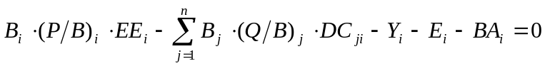 Eq. 4
where: 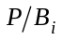 is the production/biomass ratio, 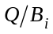 is the consumption / biomass ratio, and 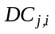 is the fraction of prey (i) in the average diet of predator (j).
Based on Eq. 3, for a system with n groups, n linear equations can be given, in explicit terms,
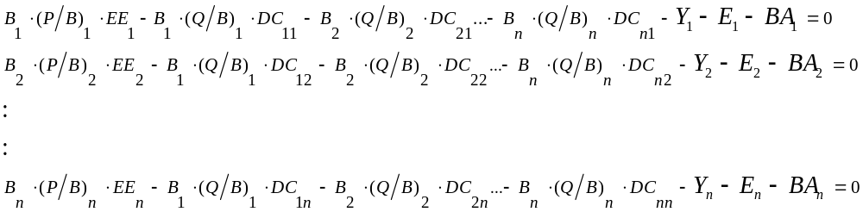Eq. 5
This system of simultaneous linear equations can be re-expressed
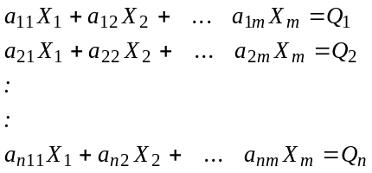 Eq. 6
with n being equal to the number of equations, and m to the number of unknowns.
This can be written in matrix notation as
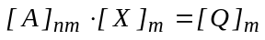 Eq. 7
Given the inverse A⁻¹ of the matrix A, this provides
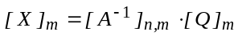 Eq. 8
If the determinant of a matrix is zero, or if the matrix is not square, it has no ordinary inverse. However, a generalized inverse can be found in most cases (Mackay, 1981). In the Ecopath model, the approach of Mackay (1981) is used to estimate the generalized inverse.
If the set of equations is over-determined (more equations than unknowns), and the equations are not consistent with each other, the generalized inverse method provides least squares estimates, which minimizes the discrepancies. If, on the other hand, the system is underdetermined (more unknowns than equations), an answer that is consistent with the data will still be output. However, it will not be a unique answer.
Of the terms Eq. 3 the production rate, P_{i}, is calculated as the product of B_{i}, the biomass of (i) and P_{i}/B_{i}, the production/biomass ratio for group (i). The P_{i}/B_{i} rate under most conditions corresponds to the total mortality rate, Z, see Allen (1971), commonly estimated as part of fishery stock assessments. The ‘other mortality’ is a catch-all term including all mortality not elsewhere included, e.g., mortality due to diseases or old age, and is internally computed from,
M0_{i} = P_{i} · (1 – EE_{i}) Eq. 9
where EE_{i} is called the ‘ecotrophic efficiency’ of (i), and can be described as the proportion of the production that is utilized in the system. The production term describing predation mortality, M2, serves to link predators and prey as,
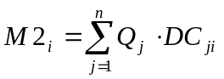 Eq. 10
where the summation is over all (n) predator groups (j) feeding on group (i), Q_{j} is the total consumption rate for group (j), and DC_{ji} is the fraction of predator (j)’s diet contributed by prey (i). Q_{j} is calculated as the product of B_{j}, the biomass of group (j) and Q_{j}/B_{j}, the consumption/biomass ratio for group (j).
An important implication of the equation above is that information about predator consumption rates and diets concerning a given prey can be used to estimate the predation mortality term for the group, or, alternatively, that if the predation mortality for a given prey is known the equation can be used to estimate the consumption rates for one or more predators instead.
For parameterization Ecopath sets up a system with (at least in principle) as many linear equations as there are groups in a system, and it solves the set for one of the following parameters for each group:
- Biomass;
- Production/biomass ratio;
- Consumption/biomass ratio; or
- Ecotrophic efficiency.
If, and only if, all four of these parameters are entered, the program will prompt you during basic parameterization whether to estimate the biomass accumulation, or, alternatively, to estimate the net migration rate. If a positive response is given, the program will use all the four basic parameters and it will establish mass-balance by calculating one of the two other parameters. If only three of the basic parameters are entered the following parameters must be entered for all groups:
- Catch rate;
- Net migration rate;
- Biomass accumulation rate;
- Assimilation rate; and
- Diet compositions.
It was indicated above that Ecopath does not rely on solving a full set of linear equations, i.e., there may be less equations than there are groups in the system. This is due to a number of algorithms included in the parameterization routine that will try to estimate iteratively as many ‘missing’ parameters as possible before setting up the set of linear equations. The following loop is carried out until no additional parameters can be estimated.
The gross food conversion efficiency, g_{i}, is estimated using
g_{i}= (P_{i}/B_{i}) / (Q_{i}/B_{i}) Eq. 11
while P_{i}/B_{i} and Q_{i}/B_{i} are attempted solved by inverting the same equation. The P/B ratio is then estimated (if possible) from

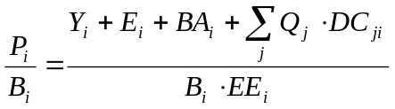 Eq. 12
This expression can be solved if both the catch, biomass and ecotrophic efficiency of group i, and the biomasses and consumption rates of all predators on group i are known (including group i if a zero order cycle, i.e., ‘cannibalism’ exists). The catch, net migration and biomass accumulation rates are required input, and hence always known;
The EE is sought estimated from
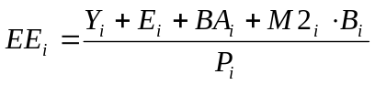, Eq. 13
where the predation mortality M2 is estimated from Eq. 10.
In cases where all input parameters have been estimated for all prey for a given predator group it is possible to estimate both the biomass and consumption/biomass ratio for such a predator. The details of this are described in Appendix 4, Algorithm 3.
If for a group the total predation can be estimated it is possible to calculate the biomass for the group as described in detail in Appendix 4, Algorithm 4.
In cases where for a given predator j the P/B, B, and EE are known for all prey, and where all predation on these prey apart from that caused by predator j is known the B or Q/B for the predator may be estimated directly.
In cases where for a given prey the P/B, B, EE are known and where the only unknown predation is due to one predator whose B or Q/B is unknown, it may be possible to estimate the B or Q/B of the prey in question.
After the loop no longer results in estimate of any ‘missing’ parameters a set of linear equations is set up including the groups for which parameters are still ‘missing’. The set of linear equations is then solved using a generalized inverse method for matrix inversion described by Mackay (1981). It is usually possible to estimate P/B and EE values for groups without resorting to including such groups in the set of linear equations.
The loop above serves to minimize the computations associated with establishing mass-balance in Ecopath. The desired situation is, however, that the biomasses, production/biomass and consumption/biomass ratios are entered for all groups and that only the ecotrophic efficiency is estimated, given that no procedure exists for its field estimation.

The energy balance of a box
A group (box) in an Ecopath model may be a group of (ecologically) related species, a single species, or a single size/age group of a given species. See Defining the system for more about defining groups.
In a model, the energy input and output of all living groups must be balanced. The basic Ecopath Eq. 1 includes only the production of a box. Here production equals predation + catches + net migration + accumulated biomass + other mortality. When balancing the energy balance of a box, other flows should be considered. After the ‘missing’ parameters have been estimated so as to ensure mass balance between groups energy balance is ensured within each group using the equation
Consumption = production + respiration + unassimilated food Eq. 14
This equation is in line with Winberg (1956) who defined consumption as the sum of somatic and gonadal growth, metabolic costs and waste products. The main differences are that Winberg (along with many other bioenergeticists, see Ney, 1990) focused on measuring growth, where we focus on estimating losses, and that the Ecopath formulation does not explicitly include gonadal growth. The Ecopath equation treats this as included in the predation term (where nearly all gonadal products end up in any case).
We have chosen to perform the energy balance so as to estimate respiration from the difference between consumption and the production and unassimilated food terms. This mainly reflects our focus on application for fisheries analysis, where respiration rarely is measured while the other terms are more readily available. To facilitate computations we have, however, included a routine (‘alternative input’) where the energy balance can be estimated using any given combination (including ratios) of the terms in the equation above.
Ecopath can work with energy - as well as with nutrient-related currencies (while Ecosim and Ecospace only work with energy related currencies). If a nutrient based currency is used in Ecopath, the respiration term is excluded from the above equation, and the unassimilated food term is estimated as the difference between consumption and production.
From Eq. 14 respiration can be estimated as a difference, and replace another parameter in model construction (see Help System, Appendix 4, algorithm 9). If the model currency is a nutrient, there is no respiration, and the proportion of food that is not assimilated will be higher.
The mass balance constraint implemented in the two master equations of Ecopath (Eq. 1and Eq. 14) should not be seen as questionable assumptions but rather as filters for mutually incompatible estimates of flow. One gathers all possible information about the components of an ecosystem, of their exploitation and interaction and passes them through the ‘mass balance filter’ of Ecopath. The result is a possible picture of the energetic flows, the biomasses and their utilization. The more information used in the process and the more reliable the information, the more constrained and realistic the outcome will be.

On the need for input parameters
Not all parameters used to construct a model need to be entered. The Ecopath model ‘links’ the production of each group with the consumption of all groups, and uses the linkages to estimate missing parameters, based on the mass-balance requirement of equation (1) that production from any of the groups has to end somewhere else in the system. This can be expressed, where there is not accumulation of biomass as
Production = Catch + biomass accumulation + predation mortality + net migration + other mortality
where the predation mortality term is the parameter that links the groups with each other. Ecopath balances the system using one production equation for each group in the system. For a system with three groups three production equations like the one above are used, i.e.,
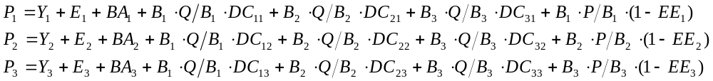 Eq. 15
where, 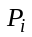is the total production of group i; Y_{i} is the catches of group i, E_{i} is the net migration of i, and BA_{i} the biomass accumulation. 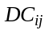 is the proportion of the diet predator group i obtains from prey group j. 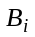 is the biomass of group i; 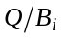 is the consumption/biomass ratio of group i. 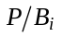 is the production/biomass ratio of group i; 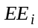 is the ecotrophic efficiency, i.e. (1 - other mortality), of group i.
Y_{i}, E_{i}, BA_{i}, and must always be entered, while entry is optional for any of the other four parameters (,,,). The above set of linear equations can be solved even if, for any of the groups, one or more of these four parameters is/are unknown (see below). It is not necessary that the same parameter is unknown for all groups, as the program can handle any combination of unknowns. The algorithms involved in the estimation of missing parameters are described in detail in Appendix 4 in the Help system. A number of algorithms have been incorporated, to estimate more than one missing parameter for each group, which takes advantage of the fact that most entries in the diet composition matrix will be zero. In some cases it may thus be possible to estimate the value of Q/B in addition to i, P/B, or EE of a group.
However, it is generally not possible to estimate the biomasses or P/B of apex predators from which there is no exports, or more specifically no fishery catches. Moreover, if too many input parameters are missing when estimating the basic parameters, a message to this effect will be displayed and the program will be aborted. In such cases, the data set will need to be complemented with additional inputs.

Defining the system
The ecosystems that can be modeled using Ecopath can be of nearly any kind: the modeler sets the limits. However, each system should be defined such that the interactions within add up to a larger flow than the interactions between it and the adjacent system(s). In practice, this means that the import to and export from a system should not exceed the sum of the transfer between the groups of the system. If necessary, one or more groups originally left outside the system should be included in order to achieve this.
The groups of a system may be (ecologically or taxonomically) related species, single species, or size/age groups, i.e., they must correspond to what is generally known as ‘functional groups’. Using single species as the basic units has clear advantages, especially as one then can use estimated or published consumption and mortality rates without having to average between species. On the other hand, averaging is straightforward and should lead to unbiased estimates if one has information on all the components of the group. The input parameters of the combined groups should simply be the means of the component parameters, weighted by the relative biomass of the components. Often one does not, however, have all the data needed for weighting the means. In such cases, try to aggregate species that have similar sizes, growth and mortality rates, and which have similar diet compositions.
A procedure has been incorporated in FishBase (www.fishbase.org) which assembles, for any country, a list of the freshwater and marine fish occurring in different habitat types, and other information useful for Ecopath models (maximum size, growth parameters, diet compositions, etc.)
For tropical applications, grouping of species is nearly always needed: there are simply too many species for a single-species approach to be appropriate for more than a few important populations. It is difficult to provide specific guidelines on how to make the groupings, as this may differ among ecosystems. Generally however, one should considers the whole ecosystem, e.g., for an aquatic model, one or two types of detritus (e.g., one to include mainly marine snow, the other discarded bycatch, if any), phytoplankton, benthic producers, herbivorous and carnivorous zooplankton, meio- and macrobenthos, herbivorous fish, planktivorous fish, predatory fish, etc., and that at least 12 groups are included, including the fishery (any number of fleets/gears), if any. But most important is the personal judgment of what is appropriate for your system.
Special consideration needs to be given to the bacteria associated with the detritus. One option, applicable in cases where no special emphasis needs to be given to bacterial biomass, production and respiration, is to disregard the flows associated with these processes, which are, in any case, hard to estimate reliably (see contributions in Moriarty and Pullin, 1987), and which tend to completely overshadow the other flows in a system. (In such cases, one assumes that the bacteria belong to a different, adjacent ecosystem linked to yours only through detritus export). Alternatively, bacteria can be attached to one or all of the detritus boxes included in a system. To do this, create a ‘box’ for the bacteria, and have them feed on one or several of the detritus boxes. (This is required because detritus, in the Ecopath model is assumed not to respire). Consider, finally, that there is no point including bacteria in your model if nothing feeds on them.
For an overview of the ecosystem concept in ecology, we suggest that you consult the book by Golley (1993).

Dealing with open system problems (species and fisheries that cross system boundaries)
For almost every defined Ecopath study area, there will be some species that have life cycles that take them outside the defined area for at least part of each year. Movements (exchange) of biomass across the area boundary can be of two types: dispersal, involving unidirectional movement of organisms to and from sink and source populations outside the study area; and migration, involving regular, repeated movements into and out of the area by the same individuals. These are fundamentally different processes, with very different policy consequences. Dispersal acts as an extra mortality-agent and recruitment-source independent of fisheries and other impacts in the study area, while migration exposes organisms from the study area to particular risks and opportunities for part of the time, without acting as a ‘permanent’ drain or source of those organisms.
Dispersal can be represented in both Ecopath and Ecosim by setting immigration and emigration rates in the Other production form in Ecopath. These rates are used in the Ecopath mass balance and are treated in Ecosim as unidirectional (non-migratory) dispersal rates. True migration is more complex to deal with, and Ecosim will give misleading answers if migration is represented only by immigration/emigration rates from Ecopath.
There are two broad options for dealing with directed migration to and from the Ecopath study area so as to avoid misleading predictions in Ecosim:
- The ‘diet import’ approach: for species that migrate to/from the study area for part of each year, include all fisheries/catches that impact the species, independent of whether these are taken within the study area. In the Diet composition form, set the diet import proportion to the proportion of time spent outside the system, and set remaining diet proportions to the diet proportions while in the system times the proportion of time spent in the system. Using this convention, Ecosim then will allow policy exploration of all fisheries that may impact the migratory species, and will treat the food intake rate (per biomass) as constant over time for the time spent feeding outside the system. Ecopath and Ecosim will ‘automatically’ account for reductions in prey impacts caused by the species for the proportion of time that the species spends feeding in outside areas. Note that the list of fisheries impacting migratory species can involve splitting fleets into ‘inside’ and ‘outside’ fishing components (which can be varied or ‘managed’ separately in Ecosim), to represent possible policy changes in where/when the migratory fish are harvested.
- The ‘model expansion’ approach: If it is considered unsafe to assume that food consumption rates obtained while outside the system (by migratory species) will remain constant in the future, then Ecosim must be provided information on possible changes in food organism populations in those outside areas. That is, the outside areas must be ‘internalized’ as part of the modeled system, by adding functional groups representing the outside food web structure. Often, adding such groups may simply mean replicating the initial Ecopath group structure, with the second set of groups labeled ‘outside species X’ and with diet matrix entries set so that the added groups feed on one another but not on the ‘inside’ groups.
A good modeling tactic is to try both approaches and see whether they give different answers. However, note that the first approach can lead to misleading answers upon entry to Ecospace, if the Ecospace mapped area includes the ‘outside’ system: in that case, the model will continue to ‘import’ part of the diet and food consumption of migratory species. Thus when the model development plan includes use of Ecospace to represent a larger spatial system, the functional group organization for that larger system needs to be included in the initial Ecopath/Ecosim model definition (approach 2).
It is possible to incorporate migration in Ecospace by defining which groups migrate and where their concentration is by month, see ‘Representing seasonal migration in Ecospace’ on page 62 for further information.

Production
Production refers to the elaboration of tissue (whether it survives or not) by a group over the period considered, expressed in whatever currency has been selected. Total mortality, under the condition assumed for the construction of mass-balance models, equal to production over biomass (Allen, 1971). Therefore, one can use estimates of total mortality (Z) as input values for the production over biomass ratio (P/B) in Ecopath models. Some examples of how to obtain P/B values is given below.
Even if the parameter is labeled ‘production/biomass’ in EwE, what should be entered is actually the mortality rate. An example, if you have a juvenile group and use a bioenergetic model to calculate the production, you should subtract the amount that is recruited to the adult group from the production in order to the actual mortality, which is what Ecosim needs to work with. Production over biomass is entered on the Basic input form. See Mortality coefficients and Predation mortality for description of Ecopath’s estimates of different mortality components in the system.
Total mortality catch curves
Total mortalities can be estimated from catch curves, i.e., from catch composition data, either in terms of age-structured catch curves; (Robson and Chapman, 1961), or of length-converted catch curves (Pauly et al., 1995). The estimation can be carried out using appropriate software for analysis, such as the FiSAT package (Gayanilo et al., 1996).
Total mortality from sum of components
Production rate is the sum of natural mortality (M = M0 + M2) and fishing mortality (F), i.e., Z = M + F. In the absence of catch-at-age data from an unexploited population, natural mortality for finfish can be estimated from an empirical relationship (Pauly, 1980) linking M, two parameters of the von Bertalanffy Growth Function (VBGF) and mean environmental temperature, i.e.,

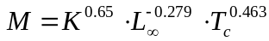 Eq. 16
where, M is the natural mortality (/year), K is the curvature parameter of the VBGF (/year), Loo is the asymptotic length (total length, cm), and Tc is the mean habitat (water) temperature, in °C .
In equilibrium situations, fishing mortality can be estimated directly from the catch (or more precisely from the ‘yield’, which expresses catches (including discards) in weight):
Fishing mortality = yield / biomass
where the yield is a rate, (e.g., t/km²/year), the biomass lacks a time dimension, (i.e., is expressed as t/km²), and thus the fishing mortality is an instantaneous rate, (e.g., per year).
Total mortality from average length
Beverton and Holt (1957) showed that total mortality (Z = P/B), in fish population whose individuals grow according to the von Bertalanffy Growth Function (VBGF), can be expressed by:
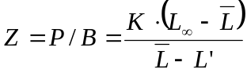
where L_{oo} is the asymptotic length, i.e., the mean size the individuals in the population would reach if they were to live and grow indefinitely, K is the VBGF curvature parameter (expressing the rate at which L_{oo} is approached), is the mean length in the population, computed from L’ upward. Here, L’ represents the mean length at entry into the fishery, assuming knife-edge selection. Note that must be > L’.

Consumption
Consumption is the intake of food by a group over the time period considered. It is entered as the ratio of consumption over biomass (Q/B). Absolute consumption computed by Ecopath is a flow expressed, e.g., in t/km² /year, while the corresponding Q/B would be /year. Consumption over biomass is entered on the Basic input form.
There are various approaches for obtaining estimates of the consumption/ biomass ratio (Q/B). They may be split into (i) analytical methods and (ii) holistic methods:
(i) The analytical methods involve estimation of ration, pertaining to one or several size/age classes, and their subsequent extrapolation to a wide range of size/age classes, representing an age-structured population exposed to a constant or variable mortality;
The required estimates of ration are obtained from laboratory experiments, from studies of the dynamics of stomach contents in nature (Jarre et al., 1991c), or by combining laboratory and field data (Pauly, 1986).
(ii) The existing methods for estimation of Q/B are empirical regressions for prediction of Q/B from some easy-to-quantify characteristics of the animals for which the Q/B values are required.
Palomares and Pauly (1989; 1998) described based on a data set of relative food-consumption estimates (Q/B, per year) of marine and freshwater population (n=108 populations, 38 species) a predictive model for Q/B using asymptotic weight, habitat temperature, a morphological variable and food type as independent variables. Salinity was not found to effect Q/B in fish well adapted to fresh or saltwater (other things being equal). In contrast the total mortality (Z, per year) showed a strong, positive effect on Q/B and also on the gross food-conversion efficiency (defined by GE = Z/ (Q/B)), by affecting the ratio of small to large fish.
The authors present three related models (see Ecoempire for implementation in EwE):
Eq. 17
(R²=0.53, 98 df), where, W∞ is the asymptotic weight (g), T’ is an expression for the mean annual temperature of the water body, expressed using T’ = 1000/Kelvin (Kelvin = °C + 273.15), A is the aspect ratio (see ), h is a dummy variable expressing food type (1 for herbivores, and 0 for detritivores and carnivores), and d is a dummy variable also expressing food type (1 for detritivores, and 0 for herbivores and carnivores)
The equation was modified to investigate the effect on mortality on Q/B, and to derive predictive models of Q/B taking explicit account of different mortalities, values of Q/B were calculated using the equation above for mortalities corresponding to f · M, where f is a multiplicative factor with value of 0.5, 1, 2 or 4, and M is the natural mortality rate that is estimated from Pauly’s (1980) empirical relationship, (included in the Ecoempire relationships).
Eq. 18
(R²=0.52, 102 df), where f is the multiplicative factor introduces above, and the rest of the variables are as defined earlier. Note that in Palomares and Pauly (1998) Equation 12, the sign for the T’ factor was reversed by mistake.
For cases where an estimate of total mortality, Z, (per year) is available the following relation may be used:
Eq. 19
The models presented here updates the models derived from 33 empirical estimates of the consumption/biomass ratio (Q/B) for marine fishes, and published by the same authors in 1989.
This relationship can be used only for fish groups that use their caudal fin as the (main) organ of propulsion.
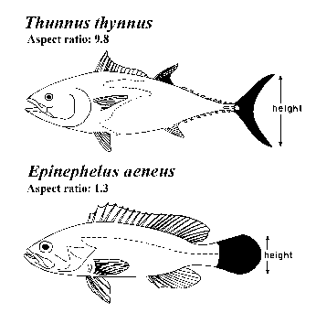
Figure 2.1. Schematic representation of method to estimate the aspect ratio (Ar = h2/s) of the caudal fin of fish, given height (h) and surface area (s, in black).

Other mortality
‘Other mortality’ is the difference between total production and the sum of export, biomass accumulation, net migration, and predation mortality. ‘Other mortality’ is called ‘M0’ in some other models. These may also include a term for mortality called ‘M1’, referring to the mortality caused by predator groups not explicitly included in the model. This kind of mortality can, in Ecopath, be considered a part of the net migration rate (the prey ‘migrates’ out of the system, and may then be eaten.) This normally should not cause problems if the recommendation is heeded to include, in Ecopath models, all the groups that occur in an ecosystem, not just some of them.
Other mortality consists of organisms dying due to diseases, starvation, etc., and the animals or plants concerned end up as part of the detritus. This mortality can be entered in Ecopath in form of the ecotrophic efficiency (EE), i.e., as (1 - other mortality). The ecotrophic efficiency is, thus, the proportion of the production that is used within the system. It is what is accounted for in Ecopath. EE is entered on the Basic input form.
It is difficult to estimate EE independently, and few, if any, direct estimates appear to exist. Intuitively one would expect EE to be very close to 1 for small prey organisms, diseases and starvation probably being, for such groups, much less frequent than predation. For some groups, EE, may however, be low. It is often seen that phytoplankton simply die off in systems where blooms occur (EE of 0.5 or less). Also, kelps and seagrasses are hardly consumed when alive (EE of 0.1 or so), and apex predators have very low EE s when fishing intensity is low: many incidences of tunas or cetaceans simply dying and sinking have been reported from open oceans, and there are indeed abyssal organisms (such as ratfishes) specialized in feeding on such carcasses.
An EE of 0.95, based on Ricker (1968) was used for many groups in Polovina's original model (Polovina, 1984a) and in other, later models.

Representation of multi-stanza life histories in Ecopath, Ecosim and Ecospace
See Edit groups for instructions on defining multi-stanza groups in EwE 6.0. See Edit multi-stanza groups for instructions on setting parameters for multi-stanza groups.
EwE users can create a set of biomass groups representing life history stages or stanzas for species that have complex trophic ontogeny. Mortality rates (M₀, predation, fishing) and diet composition are assumed to be similar for individuals within each stanza (e.g. larvae having high mortality and feed on zooplankton, juveniles having lower mortality and feed on benthic insects, adults having still lower mortality and feed on fish). Users of this feature must enter baseline estimates of total mortality rate Z and diet composition for each stanza, then biomass, QB, and BA for one “leading” stanza only.
For Ecopath mass balance calculations, the total mortality rate Z entered for each stanza-group is used to replace the Ecopath P/B for that group. That is, the Ecopath master equation is interpreted as mass balance accounting for the mortality rate for the group (EE x Z = sum of predation mortality rates, EE, calculated for the group). Further, the B and Q/B for all stanza-groups besides the leading (entry) stanza are calculated before entry to Ecopath, using the assumptions that:
(1) body growth for the species as a whole follows a von Bertalanffy growth curve with weight proportional to length-cubed; and
(2) the species population as a whole has had relatively stable mortality and relative recruitment rate for at least a few years, and so has reached a stable age-size distribution.
Under the stable age distribution assumption, the relative number of age “a” animals is given by l_{a}/Σl_{a} where the sum is over all ages, and l_{a} is the population growth rate-corrected survivorship,
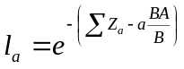
where the sum of Z’s is over all ages up to “a” and the BA/B term represents effect on the numbers at age of the population growth rate (e.g. the cohort born one year ago should be smaller by the factor 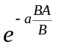 than the cohort born “a” years ago, if the relative population growth rate has been BA/B) for at least “a” years). Further, the relative biomass, b, of animals in stanza s should be
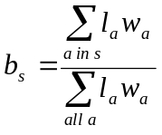
where 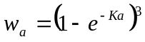 is the von Bertalanffy (1938) prediction of relative body weight at age a.
Knowing the biomass, B, for one leading stanza, and the b_{s} for each stanza s, the biomasses for the other stanzas can be calculated by first calculating population biomass
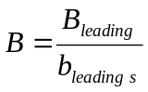,
then setting B_{s} = b_{s}B for the other stanzas. Q/B estimates for non-leading stanzas are calculated with a similar approach, assuming that feeding rates vary with age as the 2/3 power of body weight (a “hidden” assumption in the von Bertalanffy growth model). This method for ‘extending’ biomass and Q/B estimates over stanzas avoids a problem encountered in earlier ‘split-group’ EwE representations, where users could enter juvenile biomasses and feeding rates quite inconsistent with the adult biomasses and feeding rates that they had entered. The internal calculations of survivorship and biomass are actually done in monthly age steps, so as to allow finer resolution than one year in the stanza biomass and mortality structure (e.g., larval and juvenile stanzas that last only one or a few months).
On entry to Ecosim from Ecopath, the stanza age-size distribution information (l_{a}, w_{a}) is passed along and is used to initialize a fully size-age structured simulation for the multi-stanza populations. That is, for each monthly time step in Ecosim, numbers at monthly ages N_{a,t} and body weights w_{a,t} are updated for ages up to the 90% maximum body weight age (older, slow growing animals are accounted in an ‘accumulator’ age group). The body growth w_{a,t} calculations are parameterized so as to follow von Bertalanffy growth curves, with growth rates dependent on body size and (size- and time-varying) food consumption rates. Fecundity is assumed proportional to body weight above a weight at maturity, and size-numbers dependent monthly egg production is used to predict changes in recruitment rates of age 0 fish. Compensatory juvenile mortality is represented through changes in Z for juvenile stanzas associated with changes in foraging time and predator abundances. Egg production is allowed to vary seasonally or over long-term through a user-defined forcing function (see Egg production). If an egg production curve is defined the egg production term is multiplied according to the user-defined function.
In Ecospace, it is not practical to dynamically update the full multi-stanza age structures for every spatial cell (computer time and memory limits). The multi-stanza dynamics are retained, but the population numbers at age are assumed to remain close to equilibrium (changes in numbers at age associated with changes in mortality rates, foraging times, etc. are assumed to ‘immediately’ move the numbers-at-age composition to a new equilibrium). In practice, we have found that this moving-equilibrium representation of population numbers generally gives results quite close to those obtained when full age-size accounting is done dynamically, provided feeding and mortality rates do not change too rapidly. This is similar to the general finding with Ecospace that time predictions of overall abundance change are quite similar to those obtained with Ecosim, despite how the “dynamic” calculation in Ecospace is really just a stepwise movement toward predicted spatial equilibrium values for all variables.
Here are a few implementation issues that users of the multi-stanza capability should consider:
How many stanzas? The main computational burden of the full representation is in Ecosim, and this burden depends on the number of age classes accounted (calculated from K, Z for adult stanza) rather than the number of stanzas with distinct mortality/feeding patterns within the age structure. So the best advice we can give is to err on the high side. Add stanzas for each major ontogenetic shift in habitat use and diet (though larval stages can often be ignored due to low biomass, low impact on prey, and unlikely to show density-dependent effects). If necessary additional stanzas for size-age ranges that are subject to selective fishing impacts that might cause growth overfishing under some policy scenarios (growth overfishing can be a problem whenever juvenile fish are harvested over age ranges where they display accelerating growth in body weight, so cohort biomass is still increasing over the age range being fished).
Representation of seasonality? It is common for early juvenile stanzas to be completed within a short season each year. Yet Ecopath mass balance is based on annual average mass transfers. The initialization described above is based on “spreading” the seasonal effects evenly over the annual cycle (in monthly steps), and in practice this does not cause serious problems for the mass-balance calculation/Ecopath estimation. On entry to Ecosim, users can specify seasonal recruitment patterns and represent seasonal interaction dynamics in detail, but this generally forces care in all aspects of seasonality, (e.g., in prey productivity and availability as well as juvenile abundance). Generally we find that these more detailed calculations give about the same long term population dynamics as when recruitment is treated as aseasonal, except in scenarios that involve match-mismatch variation from year to year in the timing of food availability relative to the timing of recruitment (so unless you specifically want to examine match-mismatch hypotheses, consider not bothering to include seasonality in the simulations).
Representation of stanzas that occur outside the modeled system? It is common, especially in models for coastal ecosystems, to have species that spend only part (or none) of their time in the system. For example, juvenile rearing may be in the modeled ecosystem, but adult foraging and harvest impacts may occur in outside areas. The preferred way to handle trophic/fishery impacts for such species in EwE is to treat part (or all) of the diet for outside-migrant stanzas as imported, rather than to model the movement into and out of the system as immigration/emigration rates. With the diet import convention, EwE will still handle overall fishery impacts at the population scale whether or not these impacts occur within the modeled system; all that will be “lost’ is dynamic change in food availability (and feeding rates) and predation mortality of organisms during times when they are outside the modeled system (outside world treated as having constant trophic conditions). Most often, the stanzas that reside outside the modeled system are older fish, for which the assumption of constant resource availability and natural mortality risk may be quite reasonable. When it appears that using the diet-import convention is inappropriate due to changing trophic conditions outside the modeled system, then the modeled system should be extended to include the ‘outside’ trophic interactions of concern.
The multi-stanza representation is quite flexible, and users may find other ways to use it for effectively representing ‘problem processes’ in ecological systems. Such findings can be reported to www.ecopath.org for use by others.

Introductory material: Ecosim

An overview of Ecosim
Ecosim provides a dynamic simulation capability at the ecosystem level, with key initial parameters inherited from the base Ecopath model. See Ecosim inputs and Ecosim outputs for links to instructions for using Ecosim.
The key computational aspects are in summary form:
- Use of mass-balance results (from Ecopath) for parameter estimation;
- Variable speed splitting enables efficient modeling of the dynamics of both ‘fast’ (phytoplankton) and ‘slow’ groups (whales);
- Effects of micro-scale behaviors on macro-scale rates: top-down vs. bottom-up control incorporated explicitly.
- Includes biomass and size structure dynamics for key ecosystem groups, using a mix of differential and difference equations. As part of this EwE incorporates:
  - Multi-stanza life stage structure by monthly cohorts, density- and risk-dependent growth;
  - Stock-recruitment relationship as ‘emergent’ property of competition/predation interactions of juveniles.
Ecosim uses a system of differential equations that express biomass flux rates among pools as a function of time varying biomass and harvest rates, (for equations see Walters et al., 1997; Walters et al., 2000; Christensen and Walters, 2004). Predator prey interactions are moderated by prey behavior to limit exposure to predation, such that biomass flux patterns can show either bottom-up or top down (trophic cascade) control (Walters et al., 2000). By doing repeated simulations Ecosim allows for the fitting of predicted biomasses to time series data.

Ecosim basic
The basics of Ecosim consist of biomass dynamics expressed through a series of coupled differential equations. The equations are derived from the Ecopath master equation (Eq. 1), and take the form

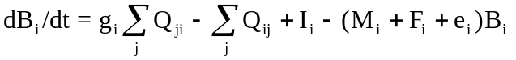 Eq. 20
where dB_{i}/dt represents the growth rate during the time interval dt of group (i) in terms of its biomass, B_{i}, g_{i} is the net growth efficiency (production/consumption ratio), M_{i} the non-predation (‘other’) natural mortality rate, F_{i} is fishing mortality rate, e_{i} is emigration rate, I_{i} is immigration rate, (and e_{i}·B_{i}-I_{i} is the net migration rate). The two summations estimates consumption rates, the first expressing the total consumption by group (i), and the second the predation by all predators on the same group (i). The consumption rates, Q_{ji}, are calculated based on the ‘foraging arena’ concept, where B_{i}’s are divided into vulnerable and invulnerable components (Walters et al., 1997 Figure 1), and it is the transfer rate (v_{ij}) between these two components that determines if control is top-down (i.e., Lotka-Volterra), bottom-up (i.e., donor-driven), or of an intermediate type.
The set of differential equations is solved in Ecosim using (by default) an Adams-Bashford integration routine or (if selected) a Runge-Kutta 4th order routine.
Further reading: Walters et al. 1997; Walters et al. 2000)

Vulnerabilities in Ecosim
One of the most important features of Ecosim is its ability to allow exploring the implications on system dynamics of different views of how the biomass of different groups in the ecosystem is controlled. The two extreme views are ‘predator’ control’ (also called top-down control) and ‘prey control’ (or bottom-up). We model this using ‘vulnerabilities,’ which represent the degree to which a large increase in predator biomass will cause in predation mortality for a given prey. Low vulnerability (close to 1) means that an increase in predator biomass will not cause any noticeable increase in the predation mortality the predator may cause on the given prey (see Figure 3.1). A high vulnerability, e.g., of 100, indicates that if the predator biomass is for instance doubled, it will cause close to a doubling in the predation mortality it causes for a given prey.
If we illustrate the relationship between predator biomass and Q/B (this is not an assumption in the actual Ecosim calculations) and assume that the predator in question does not cause any substantial (actually no) change in the prey biomass, we can calculate the relative Q/B for the predator (see Figure 3.1). For higher predator biomass a change will result in relatively stable predation mortality. Hence, if biomass is impacted so as to cause a reduction, the individual predators will get more, their Q/B increase and this will largely compensate for the reduction in their abundance, bringing the biomass back up again. At lower biomass Q/B will also increase, but to a lower degree. This is illustrated in Figure 3.2 showing how halving or doubling the predator biomass will impact the relative Q/B. At high biomasses, halving biomass results in close to a doubling in Q/B, which will tend to keep biomass high. There is, however, less and less relative surplus production as we move to the left on the curve. If biomasses are doubled instead, the Q/B will be decreased when biomasses are high, resulting in a decrease in biomass back toward the original level, i.e., the biomasses will be stable when close to carrying capacity (where v’s are low), and unstable when far below carrying capacity (where v’s are high).
If vulnerabilities are high, the amount of prey consumed by the predator is the product of predator x prey biomass, i.e., the predator biomass impact how much of the prey is consumed. Such situation may occur in situation where the prey has no refuge, and is thus always taken upon being encountered by a predator. Such top-down control, also known as Lotka-Volterra dynamics, easily leads to rapid oscillations of prey and predator biomasses and/or unpredictable behavior.
The converse (bottom-up control) is the situation that occurs when a prey is protected most of the time, (e.g., by hiding in crevices) and becomes available to predators only when it leaves the feature that protects it. Here being caught is a function of the prey’s behavior. Bottom-up control usually leads to unrealistically little biomass changes in the prey and predator(s) concerned, but which usually do not propagate through the other elements of a food web.
To model this aspect of predator-prey interactions, the group biomasses (B) on the underlying Ecopath model were reconceived in Ecosim as consisting of two components, one vulnerable, the other invulnerable to predation (B’ and V, respectively in Error: Reference source not found). Further, it is assumed that there is a flow (v_{ij}) of organisms from the invulnerable to the vulnerable stage, and conversely (v_{ji}), with the assumption v = v_{ij} = v_{ji}.
As might be seen in Figure 3.3, when v is high, the rapid replenishment of vulnerable biomass depleted by predator will rapidly drain the invulnerable part of the biomass. Thus, with v set high, predation control will be top down. Conversely, if v is low, replacement of depleted biomass from the invulnerable to the vulnerable part of the population will be slow, and the amount that the predators consume will be largely determined by the low value of v, rather than by their own biomass. Thus, when v is low, control is bottom up.
The vulnerability parameters are among the most important parameters that users change to improve the agreement of the model’s predictions with historical data (see Time series fitting in Ecosim, Hints for fitting models to time series reference data and Effect of P/B (Z) and vulnerability for time series fitting). See Vulnerabilities for help on setting vulnerabilities in Ecosim. See Fit to time series for help with Ecosim’s parameter search interface.
Further reading: Walters and Juanes (1993), Walters et al. (1997), Walters and Korman 1999, and Walters and Martell (2004).
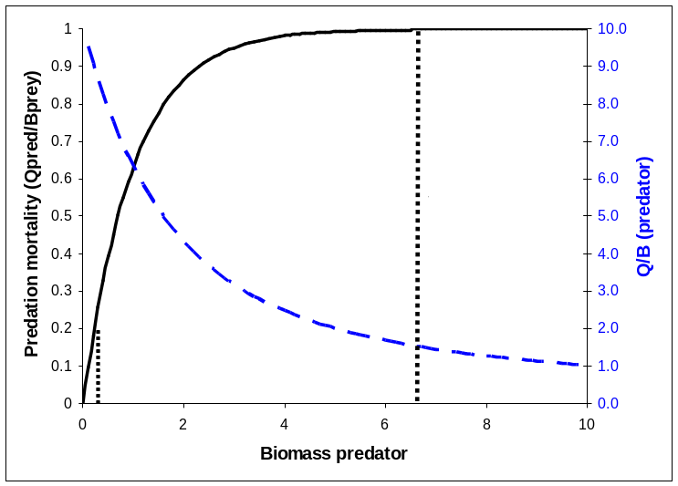
Figure 3.1. Relationship between biomass of a predator and the predation mortality it causes on a given prey, as well as the corresponding Q/B for the given predator and prey (assuming that the predator does not reduce prey biomass substantially). Vulnerability, v, is estimated as max. predation mortality/baseline predation mortality, (e.g., 5 at the leftmost stippled line). Baseline mortality is the mortality caused by the predator in the underlying Ecopath model.
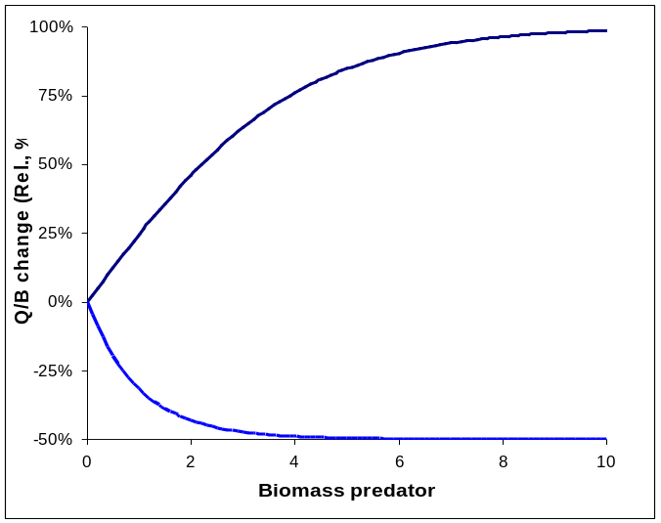
Figure 3.2. Relative increase in Q/B (%) as a function of predator biomass resulting from the predator biomass being halved or doubled. At high predator biomasses (i.e. near the carrying capacity for the given predator-prey interaction) a halving of predator biomass will result in nearly a doubling in the Q/B for the predator. The resulting surplus production will tend to bring the predator biomass back to the original level, and the overall effect is that the predator biomass will change only little. Conversely, a doubling of predators will cause the Q/B to be halved at high predator biomasses (resulting in very little effective change in biomass), while a doubling at low biomasses will result in only a very small reduction in Q/B.
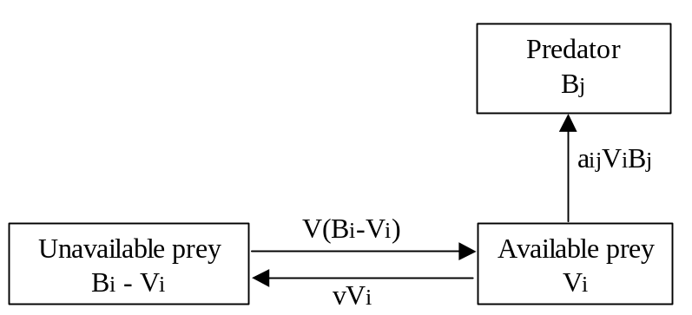
Figure 3.3. Simulation of flow between available (Vi) and unavailable (Bi - Vi) prey biomass in Ecosim. aij is the predator search rate for prey i, v is the exchange rate between the vulnerable and not-vulnerable state. Fast equilibrium between the two prey states implies Vi = vBi / (2v + aBj). Based on Walters et al. (1997).

Dealing with dynamic instability in Ecosim/Ecospace
We commonly see several types of dynamic instability following small perturbations in fishing mortality rates (to get away from initial Ecopath equilibrium):
- Predator-prey cycles and related multi-trophic level patterns;
- System simplification (loss of biomass pools due to competition/predation effects);
- Stock-recruitment instabilities (cyclic or erratic changes in recruitment and stock size for split pool groups);
- Numerical ‘chatter’ in time solutions (mainly in Ecospace).
Such patterns are not particularly common in fisheries time series, so unless you have data to support a cyclic prediction, you should probably adjust the model parameters to get rid of it.
Predator-prey and simplification effects can usually be eliminated by reducing the predation vulnerability parameters (Ecosim Vulnerabilities form, set values to 4 or less).
We know of at least four common mechanisms that can decrease the vulnerability parameters so as to create stabilizing and the appearance of ‘ratio-dependent’ or ‘bottom-up’ control of consumption rates:
- Risk-sensitive prey behaviors:
Prey may spend only a small proportion of their time in foraging arenas where they are subject to predation risk, otherwise taking refuge in schools, deep water, littoral refuge sites, etc.;
- Risk-sensitive predator behaviors (the ‘three to tango’ argument):
Especially if the predator is a small fish, it may severely restrict its own range relative to the range occupied by the prey, so that only a small proportion of the prey move or are mixed into the habitats used by it per unit time; in other words, its predators may drive it to behave in ways that make its own prey less vulnerable to it;
- Size-dependent graduation effects:
Typically a prey pool represents an aggregate of different prey sizes, and a predator can take only some limited range of sizes, limited vulnerability can represent a process of prey graduation into and out of the vulnerable size range due to growth. Size effects may of course be associated with distribution (predator-prey spatial overlap) shifts as well;
- Passive, differential spatial depletion effects:
Even if neither prey or predator shows active behaviors that create foraging arena patches, any physical or behavioral processes that create spatial variation in encounters between i and j will lead to local depletion of i in high risk areas and concentrations of i in partial predation ‘refuges’ represented by low risk areas. ‘Flow’ between low and high risk areas (v_{ij}) is then created by any processes that move organisms.
These mechanisms are so ubiquitous that any reader with aquatic natural history experience might wonder why anyone would ever assume a mass-action, random encounter model (vulnerabilities = 100 in Vulnerabilities form) in the first place.
Methods for dealing with stock-recruitment instability are discussed in the help section on using Ecosim to study compensation. Generally the simplest solutions are to check (and reduce if needed) cannibalism rates, set higher foraging time adjustment rates (Ecosim Group info form) for juvenile pools and reduce vulnerabilities of prey to juvenile fishes (Vulnerabilities form).
Numerical instabilities (chatter, oscillations of growing amplitude) occur mainly in Ecospace. They are avoided in Ecosim by only doing time dynamic integration of change for pools that can change relatively slowly. In Ecospace, the only remedy for chatter is to reduce the prediction time step (from 12/year default value, sometimes very low values such as 0.05 year are required for stability). In extreme cases, it might be necessary to ‘fool’ Ecosim/Ecospace by implicitly moving to a shorter time step for all dynamics, which you can do by dividing every Ecopath input time rate (P/B, Q/B) with the same factor.

Predicting consumption
Ecosim bases the crucial assumption for prediction of consumption rates on a simple Lotka-Volterra or ‘mass action’ assumption, modified to consider ‘foraging arena’ properties. Following this, prey can be states that are or are not vulnerable to predation, for instance by hiding, (e.g., in crevices of coral reefs or inside a school) when not feeding, and only being subject to predation when having left their shelter to feed, (see Error: Reference source not found). In the original Ecosim formulations (Walters et al 1997, 2000) the consumption rate for a given predator i feeding on a prey j was thus predicted from,
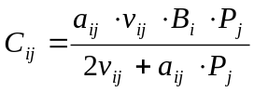 Eq. 21
where, a_{ij} is the effective search rate for predator i feeding on a prey j, v_{ij} base vulnerability expressing the rate with which prey move between being vulnerable and not vulnerable, B_{i} prey biomass, P_{j} predator abundance (N_{j} for split pool groups discussed later, and B_{j} for other groups).
The model as implemented argues that ‘top-down vs. bottom-up’ control is in fact a continuum, where low v’s implies bottom-up and high v’s top-down control.
Early experience with Ecosim has led to a more elaborate expression to describe the consumption:
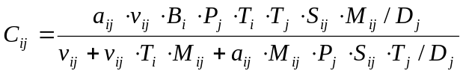 Eq. 22
where, T_{i} represents prey relative feeding time, T_{j} predator relative feeding time, S_{ij} user-defined seasonal or long term forcing effects, M_{ij} mediation forcing effects, and D_{j} represents effects of handling time as a limit to consumption rate,
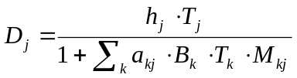 Eq. 23
where h_{j} is the predator handling time. The feeding time factors are discussed further below, (see Eq. 24). A vulnerability setting of 0 will result in consumption being estimated using bottom-up conditions only through
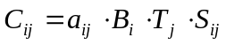

Foraging time and predation risk
The food consumption prediction relationship in Eq. 22 contains two parameters that directly influence the time spent feeding and the predation risk that feeding may entail: a_{ij} and v’_{ij}. To model possible linked changes in these parameters with changes in food availability as measured by per biomass food intake rate c_{it} = Q_{it} / B_{it} (i=juvenile index J or adult index A), we need to specify how changes in c_{it} will influence at least relative time spent foraging.
Denoting the relative time spent foraging as T_{it}, measured such that the rate of effective search during any model time step can be predicted as a_{jit} = T_{it} a_{ji} for each prey type j that i eats. Further, we assume that time spent vulnerable to predation, as measured by v’_{ij} for all predators j on i, is inversely related to T_{it}, i.e., v’_{ijt} = v’_{ij} / T_{it}. An alternative structure that gives similar results is to leave the a_{ij} constant, while varying the v_{ij} by setting v_{ijt} = T_{jt ·} v_{ij} in the numerator of Eq. 22, and v_{ijt} = T_{it ·} v_{ij} in the denominator.
For convenience in estimating the a_{ij} and v’_{ij} parameters, we scale T_{it} so that T_{i0} = 1, and v’_{I j}= v_{ij}. Using these scaling conventions, the key issue then becomes how to functionally relate T_{it} to food intake rate c_{it} so as to represent the hypothesis that animals with lots of food available will simply spend less time foraging, rather than increase food intake rates.
In Ecosim a simple functional form for T_{it} is implemented that will result in near constant feeding rates, but changing time at risk to predation, in situations where rate of effective search a_{ji} is the main factor limiting food consumption rather than prey behavior as measured by v_{ji}. This is implemented in form of the relationship:
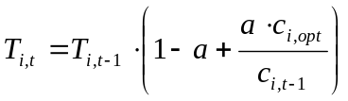 Eq. 24
where, a is a user-defined Feeding time adjustment rate [0, 1] on the Ecosim Group info form; c_{i,opt} is the (internally computed) feeding rate that optimizes feeding rate versus mortality risk for i; c_{i,t-1} is the consumption/biomass ratio in the previous time step for the group. The time spent feeding is constrained by a user-defined value (Maximum relative feeding time on the Group info form with default of two times the feeding rate in the Ecopath base model).
The relationship between foraging time, consumption and predator biomass is illustrated in Figure 3.4.
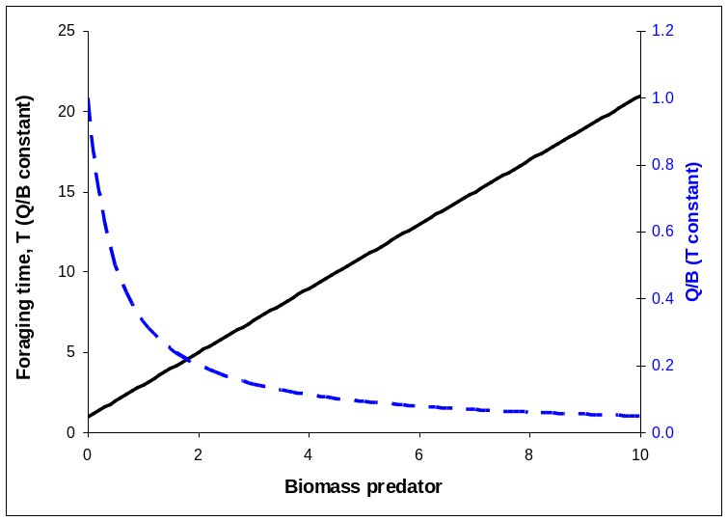
Figure 3.4. Relationship between relative foraging time (T), Q/B and predator biomass. If Q/B is held constant the foraging time (and hence predation risk) is a linear function of the predator biomass (solid line). If T is held constant the Q/B will decrease asymptotically with predator biomass (stippled line).

Time series fitting in Ecosim: evaluating fisheries and environmental effects
Ecosim can incorporate (and indeed benefits from) time series data. For many of the groups to be incorporated in the model the time series data will be available from single species stock assessments. EwE thus builds on the more traditional stock assessment, using much of the information available from these, while integrating to the ecosystem level.
When an Ecosim model is loaded, you can load time series ‘reference’ data on relative and absolute biomasses of various pools over a particular historical period, along with estimates of changes in fishing impacts over that period. After such data have been loaded and applied (using the Time series form), a statistical measure of goodness of fit to these data is generated each time Ecosim is run (using the Biomass form). This goodness of fit measure is a weighted sum of squared deviations (SS) of log biomasses from log predicted biomasses, scaled in the case of relative abundance data by the maximum likelihood estimate of the relative abundance scaling factor q in the equation y = qB (y = relative abundance, B = absolute abundance). Each reference data series can be assigned a relative weight using a simple spreadsheet in the search interface, representing a prior assessment by the user about relatively how variable or reliable that type of data is compared to the other reference time series (low weights imply relatively high variance, unreliable data).
The time series fitting uses either fishing effort or fishing mortality data as driving factors for the Ecosim model runs. A statistical measure of goodness of fit to the time series data outlined above is generated each time Ecosim is run. The model allows four types of analysis with the SS measure (see Fit to time series for help with implementing these analyses):
1. Determine sensitivity of SS to the critical Ecosim vulnerability parameters by changing each one slightly (1%) then rerunning the model to see how much SS is changed, (i.e., how sensitive the time series predictions ‘supported’ by data are to the vulnerabilities);
2. Search for vulnerability estimates that give better ‘fits’ of Ecosim to the time series data (lower SS), with vulnerabilities ‘blocked’ by the user into sets that are expected to be similar;
3. Search for time series values of annual relative primary productivity that may represent historical productivity ‘regime shifts’ impacting biomasses throughout the ecosystem;
4. Estimate a probability distribution for the null hypothesis that all of the deviations between model and predicted abundances are due to chance alone, i.e. under the hypothesis that there are no real productivity anomalies.
In addition to the nonlinear optimization routines described above the fit to data can also be improved in a feedback-process by examining some of the crucial ecological parameters in the EwE model (notably total mortality rates and the settings for top-down/bottom-up control). It is important to note here that such fitting does not include any ‘fiddling-factors’ internal to the model, instead the type of question that is addressed after each run is “which species parameters or ecological settings are not set such that the model captures the observed trends over time adequately?”
The inclusion of time series data in EwE facilitates its use for exploring policy options for ecosystem-based management of fisheries. An important preliminary conclusion from applications to various ecosystems is that the model is capable of producing a reasonable fit, (i.e. fits that can be compared to those obtained using single species models) for all available time series related to the ecological resources of an ecosystem in one go. This indicates a capability or at least a potential to replicate the known history of the ecosystems. In turn this lends some confidence to how the model can be used for policy exploration. It is also indicated that the fitting of time series in Ecosim may be used not just for identification of ecosystem effects of fishing but also to address questions of environmental impact at the ecosystem level (as well as for individual groups of course).

Hints for fitting models to time series reference data
A critical step in development of credible models for policy analysis is to show that they can at least reproduce observed historical responses to disturbances such as fishing. See also Time series fitting in Ecosim. See Time series for instructions for setting up time series data into your model.
This demonstration necessarily involves an iterative exercise in ‘fitting’ the model to data, by correcting parameter estimates and time series forcing information so as to show what values (or ranges of values, or alternative hypotheses about key processes) could explain the observed historical patterns. For any such fitting exercise, it is critical to have as long a reference period, with as many different disturbance patterns, as is possible to assemble. Note though, that only where a time series is used to ‘drive’ the model, (i.e. fishing mortalities and effort series) is it necessary to have information for all years in the time series. Estimates of relative abundance, catches, etc. are not required for all years. Short reference data series carry little information about responses to some disturbances, and hence ability of a model to fit such short series is no test at all of its ability to make useful predictions about disturbances not represented in the reference data. In more vivid terms, many model errors (structure and parameter values) will only reveal themselves (make themselves evident through strong departures of predicted from observed patterns) when the model is challenged to reproduce very long time series of responses.
Here we recommend an iterative, stepwise procedure for model fitting. It is generally not possible, or even wise, to try fitting a large ecosystem model using one big nonlinear estimation scheme that simultaneously varies all uncertain model parameters and inputs. There are simply too many inputs, some of the parameters are constrained in complex ways by mass balance considerations, and many model errors involve qualitative omissions of interaction terms (or processes, or disturbing inputs) entirely. Such possible omissions are most productively viewed as ‘alternative hypotheses’ about what processes and inputs have been important in shaping historical ecosystem behavior.
The basic idea in this procedure is as follows. Set up an Ecosim model and reference time series (of forcing inputs like fishing rates, and indices of temporal system response like relative biomasses and estimated total mortality rates). Examine the simulated and observed time patterns of response indices, look for groups that show large discrepancies in time pattern (trend), with particular emphasis on groups that have high biomass and are important prey or predator for other groups. As an example, sardines and anchovy in a Benguela model (Shannon et al., 2004) showed upward trend in data but not in initial simulation results. Focus in turn on each such group, and examine alternative hypotheses for the discrepancy (by varying appropriate parameters to see if the model fit is improved). The following are common hypotheses that should be examined in roughly the order listed:
- Bad trend data — it is possible that the model predictions are sound, but that the trend data are misleading for some reason, (e.g., increasing catchability in CPUE indices).
- Incomplete or incorrect forcing data, especially for fishing mortality rates—Ecosim-simulated patterns for exploited species will obviously not track observed patterns if those patterns have been caused by fishing, but no good time pattern of fishing mortalities (or at least fishing efforts) have been provided.
- Inappropriate vulnerability parameters for the group’s prey — low vulnerability settings (e.g., the 2.0 default) for a group’s column in the vulnerability matrix (of its prey to it) can cause two errors: (i) failure of the group to increase following reductions in mortality (due to preventing the group from increasing its total food intake); (ii) and/or failure of the group to decrease following increases in mortality, due to overestimates of compensatory Q/B responses to decreased intraspecific competition. Check this by clicking the ‘sensitivity of SS to vulnerabilities’ button in the Fit to time series form to determine whether vulnerability changes would cause changes in goodness of fit, and consider using the fitting interface to search for improved vulnerability estimates. See Effect of P/B (Z) and vulnerability for time series fitting for more information.
- Incorrect P/B (Z) setting in Ecopath for the group—it is common to see P/B, i.e. Z values set far too large in the Ecopath inputs, resulting in low EE and hence low sensitivity of a group to changes in mortality agents. Check the simulated time plot of total, fishing, and predation mortality rate components on the Ecosim Biomass form to see if the total mortality rate and its partitioning among factors are reasonable. See Effect of P/B (Z) and vulnerability for time series fitting for more information.
- Changes in system productivity—in some systems we have seen correlated declines or increases across a variety of species, despite differences among species in harvesting impacts, which might be explained by changes in basic productivity due to factors like upwelling. The Ecosim Fit to time series form can be used to ‘reconstruct’ an apparent temporal pattern in primary productivity, by fitting the model to time series for all groups while varying a time series of productivity ‘anomalies’.
- Trophic mediation effects—evaluate the possibility that changes in consumption and mortality have been caused by ‘indirect’ or ‘mediation’ effects, such as groups providing hiding places for other groups or driving behavior of groups so as to make those groups more or less vulnerable to other predators. In systems that have benthic and pelagic primary producers, note that shading effects by phytoplankton on benthic plants are not represented explicitly in Ecosim, and must be modeled as mediation effects (by setting up a mediation function that causes negative effects on benthic plant production as phytoplankton biomass increases). This is also the case with turbidity and decreased foraging efficiency of visual predators that can be caused by phytoplankton.
If none of these hypotheses produces predicted patterns similar to the data, look closely at the Ecosim predicted patterns of change in consumption, growth, and mortality rates, and try to evaluate how these rates would have to change in order to produce observed trend patterns. Examine the observed time series for other groups, particularly prey and predators of the group under study, to see if those time series suggest changes in trophic conditions (growth, mortality) that have not yet been captured by the model due to inappropriate parameter settings for the other groups.
Repeat the multiple hypothesis evaluation steps above for each group, with initial emphasis on those groups for which the model predictions depart strongly from the data. Note that ‘correcting’ the parameters and time inputs for any one group can either improve or degrade the model fits for other groups, including groups for which good fits have already been obtained. This means that the fitting/evaluation process is necessarily iterative, requiring several passes or tries to obtain an overall valid model. For example, in the Benguela model example, obtaining good fits to strong time trends in sardine and anchovy biomass (using hypotheses (3) and/or (5) above) resulted in predicted increases in several predator populations, particularly hakes, for which the data do not indicate such increase. An interesting question then arose about why the predators did not show responses to the apparently large prey increases, and this question led to examination of a variety of hypotheses about why the response did not occur (limitation of recruitment due to cannibalism, undetected increases in fishing impact as responses started to occur so as to prevent those responses from being expressed, errors in initial estimates of diet composition and dependency on sardines and anchovy by the predators, etc.).
It is possible for the step-wise, iterative process of hypothesis evaluation and model testing/fitting described above to fail completely, in at least two basic ways. First, it may result in an apparently endless cycle back and forth between groups, with each step in the cycle resulting in improvement in fit to one group at the expense of poor fit to others. Such cycles have not yet been seen in case studies, but would indicate either ‘contradictory data’, where the model structure is valid but one or more trend data sets are misleading and apparently contradict the others, or a fundamental failure of the model structure to represent some important interactions or processes.
Second, the model may fail to capture (due to lack of correct input data or structural error) the dynamics of some particular, important group that has driven the dynamics of several others, and inability to simulate this one group may contaminate a variety of model predictions. For example, in models of the Bering Sea ecosystem, we have had trouble simulating (explaining) declines that apparently occurred in small, inshore pelagic fish species in the late 1970s and early 1980s. These declines were associated with onset of a rapid decline in Stellar Sea Lion, and onset of a strong upward trend in jellyfish (which compete with small pelagic fish for zooplankton). In that model, simply forcing the small pelagics to decline (with an arbitrary fake fishery) results in considerably better fits to the data for the other groups. In several models of relatively small oceanic regions (North Sea, West Coast of Vancouver Island), we have had to deal with apparently unpredictable biomass dynamics of species (especially mackerels) that have apparently invaded the regions in conjunction with changing ocean climate regimes. In fact, it is probably a general principle that for any region that might be arbitrarily defined for analysis, there are at least some species that have potentially important impact (on predator-prey relationships) within the region but display changes that can only be explained by examining their dynamics (production, fishing impacts) over some much larger spatial domain. With respect to any small study region, it is appropriate to treat the abundances of such species as forcing functions provided policy choices made within the region are unlikely to affect the larger scale dynamics of those species.
In most early Ecosim fitting exercises, the goal has been to find even one reasonably good fit to the data, i.e. to simply demonstrate whether the model is capable (flexible) of describing historical patterns. During such exercises, interesting alternative hypotheses and parameter changes that might have provided equally good explanations have not been thoroughly documented and pursued, nor have users typically even recorded the often simple research studies and auxiliary measurements that would be needed to test among alternatives (e.g., diet composition studies to detect rare prey in cases where an abundant predator may have big impacts on such prey despite such prey not being important to support of the predator). This failure to document the ‘brainstorming’ process involved in model fitting/testing can be costly for people who then try to use the model for policy analysis for several reasons:
- Clear articulation of alternative hypotheses that could equally well explain historical changes is a critical part of adaptive policy design involving planned experimental comparisons of policy options;
- Analyses based on the model are left open to attack by stakeholders who have vested interest in presuming some particular hypothesis to be true (e.g. people who want to blame stock declines on environmental factors so as to avoid restrictions in fishing); and
- Potential value of the modeling to help guide and prioritize research projects is lost, and this is a very big issue indeed in situations where very limited scientific resources are expected to provide useful information for complex ecosystem management planning.
Documentation of alternative hypotheses and parameter-changes during the sequential fitting process would appear at first glance to be an exceedingly complex process, involving geometric increase in number of hypothesis combinations as more time series and groups are examined (e.g. if there are two ways to explain changes in group 1, and two ways to explain changes in group 2, there are 4 possible ways to explain the joint dynamics). This ‘explosion’ in hypotheses is not that serious a problem in practice, for at least two reasons: (1) uncertainty about why a group has responded or not may be independent of uncertainty about why other groups have responded, e.g. we can examine hypotheses (and policy implications) about failure of hake to increase following sardine-anchovy increases in the Benguela system, without regard to what drove those increases in the first place; and (2) typically the alternative hypotheses involve ‘environmental forcing’ versus fishing effects, and the environmental forcing hypotheses are not independent for each group (i.e. hypotheses about increases or decreases in productivity due to factors like upwelling are expected to apply to a variety of groups). The main implication of point (2) is that we can generally identify just a few overall hypotheses for why an ecosystem has behaved as it has, each with very different policy implications. For example, in the Georgia Strait, B.C. models, two main hypotheses have emerged (can be made to fit the data using Ecosim) about why a whole suite of fish species has declined: either the system as a whole has experienced major decreases in primary production, or the observed dramatic growth in marine mammal populations (harbour seal) has had devastating impacts not reflected in the relatively crude diet information available from historical studies (in conjunction with modest declines in primary production).
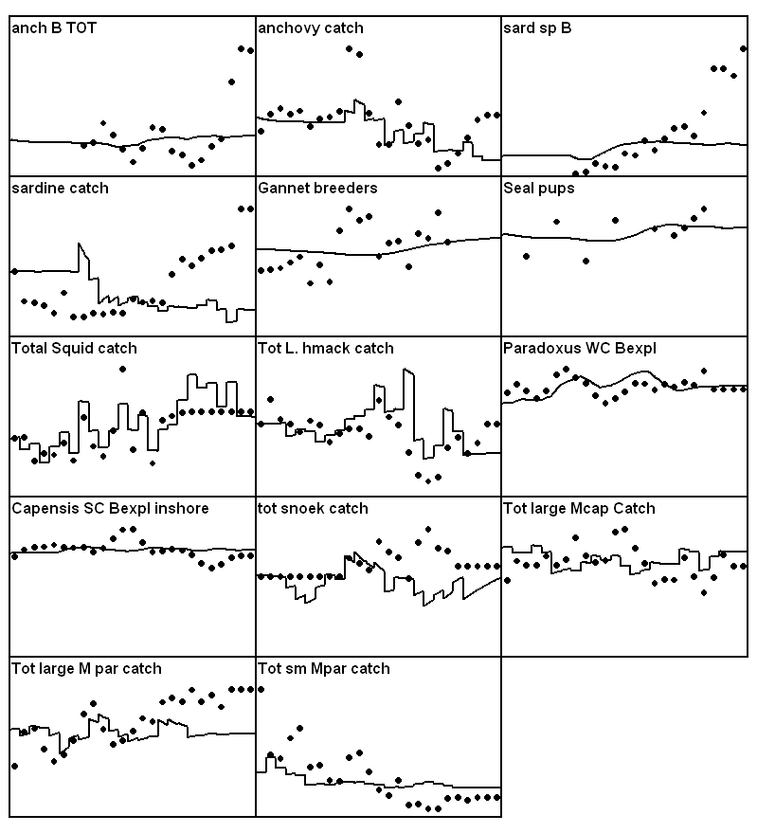
Figure 3.5. Initial time series fit for the Benguela model. Estimated using default values in Ecosim.
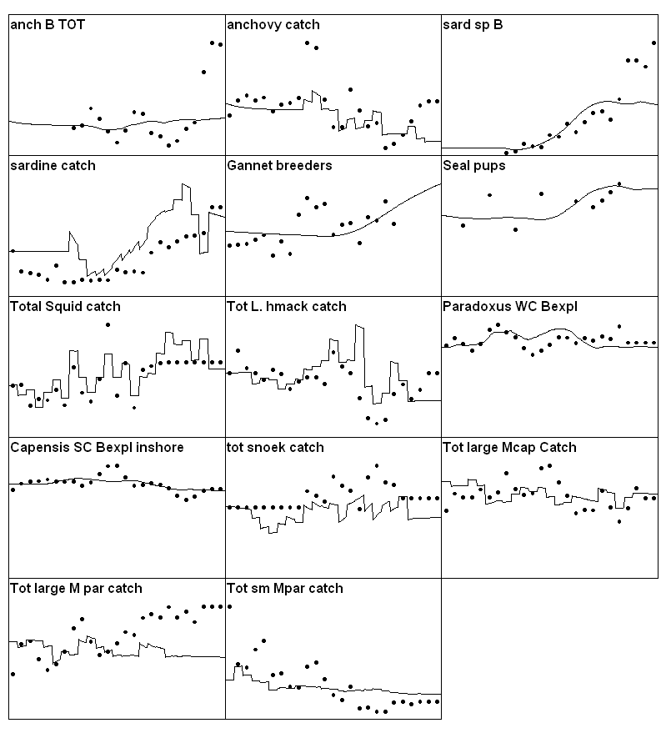
Figure 3.6. Time series fit for Benguela model after estimating vulnerabilities (for 15 groups of consumers).
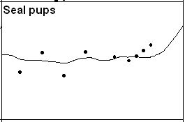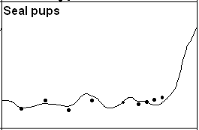
Figure 3.7. Effect of P/B rate on time series fitting for seals in the Benguela model. Left figure is with a P/B of 0.95 year⁻¹ for seals, while right-hand one is with a more realistic value of 0.15 year⁻¹.
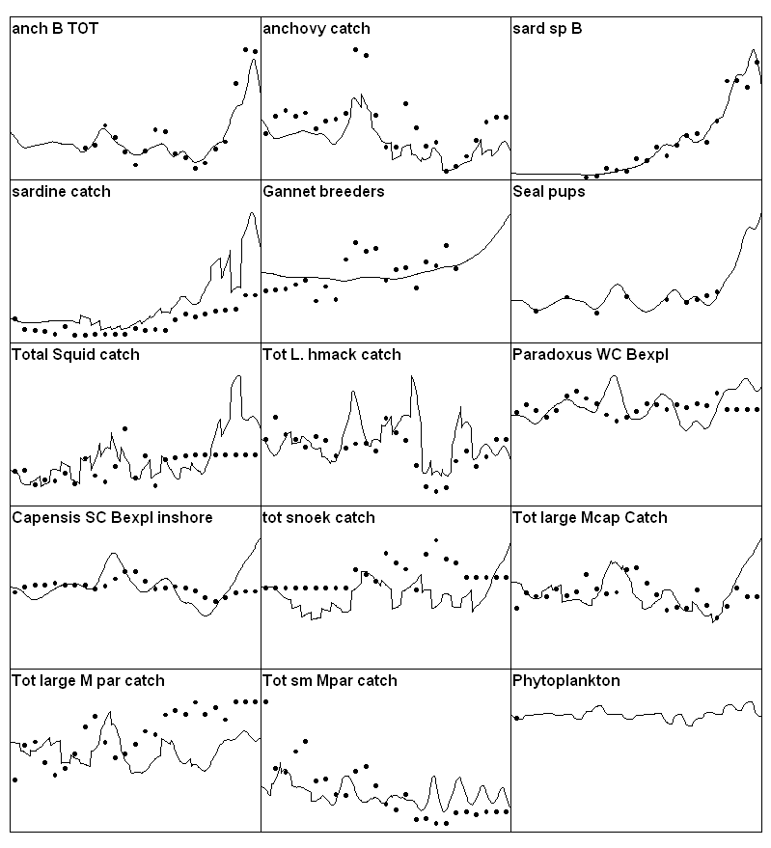
Figure 3.8. Time series fit for the Benguela model with primary production ‘anomaly’ estimated.

Effect of P/B (Z) and vulnerability for time series fitting
For the balancing it is useful to think of how growth and mortality is modeled in Ecosim. Mortality is considered a linear function of biomass (solid line in Figure 3.9), while the population increase will be a non-linear function of the biomass (dotted line in Figure 3.9). This non-linear function corresponds to the consumption times the gross food conversion efficiency (from Ecopath, where it is estimated as base production over base consumption). For a given biomass, the population will increase or decrease depending on the area between the lines. The growth/decline of a given population can hence be modified by changing either the mortality rate, or food consumption. Food consumption, in turn, is a function of complex predator-prey relationships modeled using a variable ‘vulnerability’ setting for top-down vs. bottom-up control.
This can be illustrated using a model of the Gulf of Thailand (Christensen, 1998) along with time series data from research vessel surveys in the Gulf, an initial simulation using default settings throughout (most notably a default vulnerability setting of 2 for all predator-prey interactions) produces the fit shown in Figure 3.10 for the ‘large piscivores’ group. During the time period included the fishing intensity increased with more than an order of magnitude. The model (solid line) shows a clear decline in biomass over the time, while the CPUE from the surveys (dots) indicates much less decline over time. As described above we have some handles that can be used to manipulate how Ecosim models the growth of the population. Panel B thus shows the effect of raising the groups total mortality rate from 0.8 year⁻¹ to 1.2 year⁻¹. The effect of this is to make the group much better able to tolerate the grossly increased fishing intensity over time, but it is also clear that a 50% increase in the initial mortality rate setting is insufficient to optimize the fit over time. A second handle is therefore invoked. The vulnerability setting affects how the consumption is influenced by changes in predator and prey abundance. Using the default setting of 2 (panels A and B) corresponds to assuming that if the biomass of large piscivores was increased drastically they would be able to double the predation mortality they are causing their prey. Changing the value to 1.01 for all prey of the large piscivores makes prey availability largely independent of changes in the predator abundance. As the increased fishery leads to a reduction in the biomass of large piscivores, those remaining will have a good time (from a food perspective: their consumption rate will increase, and this will tend to counterbalance the increased fishing pressure). The result is increased resilience as can be seen from panels C and D in Figure 3.10. Comparing panels B and C shows that the fit is better through incorporating bottom-up control, while panel D shows the best fit overall.
For illustration the panels E and F are included in Figure to show the effect of using a high vulnerability (v=100) for the interactions between the large piscivores and each of its prey groups. It is apparent that this does not result in any improvement in fit between model and CPUE, but in fact in the opposite. The best fit in the example is thus obtained using the parameter settings of panel D.
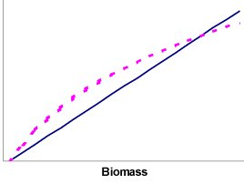
Figure 3.9. The solid line shows the predicted mortality calculated as Z ·B, and the dotted line the population growth estimated as a function of the consumption. The area between the lines can be considered ‘surplus production’.
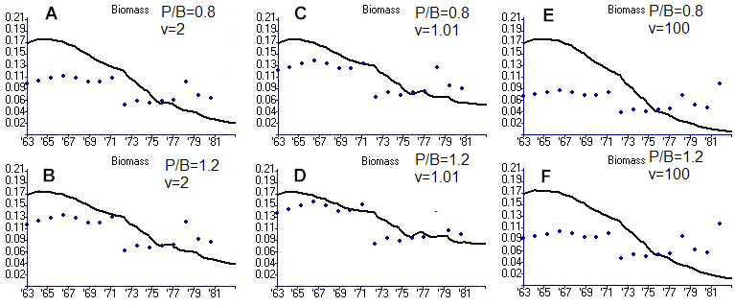
Figure 3.10. Biomass over time (lines) for ‘large piscivores’ in the Gulf of Thailand. P/B is the production/biomass ratio (equals Z, the total mortality) for the group, while v is the vulnerability setting describing how the group interacts with each of its prey groups. Dots represent CPUE from surveys.

Predator satiation and handling time effects
Ecosim and Ecospace allow you to represent two factors that may limit prey consumption rates per predator (Q/B): i) foraging time adjustments related to predation risk and/or satiation; and ii) handling time effects. Parameters for both are specified via the Ecosim Group info form.
Satiation and/or choices to forage for short times in order to avoid higher predation risk are represented by setting non-zero values for the ‘Feeding time adjustment rate’ of a group: larger values of this rate represent more rapid adjustment of foraging time. Non-zero foraging time adjustment rates cause Ecosim/Ecospace to update relative foraging time during each simulation so as to represent predators as trying to maintain Q/B near the Ecopath input base rate. For some organisms (particularly marine mammals) this foraging time adjustment may represent animals always trying to feed to satiation (Q/B from Ecopath the satiation feeding rate) and taking more or less time to reach satiation depending on prey densities (and possibly also facing higher predation risk when foraging times are longer). For other organisms, the Ecopath base Q/B may represent a much lower feeding rate than the animal could achieve under ‘safe’ laboratory conditions, and in this case we view the base Q/B as an evolutionary ‘target’ rate representing results of natural selection for balancing benefits from feeding with predation risk costs of spending more time feeding.
Handling time effects represent the notion that predators have limited time available for foraging and this time can be used up by ‘handling time’ (pursuit/manipulation/ingestion time per prey captured) rather than searching for prey, when prey densities are high. The Ecosim Group info form allows you to set ratios of maximum to Ecopath base food consumption rates per individual (or per biomass). These ratios are set to large values (1000) by default, which allows predators to increase their feeding rates without limit as prey densities increase (i.e., not limited by time required to handle each prey). In most scenarios, limitation of prey vulnerability prevents this unreasonable assumption from having noticeable effect. But in scenarios where vulnerable prey densities of at least one type do increase greatly, setting a low value (e.g., 2 or 3) for the predator’s maximum/base feeding rate ratio allows you to represent limits on feeding rate associated with time needed to handle each prey. Without such limits, your predictions of increase in predator Q/B, and hence productivity, at low predator density (or high prey density) might be too optimistic and lead you to errors like overestimating sustainable harvest rate for the predator. Also, ignoring handling time effects when one prey type increases greatly can cause an underestimate of the ‘buffering’ effect that such increases can have on predation rates felt by other prey: if the predator consumes more of the abundant prey, and spends more time handling/resting because of this, predation rates on other prey species should decrease.
Ecosim/Ecospace calculates feeding rates of predators using the ‘multispecies disc equation’, a generalization of Holling’s type II functional response model for multiple prey types. Using the maximum/base ratio from the Group info form along with the Ecopath base food consumption rate per predator, the program calculates a maximum ration and effective handling time per prey biomass eaten (handling time = 1 / (maximum prey biomass eaten per time)). This handling time (Holling’s ‘h’ parameter) is used to calculate the denominator in the disc equation formulation Q/B_{ij} = biomass of prey type i consumed per time per predator j, Qb_{ij} = a_{ij} V_{ij} / (1 + h_{j} S_{i} a_{ij} V_{ij}) where a_{ij} is the rate of effective search by predator j for type i prey, h_{j} is the predator handling time parameter, and V_{ij} is the instantaneous density of prey type i vulnerable to predator j.
V_{ij} is calculated by solving the ‘fast dynamics’ equation
dV_{ij}/dt = v(B_{i}-V_{ij}) - v’V_{ij} – a_{ij}P_{j}V_{ij} / (1 + h_{j} S_{i}a_{ij} V_{ij}) for V_{ij},
while assuming the vulnerability-exploitation dynamics are fast enough to keep dV/dt near zero (vulnerability exchange rates v, v’ large). The solution for V_{ij} over time involves a numerical procedure that can sometimes cause annoying ‘chatter’ in the Ecosim results when handling times are large (ratio of maximum/base consumption rate small). At each simulation time step the program updates an estimate of the ratio of predator search time to total time (this ratio is given by Ps_{j} = 1 / (1 + h_{j} S_{i} a_{ij} V_{ij}) in the Holling formulation), using this update to provide an improved estimate of the V_{ij}. We do this because providing an exact value for the V_{ij} (exact solution for the nonlinear equation solutions for all the V_{ij} at the condition dV_{ij} / dt=0) at each simulation time step would require excessive computer time.
An interesting and useful feature of the algebra of multispecies disc equations is that the initial (starting simulation time) value for the Ps_{j} ratio (of search time to handling time, i.e. the denominator of the disc equation) for each predator type is given just by Ps_{j} = R_{j} / (R_{j} - 1), where R_{j} is the Group info form ratio of maximum to Ecopath base consumption rate per predator. Ps_{j} is updated at each Ecosim/Ecospace time step by first calculating starting estimates of the V_{ij} using the Ps_{j} from the previous (or initial) time step, then using these estimates in the sums S_{i} a_{ij} V_{ij} that define Ps_{j}.
Bioenergetics models for fish most often indicate that feeding rates are low compared to maximum ration; typical ratios of estimated to maximum ration (Hewett-Johnson ‘P’ parameter) are around 0.3-0.4. These estimates imply R_{j} (maximum/Ecopath base ration) values of at least 2-4. If you choose to use such realistic values instead of the default 1000, and if this causes Ecosim/Ecospace to Figure oscillatory behavior, you need to consider two possibilities:
- The oscillatory behavior may be a numerical artifact of the procedure used to update Ps_{j}; or
- The model’s ‘correct’ behavior for the parameter combinations you have provided is indeed a predator-prey cycle.
If the oscillation has a period of several time steps (months), it is very likely a predator-prey cycle. Persistent predator-prey cycles are commonly predicted by models that include handling time, along with strong top-down control (high vulnerabilities v_{ij} of prey to predators). If you think the cycle is unrealistic, you should adjust the prey vulnerabilities (Ecosim Vulnerabilities form) to lower values (toward ‘bottom up’, prey vulnerability control) rather than just setting high R_{j} values. If you see very short cycles indicating numerical instability in the Ps_{j} adjustment procedure (usually happens for fast turnover groups like microzooplankton), you should set higher R_{j} values for the offending groups. This amounts to admitting that Ecosim is limited in its ability to represent very fast dynamic changes in groups that turn over very rapidly.

Modeling switching behavior in Ecosim
Predators are said to ‘switch’ from one prey to another when predator diet proportion of each type changes more rapidly than the relative abundance of that type in the environment. Eating more of something when it becomes abundant does NOT imply switching, but rather just more frequent encounters with that type; the predator is said to switch if it takes disproportionately more of the thing as it becomes more abundant.
Three mechanisms that can lead to switching patterns in diet composition and prey mortality are represented in Ecosim:
- Apparent switching away from prey that are declining in abundance, due to those prey seeing less intraspecific competition and hence spending less time at risk to predation; this effect occurs for any prey species (and impacts feeding on it by all of its predators) whenever Ecosim Feeding time adjustment is set >0 in the Group info interface.
- Apparent switching in Ecospace, caused by fitness-sensitive movement; when Ecospace parameters are set to cause increased (and/or directional) movement from cells where ‘fitness’ (per capita food intake minus instantaneous mortality rate) is lower, predators will appear (for the system as a whole) to switch to more abundant prey, and prey that are declining in abundance will see lower predation rates in the cells where they remain concentrated.
- Explicit changes in Ecosim rates of effective search, representing fine-scale behavioral choices by predators to spend more or less foraging time in the arenas where specific prey are concentrated. In this case, the behavioral choice among arenas is predicted from Ideal Free Distribution (IFD) arguments that predators should allocate foraging time so as to minimize time needed to obtain normal food consumption rates.
In the third of these approaches, the Ecosim rate of effective search a_{ij} for predator type j on prey type i is modified at each simulation time step in relation to changes in abundance of all prey types, using a ‘gravity model’ approximation for the IFD allocation of predator foraging time among prey-specific foraging arenas. The equation used for this modification is
a_{ij}(t) = K_{ij}a_{ij}B_{i}(t)^{Pj} / Σ_{i’}a_{i’j}B_{i ’}(t)^{Pj} Eq. 25
Here, a_{ij} is the base rate of effective search calculated from Ecopath and vulnerability exchange parameters, K_{ij} is a scaling constant that makes the time-specific a_{ij}(t) equal a_{ij} when all prey biomasses B_{i} are at Ecopath base values, and the ‘switching power parameter’ P_{j} is a user-supplied (empirical, to be estimated from field data or model fitting) power parameter representing how strongly the predator responds to changes in prey availability (switching power parameter on the Group info form). In particular:
P_{j} = 0, no switching
P_{j} << 1, prey must become very rare before predator j stops searching for them
P_{j} >> 1, predator switches violently when any prey increases or decreases.
P_{j} is limited to the range [0,2]. While Eq. 25 is derived by pretending that predators must allocate time among mutually exclusive foraging arenas for each of their prey types (a typically unrealistic assumption), it can still be used (with P_{j} <<1 values) to represent more general ideas about why and how predators switch among prey, e.g. formation and loss of search images for finding them.
Impact of setting a positive switching power parameter can be exemplified based on migratory striped bass. In this example switching results in much more variable for the predator – which simulation is the more appropriate can only be determined from empirical information (Figure 3.11).
Without switching
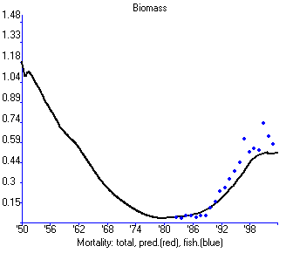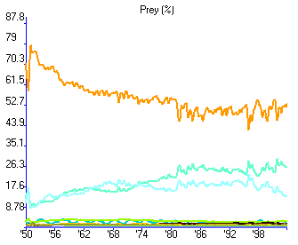

With switching (power parameter = 2)

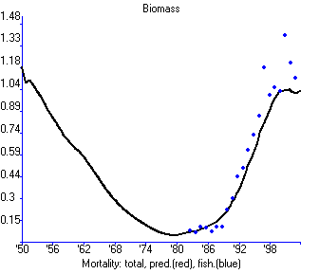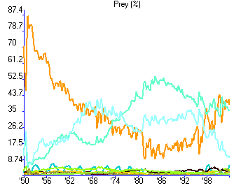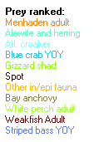

Figure 3.11. Effect of allowing switching for migratory striped bass (Chesapeake Bay model, Christensen et al., MS).

Compensatory mechanisms
Sustaining fisheries yield when fishing reduces stock size depends on the existence of compensatory improvements in per capita recruitment, growth, and/or natural mortality rates. Ecosim allows users to represent a variety of specific hypotheses about compensatory mechanisms. Broadly, these mechanisms fall in two categories:
- direct - changes caused over short time scales (order one year) by changes in behavior of organisms, whether or not there is an ecosystem-scale change due to fishing; and
- indirect - changes over longer time scales due to ecosystem-scale responses such as increased prey densities and/or reduced predator densities. Usually we find the direct effects to be most important in explaining historical response data. In the next three sections we describe how to generate alternative models or hypotheses about direct compensatory responses; these hypotheses fall in three obvious categories: recruitment, growth, and natural mortality.

Using Ecosim to study compensation in recruitment relationships
The multi-stanza representation of juvenile and adult biomasses was originally included in Ecosim to allow representation of trophic ontogeny (big differences in diet between juveniles and adults). To implement this representation, we found that it was necessary to include population numbers and age structure, at least for juveniles, so as to prevent ‘impossible’ dynamics such as elimination of juvenile biomass by competition/predation or fishing without attendant impact on adult abundance (graduation from juvenile to adult pools cannot be well represented just as a biomass ‘flow’).
When we elected to include age-structured dynamics, we in effect created a requirement for model users to think carefully about the dynamics of compensatory processes that have traditionally been studied in terms of the ‘stock-recruitment’ concept and relationships. To credibly describe the dynamics of multi-stanza populations, Ecosim parameters for split pools usually need to be set so as to produce an ‘emergent’ stock-recruitment relationship that is at least qualitatively similar to the many, many relationships for which we now have empirical data (see data summary in www.mscs.dal.ca/~myers/data.html). In most cases, these relationships are ‘flat’ over a wide range of spawning stock size, implying there must generally be strong compensatory increase in juvenile survival rate as spawning stock declines (otherwise less eggs would mean less recruits on average, no matter how variable the survival rate might be).
When Ecosim users create multi-stanza dynamics, they need to be careful in setting model parameters that define/create compensatory effects. This begins with the Ecopath input parameters; in order for the juvenile dynamics to Figure compensatory mortality changes, at least two conditions are needed or helpful:
    - the juvenile group(s) must have relatively high P/B, i.e. high total mortality rate (see Edit multi-stanza groups);
    - the juvenile group(s) must have either relatively high EE (so that most mortality is accounted for as predation effects within the model) or else the user must specify a high (near 1.0) value in the Ecosim Group info form entry for the juvenile group’s ‘Proportion of other mortality sensitive to changes in feeding time’ column.
Compensatory effects can be increased (the recruitment relationship is flat over a wider range of adult stock sizes, with a steeper slope of recruitment curve near the origin) by:
        - Limiting the availability of prey to juveniles (forcing juveniles to use small ‘foraging arenas’ for feeding) by setting all elements of the Ecosim Vulnerabilities form column for the juveniles to a small value (1.5-5); or
        - Setting a higher value for the juvenile group’s ‘Feeding time adjustment rate’ parameter in Ecosim Group info form, which causes the effective time exposed to predation while feeding to drop directly with decreasing juvenile abundance (i.e., simulates the possibility that when juveniles are less abundant, remaining ones may be able to forage ‘safely’ only in refuge sites without exposing themselves to predation risk). This option should be used only if you are fairly sure from field natural history observation that the juveniles do in fact restrict their distribution to safe habitats when at very low abundance.
It is especially important to test alternative values for the vulnerability of prey to juveniles (point i). If vulnerability is too high, the Ecosim emergent stock-recruitment relationship is likely to look almost like a straight line out of the origin, i.e. without compensatory effect. If vulnerability is too low, the relationship may develop a ‘spurious’ dome-shape.
Note that in Ecosim multi-stanza groups, the ‘Adult’ group is always the oldest stanza. The stock-recruitment relationship between this adult stage and each of the younger stages separately is calculated using the Stock recruitment form.
A stock-recruitment exercise in Ecosim
Always check the stock-recruitment curve shape, and play with Group info and Stage parameters that may affect it, before proceeding to other policy analysis. The simplest way to check this shape while minimizing complicating and confounding effects of trophic interactions is to set up Ecosim for a fairly long time scenario (40+ yrs):
  - Go to the Biomass form (Time dynamic (Ecosim) > Output >Biomass), select Individual group and then the adult pool from the drop-down menus on the bottom panel for time shaping fishing rates. Using the fishing rate sketch pad, set up a fishing rate time series pattern where fishing is first stopped for a decade or so then ramped up over the remaining years to a very high value relative to your baseline rate from Ecopath.
  - Open the Stock recruitment form, and select the same adult group (Time dynamic (Ecosim) > Output > S/R plot).
  - Then run a series of scenarios in the S/R form. If the stock ‘crashes’ completely under heavy fishing, reshape the fishing rate to stop a few years after the crash, to check for a ‘multiple equilibrium’ outcome: i.e., for some models, and especially for top predators, there may be ‘delayed depensation’ effect where the predator fails to recover after heavy fishing, due to increases in species that it eats that are in turn competitors/predators on its juveniles—these species can cause ‘recruitment failure’.

Compensatory growth (overall P/B)
Compensatory growth rate responses are modeled by setting the ‘feeding time adjustment rate’ (Group info form) to zero, so that simulated Q/B is allowed to vary with pool biomass (nonzero feeding time adjustment results in simulated organisms trying to maintain Ecopath base Q/B by varying relative feeding time). Net production is assumed proportional (growth efficiency) to Q/B, whether or not this production is due to recruitment or growth. The Q/B increase with decreasing pool biomass is increased by decreasing vulnerability of prey to the pool (Vulnerabilities form). In the extreme as vulnerability approaches zero (donor or bottom up control), total food consumption rate Q approaches a constant (Ecopath base consumption), so Q/B becomes inversely proportional to B.

Compensatory natural mortality
Compensatory changes in natural mortality rate (M) can be simulated by combining two effects: nonzero ‘Feeding time adjustment rate’ (set on the Group info form), and either high EE from Ecopath or high proportion of Mo due to predation (unexplained predation > 0). With these settings, especially when Vulnerabilities of prey to a group are low, decreases in biomass lead to reduced feeding time, which leads to proportional reduction in natural mortality rate.

Linking mediation and time forcing functions to trophic interaction rates
The basic Ecosim prediction for “flow” rate of type-i prey biomass to type-j predators is of the functional form
flow (biomass/time) = a_{ij}∙V_{ij}∙P_{j}
where a_{ij} is a “rate of effective search” parameter, V_{ij} is vulnerable prey biomass, and P_{j} is effective predator abundance (for simple models P_{j} is just predator biomass; for multistanza groups it is the sum over ages in that group of numbers at age times body weight to the 2/3 power, an index of per-predator search rate). If vulnerable prey were randomly distributed over the modeled spatial area, and V, P were expressed as abundances per unit area, then a_{ij} would be interpretable as a volume or area swept per unit predator abundance (per P_{j}) per unit time, corrected for the proportion of time actually spent searching for food (foraging time and handling time adjustments reduce a_{ij} from its theoretical maximum value for a predator that searched all the time for food).
To understand how effects of habitat changes as represented through time forcing functions, and mediation effects as expressed through mediation functions of abundances of other organisms, are likely to affect trophic flow rates, we need to be a bit more careful about the a_{ij} parameter. In particular, we need to recognize that for most trophic interactions, predators search for prey only over restricted spatial foraging arenas, and hence V_{ij} is distributed only over such areas rather than at random over the whole system. Suppose the (practically unmeasurable) restricted area where foraging by j on prey i takes place is A_{ij} per unit total model area. Suppose that while in this area, each unit of predator abundance (per P_{j}) searches an effective area a*_{ij} for prey. On average, each such area searched should result in capture of V_{ij}/A_{ij} prey, since this ratio is prey density in the arena area. In other words, the flow rate could be modeled more precisely (if we could measure A_{ij}) as
flow rate=a*_{ij}/A_{ij}∙V_{ij}∙P_{j}
i.e., the basic Ecosim equation’s a_{ij} can be interpreted as a_{ij}=a*_{ij}/A_{ij}. Expressed this way, we see that time forcing and/or mediation effects can influence the flow rate in at least three quite distinct ways:
  - by altering the effective search rate a*_{ij} of the predator, for example by using a turbidity time forcing function or a mediation function of algal biomass that reduces a*_{ij} at high algal biomass;
  - by altering the area A_{ij} over which vulnerable prey and/or predators are distributed, for example by a mediation effect where macrophyte or seagrass biomass limits the foraging area usable by small predatory fish, so increases in those plant biomasses should be represented as causing increases in A_{ij} for all prey i of the small fish as predator j. Another example would be restriction of A_{ij} for feeding on small fishes by pelagic birds caused by large pelagic fishes, which drive small fishes nearer to the surface where they are more available to the birds.
  - by altering the vulnerability exchange rates v_{ij} that determine (along with a*_{ij}/A_{ij}) V_{ij} from total prey biomass B_{i} (the basic equation for V from B is V_{ij}=v_{ij}∙B_{i}/(v_{ij}+v’_{ij}+a*_{ij}/A_{ij}P_{j}). For example, if small fish respond to increased large plant biomass by occupying a larger area, the mixing rate (v_{ij}) of planktonic food organisms into that larger area will increase as well.
Until recently, Ecosim only allowed users to apply a single time forcing function to each trophic flow rate (each i,j), and only as a multiplier (with base value 1.0) on the rate of effective search a_{ij} (Case 1 above). Likewise, users could only apply a single mediation function to each flow rate, as a multiplier on v_{ij} (Case 3 above). So, for example, users could model how increases in large plant biomass affect exchange rates of food organisms into areas adjacent to where small fish hide, but not how increases in A_{ij} imply less severe intraspecific competition (reduced effect of P_{j} on V_{ij}) and also reduced predation rates on j when it is spread over a larger area relative to its predators. Further, they could not represent such multiple impacts as reduced foraging efficiency (lower a*_{ij}) associated with increased algal abundance, or reduction in area occupied by macrophytes due to shading by the algae.
We now allow users to apply up to 5 different multiplier (time forcing and/or mediation) functions to each trophic flow (i,j) rate prediction, and to specify whether each function multiplies a*_{ij}, A_{ij}, and/or v_{ij}. Two simple forms are used to specify these multiplier options, and it is invoked simply by clicking on the i,j cell in the Ecosim Apply forcing function (consumer) or Apply mediation forms. Using these forms, users can choose the parameter which is multiplied by each forcing or mediation function, i.e. one of the following choices:
- Multiply overall predator rate of effective search (a_{i,j}), for example to represent time-varying turbidity changes that affect predator search efficiency or mediation effects of algal biomass on search efficiency.
- Multiply vulnerability exchange rate (v_{ij}), for example to represent increased movement rates of prey into vulnerable behavioral state at times when water mixing rates are higher;
- Multiply area of foraging arenas (divide A_{ij} by multiplier), for example to represent increase in habitat area available for juvenile fish refuges;
- Multiply area (divide A_{ij}) and also multiply v_{ij}, for example to represent increase in safe foraging habitat available to a predator that feeds on prey that become available in foraging arenas through passive drift/mixing processes such that increasing area used by predator results in higher proportion of total prey population being available in foraging areas at any moment.
Forms for setting up forcing and trophic mediation functions in Ecosim are found under the Ecosim input section of the Navigator window ( Time Dynamic (Ecosim) > Input > Forcing function; and Time Dynamic (Ecosim) > Input > Mediation; see Forcing function and Mediation).

Primary production
For primary producers the production is estimated as a function of the producers’ biomass, B_{i}, from a simple saturating relationship

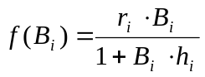 Eq. 26
where, r_{i} is the maximum production/biomass ratio that can be realized (for low B_{i}’s), and r_{i}/h_{i} is the maximum net primary production when the biomass is not limiting to production (high B_{i}’s). For parameterization it is only necessary to provide an estimate of r_{i} / (P_{i}/B_{i}), i.e., a factor expressing how much primary production can be increased compared to the base model state. If a Forcing function is applied to primary production (see Apply FF (primary producer), it multiplies the r parameter in Equation 67.

Nutrient cycling and nutrient limitation in Ecosim
Ecosim uses a very simple strategy to represent nutrient cycling and potential nutrient limitation of primary production rates. It is assumed that at any instant in time the system has a total nutrient concentration N_{T}, which is partitioned between nutrient ‘bound’ in biomass versus free in the environment (accessible to plants for nutrient uptake). That is, T is represented as the sum N_{T}=∑_{i}ŋ_{i}B_{i} + N_{f}, where ŋ_{i} is (fixed) nutrient content per unit of pool i biomass, and N_{f} is free nutrient concentration. Then assuming that N_{T} varies as dN_{T}/dt = I - vN_{T}, where I is total inflow rate to the system from all nutrient loading sources and v is total loss rate from the system due to all loss agents (volume exchange, sedimentation, export in harvests, etc.), and that v is relatively large, N_{T} is approximated in Ecosim by the (possibly moving) equilibrium value N_{T} = I/v.
Changes in nutrient loading can be simulated by assigning a time forcing function number to N_{T} on the Ecosim parameters form, in which case N_{T} is calculated as N_{T} = f_{t} N_{T}º where N_{T}º is the Ecopath base estimate of N_{T} (at the start of each simulation) and f_{t} is a time multiplier (f_{t} = 1 implies Ecopath base value of N_{T}) supplied by the user the same as any other time forcing function. Note that under the moving equilibrium assumption, changes in f_{t} can be viewed as caused by either changes in input rate I or nutrient loss rate v.
The Ecopath base estimate N_{T}º of total nutrient is entered by specifying the base free nutrient proportion p_{f} = N_{f} / N_{T}º on entry to Ecosim (also on the Ecosim parameters form: Time dynamic (Ecosim) >Input > Ecosim parameters), from which the Ecosim initialization can calculate N_{T}º as simply N_{T}º = ∑_{i} ŋ_{i} B_{i} / (1-p_{f}). Note here that the units of nutrient concentration are contained in the per-biomass relative nutrient concentrations ŋ_{i}, and these need not be specified in any particular absolute units. During each simulation, N_{f} is varied dynamically by setting it equal at any time to N_{T} - ∑_{I} ŋ_{i} B_{i}, so that accumulation of nutrient in any biomass pool(s) can reduce free nutrient available to promote primary production.
Primary production rates for producer pools j are linked to free nutrient concentration during each simulation through assumed Michaelis-Menten uptake relationships of the form PB_{j}=PB_{max,j} N_{f}/(K_{j}+N_{f}), where the parameters PB_{max,j} and K_{j} are calculated as part of the Ecosim initialization using input estimates by the user of the ratios PB_{max,j} / PB_{Ecopath,j} (Ecosim Group Info interface). The Michaelis constant K_{j} is set so that PB_{j} = PB_{Ecopath,j} when N_{f} is at the initial concentration determined by N_{T} - ∑_{I} ŋ_{i} B_{i} when all B_{i} are at Ecopath base values). The user can increase sensitivity to changes in nutrient concentration (make PB_{j} more variable with changes in N_{T} and N_{f}) by increasing the input PB_{max,j} / PB_{Ecopath,j} ratio.
The default free nutrient proportion p_{f} is set at unity, which causes N_{f} to be virtually constant over time (and hence PB_{j}’s to be virtually independent of nutrient concentration changes). Thus to “turn on” nutrient limitation effects, you must set a lower value for p_{f}, (e.g., 0.3) on the Ecosim parameters form.
Users should be aware that this simple approach to accounting for nutrient limitation can interact with the numerical method used to simulate very fast phytoplankton dynamics over time, to cause numerical instability or “chattering” in the values of phytoplankton biomass. This happens mainly in cases where pf is low, so that N_{f} is initially small. Then any biomass decline in the system (e.g. due to decline in zooplankton biomass) results in a relatively large increase in N_{f}, which can cause an over-response in the calculated phytoplankton biomass(es) B_{j}, which then drives N_{f} to near zero, which in turn causes too large a decrease in calculated B_{j} for the next monthly Ecosim time step.
Chattering can be reduced by using the Runge-Kutta integration option and/or higher pf settings. Improved numerical integration procedures should allow us to avoid the problem entirely in future Ecosim versions, but at present the computational cost of avoiding the problem by ‘brute force’ (shorter simulation time steps) would be prohibitively expensive of computer time.
Note further that the single free nutrient concentration N_{f} is linked to all primary producer groups in the model (through the uptake kinetics-PB relationships), implying competition among all plant types in the model for free nutrients. This can cause major shifts in primary production structure over time, e.g. between benthic and pelagic primary production and between grazeable and non-grazeable algal types.

Density-dependent changes in catchability
In fisheries modeling we usually represent the fishing mortality rate F as a product of catchability q times fishing effort f:
F = qf
Here the catchability q represents the mortality rate caused by a unit of fishing effort, or in intuitive terms the proportion of the stock harvested by a unit of fishing effort. A useful way to think about q is in terms of the spatial or Effort response power ganization of fishing: if each unit of effort ‘sweeps’ an area ‘a’ while the stock is distributed over a total area A, and if effort is randomly distributed within A, then q=a/A. There are two problems with this formulation:
  - A is generally seen by both fish and fishers as a much smaller area than the map area over which you might display a stock’s range (neither fish nor fishing are randomly distributed, so A is generally much smaller than the map range area for a stock), so we usually cannot predict q from simple analysis of gear swept area and total range area; and
  - almost always, the actual area A occupied by fish and fishers decreases with decreasing fish abundance, (i.e., the occupied range ‘collapses’ as stock size decreases) due to fish behaviors like shoaling and also cumulative effects of localized stock depletion events. The second problem is particularly important for fisheries analysis, since it implies that q increases, sometimes grossly, as A decreases (q = a / A increases when A decreases) whether or not there is a change in fishing technology as represented in the area swept per unit effort.
On entry to Ecosim, Ecopath has provided a base fishing rate F_{o} = Catch / (Ecopath biomass). You can specify time scenarios for F (F_{t}, t > 0) relative to this F_{o} by using either the fishing rate ‘sketch pad’ interface (Ecosim Biomass form) or time reference data files (see Time series). The Ecosim default is to treat your time series values as relative or absolute fishing rates without reference to changes in q. But you can also treat the time input values as relative fishing efforts f_{t}, where f_{o} = F_{o} (efforts scaled so base q_{o} = 1). Then to create density-dependent catchability effects, set a value greater than 1.0 for the q_{max} / q_{o} ratio(s) in the Ecosim Group info form.
For example, setting a value of 5 represents assuming that q can be as much as 5 times higher than the q that led to the Ecopath base F_{o}, if stock size is very low. That is, suppose you set q_{max} / q_{o} = 5, then run a scenario where you shape the relative fishing rate over time (now treated as relative effort) so as to cause a gross stock depletion followed by a return to f_{t} = f_{o}. In this scenario, the ‘realized’ fishing rate F_{t} can be as much as 5 times F_{o} even for f_{t} = f_{o}, due to density-dependent decrease in the effective area A occupied by the depleted stock.
Internally, Ecosim represents the density-dependent effect by calculating time dependent fishing rate Ft using the equation F_{t} = f_{t} QR_{o} / [1 + (QR_{o} - 1) B_{t} / B_{o}], where
QR_{o} = q_{max} / q_{o}
is your specified catchability increase ratio, B_{t} is stock biomass, and B_{o} is Ecopath base biomass.
Note that this dependence is applied to the individual group fishing rates rather than the relative efforts by fishing fleets, to represent the idea that decreases in area occupied by a stock (A) when biomass B_{t} is less than the Ecopath base biomass B_{o} are likely to result in concentration of efforts by fishers in general. If you need to represent a differential change in availability of fish to some particular fleet(s) but not others, you will need to develop an Ecospace model that explicitly represents spatial distinctions in where particular gears can operate. Note further that the QR parameter is not used in Ecospace: we assume random distribution of effort within each Ecospace cell, recognizing that Ecospace can already represent larger-scale range changes and associated changes in the spatial concentration of fishing effort.
In Ecosim scenarios where you do choose to treat the time input fishing information as relative fishing efforts f_{t} rather than absolute fishing rates F_{t}, you should be quite careful to recognize that catchability often increases quite dramatically for low values of B_{t}/B_{o}. QR values (q_{max}/q_{o}) of 5 to 10 are not uncommon in the fishery literature, especially for shoaling fishes like herring, sardine, and spawning cod. Further, modern fishing technologies like side-scan sonar and GPS are making fishers ever better at concentrating their swept areas ‘a’ within the actual areas A where fish are concentrated (probability of a sweep of area ‘a’ not being within the occupied area A has decreased dramatically). Even where there are not such technological changes, fishers are generally capable of making very good assessments of A just by combining their own search information with observation of where other fishers are doing well.
Note that you generally do not want to set QR > 1 for ‘reconstruction’ scenarios where you have provided historical F_{t} estimates based on single-species assessment methods such as virtual population analysis (VPA) or stock synthesis. Presumably these methods have already accounted for density dependent effects on q, by calculating F_{t}=(historical catch)/(estimated stock biomass) without regard to whether the historical catch was high relative to biomass because of catchability changes or changes in total fishing effort. But you should check the single species assessment method carefully, to insure that the method did not make an inappropriate assumption about stability of q in its reconstruction of historical biomass, (e.g., was fitted to the data using historical effort data under a constant q assumption, or was ‘tuned’ to historical catch per effort data uncorrected for temporal/stock dependent changes in q).

Modelling effort dynamics
Ecosim users can specify temporal changes in fishing fleet sizes and fishing effort in three ways:
      - By sketching temporal patterns of effort in the model run interface;
      - By entering annual patterns via reference “csv” files along with historical ecological response data; and
      - By treating dynamics of fleet sizes and resulting fishing effort as unregulated and subject to fisher investment and operating decisions (“bionomic” dynamics, fishers as dynamic predators).
To facilitate exploration of alternative harvest regulation policies, the Ecosim default options are (1) or (2). However, users can invoke the fleet/effort dynamics model by checking the box on the Biomass form. Input parameters must be set on the Fleet size dynamics form.
When the fleet/effort response option is invoked, using the checkbox on the Ecosim Biomass form, Ecosim erases all previously entered time patterns for fishing efforts and fishing rates, and replaces these with simulated values generated as each simulation proceeds. The fleet/effort dynamics simulation model uses the idea that there are two time scales of fisher response:
1) A short time response of fishing effort to potential income from fishing, within the constraints imposed by current fleet size, and
2) A longer time investment/depreciation ‘population dynamics’ for capital capacity to fish (fleet size, vessel characteristics).
These response scales are represented in Ecosim by two ‘state variables’ for each gear type g.
Fast time response model
E_{g,t} is the current amount of active, searching gear (scaled to 1.0 at the Ecopath base fishing mortality rates), and K_{g,t} is the fleet effort capacity (E_{g,t}<K_{g,t}).
At each time step, a mean income per effort index I_{g,t} is calculated as
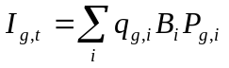
where i = ecological species or biomass group, q_{g,i} is the catchability coefficient (possibly dependent on B_{i}) for species i by gear g, and P_{g,i} is the market price obtained per biomass of i by gear g fishers. Also, mean fleet profit rates PR_{g,t} for fishing are calculated thus:
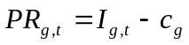
where c_{g} is the cost of a unit of fishing effort for gear g (cost and price factors are entered via the Definition of fleets and Market price forms). For each time step, the “fast” effort response for the next (monthly) time step is predicted by a sigmoid function of income per effort and current fleet capacity:
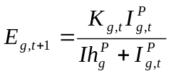
Here, Ih_{g} and p are fleet-specific response parameters. Ih_{g} is the income level needed for half maximum effort to be deployed and p is a “heterogeneity” parameter for fishers: high p values imply all fishers “see” income opportunity similarly, while low p values imply fishers “turn on” their effort over a wide range of mean incomes, as shown in Figure 3.12.
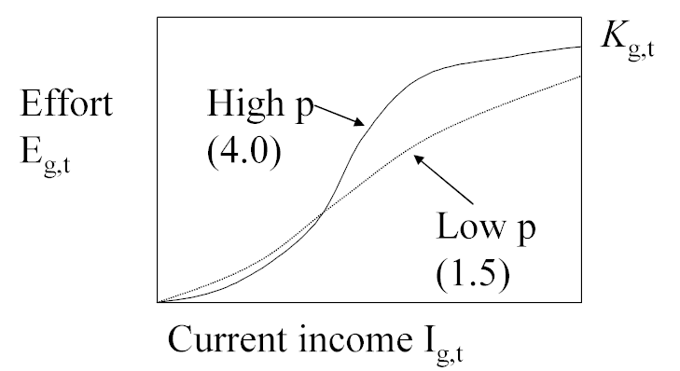
Figure 3.12. Effect of the ‘heterogeneity’ parameter, p, on effort/income function.
Slow time reponse model
For each fleet, slow effort responses are modelled as changes in fleet capacity (K_{g,t}), which is a function of the capital depreciation rate ρ_{g}, the capital growth rate r_{g,t} and profit PR_{g,t}. The capital growth rate is calculated via a growth factor gf_{g,t}, i.e.,
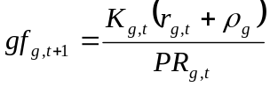
where K_{g,1}, ρ_{g} and r_{g,1} are set by the user. The annual capacity K_{g,t} is then updated as
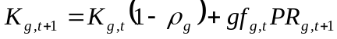.

Using Ecosim for Stock Reduction Analysis
A very useful technique for using long term data in stock assessment is Kimura’s “stock reduction analysis”. In this technique, historical catches are treated as fixed, known quantities, and are subtracted from simulated stock size over time so as to aid in estimating how large (and/or productive) the stock must have been in order to have sustained those catches and to have been reduced by some estimated fraction from its historical level. In some assessment literature, treating catches as fixed knowns is also called “conditioning on catch”. A drawback of treating catches as fixed values is that catches in fact arise from the interaction of fishing effort and abundance, and ignoring this dynamic interaction amounts to treating the catches as purely depensatory impacts on stock size (when simulated stock size declines, the fixed catches can cause progressively larger calculated fishing mortality rates F, leading to a depensatory spiral of rapid collapse in the simulated stock, which may or may not have been possible in the real system).
When creating historical reference csv files for model testing (see Import time series), all or part of a catch time series for any group(s) can be treated as a forcing input (with simulated F calculated each year as (input catch)/(simulated stock size) ) by setting its data type to -6 (rather than the usual 6 for fitting catch data). Note that the catch time series for a group can be entered in two columns, with one column set to data type 6 and one to data type -6, where catches for years to be treated as forcing are placed in the -6 column and catches for years when catch is to be predicted from effort or assessment Fs placed in the 6 column. Most often, this splitting of catches into two columns should be used in cases where there are no independent assessments of F for some early years.
The Monte carlo simulation interface in Ecosim can be used to search for ecopath biomasses needed to have sustained historical catches. We cannot search for such initial biomass values by simple nonlinear search methods, due to the biomass constraints implied by ecopath mass balance. The Monte carlo simulation interface can do a large number of simulations with randomly varying trial values of ecopath biomasses, and can retain trial values that result in improved model fit; such a search or fitting procedure is known as a “Matyas search”.

Hatchery populations in Ecosim
Multi-stanza populations can be designated as hatchery populations, and hatchery production can be varied over time using time forcing functions. To turn off natural reproduction and replace it with a time series of hatchery stocking rates, open the Edit multi-stanza groups form for a population from the Ecopath menu, and enter a nonzero value for the hatchery forcing function number. Forcing functions can be sketched using Ecosim’s Forcing function form or can be imported using Import time series on the Ecosim menu (set the data type to 2). Note that imported time series must be activated using the Time series form. After activating the imported time series, check the Forcing function form for the number allocated to your hatchery stocking time series. Note that forcing functions to represent historical changes in stocking rates can be entered via the same csv files as used to set up historical fishing and model fitting scenarios. Enter stocking rates as values relative to the stocking rate of 1.0 assumed for the Ecopath base year.
Then at each simulation time step, the base recruitment for the population (calculated from Ecopath input parameters) will be multiplied by the current time value for the designated forcing function. A forcing function value of 1.0 corresponds to the stocking rate that would result in the Ecopath base abundance (biomass) entered by the user.
Note also that if it is desired to simulate stocking of older fish at some age like 18 months, the first stanza for the population should be set to have this duration, the mortality rate (Z or P/B) for the stanza should be set to .001, and the diet for the stanza should be set to 1.0 imported (ie, do not have fish in the stanza feeding in the modeled ecosystem).

Parameter sensitivity
Ecosim does not (yet!) include any formal sensitivity analysis. Experience shows, however, that of the extra parameters added to those required by the typical Ecopath models, the most sensitive parameter is the vulnerability setting. This parameter expresses the exchange rate between the prey being in vulnerable and non-vulnerable states (see Figure 3.3).
The vulnerability parameter is in general not subject to direct measurement. There are, however, other ways of estimating it, and Ecosim includes two independent methods of estimation:
- Build Ecopath models for a system covering two different time periods, and use a routine included in Ecosim to search for vulnerability parameter settings that with the given exploitation rates will make it possible to move from the first to the second model state;
- Through fitting to time series data (see Fitting to time series data and Hints for fitting models to time series data).
It is possible and indeed recommended to use all of these methods to obtain estimates for the vulnerability parameters.

Introductory material: Ecospace

An overview of Ecospace
Real ecosystems are more complicated than the mass-balance fluxes of biomass in Ecopath, however large the number of functional groups we include in our models. Real ecosystems also have dynamics far more complex than represented in Ecosim. The issue to consider, when evaluating the realism of simulation software is, however, not how complex the software and the processes are therein. Rather, the question is which structure allows a representation of the basic features of an ecosystem, given a limited amount of inputs. On such criterion, it was obvious that the major deficiency of the Ecopath/Ecosim approach was its assumption of homogenous spatial behavior. This has been remedied through the development of Ecospace (Walters et al. 1999), a dynamic, spatial version of Ecopath, incorporating all the key elements of Ecosim.
Ecospace dynamically allocates biomass across a grid map (sketched with a mouse by the user, and typically defined by 20 x 20 cells), while accounting for:
- Symmetrical movements from a cell to its four adjacent cells, of rate m, modified by whether a cell is defined as ‘preferred habitat’ or not (running means over adjacent sets of five cells allows for smooth transitions between habitat types, which are also user-defined);
- User-defined increased predation risk and reduced feeding rate in non-preferred habitat;
- A level of fishing effort that is proportional, in each cell, to the overall profitability of fishing in that cell, and whose distribution can also be made sensitive to costs (e.g., of sailing to certain areas).
Given its recent origin, only few published applications of Ecospace have been published. However, those so far examined have a number of interesting implications, briefly reviewed below.
The first of these is that, as in the case of Ecosim, using Ecospace immediately after initial parameterization of an Ecopath model will often identify problems with that model. Particularly, predators assigned to a given habitat type must be able to encounter sufficient prey in that habitat. Indeed, this suggests that Ecopath models, though they do not explicitly consider space, always should contain implicitly spatial subsystems, with distinct food webs, corresponding to the habitat types to be defined in Ecospace. Moreover, definition of such subsystems leads to more robust simulations (less self-simplification) when the file is run under Ecosim. This, obviously reflects the fact that, in reality as well, spatial patterns do generate refuges from predation. It is those refuges that bring us to the last aspect of Ecospace to be discussed here.
Given its structure, Ecospace allows users to explore the potential role of Marine Protected Areas (MPAs) as a tool to mitigate, and perhaps reverse various ecosystem effects of fishing, notably the effects of ‘Fishing down marine food webs’. The results obtained so far (Walters et al. 1998, Walters 1999) suggest that, due to the effects of trophic cascades within MPA (as result of MPAs protecting predators, whose biomass will thus increase), and the net movements of predators toward food concentrations (i.e., out the MPA), the net effect of small MPAs may be to increase the catch of the fisheries that will invariably concentrate their operation near their perimeter. Only large MPAs, with short outer perimeter relative to their surface areas would be protected from this, as would MPAs in bays or gulfs, with limited adjacency to exploited areas.
See Getting started in Ecospace for details on how to start using Ecospace.

Representing seasonal migration in Ecospace
Larger organisms commonly have seasonal migration patterns that allow them to utilize favorable seasonal resource and environmental conditions over large spatial areas. Such movements can be represented in Ecospace in two ways. First is a simple “Lagrangian” approach that does not require explicit simulation of movement; the idea here is to simply think of the whole Ecospace map as moving in space so as to remain centered on the distribution of some dominant migratory specie(s). Second is a more complex “Eulerian” approach, which does involve explicitly modeling changes in instantaneous rates of biomass flow among the Ecospace spatial cells, in some way that approximates at least the changing center of distribution of the migratory species.
The Eulerian approach is implemented in Ecospace by allowing users to define a monthly sequence of “preferred” map cell positions (using the “Define migrations” button on the Ecospace Dispersal form, see Figure ), and to define how spread out the migrating fish are likely to be around these preferred cells by setting north-south and east-west “concentration parameters” on the Ecospace Dispersal form. The Define migrations button causes a map of the Ecospace region to be displayed, with migratory species and months of the year listed, see Figure . Preferred position for each month (and the annual trajectory of preferred positions) is set by simply clicking on this map; each such mouse click also triggers the interface to increment the entry month by 1, making it very simple to “sketch” the annual migration trajectory.
Unfortunately, there is no way to make the Ecospace migration simulations very simple to set up. Generally the user must do considerable numerical experimentation to find reasonable migration parameter values and a stable numerical solution scheme; these cannot be computed in advance since they depend on a variety of details about the spatial map grid and species movement characteristics. Here are a few key points to keep in mind while experimenting (by repeated simulations) with the migration interface:
  - If the monthly preferred cell positions are far apart (>2 or 3 cells apart), the user will need to set the Ecospace simulation time step short enough (on order of (1/12)/(mean number of cells between preffered locations), e.g., 0.08333/3=0.028 year when preferred cells are 3 rows-columns apart between months) to allow enough numerical integration time steps for animals to move between the preferred cells.
  - The concentration parameters are relative values that the user needs to set by trying alternatives (generally in the range 0.5 to 4.0) to see what values give general distribution patterns similar to those observed in the field. Low values (<1.0) lead to weak distortion of movement toward preferred cells and hence to more widely spread distributions, while high values (e.g. 3.0) give distributions strongly concentrated near the preferred cells.
  - Mean annual movement distances (Ecospace Dispersal form) have to be set large enough for migrating species to be able to “track” movements in preferred locations. As a general rule, set the base dispersal rate for migratory species to at least 100L km/yr., where L is mean body length in cm.
  - Setting high concentration parameter values (>2.0) and/or moving animals through a very complex map with many coastal blocking features can result in numerical instability in the Ecospace solution algorithm. The best way to correct this is to reduce the simulation time step; it may also be necessary to reduce the SOR w relaxation weight (Ecospace parameters form) used in solving the linear equations involved in the numerical scheme for integrating the spatial rate equations (an alternating implicit method).
  - Setting high concentration parameter values can also result in “overfishing”: Ecospace allocates total fishing effort over the map proportional to the total number of cells initially used by each fishing fleet, so when the model generates a concentrated distribution of some favored species, the total effort will concentrate accordingly and can sometimes generate very high fishing rates near the center of the migrating stock distribution. Remedies include reducing total effort (Ecospace fishery form, total effort multiplier) and distributing effort more widely (Ecospace fishery form, reduce value of “effective power”).
  - Concentrating a migratory predator can cause local depletion of food organisms and/or reduced per-predator feeding rates due to prey vulnerability limits. If these effects cause simulated total predator biomass to incorrectly decline over time (and if the user determines that the declines are not due to an artifactual overfishing effect), then it may be necessary to either increase total prey abundances (in Ecopath) or vulnerability of prey to the predator (Ecosim Vulnerabilities form).
  - Split group and multi-stanza population dynamics may behave strangely or incorrectly when one or more life history stages are migratory while other(s) are not. Ecospace does not keep track of the full population age/size distribution for each spatial cell (prohibitive memory and computing time requirement), and instead uses a running equilibrium approximation to the population composition. This approximation tends to “dampen” abundance fluctuations in the early life history stanzas that might be created by, for example, seasonal movement of the adults to spawning locations near preferred juvenile habitats.
The mathematical method used in Ecospace to create migratory behavior is quite simple. Spatial movement is represented in general in Ecospace as a set of instantaneous exchange rates across the boundaries of adjacent spatial cells. For migratory species, these exchange rates are simply multiplied by relative factors at each simulation time step, where the factors depend on distance from the preferred cell for that time step as shown in Figure 68.
(The function is reversed for movement across northern cell boundary, and similar function is used for east-west movements with map column-preferred column as the independent variable). The factor has no effect (multiplies movement rates by 1.0, so movement rates are similar in all directions) for cells near the preferred cell, and ‘shuts down’ movement away from the preferred cell for cells far from that preferred cell. Note that the base movement rates that are multiplied by the migration factors may not be the same in all directions to start with; these base rates can include advection effects and/or increased/oriented movement rates towards preferred habitat types. That is, migration effects can be combined with advection and orientation of movement toward preferred habitats; it was the desire to represent such combined effects that motivated the multiplicative factor formulation in the first place.

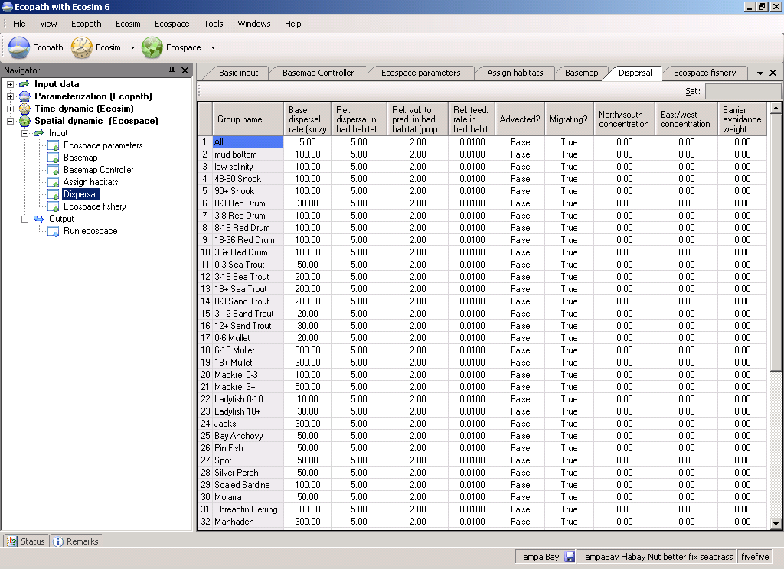

Figure 4.1. Ecospace dispersal rates and habitat specific information. Migration patterns are also defined on this tab.

GRAPHIC HERE
Figure 4.2. Seasonal migration in Ecospace. Indicate center of gravity for each month for each migrating group.

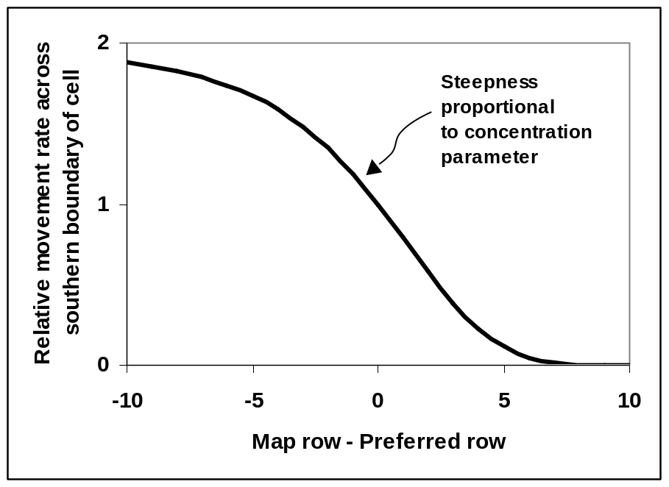
Figure 4.3. Relative movement rates; see text for details.

Advection in Ecospace
Advection processes are critical for productivity in most ocean areas. Currents deliver planktonic production to reef areas at much higher rates than would be predicted from simple turbulent mixing processes. Upwelling associated with movement of water away from coastlines delivers nutrients to surface waters, but the movement of nutrient rich water away from upwelling locations means that production and biomass may be highest well away from the actual upwelling locations. Convergence (down-welling) zones represent places where planktonic production from surrounding areas is concentrated, creating special opportunities for production of higher trophic levels.
Ecospace provides a user interface for sketching general current patterns or wind/geostrophic forcing patterns for surface currents. Based on these patterns Ecospace calculates equilibrium horizontal flow and upwelling/down-welling velocity fields that maintain continuity (water mass balance) and effects of Coriolis force. That is, the advection field is calculated by solving the linearized pressure field and velocity equations df / dt = 0, dv_{u} / dt = 0, dv_{v} / dt = 0 across the faces of each Ecospace grid (u,v) cell, where f is sea surface anomaly, the v’s are horizontal and velocity components (u, v directions) and the rate equations at each cell face satisfy (omitting grid size scaling factors for clarity):
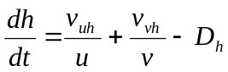 Eq. 27
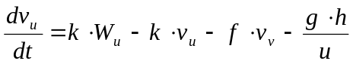 Eq. 28
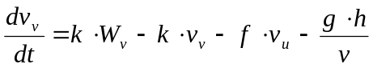 Eq. 29
Here, the W’s represent the user sketched forcing or general circulation field, h sea surface anomaly, k represents bottom friction force, f the Coriolis force, D represents downwelling/upwelling rate, and g acceleration due to sea surface slope.
Solving these equations for equilibrium is not meant to be a replacement for more elaborate advection models; generally the W_{u} and W_{v} need to be provided either by such models or by direct analysis of surface current data, so the Ecospace solution scheme is only used to assure mass balance and correct for ‘local’ features caused by bottom topography and Coriolis forces. That is, absent shoreline, bottom, and sea surface anomaly (h) effects, the equilibrium velocities are just v_{u} = W_{u}, v_{v} = W_{v} up to corrections for Coriolis force. We could just allow users to input the W fields and then calculate upwelling/downwelling rates needed to satisfy these, but solving the equations using general forcing sketches of W patterns allows us to internally correct for factors such as topographic steering of currents near shorelines, without demanding that the user enter W fields that precisely maintain mass balance (and/or correct upwelling/downwelling velocities) absent any correction scheme.
Once an advection pattern has been defined, the user can specify which biomass pools are subject to the advection velocities (v_{u},v_{v} field) in addition to movement caused by swimming and/or turbulent mixing. This allows examination of whether some apparent ‘migration’ and concentration patterns of actively swimming organisms, (e.g., tuna aggregations at convergence zones) might in fact be due mainly to random swimming combined with advective drift.
Advection fields can be read from text files. The procedure for this is as follows:
Create a .txt file, (e.g., in Notepad) with the following structure:
Number of columns in Ecospace basemap (nRow) ; Number of columns in Ecospace basemap (nCol)
Number of Months
(For each of the months specify the following:
Month Number
(For this month specify for 0 to nRow + 1, and for 0 to nCol+1, unit: m/s)
Current X-velocity, Current Y-velocity
(Repeat this for all months)
Currents for the Central Pacific may be obtained in a suitable format from http://www.oscar.noaa.gov/datadisplay/index.html)

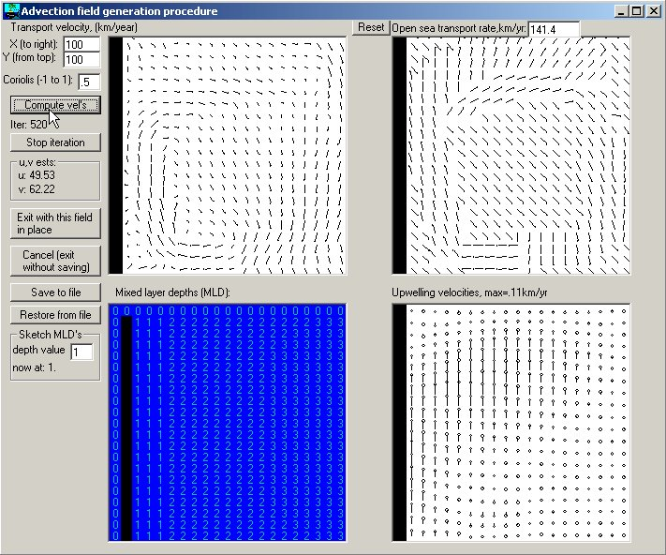

Figure 4.4. Ecospace advection model interface

Fitness-driven dispersal behavior in Ecospace (by Bob Lessard)
The default assumption in Ecospace is that dispersal and migration rates for each biomass pool are stable over space and time, except for ‘hardwired’ seasonal migration patterns. This default setting ignores the possibility that movement rates (and possibly directions) are dependent on local ‘fitness’ conditions, as measured by food intake rates and predation risk. For at least some species, at least dispersal (emigration) rates may well depend on local resource conditions and/or predation, with creatures having having higher probabilities of leaving areas where fitness is lower. Such behaviors could have major implications for design of marine protected areas, since food resource densities (for predators) are likely to be lower in protected areas, and predation risks (for smaller species) are likely to be higher in protected areas. Thus for a variety of creatures, emigration rates from protected areas might be considerably higher than base rates measured under relatively low (pre-protection) conditions.
Ecospace allows you to explore two alternative hypotheses about fitness-driven dispersal rates:
- Total emigration rates are inversely proportional to fitness in each spatial cell, without these rates being spatially oriented or biased toward more more favorable cells (‘Type 1’ fitness response);
- Emigration rates are proportional to the difference in fitness between each source cell and each cell around it, i.e. dispersal rates are higher across cell faces representing directions of higher fitness and are lower in directions toward cells or areas of lower fitness (‘Type 2’ fitness response).
The first of these hypotheses represents the idea that organisms may only be able to detect local “comfort” conditions, while the second represents the possibility that organisms can detect local spatial gradients in fitness. For both hypotheses, fitness for each cell i,j for each time step is represented by the per-capita growth minus mortality rate index f = gq_{i j} - Z_{ij}, where g is growth efficiency, q_{ij} is per capita food intake rate (Q/B) in cell ij, and Z_{ij} is total mortality rate in the cell. Note that q_{ij} can be a complex function of food resources in the cell, and Z_{ij} represents combined impact of all predators in the cell. Further, these fitness components may vary dramatically over both space and time.
To simulate fitness-driven dispersal in Ecospace, you must make three parameter settings:
- For each species/group that is to show the behavior, set the ‘Migrating?’ cell to ‘True’ in the Ecospace Dispersal form (species is treated as migratory even if it does not have a particular seasonal migration pattern);
- On the Ecospace Define Habitat form, set the text box for movement type of migratory species to 1 or 2, representing the two alternative movement hypotheses defined above (the movement type hypothesis is applied to all migratory species in any one Ecospace run);
- On the Ecospace Define Habitat form, set the ‘inverse of emigration response to fitness’ text box to a scaling parameter for the severity of the movement response for low-fitness cells. High values of this parameter (e.g. 100) make the response very weak, while low values (e.g. 0.1) make the response very strong.
The main thing that can go wrong with these settings is to use too low a value of the emigration response scaling parameter. Low values like 0.1 commonly result in spatial instability in the predicted biomass patterns (organisms overreacting to local conditions so as to successively over- and under- use adjacent cells), and can result in numerical instability in the predictions of overall biomass change (typically indicated by growing total biomass over time).
Note that seasonal migration and fitness response hypotheses can be combined to give more realistic simulations of migratory species. That is, the migration interface button (Ecospace dispersal tab) can be used to set up a ‘typical’ or normal seasonal migration pattern, and this pattern will then be modified from year to year in response to changes in spatial distributions of prey resources and/or predation risk.

Prediction of mixing rates
The instantaneous emigration rates from a given cell in Ecospace are assumed to vary based on the pool type, the groups preference for the habitat type represented by the cell, and a ‘risk ratio’ representing how the organisms in the cell respond to predation risk. Base dispersal rates are calculated based on this, but weighted based on a habitat gradient function increasing the probability of organisms moving towards favorable habitats. The mechanisms involved in this procedure are explained in more detail by Walters et al. (1999).

Predicting spatial fishing patterns
EwE works with multiple fishing fleets, with fishing mortality rates (F) initially distributed between fleets based on the distribution in the underlying Ecopath base model. In Ecospace the F’s are distributed using a simple ‘gravity model’ where the proportion of the total effort allocated to each cell is assumed proportional to the sum over groups of the product of the biomass, the catchability, and the profitability of fishing the target groups (Caddy, 1975; Hilborn and Walters, 1987). This profitability of fishing includes factors such as the cell-specific cost of fishing.
Assuming that there are N cells representing water areas, each fleet k can cause a total fishing mortality rate N · F_{k}. For each step in the simulation this rate is distributed among cells, c, in proportion to the weights G_{kc} based on:
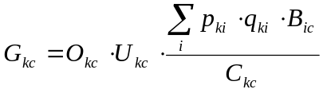 Eq. 30
where O_{kc} is 1 if cell c is open to fishing by fleet k, and 0 if not; U_{kc} is 1 if the user has allowed fleet k to work in the habitat type to which cell c belongs, and 0 if not; p_{ki} is the relative price fleet k receives for group i fish, q_{ki} is the catchability of group i by fleet k (equal to the F_{ki} in the Ecopath model); B_{ic} is the biomass of group i in cell c; and C_{kc} is the cost for fleet k to operate in cell c. Based on the weights in Eq. 30 the total mortality rate is distributed over cells according to
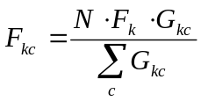 Eq. 31

while each group in the cell is subject to the total fishing mortality
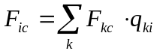 Eq. 32

Numerical solutions
Ecospace is based on the same set of differential equations as used in Ecosim, and in essence performs a complete set of Ecosim calculations for each cell for each time step. This represents a formidable amount of computations, but fortunately it has been possible to take a number of shortcuts to speed the processing up to an acceptable rate. Briefly explained the background for this takes its starting point in Eq. 20 (on page 28), which expresses the rate of change for each biomass pool over time. If the rate constants were constant over time (they are not, but if!) the biomass would change as a linear dynamical system, and would move exponentially towards an equilibrium given by (omitting indices for cell and biomass pools)
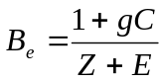 Eq. 33
while following the time trajectory
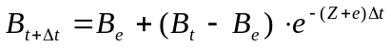 Eq. 34
Denoting the exponential weight term above W_{t} this can be re-expressed as,
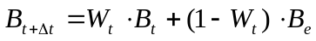 Eq. 35
Hence, if input and output rates were constant, the time solutions would behave as weighted averages of past values and equilibrium values with weights depending on the mortality and migration rates. Using expressions of the type in Eq. 35 the Ecospace computations can be greatly increased by using a variable time splitting where moving equilibria are calculated for groups with high turnover rates, (e.g., phytoplankton), while the integrations for groups with slower turnover rates, (e.g., fish and marine mammals) are based on a Runge-Kutta method. Comparisons indicate that this does not change the resulting time patterns for solutions in any noticeable way – hence, the ‘wrong’ assumption of time rate constancy introduced above is useful for speeding up the computations without noticeable detraction of the final results. The resulting computations are carried out orders of magnitude faster than it the time splitting was not included.

Ecopath with Ecosim 6: Getting started

How to obtain the Ecopath with Ecosim 6 software
The setup programme for Ecopath with Ecosim 6 (EwE 6) can be downloaded from www.ecopath.org. Alternatively (write, fax or email us and we will send you a CD with the setup software). We strongly encourage all users to register with us (with email address) so that we can keep you informed of new releases, bugs, etc.
So far more than 200 Ecopath models have been published. References to many of these are included in this guide. We are collecting manuscripts and publications with includes Ecopath applications, and would appreciate being notified (or even better to receive copies) of such work. Published Ecopath models can be downloaded from www.ecopath.org.

Software support, copyright and liability
The software is copyrighted but not copy-protected. You may freely copy and distribute the program and the documentation as long as this is not done commercially. Please inform us when you copy the software to anyone, or if you received it from someone else. This will enable new users to be registered (free of charge), and thus to be informed of new developments, bugs, etc. At the same time, you are invited to send brief descriptions of your ecosystem models to the authors, initially for inclusion on www.ecopath.org.

Installing and running Ecopath with Ecosim
Installation is done via a customized third-party setup program. Simply click on the link to the setup programme on the Ecopath website (www.ecopath.org) and choose Run. Some browsers will give a warning that the software is from an unknown publisher, click Run if you get this warning. Then follow the prompts to for saving the software. If you wish to use the Network Analysis functions, make sure the Network Analysis plug in box is checked when prompted. Click Install then Finish to complete installation. An icon for running the software will be placed on your desktop. Otherwise, navigate to the directory in which the model was saved (default: C:\Program Files\Ecopath with Ecosim 6) and run the programme (EwE6.exe) from there.
Some test data sets are included for the initial testing of the software. You can open these from the File menu.

Previous versions
Models built using EwE 5 (versions xx and later), can be converted to EwE 6 format using the Ecopath Database Conversion Wizard. When you select the old database using Open model on the File menu you will be prompted by the wizard to choose a model to extract from the old database. Select the model you wish to open and follow the prompts. EwE 6 will extract the model to a new database and save it in the same directory as the old EwE 5 database (or you can choose a new location).
Ecopath with Ecosim. Ecopath with Ecosim can only be run on PCs with a 32-bit operating system, such as Windows 95/98/Me/XP or Windows NT4/2000.

Getting help
Pressing F1 at any time while running the Ecopath program will open the Ecopath help file and give you context-sensitive help. You can also search the help files using the Help menu. Should you have problems not easily solved using the help files or this guide we encourage you to contact us for support.

General features of the Graphic User Interface
EwE 6.0 has a markedly different look to any previous version of EwE, representing much improved navigability of the software. After opening an EwE model, you will see an interface similar to that shown in Figure 5.1, consisting of:
1. Menu bar
2. Shortcut buttons
3. Navigator window
4. Main screen
5. Tabs bar
6. Status tab
7. Remarks tab
8. Status bar
Note: click on Basic input on the Navigator window to see the Ecopath model groups.
All input and output forms are listed in a nested directory in the Navigator window (see section below), enabling users to move intuitively through the steps of building and using a model. A key feature of the Graphic User Interface (GUI) is the ability to select forms from the Navigator window and display them as tabulated windows on the Tabs bar. This allows you to switch easily among forms in current use.
Users can change the look of the GUI using a number of features available on the Tools menu. In addition, any of the windows in the GUI can be hidden or visible, docked (locked in place) or floating, or can be docked to new locations. Floating windows are a particularly useful feature for users with multiple monitors as one form can be edited whilst referring to others.
A window can be switched from visible to hidden mode using the push pin icon (AutoHide) on its title bar. To switch from visible to hidden mode, click on the vertical AutoHide icon () then move your mouse away from the window and click elsewhere on the screen. It will be hidden and a tab will appear that gives you access to the hidden window. To view the window temporarily click on the tab. To switch back to visible mode, click on the horizontal push pin icon () whilst viewing the window.
Any window that is in visible mode () can be moved to a floating window or docked to a new location. To move a window, click on the title bar at the top of the window (or its tab if it is on the Tabs bar) and move the mouse whilst holding down the left mouse button. A transparent blue box and a set of window dropper icons will appear (e.g., ). To move to a floating window, drop the box anywhere on the screen except on the dropper icons. To move to a new docked location, position the mouse over the dropper icon where you would like to dock the window and release the mouse button. Use the centre docking icon () to lock a window to the Tabs bar.
If you have checked “Save window layout” on the Tools menu, changes in layout will be preserved next time you open the model.
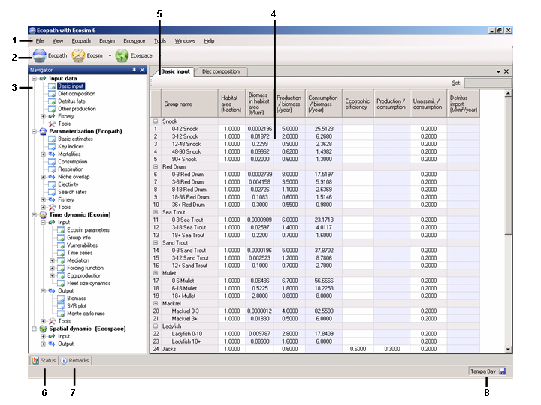
Figure 5.1. EwE 6.0 user interface, showing the basic parameter input screen. Numbers refer to the features listed at the beginning of Section 2.2.
1. Menu bar
The Menu bar contains the File, View, Ecopath, Ecosim, Ecospace, Tools, Windows and Help menus, allowing users to open, close and save models, set preferences and access Help files. This section details the menu options available on the menu bar, including instructions for opening, closing and saving models and for setting your preferences and getting help.
2. Shortcut buttons
The Ecopath, Ecosim and Ecospace shortcut buttons provide quick access to existing Ecopath models and Ecosim and Ecospace scenarios.
3. Navigator window
The Navigator window is the main navigation tool in EwE 6.0. Expanding menus provide access to all the features of Ecopath, Ecosim and Ecospace. Clicking on menu items (e.g., Basic input or Diet composition) displays these items in the Main Screen where they can be viewed and edited.
To make navigation easier, the menu nodes in the Navigator window are color coded. Green coded nodes open input forms (forms where you enter data). Blue coded nodes open output forms (forms where model results are displayed in the form of tables or graphs). Menu nodes with a “+” icon can be expanded to reveal more nodes.
Close the Navigator window by unchecking the Navigator option on the View menu or by clicking the close button at the top of the bar. The Navigator window can be hidden using the AutoHide button () on the title bar (see General features of the Graphic User Interface above). Note that you must click elsewhere on the screen before the Navigator window will disappear.
4. Main screen
The Main screen shows the forms where Ecopath, Ecosim and Ecospace model inputs are entered and edited. Model results are also displayed here. Note that nothing is displayed in the Main screen until a menu item is selected on the Navigator window. Once an item has been selected (e.g., Basic input table) it is added as a tab to the Tabs bar so that you can easily return to it after other items have been displayed.
General note about input forms. All input forms (coded with a green arrow in the Navigator window) have a Set box in the top right corner for entering values into multiple cells. For example, you may wish to enter the same value of a parameter for several groups at once. Highlight the cells for the groups you wish to have the same value and type it into the Set box. Note that you can only do this for one model variable at a time.
5. Tabs bar
The Tabs bar provides an easy means of switching between model forms. Tabs are added as they are selected on the Navigator window, enabling easy movement among forms currently in use. You can view forms simply by clicking on the tabs or by selecting them from the list under the down arrow on the right hand side of the toolbar. You can also select a form to display by checking it in the Windows menu.
The current form can be closed using the close button at the end of the Tab bar or by using the Close option on the Windows menu. You can close all open forms using the Close All Tabs option on the Windows menu.
Any form can be dragged and dropped to a floating window or docked to a new position by dragging it by the tab whilst holding down the left mouse button (see General features of the Graphic User Interface above).
6. Remarks tab
Many of the input tables allow you to enter comments and extra information about the data that have been entered.
To add a comment, select the desired cell and click on the Remarks tab to open the Remarks window. Remarks can then be entered or edited here. Remarks can be viewed later by holding your mouse over commented cells (marked with a flag in the corner) or by selecting the commented cell and clicking on the remarks button. Note, if no cell is selected, a “No selection” message will be displayed in the Remarks window. The Remarks window can be switched to visible mode by clicking on the horizontal push pin icon () whilst the window is open.
7. Status tab/Status panel
EwE 6.0 keeps a log of model actions in the Status panel, which opens when you pass your mouse over the Status tab. The Status panel can be switched to visible mode by clicking on the horizontal push pin icon () whilst the window is open.
Three types of message are displayed in the Status panel:
- Information messages []. Information messages provide feedback on regular events in EwE. Information events are confirmations of things that went well. Examples are opening the model; successful edits; and successful balancing (i.e., parameterization) of the model. Clicking and holding the mouse button over each message highlights the relevant cells in red [ ].
- Warning messages []. Warnings occur when EwE was not able to complete an action and requires the user to fix a problem, usually with the input data. For example, one of the most important of these is when parameterization fails (i..e., the model fails to balance). When this occurs, you will get the message “Your model is NOT balanced! Computed Ecotrophic Efficiencies (EE) invalid for one or more group(s).” Clicking on the “+” icon next to this message expands the message to show which groups are causing the problem. Clicking and holding the mouse button over each warning message highlights the problem cells in red [ ]*
- Critical messages []. Critical messages are very rare and should not be encountered during normal use of the software. Users encountering critical messages should try closing and re-opening the program. If the problem persists, please contact us through www.ecopath.org.
You can clear one or all messages in the status panel by right clicking on the message or panel.
*See Ecopath parameterization for important information about parameterizing Ecopath models. You should not proceed to Ecosim or Ecospace before the model is successfully parameterized.
8. Status bar
The Status bar displays the name of the active model. If unsaved changes have been made to the model, a save icon appears to remind you to save your model. The Status bar can be switched off by unchecking the Status Bar option on the View menu.

File menu
The File menu allows you to open, close and save your model.
Files are managed so that all data pertaining to a given Ecopath model (including its Ecosim and Ecospace scenarios, etc.) are saved in a Microsoft Access database (extension ‘.mdb’).
Important note: EwE 6.0 differs from previous versions in that there is only one model per database. See Open model section below for information about opening and saving models that were built using previous versions of EwE.
New model (Ctrl +N)
Use this option to create a new Ecopath model. You will be prompted to name your new model and save it in the location of your choice. Click OK, and the new model will be created. There will be one group initially, ‘Detritus’. You should keep this group as your model must have at least one detritus group.
Note that you must create and balance an Ecopath model before you can use Ecosim or Ecospace.
See Chapter 3 for instructions on how to continue with creation of a new model.
Open model (Ctrl +O)
Choose Open model to open an existing Ecopath model. You will be prompted to locate and open your Ecopath database. Alternatively, use Recent models (see section below) to open models that have been used recently. Use the Navigator window to view and edit the components of the model once it is open.
Models built using EwE 5 (versions xx and later), can be converted to EwE 6 format using the Ecopath Database Conversion Wizard. When you select the old database using Open model you will be prompted by the wizard to choose a model to extract from the old database. Select the model you wish to open and follow the prompts. EwE 6 will extract the model to a new database and save it in the same directory as the old EwE 5 database (or you can choose a new location). Any subsequent changes to the model will be saved to the new database.
Close model
Closes model. You will be prompted to save if the model has been edited since the last save operation.
Save model (Ctrl +S)
Saves the model.
Save Model As…
Saves your model under a new name, i.e., creates a new copy, which you continue to work in.
Recent models
Recently-used models can also be opened from the list under the Recent models menu item.
Exit
Close EwE 6.0. You will be prompted to save if the model has been edited since the last save operation.

View menu
The View menu allows you to choose which features of the user interface are displayed. Features that can be switched on or off are the Start pane, Navigator window, Status panel, Remarks window and Status bar.

Ecopath menu
The Ecopath menu provides quick access to the forms you need to define the basic structure of your model. These are the Edit groups, Edit multi-stanza groups and Edit fleets forms. The EwE Network analysis plugin can also be accessed through the Ecopath menu.
Edit groups
The first task in building an Ecopath model is to define the model’s functional groups (called groups or sometimes boxes). Groups are species or collections of species that share similar population dynamics and ecological function. See Defining the system for more on how to define groups.
To open the Edit groups form, choose the Edit groups option on the Ecopath menu. See Edit groups for instructions on how to use this form.
Edit multi-stanza groups
Multi-stanza groups are groups in which two or more life-stages are represented (e.g., juveniles and adults). Multi-stanza groups are defined using the Edit groups form but further parameters must be entered using the Edit multi-stanza groups form.
To open the Edit multi-stanza groups form, choose the Edit multi-stanza groups option on the Ecopath menu. See Edit multi-stanza groups for instructions on how to use this form.
Edit fleets
To add fishing fleets, delete, name and sort the fleets in your model, choose the Edit fleets option on the Ecopath menu. See Edit fleets for instructions on how to use this form.
EwE Network Analysis plugin
Ecopath enables you to perform a number of analyses based on the network analysis theory of Ulanowicz (1986), accesible by selecting EwE Network Analysis Plugin on the Ecopath menu. Note that the EwE Network Analysis plugin can also be accessed from the Navigator window (Parameterization (Ecopath) > Tools > EwE Network Analysis Plugin).
See the EwE Network Analysis Plugin section for details on using these functions.
Note: to be able to access the EwE Network Analysis Plugin, it must have been installed with EwE 6.0. If you cannot access the EwE Network Analysis Plugin, you may need to re-instal the software (see How to obtain the Ecopath with Ecosim 6 software). During the setup process, you will be prompted to check a box to install the EwE Network Analysis Plugin.

Ecosim menu
See Getting started in Ecosim: The Ecosim menu for help with the items on this menu.

Ecospace menu
See Getting started in Ecospace: The Ecospace menu for help with the items on this menu.

Tools menu
Options…
The Options menu item opens a dialogue box containing the following features that allow you to set your preferences for using the software. The window on the left of the Options dialogue box contains a menu with two nodes: Application and Model. Click on the “+” buttons to expand the nodes.
Application
Change settings that apply to the general appearance and behaviour of the software.
General
Recent files
Set the number of recently-used files to display on the File menu. You can also clear the recently-used file list using the Clear history button.
Window layout
A feature of the EwE 6.0 is the ability to customize the appearance (layout) of the Graphic User Interface (GUI) by dragging and docking any of the windows (see General features of the Graphic User Interface). Checking the Save windows layout box saves changes to the appearance of the GUI for the next time the model is opened. Unchecking the box means that the model will be re-opened with the default layout. You can also set where the layout file is saved by typing it directly or using the browse […] button. Note that a different layout file is saved for each model.
Message display
Select Message to set the way that critical messages, warning messages and information messages are displayed (i.e., as a pop-up message; in the Status panel; or as a pop-up message in the Status panel).
Color
The Color options allow you to set the colors for a large number of components of the model and GUI.
Units
There are two basic choices for the ‘currency’ of your model: energy-related units (which imply a respiration term), and nutrient-related units (which imply no respiration term). Only models constructed using an energy-related currency (t·km²·year⁻¹) can be run under Ecosim and Ecospace.
Selection of the time unit does not influence any of the calculations in Ecopath (except for determining whether Ecosim/Ecospace can be assessed or not, see above). It affects only the labels on tops of the output forms, etc.
Use the Units interface to set the Energy, Time and Nutrients units used in your model. Default units for energy and time are wet weight (t·km²) and year respectively.
Model
Change settings that apply to the current model.
General
You can set the number of relevant decimal digits to be displayed. Relevant decimal digits are defined as digits that occur after the first non-zero decimal place. For example, if the number of relevant decimal digits is set to three, 0.3654 would be displayed as 0.365 and 0.0003654 would be displayed as 0.000365. Note that this is for display only and no rounding actually occurs in the running of the model. Double-clicking a number in a cell to edit it shows all the decimal places used in the calculations.
NOTE: For values calculated by the model (displayed in yellow-shaded cells, e.g., the Sum of the prey proportions in the Diet matrix) the number you set in this box will be used to set number of decimal places.
Color
Use this window to set the colors for individual model-groups. These colors will be displayed in Ecosim and Ecospace output plots.

Windows menu
Use the Windows menu to choose which open Tab is displayed on the Main Screen (Tabs are originally opened using the Navigator pane). You can close all currently open Tabs and the contents of the Navigator pane using the Close All Tabs option.

Help menu
Use the Help menu to search or browse the Help files. Context-specific help can also be obtained by pressing F1 on your keyboard at any time.

Using Ecopath. Part 1: Ecopath inputs

Introduction
This chapter describes the steps taken to build, parameterize and balance an Ecopath model. Chapter 1 of the User Guide gave a scientific overview of the fundamental features of Ecopath and descriptions of the basic equations governing Ecopath, in particular, the system of linear equations that Ecopath solves under the assumption of mass balance. Other major assumptions are also discussed in Chapter 1 and consideration is given to the types of data that are appropriate for use with Ecopath.
Before proceeding with the instructions below for building an Ecopath model, you are strongly encouraged to read Chapter 2 of the User Guide and thoroughly familiarise yourself with the relevant scientific literature, particularly the original Ecopath, Ecosim and Ecospace papers (Polovina 1984; Christensen and Pauly 1992; Walters et al. 1997; 1999; Christensen and Walters 2004).
The first task in building an Ecopath model is to define the model’s functional groups and fishing fleets (see Edit groups, Edit multi-stanza groups and Edit fleets). Once the basic structure of the model is in place, you can enter parameters using the forms found under the Input data node in the Navigator window.

Edit groups
The first task in building an Ecopath model is to define the model’s functional groups (called groups or boxes). Groups are species or collections of species that share similar population dynamics and ecological function. See Defining the system for more on how to define groups.
To add and edit functional groups to an Ecopath model, choose the Edit groups option on the Ecopath menu on the Menu Bar. This will open a form where you can add, delete, name and sort the functional groups in your model.
To close the Edit groups form and implement changes, click the OK button. To exit without implementing any changes, click the Cancel button.
After adding model groups on the Edit groups form, you can proceed to the Input data forms to enter parameters for your groups (i.e., Basic input, Diet composition, Detritus fate and Other production forms, accessible in the Navigator window under the Input data node).
Add/insert groups
Add groups using the Insert button. In a brand new model, groups will be inserted above the detritus group. In an existing model, select the row where you would like a new group inserted and click Insert. A new group will be added above the selected row. If no row is selected, new groups will be added above the first row. Note that when you add a new group, its status in the Status column will be given as “To create”. Clicking the OK button closes the Edit groups form and implements the group insertion.
Group name
New groups are given the default name “New Group”. Edit group names by clicking once in the appropriate Group name cell. The box will be highlighted and you can start typing. To edit an existing group name, double click on the name and the name will be highlighted. You can then edit the name.
Important note: Group names should be unique. If you have multi-stanza groups in your model (see section below), each stanza should have a unique group name (e.g., Juvenile cod; Adult cod). The name of the multi-stanza group as a whole (e.g., Cod) is entered under Multi-stanza group name. See section on multi-stanza groups below for more detail on defining multi-stanza groups.
Define group type
You must define whether a functional group is a primary producer, consumer or detritus by checking the appropriate box.
- Primary producers (producers) obtain all of their energy from photosynthesis. By definition, their trophic level is 1.
- Consumers obtain their energy by consuming other organisms. They have trophic level > 1.
- Detritus groups are dead. Note that you must enter at least one detritus group and you can have as many detritus groups as you like. Note also that detritus groups must be placed after all living groups (i.e., they must have a higher group number than the last living group). You must also specify where the surplus detritus (left over after feeding by detritivores) will go using the Detritus fate form.
Sort groups
You can change the order of groups in the model using the Up and Down buttons. Clicking the OK button closes the Edit groups form and implements the new group numbers.
Delete groups
Groups can be deleted from the model using the Delete button. Models selected for deletion will be marked “To delete” in the Status column. Clicking the OK button closes the Edit groups form and implements the group deletion.
WARNING: Group deletion cannot be undone. When you click the OK button, you will receive a warning message for each group to be deleted. Click Yes to continue with group deletion or No if you do not wish to delete the group. The Edit groups form will close.
Defining multi-stanza groups
The Edit groups form allows you to create groups representing life history stages or stanzas for species that have complex trophic ontogeny (before adding multi-stanza groups, see the introductory material on multi-stanza groups for more information on how these groups are modelled in Ecopath, Ecosim and Ecospace).
To define a multi-stanza group:
Add the stanzas as separate groups using the Insert button. Note that each stanza must have a unique group name (e.g., Juvenile cod; Adult cod).
Name the multi-stanza group as a whole (e.g., Cod) in the Multi-stanza group name column. Once you have created a multi-stanza group name, it is added to a pull-down menu in the Multi-stanza group name column.
Enter the start age of each stanza in months in the Stanza age (in months) column. Note that your youngest stanza must have a start-age of zero months. If you do not have an age-zero stanza, Ecopath will set the youngest stanza’s start age to zero (a message box will inform you of this).
IMPORTANT. After defining a multi-stanza group(s), you must set the values of additional parameters for the group(s). See Edit multi-stanza groups for details.

Edit multi-stanza groups
Multi-stanza groups are defined using the Edit groups form. These groups represent life history stages or stanzas for species that have complex trophic ontogeny. Mortality rates (M₀, predation, fishing) and diet composition are assumed to be similar for individuals within each stanza (e.g., larvae having high mortality and feeding on zooplankton, juveniles having lower mortality and feeding on benthic insects, adults having still lower mortality and feed on fish). For Ecosim and Ecospace it is advised to split top predators into multi-stanza groups as this makes their dynamic more realistic, provides insights on stock-recruitment relationships, and allows consideration of stanza-specific habitat use.
You must enter baseline estimates of total mortality rate Z (i.e., P/B) and diet composition for each stanza, then biomass and consumption (Q/B) for one “leading” stanza only (the oldest stanza). Biomass and consumption are then computed for the other stanzas, assuming a stable age distribution. See the introductory material on multi-stanza groups and Using Ecosim to study compensation in recruitment relationships for more information on how these groups are modelled in Ecopath, Ecosim and Ecospace.
Once you have defined a multi-stanza group(s) you must go to the Edit multi-stanza groups form to set the parameters needed to calculate the biomass and numbers in each age category. To open the Edit multi-stanza groups form, choose the Edit multi-stanza groups option on the Ecopath menu. Features of the Edit multi-stanza groups form are shown in Figure 6.1.
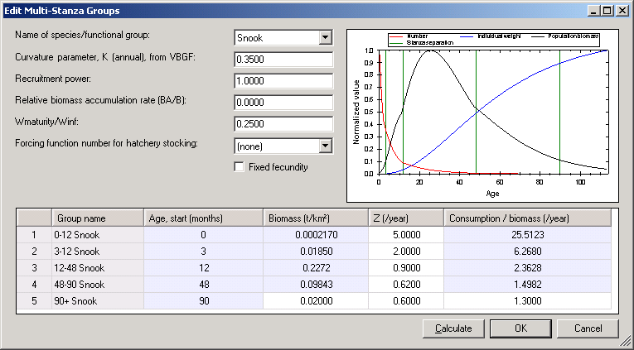
Figure 6.1. The Edit multi-stanza groups form
Name of species/functional group
Use the pull-down menu to select the multi-stanza goup to edit.
Curvature parameter, K
Set the von Bertalanffy growth rate (von Bertalanffy 1938). Note that it is assumed that body growth for the species as a whole follows a von Bertalanffy growth curve with weight proportional to length-cubed.
Recruitment power
This parameter is used by Ecosim and sets the degree of density dependence in juvenile survival for juveniles outside the modelled area. Set a low value, (e.g., 0.1-0.5) for this parameter if the juveniles for a group spend some time ‘outside’ the system in a nursery area where they are subject to density-dependent juvenile mortality rate, (e.g., juvenile Pacific salmon abundance may be limited by freshwater nursery habitat, so that numbers recruiting to a coastal oceanic area can be practically independent of adult abundance in the oceanic area, especially if juvenile production is ‘enhanced’ by hatchery systems).
Note that you should not need to change other basic parameters defining trophic ontogeny for split groups. When it is the very early juvenile stage that is spent in some rearing habitat outside your modeled area (e.g. a stream or coastal lagoon), you may model the effect of limiting factors within that rearing habitat just by adjusting the recruitment power parameter, without bothering to account factors such as ‘Import’ of food to the juvenile biomass while juveniles are in the rearing area (cumulative effect of such trophic development are automatically calculated when scaling the juvenile body sizes within Ecosim based on Ecopath juvenile pool biomass). You can also use a low recruitment power parameter to make juvenile recruitment ‘flat’ with respect to modeled adult biomass due to recruitment of juveniles from some adult population ‘egg source’ outside the modeled area.
Relative biomass accumulation rate (BA/B)
The BA/B term represents effect on the numbers at age of the population growth rate (e.g. the cohort born one year ago should be smaller by the factor than the cohort born “a” years ago (see Multi-stanza groups). See Other production for notes about estimating the relative biomass accumulation rate.
Weight at maturity/W_infinity
Set the mean weight at maturity/w∞. Note that it is assumed that body growth for the species as a whole follows a von Bertalanffy growth curve with weight proportional to length-cubed.
Forcing function number for hatchery stocking
Multi-stanza populations can be designated as hatchery populations (see Hatchery populations in Ecosim), and hatchery production can be varied over time in Ecosim using time forcing functions. To turn off natural reproduction select the hatchery forcing function from the pulldown menu in the Forcing function number for hatchery stocking box.
Note, you must already have a forcing time series loaded in Ecosim (see Time series and Forcing function). Note that forcing functions to represent historical changes in stocking rates can be entered via the same csv files as used to set up historical fishing and model fitting scenarios. Enter stocking rates as values relative to the stocking rate of 1.0 assumed for the Ecopath base year.
At each simulation time step, the base recruitment for the population (calculated from Ecopath input parameters) will be multiplied by the current time value for the designated forcing function.
Note also that if it is desired to simulate stocking of older fish (e.g., 18 months), the first stanza for the population should be set to have this duration, the mortality rate (Z or P/B) for the stanza should be set to .001, and the diet for the stanza should be set to 1.0 imported (i.e., do not have fish in the stanza feeding in the modeled ecosystem).
Fixed fecundity
Some types of organism (e.g., marine mammals or some sharks) may have a fixed number of young each year, regardless of adult body weight. Checking the Fixed fecundity check box …
Age, start (months)
The start age of each stanza is set on the Edit groups form. Note that the youngest stanza must have a start age of zero months.
Biomass
You must enter estimated absolute biomass (in appropriate units) for one “leading” stanza (i.e., the oldest stanza).
Z (Production/Biomass)
You must enter estimated total mortality rates for each stanza. A single-species age-structured model can be used to help estimate these parameters.
Consumption/Biomass
You must enter estimated consumption/biomass (Q/B) for one “leading” stanza (i.e., the oldest stanza).
A plot showing numbers at age, biomass age and weight at age is shown at the left of the form. This plot can be used to guide you in setting parameters for the group. To update the plot after changing parameters, click the Calculate button. To close the form and implement changes, click the OK button. To exit without implementing any changes, click the Cancel button.

Edit fleets
To define the fishing fleets in your model, choose the Edit fleets option on the Ecopath menu. This will open a form where you can add, delete, name and sort the fleets in your model (see below). To close the Edit fleets form and implement changes, click the OK button. To exit without implementing any changes, click the Cancel button.
After adding fleets on the Edit groups form, you can proceed to the Input data forms to enter parameters for your fleets (see Definition of fleets, Landings, Discards, Discard fate, Market price, Non-market price and Fleet size dynamics).
Add/insert fleets
Add fleets using the Insert button. In a brand new model, there is one default fleet (Fleet1) and new fleets will be inserted above this fleet. In an existing model, select the row where you would like a new fleet inserted and click Insert. A new fleet will be added above the selected row. If no row is selected, new fleets will be added above the first row. Note that when you add a new fleet, its status in the Status column will be given as “To create”. Clicking the OK button closes the Edit fleets form and implements the group insertion.
Fleet name
New fleets are given the default name “New Fleet”. Edit fleet names by clicking once in the appropriate Fleet name cell. The box will be highlighted and you can start typing. To edit an existing fleet name, double click on the name and the name will be highlighted. You can then use your mouse to select the part of the name to be edited.
Sort fleets
You can change the order of fleets in the model using the Up and Down buttons. Clicking the OK button closes the Edit fleets form and implements the new fleet numbers.
Delete fleets
Fleets can be deleted from the model using the Delete button. Models selected for deletion will be marked “To delete” in the Status column. Clicking the OK button closes the Edit fleets form and implements the fleet deletion.
WARNING: Fleet deletion cannot be undone. When you click the OK button, you will receive a warning message for each fleet to be deleted. Click Yes to continue with fleet deletion or No if you do not wish to delete the fleet. The Edit fleets form will close.

Ecopath input data
Once you have defined the model’s functional groups and fishing fleets using the Edit groups, Edit multi-stanza groups and Edit fleets forms, you can enter the input parameters for functional groups and fisheries. Data is input into Ecopath using a number of entry forms accessible under the Input data node in the Navigator window. These forms include: Basic input, Diet composition, Detritus fate, Other production, Definition of fleets, Landings, Discards, Discard fate, Market price, Non-market price and Fleet size dynamics).
Before entering data, you are encouraged to read the introductory material on the mass balance approach to ecosystem modelling for information about how the input parameters are used in the model (the set of Ecopath equations, Energy balance and the need for Input parameters). For details on Ecopath outputs see also Notes on parameterizing an Ecopath model and Balancing a model.
Generally, leaving an input blank on a data entry form implies it is unknown. For some required parameters defaults are supplied and skipping over these means accepting the default values. This is the case for biomass accumulation, detritus import, landings, discards, migrations and prices. You should be aware that opting for default values is as much a modelling decision as setting a new value, i.e., default values will not necessarily be appropriate for your ecosystem.

Basic input
The Basic input form is accessed through the Navigator window. Click once with the left mouse key in the group name column to enter group information.
Habitat area
The fraction of the total area in which the group occurs, that is, the fraction of the total area to which the biomass in habitat area pertains. Default is that the habitat area is 1, i.e. that the group occurs in the total area.
Biomass in habitat area
The average biomass per unit area in the habitat area where the group occurs. It is assumed that an average value can be used to represent the biomass of each group. Appropriate units should be used, (e.g., t/km²) for the biomasses. Entry of biomasses is optional for living groups but biomass(es) should be entered for the detritus group(s). However, if biomasses are unknown for all living groups and there are no exports from any of the groups, it is necessary to enter at least one biomass estimate, preferably of a top predator.
Biomasses should be entered relative to the habitat area where the group occurs. An example: assume a species for instance has a biomass of 1 t/km² in its habitat area, and the habitat area is 100 km², while the total area in your model is 1000 km². You should then enter a habitat area of 0.1 and a biomass in habitat area of 1 t/km² as the biomass for the group in your model.
Production/biomass
Enter the Production/Biomass (P/B) ratio for each group using consistent units, i.e., per year. The P/B ratio is equivalent to the instantaneous rate of total mortality (Z) used by fisheries biologists (Allen 1971). Entry of P/B ratios is optional.
Production includes fishery yield plus predation plus net migration plus biomass change plus other mortality; or
P/B = Z = F + M2 + NM + BA + M0.
For more details, see Production.
Consumption/biomass
Consumption/biomass (Q/B) ratios are entered using the same units as for P/B. Entry of consumption/biomass ratios is optional. For more details, see Consumption.
The Q/B input box will be blocked (blue color) for primary producers. If your model unit is carbon, you can however, click the blue input box, and enter a Q/B value, which will be used to calculate respiration for the group.
Ecotrophic efficiency
The ecotrophic efficiency (EE) is the fraction of the production that is used in the system, i.e. either passed up the food web, used for biomass accumulation, migration or export. Ecotrophic efficiency is difficult to measure directly. It varies between 0 and 1 and can be expected to approach 1 for groups with considerable predation pressure. The part of the production that is not included in the EE is often called ‘other mortality’. EE is dimensionless, and the entry of EE values is optional.
The ecotrophic efficiency of a detritus group is defined as the ratio between the flow out of a detritus box, and the flow into the same box. EE for detritus cannot be entered, it is always calculated.
Production/consumption
Production/consumption expresses the ratio between production (P) and consumption (Q) and is a dimensionless parameter. P/Q corresponds to what was called the gross food conversion efficiency (GE) in early versions of the software.
In normal cases, P/Q values will range from 0.05 to 0.3, i.e., the consumption of most groups is about 3-10 times higher than their production. Exceptions are top predators, e.g., marine mammals, which can have lower P/Q values, and small fast-growing fish larvae or nauplii or bacteria, which can have higher P/Q values. The value of the ratio is checked, in Ecopath, and warnings are given if production exceeds consumption (as can occur in organisms with symbiotic algae, such as corals and giant clams), or if the production exceeds half the consumption (which may be acceptable for bacteria, small nauplii and fish larvae, but usually not for other groups).
P/Q can only be entered if P/B and/or Q/B is left blank. If P/Q is entered along with, e.g., P/B, then Q/B will be calculated as,
Q/B = (P/B) / (P/Q).
Unassimilated consumption
An estimate of the fraction of the food that is not assimilated must be entered if the currency of your model is energy-related (see Units). Following Winberg (1956), a default value of 0.2 is suggested for carnivorous fish groups if other estimates are not available. Thus, 80% of the consumption is assumed to be physiologically useful while the non-assimilated food (consisting of faeces) is directed to the detritus. For herbivores, the proportion not assimilated may be considerably higher, e.g., up to 0.4 in zooplankton.
If the currency is a nutrient, there is no respiration, and the fraction of the food that is not assimilated is calculated as (1 - production / consumption). In this case, it is not possible to input the fraction of the food that is not assimilated.
The parameter for non-assimilated food is dimensionless, it is entered as a proportion. A routine checks whether the sum of gross efficiency plus proportion of food not assimilated exceeds 1, and displays a warning if so. Then, a new and consistent proportion for the non-assimilated food must be entered.
Detritus import
If there is import of detritus to the system, enter the quantity as a rate with a unit of, e.g., t / km² / year.

Diet composition
In Ecopath predation links together the different groups in the model and diet composition must be entered for all groups. Unfortunately, quantitative information on diet composition is sparse. Further, much of the available information on diet compositions is expressed on a ‘percent occurrence’ basis or as ‘dominance’, both of which are of little use for quantification of diets. Diet inputs should represent weight, volume or energy content of the preys, which are all equivalent (MacDonald and Green 1983).
The Diet composition form is accessed through the Navigator window. Enter diet composition, for all consumers, column by column (i.e., predators are represented by column and their prey by row). The diet compositions of each group should sum to 1. For guidance, the current sum of the fractions representing the food composition is summed at the second-last row (Sum). The last row (1 – Sum) shows the proportion of prey still to be entered. You can use the Sum to one button at the top of the Diet composition screen to raise a diet to unity. If diets do not sum to unity when you start basic estimation (i.e., try to balance the model) you will be given the option of having the software do the raising for you, or to return to the diet to do it yourself.
In Ecopath ‘import’ to a system is the consumption of preys that are not a part of the system as it is defined (for example for species that spend fractions of the year feeding outside the area of the model). Note that import is different from migration, which is a production term. Import is treated as a ‘prey’ in the diet composition, and should be entered as a fraction of the total diet. See Dealing with open system problems for more information on how to treat groups that moves in and out of the modeled area.
A warning about zero order cycles, i.e. groups that feed on themselves (‘cannibalism’): avoid situations where the fraction of the food of a group taken from that same group exceeds 0.1. This may occur when adults feed on their own juveniles. In such cases, it is advised to split the box into groups representing predator and prey stanzas, i.e., adults and juveniles. This will not only reduce or eliminate a zero-order cycle, and the bothersome computational problems usually associated with such cycles, but also lead to groups with better-defined characteristics (because adults usually have P/B ratios lower than those of juveniles).

Detritus fate
The Detritus fate form is accessed through the Navigator window. If there is more than one detritus group in the system, you must specify where the detritus left over after the detritivores have covered their food intake is to be directed. Surplus detritus can be directed to the same detritus group (equivalent to ‘biomass accumulation’) or to other groups, by entering the appropriate fractions directed to each detritus groups. If these fractions sum to less than 1, the remaining part of the surplus detritus will be exported out of the system.

Other production
Other production refers to production represented in Ecopath by Migration and Biomass Accumulation. Migration is not the same as import – emigration and immigration are production factors, while import is food consumption. See Dealing with open system problems for more information on how to treat groups that moves in and out of the modeled area.
If B, P/B, Q/B and EE are entered for a group, a prompt will appear during parameterization asking if you want to estimate biomass accumulation. If you answer no to this, a new prompt will ask if you want to estimate net migration. If you answer yes, the program will estimate net migration.
The net migration is calculated as immigration less emigration. This means that net migration will be negative if there is more coming into the system than leaving it. This may seem contradictory but it should be remembered that a negative mortality yields an increase in population. Fisheries biologists rarely consider migration, at least in biomass terms, and even more rarely quantify it. If the net migration is positive (immigration > emigration), but not entered, the main effect will depend on the previous entries:
- if the production had been entered, the fraction of production directed toward the detritus will be overestimated; or
- if production was to be estimated, this estimate will be underestimated.
Immigration
Migration into the area covered by the model. Must be entered as a non-negative value. Unit is a flow, e.g., t / km² / year.
Emigration
Migration out of the area. Must be entered as a non-negative value. Unit is a flow, e.g., t / km² / year.
Emigration rate
Emigration can also be presented as the proportion of the population emigrating from the system in a year (unit is /year). The immigration rate can be entered by setting the emigration rate to a negative value.
Biomass accumulation
Ecopath is not necessarily a steady-state model. If the biomass for a group is known, e.g., at the beginning of the year and at the beginning of the next year, the biomass accumulation (BA) can be calculated as the difference between these biomasses. BA is a production term that can be entered for all living groups (default is 0), but is calculated for detritus groups (see section 3.3.5 Detritus fate). BA is a flow term, with a rate unit of, e.g., t / km² / year. The default value for BA is zero indicating no biomass accumulation. A negative value signifies biomass depletion (biomass decreased during period modeled).
If B, P/B, Q/B and EE are entered for a group, a prompt will ask during parameterization if you want to estimate BA. If you answer yes to this question the BA will be calculated, overruling any BA you may have entered.
Biomass accumulation rate
Biomass accumulation can also be represented as a rate (i.e., proportion of the total biomass; unit is /year).

Fishery
Forms for editing fishery parameters are found under the Fishery node in the Navigator window. See Definition of fleets, Landings, Discards, Discard fate, Market price, Non-market price and Fleet size dynamics.

Definition of fleets
You must first define your fleets using the Edit fleets form, accessible from the Ecopath menu. The Definition of fleets form, under the Fishery node in the Navigator window, can then be used to set the costs, profits and value for the fishing fleets in the model. Costs and values are used for calculations in Ecosim and Ecospace simulations.
Fixed cost
Fixed cost is the cost of operating a fleet unit, independent of effort, in the unit time defined in Ecopath (typically on annual basis). The definition of ‘fixed’ costs depends on the actual situation being modeled. To illustrate this consider some examples:
A new module of Ecospace, Ecoseed, allows for effort reduction to nil in connection with simulated increase in protected areas from 0 to 100% of total model area. As the last boats operating in a fleet cannot bear the total ‘fixed’ costs of the total fleet; they should only bear the ‘fixed’ costs that are independent of effort. For this type of application use the ‘fixed costs’ only for costs that are independent of effort at the fleet scale, for instance for the costs of management and monitoring, (and subsidies if there are fixed subsidies to the fleet). Costs that are capacity dependent in this situation should be considered effort-related variable costs instead.
Effort can also be changed in Ecosim:
- If the changes are relatively small and intended to represent changes in effort with constant capacity, the fixed costs can be seen to represent all costs that are effort-independent at the boat-level. Examples are costs for management, monitoring, licenses, capitalization, and insurance.
- If the changes are major, the procedure outline for Ecoseed above should be adopted instead. Hence, consider the fixed costs to be effort-independent at the fleet level.
Effort related cost
Represents costs that are a function of effort. The examples above give some guidance to how these should be defined. Enter the costs as a percentage of the total value of the fishery in the given year. Simulation in Ecosim with changes in fishing effort are entered relative to the base effort, hence if the effort is increased with, e.g., 10% the variable costs are assumed to increase 10% as well, whereas the fixed costs are assumed unchanged.
Ecosim: use Effort related costs for all variable costs (e.g., fuel, gear costs and crew wages);
Ecospace: use Effort related costs for variable costs that depend on effort, e.g., for gear costs (which mainly depend on how many hours the gears is used), but not for costs that depend on spatial effort allocation, e.g., sailing costs.
Sailing related cost
For Ecospace applications it is recommended to use two separate forms for variable costs: effort-related and spatially-related (i.e., sailing related). Do not enter sailing related costs if you are only using Ecosim, use Effort related costs for all variable costs.
If you are using Ecospace, use Effort related costs for variable costs that depend on effort, e.g., for gear costs. Enter costs that depend directly on spatial effort allocation, e.g., fuel costs and crew wages as Sailing related costs.
Profit
Profit is calculated as percentage of value, calculated from total value less all costs. It cannot be entered directly.
Total value
The total value is the value of all landings (as entered on subsequent forms). It is displayed here only to indicate that the ‘100 %’ relates to value, not to total costs.

Landings
Landings and catches are not the same, as discarding is an integral part of most fishing operations. Ecopath calculates: Catch = landings + discards.
You should therefore enter only the landings here – while any discards should be entered on the discards form. Landings must be expressed as flows, typically in t/km²/year. The area to be used should be the total area of your model, not just habitat area, or the area in which the fleet operates. For instance, if you are entering information for a coastal shrimp fishery, the landings (and discards) should be calculated relative to the total area of the model – even if most of it is too deep for trawling.
In a model of an ecosystem exploited by a fishery, the catch is the total extractions over the time period considered in the model, (e.g., a year), for each of the groups modeled. Similarly, in an aquaculture system the ‘catch’ is the harvest from each group over the time period considered, (e.g., a growing season).
Fishery catches are normally based on landing statistics. This may cause a problem as official statistics are generally on a regional basis, not on an ecosystem basis. This can be of importance when defining the system to be modeled, either as a geographical/political region or as an ecosystem. It is necessary to consider the availability of appropriate catch data when taking such decisions.
The catches together with other export sum up to the total export. Catches are also used to estimate the fraction of primary production that is utilized in the system (i.e., the ‘gross efficiency of the fishery’).

Discards
Discarding is a normal practice in most fisheries. If you do not enter any information, you are assuming that discarding does not take place. If discarding does take place this is worse than guessing! Therefore, it is better to use information from similar fisheries in other areas or perhaps based on interviews with fishers in your area. Discarding may affect trophic and population dynamics. For example, in shrimp fisheries where the discards include predators on shrimps that may be turned into food for shrimps, a trophic ecosystem model can be used to quantify the role of discarding. Note that you must tell Ecopath where to send discards using the Discard fate form.

Discard fate
Ecopath needs to be told what to do with the discards you enter as part of the catches. Discards can either go to a detritus group or be exported. Discard fate is entered as a proportion, i.e., a value between and including 0 and 1, representing the fraction of the discards directed to a given detritus group (or exported). If you are interested in quantifying the ecological impact of discarding it is recommended that you make a special detritus group called, e.g., ‘Discarded fish’ and direct the discards to this group.

Market price
Enter the market value (in the specified monetary unit per unit catch) for each group for each gear (fleet). It is not important whether the market values are entered in, e.g., Euro/kg or Euro/tonnes, as long as the entries are consistent between groups. The market prices are fleet-specific on the entry forms as quality and hence price varies more between fleets than within fleets. See also Non-market price.

Non-market price
Shadow price or non-market price represents the value of a resource in the ecosystem, e.g., for non-exploitative uses. Values should be expressed in monetary units per unit biomass. At present it is assumed that there is a linear relationship between the biomass of a resource and its non-market price (if there is any). Hence, for groups with a non-market price it is assumed that a doubling in biomass will lead to a doubling of the resource’s non-market value. See also Market price.

Using Ecopath. Part 2: Parameterization and outputs

Notes on parameterizing an Ecopath model
Below are some important considerations for parameterizing (i.e., balancing) your Ecopath model so that mass balance is achieved. Make sure you are also familiar with the introductory material on Ecopath parameterization (Mortality for a prey is consumption for a predator, The energy balance of a box and On the need for input parameters).
For more detailed notes on balancing your model we recommend you also read Balancing a model.
Ecopath parameterization
Once you have entered sufficient input parameters you can proceed to estimate the parameters of Ecopath by selecting Basic estimates under the Parameterization node in the Navigator window. The missing parameters will be estimated so that mass balance is achieved. The estimation is performed using a number of algorithms and a routine for matrix inversion described in Section Error: Reference source not found, on page Error: Reference source not found in general terms. (See also Appendix 4 in the Help system for computational aspects).
Once the program has estimated the parameters, the system balances the input and output of each group, using respiration for adjustments. The relationship used is:
Consumption = Production + Respiration + Non-assimilated food
where,
Consumption is the total consumption of a group, i.e., biomass · (consumption / biomass);
Production excludes primary production, i.e., is defined by biomass · (production / biomass) · (1 - PP),
where PP is the proportion of total production that can be attributed to primary production (thus (1 - PP) = 0 in plants, 1 in heterotrophic consumers, and intermediate in e.g. corals or tridacnid clams);
Respiration is the part of the consumption that is not used for production or recycled as feces or urine. Respiration is nonusable currency, i.e., it cannot be used by the other groups in the system. Autotrophs with Q/B = 0 and detritus have zero respiration;
Nonassimilated food is an input parameter expressing the fraction of food that is not assimilated, (i.e., is egested or excreted). For models whose currency is energy, the default is 0.20, i.e. 20% of consumption for all groups, though this is most applicable for finfish groups (Winberg, 1956). The non-assimilated food is directed to the detritus;
If the model currency is a nutrient, there is no respiration. Instead, the model is balanced such that the non-assimilated food equals the difference between consumption and production.
Parameter evaluation
The program estimates the missing parameters and a number of indices without further input. Your model will probably not look very convincing the first time you run it. Keep an eye open for warning messages while you make your way through the forms. In the more serious cases, the parameter estimation will be aborted, and you will have to edit your data. To improve your chances of identifying problems, you will in some cases only get a warning and the program will continue.
The sections below may help you evaluate the results of a run.
Are the EE’s between 0 and 1?
When examining the output of a run, the first and perhaps most important items to consider are the ecotrophic efficiencies (which are usually calculated). The values should be between 0 and 1 (inclusive). Here, a value of zero indicates that any other group does not consume the group in the system, and neither is it exported. Conversely, a value near or equal to 1 indicates that the group is being heavily preyed upon or grazed and/or that fishing pressure is high, leaving no individuals to die of old age. The whole range of ecotrophic efficiencies can be found in nature. However, a generalization has emerged from previous modeling: for most groups, the EE should be close to one, the exceptions being top predators and primary producers.
If, in a first run, any of the EE values are larger than 1, something is wrong: it is not possible for more of something to be eaten and/or caught than is produced. The problem can of course be due to the equilibrium assumption not being met, e.g., when the model includes a new fishery on a previously unexploited stock. Unless this is known to be the case, you should have a closer look at the input parameters.
It may be worthwhile to check the food consumption of the predators, and the production estimates of the group. Compare the food intake of the predators with the production of their prey. Most often, the diet compositions will have to be changed - often the diets are more ‘pointers’ to, than reliable estimates of the real values.
Often ‘cannibalism’ in the sense of within-group predation causes problems. If a group contributes 10% or more to its own diet, this alone may result in consumption being higher than the production of the group. The solution to this is to split the group into juveniles and adults, with the adults acting as predator on the juveniles. The juveniles must then have a higher production rate than the adults, as production is almost always inversely related to size. Splitting groups into juveniles and adults is also useful for the Ecosim discussed later.
It is advisable to make one change at the time when editing input parameters. Make that one change, rerun the Basic estimates routine, re-examine the run, and if necessary re-edit the data, etc. Continue with one change at a time until you get a run you consider acceptable. Make sure through the entry of remarks to record en route what you do and why.
An alternative routine for balancing is to use Ecoranger. This routine will use randomly selected parameter combinations to find possible models. Note that even Ecoranger will fail to balance a model if the initial set of basic input is very far away from a possible configuration, in such cases, Ecoranger will abort and display a list of the first 50 failed runs. By examining the list and checking what went run it is usually possible to pinpoint the most problematic input.
Ecotrophic efficiency of detritus
The ecotrophic efficiency, EE, of a detritus group is defined as the ratio between what flows out of that group and what flows into it. Under steady-state assumption, this ratio should be equal to 1.
The fate of the detritus (DF) can be entered (Detritus fate form). If all detritus from a detritus group is directed to other detritus boxes the EE of the group will be 1.
Estimates of EE of less than 1 indicate that more is entering a detritus group than is leaving it.
Estimates of EE of more than 1 for a detritus group also require attention. They indicate that the primary production and/or the inputs to the lower parts of the food web are too small to support consumption from that group. It will be necessary to examine the basic inputs that define production and consumption of the lower parts of the food web closely, and to examine whether more detritus should be directed to the detritus group.
Of importance for the flow to detritus is the parameter for non-assimilated food. The default value of 0.2 often underestimates egestion, especially for herbivores and detritivores. For instance that a value of 0.4 for zooplankton often leads to more reasonable respiration/biomass ratios than 0.2. Higher parameter values means that a greater flow is directed to detritus and less to respiration for a given group.
Are the ‘efficiencies’ possible?
Recall that the gross food conversion efficiency, GE, is defined as the ratio between production and consumption. In most cases, production/consumption ratios will range from 0.1 to 0.3, but exceptions may occur, (e.g., bacteria, nauplii, fish larvae and other small, fast-growing organisms). If the GE values are unrealistic, check the input parameters, especially for groups whose production has been estimated. In such cases, carefully editing the diet composition of the predators of the problem groups will generally help.

Balancing a model
Once you have entered sufficient input parameters you can proceed to estimate the parameters of Ecopath by selecting Basic estimates under the Parameterization node in the Navigator window. The missing parameters will be estimated so that mass balance is achieved. Before parameterizing a model make sure you are also.
Important note: If Ecopath has NOT been balanced already since opening or making changes to the input parameters, selecting any of the forms under the Parameterization node in the Navigator window will cause Ecopath to attempt to balance the model. Note also that you will not be able to balance your model if the sum of the Diet composition for each predator does not sum to 1. Return to the Diet composition form and fix the problem if this is the case.
Below are some important notes to help you during model parameterization (balancing). Before commencing balancing, we recommend you first read Notes on parameterizing an Ecopath model and are familiar with the introductory material on Ecopath parameterization (Mortality for a prey is consumption for a predator, The energy balance of a box and On the need for input parameters).
Problems in parameter estimation will be shown in the Status panel. Two types of message may be displayed in the Status panel while you are balancing your model:
- Information messages []. Information messages provide feedback on regular events in EwE. Information events are confirmations of things that went well. Examples are opening the model; successful edits; and successful balancing (i.e., parameterization) of the model. Clicking and holding the mouse button over each message highlights the relevant cells in red [ ].
- Warning messages []. Warnings occur when EwE was not able to complete an action and requires the user to fix a problem, usually with the input data. For example, one of the most important of these is when parameterization fails (i..e., the model failed to balance). When this occurs, you will get the message “Your model is NOT balanced! Computed Ecotrophic Efficiencies (EE) invalid for one or more group(s).” Clicking on the “+” icon next to this message expands the message to show which groups are causing the problem. Clicking and holding the mouse button over each warning message highlights the problem cells in red [ ]*.
An exhaustive set of guidelines for how a model should be balanced cannot be given. However, if it existed, such a set would include the following general guidelines:
- Make sure to document what is done in the balancing process by entering remarks for all parameters and to extract these subsequently. A model where the balancing process is not appropriately documented is not likely to be publishable;
- Remember which data are the more reliable and avoid changing these;
- Formulate assumptions and argumentation for changes: the ones easy to explain are likely to be the better assumptions;
- Start by looking at the estimated values. Are the EE values possible (less than 1)? Are the GE (= P/Q) values physiologically realistic (0.1-0.3 for most groups, perhaps lower for top predators and higher for very small organisms, (e.g., up to 0.5 for bacteria). If not decide from where the problem is the biggest if you want to balance your model starting from the bottom (producers) or from the top down;
- Search out one group with a bigger problem and try to solve this. Are the P/B, Q/B and B values appropriate for this group? What would happen to, e.g., the GE and the EE if you changed the parameters? If the problem is the consumption by predators, look at the predation mortality estimate form, and identify the quantitatively most important predators. Check the diet compositions and B and Q/B values for these predators;
- Continue for as long as necessary, documenting carefully what changes are made. It may be a good idea to save the data file under a new name each time changes are made (e.g. starting with ‘Model_1’, on to ‘Model_2’ etc.;
- You may get warnings that the ‘Respiration cannot be negative’. If this happens the second master equation of Ecopath has been violated. We have:

Consumption = production + respiration + unassimilated food, or Q = P + R + U. Expressing this relative to consumption we have: P/Q + R/Q + U/Q = 1. Of these P/Q is entered as GE or the gross food conversion efficiency and U/Q us the proportion of food that is not assimilated. If GE + U/Q exceeds unity then R/Q and hence the respiration, R, has to be negative. You will need to reduce the production/consumption (GE) ratio by lowering the production/biomass (P/B) ratio or increasing the consumption/biomass (Q/B) ratio, and/or reduce the proportion of unassimilated food;
- Examine the respiration/biomass (R/B) ratios for each group. Generally this ratio reflects activity level. For fish it should as a rule be in the range 1-10 year-1, for copepods perhaps around 50-100. Please consult physiology handbooks for more information. If the ratio seems high it may be necessary to change the (assumed) proportion of the food that is not assimilated on the basic input form;
- Examine the Electivity form on the Basis Parameter form. Do the preferences seem reasonable?
- Examine the Predation mortalities on the Mortalities form in the Navigator window. The predation mortality spreadsheet will show you how important the various predators are for any group. Does this show what you expect? Are the predators shown to be the most important predators in accordance with what you expect? If not, re-evaluate your model’s diet compositions. The information on the mortality forms is very important!
- Noting how the energy balance of a group is formulated, it is clear that, for instance, increasing the proportion of the consumption that is not assimilated will leave less energy to respiration (production being unaffected). This will result in a lower R/B ratio and a larger flow to the detritus. The latter may be necessary to balance the model if there is only little system surplus production.
See Boxes 1-3 below for notes about some common causes of problems during balancing.

Box 1. Problem: Loops
In cases where P/B is to be estimated for groups that feed on each others (cycles) the program may first estimate a P/B for one groups based on the consumption by the other groups. Subsequently it may estimate the P/B for the second group based on the consumption by the first, and then it may continue with the P/B for the first again, and so on in a loop. The result may be completely unrealistic parameter estimates.

It is necessary to break such loops, e.g., by entering the P/B for one of the groups. If all ecotrophic efficiencies are low it indicates that the trophic transfer efficiencies are low. This may be OK for a system with high production and low abundance of organisms. It may however also indicate that the estimates of the biomasses in the system are too low.

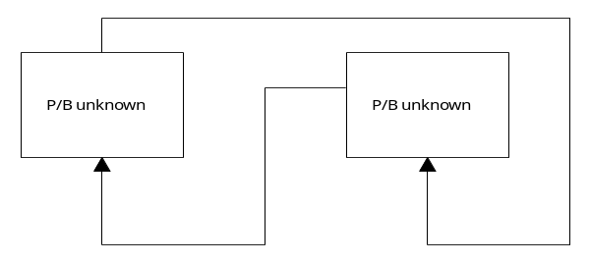

Box 2. Problem: Cannibalism (0-order cycles)
Groups where 0-order cycles (cannibalism) are important should be broken into two or more groups. Such cases occur, for example, when a predatory fish feeds on fish of the same species or grouping. The prey fish will, however, be smaller fish, and often the P/B value for the group is based on the recruited part of the population only, and thus does not cover the dynamics of the juveniles, (which generally have much higher P/B values than the recruited part of the population). The solution may be to split the group in an adult and a juvenile fish group. This will also be an advantage for subsequent Ecosim simulations.
Remember that the gross food conversion efficiency or GE is the P/Q ratio. Typically this ratio is in the range of 10-30%. If the proportion of the 0-order cycle is in the same range there may not be any production left over for other purposes (predation and export). As a guideline if a 0-order cycle includes more than say 5% of the diet composition it is necessary to consider if it would be better to split the group in two.
Box 3. Problem: Estimation of predator consumption and prey production
In this example it is assumed that the consumption is unknown for the predator and the (used part of the) production, (i.e., the B, P/B or EE) unknown for all of the prey groups. In this case, it will not be possible for the program to calculate meaningful parameters and it will (probably) resort to the trivial solution: set the Q/B for the predator to zero, and see what can be estimated for the other groups. The problem is easily identified from an examination of the estimated parameters and statistics. The solution may well be to either input a gross efficiency for the predator or one of the missing input parameters for one of the prey groups.
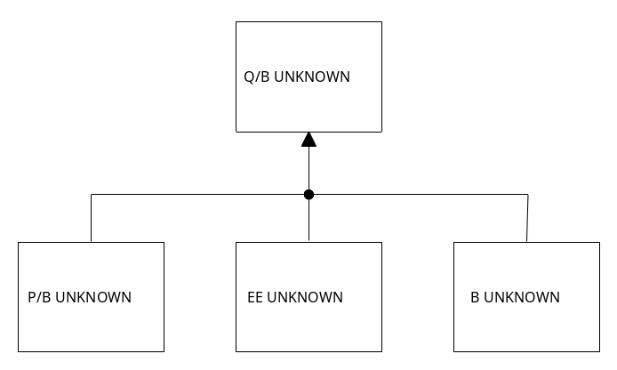

Basic estimates
Once you have entered sufficient input parameters you can proceed to estimate the parameters of Ecopath by selecting Basic estimates under the Parameterization node in the Navigator window. The missing parameters will be estimated so that mass balance is achieved. Both input (black font) and calculated (blue font) parameters are displayed on the Basic estimates form.
Before attempting to balance your model, we recommend you read Notes on parameterizing an Ecopath model and Balancing a model.
The parameter estimation program outputs a number of indices that may be of use for assessing the status of the overall ecosystem and of its constituent groups. These can be found in the current (Basic estimates) form as well as on the Key indices, Mortalities, Consumption, Respiration, Niche overlap, Electivity, Search rates and Fishery forms.
Notes on most of the parameters below have already been provided in the notes on Basic parameters, but we repeat them here as a reminder.
Trophic level
Lindeman (1942) introduced the concept of trophic levels. In Ecopath, the trophic levels are not necessarily integers (1, 2, 3...) as proposed by Lindeman, but can be fractional (e.g., 1.3, 2.7, etc.) as suggested by Odum and Heald (1975). A routine assigns definitional trophic levels (TL) of 1 to producers and detritus and a trophic level of 1 + [the weighted average of the preys' trophic level] to consumers.
Following this approach, a consumer eating 40% plants (with TL = 1) and 60% herbivores (with TL = 2) will have a trophic level of 1 + [0.4 · 1 + 0.6 · 2] = 2.6. The fishery is assigned a trophic level corresponding to the average trophic level of the catch, i.e. without adding 1 as is done for ‘ordinary’ predators.
The trophic level is a dimensionless index.
Habitat area (fraction)
The fraction of the total area in which the group occurs, that is, the fraction of the total area to which the biomass in habitat area pertains. Default is that the habitat area is 1, i.e. that the group occurs in the total area.
Biomass in habitat area
The average biomass per unit area in the habitat area where the group occurs. It is assumed that an average value can be used to represent the biomass of each group. Appropriate units should be used, (e.g., t/km²) for the biomasses. Entry of biomasses is optional for living groups but biomass(es) should be entered for the detritus group(s). However, if biomasses are unknown for all living groups and there are no exports from any of the groups, it is necessary to enter at least one biomass estimate, preferably of a top predator.
Biomasses should be entered relative to the habitat area where the group occurs. An example: assume a species for instance has a biomass of 1 t/km² in its habitat area, and the habitat area is 100 km², while the total area in your model is 1000 km². You should then enter a habitat area of 0.1 and a biomass in habitat area of 1 t/km² as the biomass for the group in your model.
Biomass
This is the Biomass in habitat area x Habitat area.
Production/biomass
Enter the Production/Biomass (P/B) ratio for each group using consistent units, e.g., per year. The P/B ratio is equivalent to the instantaneous rate of total mortality (Z) used by fisheries biologists (Allen 1971). Entry of P/B ratios is optional.
Production includes fishery yield plus predation plus net migration plus biomass change plus other mortality; or
P/B = Z = F + M2 + NM + BA + M0.
For more details, see Production.
Consumption/biomass
Consumption/biomass (Q/B) ratios are entered using the same units as for P/B. Entry of consumption/biomass ratios is optional. For more details, see Consumption.
The Q/B input box will be blocked (blue color) for primary producers. If your model unit is carbon, you can however, click the blue input box, and enter a Q/B value, which will be used to calculate respiration for the group.
Ecotrophic efficiency
The ecotrophic efficiency (EE) is the fraction of the production that is used in the system, i.e. either passed up the food web, used for biomass accumulation, migration or export. Ecotrophic efficiency is difficult to measure directly. It varies between 0 and 1 and can be expected to approach 1 for groups with considerable predation pressure. The part of the production that is not included in the EE is often called ‘other mortality’. EE is dimensionless, and the entry of EE values is optional.
The ecotrophic efficiency of a detritus group is defined as the ratio between the flow out of a detritus box, and the flow into the same box. EE for detritus cannot be entered, it is always calculated.

Key indices
Biomass accumulation
Ecopath is not necessarily a steady-state model. If the biomass for a group is known, e.g., at the beginning of the year and at the beginning of the next year, the biomass accumulation (BA) can be calculated as the difference between these biomasses. BA is a production term that can be entered for all living groups (default is 0), but is calculated for detritus groups (see section 3.3.5 Detritus fate). BA is a flow term, with a rate unit of, e.g., t / km² / year. The default value for BA is zero indicating no biomass accumulation. A negative value signifies biomass depletion (biomass decreased during period modeled).
If B, P/B, Q/B and EE are entered for a group, a prompt will ask during parameterization if you want to estimate BA. If you answer yes to this question the BA will be calculated, overruling any BA you may have entered.
Biomass accumulation rate
Biomass accumulation can also be represented as a rate (i.e., proportion of the total biomass; unit is /year).
Net migration
The net migration is calculated as immigration less emigration. This means that net migration will be negative if there is more coming into the system than leaving it. This may seem contradictory but it should be remembered that a negative mortality yields an increase in population. Fisheries biologists rarely consider migration, at least in biomass terms, and even more rarely quantify it. If the net migration is positive (immigration > emigration), but not entered, the main effect will depend on the previous entries:
- if the production had been entered, the fraction of production directed toward the detritus will be overestimated; or
- if production was to be estimated, this estimate will be underestimated.
See Other production and Dealing with open system problems for important notes about migration in Ecopath.
Flow to detritus
For each group, the flow to the detritus consists of what is egested (the non-assimilated food) and those elements of the group, which die of old age, diseases, etc., (i.e., of sources of ‘other mortality’, expressed by 1 - EE). The flow to the detritus, expressed, e.g., in t·km⁻²·year⁻¹, should be positive for all groups.

Box 4. Problem: Estimation of Q/B for detritivores
It is not possible to estimate the consumption/biomass ratio for groups that feed exclusively on detritus. For detritus the production is not defined, and it will be necessary for such detritivores to input an estimate of Q/B (or P/B and an estimate for GE, gross food conversion efficiency).

Net efficiency
The net food conversion efficiency is calculated as the production divided by the assimilated part of the food, i.e.,
Net efficiency = P/B / (Q/B · (1 - GS))
where P/B is the production / biomass ratio, Q/B is the consumption / biomass ratio, and GS is the proportion of the food that is not assimilated.
The net efficiency can also be expressed
Net efficiency = Production / (production + respiration)
The net efficiency is a dimensionless fraction. It is positive and, in nearly all cases, less than 1, the exceptions being groups with intermediate trophic modes, e.g., groups with symbiotic algae. The net efficiency cannot be lower than the gross food conversion efficiency, GE.
Omnivory index
The ‘omnivory index’ was introduced in 1987 (Pauly et al., 1993a) in the initial version of the Ecopath II software. This index (OI) is calculated as the variance of the trophic level of a consumer's prey groups. Thus
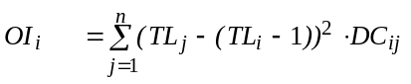 Eq. 36
where, 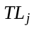is the trophic level of prey j, 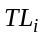 is the trophic level of the predator i, and, 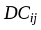 is the proportion prey j constitutes to the diet of predator i.
When the value of the omnivory index is zero, the consumer in question is specialized, i.e., it feeds on a single trophic level. A large value indicates that the consumer feeds on many trophic levels. The omnivory index is dimensionless.
The square root of the omnivory index is the standard error of the trophic level, and a measure of the uncertainty about its precise value due to both omnivory and sampling variability.

Mortalities
The Mortalities node in the Navigator window contains two forms that summarise the sources of mortality in the model. The Mortality coefficients form breaks down mortality for each group in the model into its component parts (P/B, F, predation mortality, biomass accumulation, net migration and EE). The Predation mortality form further breaks down the predation mortality for each prey group by showing the predation mortality rate caused by each of its predators. These two forms are arguably the most important reference for the user during the model-balancing process, as they can be used to indicate which mortality components are most likely to be causing problems.
See Notes on parameterizing an Ecopath model and Balancing a model for more advice about balancing your model.

Mortality coefficients
The Mortality coefficients form (Figure 7.1) is one of the most important forms on the Parameterization menu and it is, as a rule, the first one that should be checked when balancing a model. This form gives the Ecopath-predicted values of each type of mortality for each group in the model (see below). During balancing, the Mortality coefficients form will guide you in identifying where problems are (e.g., if it’s fishing or predation mortality that is too high). If predation mortality is too high, then you can use the Predation mortality form to identify which predators are causing the problem.
Components of mortality in Ecopath
Under equilibrium, each group can be represented by an average organism, with an average weight. This makes it possible to use equations for estimating mortality in numbers, even when dealing with biomass. One such equation is
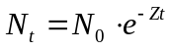 Eq. 37
where 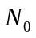is a number of organism at time = 0; 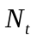is the number of survivors at time = t; and Z is the instantaneous rate of mortality.
Under the assumption that 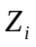, the mortality of group i, is constant for the organisms included in i, it turns out that, for a large number of growth functions (including the von Bertalanffy Growth Function, or VBGF):
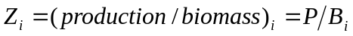 Eq. 38
or instantaneous mortality equals total production over mean biomass (Allen, 1971).
The mortality coefficient can be split into its components following a procedure well known among fisheries biologists, i.e.,
Z_{i} = P/B_{i} = Fishing mortality + Predation mortality + Biomass accumulation + Net migration + Other mortality
or
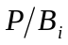=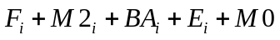 Eq. 39
In some models, (e.g., the Multispecies Virtual Population Analysis model of the North Sea, Sparre, 1991), the ‘other mortality’ component is split between M1_{i}, i.e., predation by predators not included in the model, and 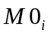, ‘other mortality’, caused by diseases, senescence, etc. In Ecopath, M1 is not included, as all predation mortality should be described explicitly. Further, M0_{i} is not entered directly, but is computed from the ecotrophic efficiency, EE_{i}, Thus:
F_{i} is the Fishing mortality coefficient;
M2_{i} is the Predation mortality coefficient;
BA_{i} is the Biomass accumulation coefficient;
E_{i} is the Net migration coefficient (immigration less emigration).
M0_{i} is the Other mortality coefficient.
Ecopath-predicted values for these coefficients are given on the Mortality coefficients form. The mortality coefficients are estimated from the following equations:
Z_{i} = P/B_{i}
M2_{i} = (∑B_{i} · Q/B_{i} · DC_{ji}) / B_{i}
F_{i} = Y_{i}/B_{i}
M0_{i} = (1-EE_{i}) · P/B_{i}
where Q/B_{j} is the consumption/biomass ratio of predator j;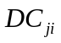is the proportion prey i constitutes to the diet of predator j, 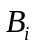 is the average biomass of i, and 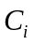 is the catch of i. The biomass accumulation term, BA_{i}, is a basic input term.
If any component of the system is harvested, a summary of the mortality coefficients can be displayed, which presents total mortality (Z = P/B) and its component: fishing mortality (F), other exports (E), other mortality (M0), and predation mortality (M2). Predation mortality is further broken down to show the contribution of each consumer groups to the total predation mortality of each prey group.
See also introductory material on Production, Consumption, Dealing with open system problems and Other mortality.
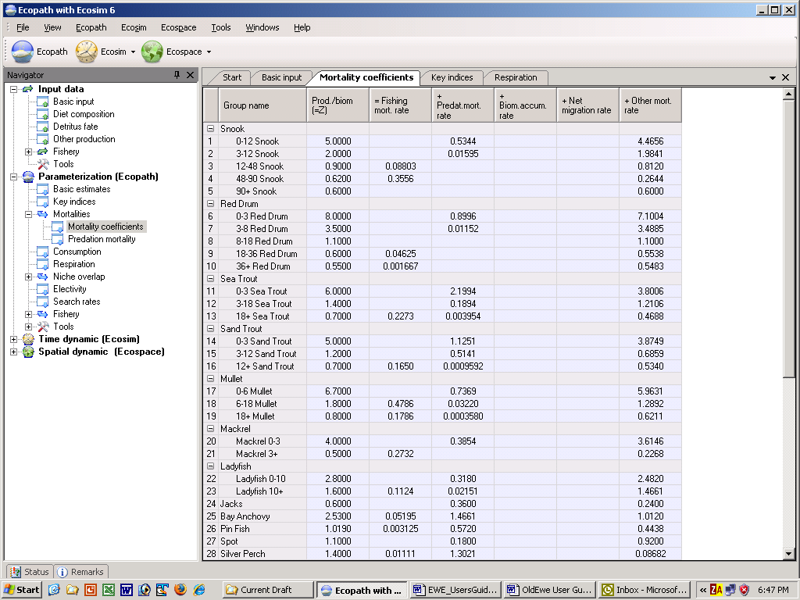
Figure 7.1. Mortality rates. Z is total mortality; F is fishing mortality; M0 other mortality; and M2 predation mortality. Z = P/B = F + E + M0 + M2.

Predation mortality
The predation mortality of a group (i) is the sum of the consumption of i by the other groups, divided by the biomass of group (i). Predation mortality is calculated in the program, i.e., it is not an input parameter. Predation mortality corresponds to what is called ‘M2’ in some other models.
The Predation mortality form (Figure 7.2) is very important and should be checked frequently when balancing a model. To begin with, the Mortality coefficients form will guide you to particular mortality coefficients that are causing problems with balancing. If predation mortality is too high then the Predation mortality form will help you identify which predators are causing the problem for a particular prey group. To help you identify possible problem predators, cells with unusually high predation mortalities will be shown with a white background instead of the usual blue background. Note that this is intended as a guide only to show which predators are contributing most to a prey species’ mortality. You should use the literature, expert opinion and your understanding of the ecosystem to decide which predation mortalities should be changed and by how much.
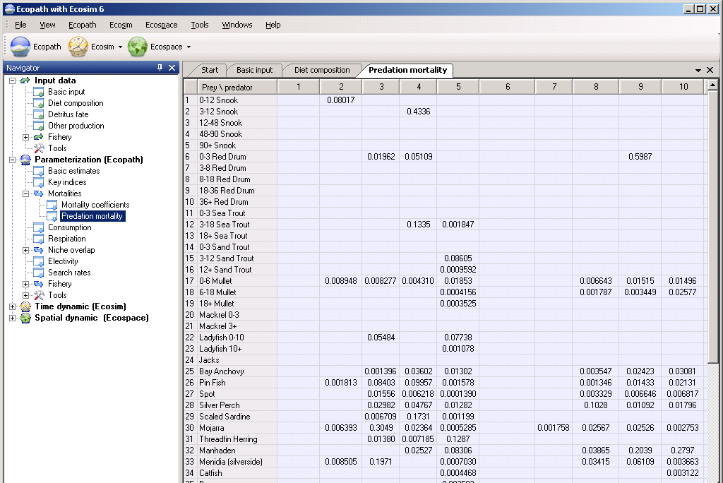
Figure 7.2. Predation mortality form showing the quantitatively important predators and prey for all groups. This screen can be used to great advantage when balancing a model with one or several values of EE>1, to identify the consumers (in columns) exerting the strongest pressure on the group(s) (in rows) with excessively high EE values.

Consumption
Ecopath’s estimates of consumption (food intake) can be obtained by selecting Consumption under the Parameterization node in the Navigator window.
The consumption of a living group is the product of its biomass (B) times its consumption/biomass ratio (Q/B). The food intake is a rate expressed, e.g., as t · km⁻² · year⁻¹. The consumption table also displays all flows to the detritus group(s).

Respiration
Ecopath’s estimates of respiration can be obtained by selecting Consumption under the Parameterization node in the Navigator window.The Respiration form displays the predicted values for respiration and assimilation of food by all groups.
Respiration
Respiration includes all non-usable ‘model currency’ that leaves the box representing a group.
When the currency is energy or carbon, the bulk of the assimilated food will end up as respiration. If, however, a nutrient (e.g. phosphorus or nitrogen) is used as currency, all nutrients that leave the box is re-utilized; in this case, respiration is nil.
Primary producers will not have respiration if the unit is energy based. Note, however, that for Carbon models you can enter a Q/B for producers (the input box will be colored yellow, but click it and you can enter a Q/B value nevertheless), and respiration values will be calculated for the producers.
Since assimilated food ends up as either production or respiration, only one of these two quantities needs to be estimated, as the other - here respiration - can be calculated as a difference. In Ecopath, this is calculated as the difference between the assimilated part of the consumption and that part of production that is not attributable to primary production (i.e., 1 - TM). Thus, for groups with intermediate values of TM, i.e., for mixed producers/consumers, only that part of the production that is not attributable to primary production is subtracted. For reasons of consistency, in Ecopath, detritus is assumed not to respire, although it would if bacteria were considered part of the detritus (which is one reason why it is better to create one or more separate groups for the detritus-feeding bacteria if this difficult group is to be included at all).
The respiration of any living group (i) can be expressed as,
Eq. 40
where 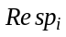 is the respiration of group i, 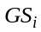 is the fraction of i's consumption that is not assimilated, 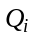 is the consumption of i, and 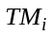 is the proportion of the production that can be attributed to primary production. If the unit is a nutrient 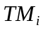 is equal to zero, irrespective of whether the group is an autotroph or not (nutrients are not ‘produced’), and, 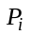 is the total production of group i.
Respiration is used, in Ecopath, only for balancing the flows between groups. Thus, it is not possible to enter respiration data. However, known respiration values (i.e., the metabolic rate) of a group can be compared with the output, and the input parameters adjusted to achieve the desired respiration. (For an application of this approach, see Browder, 1993)
Respiration is a non-negative flow expressed, e.g., in t · km⁻² · year⁻¹. If the currency is a nutrient, (e.g., nitrogen or phosphorus), respiration is zero: nutrients are not respired, but egested and recycled within systems.
Assimilation
The part of the food intake that is assimilated is computed for each consumer group from
B_{i} · (Q/B)_{i} · (1 - GS_{i}) Eq. 41
where 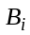 is the biomass of group i; is the consumption / biomass ratio of group i; and is the part of the consumption that is not assimilated.
The three values needed for the estimation are all input parameters. Assimilation is a flow expressed, e.g., in t · km⁻² · year⁻¹.
Respiration/Assimilation
The (dimensionless) ratio of respiration to assimilation cannot exceed 1, because respiration cannot exceed assimilation. For top predators, whose production is relatively low, the respiration/assimilation ratio can be expected to be close to 1, while it will tend to be lower, but still positive, for organisms at lower trophic levels.
Production/Respiration
The (dimensionless) ratio production / respiration express the fate of the assimilated food. Computationally, this ratio can take any positive value, though thermodynamic constraints limit the realized range of this ratio to values lower than 1.
Respiration/Biomass
The R/B ratio can be seen as an expression of the activity of the group. The higher the activity-level is for a given group, the higher the ratio. The R/B ratio is strongly impacted by the assumed fraction of the food that is not assimilated, see the basic input form. If the ratio is too high, this may be due to GS being too low.
The ratio respiration / biomass can take any positive value, and has the dimension time⁻¹.

Niche overlap
Ecopath-predicted values for Prey overlap and Predator overlap are displayed in separate forms under the Niche overlap node (under Parameterization) in the Navigator window.
Numerous overlap indices have been suggested for quantification of how species overlap. Hurlbert (1978) and Loman (1986) summarized different types of indices, and described their properties based on a number of hypothetical examples.
Here a simple niche overlap index is adopted and it is shown how it can serve as a starting point for the development of a new (predator) niche overlap index incorporating predation. The procedure involved in deriving a predator niche overlap index (from a prey niche overlap index) should be generally applicable, i.e., not limited to the type of index presented below.
Pianka (1973) suggested the use of an overlap index derived from the competition coefficients of the Lotka-Volterra equations. This index, O_{jk} , which has been used for many descriptions of niche overlap, can be estimated, for two species/groups (j) and (k), from
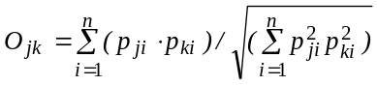 Eq. 42
where P_{ji} and P_{ki} are the proportions of the resource (i) used by species (j) and (k), respectively. The index is symmetrical and assumes values between 0 and 1.
A value of 0 suggests that the two species do not share resources, 1 indicates complete overlap, and intermediate values show partial overlap in resource utilization.
Closer examination of the Pianka overlap index shows it to have an unwanted characteristic, and it is therefore slightly modified here. If one of the groups (say j) only overlaps with one other group (k) then P_{ji} will be zero for all values of (i) but (i) = (k), where it will reach a value of 1. In such a case, the denominator of Equation (1) will always be 1, and the overlap index will equal P_{ki}, whereas a value between P_{ki} and P_{ji} would be more reasonable. This behavior is caused by the geometric mean implied in the denominator of (1), and can be circumvented by the use of an arithmetic mean. For this (1) is changed to
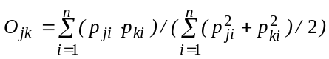 Eq. 43
where the index and all of its terms can be interpreted as above. This version of the Pianka overlap index is used in the subsequent calculations.
The niche overlap index can be used to describe various kinds of niche partitioning. Here attention will be focused on the trophic aspects. In this case, the P_{ki} and P_{ji} in (2) can be interpreted as the fraction prey (i) contributes to the diets of (j) and (k), respectively.
Using an approach similar to that above, it is possible to quantify the predation on all preys (m) and (n) by all predators (l), and to derive a ‘predator’ composition, estimated from
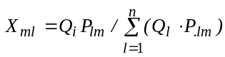 Eq. 44
and
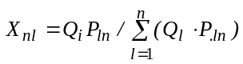 Eq. 45
Here X_{ml} can be interpreted as the fraction the predation by (l) contributes to the total predation on (m), while Q_{l} is the total consumption for predator (l). The predator compositions given above correspond to what Augoustinovics (1970) defined, in the context of input-output analysis, as ‘technical coefficients’.
Based on the predator composition a ‘predator overlap index’ (P) can be derived as
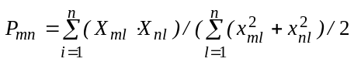 Eq. 46
the values of this predator overlap index range between 0 and 1 and can be interpreted in the same way as those of the prey overlap index, given in (2).
In the present version, only one type of niche overlap index is incorporated, but both predator and prey niche overlap is given for this index. Given users' interest, more indices may be included in later versions of EwE.

Electivity
The electivity (selection index) describe a predator’s preference for prey. It scales from -1 to 1; where -1 indicates total avoidance of a prey; 0 indicates that a prey is taken in proportion to its abundance in the ecosystem; and 1 indicates total preference for a prey. The electivity values are highlighted using a color scale for the background, scaling from –1 (white) to 1 (red) using shades of red for intermediate values. The electivity index displayed is the standardized forage ration of Chesson(1983), see below.
One of the most widely used indices for selection is the Ivlev electivity index, E_{i} (Ivlev 1961) defined for a group (i) as:
E_{i} = (r_{i} – P_{i}) / (r_{i} +P_{i})
where r_{i} is the relative abundance of a prey in a predator's diet and P_{i} is the prey's relative abundance in the ecosystem. E_{i} is scaled so that E_{i} = -1 corresponds to total avoidance of, E_{i} = 0 represents non-selective feeding on, and E_{i} = 1 shows exclusive feeding on a given prey i. Note that within Ecopath, r_{i} and P_{i} refer to biomass, not numbers.
The Ivlev electivity index was included in the DOS version of Ecopath because it often shows up in the literature. This index has, however, a major shortcoming, seriously limiting its usefulness as a selection index: as shown by several authors, e.g., Jacobs (1974), the Ivlev index is not independent of prey density.
A better approach is to use the standardized forage ratio (S_{i}) as suggested by Chesson (1983). This index is independent of prey availability, and is given by:
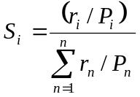
where r_{i} and P_{i} are defined as above, and n is the number of groups in the system. The standardized forage ratio as originally presented takes values between 0 and 1, with S_{i} = 0 representing avoidance and S_{i} = 1 exclusive feeding.
As implemented in Ecopath the forage ratio has been transformed (linearly) such as to vary between -1 and 1, so that -1, 0 and 1 can be interpreted as for the Ivlev index.

Search rates
One surprising feature of the system of linear equations underlying the Ecopath approach is that it can be used to estimate the Lotka-Volterra mass-action term ‘a’, which has the dimension of a volume searched per unit time by a given predator j seeking a certain prey i. If we start from the first Ecopath Master Equation:
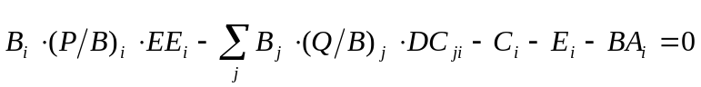
where B is biomass, P production rate, EE the ecotrophic efficiency, C the catch rate, BA the biomass accumulation rate, E the net migration rate, Q the consumption rate, DC_{ji} the proportion i contributes to the diet of j (each of the consumers). Separating the biomass accumulation rate, BA, and re-expressing as a differential equation:
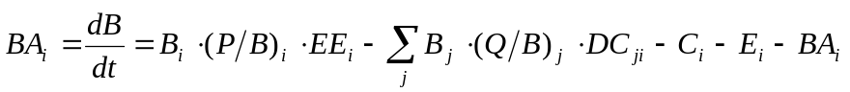
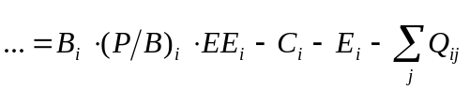
where Q_{ji} expresses the consumption rate for consumer j of prey i. We can then solve for a_{ji} = Q_{ji}/(B_{j}·B_{i}), which defines the Lotka-Volterra mass-action term a the quotient of the amount of i consumed by j, divided by the product of their biomasses.
This mass-action term is used as ‘fixed support’ for the ‘lever’ which, in Ecosim, regulates the consumption of predators, given the changing biomasses of their preys, and their own changing biomasses.
The values of ‘a’ depend obviously on the units used, and the biomass units used in Ecopath render difficult a direct interpretation of the numbers in the ‘Search rate’ table. However, they can easily be converted into values of ‘a’ applying to single organisms, given that the ratio of the individual prey and predator weights are divided into the values of ‘a’ for each pair of prey and predator.

Fishery
The Fishery node under Parameterization node in the Navigator window summarizes total catch (Quantity) and Value of each fished group by fleet. Only groups for which landings and/or discards have been entered are shown.
Quantity
The Quantity form shows total catch for fished groups by fleet, where
Catch = Landings + Discards
where Landings and Discards are entered as Ecopath inputs under the Fishery node under Input data in the Navigator window. The form also displays the Trophic level of each fleet and of the fishery in total.
Value
The Value form shows the calculated value for fished groups (i) by fleet (g), where
Value_{i,g} = Market price_{i,g} . Landings_{i,g}
where Market price and Landings are entered as Ecopath inputs under the Fishery node under Input data in the Navigator window.
The Non-market value of each resource is also shown in a separate column on the Value form (if any Non-market prices have been defined under the Fishery node under Input data in the Navigator window), where
Non-market value = Non-market Price . Biomass

Tools
Tools currently available in Ecopath are the Flow diagram and the EwE network analysis plugin.

Flow diagram
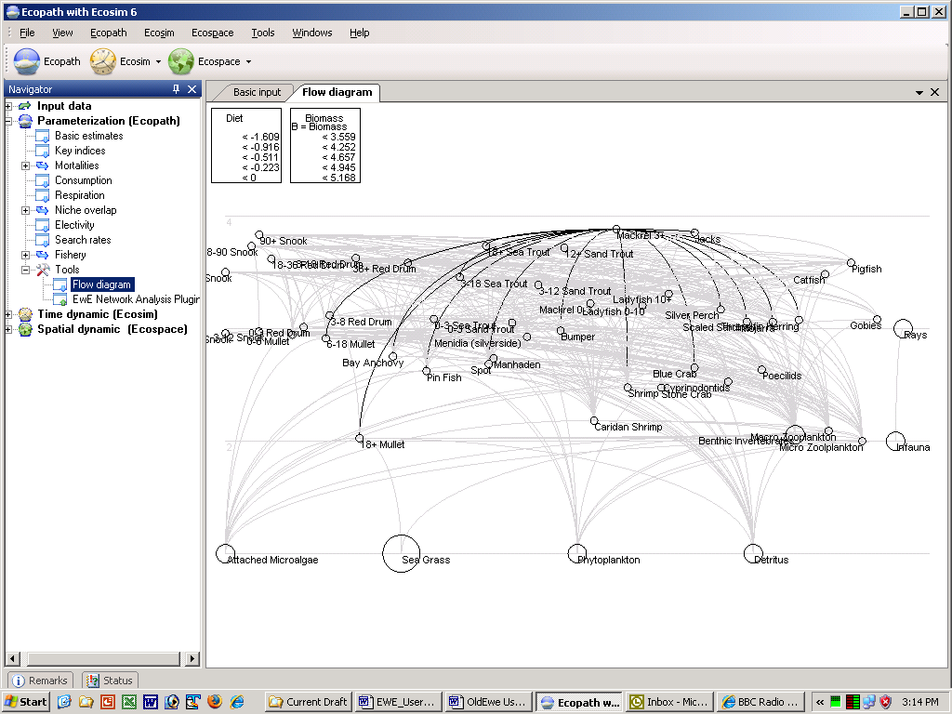
Figure 7.3. Flow diagram

EwE network analysis plugin
The Ecopath software links concepts developed by theoretical ecologists, especially the network analysis theory of Ulanowicz (1986), with those used by biologists involved with fisheries, aquaculture and farming systems research. The Network analysis component of Ecopath is included as a plugin under the Tools node under the Parameterization node in the Navigator window. It can also be accessed from the Ecopath menu.
The output forms included in the plug in include: Trophic level decomposition, Flows and biomasses, Primary production required, Mixed trophic impact, Ascendancy, Flow from detritus, Cycles and pathways, Network analysis indices in Ecosim. The notes on these sections give only brief accounts of the concepts from theoretical ecology included in Ecopath. For complete descriptions, we refer to the literature cited in the respective sections.
Note that because the network analysis feature is a plugin, the above components are accessed via a separate menu that is displayed when you select the Network analysis node (see Figure 7.4). You can re-size the Navigator window and the Network analysis menu by dragging the side of their respective windows. You can also hide the Navigator window using the AutoHide button () in the top corner of the window.
Note: to be able to access the EwE Network Analysis Plugin, it must have been installed with EwE 6. If you cannot access the EwE Network Analysis Plugin, you may need to re-instal the software (see How to obtain the Ecopath with Ecosim 6.0 software). During the setup process, you will be prompted to check a box to install the EwE Network Analysis Plugin.
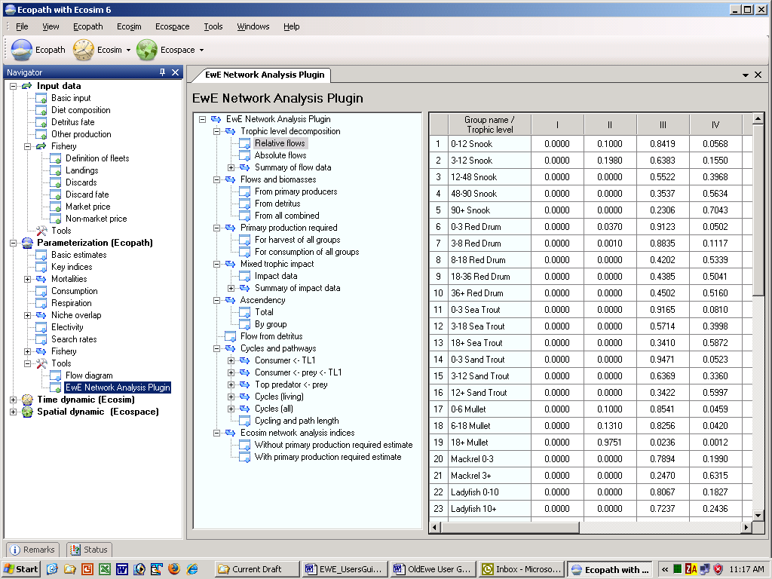
Figure 7.4. The EwE Network Analysis Plugin menu.

Trophic level decomposition
In addition to the routine for calculation of fractional trophic levels, a routine is included in Ecopath which aggregates the entire system into discrete trophic levels sensu Lindeman. This routine, based on an approach suggested by Ulanowicz (1995), reverses the routine for calculation of fractional trophic levels. Thus, for the example when a group obtains 40% of its food as a herbivore and 60% as a first-order carnivore, the corresponding fractions of the flow through the group are attributed to the herbivore level and the first consumer level. The results of this analysis are presented in the Relative flows table under the Trophic level decomposition node (these are proportions adding up to 1). These proportions are converted to absolute amounts, presented in the Absolute flows table (t.km².year⁻¹ or grams of carbon.m².year⁻¹), thus enabling the flows to be aggregated by trophic level and summarized in different ways. See Flows and biomasses and Summary of flow data for descriptions of these summaries.
Flows from detritus to the different model groups are also calculated when you select the Flow from detritus menu item.

Summary of flow data
Transfer efficiency
Based on the trophic aggregation tables (see Flows and biomasses), the transfer efficiencies between successive discrete trophic levels can be calculated as the ratio between the sum of the exports from a given trophic level, plus the flow that is transferred from trophic level to the next, and the throughput on the trophic level. This is presented in a table with transfer efficiencies (%) by trophic levels (Figure 7.5).
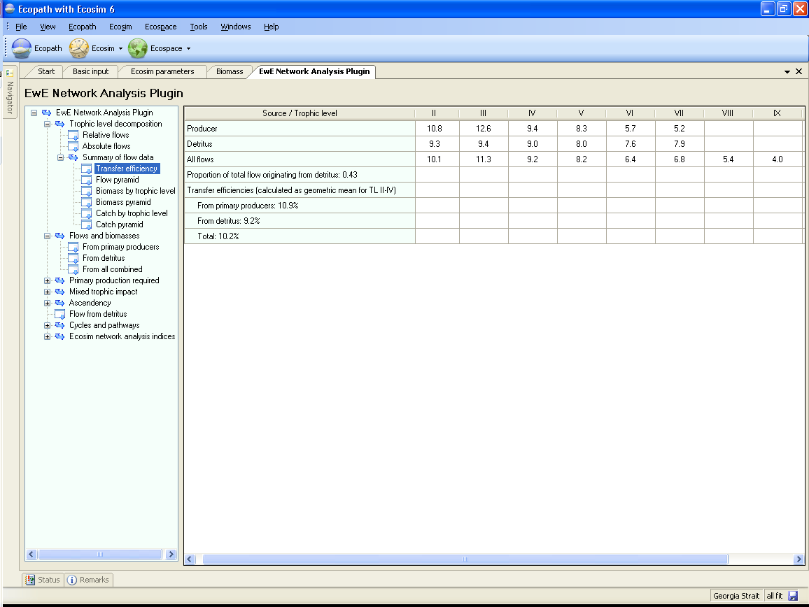
Figure 7.5
Flow pyramid
The transfer efficiencies (see above) can be used for constructing a figure presenting the trophic flows in the form of a pyramid that can be produced by selecting the Flow pyramid menu item on the EwE Network Analysis Plugin menu (Trophic level decomposition > Summary of flow data > Flow pyramid). Here, the traditional two-dimensional Lindeman pyramids, consisting of a number of rectangles placed on top of each other, are replaced by a three-dimensional, Egyptian-style, solid pyramid.
These pyramids are drawn such that the volume of each compartment representing a trophic level is proportional to the total throughput of that level. In addition, to enable various comparisons, the top-angle of the pyramids was made inversely proportional to the geometric mean of the transfer efficiencies between trophic levels observed in the system.
The efficiency of detritus transfer is not defined. On the other hand, the outputs include the ratio of total flow originating from the detritus to the total flow originating from both primary producers and detritus. This ratio, which may be viewed as an index of the importance of detritus in a system, is the quantitative form of yet another of Odum's (1969) measures of ecosystem maturity. The index is complementary, i.e., it sums to 1 with the proportion of the total flow that originates from the primary producers.
Biomass by trophic level and Biomass pyramid
Biomass pyramids can be constructed based on biomasses by trophic level. For calculation of this the biomass of each group in the system is distributed onto trophic levels in proportion to the flows by trophic levels for the groups.
Catch by trophic level and Catch pyramid
Catch pyramids can be constructed based on catch by trophic level. For calculation of this the catch of each group in the system is distributed onto trophic levels in proportion to the flows by trophic levels for the groups.

Flows and biomasses
The absolute flows calculated in the Trophic level decomposition and Flow from detritus analyses can be aggregated to produce useful summaries by trophic level. Results are presented in three tables, where the import (on Trophic Level I only), consumption by predators, export, flow to the detritus, respiration, and throughput are given by trophic level. The throughput is the sum of the flows in the other columns (see Figure 7.6).
From primary producers
The first table presents flows originating from the primary producers.
From detritus
The second table summarizes the flows originating from the detritus.
From all combined
The third table presents the summed flow for the system as a whole.
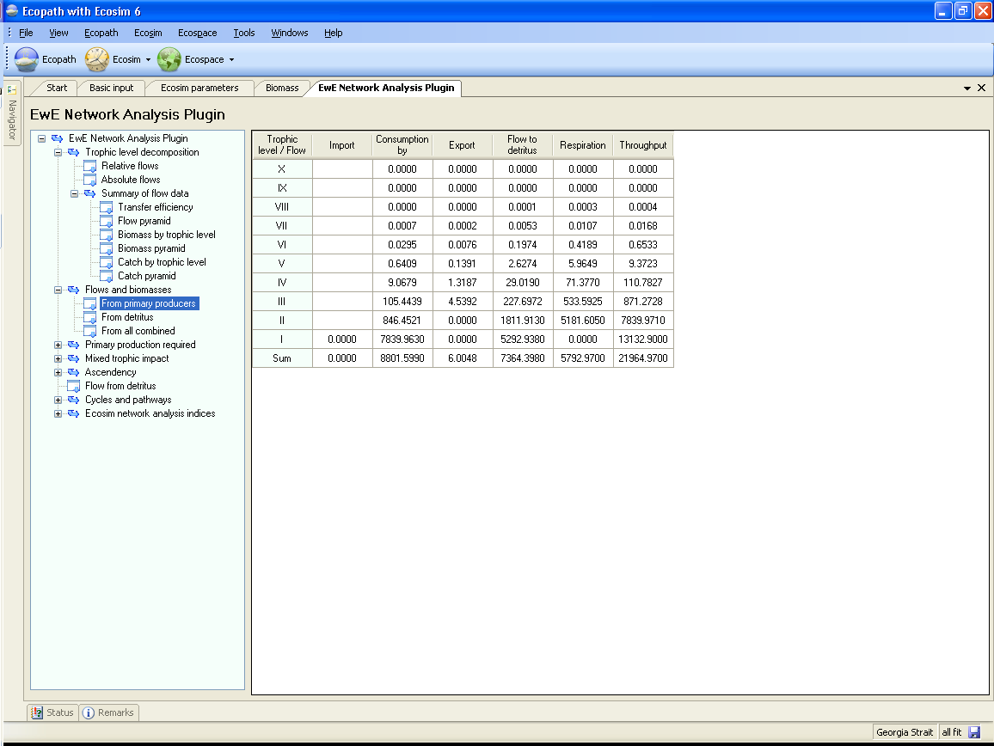
Figure 7.6

Primary production required
For terrestrial systems, it has been shown by Vitousek et al. (1986), based on a detailed analysis of agriculture, industry and other activities, that nearly 40% of potential net primary production is used directly or indirectly by these activities. Comparable estimates for aquatic systems were not available until recently, though a rough estimate, of 2% was presented in the same publication. This figure, much lower than that for terrestrial systems, was based on the assumptions that an ‘average fish’ feeds two trophic levels above the primary producers, and has been since revised upward (Pauly and Christensen, 1995).
The crudeness of Vitousek et al.’s approach for the aquatic systems was due mainly to lack of information on marine food webs, especially on the trophic positions of the various organisms harvested by humans. Models of trophic interactions may however help overcome this situation, and an alternative approach, based on network analysis, may be suggested for quantification of the primary productivity required to sustain harvest by humans (or by analogy by any other group that extracts production from an ecosystem).
To estimate the primary production required (PPR, Christensen and Pauly, 1993a) to sustain the catches and the consumption by the trophic groups in an ecosystem, the following procedure has been implemented in Ecopath: First, all cycles are removed from the diet compositions, and all paths in the flow network are identified using the method suggested by Ulanowicz (1995). For each path, the flows are then raised to primary production equivalents using the product of the catch, the consumption/production ratio of each path element times the proportion the next element of the path contributes to the diet of the given path element. For a simple path from trophic level (TL) I (primary producers and detritus), over TL II and III, and on to the fishery,
the primary production (or detritus) equivalents, PPR, corresponding to the catch of Y is:
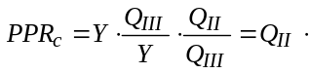
For the general (and more realistic) case where the pathways includes branching the PPR corresponding to a catch Y of a given group can be quantified by summing over all pathways leading to the given group the PPR’s
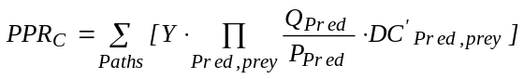 Eq. 47
where P is production, Q consumption, and DC’ is the diet composition for each predator/prey constellation in each path (with cycles removed from the diet compositions).
The PPR required to sustain the catch is presented as a page on the PPR form.
Further, the PPR for sustaining the consumption of each trophic group in a system can be estimated from the same equation as above by substituting the catch, Y, with the production term, P, calculated as the production/biomass ration, P/B, times the biomass, B. This is presented on a separate page on the PPR form.
PPR should actually be interpreted as flow from Trophic Level I as it includes primary production as well as detritus uptake. The denominator, PP, thus actually includes all ‘new’ flow to the detritus groups, i.e. flow from primary producers and import of detritus.
The PPR is closely related to the emergy concept of H. T. Odum (1988), and is proportional to the ecological footprint of Wackernagel and Rees (1996).

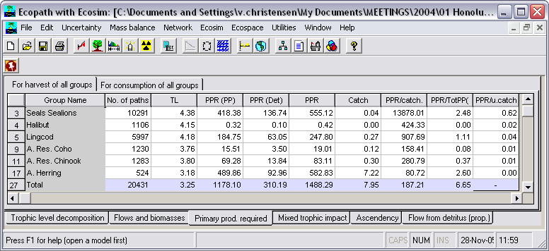

FIGURE 7.7 Primary production required (PPR) to sustain the fishery, calculated based on all food pathways in the system. In this system the fishery is appropriating 6.65% of the primary production, all indirectly.

Mixed trophic impact
Leontief (1951) developed a method to assess the direct and indirect interactions in the economy of the USA, using what has since been called the Leontief matrix. This approach was introduced to ecology by Hannon (1973) and Hannon and Joiris (1989). Using this, it becomes possible to assess the effect that changes the biomass of a group will have on the biomass of the other groups in a system. Ulanowicz and Puccia (1990) developed a similar approach, and a routine based on their method has been implemented in the Ecopath system. The example given represents the open ocean, central part of the South China Sea ecosystem (Pauly and Christensen, 1993).
The MTI for living groups is calculated by constructing an n x n matrix, where the i,j^{th} element representing the interaction between the impacting group i and the impacted group j is
MTI_{i,j} = DC_{i,j} – FC_{j,i} , Eq. 48
where DC_{i,j} is the diet composition term expressing how much j contributes to the diet of i, and FC_{j,i} is a host composition term giving the proportion of the predation on j that is due to i as a predator. When calculating the host compositions the fishing fleets are included as ‘predators’.
For detritus groups the DC_{i,j} terms are set to 0. For each fishing fleet a ‘diet compositions’ is calculated representing how much each group contributes to the catches, while the host composition term as mentioned above includes both predation and catches.
The diagonal elements of the MTI are further increased by 1, i.e.
MTI_{i,i} = 1 + MTI_{i,i} Eq. 49
The matrix is inversed using a standard matrix inversion routine.
The mixed trophic impact graph can be opened using the Graph of mixed trophic impacts form. The number of group included in the mixed trophic impact graph can be limited using the Show/hide groups on mixed trophic impacts graph form.
Error: Reference source not found shows the direct and indirect impact that the very small increase of the biomass of groups mentioned to the left of the histograms (rows) have on the biomass of the other groups mentioned above the histograms (columns). The bars pointing upwards indicate positive impacts, while the bars pointing downwards show negative impacts. The bars should not be interpreted in an absolute sense: the impacts are relative, but comparable between groups.
In this example, the apex predators will have a negative impact on their preferred prey, epipelagic nekton, and an indirect, if slight (0.03, not visible on Figure 7.8 but available on the mixed trophic impact table output by the program) positive impact on the prey of their prey, the larger zooplankton (this effect is known as a ‘cascade’). Further, the impact of the epipelagic nekton on the microzooplankton is slightly positive (0.01), even though the former feeds on microzooplankton directly. This is because the epipelagics also feed on the large zooplankton, and this overrules the direct impact.
Most groups have a negative impact on themselves, interpreted here as reflecting increased within-group competition for resources. Exceptions exist; thus, if a group cannibalizes itself (0-order cycle), the impact of a group on itself may be positive.
The mixed trophic impact routine can also be regarded as a form of ‘ordinary’ sensitivity analysis (Majkowski, 1982). In this system, it can be concluded, e.g., that the impact of the bathypelagics on any other group is negligible: these fishes are too scarce to have any quantitative impacts. This can be seen to indicate that one need not allocate much effort in refining one’s parameter estimates for this group; it may be better to concentrate on other groups.
One should regard the mixed trophic impact routine as a tool for indicating the possible impact of direct and indirect interactions (including competition) in a steady-state system, not as an instrument for making predictions of what will happen in the future if certain interaction terms are changed. The major reason for this is that changes in abundance may lead to changes in diet compositions, and this cannot be accommodated with the mixed trophic impact analysis.

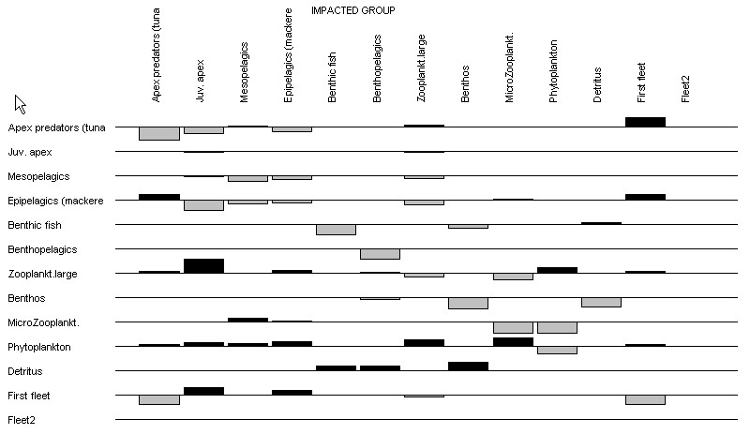

Figure 7.8. Mixed trophic impacts showing the combined direct and indirect trophic impacts that an infinitesimal increase of any of the groups on the left is predicted to have on the groups in the columns.

Ascendancy
Ascendency is a measure of the average mutual information in a system, scaled by system throughput, and is derived from information theory (see Ulanowicz and Norden, 1990). If one knows the location of a unit of energy the uncertainty about where it will next flow to is reduced by an amount known as the average mutual information’,
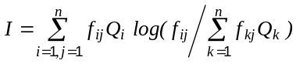 Eq. 50
where, if 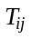 is a measure of the energy flow from j to i, 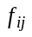 is the fraction of the total flow from j that is represented by , or,
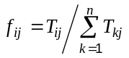 Eq. 51
is the probability that a unit of energy passes through i, or
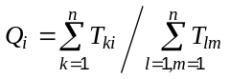 Eq. 52
is a probability and is scaled by multiplication with the total throughput of the system, T, where
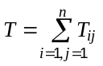 Eq. 53
Further
Eq. 54
where, it is A that is called ‘ascendency’. The ascendency is symmetrical and will have the same value whether calculated from input or output.
There is an upper limit for the size of the ascendency. This upper limit is called the ‘development capacity’ and is estimated from
Eq. 55
where H is called the ‘statistical entropy’, and is estimated from
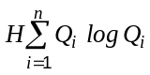 Eq. 56
The difference between the capacity and the ascendency is called ‘system overhead’. The overheads provide limits on how much the ascendency can increase and reflect the system's ‘strength in reserve’ from which it can draw to meet unexpected perturbations (Ulanowicz, 1986). As an example, the part of the ascendency that is due to imports, 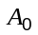, can increase at the expense of the overheads due to imports, 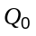. This can be done by either diminishing the imports or by importing from a few major sources only. The first solution would imply that the system should starve, while the latter would render the system more dependent on a few sources of imports. The system thus does not benefit from reducing below a certain system-specific critical level (Ulanowicz and Norden, 1990).
The ascendency, overheads and capacity can all be split into contributions from imports, internal flow, exports and dissipation (respiration). These contributions are additive.
The unit for these measures is ‘flowbits’, or the product of flow (e.g., t·km⁻² year⁻¹) and bits. Here the ‘bit’ is an information unit, corresponding to the amount of uncertainty associated with a single binary decision.
The overheads on imports and internal flows (redundancy) may be seen as a measure of system stability sensu Odum, and the ascendency / system throughput ratio as a measure of information, as included in Odum’s attributes of ecosystem maturity. For a study of ecosystem maturity using Ecopath see Christensen (1995a).
Ecopath calculates ascendency, overheads and capacity for the whole system (Total form) and by group (By group form).

Flow from detritus
The Trophic level decomposition analysis calculated the the fractions of the flow from each trophic level through each model group. The Flow from detritus analysis is equivalent, but calculates the flow from detritus through each group and converts it to absolute flows (t.km⁻².year⁻¹). The results are summarized in the Trophic aggregation analyses (see Flows and biomasses).

Cycles and pathways
A routine based on an approach suggested by Ulanowicz (1986) has been implemented to describe the numerous cycles and pathways that are implied by the food web representing an ecosystem. For a further description see Ulanowicz (1986, his examples 4.4 and 4.5, page 65f.).
Each routine below has two forms: Pathway and Summary of pathways. The summary routine counts the number of all pathways leading from the prey to the selected consumer. The mean path length will be calculated and displayed on the form. This mean path length is calculated as the total number of trophic links divided by the number of pathways.
Note: For each of the subheadings below, to activate the Pathway and Summary of pathways routines, you must first select the appropriate Pathway menu item and select the groups to be used in the analysis.
Consumer <- TL1
This routine lists all pathways leading from all groups on Trophic Level I (primary producers and detritus) to any selected consumer. A list of all consumers in the system will be displayed, and one can select from this. The program then searches through the diet compositions, finds all the pathways from the primary producers to the specified consumer, and then presents these pathways. Further, a summary presents the total number of pathways and the mean length of the pathways (under the Summary of pathways menu item). The latter is calculated as the total number of trophic links divided by the number of pathways.
Consumer <- prey <- TL1
This routine lists all pathways leading from all groups on Trophic Level I (primary producers and detritus) to any selected consumer via a selected prey. A pull-down list of all consumers in the system will be displayed after the heading “Pathways leading to:”. Select the consumer of interest from this list then choose a specific prey from the right-hand pull-down list. The program searches through the diet compositions, finds all the pathways from the primary producers, via the selected prey, to the specified consumer, and then presents the pathways. A summary presents the total number of pathways and the mean length of the pathways (under the Summary of pathways menu item).
Top predator <- prey
Here, one enters a prey group, and the program will find all pathways leading from this prey to all top predators. A summary presents the total number of pathways and the mean length of the pathways (under the Summary of pathways menu item).
Cycles (living)
The routine identifies all cycles in the system excluding detritus and displays these, in ascending order, starting with ‘zero order’ cycles (‘cannibalism’). In addition, the total number and the mean length of the cycles will be displayed.
Cycles (all)
The routine identifies all cycles in the system and displays these, in ascending order, starting with ‘zero order’ cycles (‘cannibalism’). In addition, the total number and the mean length of the cycles will be displayed.
Cycling and path length
The ‘cycling index’ is the fraction of an ecosystem's throughput that is recycled. This index, developed by Finn (1976), is expressed here (Figure 7.9) as a percentage, and quantifies one of Odum's (1969) 24 properties of system maturity (Christensen 1995). Recent work shows this index to strongly correlate with system maturity, resilience and stability.
In addition to Finn's cycling index, Ecopath includes a slightly modified ‘predatory cycling index’, computed after cycles involving detritus groups have been removed.
The path length is defined as the average number of groups that an inflow or outflow passes through (Finn 1980). It is calculated as
Path length = Total System Throughput / (∑ Export + ∑ Respiration).
As diversity of flows and recycling is expected to increase with maturity, so is the path length. The effects of changes in the ecosystem on the network analysis indices (such as total systems throughput, Finn and predatory cycling indices, ascendency, overhead and their breakdown into various components) can then be plotted over time and compared for various scenarios of Ecosim (see Network analysis indices in Ecosim).

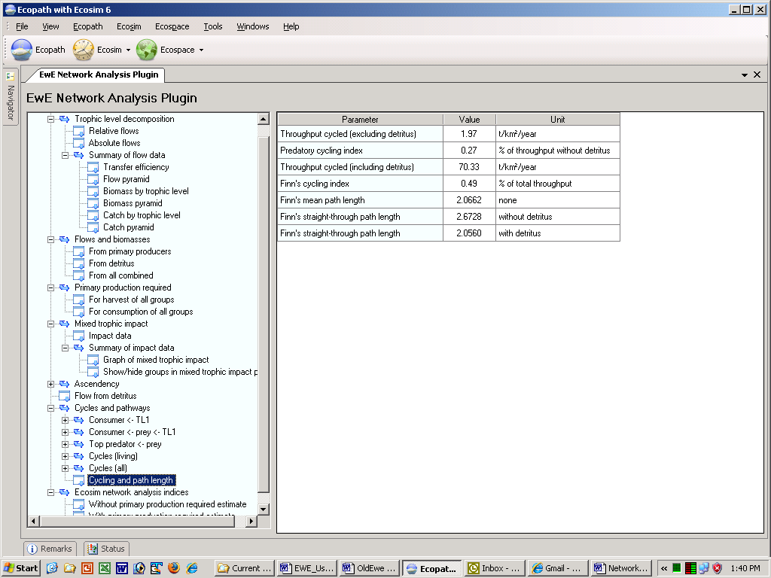
Figure 7.9.

Network analysis indices in Ecosim (by Sheila Heymans)
Some network analysis indices have been extended into Ecosim.
To obtain these indices and their changes over time from Ecosim, the “Indices” checkbox should be checked on the Ecosim Biomass form. If Network Analysis has not been invoked prior to Ecosim, a message stating “Trophic levels not read, do Network Analysis” will be given. It is not necessary to wait for all the cycles to be calculated (which might take 24 hours), but you can press cancel to obtain the Network Analysis indices given in Ecosim.
When the “Indices” checkbox is checked and Ecosim is run the FIB, Kempton’s Q etc. indices will be shown in Ecosim, and a file named “network.csv” will be saved in the same directory as the Ecopath database. This file should be renamed if you want rerun the network analysis indices, as it will also save results to the same file.
The file (see Table 7.1 below for example) will give the throughput (Trput), development capacity (Capacity), Ascendency on import (Asc import), flow (Asc flow), export (Asc exp) and respiration (Asc resp), Overhead on import (Ovh import), flow (Ovh flow), export (Ovh exp) and respiration (Ovh resp), predatory cycling index (PCI) and Finn cycling index (FCI) for each monthly time step of the simulation.
Table 7.1. The effects of changes in the ecosystem on the network analysis indices (such as total systems throughput, Finn and predatory cycling indices, ascendency, overhead and their breakdown into various components) can then be plotted over time and compared for various scenarios of Ecosim.
Trput | Capacity | Asc import | Asc flow | Asc exp | Asc resp | Ovh import | Ovh flow | Ovh exp | Ovh resp | PCI | FCI
5.85E+1 | 374912.1 | 0 | 48.7 | 7.54E+1 | 29.00 | 0 | 18.02 | -7.54E+15 | 1.42 | 7.16 | 5.65E-1
5.85E+1 | 374899.4 | 0 | 48.7 | 7.54E+1 | 29.00 | 0 | 18.02 | -7.54E+15 | 1.42 | 7.16 | 5.65E-1
5.85E+1 | 374908.6 | 0 | 48.7 | 7.54E+1 | 29.00 | 0 | 18.02 | -7.54E+15 | 1.42 | 7.16 | 5.65E-1

Using Ecosim. Part 1: Ecosim inputs
Ecosim provides a dynamic simulation capability at the ecosystem level, with key initial parameters inherited from the base Ecopath model. This chapter describes the steps taken to set up Ecosim scenarios (The Ecosim menu; Ecosim parameters; Group info; Vulnerabilities); read in Time series data; set up Mediation, Forcing and Egg production functions; and set parameters for Fishing effort dynamics.
Before proceeding with Ecosim, we recommend you read the introductory material on Ecosim (An overview of Ecosim, Ecosim basic, Predicting consumption, Time series fitting in Ecosim, Hints for fitting models to time series reference data and Time series random effects, also found in Chapter 1 of the User Guide). You should also be familiar with the published literature on Ecosim, particularly Walters et al. 1997; Walters et al. 2000; Christensen and Walters 2004).

Getting started in Ecosim: The Ecosim menu
When working in Ecosim or Ecospace you work within a ‘scenario’. A given Ecopath model can have any number of Ecosim and Ecospace scenarios attached, and they all inherit their basic parameters (such as number of groups, group names, diets and other parameters) from the parent Ecopath model. If you change a group name or delete a group in Ecopath the changes will be carried over to existing (and new) Ecosim and Ecospace scenarios. A scenario keeps track of all the information that is needed to store and later duplicate a simulation.
Important note: Before using Ecosim you must have a balanced Ecopath model. Once you have finished balancing your Ecopath model you can begin using Ecosim. Note that once you start using Ecosim, especially when you start fitting to time series data, you will most likely encounter unexpected problems that require you to iteratively make adjustments to your Ecopath model (for example, groups becoming extinct because predation or fishing pressure is too high). Iterating between Ecopath and Ecosim in this way can be time-consuming but is very informative. Indeed, running Ecosim is an important test of the viability of a newly-balanced model and can raise interesting research questions.
New scenario
When you are ready to start using Ecosim, you must first create a new Ecosim scenario. You can do this by selecting New Scenario on the Ecosim menu (Figure 8.1). This will open the New Ecosim scenario dialogue box (Figure 8.2a) where you can re-name your new scenario and add a description. Alternatively, you can click once on the Ecosim shortcut button [], which will open the Load Ecosim scenario dialogue box (Figure 8.2 b). Select the Create option to change it into the New Ecosim scenario dialogue box.
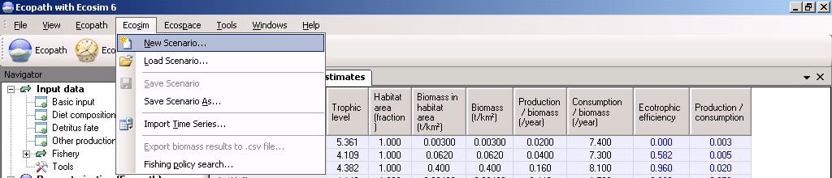
Figure 8.1. The Ecosim menu. The Ecosim shortcut button can also be seen immediately to the left of the open menu.
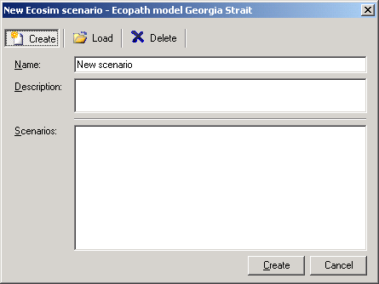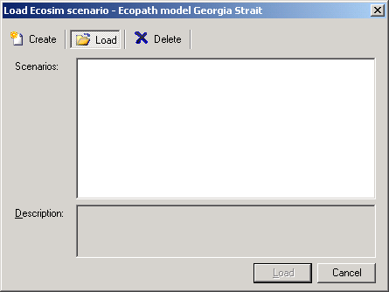
Figure 8.2a Figure 8.2b Have some scenarios here
Load scenario
The procedure for opening an existing Ecosim scenario is similar to that for creating a new scenario. Open the Load Ecosim scenario dialogue box by selecting Load scenario from the Ecosim menu. Existing scenarios will be listed in the Scenarios window (Figure 8.2b). Select the scenario you wish to load and click the Load button at the bottom of the dialogue box.
Alternatively, you can open a scenario directly using the Ecosim shortcut button []. Click on the down arrow on the right of the bottom to open a list of available Scenarios and click on the name of the desired scenario. Note that the model must be closed and re-opened before new scenarios are added to menu under the Ecopath shortcut button. New scenarios can always be accessed from the Load Ecosim scenario dialogue box, regardless of when they were created.
Deleting an Ecosim scenario is easily done using the Load Ecosim scenario dialogue box. Simply select the scenario you wish to delete in the Scenarios window and click the Delete button at the top of the dialogue box. The Load button at the bottom of the box will then change to a Delete button, which must be clicked. You will be given the option to proceed or cancel. Clicking Yes implements deletion. Clicking No cancels deletion and you can then exit the dialogue box by clicking the Cancel button.
WARNING: Scenario deletion cannot be undone.
Save Scenario
You can save a scenario at any time by selecting Save scenario on the Ecosim menu.
Save Scenario As
The Ecosim menu also has a Save As option, allowing you to save your scenario under a new name. This is an important feature that allows you to preserve properties of an Ecosim scenario that you are happy with (e.g., Vulnerabilities, Group info), while exploring the impact of other factors in different scenarios. It is also a useful way to create a backup of a successful scenario before trying out new parameter values.
Import time series
There are two main types of data that you can read in to Ecosim: historical comparison data and time forcing data. Use Import time series to open a dialogue box that enables you to import a data file containing these types of data. For further instructions on using this dialogue box, see Import time series.
For important introductory information about fitting Ecosim models to time series data, see Time series fitting in Ecosim and Hints for fitting models to time series reference data.
Export Biomass Series to .csv file
Exports the raw resultsof the last Ecosim run to a csv file. See the Biomass form for more details about these results.
Fishing Policy Search
Opens the Fishing policy search form.

Ecosim parameters
The Ecosim parameters form (Time dynamic (Ecosim) >Input > Ecosim parameters) is designed to enter and store key information on the current Ecosim simulation.
Duration of simulation (years)
Default is 20 years, while the maximum is 999 years. It is possible to save the end state of a simulation, and continue a new simulation from the end point, thus enabling even-longer term simulations.
Base proportion of free nutrients
The Base proportion of free nutrients parameter sets the base proportion of free nutrients in the algorithm used to represent nutrient cycling. You should read the section on Nutrient cycling and nutrient limitation in Ecosim before attempting to simulate nutrient forcing.
The default free nutrient proportion is set at unity, which causes the free nutrient concentration to be virtually constant over time. Thus to “turn on” nutrient limitation effects, you must set a lower value for the base proportion of free nutrients parameter, (e.g., 0.3). You can also assign a forcing function to drive nutrient cycling (see below).
Nutrient loading forcing function number
Changes in nutrient loading can be simulated by assigning a time forcing function number to the annual total nutrient concentration on the Ecosim parameters form (the forcing time series can be read from a csv file, see Import time series, or typed directly using the Time series form). In this case, total nutrient concentration N_{T} is calculated as N_{T} = f_{t} N_{T}º where N_{T}º is the Ecopath base estimate of N_{T} (at the start of each simulation) and f_{t} is a time multiplier (f_{t} = 1 implies Ecopath base value of N_{T}º) supplied by the user the same as any other time forcing function.
Before attempting to simulate nutrient forcing, you should read the section on Nutrient cycling and nutrient limitation in Ecosim.

Group info
The Group info form (Time dynamic (Ecosim) > Input > Group info) enables entry of the Ecosim parameters listed below. You must already have an Ecosim scenario loaded (see Ecosim menu) before you can us this form. Each scenario can have its own set of Group info parameters.
Maximum relative P/B
In Ecosim, the simulated biomass of some prey group may increase such that their predators, if not somehow constrained, would be able to consume huge amounts of prey, with their own biomass growing accordingly.
To constrain this, the option is provided to limit, via a multiplier, the increase of P/B that results from abundant prey being available.
Maximum relative feeding time
If prey becomes more scarce, (e.g., because predator abundance increases), their predators will have to spend more time feeding (and hence be at a greater risk to predation themselves). Use this variable to limit how much the feeding time may increase. The default is that the feeding time may at the most double, i.e., a value of 2.0. There is empirical evidence showing limits to how great a predation risk organisms are willing to take. Juveniles may for instance be found hiding at food-deprived shorelines even though suitable prey is more abundant in the pelagic zone close by. Going out to there for prey would however place the juveniles at a considerable risk of predation, and they may choose not to do so, or at least to lower the risk by limiting the time spent feeding. For more information see Foraging time and predation risk.
Feeding time adjustment rate (Range: [0,1])
This factor determines how fast organisms adjust feeding times so as to stabilize consumption rate per biomass (see Foraging time and predation risk). Setting the value to 0.0 causes feeding time (and hence time exposed to predation risk) to remain constant, all changes in consumption per biomass then result in growth rate changes. Setting this parameter to zero also results in simulation of compensatory growth rate responses (see Compensatory growth). Setting it to 1.0 results in fast time response, which causes reduction in vulnerability to predation rather than increased growth rate when/if food density increases. See Compensatory recruitment for recommendations for using this parameter to create the effects of compensation in recruitment in models with multi-stanza groups. See Compensatory natural mortality for recommendations for using this parameter to create the effects of compensation in natural mortality.
In general we recommend that you set the feeding time to 0 for all groups, apart from, e.g., marine mammals where a value of 0.5 often seems reasonable. Explore the consequences of changing this factor.
Fraction of other mortality sensitive to changes in feeding time [0-1]
This is the proportion of the unexplained natural mortality rate (M0, 1-EE x total mortality rate) that is assumed to be sensitive to changes in feeding time. Setting it to 0.0 causes M0 to remain constant. Setting it to a higher value causes that proportion of M0 to vary in proportion to relative time spent feeding (see feeding time factor above). Setting nonzero value along with nonzero feeding time factor generally results in density-dependent M: as density increases, feeding time usually has to increase to maintain food consumption rate, and this increased feeding time leads to higher mortality rate. See Compensatory recruitment for recommendations for using this parameter to create the effects of compensation in recruitment in models with multi-stanza groups.
Predator effect on feeding time [0-1]
Setting a nonzero value for this parameter allows you to simulate direct response of feeding time and food consumption rate to changes in predator abundance, i.e. ‘risk sensitive foraging behavior’. If the value is high, it is assumed that a high proportion of the food consumption rate per biomass is ‘discretionary’, i.e., the organism will reduce target food consumption rate (and hence time exposed to predation risk) by up to this fraction if predator abundance increases, and will correspondingly increase food consumption rate if predator abundance falls below the Ecopath baseline. Note that the feeding time adjustment rate (see above) has to be greater than zero in order to see effects from nonzero values of this parameter (effect is expressed in calculations as changes in time spent feeding with changes in predator abundance, and such changes are not implemented unless adjustment rate is greater than zero).
Density-dependent catchability (>=1)
See introductory material on Density-dependent changes in catchability, also in Chapter 3 of the User Guide.
QBmax/QBo (handling time) [>1]
See introductory material on Predator satiation and handling time effects, also in Chapter 3 of the User Guide.
Switching power parameter [0-2]
Default 0 is no switching. See introductory material on Modeling switching behavior, also in Chapter 3 of the User Guide.

Vulnerabilities (flow control: foraging arena parameter)
One of the most important features of Ecosim is its ability to allow exploring the implications on system dynamics of different views of how the biomass of different groups in the ecosystem is controlled. The two extreme views are ‘predator’ control’ (also called top-down control) and ‘prey control’ (or bottom-up). We model this using ‘vulnerabilities’, which represent the degree to which a large increase in predator biomass will cause in predation mortality for a given prey (see Vulnerabilities in Ecosim for details).
Low vulnerability (close to 1) means that an increase in predator biomass will not cause any noticeable increase in the predation mortality the predator may cause on the given prey. A high vulnerability, e.g., of 100, indicates that if the predator biomass is for instance doubled, it will cause close to a doubling in the predation mortality it causes for a given prey. The vulnerability parameters are among the most important parameters that can be changed to improve the agreement of the model’s predictions with historical data (see Time series fitting in Ecosim, Hints for fitting models to time series reference data and Effect of P/B (Z) and vulnerability for time series fitting). See also Fit to time series.
Vulnerabilities are entered on (or transferred from the time series fitting routine to) the Vulnerabilities form (Time dynamic (Ecosim) > Input > Vulnerabilities; see Figure 8.3). You must already have an Ecosim scenario loaded (see Ecosim menu) before you can set vulnerabilities. You must set the vulnerabilities for each new scenario, as all new scenarios have a default setting of 2.0. Note that the default value of 2.0 is arbitrarily assigned. Choosing to keep the default values is as much a decision as setting them to a new value. See Vulnerabilities in Ecosim for further scientific guidance on setting vulnerabilites.
Vulnerabilities can be set for the entire system (using the Set box in the upper right corner of the form). In general, because the vulnerability settings concern foraging behaviour, the same vulnerability is set for all of the prey of a certain predator (i.e., vulnerabilities are set column-wise). Individual values can be entered to characterize, e.g., the interactions of one (or several) predator/prey pair(s) under special conditions. We caution against setting different vulnerability parameters for every predator-prey interaction. While doing so may provide a better statistical fit to the time series data, it is unlikely that there is enough information in the data to distinguish among different parameter-combinations: i.e., the model will be overparameterized.
To transfer a set of vulnerabilities to a new scenario, use the Save scenario as option on the Ecosim menu to save an existing scenario and its associated vulnerabilities under a new name. Alternatively, use different scenarios to test for sensitivity to different sets of vulnerability values.
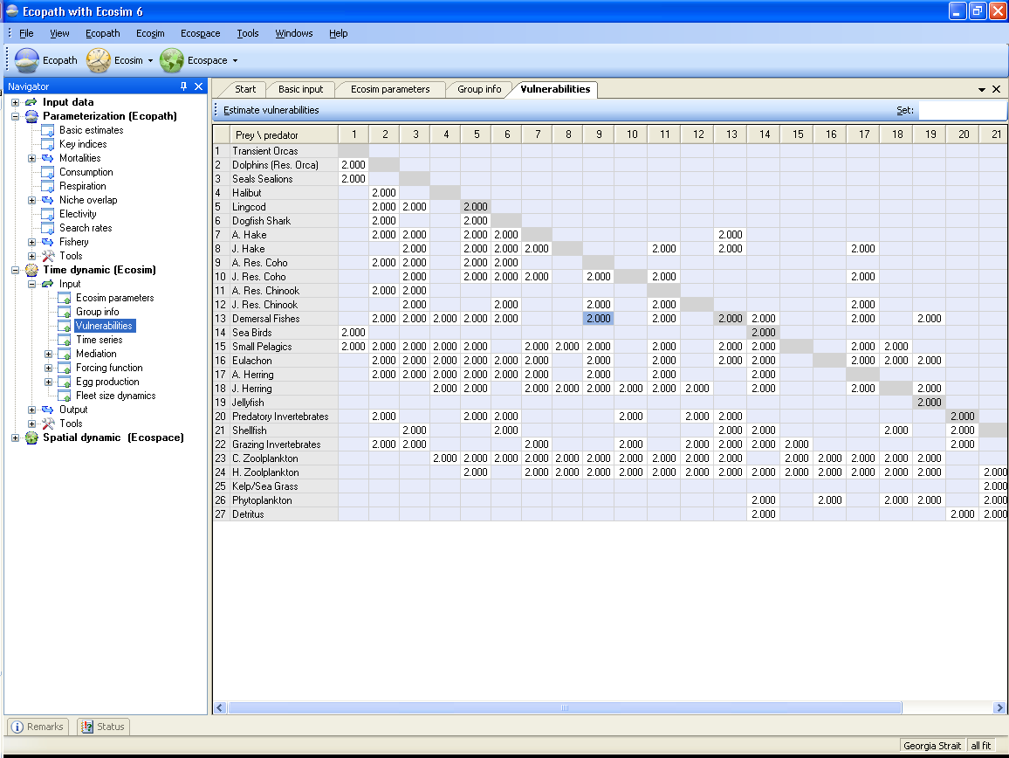
Figure 8.3. Ecosim vulnerability settings reflecting how far a consumer is from its carrying capacity with regards to a prey.

Time series
A critical step in development of credible models for policy analysis is to show that they can at least reproduce observed historical responses to disturbances such as fishing (see introductory material on Time series fitting in Ecosim, Hints for fitting models to time series reference data as well as the help section on Ecosim’s Time series fit search interface, which searches for Vulnerabilities that can help improve the model’s fit).
There are two main types of data that you can read in to Ecosim: historical comparison data and time forcing data. Historical comparison data enable comparison between historical observations and the model’s predictions. Time forcing data are used to force certain variables in the model (i.e., ‘drive’ the model). Fishing effort (by gear or by pool) and fishing mortality can be forced in Ecosim.
The Time series form (Time dynamic (Ecosim) > Input > Time series) provides an interface where users can read in, view and activate time series for use in Ecosim.
Reading time series into Ecosim
There are two ways to read time series data into Ecosim: (i) time series can be imported from a csv file (see Import… below); or (ii) time series can be typed or pasted in directly using the Time series form (see Values… below).
When you open the Time series form for the first time, there will be no time series displayed in the lower panel (Figure 8.4). To get started, use either the Import… or the Add… buttons on the lower panel of the form.
Import…
Opens the Import time series dialogue box. This allows you to import multiple time series simultaneously from a CSV (Comma Separated Values) format file and is the most commonly-used means of reading time series data into Ecosim. See Import time series for instructions on using this form. Note that this form can also be accessed from the main Ecosim menu.
After importing time series, they must be activated using Apply (see below).
Add…
Opens the Add time series dialogue box for adding time series manually (Figure 8.5). To add a time series using the Add time series dialogue box:
1. Type (select?) the number of years for the time series.
2. Click the Set button.
3. Select the data type from the drop-down menu in the Type window. Available data types are Absolute biomass, Average weight (for multi-stanza groups only), Catch, Fishing mortality*, Fishing effort (by fleet)*, Relative biomass, Time forcing*† or Total mortality.
*Indicates forcing time series;
†Indicates a series used for physical forcing of nutrient concentrations (see Ecosim parameters and links therein); hatchery production (see Hatchery populations in Ecosim); parameters that affect trophic interactions through abiotic factors (see Forcing function and Apply forcing function (consumers)); or primary production (see Apply forcing function (primary producers)).
4. Select the Ecopath group to which the time series applies from the drop-down menu in the Group window.
5. Assign the data series a relative weight using the Weight window. This represents a prior assessment by the user about relatively how variable or reliable that type of data is compared to the other reference time series (low weights imply relatively high variance or unreliable data; higher weights imply low variance or reliable data).
6. Type the Y-values of the time series in the right hand column. Monthly time-steps are automatically displayed in the left hand column.
7. Click OK. The time series will be displayed in the main panel of the form and also as a thumbnail in the lower panel.
After adding a time series, it must be activated using Apply (see below).
Duplicate
Copies the currently-selected time series.
Remove
Removes the currently-selected time series.
Apply
All imported time series must be applied before they are available to Ecosim. To apply time series:
1. Click Apply in the bottom panel of the Time series form to open the Apply time series dialogue box (Figure 8.6). Select individual time series using the check boxes or select all available time series using the All button. If you have several datasets loaded, the datasets will be shown as nested menus. You can apply time series from different datasets simultaneously.
2. Click the Apply button on the dialogue box.
Thumbnails of successfully applied time series will be shown with a check mark (Figure 8.7).
There are two additional buttons at the top of the Time series form. First select a time series from the thumbnails in the bottom panel, then:
Save
Opens a dialogue box prompting you to save the currently-selected time series to a bitmap file (.bmp). Use this dialogue box to name the file and browse for a location to save it.
Values
Displays information and values for the currently-selected time series.
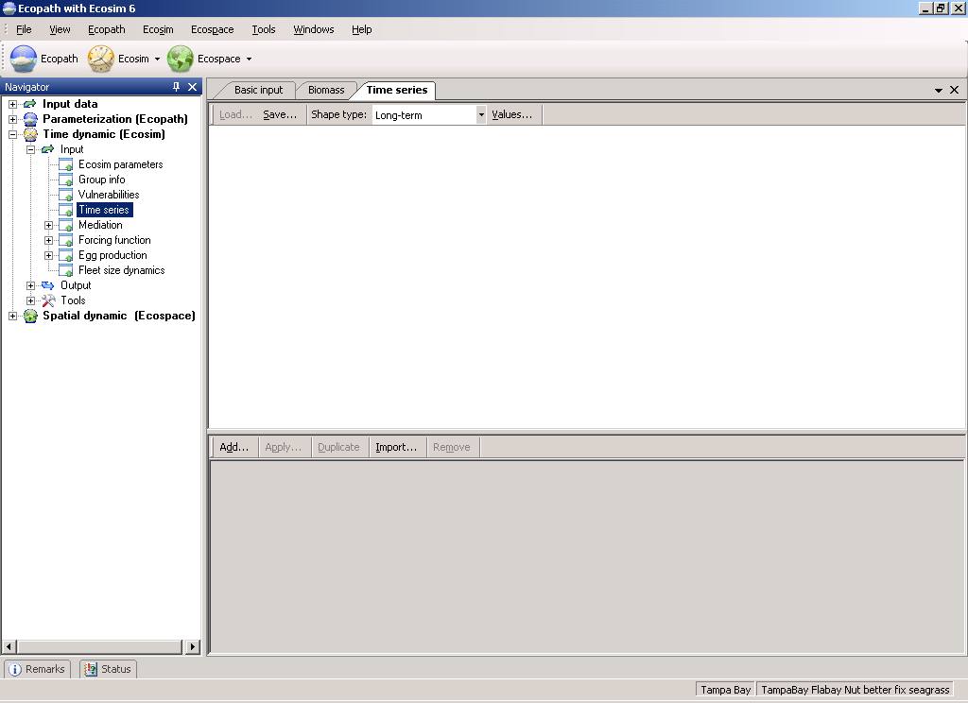
Figure 8.4.
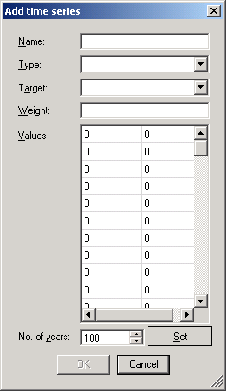
Figure 8.5.
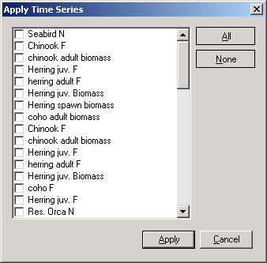
Figure 8.6.
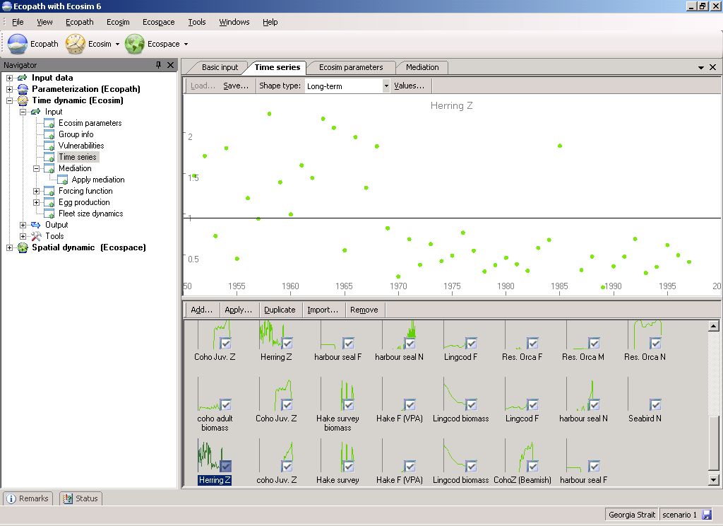
Figure 8.7.

Import time series
There are two main types of data that you can read in to Ecosim: historical comparison data and time forcing data. Historical comparison data enable comparison between historical observations and the model’s predictions. Time forcing data are used to actually force certain variables (fishing effort, fishing mortality) in the model (i.e., ‘drive’ the model). You can load both types of data with the same data file, using the codes for different data types listed below (forcing data types are indicated in parentheses).
The time series data file
For historical comparison data, you can leave cells blank for which you have no data. Ecosim will assume that the first calendar year for which you enter a data row (e.g., 1976) is to be the simulation start year. Forcing time series must have an entry for every year of the simulation. Note that relative fishing rate by gear type must be scaled so relative value is 1.0 for the Ecopath base year (year for which catches are provided to Ecopath).
The spreadsheet must be identical in format as shown in Figure XX2 (i.e., cells 1-3 in the first column must read “Name”, “Pool code” and “Type” respectively and the years of the simulation must be listed below these in the first column). For each data series (column) you must enter the Ecopath group number (Pool code) and specify the data type (see list of data types below). You can use the first row (Name) to describe the group and the data. This information will be displayed on output graphs.
Overview of data types:
-1 Force biomass (forcing)
0 Relative biomass
1 Absolute biomass
2 Time forcing data (forcing) *
3 Effort data by gear type (forcing)
4 Fishing mortality, (F) by pool (forcing)
5 Total mortality, (Z) by pool
-5 Forced total mortality (Z) (forcing)
6 Catches
-6 Forced catches (forcing) †
7 Average weight (stanzas only)
* Using data type 2, you can force nutrient concentrations (see Ecosim parameters and links therein); parameters that affect trophic interactions through abiotic factors (see Forcing function and Apply FF (consumer)) or primary production (see Apply FF (primary producer)).
† Forcing catches enables Use of Ecosim for Stock Reduction Analysis.
How to import a time series data file
Important note. After importing a time series file, you must activate the time series using the Time series form.
Note that you must already have an Ecosim scenario loaded before you can import a time series data file (see Ecosim menu for instructions for creating and loading Ecosim scenarios).
The Import time series dialogue box (Figure 8.8) allows you to load time series data stored in CSV (comma separated values) or similar text format. It can be accessed:
(i) from the Ecosim; or
(ii) from the Time series form (Import…).
To read in a data file, click Browse to locate your file or select it from the clipboard. You must then set the delimiter used to separate the values in the .csv or text file and the separator used as a decimal point. Your data will be displayed in the bottom window of the form (see Figure XX2). If everything looks as you expected it, click the Import button. If the data is not displaying as expected, first double-check that the Delimiter and Decimal separator settings are correct before checking that your file is in the correct format.
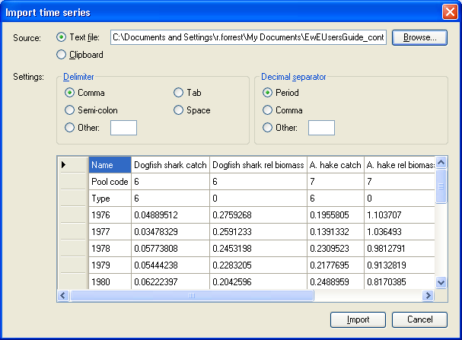
Figure 8.8.

Mediation
You can define a series of ‘trophic mediation functions’ that are used to modify vulnerabilities of selected prey types i to their predators j using Ecosim’s Mediation form (see Using the trophic mediation form below for instructions, although you should read this brief introduction first).
It is not uncommon for some third type of organism (i.e., mediating organism) to affect the feeding rate of one type of organism j on another i. At least two types of effects are possible:
Facilitation: the third organism type behaves in some way that makes type i prey more available to predator j when the third organism is more abundant. For example, pelagic piscivores like tuna may drive smaller fishes to the surface, where these fishes are then more available to birds. This is a concern for marine mammals and birds in the Eastern Pacific Ocean, at least in areas where heavy fishing has reduced abundances of tunas and billfishes.
Protection: the third organism provides protection for prey type i when the third organism is more abundant. For example, juvenile fishes (as type i prey) may use corals, macrophytes, and/or sponges for protection from predators, and fishing may directly impact these ‘cover’ types. K. Sainsbury (pers. comm.) has emphasized the possible importance of this effect for evaluating impact of trawling on the Northwest Shelf of Australia. For another example, increases in phytoplankton may reduce water clarity and hence search efficiency of visual predators on small fishes, which would tend to reinforce the ‘cascade effect’ of increasing abundance of small fishes causing reduced zooplankton abundance and hence increased phytoplankton abundance.
Each trophic mediation function is defined in the following steps:
- Sketch a functional form (Mediation shape on the Mediation form) for the mediation effect (i.e. the mediation affect as a function of the biomass of the mediating organism);
- Define the X variable for each function by specifying relative weightings for the effects of different mediating organisms. Weightings can be specified for one or more Ecopath groups, so that X becomes a weighted sum of mediating organism biomasses (i.e., more than one group can have the same trophic mediation effect but to different degrees); and
- Applying the ‘trophic mediation function’ to specific predator-prey interactions (using the Apply mediation form).
Sketching a function that increases with increasing X represents facilitation effects (prey more vulnerable when X is large), while sketching a function that decreases with X represents protection effects (prey less vulnerable when X is large). The idea behind making X a weighted sum of third organism biomasses is to:
- Allow differential protective ‘quality’ for alternative organisms that provide cover for prey; and
- Recognize that several different groups may have different tendencies to generate facilitation effects, e.g., some tunas may commonly chase bait fishes to the surface while others may not.
The sketch function approach allows considerable flexibility in specifying the form of the relationship between third organisms and trophic vulnerabilities. Such effects are essentially statistical, and cannot usually be described by any simple functional form. Effects may only occur above/below some threshold abundances, may or may not be large even when third organism abundances are very low, etc.
To avoid unnecessary parameter specification, the functions are automatically scaled relative to Ecopath baseline inputs: the X axis of each function is scaled relative to the weighted initial sum of third organism biomasses, and the function is internally scaled so that Y=1.0 when X = Ecopath initial weighted sum. The only restriction on the form of the function is that the user must not specify a relative Y value of 0.0 when X = Ecopath base value.
Internally, the Ecosim routines use the trophic mediation functions to modify prey vulnerabilities v_{ij} in the basic trophic flow equations. At each simulation time step, any i,j flow that has been defined to be affected by a mediation function is modified to use an effective v_{i,j} = v_{i,j base} · Y/Y_{o}, where Y is the current value of the mediation function, which depends on the current X of that function, and Y_{o} is the value of the function when X = Ecopath base weighted sum of mediating biomasses.
Using the trophic mediation form
To implement trophic mediation in Ecosim, open the Mediation form (Time dynamic (Ecosim) > Input > Mediation; see Figure 8.9). Note you must have an Ecosim scenario loaded before you can use the Mediation form. There are three steps to the process:
1. Define trophic mediation shapes;
2. Define and edit relative weight of impacting groups; and
3. Apply trophic mediation shapes to predator-prey interactions.
Details of each step are given below.
Step 1. Define trophic mediation shapes
When you open the Mediation form for the first time, you will see nine ‘blank’ mediation shapes with default value of 0.5. To define a mediation shape, first select one of these blank shapes. You can then define trophic mediation shapes in one of two ways:
          - Shapes can be drawn freehand using the blue sketch pad. You will see your sketched shape transferred to the thumbnail in the bottom pane;
          - Alternatively, you can use standard mathematical shapes. Click Options… at the top of the Mediation form to open the Options dialogue box. Select Shape from the menu on the left of the dialogue box (Figure 8.10a) to see a list of standard shapes (e.g., linear, sigmoid, exponential, ...). You can tailor the shape to your specific requirements by setting the Y Zero, Y End, Y Base and Steepness parameters in the cells provided. Select Options from the menu on the left of the dialogue box for display settings (Figure 8.10b).
Reset mediation shape
Clicking the Reset button at the top of the Mediation form resets the current trophic mediation shape to the default value of 1.0.
Save …
Clicking the Save… button at the top of the Mediation form opens a dialogue box prompting you to save the current trophic mediation shape to a bitmap file (.bmp). Use this dialogue box to name the file and browse for a location to save it.
There are four additional menu items on the bottom pane of the Forcing function form that allow you add, copy, rename and delete forcing or seasonal shapes.
Add…
Adds an extra blank mediation shape.
Duplicate
Copies the currently-selected mediation shape.
Remove
Removes the currently-selected mediation shape.
Rename
Rename the currently-selected mediation shape by selecting Rename. You will then be able to type in a new name for the shape.
Step 2. Define and edit relative weight of impacting groups
The Edit relative weight (Edit…) button is found in the middle of the Mediation form just above the Relative weight graph (see Figure 8.9). As discussed above, the relative weightings are used to assign a weighted sum of third organism biomasses to the X axis of each trophic mediation function to represent several different groups having the same trophic mediation effect but to different degrees. Note that third-party groups can be functional groups of organisms (Ecopath groups) or fishing fleets.
Assign relative weightings in the following steps:
1. First, you must select a Mediation shape from the set of mediation shapes at the bottom of the Mediation form. Once you have selected the desired mediation shape, click the Edit… button to open a form to assign relative weightings by group for that particular mediation shape (Define biomass percentage form; Figure 8.11).
2. On the Define biomass percentage form, select third-party groups/fleets from the menu on the left and move them to the Assigned groups and fleets table using the green arrow.
3. For each third-party group, assign a relative weighting using the Relative weight box at the top of the form. To illustrate this: if you believe three of your model groups (Group 3, Group 4 and Group 5) act as third-party groups by facilitating a particular predator-prey interaction (represented by Mediation Shape 1), and you enter 2 for Group 3, 1 for Group 4, and 0.5 for Group 5, the biomasses on the X-axis of Mediation Shape 1 will be weighted as 2 · B₃ + 1 · B₄ + 0.5 · B₅.
4. When you have finished assigning relative weightings, click OK.
Relative weights for each group will now be displayed as a bar graph on the lower panel of the Mediation form, with Ecopath Groups on the X-axis and Relative weight on the Y-axis (Figure 8.12).
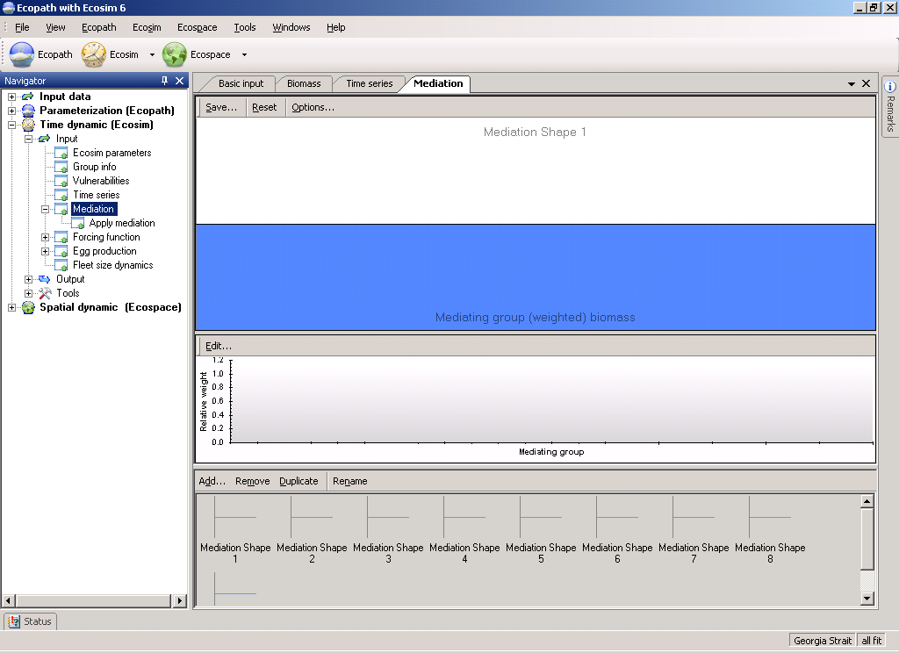
Figure 8.9
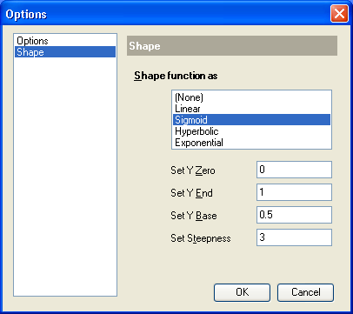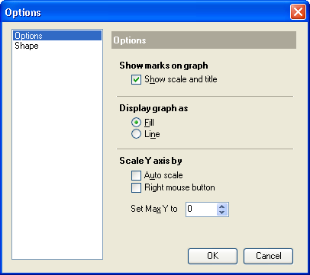
Figure 8.10a & b

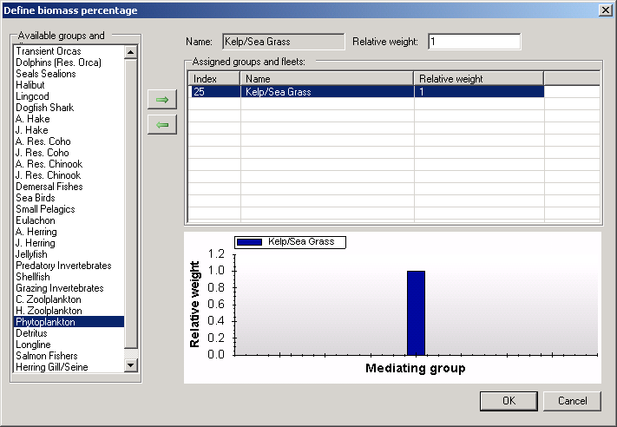
Figure 8.11.
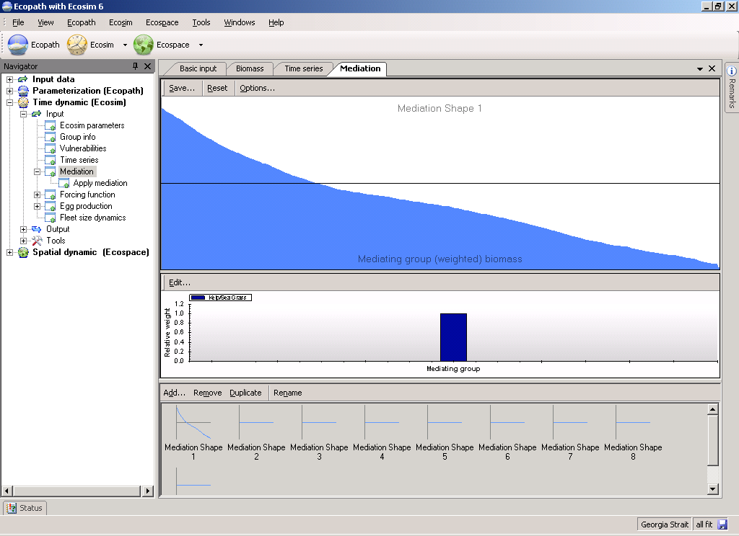
Figure 8.12
Step 3. Apply mediation shapes
After you have defined the mediation shapes continue to the Apply mediation form to define the predator-prey relationships that each of the mediation functions impact. This step is essential as your trophic mediation functions cannot be applied without it.

Apply mediation
The Apply mediation form (Time dynamic (Ecosim) > Input > Mediation > Apply Mediation) is used to apply the trophic mediation functions you defined using the Mediation form.
Before using the Apply mediation form, you must first define at least one trophic mediation function following the instructions for using the Mediation form. It is recommended you read the introductory material on Linking mediation and time forcing functions to trophic interaction rates to understand how trophic mediation functions are applied in Ecosim.
Selecting Apply mediation opens a form that consists of a grid representing predator (j) / prey (i) interactions (Figure 8.13). Predators are represented in columns with prey in rows. Predator/prey interactions, as defined in the Diet composition are indicated by white cells.
To apply a trophic mediation function, select the i,j cell representing the predator/prey interaction to which you wish to apply the function. This will open the Apply forcing and mediation functions dialogue box (Figure 8.14). The affected prey and predator group will be displayed at the top of the form.
Next, select the parameter to which the mediation multiplier is to be applied using the radio buttons at the bottom of the dialogue box. There are four possible options:
- Multiply overall predator rate of effective search (a_{i,j}), for example to represent time-varying turbidity changes that affect predator search efficiency or mediation effects of algal biomass on search efficiency.
- Multiply vulnerability exchange rate (v_{ij}), for example to represent increased movement rates of prey into vulnerable behavioral state at times when water mixing rates are higher;
- Multiply area of foraging arenas (divide a_{ij} by multiplier), for example to represent increase in habitat area available for juvenile fish refuges;
- Multiply area (divide a_{ij}) and also multiply v_{ij}, for example to represent increase in safe foraging habitat available to a predator that feeds on prey that become available in foraging arenas through passive drift/mixing processes such that increasing area used by predator results in higher proportion of total prey population being available in foraging areas at any moment.
The selected modifier will be shown in the window Applied shape functions window (Figure 8.14).
Next, select the desired mediation shape from the Available shape functions window at the left of the dialogue box by clicking the green arrow. This will move the shape function into the Applied shape functions window. You can remove a shape from this window by clicking the remove button immediately below the green arrow. Note that a common form is used to apply Mediation and Seasonal/Forcing functions. Do not select a seasonal or forcing function.
Finally, click OK. You should see the number of the mediation function (preceded by ‘M’) you selected in the predator/prey cell.
Note that you can apply up to five seasonal, forcing and/or mediation functions to each predator-prey interaction.
Clear all
You can clear all applied seasonal, forcing and/or mediation functions from the predator-prey grid by selecting Clear all from the top of the Apply forcing function form.
Set all …
To apply a mediation function to the interactions between a particular predator and all of its prey species, click on the number of the predator at the top of the form. When the Apply forcing and mediation functions dialogue box opens you will see a message at the top of the box reflecting that all the prey are affected. Similarly, to apply a mediation function to the interactions between a particular prey species and all of its predators, click on the number of the prey at the side of the form to open the Apply forcing and mediation functions dialogue box. Follow the steps above to select shape function(s).
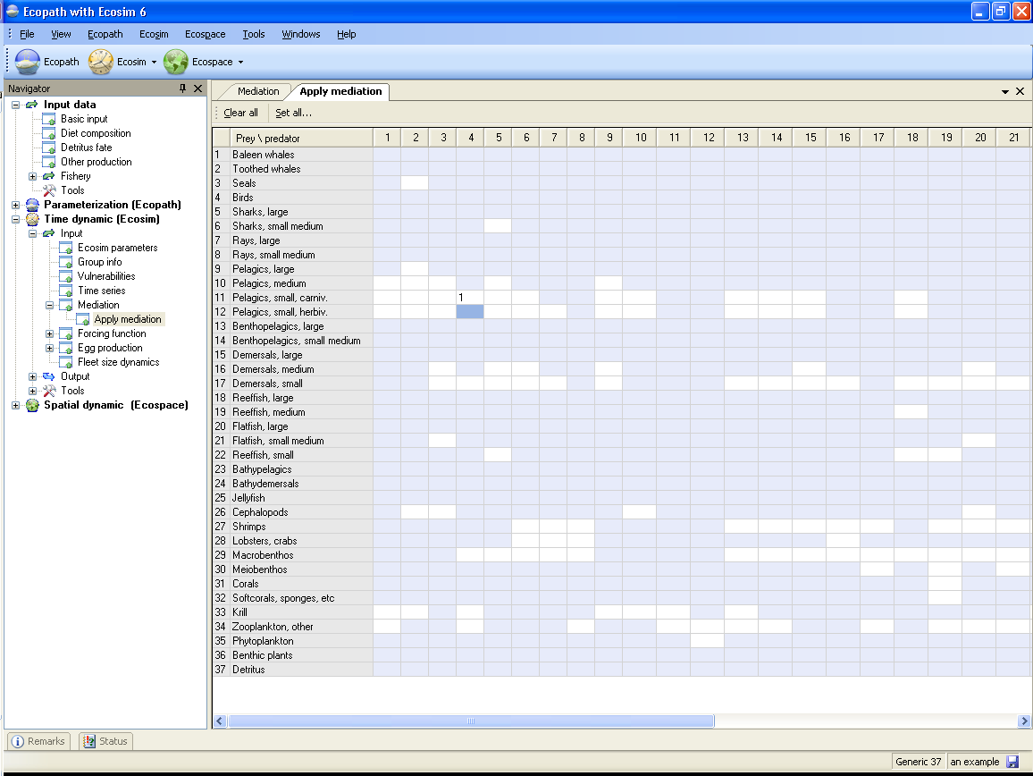
Figure 8.13
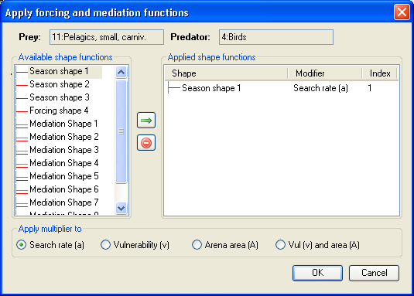
Figure 8.14.

Forcing function
As presently conceived Ecosim does not incorporate the interactions between the components of the food web defined by the underlying Ecopath file, and physical or other environmental factors affecting the ecosystem thus described. Ecosim, like Ecopath, describes only feeding interactions. Ecosim does, however, contain a routine to allow a ‘forcing function’, which may represent physical or other environmental parameters, to influence these trophic interactions. These forcing functions, which can be used to modify the Q/B ratio of the consumer groups included in an underlying Ecopath file (see Linking mediation and time forcing functions to trophic interaction rates). You can also use a forcing function to force primary production directly (see Primary production in Ecosim). Forcing functions in Ecosim are of two types:
- Seasonal (i.e. within a year); and
- Longer term.
There are three seasonal forcing functions their default setting is uniform (no seasonal forcing). However, sinusoid or other shapes can easily be sketched in, with, e.g., a maximum in summer and a minimum in winter (see below for instructions).
Each seasonal shape may be different. It might be appropriate to use highly variable shapes for ‘fast groups’ (usually small organisms) and shapes with low amplitude for slow groups (usually large, long-lived organisms).
The long-term shapes are similar to the seasonal shapes, except that their time scales refer, as the name implies, to a year period equal to the duration of the simulation (calculated with monthly time steps). If your time series has annual time steps, Ecosim will use the same value for each month in the year. Such shapes may be used to represent e.g., decadal regime shifts, such as occur in the North Pacific. By default only one long-term (‘forcing’) shape is activated but addition long-term shapes can be added (see Add below).

Defining Seasonal/Long-term forcing shapes
Important note: after you have defined forcing shape(s) as described below, you must continue to one of the Apply forcing function forms (Apply FF (consumer) or Apply FF (primary producer) ) to set the groups affected by the forcing function. This step is essential as your long-term forcing or seasonal functions cannot be applied without it.
There are a number of ways to define forcing shapes in Ecosim. First, forcing functions can be read in as time series from a csv file using the Import time series on the Time series form or the Ecosim menu. Set the ‘data type’ to 2 in the csv file. Note the series must be activated using the Time series form.
Alternatively, you can define a forcing function using the Forcing function form (Time dynamic (Ecosim) > Input > Forcing function). Note you must have an Ecosim scenario loaded before you can open this form.
When you open the Forcing function form for the first time, you will see four ‘blank’ forcing shapes (three seasonal shapes and one annual forcing shape), each with constant default value of 1.0. If there is currently a data file activated containing one or more time series of data type 2, these will also be displayed.
To define a forcing shape using the Forcing function form, first select one of the ‘blank’ shapes in the lower pane. Be sure to select a ‘Seasonal shape’ for monthly data or a ‘Forcing shape’ for long-term data. You can then define forcing shapes in one of three ways:
          - Shapes can be drawn freehand using the red sketch pad. If you have selected a Seasonal shape, the X-axis will appear as the months January to December and your sketch will be drawn in monthly blocks (Figure 8.15a). If you have selected an annual Forcing shape, the X-axis will be shown as Years 1-100. The sketch will be smooth (Figure 8.15b). You will see your sketched shape transferred to the selected shape in the bottom pane;
          - Alternatively, you can use standard mathematical shapes. Click Options… at the top of the Forcing function form to open the Options dialogue box. Select Shape from the menu on the left of the dialogue box (Figure 8.16a) to see a list of standard shapes (e.g., linear, sigmoid, exponential, ...). You can tailor the shape to your specific requirements by setting the Y Zero, Y End, Y Base and Steepness parameters in the cells provided. Select Options from the menu on the left of the dialogue box for display settings (Figure 8.16b).
          - You can also type in values directly by clicking on Values… at the top of the Forcing function form. This will open a dialogue box where you can type in the Y values of the forcing shape into the cells in the left-hand column of the form. Indices of the X values (months) are already given in the right-hand column of the form (Figure 8.17).
Note that if you have defined the seasonal or long-term forcing shape using methods (i) or (ii) the Values dialogue box will also act as an output and display these values.
Reset
Clicking the Reset button at the top of the Forcing function form resets the current forcing or seasonal shape to the default constant value of 1.0.
Save
Clicking the Save… button at the top of the Forcing function form opens a dialogue box prompting you to save the current forcing shape to a bitmap file (.bmp). Use this dialogue box to name the file and browse for a location to save it.
Shape type
Sets whether the selected shape is a seasonal or long-term forcing shape.
There are four additional menu items on the bottom pane of the Forcing function form that allow you add, copy, rename and delete forcing or seasonal shapes.
Add…
Adds an extra blank long-term forcing shape. If necessary, use Shape type to change the long-term forcing shape to a seasonal shape.
Duplicate
Copies the currently-selected shape.
Remove
Removes the currently-selected shape.
Rename
Rename the currently-selected shape by selecting Rename. You will then be able to type in a new name for the shape.
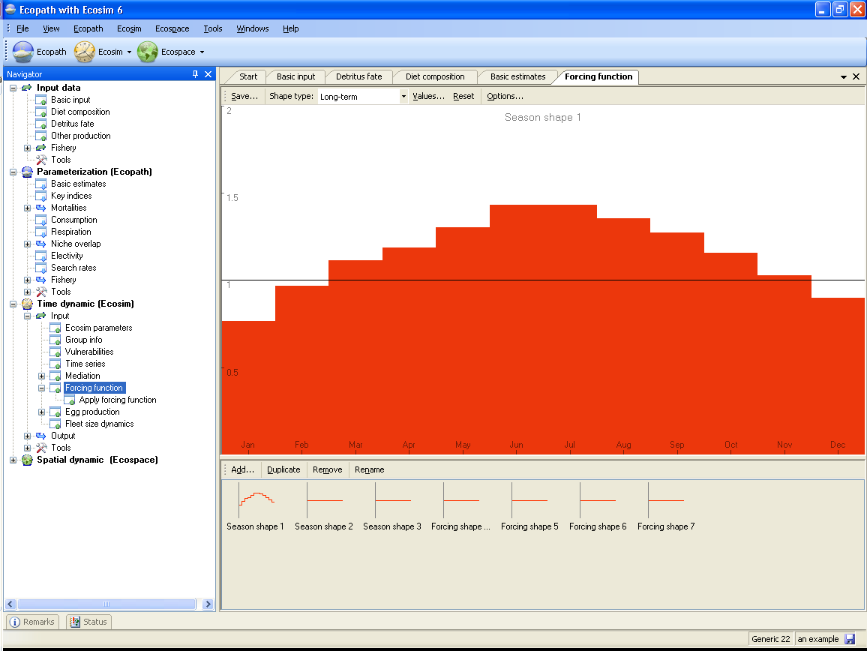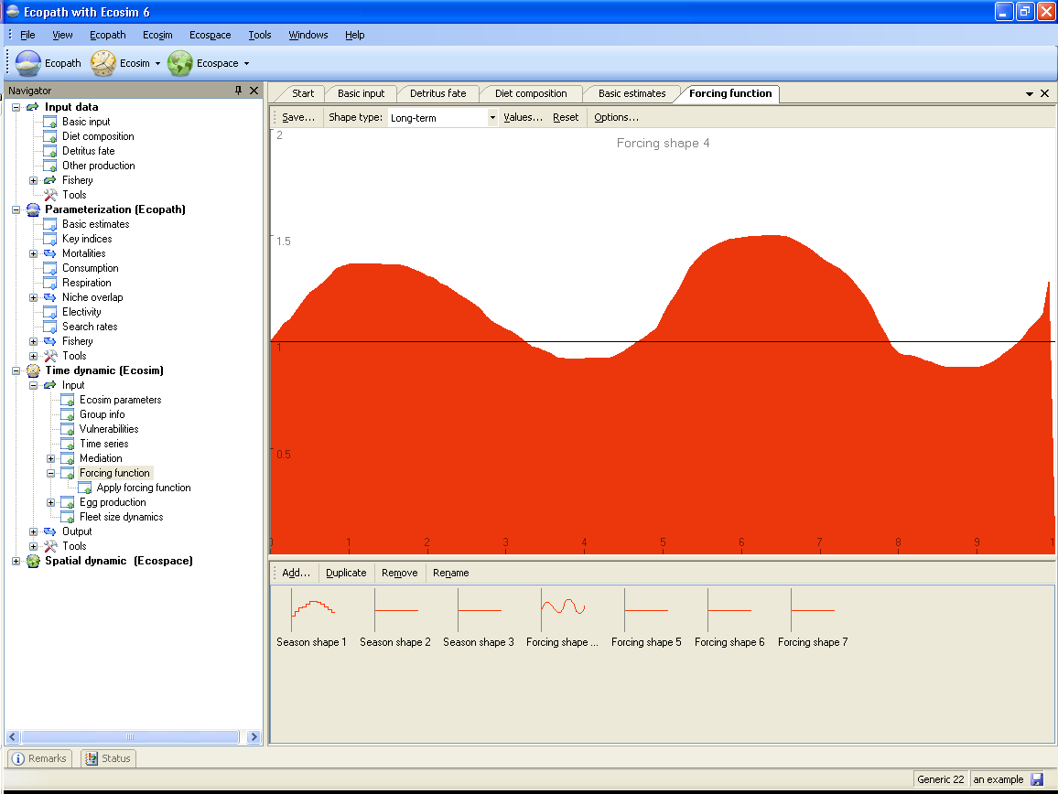
Figure 8.15a and 8.15b
Figure 8.16a & 8.16b
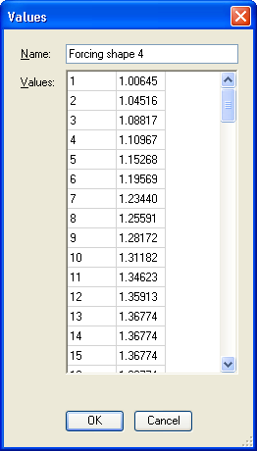
Figure 8.17.

Apply forcing function (consumer)
Forcing functions represent physical or other environmental parameters that may influence trophic interactions. These forcing functions can be used to modify the Q/B ratio of the consumer groups in the model (see Linking mediation and time forcing functions to trophic interaction rates), or to directly influence primary production (see Primary production in Ecosim).
To apply a forcing function to trophic flows (i.e., predator-prey interactions), use the Apply FF (consumer) form. To apply a forcing function to primary productivity directly, use the Apply FF (primary producer) form. Before using either Apply FF form, you must first define at least one seasonal or long-term forcing function following the instructions for using the Forcing function form.
The Apply FF (consumer) form consists of a grid representing predator (j) / prey (i) interactions (Figure 8.18). Predators are represented in columns with prey in rows. Predator/prey interactions, as defined in the Diet composition are indicated by white cells.
To apply a long-term forcing or seasonal function, select the i,j cell representing the predator/prey interaction to which you wish to apply the function. This will open the Apply forcing and mediation functions dialogue box (Figure 8.19). The affected prey and predator group will be displayed at the top of the form.
Next, select the parameter to which the forcing multiplier (represented by the forcing function) is to be applied using the radio buttons at the bottom of the dialogue box. There are four possible options:
- Multiply overall predator rate of effective search (a_{i,j}), for example to represent time-varying turbidity changes that affect predator search efficiency or mediation effects of algal biomass on search efficiency.
- Multiply vulnerability exchange rate (v_{ij}), for example to represent increased movement rates of prey into vulnerable behavioral state at times when water mixing rates are higher;
- Multiply area of foraging arenas (divide a_{ij} by multiplier), for example to represent increase in habitat area available for juvenile fish refuges;
- Multiply area (divide a_{ij}) and also multiply v_{ij}, for example to represent increase in safe foraging habitat available to a predator that feeds on prey that become available in foraging arenas through passive drift/mixing processes such that increasing area used by predator results in higher proportion of total prey population being available in foraging areas at any moment.
The selected modifier will be shown in the window Applied shape functions window (Figure 8.19).
Next, select the desired forcing or seasonal shape from the Available shape functions window at the left of the dialogue box by clicking the green arrow. This will move the shape function into the Applied shape functions window. You can remove a shape from this window by clicking the remove button immediately below the green arrow. Note that a common form is used to apply Mediation and Seasonal/Forcing functions. Do not select a mediation function.
Finally, click OK. You should see the number of the forcing or seasonal function you selected in the predator/prey cell (preceded by ‘F’).
Note that you can apply up to five seasonal, long-term forcing and/or mediation functions to each predator-prey interaction.
Clear all
You can clear all applied seasonal, forcing and/or mediation functions from the predator-prey grid by selecting Clear all from the top of the Apply FF (consumer) form.
Set all …
To apply a forcing function to the interactions between a particular predator and all of its prey species, click on the number of the predator at the top of the form. When the Apply forcing and mediation functions dialogue box opens you will see a message at the top of the box reflecting that all the prey are affected. Follow the steps above to select shape function(s).
Figure 8.18
Figure 8.19.

Apply forcing function (primary producer)
Forcing functions represent physical or other environmental parameters that may influence trophic interactions. These forcing functions can be used to directly influence primary production (see Primary production in Ecosim), or to modify the Q/B ratio of the consumer groups in the model (see Linking mediation and time forcing functions to trophic interaction rates).
To apply a forcing function to primary productivity directly, use the Apply FF (primary producer) form. To apply a forcing function to trophic flows (i.e., predator-prey interactions), use the Apply FF (consumer) form. Before using either Apply FF form, you must first define at least one seasonal or long-term forcing function following the instructions for using the Forcing function form.
The Apply FF (primary producer) form consists of a grid representing all model groups, although only the cells representing primary producers are active (colored white).
To apply a long-term forcing or seasonal function, select the cell representing the primary producer to which you wish to apply the function. This will open the Apply forcing and mediation functions dialogue. The primary producer group will be displayed in both predator and prey boxes at the top of the form. In this case the multiplier can only be applied to the primary production rate (selected automatically at the bottom of the dialogue box).
Next, select the desired forcing or seasonal shape from the Available shape functions window at the left of the dialogue box by clicking the green arrow. This will move the shape function into the Applied shape functions window. You can remove a shape from this window by clicking the remove button immediately below the green arrow. Note that a common form is used to apply Mediation and Seasonal/Forcing functions. Do not select a mediation function.
Finally, click OK. You should see the number of the forcing or seasonal function you selected in the predator/prey cell (preceded by ‘F’).
Clear all
You can clear all applied seasonal, forcing and/or mediation functions from the grid by selecting Clear all from the top of the Apply FF (primary producer) form.
Set all …
Opens the Apply forcing and mediation functions dialogue box. The selected forcing function will be applied to all primary producer groups.

Egg production
Ecosim allows linking a seasonally and long-term oscillating forcing function with the function through which the adults of multi-stanza groups are made to generate eggs/larvae, i.e., the earliest form of the youngest stanza (see Representation of multi-stanza life histories in Ecopath, Ecosim and Ecospace). Here, it is assumed that a seasonally variable factor (or a set of factors) causes the number of egg/larvae that would be produced, given the adult biomass, to vary as a function of the month. Alternatively, this factor can be interpreted as seasonally modulating the mortality of the eggs/larvae, independently of their density.
This linkage thus allows simulating the effect of abiotic variables, such as, e.g., the effect of wind-induced offshore transport of Peruvian anchoveta, a process which removes eggs/larvae from the (coast-bound) population independently of the density of their food organisms, or of their predators (Mendelssohn, 1989).
Moreover, by shifting the peak(s) of such forcing function relative to the peak(s) of a forcing function for seasonal production of phyto- and/or zooplankton, the match/mismatch hypothesis of Cushing (1975), and related hypotheses, can be tested in an ecosystem context: something previously not achievable.
Defining Egg production shapes
To link a multi-stanza group with a seasonally oscillating or long-term forcing function, go to the Egg production form (Time dynamic (Ecosim) > Input > Egg production). Note you must have an Ecosim scenario loaded before you can open the Egg production form. You must also have multi-stanza groups defined in your Ecopath model to be able to use this form.
Important note: after you have defined the egg production shape(s) as described below you must continue to the Apply egg production form to define the multi-stanza group(s) affected by the egg production function(s). This step is essential as your egg production functions cannot be applied without it.
When you open the Egg production form for the first time, you will see a ‘blank’ egg production shape with constant default value of 1.0.
To define an egg production shape, first select the ‘blank’ shape in the lower pane. Use the Shape type menu at the top of the form to set whether the function is long-term (occurs over a number of years) or seasonal. The X-axis of the yellow sketch pad will change accordingly.
You can then define egg production shapes in one of three ways:
          - Shapes can be drawn freehand using the yellow sketch pad. If you have selected a Seasonal shape, the X-axis will appear as the months January to December and your sketch will be drawn in monthly blocks (Figure 8.20a). If you have selected an annual shape, the X-axis will be shown as the monthly time steps of the model. The sketch will be smooth (Figure 8.20b). You will see your sketched shape transferred to the selected shape in the bottom pane;
          - Alternatively, you can use standard mathematical shapes. Click Options… at the top of the Egg production form to open the Options dialogue box. Select Shape from the menu on the left of the dialogue box (Figure 8.21a) to see a list of standard shapes (e.g., linear, sigmoid, exponential, ...). You can tailor the shape to your specific requirements by setting the Y Zero, Y End, Y Base and Steepness parameters in the cells provided. Select Options from the menu on the left of the dialogue box for display settings (Figure 8.21b).
          - You can also type in values directly by clicking on Values… at the top of the Egg production form. This will open a dialogue box where you can type in the Y values of the egg production shape into the cells in the left-hand column of the form. Indices of the X values (months) are already given in the right-hand column of the form (Figure 8.22). And years
Note that if you have defined the egg production shape using methods (i) or (ii) the Values dialogue box will act as an output and display these values.
Reset
Clicking the Reset button at the top of the Egg production form resets the current egg production shape to the default constant value of 1.0.
Save
Clicking the Save… button at the top of the Egg production form opens a dialogue box prompting you to save the current shape to a bitmap file (.bmp). Use this form to name the file and browse for a location to save it.
Shape type
Sets whether the selected shape is a seasonal or long-term forcing shape.
There are four additional menu items on the bottom pane of the Egg production form that allow you add, copy, rename and delete egg production shapes.
Add…
Adds an extra blank shape.
Duplicate
Copies the currently-selected shape.
Remove
Removes the currently-selected shape.
Rename
Rename the currently-selected shape by selecting Rename. You will then be able to type in a new name for the shape.
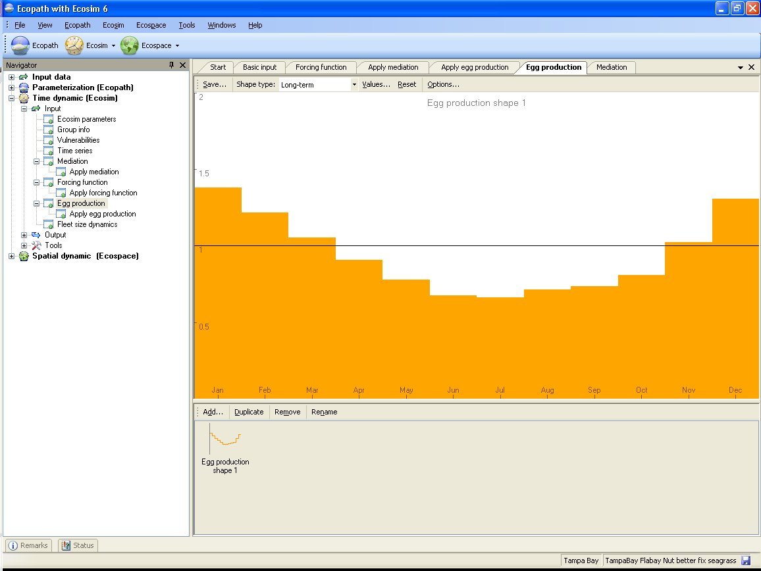
Fig 8.20a (8.20b will be long-term)

Figure 8.21a & 8.21b
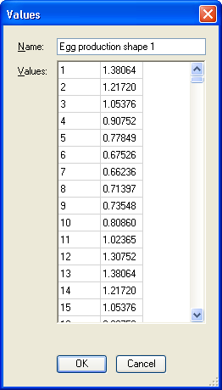
Figure 8.22

Apply egg production
The Apply egg production form (Figure 8.23) is used to apply the forcing functions you defined using the Egg production form.
Egg production forcing can only be applied to multi-stanza model groups, whose population dynamics are represented using an age-structured model that explicitly includes a function for fecundity, based on average weight of the adults. It is assumed that a seasonally variable factor (or a set of factors) causes the number of egg/larvae that would be produced, given the adult biomass, to vary as a function of the month. Alternatively, this factor can be interpreted as seasonally modulating the mortality of the eggs/larvae, independently of their density. See also the introductory material on Representation of multi-stanza life histories in Ecopath, Ecosim and Ecospace.
Before using the Apply egg production form, you must first define at least one egg production function following the instructions for using the Egg production form. The egg production forcing function must then be applied in Ecosim, using this form.
Available egg production shapes are shown in the left-hand panel on the Egg production form. To apply egg forcing to a group, simply select the number of the desired egg production shape from the drop-down menu in the cell next to the name of the appropriate multi-stanza group. Alternatively, apply the same shape to all groups by typing the shape number int the Reset all to shape no window at the top of the form.
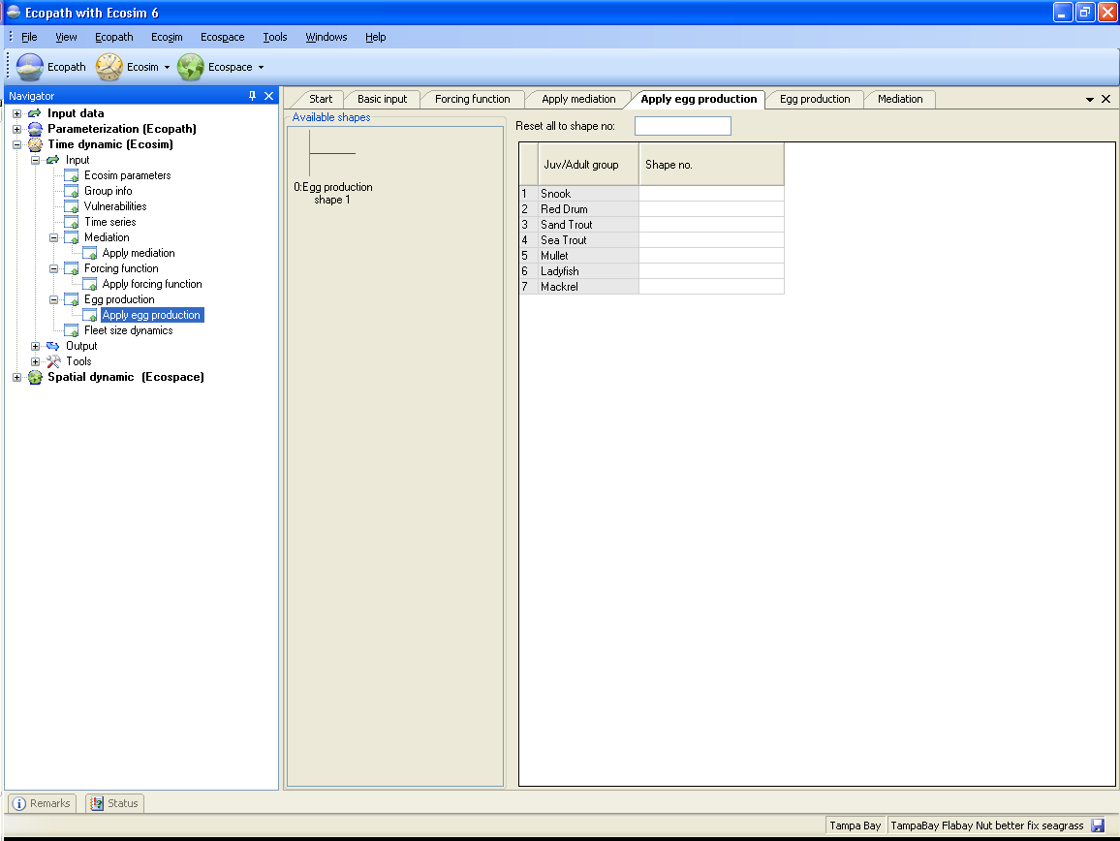
Figure 8.23

Fleet size dynamics
Ecosim users can choose to treat dynamics of fleet sizes and resulting fishing effort as unregulated and subject to fisher investment and operating decisions. The models are described in detail in the introductory material (Modelling effort dynamics) and are also described briefly here.
Users wishing to use the fleet/effort dynamics model should check the “fleet/effort response” box on the Biomass form in Ecosim. When this box is checked, Ecosim erases all previously entered time patterns for fishing efforts and fishing rates (e.g., from the sketch pad or from the time series data file), and replaces these with simulated values generated as each simulation proceeds.
In this model, there are two time scales of fisher response: (1) a short time response of fishing effort to potential income from fishing, and (2) a longer time investment/depreciation model for capital capacity. You need to set two parameters for the short time response model (‘Effort response power’ and ‘Initial effort/capital capacity’) and two for the longer time model (‘Capital depreciation rate’and ‘Initial capital growth rate’).
1. Fast time reponse model
For each time step, the “fast” effort response for the next (monthly) time step is predicted by a sigmoid function of income per effort and current fleet capacity. For each gear, g, at each monthly timestep, t, Effort, E_{g,t} is the current amount of active, searching gear, i.e.,
where p and Ih_{g} are fleet-specific response parameters, K_{g,t} is fleet capacity and I_{g,t} is income. Fleet capacity K_{g,t} is initialised using ‘Initial effort/capital capacity’ (see below) and is updated using the slow time response model (see next section).
Effort response power
Use ‘Effort response power’ to set the parameter p, which represents a “heterogeneity” parameter for fishers: high p values imply all fishers “see” income (I) opportunity similarly, while low p values imply fishers “turn on” their effort over a wide range of mean incomes (see figure).
Initial effort / capital capacity
This parameter is the ratio of initial fishing effort to fleet capacity (i.e., the proportion of maximum effort deployed in the first time step). It is used to set the initial fleet capacity Kg,1 as well as the income level needed for half the maximum effort to be deployed (Ihg).
Calculating Kg,1: For each fleet, initial fleet capacity K1 is calculated as the inverse of ‘Initial effort/capital capacity’ (initial effort is scaled to be 1 at Ecopath base condition), i.e., if ‘Initial effort/capital capacity’ is set at 0.5, then the fleet capacity will be set to 2 because half of the maximum effort is deployed. Kg,t is updated at each time step using the slow time response model.
Calculating Ihg: ‘Initial effort/capital capacity’ is also used to calculate Ihg. When the ratio is set at the 0.5 default value, Ihg is set to the initial income (summed over pools of Ecopath base catches x prices for each fleet).
2. Slow time reponse model
For each fleet, slow effort responses are modelled as changes in fleet capacity (K_{g,t}), which is a function of the ‘Capital depreciation rate’, the ‘Capital growth rate’ and Profit (calculated dynamically in Ecosim). See Modelling effort dynamics for full description of the model.
Capital depreciation rate
Set the rate of capital depreciation here. Capital depreciation rates for fishing fleets are typically in the range 0.04 to 0.10 (equipment lasts 10-25 yrs), although will vary on a fleet by fleet basis.
Initial capital growth rate
Set the initial rate of annual capital growth here. A value of zero would represent a fleet with no growth (e.g., at bionomic equilibrium). For rapidly growing fleets, set the value at 0.5 or higher. If you have data on the maximum effort deployed for a number of years before and after the Ecopath base year, you can estimate this parameter empirically.

Using Ecosim. Part 2: Ecosim outputs
Once you have set up your Ecosim scenario(s) using the Ecosim input forms, you can test your model’s predictions using Ecosim. This chapter describes the forms used to run Ecosim (Biomass, Stock-Recruitment plot, Monte Carlo runs), as well as important Ecosim tools Fishing policy search and Fit to time series. An Ecosim exercise to help you test your model is also included.
Before using Ecosim, we recommend you read the introductory material on Ecosim (An overview of Ecosim, Ecosim basic, Predicting consumption, Time series fitting in Ecosim, Hints for fitting models to time series reference data and Time series random effects, also found in Chapter 1 of the User Guide). You should also be familiar with the published literature on Ecosim, particularly Walters et al. 1997; Walters et al. 2000 (Capabilities); MSY paper; Policy search papers…).

An Ecosim exercise
Below is a cursory check of Ecosim’s behavior, which it is advised that you check out.
After loading an Ecosim scenario:
- Go straight to the Biomass form. Click ‘Run’. Make sure everything is flat or changing according to the Biomass Accumulation you specified in Ecopath. Crazy cases: discard effects may cause troubles.
- Next: Go to Ecosim parameters: set the Duration of simulation to 30-50 years. Make a small disturbance for the combined fishery using the sketch pad on the Biomass form. If everything is okay in the settings it should come back to the initial value eventually. Are all groups reacting at the speed you expect them to?
- Next take out feeding time dynamics, set to zero.
- Set the unexplained predation to 0 throughout.
- Go to Vulnerabilities (the most important tab in Ecosim). Set to 100 (top down).
- Reset F’s.
- Run: seems okay?
- Create a small disturbance.
- Run and you will get chaotic behavior, violent oscillations and groups dropping out completely. Typical Lotka-Volterra behavior
- Put in flow control setting of 2 throughout. [Interpretation: curves go through 0, the Ecopath value and two times the base (Zmax/Zbase)] Run: it will generally run OK.
- Try to increase vulnerability settings to 4, then 5 etc. See how far you can go and still get something sensible.
- Do you have a sensible model? What would happen if you had no fishery. Shut the fishing down and set the run duration to 60-70 years to see how it will work for slow group. Reasonable result: should in general maintain all the groups we see today.
- Now check how high you can go with the flow control vulnerability setting. It’s harder now because the fishing is gone, so there are more top predators. This will help you get more reliable vulnerability settings. You need to have reasonable vulnerability settings before you can proceed.
- Turn the feeding time factor back on. This will change the feeding time, 1 can cause numerical instability. If this happens it will create violent oscillations and more groups may drop out. Try, e.g., 0.2 will change feeding behavior with some 20% per month. If groups are still dropping out the foraging behavior is slowing things down, so the the feeding time factor is not big enough. It tries to maintain the Q/B by changing foraging time.
- Group info: predator effective feeding time. The target feeding time is set according to predator abundance. Setting the value to 1 means a group is willing to give up feeding if predation risk is high. Zero means the group is ignoring predation risk but feeds independently. Top predators may be reducing feeding due to parasite risk (often ignored predators). Try an intermediate value, e.g., 0.5.
- Initially you may not have any idea of what values to use, so play, try it out.
- What we have been doing? Trying to maintain the mass interaction model by adding behavior to equation.
- Next, look at multi-stanza groups. Increase fishing heavily for 5-10 years, and then shut the fishery down. The juvenile groups should be hit hard.
- Open the Stock-Recruitment plot: There will often be erratic behavior for short to medium- lived groups, and Beverton-Holt (BH) curves for long lived ones. If you don’t see BH curves for long lived groups, something is likely to be wrong with your parameters.
- Next use the forcing functions. Here’s an experiment: change primary productivity over time using a forcing function and apply to phytoplankton (using Apply FF (primary producer)), and look at how it propagates up through the food web.
- Use Overlay on the Biomass form for an easy (sensitivity) check of how parameter values impact the results.

Biomass
The Ecosim module of EwE provides two ways to explore impacts of alternative fishing policies:
1. Fishing rates can be ‘sketched’ over time and results (catches, economic performance indicators, biomass changes) examined for each sketch. This is using Ecosim in a ‘gaming’ mode, where the aim is to encourage rapid exploration of options (see below for help with this approach).
2. Formal optimization methods can be used to search for fishing policies that would maximize a particular policy goal or ‘objective function’ for management (see Using Ecosim for policy exploration for help with this approach).
The first approach has been widely applied for exploring ecosystem effects of changes in fishing effort and is implemented using the Biomass form, the main form for running Ecosim (Time dynamic (Ecosim) > Output > Biomass).
Before running Ecosim, you should be familiar with the introductory material: at least An overview of Ecosim, Ecosim basic, Vulnerabilities in Ecosim. See Chapter 3 of the EwE 6 User guide for more details about the workings of Ecosim.
Running Ecosim
The Biomass form (Figure 9.1) consists of a lower panel, where users can sketch or set fishing rates by fleet/gear or Ecopath group and an upper panel where output biomasses are displayed. On the lower right-hand side of the form are buttons allowing the user to run Ecosim and view outputs (see sections below).
Features of the lower (Fishing rate) panel
Drop-down menu with fleet and group names
Use this list to select which fleets or groups you want to change fishing rate for. Note: if an Ecopath group is selected, then relative Fs sketched on the sketch pad will be applied across all fleets.
Reset Fs
Reset all fishing rates (all groups all fleets) to their Ecopath base values.
Set F to 0
Set fishing for the fleet/group selected to zero.
F value …
For entry of a fishing intensity value to be applied to the fleet/group selected (or enter a list of comma separated values to set Fs for all fleets).
Fishing rate sketch pad
The sketch pad is used to display time series of relative fishing rates when the fishing mortality is applied to an individual group. When the fishing mortality is applied to a ‘fleet’ the Y-scale of the sketch pad consists of effort multipliers. In either case (individual group or fleet), the default uniform series (representing the Ecopath base values) can be replaced by a time-varying shape, representing temporal changes in the pattern of fishing, by sketching with the mouse (left button held down). The Y-axis will automatically re-scale as you drag your mouse up or down on the sketchpad. The fishing rates are expressed relative to the fishing rates in the underlying Ecopath model.
To set linear trend for change in fishing rates: if you first click the start point with the left mouse button, and then the end point with shift + the left mouse button, a line will be drawn between the two points. Use this to enter, e.g., a linear increase over time in relative fishing rates.
Fleet and effort dynamics
Ecosim users can specify temporal changes in fishing fleet sizes and fishing effort in three ways: (1) by sketching temporal patterns of effort in the model run interface (see above); (2) by entering annual patterns via reference “csv” files along with historical ecological response data (see Time series); or (3) by treating dynamics of fleet sizes and resulting fishing effort as unregulated and subject to fisher investment and operating decisions.
To invoke the fleet/effort dynamics model (Option 3 above), check the “fleet/effort response” box on the Biomass tab. When this box is checked, Ecosim erases all previously entered time patterns for fishing efforts and fishing rates, and replaces these with simulated values generated as each simulation proceeds. See Modelling effort dynamics for detailed description of the effort dynamics model. To set the input parameters, use the Fleet size dynamics form.
Features of the upper (Ecosim biomass output) panel
Overlay
Check the Overlay box to display subsequent runs on the same plot (i.e., the plot is not cleared when the Run button is pressed).
Annual output
Check the Annual output box to display
Scale
Check the Scale box to display
Show/hide groups
Opens a form for hiding/displaying groups on the biomass graph.
Sum of squared deviations (SS)
This is an Ecosim output. When an Ecosim model is loaded, you can load time series ‘reference’ data on relative and absolute biomasses of various groups over a particular historical period, along with estimates of changes in fishing impacts over that period. After time series data have been loaded and applied (see Time series), a statistical measure of goodness of fit to these data is generated each time Ecosim is run. This goodness of fit measure is a weighted sum of squared deviations (SS) of log biomasses from log predicted biomasses, scaled in the case of relative abundance data by the maximum likelihood estimate of the relative abundance scaling factor q in the equation y = qB (y = relative abundance, B = absolute abundance).
See Time series fitting in Ecosim for more details about the sum of squared deviations measure.
Main upper panel
The main part of the upper panel is used to display Ecosim’s predicted time series of biomass for groups selected using the Show/hide groups form. Biomasses are shown relative to their baseline Ecopath values. If time series have been loaded and applied, they will be displayed as colored dots on the graph, while Ecosim’s predicted outputs will be displayed as colored lines (Figure xx1).

Vertical red lines indicate when to start averaging results for before/after comparisons (displayed using the Results button, see Error: Reference source not found). Use a left mouse-click to drag the lines to their desired positions.
Group tab
To the right of the upper panel, under the Group tab, a smaller panel displays the groups’ names, in the same colors as used for the biomass lines, in order of group number. Clicking on the name of any group in this panel (and releasing the mouse button) results in all other groups being greyed out so that the group of interest can be clearly seen. Click on All groups at the top of the list to return all groups to their original colors.
Layer tab
Behind the Group tab is the Layer tab.
Run Ecosim and view outputs
Run
Click Run to generate time series of biomasses (which will be displayed in the upper panel). The magnitude of changes for each group will depend on many factors, chiefly the fishing regime and the vulnerability settings.
Note that fishing regimes should generally change gradually from one fishing mortality level to the next, not abruptly. Also, the baseline (Ecopath) fishing mortality should be left unchanged for a year or so.
Plots
Click this button to open a form displaying a series of plots of the results of the Ecosim simulations (see Plots for further help with this form).
Results
Clicking Results after a run opens the Ecosim results dialogue box (Figure 9.2), which shows a result summary for the run, with start and end dates set using the vertical red lines in the Main upper panel (see above). If you wish to compare results from the beginning and end of the run, first move the vertical red lines accordingly.
You can choose to see results by fleet or by individual group. Results by individual group can be viewed by individual gears or by combined gears (selected using the drop-down menu).
Raw biomass results can be seen by exporting them to a csv file, using Export biomass results to .csv file on the Ecosim menu.

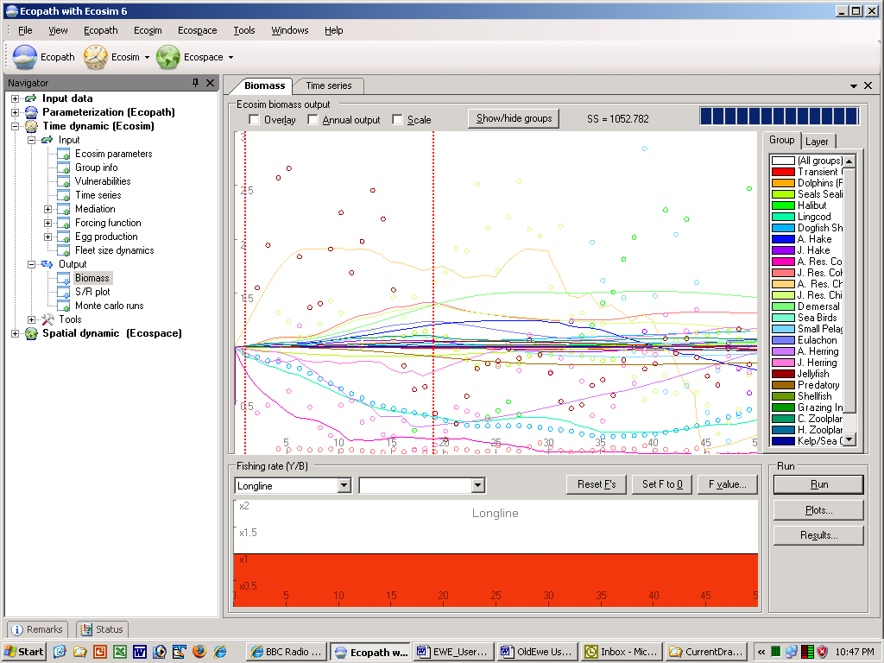
Figure 9.1.
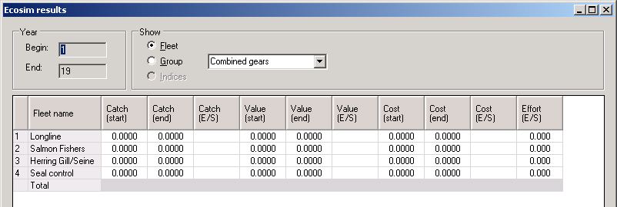
Figure 9.2.

Plots
The Plots button on the Biomass form opens a form displaying a series of plots of the results of the Ecosim simulations (see Figure 9.3). Select the group to be displayed by clicking on its name in the Groups window on the right of the form. Plots will be displayed showing time series of predicted biomass, consumption/biomass, predation mortality, total mortality, feeding time, percentage of prey, yield and production/consumption.
If you have loaded and applied time series of historical data using the Time series form, dots will appear on the Biomass plot showing the observed biomass time series, while dots on the Yield plot will show observed catches (t · km⁻² · year⁻¹). Ecosim’s predicted biomasses and catches are shown as lines.
Time series
Displays values of currently-loaded time series for the selected group.
Save data to .csv…
Saves eight csv-files, one for each of the displayed plots, storing the data for all groups.
Show all fits
Opens the Display all fits form, which displays all fits to time series in a form suitable for printing (Figure 9.4). Customize the plot and outputs using the following settings on the form:
- Use Display options and Show/hide groups to select which plots to display (by data type and by group, respectively).
- Use General options (on the left-hand side of the form) to set font, number of plots per row, dot size, line size and margins.
- Change Y scale allows you to set the maximum Y-value for each individual plot.
- Use Save as image to save the plots as a bitmap (.bmp) file.
- Print the plots directly using Print… and Print preview….
- Export the data to three csv files showing results for biomasses, catches and mortality using Save data to .csv.
Close
Closes the Plots form.
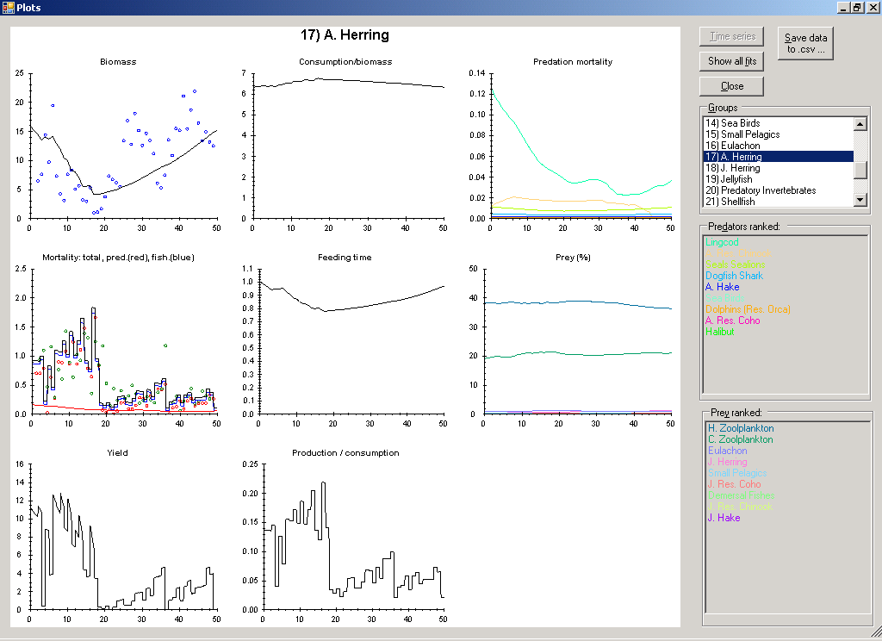
Figure 9.3.

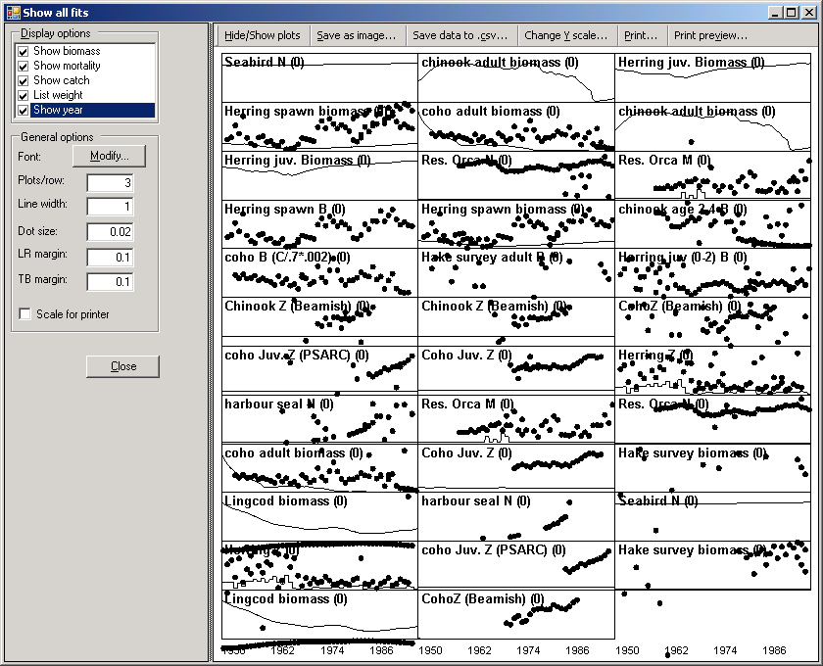
Figure 9.4.

Stock recruitment (S/R) plot (multi-stanza groups only)
The S/R plot form displays the emerging stock-recruitment plot for the multi-stanza groups in your model, anabling users to test for the effects of compensatory recruitment in the model. Compensatory recruitment effects are usually expressed as a flat or dome-shaped relationship between numbers of juveniles recruiting to the adult pool versus parental abundance (the stock-recruit relationship). There is a way to create such an effect in Ecosim:

Set a non-zero feeding time adjustment for the juvenile with high EE, or high proportion of the ‘other’ mortality (the mortality not accounted for) being sensitive to changes in predator feeding time.
This represents density-dependent changes in juvenile mortality rate associated with changes in feeding time and predation risk. It is usually also important that the vulnerabilities of prey to the juvenile group (Vulnerabilities form) also be relatively low.
See Using Ecosim to study compensation in recruitment relationships for a more detailed description of density dependent recruitment in Ecosim. There you will find details of an Ecosim exercise you should do to check the stock recruitment curve of each multi-stanza group in your model. Always check the stock-recruitment curve shape, and play with Group info parameters that may affect it before proceeding to other policy analysis.
Running the stock-recruitment analysis
The S/R plot form utilizes the fishing mortality and biomass patterns from the Biomass form. Therefore you should first run the Ecosim simulation on the Biomass form before running the stock-recruitment analysis.
Ecosim calculates the stock-recruitment relationship between the oldest stanza in the group (i.e., the adult group) and each of its juvenile groups (i.e., separate plots are generated for the relationship between the adult stock size and each of the juvenile groups you have specified). To run the stock-recruitment analysis, select the juvenile group you wish to view from the menu at the left-hand side of the form (Figure 9.5) and click the Run button at the bottom right of the form.
Note that all stock-recruitment relationships are calculated simultaneously, so once you have run the analysis you can use the menu to look through all relationships.
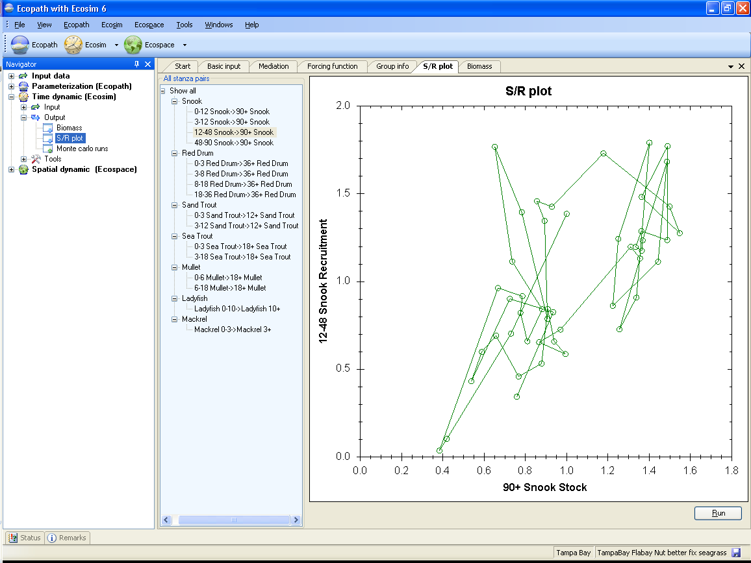
Figure 9.5

Monte Carlo runs
Ecosim allows users to use a Monte Carlo approach to search for Ecopath parameter-combinations that improve the fit of the model to time series data (i.e., reduce the weighted sum of squared deviations, SS; see Time series fitting in Ecosim). The Monte Carlo approach can be used to test for sensitivity of Ecosim’s outputs to Ecopath input parameters.
To use the Monte Carlo interface, open the Monte carlo runs form (Time dynamic (Ecosim) > Output > Monte carlo runs; Figure 9.6).
Monte Carlo inputs
Number of simulation trials
Set the number of trials. Each trial represents an Ecosim run with a randomly-selected set of Ecopath parameters (B, P/B, EE, BA) for each group. Parameters are drawn from a uniform distribution centred on the base Ecopath value with coefficient of variation (c.v.) set by the user.
Show biomass trajectories on Ecosim plot
Displays Ecosim results on the Biomass plot tab in the lower panel of the form.
Retain better fitting estimates (use trials to seach)
Retains …
Retain current Ecosim fishing rate pattern
Retains
Apply time series
Opens a dialogue box where you can apply time series that have been loaded into Ecosim (i.e., you do not have to return to the Time series form to apply time series). You can also remove time series from the analysis using this dialogue box. See Time series for more information about loading time series in Ecosim.
B, P/B, EE, BA
The Ecopath parameters tabs in the lower panel show the mean, lower limit and upper limit of the distribution used to draw random values for B, P/B, EE and BA for each group in the model. The mean of the distribution is set as the base Ecopath value of the parameter. Users can set the coefficient of variation (c.v.) which is then used to calculate the upper and lower limits of the distribution (upper limit = mean + 2*c.v.*mean; lower limit = mean - 2*c.v.*mean). For parameters you do not wish to change, set the c.v. to zero. Setting the c.v. for a group for one parameter applies the same c.v. to all parameters.
Note that the parameter combinations resulting from the random draw must result in a balanced Ecopath model (i.e., before running each trial, Ecosim keeps drawing new sets of parameters until a balanced Ecopath model is achieved). This means that the range of the parameter values actually used may be smaller than that set by the user. Users should check the range of the input parameters that were actually used in the trials in the output csv (see below).
Monte Carlo outputs
Trial
Tracks the current trial number.
Ecopath runs
Tracks the number of parameter-combinations tried until a balanced Ecopath model is achieved. Note that the maximum number of tries is 2000. If a trial reaches 2000 Ecopath runs then a balanced model could not be achieved with any parameter combinations and the simulation trial is run with an unbalanced model. This may indicate that the c.v.s have been set too large, reducing the likelihood of finding parameter values that combine to produce a balanced model.
SS measures
At the top right-hand side of the form, the original (i.e., before the simulation) weighted sum of squared deviations (SS) is shown. Current SS shows the value of SS achieved for the current trial. Best SS shows the lowest SS achieved for any of the runs.
Data from best fitting trial
After all trials have been completed, the parameter-values that resulted in the lowest SS are shown on the second-last tab in the lower panel of the form. When the trials are complete, the software automatically displays this tab.
Biomass plot
If the Show biomass trajectories on Ecosim plot box is checked, biomass trajectories are displayed for each trial on the Biomass plot tab (Figure 9.7). This tab is automatically displayed when you click Run trials.
You can choose to overlay trajectories for each trial, switch from monthly to annual output and scale the results using check boxes. Show/hide groups, highlighting of trajectories for a single group and viewing of layers is also enabled, with the same functionality as for the Biomass form.
The Apply best fits button applies the parameter-values that resulted in the lowest SS (shown on the Data from best fitting trial tab) to your Ecopath model (i.e., overwrites the original values).
Warning: it is a good idea to save a backup of your model using Save as on the File menu before you overwrite your original parameters using Apply best fits!
Export results
Not implemented yet
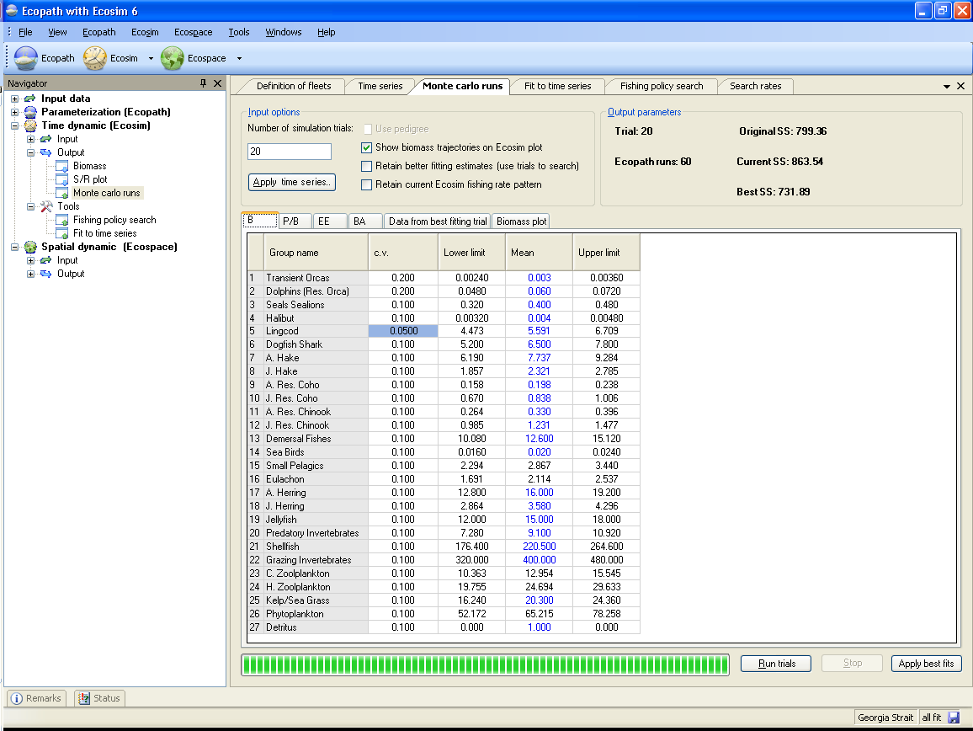
Figure 9.6
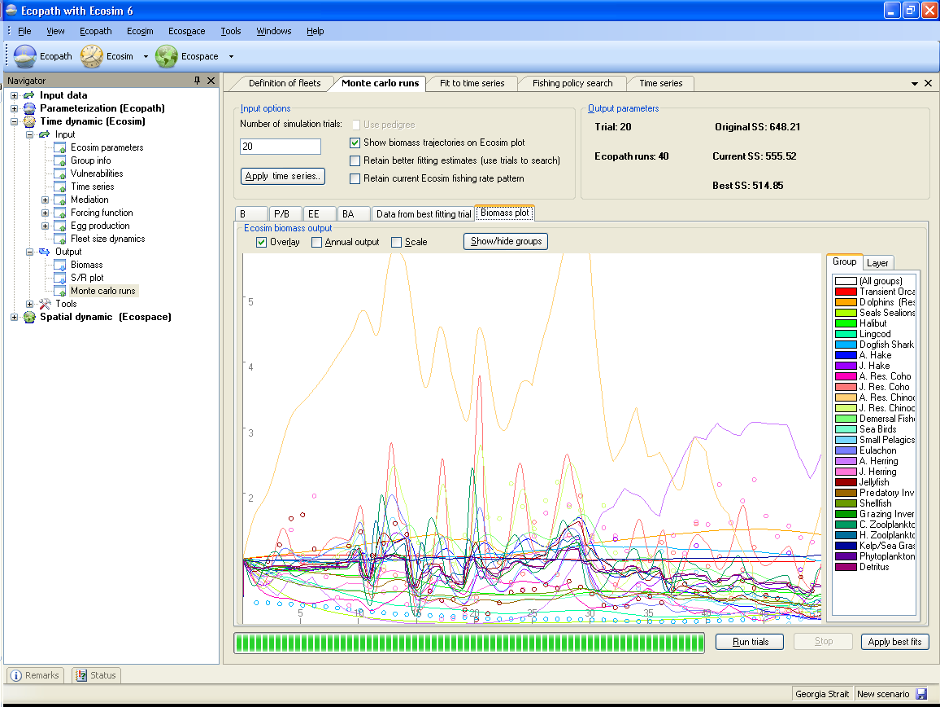
Figure 9.7

Fishing policy search
A central aim of fisheries management is to regulate fishing mortality rates over time so as to achieve economic, social and ecological sustainability objectives. An important dynamic modeling and assessment objective is thus to provide insight about how high these mortality rates should be, and how they should be varied over time (at least during development or recovery from past overfishing). We cannot expect models to provide very precise estimates of optimum fishing mortality rates, but we should at least be able to define reasonable and prudent ranges for the rates.
Ecosim provides two ways to explore impacts of alternative fishing policies:
1. Fishing rates can be ‘sketched’ over time and results (catches, economic performance indicators, biomass changes) examined for each sketch. This is using Ecosim in a ‘gaming’ mode, where the aim is to encourage rapid exploration of options.
2. Formal optimization methods can be used to search for fishing policies that would maximize a particular policy goal or ‘objective function’ for management.
These approaches can be used in combination, e.g. by doing a formal optimization search then ‘reshaping’ the fishing rate estimates from this search in order to meet other objectives besides those recognized during the search process.
The first of these approaches has been implemented in Ecosim since its first version, and has been widely applied for exploring ecosystem effects of changes in fishing effort (see Ecosim basic and the help topic for the Biomass form). The second is ‘open loop’ policy exploration simulation that acknowledges that policy may be defined as an approach towards reaching a broadly defined goal, that fisheries policies are often implemented via TACs that are recalculated annually, and through regulation that affects fleet structure and deployment.
Two very different approaches can be taken to the identification of optimum levels of fishing efforts for multiple fleets that may each harvest multiple species from an ecosystem. The first or ‘sole owner’ approach is to identify a single, overall performance measure for combined value from all fishing operations, then vary the by-fleet efforts so as to try and maximize this performance measure. The sole owner approach has been used extensively in past Ecosim optimization exercises, using performance measures ranging from total profit from fishing (sum over fleets of incomes minus costs) to total employment (sum of catches times employment per catch) to risk-averse utility measures that favor a balanced ‘investment portfolio’ of fishing activities. A fundamental problem with this approach is the implicit assumption of value and cost pooling; supposedly ‘optimum’ solutions often involve operating one or more fleets at uneconomic levels, essentially using these fleets to cull some fish species so as to increase production from other, more valued species.
The second or ‘multiple fishing rights’ approach is to treat each fishing fleet (and perhaps non-consumptive stakeholder or user groups as well) as a separate economic industry with some legal right or entitlement to harvest, then seek a level for each fleet that optimizes a fleet-specific performance criterion such as total profits or growth until profitability (ratio of profits to income or cost) falls to a typical or reasonable level for economic industries in the economy as a whole.
See Implementing policy optimization in Ecosim below for help with implementing these two approaches in Ecosim.
Policy objectives
Ecosim allows users to implement ‘open loop’ policy exploration simulations that acknowledges that policy may be defined as an approach towards reaching a broadly defined goal. The goal function for policy optimization is defined by the user in Ecosim, based on an evaluation of four weighted policy objectives:
1. Maximize fisheries rent;
2. Maximize social benefits;
3. Maximize mandated rebuilding of species;
4. Maximize ecosystem structure or ‘health’.
The first of these, maximizing profits, is based on calculating profits as the value of the catch (catch · price, by species) less the cost of fishing (fixed + variable costs). Giving a high weight to this objective often results in phasing out most fleets except the most profitable ones, and the wiping out of ecosystems groups competing with or preying on the more valuable target species.
The second objective, maximizing social benefits, is expressed through the employment supported by each fleet. The benefits are calculated as number of jobs relative to the catch value, and are fleet specific. Therefore social benefits are largely proportional to fishing effort. Optimizing efforts often leads to even more extreme (with regards to overfishing) fishing scenarios than optimizing for profit.
The third objective, maximization of mandated rebuilding of species (or guilds), is incorporated to capture that external pressure (or legal decisions) may force policy makers to concentrate on preserving or rebuilding the population of a given species in a given area. In Ecosim this corresponds to setting a threshold biomass (relative to the biomass in Ecopath) for the species or group, and optimizing towards the fleet effort structure that will most effectively ensure this objective. The implications of this are case-specific: we are finding that the optimization routine may rigorously hammer (through increased fishing) competitors and predators of the species in question; or at the other extreme that fisheries may be shut down without social or economic consideration (as is indeed often the case when legal considerations take over).
The last objective included, maximizing ecosystem structure (or 'health') is inspired by E.P. Odum’s description of ecosystem ‘maturity’, wherein mature ecosystems are dominated by large, long-lived organisms, (see Christensen, 1995a). The default setting we have incorporated for ecosystem structure is therefore the group-specific biomass/production ratio as this measure is indicative of the longevity of the groups. The ecosystem structure optimization often implies reduction of fishing effort for all fleets except those targeting species with low weighting factors.
The fishing policy search routine estimates time series of relative fleet sizes that would maximize a multi-criterion objective function. In Ecosim, the relative fleet sizes are used to calculate relative fishing mortality rates by each fleet type, assuming the mix of fishing rates over biomass groups remains constant for each fleet type, (i.e., reducing a fleet type by some percentage results in the same percentage decrease in the fishing rates that it causes on all the groups that it catches). However, density-dependent catchability effects can be entered (using Ecosim’s Group info form), and if so reductions in biomass for a group may result in fishing rate remaining high despite reductions in total effort by any/all fleets that harvest it. Despite this caveat, the basic philosophy in the fishing policy search is that future management will be based on control of relative fishing efforts by fleet type, rather than on multispecies quota systems. It is not yet clear that there is any way to implement multispecies quotas safely anyway, without either using some arbitrary conservative rule like closing the fleet when it reaches the quota for the first (weakest) species taken or else allowing wasteful discarding of species once their quotas are reached.
Optimization procedure
Invoking the search option causes Ecosim to use a nonlinear optimization procedure known as the Davidson-Fletcher-Powell (DFP) method to iteratively improve an objective function by changing relative fishing rates, where each color-coded ‘year/fleet block’ defines one parameter to be varied by the procedure (e.g. setting four color code blocks means a 4-parameter nonlinear search). DFP runs the Ecosim model repeatedly while varying these parameters; in the search output display, each simulation trial is labeled an ‘eval’ or function evaluation. So if you are running a large model for many years, where each simulation takes several seconds to do, the search may take quite a long time to do enough function evaluations to find a maximum for the objective function.
The parameter variation scheme used by DFP is known as a ‘conjugate-gradient’ method, which involves testing alternative parameter values so as to locally approximate the objective function as a quadratic function of the parameter values, and using this approximation to make parameter update steps. It is one of the more efficient algorithms for complex and highly nonlinear optimization problems like the one of finding a best fishing pattern over time for a nonlinear dynamic model.
The objective function can be thought of as a ‘multi-criterion objective’, represented as a weighted sum of three criterion components or indicators: economic, social, and ecological. Assigning alternative weights to these components is a way to see how they conflict or tradeoff with one another in terms of policy choice. For example, placing a high weight on the net economic value component (total fishing profits) typically causes the optimization to favor lower fleet sizes and severe simplification of the simulated ecosystem to maximize production of only those species that are most profitable to harvest. Placing a high weight on the employment (social) indicator typically results in favoring larger fleet sizes, and again often severe ecological simplification in order to maximize production for the fleet that employs the most people. The ecological criterion component is intended to balance these socioeconomic optimization effects: the ecological component is calculated as a sum of squared deviations of biomasses over time from biomasses that the user considers ‘desirable’ in terms of objectives like maintenance of biodiversity and insurance against ecological instability. The sum of squared deviations of biomasses from desirable values is treated as a negative value: larger sums of squares result in a decrease in the overall objective function value.
The search procedure results in what control systems analysts call an ‘open loop policy’, i.e. a prescription for what to do at different future times without reference to what the system actually ends up doing along the way to those times. It would obviously be very wrong to just apply an open loop policy blindly over time, each year committing a fishery to fishing rates calculated at some past time from only the data available as of that time. In practice, actual management needs to be implemented using ‘feedback policies’ where harvest goals are adjusted over time as new information becomes available and in response to unpredicted ecological changes due to environmental factors. But this need for feedback in application does not mean that open loop policy calculations are useless: rather, we see the open loop calculations as being done regularly over time as new information becomes available, to keep providing a general blueprint (or directional guidance) for where the system can/should be heading. Also, we can often gain valuable insight about the functional form of better feedback policies (how to relate harvest rates to changes in abundance as these changes occur) by examining how the open loop fishing rates vary with changes in abundance, especially when the open loop calculations are done with Ecosim ‘time forcing’ to represent possible changes in environmental conditions and productivity in the future. For an example of this approach to design of policies for dealing with decadal-scale variation in ocean productivity for single species management, see Walters and Parma (1996).

Implementing policy optimization in Ecosim
The Fishing policy optimization search is implemented using the Fishing policy search form (Time dynamic (Ecosim) > Outputs > Tools > Fishing policy search) (Figure 9.8). Alternatively, the form can be opened from the Ecosim menu.
Two different approaches can be taken to identification of optimum levels of fishing efforts for multiple fleets that may each harvest multiple species from an ecosystem, the ‘Sole owner’ approach and the more complex ‘Multiple fishing rights’ approach (see Christensen and Walters 2004). Implementation of the policy search in Ecosim using each of these two approaches is detailed below.
1. The ‘sole owner’ or societal approach
The aim of the ‘sole owner’approach is to identify a single, overall performance measure for combined value from all fishing operations, then vary the by-fleet efforts so as to try and maximize this performance measure.
Several steps are involved in using the window that then appears:
- Select Maximize system objectives from the Optimization approach drop down menu on the top left panel of the form.
- Define ‘fleet/year parameter blocks’ for the search procedure. In the top right panel of the form, click on a fishing rate color code from the color bar then, on the fleet/year box below, hold down the left mouse button and sketch the color onto a block of cells representing a set of years for a fleet, where each color-coded ‘year/fleet block’ defines one parameter (i.e., fishing rate) to be varied by the DFP search procedure (i.e., the procedure will iteratively try to improve the objective function by varying the relative fishing rates in each of the color-coded year/fleet blocks). Then select a second color code and sketch the year/fleet block for this color. Continue until all year/fleet blocks have been specified (you can increase the number of blocks using the box at the end of the color bar). Any fleet/year blocks left black will not be modified by the search procedure (i.e. will be left at Ecopath base fishing rate or most recently sketched fishing rate values).

You can also use the Set every gear button to automatically set a different color block for each gear (i.e., apply a single effort level over time for each fleet). If you want to set more than one color block for each fleet, you can set the number of years per color block using the Year/block box, where the default number of years per block is the number of years in the series. If you reduce the number of years per block, this is taken into account when you use Set every gear. Use the Start and End year boxes to set the years over which the search procedure operates.

Note that the colors are used only to differentiate the fleet/year blocks from each other and have no intrinsic value.
- Define objective function weights for net economic value (total landed value of catch minus total operating cost to take this landed value), employment (a social indicator, assumed proportional to gross landed value of catch for each fleet with a different jobs/landed value ratio for each fleet), and ecological stability (measured by departures of biomasses over time from target biomass levels specified by entering ratios of target to Ecopath base biomasses) using the Rel. weight column of the Value component table. Note that you may initially need play with different values for the objective function weight for each factor to find ranges that produce contrast in the final value of the objective function.

Note that there are two possible economic optimization criteria. The first is to imagine a ‘sole owner’ or full cooperation among fishers, where all incomes and costs are pooled and profits shared among fishers. This is the default case for the economic net profit calculation, and the policy interface will seek to maximize total profits totaled over all fleets even if this means operating some fleets unprofitably (to act as controls on less valued species that compete/predate on more valued ones). The second option (invoked by checking the Prevent costs > earnings check box on the search interface) is to seek maximum total profits over all fleets, but subject to the fleet viability constraint that each fleet must earn at least enough to meet its operating costs, i.e. must be economically viable in its own right. This second option is in effect a constrained cooperative economic solution, constrained by the requirement that no fleet be operated at a level that would require public subsidy or transfer payments from other fleets.

If you are placing weight on Employment, Mandated rebuilding or Ecosystem structure you may also need to set extra parameters for these in the two tables in the bottom panel of the form.

Jobs/catch value

Use this table to set the number of jobs relative to the catch value. The default is 1 for each fleet, implying that if the catch doubled, the number of jobs would also double.

Mandated rel. biomass

Use this column to set a threshold biomass (relative to the biomass in Ecopath) for the species or group of interest. The search routine will search for the fleet effort structure that will most effectively ensure this objective.

Structure rel. weight

When Ecosystem structure is included in the objective function, the search routine favours larger biomasses of long-lived organisms, indicated by B/P (i.e., P/B⁻¹). These values are listed in the Structure rel. weight column and can be changed if users wish to place more or less weight on some groups than indicated by their B/P or if the user wishes to optimize for something other than B/P under the ecological objective.

Max. fishing mortality

For some groups, a threshold fishing mortality that should not be exceeded may be legislated. Use Max. fishing mortality instead of Mandated rel. biomass (with a weight placed on Mandated rebuilding in the Value component table) to explore, for example, the effects of using non-selective gears that catch species with low threshold fishing mortalities as bycatch.
- Set the maximum number of evaluations. The default is 200. Quite often the maximum of the objective function will be found before the maximum number of iterations is reached. If the results have not converged on a solution by the end of the iterations, try the seach again with a greater number of iterations.
- Invoke the search procedure by clicking the Search button at the bottom of the form. Results will be pasted to the Iteration results (table) tab in the bottom left hand panel of the form. Each row shows the results from one evaluation, showing the value of each objective then the fleet effort values for each color block that resulted in the objective values. If the routine converges on a maximum value for the objective function, the last row will represent the optimum fleet effort values.
- Test for local maxima and sensitivity to objective weights. It must be understood that nonlinear optimization methods like DFP can be tricky to use and can give grossly misleading results: in particular the method can ‘hang up on local maxima’, and can give unrealistic, extreme answers due to inappropriate objective functions. To check for false convergence to local maxima, rerun the search at least a few times using the ‘random starting F’s’ option on the Fishing policy search form, and check final answers by forcing additional iterations using the ‘start at current F’s’ option. To test for sensitivity of the results to objective function parameters, try searches for a variety of values of the objective function weights and parameters.

Maximise portfolio utility

Note that instead of setting relative weights to different objectives as described above, users may wish to us an alternative objective function that invokes risk-averse utility measures that favor a balanced ‘investment portfolio’ of fishing activities. This function makes use of the B/P values set under Structure rel. weight. To find out more about this function, see Maximize portfolio utility. If you wish to proceed, check the Maximise portfolio utility check box.
Batch run
Users wishing to plot a ‘trade-off surface’ showing how placing weight on one objective affects the value of another objective can use the Batch run option (by clicking the Batch run box in the top left panel of the form). Then, on the Batch run tab, set the minimum, maximum and step size of the range of objective weights you wish to search over for each objective. Click the Search button, which will invoke a full search for every combination of objective weights in the ranges you have set, stepping over the values in each range one by one, and will therefore take some time.
Results will be pasted to the the Iteration results (table) tab in the bottom left hand panel of the form. Note that each row now represents the final optimal results of each optimization search in the batch. The final results table shows each optimal objective value as well as the objective weights used for each search. Plot objective weights on the x and y axes of a surface plot with the objective value of interest on the z axis to show how the objective value is affected by the weight placed on other societal objectives.
2. Multiple fishing rights
A fundamental problem with the ‘sole owner’ approach is the implicit assumption of value and cost pooling. Supposedly ‘optimum’ solutions often involve operating one or more fleets at uneconomic levels, essentially using these fleets to cull some fish species so as to increase production from other, more valued species.
The ‘multiple fishing rights’ approach is to treat each fishing fleet (and perhaps non-consumptive stakeholder or user groups as well) as a separate economic industry with some legal right or entitlement to harvest, then seek a level for each fleet that optimizes a fleet-specific performance criterion such as total profits or growth until profitability (ratio of profits to income or cost) falls to a typical or reasonable level for economic industries in the economy as a whole. The basic problem in this ‘multiplayer game’ approach is that performances of the fleets are linked through bycatch and trophic interaction effects. Growth of some fleets may enhance fishing opportunities for others (e.g. fishing on piscivores can result in higher net production of planktivores), while growth of other fleets may shunt surplus production away from other fleets (e.g. fishing on planktivores can reduce production of piscivores and abundances of non-target species that are valued for non-consumptive activities like whale-watching).
When filtered through the complex of ecological interactions involved in a food web, the net effect of any fleet on any other can be quite counter-intuitive. For instance, in development of management policy for red snapper (Lutjanus campechanus) in the Gulf of Mexico, it has been assumed that large bycatches of this species in shrimp trawls have been deleterious to recruitment, and that sustainable harvests of red snapper would be increased if shrimp trawlers were required to use bycatch reduction devices (BRDs). But in fact there is evidence that recruitment of the snapper may actually have increased since development of the shrimp fishery, and ecosystem modeling exercises suggest that this may be because shrimp trawling has had a larger negative effect on competitors and predators of juvenile red snapper (and shrimp) than its direct mortality effect on the juveniles.
One approach to multispecies optimization would be to promote selective fishery practices by each fleet (minimize wasteful bycatch with no apparent trophic benefits), then encourage each fleet to develop to an optimum economic level (defined by some criterion like profit or profitability). Then as multiple fleets develop in successive moves of the multiplayer game, cross-impacts (both positive and negative) would be exposed in terms of impacts on catches and costs, and the optimum or target level for each fleet would evolve over time in response to changes in the other fleets. Such a system might or might not approach some multi-fleet bionomic equilibrium (they typically do in Ecosim simulations), but that equilibrium would typically involve considerable erosion in ecosystem structure especially at top trophic levels due to shunting of production into fisheries for species of lower trophic levels.
An alternative approach is to explicitly recognize the linkages among fleets in potential production caused by trophic interactions, and to enforce the right of each fleet to a productive existence by charging any other fleet that negatively impacts on its potential production (as an ‘externality’ caused by the impacting fleet) for the losses that the impacting fleet causes. A simple way to assess such costs in a simulation framework is to first find the equilibrium catches, incomes, and costs for all fleets held constant at some starting level, then shut down one simulated fleet and run the simulation to equilibrium with just the other fleets still fishing. The equilibrium gains in income achieved by the other fleets are a direct estimate of the income losses caused by the fleet that has been shut down. Repeating such shut-down simulations for every fleet results in a cross-impact matrix of costs (or net benefits) to every fleet caused by every other fleet.
The cross-fleet cost assessment method suggests a simple optimization procedure for finding optimum combinations of fleet sizes under the ‘multiple fishing rights’ approach to management. Start at a base size for each of the fleets, and perform the closure simulation test described above for each fleet to estimate its ‘current’ costs to other fleets. Using those costs, calculate net profits or profitability for each fleet if that fleet were held accountable for all trophic interaction costs (i.e. calculate its income minus direct operating costs minus costs incurred by other fleets in the form of lost production caused by it). Based on that corrected profitability, increment or decrease the fleet size toward a target (economic optimum or socially acceptable) level. Take the resulting set of levels as a new starting point, and repeat the cost, adjusted profitability, and fleet size update calculations. Based on numerical experience with this approach using Ecosim models, the successive moves in this multiplayer game typically result in a unique bionomic equilibrium after a few dozen moves (provided the moves are not so large as to cause instability or chatter in the fleet size solution vector).
Besides explicitly recognizing rights to existence for various fishing fleets or methods, this iterative approach typically produces fleet size solutions that (1) preserve diversity of economic activities and options; (2) avoid loss of biological diversity through deliberate or inadvertent ‘fishing down the food web’ or concentration of ecological production in just a few most valuable species; and (3) allow considerable flexibility among fishing activities in defining alternative performance criteria, e.g. profitability standards can be set quite differently for recreational and artisanal fisheries than would be considered best for typical industrial fisheries. Most importantly, there is no presumption that ‘society’ as a whole can best be served through some particular combination of fleet sizes that maximizes some arbitrary, overall performance criterion.
Implementing an iterative approach for multiple fishing rights optimization
Implementation of the iterative approach described above for multiple fishing rights optimization is very simple:
- First reset all fishing efforts to their Ecopath base levels (1.0), then sets the number of simulation years large enough for the simulated ecosystem to reach equilibrium after any fleet is shut down (typically 30-50 yrs).
- Open the Fishing policy search form and select Maximize by fleet values from the Optimization approach drop down menu on the top left panel of the form.
- Click the Set every gear button to apply a single effort level over time for each fleet,
- Click the Search button at the bottom of the form. As each n+1 simulations are completed in the iterative approach (n=number of fleets) and efforts are updated, new effort levels are displayed in tabular form along with values of alternative performance measures for overall system management (total profits, total employment, ecological diversity index). Further, a table is displayed for the current effort levels, with total equilibrium incomes (per model unit area per year) and percentages of these incomes ‘charged’ by other fleets as costs to them in the form of lost incomes due to bycatch and trophic interaction effects.
Note that the multiple fishing rights optimization seeks effort levels that achieve target profitabilities (profit/income), NOT maximum total profits or other measure of total industry performance. Such total industry measures are not typically used in regulation of industries in general, and there has been no convincing argument about why they should be used in fisheries except for the public-ownership possibility that the public could capture rents from public resources (but there is as yet no single instance in the field where such rents have actually been captured by the public; instead the rents in severely limited fisheries go to making vessel owners wealthy).
One useful tactic is to move back and forth between the multiple fishing rights optimization and the Ecosim ‘Equilibrium’ form. The equilibrium analysis is just a very long simulation run (actually two runs each starting from initial Ecopath equilibrium), with gradually increasing effort for the selected fishery (or fishing rate for selected stock). The graphical display then shows the fishery’s ecosystem impact ‘signature’ as expected changes in equilibrium biomass of all functional groups with changes in the fishery’s effort. Typically this signature involves decreases in approximated equilibrium biomass for some species (especially targeted ones) with increasing effort, and increases in other species. Examining these signatures can help to identify reasonable levels of profitability and also why some fleets are penalized more than others.
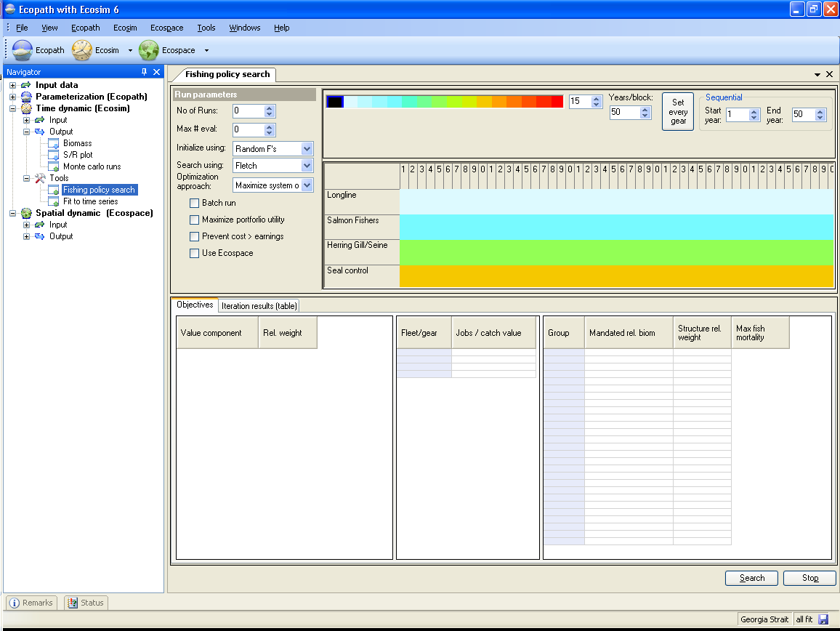
Figure 9.8

Maximize portfolio utility (maximizing risk-averse log utility for economic and existence values)
One option in the search procedure for optimum fishing patterns is to search for relative fleet sizes that would maximize a utility function of the form w1log(NPV)+w2Slog(B)-w3V, where the wi are utility weights chosen by the user and the utility components NPV, Slog(B), and V are defined as:
- NPV is net present economic value of harvests, calculated as discounted sum over all fleets and times of catches times prices minus costs of fishing, ie the discounted total profit from fishing the ecosystem.
- Slog(B) is an existence value index for all components of the ecosystem over time. It is calculated as the discounted sum over times and biomass pools of user-entered Structure weights times logs of biomasses, scaled to per-time and per-pool by dividing the sum by the number of simulation years and number of living biomass pools.
- V is a variance measure for the prediction of log(NPV)+Slog(B). It is assumed to be proportional to how severely the ecosystem is disturbed away from the Ecopath base state, where disturbance is measured at each time in the simulation by the multidimensional distance of the ecosystem biomass state from the Ecopath base state. This term is negative, implying that increased uncertainty about the predictions for more severe disturbances causes a decrease in the mean of log(NPV); this term represents both aversion to management portfolio choices that have high variance in predicted returns, and the observation that the mean of the log of a random variable (NPV*PB) is approximately equal to the log of the mean of that variable minus ½ the variance of the variable. Large w3 can be used to represent both high uncertainty about predictions that involve large deviations of biomass from the Ecopath base state, and strong risk aversion to policy choices that have high uncertainty.
This utility function combines several basic concepts of utility. First, the log scaling of value components represents the notion of "diminishing returns", that adding some amount to any value measure is less important when the value measure is already large than when the value measure is small. Second, the log scaling also represents the notion of "balance", that no value component should be ignored entirely (unless it is assigned a zero wi); the overall utility measure approaches minus infinity if either net economic performance (NPV) or if any biomass component of the ecosystem (any biomass Bi in Slog(B)) approaches zero. Third, it represents the notion that our predictions about the future of both economic performance and biodiversity (biomasses) become progressively more uncertain for policies that policies that result in more extreme departures from the Ecopath base state about which we presume to have at least some knowledge.
In the terminology of portfolio selection theory in economics, fishing policies result in a portfolio of value components with "expected total returns on investment" equal to NPV+SB. But policies that have higher expected total returns are most often also ones that would push the ecosystem into more extreme states, and hence represent portfolio choices with higher variance in total returns. For example, maximizing the deterministic prediction of NPV in Ecosim often involves a "farming policy", in which fishing is deployed so as to severely simplify the ecosystem to maximize production of one or a few species that appear at present to be the most valuable (price, potential total catch). This may even involve deploying some fleets just to remove predators and competitors for the most valued species, just like deploying pesticides and herbicides to remove "pests" in agricultural systems. But simplifying an ecosystem in such ways can make the behavior of the system deeply unpredictable, by creating opportunities for ecological response (population growth) by a variety of species that are rare in the "normal" ecosystem and hence are not well researched or understood in terms of their potential impacts on valued species should they become abundant. Simplifying an ecosystem is hence much like investing in high-risk, high-return stock market options; such investments may make you rich, but they may also bankrupt you. Most people are risk-averse as investors, and seek to "spread risk" by investing in "balanced portfolios" with lower expected returns on investment but much lower probabilities of severe loss.
The prediction variance measure V is not meant to represent all components of variation or uncertainty about future biomasses and fishery values. V goes to zero for policies that hold or maintain the ecosystem at the Ecopath base state Bo for every biomass, for all simulation times. It is obviously not correct to suggest that we would expect no variance in future biomasses (and hence in the harvest components of NPV as well) if such a policy were implemented. Imagine running a very large number of simulations of future biomass changes under such a policy, while varying all possible uncertain quantities such as the Ecopath base biomasses and biomass accumulation rates, productivities, Ecosim vulnerability parameters, environmental forcing inputs representing oceanographic productivity regimes, future demand and price patterns, and changing vulnerabilities to fishing due to biophysical and technological factors. Even for the baseline policy where Ecosim predicts stable ("flat line trajectory") expected or mean biomasses over time, these simulations would likely reveal high variances and complex covariance patterns for most biomasses over time, i.e. we would see wide probability distributions of possible future biomass states for the ecosystem. We should not be arrogant enough to suggest that we can describe all the uncertainties well enough to accurately calculate the variances of such distributions. But note that much of that variance in predictions of future biomasses (and hence variance in the value components) would be due to sources of uncertainty and variability that are the same no matter what the policy choice, i.e. would cause about the same amount of variance in predictions for any future harvest policy that we might simulate. When comparing policy choices using an optimization objective function, there is no point in including extra constant terms that do not change with the policy variables (e.g. a base variance Vo in predictions that does not change with fishing rate policy and just represents uncertainty about any prediction that Ecosim might make). Hence the V distance measure is meant to represent only extra variance or uncertainty in predictions for policy scenarios that would likely drive biomasses far from the Ecopath mean state.
Note that Ecosim does not deliberately advocate or promote any particular risk-averse portfolio approach to public investment in ecosystem harvest and existence values. Rather, it provides the logarithmic utility function option so that users who do have highly risk-averse attitudes about ecosystem values can identify policy options that would better meet their objectives. Users should always construct a series of policy scenarios with varying utility weights w1, w2, and w3 on the log utility components, to see how placing different emphases on these components would alter the predicted best policy choice.

Fit to time series
When an Ecosim model is loaded, you can load time series ‘reference’ data on relative and absolute biomasses of various pools over a particular historical period, along with estimates of changes in fishing impacts over that period. After such data have been loaded and applied (see Time series), a statistical measure of goodness of fit to these data is generated each time Ecosim is run. This goodness of fit measure is a weighted sum of squared deviations (SS) of log biomasses from log predicted biomasses, scaled in the case of relative abundance data by the maximum likelihood estimate of the relative abundance scaling factor q in the equation y = qB (y = relative abundance, B = absolute abundance). Each reference data series can be assigned a relative weight using a simple spreadsheet in the search interface, representing a prior assessment by the user about relatively how variable or reliable that type of data is compared to the other reference time series (low weights imply relatively high variance, unreliable data).
The Fit to time series search interface (Time dynamic (Ecosim) > Outputs > Tools > Fit to time series; Figure 9.9) allows users to do four types of analysis with the SS measure:
- Determine sensitivity of SS to the critical Ecosim vulnerability parameters (Vulnerabilities form), by changing each one slightly (1%) then rerunning the model to see how much SS is changed (i.e., how sensitive the time series predictions ‘supported’ by data are to the vulnerabilities). See Option (1) below;
- Search for vulnerability estimates that give better ‘fits’ of Ecosim to the time series data (lower SS), with vulnerabilities ‘blocked’ by the user into sets that are expected to be similar, (i.e., user can search for just one best overall vulnerability, or for better estimates for up to 15 ‘blocks’ of predator-prey vulnerabilities). See Option (2) and/or (3) below;
- Search for time series values of annual relative primary productivity that may represent historical productivity ‘regime shifts’ impacting biomasses throughout the ecosystem (for this search, the user must have linked a time forcing function to primary production using the Apply forcing function to primary production form and setting the i,i element of the forcing table for i = primary producers to the number of the forcing function). See Option (2) and/or (3) below;
- Estimate a probability distribution for the null hypothesis that all of the deviations between model and predicted abundances are due to chance alone, i.e. under the hypothesis that there are no real productivity anomalies. See Option (4) below.
1. Option (1)
Option 1 (above) is invoked by clicking one of the two Sensitivities of SS to vulnerability button at the bottom of the screen. You can choose whether to determine sensitivity of SS to vulnerabilities associated with individual predator-prey interactions (i.e., by predator-prey cell) or to vulnerability settings for all of a predator’s foraging arena (i.e., by predator column).
Progress in this assessment is shown by placing an X in the vulnerability layout grid (on the right of the form) as the sensitivity to each vulnerability is computed. When all tests are completed, relative sensitivities are shown on a color code scale on the vulnerability grid. A grid cell shown in red (for prey type in row i, predator type in column j of the grid) is one for which SS was most sensitive (among those tested) to changing that vulnerability, while a grid cell shown in blue is one for which SS was not sensitive to changing that vulnerability. Note that the colors shown on the vulnerability grid after this search are purely to help the user identify vulnerability blocks for the parameter search, and are NOT used by the interface to define vulnerability blocks for estimation.
It is, however, possible to transfer the information from the sensitivity table to the search table using one of the three transfer buttons on the form. We recommend that you use the transfer some pred/prey or transfer by pred column rather than the transfer by prey row, which biologically makes less sense.
2/3. Options (2) and/or (3)
Options 2 and/or 3 are invoked by pressing the Search button on the search interface, after deciding which parameters to include in the search by setting nonzero variance values for one or both of Vulnerability search and Anomaly search:
Vulnerability search
Checking the Vulnerability search box and setting its variance > 0 causes the search to include parameter blocks that have been sketched as non-black in the vulnerability layout grid on the right side of the search interface.
Anomaly search
Checking the Anomaly search box and setting its variance > 0 causes the search to include primary productivity parameters for the specified year range (set using the First year and Last year boxes). You must also select a time series forcing shape from the drop down menu to the right of the Anomaly search box (see Apply forcing function for primary production).
The variance values set by the user are treated as Bayesian ‘prior’ variances for the parameters included in the search. Large variance values ‘allow’ the search procedure to vary the parameters more widely in search of lower SS parameter combinations.
When the search button is pressed, a frame appears at the left of the interface to show progress of the SS minimization procedure (a Marquardt nonlinear search algorithm with trust region modification of the Marquardt steps). For each step in the search, the algorithm must run the Ecosim model at least N + 1 times, where N is the number of parameters with nonzero variances (N can be up to Last year - First year + 16). A dot is written in the frame for each Ecosim run. For most of these runs, what the algorithm is doing is to increment one PP annual value or one vulnerability block value slightly, so as to calculate the ‘Jacobian matrix’ of sensitivities of each of the predicted time series observations to each of the parameters. After N+1 such checks, the Jacobian matrix is used to estimate an initial best step change for each parameter, and a few more runs are used to further improve the step. The algorithm stops when these changes become very small (or a numerical error occurs in the search calculations, if the search results in unrealistic values for some parameters). If no numerical error occurs during the search, the best estimates found during the search will be displayed in the Forcing functions tab (for PP time series) and/or the Flow control tab (for vulnerabilities). These new values will be saved with the Ecosim scenario if the user answers yes to the save scenario message on exit from Ecosim.
4. Option (4)
Option 4 is necessary because, when you use the search interface to estimate time series values of a forcing function, e.g., to obtain a temporal pattern of apparent primary production ‘anomalies’ for the ecosystem, you need to be careful about the risk of obtaining a spurious anomaly sequence that just represents measurement errors in the fitting data. Generally, if you are fitting the data to n independent time series of relative abundance, (i.e., for n of the groups), you can expect the fitting procedure to reduce the sum of squares (SS) by the proportion (n-1)/n by varying time forcing values even if there is no real time forcing effect. So if n=1, the fitting procedure can usually find a sequence of forcing values that make SS=0, but this sequence is meaningless (could be either real productivity anomalies or just spurious way of explaining measurement errors in the single abundance time series).
The Null hypothesis distribution SSred/SSo button allows you to estimate a probability distribution for the F statistic SS_{reduced}/SS_{base} under the null hypothesis that all of the deviations between model and predicted abundances are due to chance alone, i.e. under the hypothesis that there are no real productivity anomalies. The calculation of this F statistic requires a Monte-Carlo simulation procedure in order to account for autocorrelation in the model residuals that is expected even under the null hypothesis. Be warned that even if you do find a statistically significant reduction in SS by using the search procedure, this does not mean that the estimated sequence of relative primary production values is in fact ‘real’. All that you can say is this: “assuming that primary production was in fact variable and that this did cause changes in relative abundance throughout the food web, then our best estimate of the historical pattern of variation is the one obtained by the fitting procedure”.
Use the Time series weight box to set relative weights. This represents a prior assessment by the user about relatively how variable or reliable that type of data is compared to the other reference time series (low weights imply relatively high variance or unreliable data; higher weights imply low variance or reliable data). This grid will/will not overwrite weights that were set on the Time series form.
For users familiar with nonlinear estimation procedures used in single-species stock assessment, e.g., for fitting production models to time series CPUE data, searches on the vulnerability parameters should look quite familiar. In essence, the Ecosim search procedure for vulnerabilities is just an ‘observation error’ fitting procedure where vulnerability changes usually have effects quite similar to changes in population ‘r’ parameters in single-species models. Allowing the search to also include historical primary production ‘anomalies’ corresponds to searching also for ‘nuisance parameter’ estimates of what we usually call the ‘process errors’ in single species assessment.
Ecosim users are cautioned that the search procedure in no way guarantees finding ‘better’ Ecosim parameter estimates. Better fits to data can easily be obtained for the wrong reasons (some time series, particularly CPUE data, can be misleading in the first place, as can historical estimates of changes in fishing mortality rates; many parameter combinations may equally well ‘explain’ patterns in the data). Nonlinear search procedures can become lost or ‘trapped’ at local parameter combinations where there are local minima in the SS function far from the combinations that would actually fit the data best.
The best way to insure against the technical problems of searching a complex SS function is to use ‘multiple shooting’: start the search from a variety of initial parameter combinations (patterns sketched in time forcing function and/or vulnerability settings in flow control interface) and check whether it keeps coming back to the same final estimates. Look very closely at the time series data for possible violations of the assumption that y = qB, due to progressive changes in the methods of measuring relative abundance (y) or nonlinearities caused by factors such as density-dependent catchability. If y is a biomass reconstruction from methods such as VPA that assume constant natural mortality rate M, watch out for spurious trends in y caused by the sort of changes in M that Ecosim predicts, particularly for younger animals. Look for alternative combinations of Ecosim parameters that appear to fit the data equally well but would imply quite different responses to policy changes such as increases in fishing rates.
Search procedures are most useful in diagnosing problems with both the model and data. That is, the greatest value of doing some formal estimation is while it seems not to be working, when it cannot find good fits to data. Poor fits can be informative about both the model and the data. For example, in a study on impact of lobster fishing on Hawaiian monk seals, it seemed initially that Ecosim could ‘explain’ monk seal decline as a consequence of fishing down one of their foods, the lobster. But this hypothesis never really fit the monk seal population trend data well: Ecosim predicted a monk seal decline with development of the lobster fishery, but nowhere as severe or persistent as the observed decline. This lack of fit told us we needed to look for some other factor that hit the monk seals well after the lobster fishery had its impacts, and this factor turned out to be an oceanographic regime shift (decrease in primary productivity) that apparently impacted the availability of fish prey as well as lobsters. As an example of learning things about the data as well as the model, attempts to fit Ecosim to historical abundance estimates (from VPA) for Pacific herring in the Georgia Strait, British Columbia, Canada, have consistently led to Ecosim predicting lower juvenile herring abundances than observed during peak periods of historical fishing, and lower recent biomass of adult herring than observed. It looks in this case like the problem is with the data, not Ecosim: VPA likely resulted in overestimates of juvenile herring abundance during a period when we would expect juvenile herring to have had higher natural mortality rate than assumed in the VPA, and overestimates of adult biomass due to not correcting the VPA estimates for observed changes in growth rates (lower conditions factors observed) during the period where Ecosim predicts lower biomass.
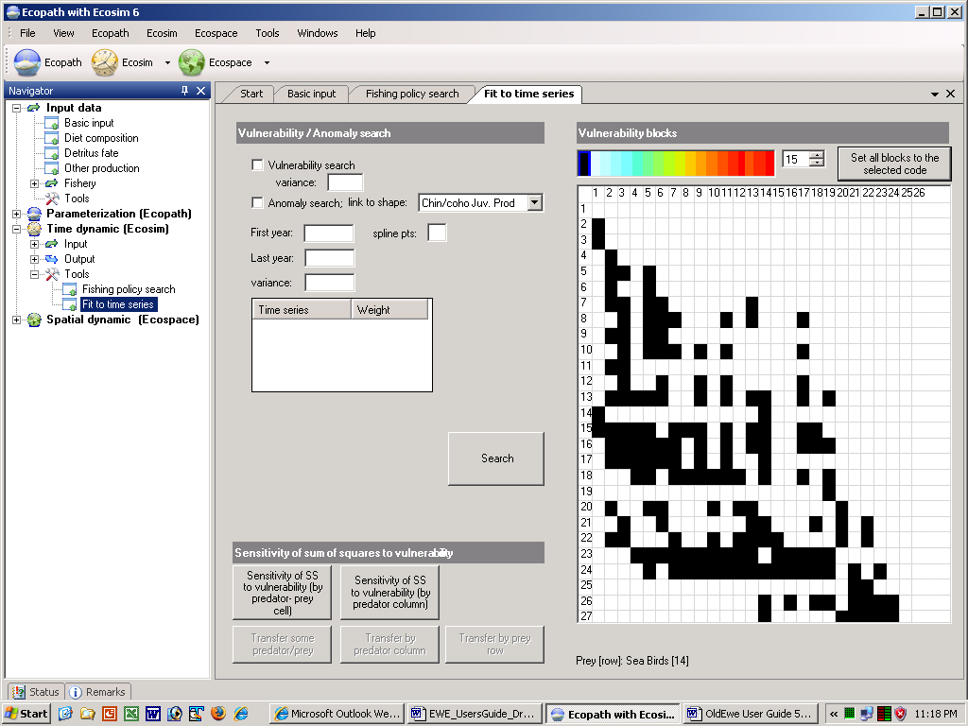

Figure 9.9 Ecosim: fitting to time series data. Results from checking “sensitivity of SS to v’s”. The most sensitive interactions can subsequently be used for the vulnerability search by choosing one of the three ‘transfer’ buttons (though avoid the option to transfer by prey row). Next click ‘Search’ or if desired, check the ‘Anomaly search’ first (if so link primary producers to the shape file listed). See text for further explanation.

Equilibrium analysis
This analysis takes the partial derivatives of the differential equations which define Ecosim (dB/dt = f(fishing rate, predation rate, etc.) with regard to fishing mortality (δB/δF), and sets these equal zero to identify the biomass values that would result from the continued application of the different levels of fishing mortality (F).
The analysis can be performed by varying F for different fleet (in which case the x-axis is a multiplier of its effort) or for different groups (in which case the x-axis has the dimension /year).
The results consist of a plot, centered about the Ecopath baseline value of F with, on the left, the biomasses of different groups resulting from low F (including F = 0 at the leftmost side of the graph), and on the right, the biomasses resulting from increasing effort above its Ecopath baseline.
To accommodate a large number of groups, the y-scale can be represented as multiple of the biomasses in the underlying Ecopath files, with 8x the upper, and 1/8 the lower limit; further a linear scale for the biomass ratios can be activated by pressing the ‘linear-scale’ button.
Also, the total value and the total catch is shown on the plot (unless hidden using the ‘Hide’ button in Ecosim. This catch line often takes a roughly parabolic form, as appropriate given that it roughly corresponds to the catch levels predicted by surplus-production models.
Evaluation of equilibrium MSY reference points
Though most Ecosim harvest policy analyses are conducted by varying regulatory policies applied to fishing fleets, a command button on the Equilibrium form in Ecosim can be used to carry out a series of long term (100+yr) simulations to estimate single species MSY and F_{msy} reference points and to evaluate ecosystem-scale performance if these reference points were simultaneously implemented. Three types of results are produced by the analysis:
- An estimate of MSY and F_{msy} for each harvested group, obtained by running the Ecosim model to equilibrium for a range of F values while holding biomasses of all other groups constant (except other life history stanzas for the same species in split and multi-stanza cases). This essentially means treating the ecosystem that ‘surrounds’ each group as constant, then examining predicted compensatory responses by the group (and other stanzas representing the same species) caused by the foraging arena functional response and related foraging time adjustment parameters.
- An estimate of the MSY that would be realized for each group if the single-species F_{msy} policy from (1) were applied simultaneously to all groups in the model. For each group, this estimate of MSY can be substantially different from the single-species MSY estimate from (1). Some groups may be more productive when the system is widely harvested (due to reduced competition and predation), while other groups may be less productive (due to harvesting of their food resources).
- An estimate of the change in MSY from step (2), i.e. in MSY evaluated while considering species interactions, due to reducing the F for each group by 10% from the single-species F_{msy} value. This is a matrix of results; each row of the matrix shows how MSY for every other harvested group would be enhanced or reduced by reducing the harvest of any one group. This matrix identifies groups for which single-species (myopic) management would have the most impact on ability of the system to sustain harvests from other species.
Note that step (2) is not the same as producing an estimate of the change in MSY that would be expected if the F_{msy} from (1) were applied to just one group at a time, while holding F’s for all other groups at Ecopath base values but allowing dynamic responses in all biomasses. That assessment typically produces a more optimistic estimate of MSY for each group than results from holding other groups constant as in (1), due to increases in food species abundances and decreases in predator abundances when any one group is harvested harder.
Three products are produced by the analysis. First, EwE writes a csv (comma delimited text) file for use in Excel. The file is placed in the same folder as the current database, and has a row for each harvested group and the following fields:
Group name;
Ecopath base F;
Single species F_{msy} estimate (holding other groups constant);
Single species MSY estimate (holding other groups constant);
Ecosystem-scale MSY estimate (MSY for the group if all other groups were harvested at F_{msy}).
Second, EwE produces a bar chart showing the single species MSY estimates and corresponding MSY estimates if all other groups were harvested at F_{msy}; this chart allows quick identification of groups for which the single-species analysis would be overly optimistic or conservative if MSY harvest policies were applied to all other species at the same time. Third, EwE produces a bar-chart matrix, with each row of the chart representing 10% reduction in F from F_{msy} for one group, and the bars across this row representing resultant change in equilibrium yield for each of the other harvested groups.
A particularly important result from the analysis is to help detect possible errors in Ecosim parameter settings. It is very common for default Ecosim “flow control” or vulnerability settings (v = 2) to result in Fmsy estimates that are far too optimistic, especially for species/groups that are far below natural (unfished) biomass equilibrium in the Ecopath base state. The flow control column for such groups should be assigned high values to represent the prediction that the group could eat much more prey if allowed to recover in biomass, which also represents the prediction that there would not be much further improvement in compensatory response with further biomass decrease.

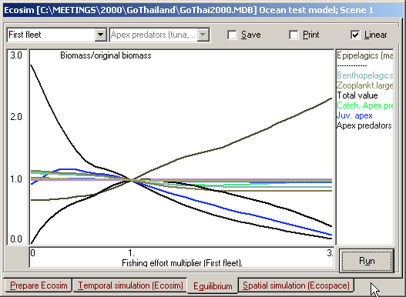

Figure 9.10. Ecosim equilibrium analysis, an ecosystem-level Yield-per-Recruit analysis.

Using Ecospace. Part 1: Ecospace inputs

Getting started in Ecospace: The Ecospace menu
Ecospace (Walters et al. 1999) is a dynamic, spatial version of Ecopath, incorporating all the key elements of Ecosim. Ecospace dynamically allocates biomass across a grid map (sketched with a mouse by the user, and typically defined by 20 x 20 cells), while accounting for:
- Symmetrical movements from a cell to its four adjacent cells, of rate m, modified by whether a cell is defined as ‘preferred habitat’ or not (running means over adjacent sets of five cells allows for smooth transitions between habitat types, which are also user-defined);
- User-defined increased predation risk and reduced feeding rate in non-preferred habitat;
- A level of fishing effort that is proportional, in each cell, to the overall profitability of fishing in that cell, and whose distribution can also be made sensitive to costs (e.g., of sailing to certain areas).
See An overview of Ecospace for a more detailed introduction of Ecospace.
When working in Ecospace you work within a ‘scenario’. A given Ecopath model can have any number of Ecospace scenarios attached, and they all inherit their basic parameters (such as number of groups, group names, diets and other parameters) from the parent Ecopath model. If you change a group name or delete a group in Ecopath the changes will be carried over to existing (and new) Ecospace scenarios. A scenario keeps track of all the information that is needed to store and later duplicate a simulation.
Important note: Before using Ecospace you must have a balanced Ecopath model. It is also recommended you have fit the model to time series data by adjusting the Vulnerability settings (see Time series, Time series fitting in Ecosim, Hints for fitting Ecosim models to time series data and Fit to time series).
New scenario
When you are ready to start using Ecospace, you must first create a new Ecospace scenario. You must have an Ecosim scenario loaded before you can create a new Ecospace scenario (using the Ecosim menu). Subsequent Ecospace simulations will use the parameter values (e.g. Vulnerability settings, Group info parameter settings) from the loaded Ecosim scenario.
After loading an Ecosim scenario, select New Scenario on the Ecospace menu (Figure 10.1). Alternatively, you can click once on the Ecospace shortcut button [], which will open the Load Ecospace scenario dialogue box (Figure 10.2 b). Select the Create option. This will open the New Ecospace scenario dialogue box (Figure 10.2a) where you can re-name your new scenario and add a description.

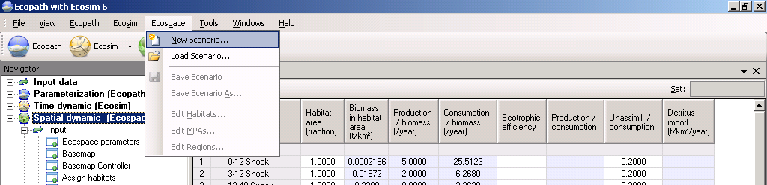
Figure 10.1. The Ecospace menu.
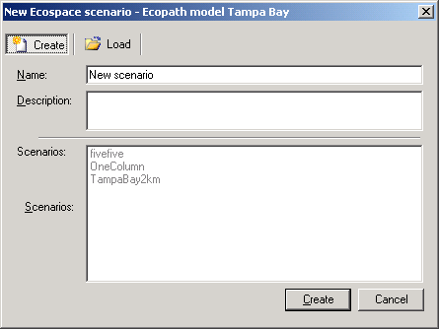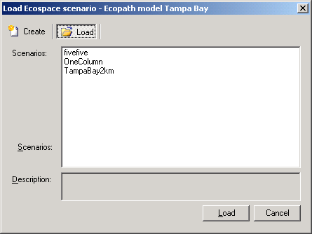
Figure 10.2a Figure 10.2b
Load scenario
The procedure for opening an existing Ecospace scenario is similar to that for creating a new scenario. You must have an Ecosim scenario loaded before you can create a new Ecospace scenario (using the Ecosim menu). After loading the Ecosim scenario, open the Load Ecospace scenario dialogue box by selecting Load scenario from the Ecospace menu. Existing Ecospace scenarios will be listed in the Scenarios window (Figure 10.2b). Select the scenario you wish to load and click the Load button at the bottom of the dialogue box.
Alternatively, you can open a scenario directly using the Ecospace shortcut button []. Click on the down arrow on the right of the bottom to open a list of available Scenarios and click on the name of the desired scenario. Note that the model must be closed and re-opened before new scenarios are added to menu under the Ecopath shortcut button. New scenarios can always be accessed from the Load Ecospace scenario dialogue box, regardless of when they were created.
Deleting an Ecospace scenario is easily done using the Load Ecospace scenario dialogue box. Simply select the scenario you wish to delete in the Scenarios window and click the Delete button at the top of the dialogue box. The Load button at the bottom of the box will then change to a Delete button, which must be clicked. You will be given the option to proceed or cancel. Clicking Yes implements deletion. Clicking No cancels deletion and you can then exit the dialogue box by clicking the Cancel button.
WARNING: Scenario deletion cannot be undone.
Save Scenario
You can save a scenario at any time by selecting Save scenario on the Ecospace menu.
Save Scenario As
The Ecospace menu also has a Save As option, allowing you to save your scenario under a new name. This is an important feature that allows you to preserve properties of an Ecospace scenario that you are happy with, while exploring the impact of other factors in different scenarios. It is also a useful way to create a backup of a successful scenario before trying out new parameter values.
Edit habitats…
Opens the Edit habitats dialogue box, used for setting up the Ecospace Base map. See Define Ecospace habitats for help with this dialogue box.
Edit MPAs…
Opens the Edit MPAs dialogue box, used for setting up the Ecospace base map. See Define Ecospace habitats for help with this dialogue box.
Edit regions…
Opens the Edit regions dialogue box, used for setting up the Ecospace base map. See Define Ecospace habitats for help with this dialogue box.

Ecospace parameters
Initialization
Users are given two options for initializing biomasses in Ecospace cells.
Ecopath base biomasses
Simply assign the Ecopath mean biomass for each pool to every spatial cell that has suitable habitat for that type of organism, and lower biomass to every non-suitable cell. In this case the Ecosim estimates of predation parameters (vulnerabilities, predator search rates) are left unchanged. However, this option generally results in underestimates of biomass density in favorable habitats, especially for biomass types that actually have high biomass on just a few spatial sites or cells.
Habitat-adjusted biomasses
Distribute the entire Ecopath mean biomass for each pool onto just those cells that are suitable for the organism, i.e., to concentrate the overall mean biomass into those map cells where the biomass is actually found. For example, a creature with overall Ecopath mean biomass of 10 t/km² would be assigned a biomass of 100 t/km² in suitable cells, if just 10% of the cells are assigned a habitat type suitable for it. In this second option, predation vulnerabilities, predator search rates, and primary producer P/B vs B parameters are adjusted to reflect the new, localized ‘mean’ biomasses expected in habitat types where animals actually are abundant.
Model
Model type
You must indicate the type of Ecopath model you are using. Model types can be EwE 6 multi-stanza model (i.e., created using EwE 6); IBM (i.e., individual-based model XXX); or EwE 5 style (i.e., created using EwE5.
Threading
I don’t know what this is.
Run time
- Set the Total run time for the simulation and the Number of time steps per year (i.e., set this to 12 for monthly time steps).
- Max no. of iterations.
- Tolerance
- Successive over-relaxation
- Predict effort
- Use exact calculations for migratory species
Summary
Start time
End time
Summary length (timesteps)

Define Ecospace habitats
‘Habitats’, in Ecospace, are sets of (water) cells sharing certain features affecting the movements, feeding rate, and survival of the Ecopath model components occurring therein. Any number of user defined habitats can be used in Ecospace along with the catch-all habitat no. 1, called ‘All habitats’.
Typically, the features defining habitats are distance from the coast (inshore, offshore…), or depth (shallow, intermediate, deep…) and/or bottom type (rocky, sandy, muddy…). Habitats are thus as easy to define as it is to obtain rough bathymetric maps or maps indicating bottom types.
Ideally, the habitats defined in Ecospace should correspond to ‘sub-web’, i.e., to a set of primary producers, herbivorous and other consumers occurring only over that habitat. Such sub-webs, defined through the diet composition matrix of an Ecopath file may be linked, through higher trophic levels groups, with other sub-webs in the same system, as also occurs in nature. Herein, the higher trophic level groups, through their ability to feed in different habitats, integrate the different subsystem into a whole.
Assuming that such sub-webs are implicit in the Ecopath file underlying an Ecospace analysis, all that is needed is, thus to give names – preferably short and descriptive – to the habitat types in question, using the Edit habitats dialogue box (see below). Habitats can be set as MPAs for all or part of the year, using the Edit MPAs dialogue box (see below). Users can also define regions, using the Edit Regions dialogue box (see below).
Note organisms at the upper trophic levels, (i.e., nekton) due to their high mobility will tend to ‘prefer’ a wide range of habitats rather than a specific one. The habitat name ‘All’ should be used for organisms ranging across all habitat types.
Also note that definition of habitat in Ecospace usually includes the entire water column, from the surface to the bottom. Thus, while ‘rockfishes’ will tend to be limited to hard bottoms, and burrowing bivalves to soft bottoms, small coastal pelagics, which occur higher up in the water column, may ‘prefer’ hard and soft bottom habitats, as long as both are coastal.
To facilitate documentation of an Ecospace scenario, space is provided to add, besides the (short) name of each habitat, a longer definition, e.g., as taken from some published description.
Edit habitats
Habitats are defined using Edit habitats dialogue box, accesible from the Ecospace Basemap form or directly from the Ecospace menu (Figure 10.3). Any number of user defined habitats can be used in Ecospace along with the catch-all habitat No. 1, called ‘All’. Type the number of habitats in the Define number of habitats box then click Update # habitats. Type names for the habitats in the appropriate cells. After you have assigned the habitats to the base map using Assign habitats form the fractions of each habitat will be updated automatically.
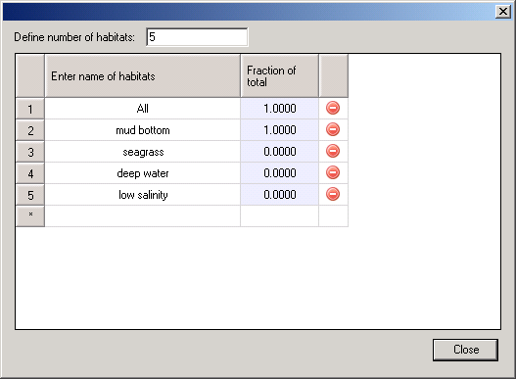
Figure 10.3
Edit MPAs
Users can overlay habitats with designated marine protected areas (MPAs). MPAs are defined using Edit MPAs dialogue box, accesible from the Ecospace Basemap form or directly from the Ecospace menu (Figure 10.4). Type the number of MPAs in the Define number of MPAs box then click Update # MPAs. MPAs will automatically be named MPA1, MPA2 etc. They can be renamed by typing directly in the name cell.
You can simulate seasonal MPAs by setting the months of the year that the MPA is operational in the check boxes provided. Use the Ecospace fishery form to assign which fleets can and cannot fish in the MPA. Assign the MPAs to the base map using the Basemap form.
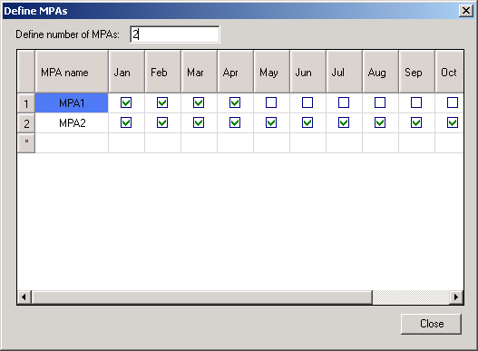
Figure 10.4
Edit regions
Users can also overlay habitats with statistical ‘regions’ (i.e., groups of cells). Regions represent areas of management interest and may or may not have biological significance. Organisms cannot be assigned to regions, only habitats.
Regions are defined using Edit regions dialogue box, accesible from the Ecospace Basemap form or directly from the Ecospace menu (Figure 10.5). Type the number of regions in the Define number of regions box then click Update # regions. Regions will automatically be named Region1, Region2 etc. They can be renamed by typing directly in the name cell. Assign the regions to the base map using the Basemap form.
To set each habitat as a region, click the Habitat = regions button on the Edit regions dialogue box. In this case, the regions will automatically be updated on the basemap to be the same as the habitats. Note, you must assign habitats on the basemap before setting each habitat as a region. To set each cell as a region, click the Make each cell a region button. Again, regions will automatically be updated on the basemap.
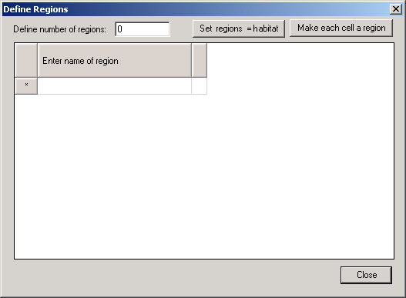

Figure 10.5

Basemap
The basemap is used to mediate between an Ecopath file - which assumes an homogenous distribution of the biomasses in an undefined space – and a real ecosystem with geographic features (land vs. water, bathymetry, etc.) impacting on the distribution of the biomasses in that file.
- The Ecospace basemap is defined, at first, by entering the number of cells in rows and columns, and the cell length (in km). The cells are square units, but the maps not need be so; both square and rectangular maps can be accommodated, but rectangular maps should not be defined too ‘thin’, (i.e., their aspect ratio (AR = height/width) is recommended to remain in the range 5 ≤ AR ≤ 0.2).
The number of homogenous cells in the basemap may range from 9 (for a square 3x3 map, used e.g. for verification or demonstration purposes) to 10 000, (e.g., for a square 100 x 100 map).
We recommend, unless otherwise required the intermediate 20 x 20 map provided as default, which represents a compromise between showing details and maintaining a high computing speed. When a desired number of cells is entered, the number of cells used in the basemap is computed as the number of square cells that is closest to the number entered, while remaining compatible with the aspect ratio of the map.
One defined in terms of its dimension, the basemap is used to sketch and show, by cell:
- land vs. water areas: The distinction between land and water areas is crucial to the definition of the basemap: this distinction determines the map’s overall appearance (i.e., its resemblance to a geographic map) and, in case of detailed maps, the routes through which organisms move between adjacent cells.
Thus, a system including a number of narrow, crooked channels must be simplified, as movements on Ecospace map can only resemble those of rooks on chessboards, but not those of bishops.

Though not contributing to the results, the basemap cells defined as ‘land’ consume memory and computing time; thus, their number should be kept as small as possible, e.g. by orienting the basemap sideways where appropriate.
The basemap may include open borders, i.e., water areas not bounded by land. In such cases, the flow of organisms out of a border cell is compensated for by an equal flow of organisms into the cell, i.e., the system will not ‘leak’.
- Different habitat types: These are defined on the ‘Define habitats’ tab.
- Restricted or protected areas; Restricted areas are here defined as set of (water) cells in which at least one fleet is restricted from fishing, and at least one other fleet may operate.
Protected areas are defined as set of cells in which no fleet is permitted to operate. (Thus, ‘cheating’, wherein one or several fleets illegally operate inside a protected area, can be accommodated by Ecospace).

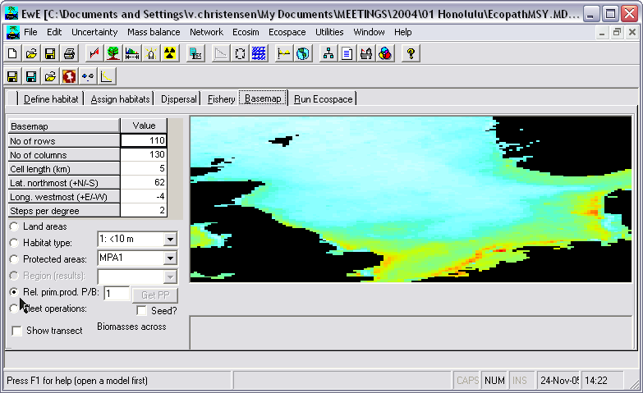

Figure 10.6. Ecospace basemap. Land areas, habitat types, MPA areas, relative primary production, and cost of fishing can be defined on the spatial grid. The ‘Set Advection field’ links to an advection model. This basemap is read via the Web from a linked server at UBC (available through ‘Define habitat’ map), and illustrates spatial primary productivity based on SeaWiFS data.
Restricted or protected areas (R/PAs) may consist of one or several cells, adjacent or not, and may touch upon a coastline, or not.
Note that for a number of theoretical and practical reasons, marine protected areas (MPAs) and other forms of R/PAs are more effective when they have as few cells as possible that are adjacent to exploited cells. This can be achieved by making the R/PA as compact as possible (i.e., ‘round’ or square rather than elongated), and locating it adjacent to a coastline.
- Distribution of primary producers P/B: Primary production may vary in different areas of an ecosystem, e.g., due to terrigenous inflow of nutrients, or processes that lead to mixing or upwelling of water masses.
Mapping such areas is done by sketching a multiplier of the baseline P/B for primary producers. This multiplier, which may range from 0.01 to 100, can thus be used to depict anything from areas with very low primary production rates to areas with very high rates compared to the underlying Ecopath model. The values entered are relative and the total primary production is scaled so that it will be the same as in the base Ecopath model.
Warning: Ecospace is sensitive to this setting. Even if the range is 0.01 to 100 such extremes should be used with great care only.
- and by fleet: Pressing ‘fleet operations’ and choosing one of the fleets (defined in the underlying Ecopath file) opens a small text box, which allows:
- Identification of a port/landing place: Ecospace allows only one port/landing place per fleet. Hence, if one’s fleet use several ports/landing places, the underlying Ecopath file must be modified accordingly (by replacing the existing fleet by several fleets, of which each has its own port/landing place). Also note that, to avoid ambiguities, a port/landing place is defined by a (yellow) water cell, not by a land cell. Note: this feature not yet activated.
- Mapping the cost of sailing: Costs of sailing are multipliers of variable costs, sketched onto the map. These costs should reflect distance from the port/landing place, as modified by other factors (e.g., winds or currents).

- Show transect: Show a biomass transect, whose two ends (red buttons) can be moved. This is used to further facilitate interpretation of an Ecospace run. The small display below the distribution map shows the (log) biomass of the different groups along a transect defined by the position of the two red/orange buttons on the basemap.
As might be seen (once a simulation has been performed), the biomass drop when the transect line crosses cells defined as land. The transect line allows identification of trophic cascades (abundant predators, scarce prey, and vice versa) in an ecosystem context, notably when drawn across Restricted/Protected Areas, where top predator biomasses tend to be high.
Completing the basemap is achieved by clicking any of the buttons defined by the above bullets, then using the mouse to sketch the corresponding map information.
Details on ‘Habitat’ and the Fishery can be obtained by clicking the corresponding tabs.

Assign habitats
Once habitats have been defined (see Define Ecospace habitats), (and sketched onto the basemap), the components of the underlying Ecopath model must be assigned to their ‘preferred’ habitat. ‘Preferred’ here means that the group in question will be adapted such that,
- its feeding rate and hence its growth rate as well are higher in that habitat than in others;
- its survival rate is higher in that habitat (because the predation rate is higher in non-preferred habitat);
- its movement rate is higher outside than within good habitat.
All three of these choices imply different mechanisms for defining what is good and bad habitat, and users can determine (through the Dispersal form) the relative strength of these mechanisms.
However, the first job is to assign groups to habitats, which is easy to do if the habitats have been defined in terms of parameters that are themselves easy to determine.
Thus, if the habits defined are ‘shallow’ and ‘deep’, assigning the groups to their preferred habitat simply consists of clicking ‘shallow’ for model groups known to limit themselves to shallow waters, and conversely for ‘deep’.
Note, however, that organisms assigned e.g. to ‘deep’ waters will usually consume preys also assigned to ‘deep’ waters, and conversely for shallow water organisms. Only groups assigned to ‘All’ habitats can be expected to feed indiscriminately in all habitats.
In the special case of multi-stanza groups, it will be appropriate, in most cases, to assign the juveniles to one or several inshore/shallow habitats, out of reach of the often ‘cannibalistic’ adults, assigned to habitats that are deeper, or further offshore.

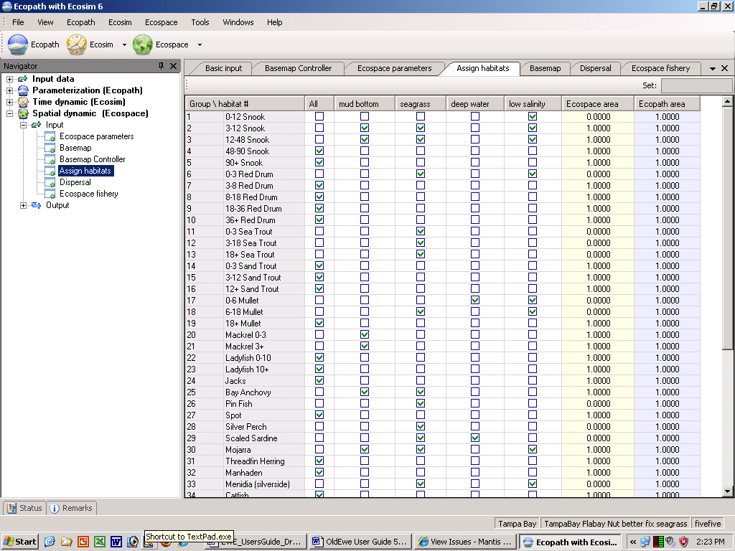

Figure 10.7. Assign groups to Ecospace habitats. The ‘Ecospace area’ is calculated from the basemap, while the ‘Ecopath area’ is the habitat area fraction assigned to the individual group in the underlying Ecopath model. When Ecospace shows initial imbalance at the start of a simulation it my be because of inappropriate distribution of habitat areas, and a more careful allocation if often required to improve model behaviour.

Dispersal
The organisms (i) in an Ecopath model have an aggregated biomass (B_{i}), and are not assumed to move within the area covered by that Ecopath model. In Ecospace, a fraction (B’_{i}) of the biomass of each cell is always on the move, wherein
B’ = m · B_{i}
with m having the dimension of length / time (i.e., km / year) i.e., a velocity or ‘speed’.
However, m is not a rate of directed migration, as occur seasonally in numerous fish populations. Rather, m should be regarded as dispersal and seen as the rate (km/year) the organisms of given ecosystem would disperse as a result of random movements.
Thus, Ecospace simulation are initiated by distributing all organisms evenly onto the basemap, at the density (t · km⁻²) defined by the underlying Ecopath model. Then all biomass pool start moving, as a function of their value of m, out of their cell and into adjacent cells, there consuming food, and being themselves consumed.
Given differential food consumption and survival rates in preferred vs. non-preferred habitat, this will soon generate richly patterned distributions, wherein each cell includes different biomass of each of the groups in the system.
Note that the final results of Ecopath simulations tend to be largely independent of the specific values of m used, and hence long debates on the best choice of these values may not be necessary – at least not until field estimate, based, e.g., on tagging studies have become available.
Note, finally that the biomass of a group within a given cell is usually not multiplied by the same value of m for each of the flows out of the cell (4 in the case of a cell not touching on land).
Rather, a distinct value of m’ is used for each cell, resulting from the multiplication of a group’s value of m with that cell’s index of suitability S. This index is itself computed, for each cell as the mean of its ‘preference values’. These preference values are automatically set at unity in non-preferred habitat, and a user-defined, higher value (PV>1) can be entered for preferred habitat(s). Thus, if S > 1, the movement rate into preferred habitat (and out of non-preferred habitat) will be higher than into non-preferred habitat (and out of preferred habitat). Setting PV for preferred habitat equal to unity (1) makes this mechanism of habitat differentiation inoperative.
Base dispersal rate
This is the absolute value of m to be used in the simulation. The default value is 300 km · year⁻¹ for all groups apart from detritus groups to which discards are added, (and for which we use a default of 10 km · year⁻¹).
Relative dispersal in bad habitats
The dispersal rates are assumed to differ between preferred and non-preferred habitats, with higher values of m within non-preferred habitats than in preferred habitats. Such assumption is realistic as it implies that organisms in non-preferred habitats will strive to leave these, and attempt to return as rapidly as possible to their preferred habitats.
The default value for the multiplier of m is 2.0 and the upper limit 10.0.
Vulnerability to predation in bad habitats
The increased vulnerability to predation (or grazing) of various organisms outside their ‘preferred’ habitat can be changed using a multipliers. The default value of the multiplier is 2.0 for all groups, and it can be increased by up to a factor of 100, while entering a value of 1 will make this mechanism inoperative.
Conceptualizing this mechanism is straightforward: imagine as an extreme case how easy it would be for a pelagic carnivore to grab a typical coral reef fish, e.g. a butterfly fish, blown by a freak wave off its reef, into an open water area. A less extreme case would be a member of a very abundant population, pushed out of its preferred habitat by its competitors of the same species.
To avoid occurrence of groups outside of their preferred habitats you should set the vulnerability to a high value.
Relative feeding rates in bad habitats
Organisms outside their preferred habitat may be conceived as less likely to consume as much appropriate food as their congeners within preferred habitat, due to the unavailability of such food, or the danger associated with foraging.
To simulate this, Ecospace users can reduce the feeding rate of ecosystem components down to 0.01 times the Ecopath baseline (i.e., the Q/B value). The default is 0.5, and this mechanism can be made inoperative by setting the feeding rate multiplier equal to unity (1).
Advected?
Indicate here whether a group is advected or not, this may, e.g., be the case for plankton. See Advection in Ecospace for more details on implementation of advection in Ecospace.
Migrating?
Indicate here whether a group is migrating or not. For migrating groups/life stages enter concentration parameters and define migration patterns (using the so named button). See Representing seasonal migration in Ecospace for more details on implementation of seasonal migration in Ecospace.
North/south and East/west concentration
Larger organisms commonly have seasonal migration patterns that allow them to utilize favorable seasonal resource and environmental conditions over large spatial areas. Such movements can be represented in Ecospace in two ways. First is a simple “Lagrangian” approach that does not require explicit simulation of movement; the idea here is to simply think of the whole Ecospace map as moving in space so as to remain centered on the distribution of some dominant migratory specie(s). Second is a more complex “Eulerian” approach, which does involve explicitly modeling changes in instantaneous rates of biomass flow among the Ecospace spatial cells, in some way that approximates at least the changing center of distribution of the migratory species.
The Eulerian approach is implemented in Ecospace by allowing users to define a monthly sequence of “preferred” map cell positions and to define how spread out the migrating fish are likely to be around these preferred cells by setting north-south and east-west “concentration parameters”.
For more detail see Representing seasonal migration in Ecospace.
Barrier avoidance weight (by Will – EDIT)
The old algorithm is very bad about getting fish stuck in complex habitat, if they have to migrate around it. I've put in an algorithm that gets fish around obstacles, but if used on it's own, there is no control over EW/NS concentrations, and the distribution of fish that results is diamond shaped. So now the way it works, is it uses the original method, but then modified by this path-finding algorithm which pushes the fish out of traps. How much weight is put on the path finding is in the barrierAvoidanceWeight. It should start out at 0 (it does nothing), and then can be increased slowly up to 1 if fish are getting stuck. Increasing this weight also tends to concentrate the fish more tightly, so the EW/NS concentrations can then be lowered to even things out.
Figure 10.8. Ecospace dispersal rates and habitat specific information. Migration patterns are also defined on this form.

Ecospace fishery
The Ecospace fishery form (Figure 10.9) is used to assign fleets, i.e., to define in which habitat(s) a fishing fleet may operate, and to identify whether a given fleet may operate within a restricted area.
For each fleet indicate where it may operate by clicking:
- All: if it can operate in all habitats (default setting), or;
- For each habitat click if may operate in the given habitat;
- MPA: click if the fleet is allowed to operate in the given protected areas.
Effective power: sets relative catchabilities by gear type, treating effort for each gear as starting at base value of 1.0 so that F for the gear (F = qE=Catch/biomass) is 1.0 · q where q is relative catchability. This is to avoid measuring effort in some unnecessary unit. Effective power should be entered as a non-negative parameter, and has a default value of 1.
Total efficiency multiplier: a scaling factor for effort by fleet, it should be non-negative, and has a default value of 1.

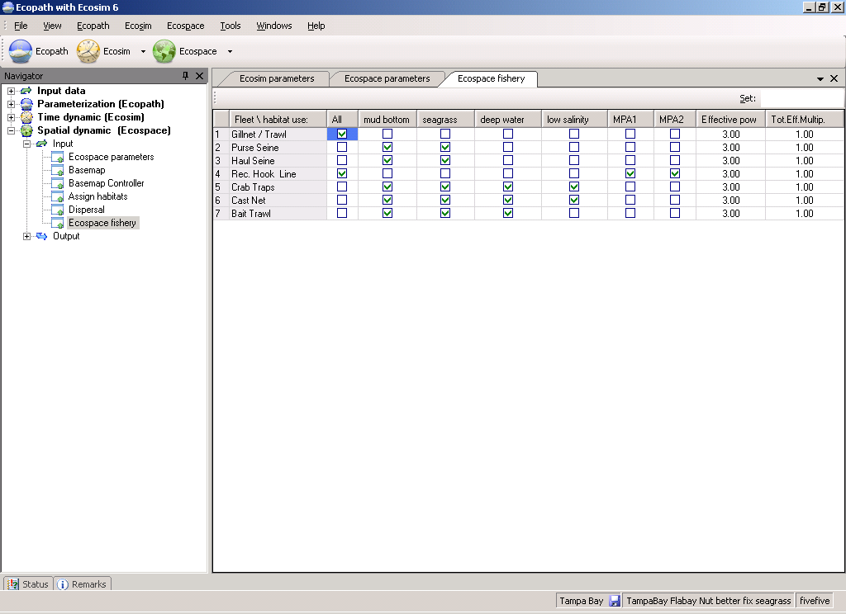
Figure 10.9

Ecospace. Part 2: Ecospace outputs

Run Ecospace
The business of Ecospace is predicting distributions, and its main outputs are distribution maps, one for each ecosystem component. Here, positive deviations (biomass increases) from the Ecopath baseline levels are shown in red, and negative deviation (decrease) in blue (see color scale on right of panel representing map.
Ecospace runs thus imply the display of a succession of maps, one per iteration and group. Usually, the features of these maps will be gradually converging toward some stable equilibrium distribution. Alternatively these maps may regularly ‘flip’ between two states, suggesting some sort of dynamic equilibrium.
Which of these alternative occurs can be seen more clearly from the small panel on the lower left corner of the Ecospace run window, which traces the progress of the run.
To facilitate interpretation of the effort distribution and related maps, a button has been added to export a spreadsheet with a table representing the numbers used to construct that table.
Relative biomass
Show relative biomasses on the plots
Fishing effort
Show distribution of fishing effort over space for each of the fleets. In Ecospace, fishing effort is assigned to spatial cells through a ‘gravity model’, wherein effort is proportional to the net benefits gained from exploiting a given cell.
In the simple case that all exploited group have the same economic value (default = 1 monetary unit per tonne), and that all cells require the same sailing cost (default), fishing effort will be assigned to the (water) cells of the base map in proportion to their fishable biomass.
Thus, for example, fishing effort will tend to concentrate at the edges of protected areas – one reason, incidentally, why these edges should be as short as possible.
Show all
Show plots for all groups
Show non-hidden
Show plots for groups which are not-hidden on the Show/hide dialogue box.
Show only group below
Show plot for only the group that is selected in the drop-down list box below. You can change which group to display by selecting another group.
Enlarge plot
Enlarge the plot below, and show it on the right. You can use the mouse pointer to see the group names linked to the lines.
Move title
A title is displayed on each of the Ecospace plots to the right. Clicking this command button will move the titles from the top to the bottom. One more click will hide the titles, one more show them at the top, etc.
Time plot
Plot showing biomass over time relative to biomass in Ecopath base run for each group. The scale is logarithmic spanning from 0.1 over 1 (same biomass as in Ecopath) to 10.
The time plot panel shows the (log) biomass of each group over time, from the start of the simulation, to its end. Usually, this will consist of a phase of rapid change, followed by a convergence of all groups toward their equilibrium states (flat lines). In other case, the lines representing the biomasses will oscillate more or less regularly (the preys usually displaying troughs when their predators show peaks, and vice versa), which will diagnose the dynamic equilibrium mentioned above.
Finally, one or several of the lines representing the biomass of various groups may decrease or increase continuously, indicating that this (or these) group(s) cannot be accommodated in the system. Thus, a group may decrease because it cannot find sufficient food in its assigned habitats, or encounters too many predators when feeding, non-withstanding it being mass-balanced in the underlying Ecopath file.
Alternatively, a group may increase due its ability to outgrow predatory control in its assigned habitats, or in another habitat, a feature sometimes due to an excessively high value of P/B, or to a diet composition that is too broad.
Vertical hatch lines on time plot
Used to set the two time periods to be used when displaying ‘Results’. Left-click with the mouse to set the first time, and right-click to set the second. When Ecospace reaches the first line it will average results over the next n (default 5) runs. You can change the value of n on the ‘Prepare Ecosim’, ‘Run info’ tab.
Run
Start the run. Will change to ‘Stop’ once pressed, and to ‘Run’ again at the end of the run
Pause
Pause the run, e.g., to set up a protected area on the basemap.
Results
Will display a summary of the results. Will be activated at the end of a run.
Overlay
Hatch to overlay the time plots on the graph below. Use this to check for initialization errors, i.e. this button is mainly used to ensure that successive runs give the same results.

Capabilities and limitations
EwE has been developed largely through case studies, where users have challenged us to add various capabilities and as we have seen inadequacies through comparison to data; see as a good example the discussions in the proceedings from an FAO workshop on the application of EwE (Pauly 1998). Various capabilities have been added to EwE in response to these challenges, and there have inevitably been some uncertainty about what the approach and software presently can and cannot do, and about how it should be used in the design of sustainable fisheries policies. Such uncertainty may be expressed through too simplistic interpretations of what mass balance and biomass dynamics models are capable of representing, through to unwarranted optimism about how it should be used to replace or complement existing assessment tools. Here we review the capabilities and limitations through a series of ‘frequently asked questions’, followed by explanations of what we think EwE is actually capable of doing.
Note that many of the questions discussed below have their root in an assumption that EwE is somehow intended to supplant or replace single-species assessment methods. Our primary goal when developing EwE has been to develop a capability for asking policy questions that simply cannot be addressed with single-species assessment. Examples are questions about impacts of fishing on nontarget species, and the efficacy of policy interventions aimed at limiting unintended side effects of fishing. Also, as is shown through examples below, EwE can now incorporate time series data from single-species assessment as input and use these for parameter fitting. We indeed advocate an iterative process where information is passed between single-species analysis and EwE to check and improve estimates in the process, addressing questions about the degree to which ecosystem events can and cannot be attributed to impact of fisheries, climate change, etc.
Does Ecopath assume steady state or equilibrium conditions?
Ecopath provides an ‘instantaneous’ estimate of biomasses, trophic flows, and instantaneous mortality rates, for some reference year or multi-year averaging window. Biomasses need not be at equilibrium for the reference year, provided the Ecopath user can provide an estimate of the rate of biomass ‘accumulation’ (or depletion) for each biomass for that reference year. In fact, in a number of cases, e.g., Christensen (1995b) it was necessary to recognize that biomasses were in fact changing over the period for which Ecopath reference data (B, P/B, Q/B, diet composition) were provided. In these cases, assuming equilibrium for the reference year led to overly optimistic estimates of sustainable fishing mortality rates.
Should Ecopath be used even if there is insufficient local information to construct models, or should more sampling go first?
It is a fairly common conception that since we do not know enough to make perfect models at the individual or species level there is no way we can have enough information at hand to embark on modeling at the ecosystem level. This may hold if we try to construct models bottom-up – we cannot account for all the actions and processes involving all the individuals of the world. This is, however, not what Ecopath models do. Instead they place piecemeal information in a framework that enables evaluation of the compatibility of the information at hand, gaining insights in the process. Adding to this is that there is much more information of living marine resources available than most will anticipate. The best demonstration of this can be obtained by searching the FishBase database on finfish (Froese and Pauly, 2000, www.fishbase.org) for Ecopath-relevant information using the semi-automated search routine available for this specific purpose at the website.
Another aspect is that ecosystem models can help direct research by pinpointing critical information and gaps in the present knowledge. As more information becomes available it is straightforwardly included in the model, improving estimates and reducing uncertainty.
Does EwE ignore inherent uncertainty in assembling complex and usually fragmentary trophic data?
Ecopath has a number of routines that encourage users to explore the effects of uncertainty in input information on the mass balance estimates. In particular, the ‘Ecoranger’ routine allows users to calculate probability distributions for the estimates when they specify probability distributions for the input data components. Similarly, Ecosim has a graphical interface that encourages policy ‘gaming’ and sensitivity testing.
Lack of historical data and difficulty in measuring some ecosystem components and processes will likely always plague efforts to understand trophic structure and interactions. This is not a problem with Ecopath, but rather with aquatic ecology in general. We need to respond to it not by complaining about the incompleteness of our data, but rather by using models like EwE to direct research attention toward components that are most uncertain and also make the most difference to policy predictions. We also need to use the models to search for robust policy options and management approaches that will allow us to cope with the uncertainty, rather than pretending that someday it will just go away.
When EwE is used for policy comparison, it is important to recognize that incorrect comparisons (EwE leading user to favor a wrong policy) are not due to uncertainty in general about the model parameters, but rather to errors in specific input data to which the particular policy comparison is sensitive. In other words, EwE can give correct answers for some policy comparisons but wildly incorrect ones for others, so it is meaningless to claim that it should not be used because of uncertainty in general. For example, EwE predictions of the impact of increasing fishing rates for a particular species are most sensitive to assumptions about vulnerability of prey to that species, since the vulnerability parameters largely determine the strength of the compensatory response by the species to increased mortality rate. But even if EwE predicts the strength of the compensatory response to fishing correctly, it may still fail to predict response of that same species to a policy aimed at increasing its productivity by reducing abundance of one or more of its predators: EwE may have a good estimate of total mortality rate for the species, but a very poor estimate of how that mortality rate is distributed among (or generated by) predators included in the model.
Can Ecopath mass balance assessments provide information directly usable for policy analysis?
Instantaneous snapshots of biomass, flows, and rates of biomass change have sometimes been used to draw inferences about issues such as ecosystem health as measured by mean trophic level or other indices of fishing impact, (e.g., Christensen, 1995a; Pauly and Christensen, 1995; Pauly et al., 1998a). But the snapshots cannot be used directly to assess effects of policy changes that would result in changes in rates, (e.g., reduction in fishing rates) since the cumulative effects of such changes cannot be anticipated from the system state at one point in time. In fact the Ecosim part of EwE was initially developed specifically to provide a method for predicting cumulative changes, while recognizing that all rate processes in an ecosystem may change over time, as biomasses change. For example, one might conclude from the Ecopath mortality rate estimates or mixed trophic impact analysis that reducing the abundance of some particularly important predator might result in lower mortality rates of its prey, and hence growth in abundance of these prey. This prediction may hold for a short time, but might be reversed entirely over longer time scales due to increases in abundance of other predators or on an intermediate time scale due to predator prey switching in response to the initial responses in prey density.
Can Ecopath provide a reliable way of estimating potential production by incorporating knowledge of ecosystem support capabilities and limits?
Ecologists have long sought simple ways of predicting productive potential of aquatic ecosystems from ‘bottom up’ arguments about efficiency of conversion of primary production into production of higher trophic levels, (e.g., Polovina and Marten, 1982). While Ecopath inputs can be organized so as to provide such predictions, we do not recommend using EwE for management this way. There are simply too many ways that simple efficiency predictions can go wrong, particularly in relation to ‘shunting’ of production into food web components that are not of direct interest or value in management, (e.g., ungrazeable algae, fish species that are not harvested). Ecopath can help provide broad bounds for potential abundances and production in an exploratory research mode, but these bounds are unlikely to be tight enough to be useful for management planning related to fishery development or recovery potential.
Can Ecopath predict biomasses of groups for which no information is available?
In most EwE applications today, we try very hard to avoid using the Ecopath biomass estimation capability for more biomass components than absolutely necessary. Estimation of biomass with Ecopath usually requires making explicit assumption about the ecotrophic efficiency, i.e., about the proportion of the total mortality rate of a group that we account for by the predation, migration, biomass accumulation and fishing rates included explicitly in the Ecopath data. There is rarely a sound empirical basis for using any particular value of EE, except perhaps for top predators in situations where total mortality rate (Z=P/B) is well estimated and EE represents a ‘known’ ratio of fishing rate (F) to total Z (and the rest of Z, e.g., the natural mortality (M) is known not to be due to other predators included in the model nor to other factors not considered).
Where biomasses really are unavailable or are known to be biased, e.g., if the only biomass estimates for pelagics are from swept-area analysis based on demersal trawling, it may still be better to use assumed EE’s than to stop short of constructing an ecosystem model pending, e.g., funding and development of capabilities to conduct acoustic surveys. In such cases one can assume reasonable EE values for groups where biomasses are missing – an example: small pelagics do not die of old age in an exploited ecosystems, most are either eaten or caught, hence EE is likely to be in the range 0.90 to 0.99. As confidence intervals can be assigned to all input parameters and can be estimated for the output parameters using the Ecoranger module of EwE (where a range for acceptable output parameters is also incorporated as part of the model evaluation process), the mass balance constraints of the model can be used to predict potential ranges for biomasses of the system in the system,
Should Ecopath mass balance modeling be used only in situations where data are inadequate to use detailed, more traditional methods like MSVPA?
Multispecies virtual population analysis (MSVPA) has been used to reconstruct age-size and time dependent estimates of trophic flows and mortality rate components, using the VPA assumption that historical abundances can be inferred by back-calculating how many organisms must have been present in order to account for measured and estimated removals from those organisms over time (Sparre, 1991; Magnússon, 1995). In a sense, Ecopath does this as well, but generally does not account for size-age dependency and temporal variation (biomasses are constrained to be large enough to account for assumed removals estimated from biomasses, consumption/biomasses, and diet composition of predators, just as in MSVPA).
But the really big difference between Ecopath and MSVPA is not in the detail of calculations; constructing an Ecopath model that details age, size and time components would be tedious but feasible. The more important difference is in the use of direct data on total mortality rate by Ecopath, in the form of the P/B ratio that Ecopath users must provide. Ecopath biomass and mortality estimates are ‘constrained’ to fit the total mortality rates entered as P/B data. In contrast, MSVPA (like single-species VPA) can produce cohort abundance patterns (die-off patterns over age-size and time) that do not agree in any way with apparent cohort decay patterns evident from direct examination of the size-age composition data. In effect, the MSVPA (and VPA) user must reject or ignore any direct evidence about total mortality rate Z that might be present in age-size composition data, and must treat discrepancies between apparent Z from the cohort reconstructions versus apparent Z from composition data as being due to size-age dependent changes in vulnerability to the composition sampling method. This can be unwise, just as it has been unwise to ignore information about Z in single-species VPA, (e.g., Newfoundland cod VPA's resulted in much lower estimates of Z than would be estimated from catch-curve analysis of the age composition data, and in this case it turned out that VPA tuning resulted in underestimates of fishing mortality rate,Walters and Maguire, 1996).
It is obviously comforting to us as biologists to be able to provide more detailed accounting of predation interactions, which are almost always size and age dependent. But in assessments of ecosystem-scale impacts of changes in trophic conditions, it is not automatically true that the best aggregate estimate is the sum of component estimates, any more than it is automatically true in single-species assessment that more detailed models and data always provide better assessments than simpler models. For statistical and logical reasons, the ‘more is better’ argument is no more valid in dynamic modeling than it is in multiple regression analysis, where we are familiar with how adding more independent variables often results in better fits but poorer predictions.
As noted in the following two points, Ecopath and Ecosim do not ‘ignore’ the fact that trophic interactions are strongly size-age and seasonally structured. Rather, we assume that initial (Ecopath base or reference period) structuring has been adequately captured in preparing average/total rate input data, and that changes in structural composition over time are not large enough to drastically and persistently alter interaction rates/parameters. This is very similar to the assumption in single-species biomass dynamics and delay-difference modeling that stock composition changes produce regular or predictable changes in overall (stock-scale) production parameters, not that there is no composition effect in the first place.
Do EwE models ignore seasonality in production, mortality, and diet composition?
In most applications, Ecopath calculates components of biomass change over a one-year accounting step. There is no explicit assumption about how mortality rates, consumption rates, and diet composition may have varied within this step, except that the Ecopath user is assumed to have calculated a correct, weighted average of the rates over whatever seasonality may have been present in the data. Such averages can be difficult to calculate in practice, and a program interface component has been developed to help users with this chore (Martell, 1999).
In Ecosim, model users can define seasonal ‘forcing shapes’ or functions that can be applied as seasonal multipliers to the modeled production and consumption rate functions. Generally, including seasonal variation in this way results in graphics displays that are hard to follow visually (strong seasonal oscillations in ecosystem ‘fast’ variables like phytoplankton concentration), but very little impact on predicted interannual (cumulative, long term) patterns of system change.
Do biomass dynamics models like Ecosim treat ecosystems as consisting of homogeneous biomass pools of identical organisms, hence ignoring, e.g., size-selectivity of predation?
The biomass rate equations in Ecosim (sums of consumption rates less predation and fishing rates) can be viewed as ‘sums of sums’, where each trophic flow rate for an overall biomass pool is the sum of rates that apply to biomass components within that pool. In this view, doing a single overall rate calculation for a pool amounts to assuming that the proportional contributions of the biomass components within the pool remain stable, i.e., the size-age-species composition of the pool remains stable over changes in predicted overall food consumption and predation rates. In fact, the assumption is even weaker: pool composition may indeed change over time provided that high and low rate components change so as to balance one another; or proportional contribution of major components is stable enough so that total rates per overall biomass are not strongly affected.
We know of at least one condition under which the compositional stability assumption may be violated – when ratios of juvenile to adult abundance can change greatly, (e.g., under changes in fishing mortality) for a species that has strong trophic ontogeny (very different habitat use and trophic interactions by juveniles). To deal with such situations, Ecosim allows model users to 'split' biomass pools representing single-species with strong trophic ontogeny or size-dependent vulnerability to harvest, into multiple-age stanza groups. For populations represented this way, the Ecosim biomass dynamics equations are replaced with an explicit age structured model for monthly age cohorts in each of the stanzas (animals are lumped into one adult age group after reaching 95% of the asymptotic maximum body weight). The cohorts in each stanza can have distinctive diet composition and predation risks. Food search rates and metabolic rates per individual are calculated so as to have the animals Figure growth with a basic von Bertalanffy functional form, but with growth rates varying with food availability. Recruitment is calculated for each month from total egg production, and egg production per individual is assumed to increase linearly with body size above a size at maturity.
Thus, for ‘split pool’ species Ecosim replaces the biomass dynamics model with a much more detailed and realistic population model, (see ‘Error: Reference source not found’ on page Error: Reference source not found). This allows Ecosim users to not only represent compositional effects, but also to examine the emergent stock-recruitment relationship caused by density-dependent changes in adult fecundity and juvenile growth and foraging time behavior.
Do ecosystem biomass models ignore behavioral mechanisms by treating species interactions as random encounters?
Historically, trophic interaction rates in biomass dynamics models have been predicted by treating predator-prey encounter patterns as analogous to ‘mass-action’ encounters between chemical species in chemical reaction vat processes, where reaction (encounter, ‘predation’) rates are proportional to the product of predator and prey densities. Such ‘Lotka-Volterra’ models generally predict much more violent dynamic changes, and considerably simpler ecosystem organization, than we see in field data.
Ecosim was constructed around the proposition that this mass-action principle is deeply incorrect for ecological interactions, and instead interactions take place largely in spatially and temporally restricted ‘foraging arenas’ where prey make themselves available to predation through activities such as foraging and dispersal. To represent this within-pool heterogeneity, we treat each biomass pool as consisting at any instant of two biomass components with respect to any predator, one sub-pool of individuals vulnerable to the predator and another sub-pool ‘safe’ from the predator. In this view, predation rate is limited jointly by search efficiency of the predator for vulnerable prey individuals, and exchange rate of prey between the invulnerable and vulnerable states. When Ecosim users set the vulnerability exchange rates to high values, the model moves toward ‘top down’ or mass-action control of predation rates. When users set the vulnerability rates to low values, the model moves toward ‘bottom up’ control where predation rates are limited by how fast prey move (or grow, or disperse) into the vulnerable state.
Obviously the two-state (vulnerable/invulnerable) representation of prey biomass composition is a first approximation to the much more complex distribution of vulnerabilities among prey individuals that is likely to be present in most field situations. But it goes a remarkable way toward explaining dynamic patterns (lack of predator-prey cycles, persistence of apparent competitors and high biodiversity) that we have been unable to explain with simpler Lotka-Volterra mass-action models.
Do Ecosim models account for changes in trophic interactions associated with changes in predator diet compositions and limits to predation such as satiation?
In nature, diet compositions and feeding rates can change due to five broad factors:
- changes in ‘habitat factors’ such as water clarity, temperature, and escape cover for prey;
- changes in prey abundance and activity, and hence encounter rates with predators;
- changes in predator abundance, and hence interference/exploitation competition for localized available prey;
- changes in predator search tactics (search images, microhabitat used for foraging);
- handling time or satiation limitations to predator feeding rates.

Ecosim allows (or requires) representation of four of these factors, namely all but predator search tactic changes (4). Type (1) factors can be optionally introduced by including ‘time forcing’ functions representing temporal habitat change, and or ‘trophic mediation’ functions where other biomasses modify predation interaction rates for any predator-prey pair(s). Types (2), (3), and (5) are built into the calculations by default (though some effects can be disabled by particular parameter choices).
In Ecosim, changes in prey abundance (factor (2) above) lead to proportional changes in predator diet composition only when prey feeding times are deliberately held constant by ‘turning off’ Ecosim foraging time adjustment parameters. When prey foraging time is allowed to vary (default assumption), declines in prey density generally result in apparent sigmoid (type III) decreases in predator consumptions of that prey type: as the prey declines, it generally spends less time feeding (reduced intraspecific competition for its own prey) and hence reduced encounter rates with its predators. The user can exaggerate this sigmoid effect by turning on parameters that cause the prey to spend less time feeding when predation risk is high (i.e., direct response to perceived predation risk).
Predator satiation effects are represented in Ecosim by foraging time adjustments such that predators ‘try’ to maintain constant food consumption rates (unless foraging time adjustments are deliberately disabled), by spending more time feeding when feeding rates begin to decrease due to decreasing densities of one or more prey types. Likewise, handling time limits to feeding rate (lower attack rate on any one prey type as abundance of another increases, due to predator spending more time pursuing/handling individuals of the other type) are represented by a ‘multispecies disc equation’ (generalization of Holling’s type II functional response model).
Our philosophy in developing Ecosim predation rate predictions has been to look first at the fine-scale (space, time) behavioral ecology of prey and predators, and in particular at how they vary and ‘manage’ their time. Overall predation response patterns, such as Type II sigmoid effects of reduced prey density, then ‘emerge’ as effects of the time management representation rather than being ‘hardwired’ into the model by particular overall equations for predation rates and diet composition.
Are the population models embedded in Ecosim better than single-species models since they explain the ecosystem trophic basis for production?
In a number of case studies, Ecosim users have treated the model as though it were a single-species assessment tool, varying its parameters so as to fit time series data for a particular species, (e.g., yellowfin tuna in the Eastern Pacific, herring in southern British Columbia). In such cases, it generally turns out that the biomass dynamics or delay-difference ‘submodel’ for the target species behaves quite similarly when ‘embedded’ in Ecosim (with explicit accounting for production and mortality rate as function of food resources and predators) to the corresponding single-species assessment model where competition effects are represented as implicit functions of stock size, (e.g., stock recruitment model) and predation mortality rates are assumed constant.
So if one has an Ecosim model whose ‘production’ parameters have been estimated by fitting the model to single-species data, and a corresponding single-species model also fitted to the data, one should not be surprised that the two approaches usually give about the same answers to policy questions related to changing fishing mortality rate for the species, (e.g., fishing rates for MSY). Ecosim models may diverge from the single-species predictions at very low stock sizes (Ecosim may predict ‘delayed depensation’ effects due to changes in predation rates on juveniles), but otherwise do not generally lead us to interpret the single-species data any differently with respect to single-species assessment issues, (e.g., MSY) than if we just used the single-species model.
Thus, it would be wrong when applying Ecosim for single-species harvest policy analysis to contend that Ecosim is ‘better’ than a single-species model, when both give the same answer. It may comfort us to know as biologists that the Ecosim representation has somehow explained production in terms of ecosystem relationships rather than implicit relationships on stock size, but making biologists ‘feel better’ should not be a criterion for judging the effectiveness of a policy tool. When fitting Ecosim to the data we encounter the same risks as in single-species assessment of incorrect biomass estimation, misinterpretation of trend data, (e.g., hyperstability of catch per effort data), and failure to account for persistent effects such as environmental regime changes or confounding of these effects with the effects of fishing.
Do Ecosim population models provide more accurate stock assessments than single-species models by accounting for changes in recruitment and natural mortality rates due to changes in predation rates?
As noted above, using Ecosim for single-species assessments usually results in similar fits to historical data as would be obtained with traditional surplus production or delay-difference models. In principle Ecosim should be able to improve a bit on models that assume stationary stock-recruitment relationships and constant natural mortality rates, at least for mid-trophic level species that may be subject to highly variable predation risk. But in practice we have so far not obtained substantial improvements in fit to data, which could be due to poor data or to stability in mortality rates of the sort predicted when Ecosim vulnerability parameters are set to mimic ‘bottom up’ control of predation rates.
In one case (the Strait of Georgia, British Columbia) where we have fit Ecosim to multiple time series data on major species (herring, salmon, hake, ling cod, seals) by estimating ‘shared production anomalies’ attributed in the fitting to changes in primary productivity, we were able to show that about half the total variance around single-species model fits to changes in relative abundance over time could be explained by ecosystem-scale effects. That is, we were able to ‘improve’ on the single-species fitting, but this improvement was due to assuming changes in ecosystem scale ‘forcing’ rather than to accounting for temporal variation in predation mortality rates associated with impacts of fishing on predators. In another case (French Frigate Shoals, Hawaii) we were again able to fit time series data (rock lobsters, monk seals) better by including effects of an ecosystem-scale regime shift (decreased primary production in the Central North Pacific after 1990), and were not able to explain deviations from single-species model fits through changes in trophic interactions alone.
These cases, along with experience that Ecosim generally does not behave much differently from single-species models when only fishing effects are considered, lead us to suspect that Ecosim (and perhaps other, more detailed trophic interaction assessments) will not lead to substantial improvements in stock size prediction just by accounting for predator-prey effects. However, there is a good chance that Ecosim will be very helpful in interpreting effects of large-scale, persistent regime changes that are likely to have caused ecosystem-scale changes in productivity. In such situations, Ecosim may be particularly helpful in finding some resolution for the so-called ‘Thompson-Burkenroad’ debates about the relative importance of fishing versus environmental changes in driving historical changes in abundance (see Skud, 1975 for a review) .
Rather than treating Ecosim and single-species methods as if they were competitors, a useful assessment tactic may be to work back and forth between Ecosim and single-species assessment methods, using each to check and improve the other. For example, we have used ordinary VPA and stock synthesis results for Pacific herring as reference ‘data’ (summary of raw age composition, harvest, and spawn survey data) for fitting Ecosim models of the Georgia Strait. The Ecosim herring model predicts somewhat lower abundances than VPA during periods of low stock size, and somewhat higher abundances than VPA during high stock periods. Ecosim also estimates lower natural mortality rates (M) for herring during the low abundance periods. If Ecosim is correct in estimating that M has been (weakly) density-dependent, then VPA has probably overestimated abundance (used too high an M in the VPA backcalculation) during population lows, and is probably underestimating juvenile abundance now (due to using an M that is too low for the current high stock size).
Can one rely on the Ecosim search procedure time series fitting to produce better parameter estimates?
Ecosim users are cautioned that the search procedure in no way guarantees finding ‘better’ parameter estimates. Better fits to data can easily be obtained for the wrong reasons (some time series, particularly catch/effort data, can be misleading in the first place, as can historical estimates of changes in fishing mortality rates; many parameter combinations may equally well ‘explain’ patterns in the data). Nonlinear search procedures can become lost or ‘trapped’ at local parameter combinations where there are local minima in the SS function far from the combinations that would actually fit the data best. The best way to insure against the technical problems of searching a complex SS function is to use ‘multiple shooting’: start the search from a variety of initial parameter combinations, and see if it keeps coming back to the same final estimates. Look very closely at the time series data for possible violations of the assumption that the relative abundance, y, is a product of a scaling factor and the total biomass, due to progressive changes in the methods of y or nonlinearities caused by factors such as density-dependent catchability. If y is a biomass reconstruction from methods such as VPA that assume constant natural mortality rate M, spurious trends in y caused by the sort of changes in M that Ecosim predicts, particularly for younger animals, call for concern. Alternative combinations of Ecosim parameters may fit the data equally well but would imply quite different responses to policy changes such as increases in fishing rates.
Search procedures are most useful in diagnosing problems with both the model and data. That is, the greatest value of doing some formal estimation is while it seems not to be working, when it cannot find good fits to data. Poor fits can be informative about both the model and the data.
Does Ecosim ignore multispecies technical interactions (selectivity or lack of it by gear types) and dynamics created by bycatch discarding?
By separating groups into juveniles and adults, each with different biomasses and catches (and hence fishing mortalities), fundamental differences in selection can be accounted for. Moreover, Ecosim users can specify fishing mortality patterns over time either at the group level (fishing rate for each group over time) or the fleet level. Fleet level changes are specified as changes in relative fishing effort (relative to the Ecopath baseline model), and these changes impact fishing rates for the species caught by each gear in proportion to Ecopath base estimates for the species composition of the gear. That is, technical interactions (fishing rate effects on a variety of species caused by each gear type) are a basic part of the Ecopath data input and Ecosim simulations. However, Ecosim does not provide simple scenario development options for simulating tactics that might make each gear more or less selective in future.
Discarded bycatch can be treated as a biomass pool in Ecopath, i.e., as a diet component (and hence component of production) by species that consume discards (e.g. sharks, birds, shrimp, and crabs). Ecopath input data on bycatch and discard rates are passed to Ecosim, and Ecosim does time accounting for changes in discard rates and biomass in relation to simulated changes in fishing fleet sizes. In scenarios where some species are heavily dependent on bycatch, Ecosim will then track impacts of bycatch management on food availability and feeding rates of such species. For instance, Ecosim has produced some very interesting scenarios for shrimp fishery development and how shrimp often appear to become more productive under fishing, by including effects of both reducing abundance of predatory fishes (when they are killed as bycatch) and providing biomass from those fishes as food for the shrimp.
Does Ecosim ignore depensatory changes in fishing mortality rates due to range collapse at low stock sizes?
Ecosim users have two options for specifying fishing mortality rate patterns: (1) direct entry of fishing rate (F) values over time; or (2) entry of relative fishing effort values over time, with fishing rate calculated as q(B)·(relative effort), where q(B) is a biomass-dependent catchability coefficient. Under the second option, q is modeled as a hyperbolic function of B (q = q_{max} / (1 + kB)), so that q can be increased dramatically with decreases in stock size. The concept in this formulation is to recognize that catchability q can be expressed as a ratio q = a / A, where a is the area swept by one unit of effort and A is the area over which fish are distributed. Increases in q with decreasing stock biomass are usually assumed to be caused by decreases in stock area A occupied with decreases in B.
Does Ecosim ignore the risk of depensatory recruitment changes at low stock sizes?
Depensatory recruitment changes are apparently not common (Myers et al., 1995; Liermann and Hilborn, 1997), but should not be ignored in risk assessments for situations where a depensatory recruitment decline would have large economic or social consequences. Depensatory effects are usually assumed to be due to Type II predator feeding effects, where predators would exert an increasing mortality rate on juvenile fishes if they tend eat a constant number of juveniles despite decreasing juvenile density. There are relatively few field situations where we would expect such type II predator feeding effects (like migrating pink salmon fry being eaten by resident trout in a small stream).
Ecosim has helped identify another possible depensation mechanism that may be more common, which we call the ‘delayed depensation’ or ‘cultivation-depensation’ effect (Walters and Kitchell, 2001). When a large, dominant species is fished down in Ecosim models, the model often predicts a substantial increase in smaller-sized predators that have been kept down in abundance by a combination of direct predation and competition effects with the large dominant species. These predators then cause an increase in predation mortality rate on (or compete for food with) juveniles of the large dominant. This causes a depensatory decrease in the recruitment rate per spawner for the large dominant, slowing or preventing population recovery even if the fishing effects are removed.
So far from ignoring depensatory recruitment effects, Ecosim warns us to be more careful about the risk of these effects. It warns us to be especially wary in the management of the most common, large, and dominant fish species that are the most valuable components of most fisheries.

Major Pitfalls in the Application of EwE
EwE can produce misleading predictions about even the direction of impacts of policy proposals. Erroneous predictions usually result from bad estimates or errors of omission for a few key parameters, rather than ‘diffuse’ effects of uncertainties in all the input information. We warn EwE users to be particularly careful about the following problems that we have seen in various case studies.
Incorrect assessments of predation impacts for prey that are rare in predator diets
It is easy to overlook a minor diet item in specifying diet composition for some predator. Unfortunately, while that prey type may not be important for the predator, it may represent a very large component of total mortality for the prey type. This is a particularly important problem in representation of mortality factors for juvenile fishes, which usually suffer high predation mortality rates but are often not major components of any particular predator’s diet and are notoriously difficult to measure in diet studies (fast digestion rates, highly erratic and usually seasonal occurrence in predator diets).
Another way that ‘minor’ diet items can come to assume considerable importance is through ‘cultivation-depensation’ effects (Walters and Kitchell, 2001). Suppose for example that some small predatory fish is kept at low densities by another, larger predator, but the number of predation events needed to exert this control is small compared to the total prey consumption by the larger predator. It would be easy to miss this linkage entirely in formulating the initial Ecopath model. But then suppose the larger predator is fished down, ‘releasing’ the smaller predator to increase greatly in abundance. The smaller predator may then cause substantial decrease in juvenile survival rates of the larger predator, creating a ‘delayed depensation’ effect on the larger predator’s recruitment. Possibly the larger predator was abundant in the first place at least partly because it was able to exert such control effects on predators/competitors of its own juveniles. Even if such ‘perverse’ trophic interactions are rare, they are certainly worth worrying about because they imply a risk that overfishing will result in delayed recovery or a persistent low equilibrium abundance for larger predators.
Trophic mediation effects (indirect trophic effects)
We use the term ‘mediation effect’ for situations where the predation interaction between two biomass pools is impacted positively or negatively by abundance of a third biomass type. For example, predation rates on juvenile fishes by large piscivores may be much lower in situations where benthic algae, corals, or macroinvertebrates provide cover for the juveniles. Pelagic birds like albatrosses that feed on small fishes may depend on large piscivores to drive these small fishes to the surface where they are accessible to the birds. Some large piscivores may create enough predation risk for others to prevent those others from foraging on some prey types in some habitats.
When a mediation effect is in fact present but is not recognized in the Ecosim model development, it is not unlikely for the model to predict responses that are qualitatively incorrect. For example, fishing down tunas in a pelagic model is likely to result in predicted increases in abundance of forage fishes, and hence to predicted increases in abundance of pelagic birds. But in fact, reducing tuna abundance may have exactly the opposite effect, resulting in bird declines due to the baitfish spending less time at the surface when tuna are less abundant.
Underestimates of predation vulnerabilities
Predation impacts can be limited in Ecosim by assuming low values of the exchange parameters (v’s) between behaviorally invulnerable and vulnerable prey ‘states’. We call these exchange parameters ‘vulnerabilities’, and they are estimated by assuming ratios of maximum to Ecopath base estimates of prey mortality rates for each predator-prey linkage. That is, if M(o)_{ij}=C(o)_{ij}/B(o)_{i} is the base instantaneous natural mortality rate for prey type i caused by predator j base (Ecopath estimate) consumption rate C(o)_{ij} on prey base biomass B(o)_{i}, we assume that the maximum possible rate for very high predator j abundance would be v_{ij}B_{i} where v_{ij}=KM(o)_{ij}, K>1, represents the rate at which prey become vulnerable to predator j. By using a K near 1, i.e. v_{ij} only a little larger than M(o)_{ij}, Ecosim users can simulate the ‘bottom up’ control possibility that changes in predator abundances do not cause much change in prey mortality rates because these rates are limited by physiological or behavioral factors of the prey. The assumption that there are such limitations is supported by scattered observations where total mortality rates (Z) were poorly correlated with changes in predator abundances.
Another way of saying that vulnerabilities of prey to predators are very limited is to say that predators are already eating almost every prey that does become vulnerable. If this is indeed true, then there is likely intense exploitation competition among predators for the prey that do become vulnerable, i.e. the number of vulnerable prey seen by each predator is severely limited by the number of other predators competing for those prey. This has potentially large implications for the dynamics of the predator: reductions in predator abundance may be accompanied by large increases in the densities of vulnerable prey available to each remaining predator. In such cases, Ecosim will predict a strong compensatory effect on the predator of reduced predator abundance (strong increases in food consumption rate and growth, or large decreases in predator foraging time with attendant decreases in mortality risk faced by the predator).
So the net effect of assuming low prey vulnerabilities is also to assume that predators should Figure strong compensatory responses to reduced abundance of conspecifics, which in simulations of increased fishing pressure means strong compensatory responses and hence lower risk of overfishing. An enthusiastic proponent of ‘bottom up’ control of trophic processes must therefore also be a strong proponent of the idea that it is hard to overfish. This is a very risky assumption.
Non-additivity in predation rates due to shared foraging arenas
The default assumption in Ecosim is to treat each predation rate linkage as occurring in a unique ‘foraging arena’ defined by the behaviors of the specific prey and predator. In this formulation, elimination of one predator will result in a decrease in total prey mortality rate equal (at least initially) to the Ecopath base estimate of that predator’s component of the prey total mortality rate. This may be partly compensated by increases in mortality rate due to other predators if the prey increases in abundance and spends more time foraging in response to increased intraspecific competition, but in general this compensatory effect will not completely replace the initial mortality rate reduction.
But suppose this formulation is wrong, and in fact the mortality rate of the prey represents movement of the prey into behavioral or physiological states, (e.g., parasite loads) for which it is vulnerable to predators in general. In this case, removal of any one predator may simply result in the vulnerable prey individuals being taken just as fast, but by other predators. In this case, the total mortality rate of the prey will change much less than predicted by Ecosim.
For example, we recently used Ecosim to evaluate whether control of predatory sharks might help improve juvenile survival rates of monk seals off Hawaii. Sharks appear to be the proximate cause of many juvenile deaths, and it appears that juveniles are exposing themselves to much higher predation risk than normal due to decreases in prey abundance caused by a combination of lobster fishery and ocean productivity (‘regime shift’) effects. In this case, Ecosim predicts that shark control will at least temporarily improve monk seal juvenile survival rates. But if the real problem is not sharks, but rather that juvenile seals are spending more time exposed to predators in general, the Ecosim prediction about efficacy of control may be grossly optimistic: other predators may just take up the ‘slack’ after shark removal.
Temporal variation in species-specific habitat factors
Attempting to fit Ecosim models to time series data has revealed some cases where an important species or biomass pool shows dramatic change that cannot be attributed to any known change in trophic relationships or harvesting. Then this dramatic but ‘unpredictable’ change appears to result in major trophic impact on the rest of the ecosystem. An example would be a planktivorous fish species that is important to piscivores in the system (so piscivores respond strongly to changes in its abundance), which shows high recruitment variation and occasional very strong year classes that support temporary piscivore increases. It is quite possible for such recruitment ‘events’ to be linked to very localized habitat factors that affect juvenile survival of the planktivore, so that each event results in a persistent cascade of abundance changes throughout the food web. Another example would be loss of specific spawning sites or habitat for one species, which causes it to decline despite favorable trophic conditions in terms of food supply and predation risk.
Ecosim can help us detect possible habitat problems, by revealing prediction ‘anomalies’ from biomass patterns expected under trophic and fishing effects alone. But there is also a risk of producing ‘spurious’ good fits to Ecosim, when Ecosim parameters are varied so as to explain as much of the biomass change as possible; that is, Ecosim may explain patterns as trophic/fishing effects that in fact have been due to habitat changes. This is a particular risk in situations where habitat change involves some fairly regular ‘regime shifts’ or cycles in habitat variables; Ecosim may well attribute cyclic biomass changes in such situations to predator-prey instabilities rather than environmental forcing.

ACKNOWLEDGEMENTS
We take this opportunity to thank the programmers who have worked with the Ecopath project, and the many colleagues who have interacted with us in the development of EwE. We thank the Ecopath users for their interest, especially those who supplied us with comments, experiences and reprints.
The development of Ecopath was made possible through project grants from the Danish International Development Assistance, Danida, to ICLARM, and from the Pew Charitable Trusts. Development of a new generation of the software is currently in progress through funding from the Lenfest Ocean Program, see www.lenfestoceanfutures.org, and we gratefully acknowledge their support.

REFERENCES
Allen, K. R. 1971. Relation between production and biomass. J. Fish. Res. Board Can., 28:1573-1581.
Baird, D., and Ulanowicz., R. E. 1989. The seasonal dynamics of the Chesapeake Bay ecosystem. Ecological Monographs, 59(4):329-364.
Beverton, R. J. H., and Holt, S. J., 1957. On the Dynamics of Exploited Fish Populations. Chapman and Hall, Facsimile reprint 1993, London. 533 pp.
Brey, T. 1999. A collection of empirical relations for use in ecological modelling. Naga. Manila, 22(3):24-28.
Browder, J. A., 1993. A pilot model of the Gulf of Mexico continental shelf. In: Trophic Models of Aquatic Ecosystems. pp. 279-284, Ed. by V. Christensen and D. Pauly, ICLARM Conference Proceedings No. 26, 390 p.,
Caddy, J. F. 1975. Spatial model for an exploited shellfish population, and its application to the Georges Bank scallop fishery. J. Fish. Res. Board. Canada, 32:1305-1328.
Calder, W. A. I., 1984. Size, function and life history. In: Harvard University Press, Cambridge. 431 p.
Christensen, V. 1995a. Ecosystem maturity - towards quantification. Ecological Modelling, 77(1):3-32.
Christensen, V. 1995b. A model of trophic interactions in the North Sea in 1981, the Year of the Stomach. Dana, 11(1):1-28.
Christensen, V. 1998. Fishery-induced changes in a marine ecosystem: insight from models of the Gulf of Thailand. Journal Of Fish Biology, 53:128-142.
Christensen, V., and Pauly, D. 1992. Ecopath II - a software for balancing steady-state ecosystem models and calculating network characteristics. Ecological Modelling, 61(3-4):169-185.
Christensen, V., and Pauly, D., 1993a. Flow characteristics of aquatic ecosystems. In: Trophic Models of Aquatic Ecosystems. pp. 338-352, Ed. by V. Christensen and D. Pauly, ICLARM Conference Proceedings 26, Manila
Christensen, V., and Pauly, D., eds., 1993b. Trophic Models of Aquatic Ecosystems. ICLARM Conference Proceedings 26, Manila, 390 pp.
Christensen, V., and Walters, C. J. 2004. Ecopath with Ecosim: methods, capabilities and limitations. Ecological Modelling, 172(2-4):109-139.
Cushing, D. H., 1975. Marine ecology and fisheries. In: Cambridge University Press, Cambridge, 278 p.
Dalsgaard, J. P. T., Lightfoot, C., and Christensen, V. 1995. Towards quantification of ecological sustainability in farming systems analysis. Ecological Engineering, 4(3):181-189.
Deriso, R. B. 1980. Harvesting strategies and parameter estimation for an age-structured model. Can. J. Fish. Aquat. Sci., 37:268-282.
Ernest, S. K. M., and Brown, J. H. 2001. Delayed Compensation for Missing Keystone Species by Colonization. Science, 292(5514):101-104.
Finn, J. T. 1976. Measures of ecosystem structure and function derived from analysis of flows. J. Theor. Biol., 56:363-380.
Froese, R., and Pauly, D., eds., 2000. FishBase 2000: Concepts, design and data sources. ICLARM, Los Baños, Philippines, 346 pp.
Funtowicz, S. O., and Ravetz, J. R., 1990. Uncertainty and Quality in Science for Policy. Kluwer, Dortrecht.
Gayanilo, F. C. J., Sparre, P., and Pauly, D., 1996. The FAO-ICLARM Fish Stock Assessment Tools (FiSAT) User's Guide. In: FAO Computerized Information Series (Fisheries) No. 7. FAO, Rome. 126 p.
Golley, F. B., 1993. A History of the Ecosystem Concept in Ecology. In: Yale University Press, New Haven.
Guénette, S., and Diallo, I., 2002. Addenda: Eléments pour la construction de modèles de l'écosystème de la zone économique de Guinée pour les années 1985 et 1998. In: Modèles trophiques des ecosystèmes marins nord-ouest africains / Trophic models of northwest African marine ecosystems. Projet SIAP, Module Ecopath, Document Technique N° 3 (SIAP/EP/DT/03). pp. 104-108, Ed. by D. Pauly, J. M. Vakily, and M. L. Palomares, SIAP Project Coordination Unit, Conakry, Guinea
Hannon, B. 1973. The structure of ecosystems. J. Theor. Biol., 41:535-546.
Hannon, B., and Joiris, C. 1989. A seasonal analysis of the southern North Sea ecosystem. Ecology, 70(6):1916-1934.
Hilborn, R., and Walters, C. J. 1987. A general model for simulation of stock and fleet dynamics in spatially heterogeneous fisheries. Canadian Journal Of Fisheries And Aquatic Sciences, 44(7):1366-1369.
Hoenig, J. M. 1983. Empirical use of longevity data to estimate mortality rates. Fish. Bull., 82(1):898-903.
Hurlbert, S. H. 1978. The measurement of niche overlap and some relatives. Ecology, 59:67-77.
Jarre, A., Muck, P., and Pauly, D., 1991a. Two approaches for modelling fish stock interactions in the Peruvian upwelling ecosystem. 171-184 pp.
Jarre, A., Muck, P., and Pauly, D. 1991b. Two approaches for modelling fish stock interactions in the Peruvian upwelling ecosystem. ICES mar. Sci. Symp., 193:178-184.
Jarre, A., Palomares, M. L., Soriano, M. L., Sambilay, V. C., Jr., and Pauly, D., 1991c. Some new analytical and comparative methods for estimating the food consumption of fish. 99-108 pp.
Laska, M. S., and Woottom, J. T. 1998. Theoretical concepts and empirical approaches to measuring interaction strength. Ecology, 79:461-476.
Leontief, W. W., 1951. The Structure of the U.S. Economy. Oxford University Press, New York.
Libralato, S., Christensen, V., and Pauly, D. 2006. A method for identifying keystone species in food web models. Ecological Modelling, 195(3-4):153-171.
Liermann, M., and Hilborn, R. 1997. Depensation in fish stocks: a hierarchic Bayesian meta-analysis. Canadian Journal Of Fisheries And Aquatic Sciences, 54:1976-1984.
Lindeman, R. L. 1942. The trophic-dynamic aspect of ecology. Ecology, 23:399-418.
Loman, J. 1986. Use of overlap indices as competition coefficients: tests with field data. Ecological Modelling, 34:231-243.
MacDonald, J. S., and Green, R. H. 1983. Redundancy of variables used to describe importance of prey species in fish diets. Can. J. Fish. Aquat. Sci., 40:635-637.
Mackay, A. 1981. The generalized inverse. Practical Computing (September), 108-110.
Magnússon, K. G., 1995. An overview of the multispecies VPA - theory and applications. In: Reviews in Fish Biology and Fisheries, 5(2): 195-212.
Majkowski, J., 1982. Usefulness and applicability of sensitivity analysis in a multispecies approach to fisheries management. In: Theory and management of tropical fisheries. ICLARM Conf. Proc. 9. pp. 149-165, Ed. by D. Pauly and G. I. Murphy,
Martell, S. 1999. Incorporating seasonality into Ecopath. FishBytes, 5(6):1-3. Fisheries Centre, UBC.
McAllister, M. K., Pikitch, E. K., Punt, A. E., and Hilborn, R. 1994. A Bayesian approach to stock assessment and harvest decisions using the sampling/importance resampling algorithm. Canadian Journal Of Fisheries And Aquatic Sciences, 51(12):2673-2687.
Mendelssohn, R., 1989. Reanalysis of recruitment estimates of the Peruvian anchoveta in relation to other population parameters and the surrounding environment. In: The Peruvian Upwelling Ecosystem: Dynamics and Interactions. pp. 364-385, Ed. by D. Pauly, P. Muck, J. Mendo, and I. Tsukayama, ICLARM Conference Proceedings 18,
Moriarty, D. J. W., and Pullin, R. S. V., eds., 1987. Detritus and microbial ecology in aquaculture. ICLARM Conference Proceedings 14, 420 p.
Myers, R. A., Barrowman, N. J., Hutchings, J. A., and Rosenberg, A. A. 1995. Population dynamics of exploited fish stocks at low population levels. Science, 269(5227):1106-1108.
Naeem, S., and Li, S. 1997. Biodiversity enhances ecosystem reliability. Nature, 390(6659):507-509.
Nash, J. C., 1979. Compact Numerical Methods for Computers: Linear Algebra and Functional Minimization. Adam Hilger Ltd, Bristol.
Nee, S. 1990. Community construction. Trends Ecol. Evol., 5(10):337-339.
Ney, J. J. 1990. Trophic economics in fisheries: assessment of demand-supply relationships between predators and prey. Rev. Aquat. Sci., 2(1):55-81.
Odum, E. P. 1969. The strategy of ecosystem development. Science, 104:262-270.
Odum, E. P., 1971. Fundamentals of Ecology. W.B. Saunders Co, Philadelphia. 574 pp.
Odum, H. T. 1988. Self-organization, transformity and information. Science, 242:1132-1139.
Odum, W. E., and Heald, E. J., 1975. The detritus-based food web of an estuarine mangrove community. In: Estuarine research. pp. 265-286, Ed. by L. E. Cronin, Academic Press, New York, Vol. 1.
Okey, T. A., Banks, S., Born, A. F., Bustamante, R. H., Calvopiña, M., Edgar, G. J., Espinoza, E., Fariña, J. M., Garske, L. E., Reck, G. K., Salazar, S., Shepherd, S., Toral-Granda, V., and Wallem, P. 2004. A trophic model of a Galápagos subtidal rocky reef for evaluating fisheries and conservation strategies. Ecological Modelling, 172:383-401.
Okey, T. A., and Pauly, D., 1998. A trophic mass-balance model of Alaska's Prince William Sound ecosystem, for the post-spill period 1994-1996. Report, Fisheries Centre research reports. Vancouver BC [Fish. Cent. Res. Rep.], 1998, vol. 6, no. 4, 155 pp.
Okey, T. A., and Pauly, D., eds., 1999. Trophic mass-balance model of Alaska's Prince William Sound ecosystem for the post-spill period 1994-1996. Fisheries Centre University of British Columbia, Vancouver, B.C., Canada, xii, 138 p.: p., col. ill., maps (some col.), 128 cm. pp.
Paine, R. T. 1969. A note on trophic complexity and community stability. American Naturalist, 103:91-93.
Paine, R. T. 1992. Food-web analysis through field measurement of per capita interaction strength. Nature, 355(6355):73-75.
Paine, R. T. 2002. Trophic Control of Production in a Rocky Intertidal Community. Science, 296(5568):736-739.
Palomares, M. L. D., and Pauly, D. 1989. A multiple regression model for predicting the food consumption of marine fish populations. Aust. J. Mar. Freshwat. Res., 40:259-273.
Palomares, M. L. D., and Pauly, D. 1998. Predicting food consumption of fish populations as functions of mortality, food type, morphometrics, temperature and salinity. Marine & Freshwater Research, 49(5):447-453.
Pauly, D. 1980. On the interrelationships between natural mortality, growth parameters, and mean environmental temperature in 175 fish stocks. J. Cons. int. Explor. Mer, 39:175-192.
Pauly, D., 1984. Fish population dynamics in tropical waters: A manual for use with programmable calculators. ICLARM, MANILA (PHILIPPINES).
Pauly, D. 1986. A simple method for estimating the food consumption of fish populations from growth data of food conversion experiments. U.S. Fish. Bull., 84(4):827-840.
Pauly, D., 1989. Food consumption by tropical and temperate marine fishes: some generalizations. In: J. Fish Biol. (Suppl. A), pp. 11-20.
Pauly, D., and Christensen, V., 1993. Stratified models of large marine ecosystems: a general approach and an application to the South China Sea. In: Large marine ecosystems: stress, mitigation and sustainability. AAAS Press, Washington, DC. pp. 148-174, Ed. by K. Sherman, L. M. Alexander, and B. D. Gold,
Pauly, D., and Christensen, V. 1995. Primary production required to sustain global fisheries. Nature, 374(6519):255-257 [Erratum in Nature, 376: 279].
Pauly, D., Christensen, V., Dalsgaard, J., Froese, R., and Torres, F., Jr. 1998a. Fishing down marine food webs. Science, 279(5352):860-863.
Pauly, D., Christensen, V., and Walters, C. 2000. Ecopath, Ecosim, and Ecospace as tools for evaluating ecosystem impact of fisheries. ICES Journal of Marine Science, 57(3):697-706.
Pauly, D., Moreau, J., and Abad, N. 1995. Comparison of age-structured and length-converted catch curves of brown trout Salmo trutta in two French rivers. Fisheries Research, 22:197-204.
Pauly, D., Pitcher, T., and Preikshot, D., eds., 1998b. Back to the future: Reconstructing the Strait of Georgia ecosystem. Fisheries Centre Research Reports, 6(5), 103 pp.
Pauly, D., Soriano-Bartz, M., and Palomares, M. L., 1993a. Improved construction, parametrization and interpretation of steady-state ecosystem models. In: Trophic models of aquatic ecosystems. ICLARM Conference Proceedings No. 26. pp. 1-13, Ed. by V. Christensen and D. Pauly,
Pauly, D., Soriano-Bartz, M. L., and Palomares, M. L. D., 1993b. Improved construction, parametrization and interpretation of steady-state ecosystem models. ICLARM, MANILA (PHILIPPINES). 1-13 pp.
Pianka, E. R. 1973. The structure of lizard communities. Ann. Rev. Ecol. Syst., 4:53-74.
Piraino, S., Fanelli, G., and Boero, F. 2002. Variability of species' roles in marine communities: change of paradigms for conservation priorities. Marine Biology, 140:1067-1074.
Polovina, J. J. 1984a. Model of a coral reef ecosystems I. The ECOPATH model and its application to French Frigate Shoals. Coral Reefs, 3(1):1-11.
Polovina, J. J. 1984b. An overview of the ECOPATH model. Fishbyte, 2(2):5-7.
Polovina, J. J., and Marten, G. G., 1982. A comparative study of fish yields from various tropical ecosystems. In: Theory and management of tropical fisheries. ICLARM Conference Proceedings. 9. pp. 255-286, Ed. by D. Pauly and G. I. Murphy,
Power, M. E., Tilman, D., Estes, J. A., Menge, B. A., Bond, W. J., Mills, L. S., Daily, G., Castilla, J. C., Lubchenco, J., and Paine, R. T. 1996. Challenges in the quest for keystones. Bioscience, 46(8):609-620.
Ricker, W. E., 1968. Food from the sea. In: Resources and man. A study and recommendations. pp. 87-108, Ed. by C. o. Resources and Man, W.H. Freeman and Company, San Francisco
Robson, D. S., and Chapman, D. G. 1961. Catch curves and mortality rates. Trans. Amer. Fish. Soc., 90(2):181-189.
Schnute, J. 1987. A general fishery model for a size-structured fish population. Can. J. Fish. Aquat. Sci., 44:924-940.
Shannon, L. J., Christensen, V., and Walters, C. 2004. Modelling stock dynamics in the southern Benguela ecosystem over the last twenty five years. African Journal of Marine Science, 26:179-196.
Sheldon, R. W., Prahask, A., and Sutcliffe Jr., W. H. 1972. The size distribution of particles in the ocean. Limnology and Oceanography, 17:327-340.
Sheldon, R. W., Sutcliffe Jr., W. H., and Paranjape, M. A. 1977. The structure of the pelagic food chain and the relationship between plankton and fish production. J. Fish. Res. Board Can., 34:2344-2353.
Skud, B. E., 1975. Revised estimates of halibut abundance and the Thompson-Burkenroad debate. International Pacific Halibut Commission Scientific Report 56,
Sparre, P. 1991. An introduction to multispecies virtual analysis. ICES Mar. Sci. Symp., 193:12-21.
Tilman, D. 2000. Causes, consequences and ethics of biodiversity. Nature, 405(6783):208-211.
Ulanowicz, R. E., 1986. Growth and Development: Ecosystem Phenomenology. Springer Verlag (reprinted by iUniverse, 2000), New York. 203 pp.
Ulanowicz, R. E., 1995. Ecosystem Trophic Foundations: Lindeman Exonerata. In: Chapter 21 p. 549-560 In: B.C. Patten and S.E. Jørgensen (eds.) Complex ecology: the part-whole relation in ecosystems, Englewood Cliffs, Prentice Hall.
Ulanowicz, R. E., and Norden, J. S. 1990. Symmetrical overhead in flow and networks. Int. J. Systems Sci., 21(2):429-437.
Ulanowicz, R. E., and Puccia, C. J. 1990. Mixed trophic impacts in ecosystems. Coenoses, 5:7-16.
Vitousek, P. M., Ehrlich, P. R., and Ehrlich, A. H. 1986. Human appropriation of the products of photosynthesis. Bioscience, 36:368-373.
Wackernagel, M., and Rees, W., 1996. Our ecological footprint: reducing the human impact on the Earth. In: New Society Publishers. Gabriela Island. 160 p.
Walters, C., Christensen, V., and Pauly, D. 1997. Structuring dynamic models of exploited ecosystems from trophic mass-balance assessments. Reviews In Fish Biology And Fisheries, 7(2):139-172.
Walters, C. J. and F. Juanes (1993). Recruitment limitations as a consequence of natural selectionfor use of restricted feeding habitats and predation risk taking by juvenile ¯shes. Can. J. Fish.Aquat. Sci. 50, 2058{2070.
Walters, C. J. and J. Korman (1999). Linking recruitment to trophic factors: revisiting theBeverton-Holt recruitment model from a life history and multispecies perspective. Rev. FishBiol. Fish. 9, 187-202.
Walters, C., and Kitchell, J. F. 2001. Cultivation/depensation effects on juvenile survival and recruitment: implications for the theory of fishing. Canadian Journal Of Fisheries And Aquatic Sciences, 58:39-50.
Walters, C., and Maguire, J. J. 1996. Lessons for stock assessment from the northern cod collapse. Reviews In Fish Biology And Fisheries, 6(2):125-137.
Walters, C., and Parma, A. M. 1996. Fixed exploitation rate strategies for coping with effects of climate change. Canadian Journal Of Fisheries And Aquatic Sciences, 53(1):148-158.
Walters, C., Pauly, D., and Christensen, V. 1999. Ecospace: Prediction of mesoscale spatial patterns in trophic relationships of exploited ecosystems, with emphasis on the impacts of marine protected areas. Ecosystems, 2(6):539-554.
Walters, C., Pauly, D., Christensen, V., and Kitchell, J. F. 2000. Representing density dependent consequences of life history strategies in aquatic ecosystems: EcoSim II. Ecosystems, 3(1):70-83.
Watters, G. M., Olson, R. J., Francis, R. C., Fiedler, P. C., Polovina, J. J., Reilly, S. B., Aydin, K. Y., Boggs, C. H., Essington, T. E., Walters, C. J., and Kitchell, J. F. 2003. Physical forcing and the dynamics of the pelagic ecosystem in the eastern tropical Pacific: simulations with ENSO-scale and global-warming climate drivers. Canadian Journal Of Fisheries And Aquatic Sciences, 60(9):1161-1175.
Winberg, G. G., 1956. Rate of metabolism and food requirements of fishes. In: Transl. Fish. Res. Board Can., Translation Series 194. pp. 1-253.

Appendix 1

Definition of some terms relevant to the construction of mass-balance ecosystem models.

