- Calculate the total revenue generated from all pizza sales.
SELECT
SUM( total_price ) AS total_revenue
FROM pizza_data;
RESULT-
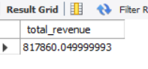
- Find the average order value of all customers orders .
SELECT
SUM(total_price) * 1.0 / COUNT(DISTINCT order_id) AS average_order_value
FROM pizza_data;
RESULT-
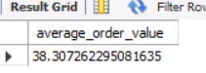
- Calculate the total number of pizzas sold .
SELECT SUM(quantity) AS total_pizzas_sold
FROM pizza_data;
RESULT-
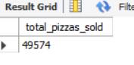
- Determine the total number of orders placed .
SELECT COUNT(DISTINCT order_id) AS total_orders
FROM pizza_data;
RESULT-
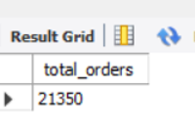
- Calculate the average number of pizzas sold per order.
SELECT
CAST(SUM(quantity) AS DECIMAL(10,2)) /
COUNT(DISTINCT order_id) AS avg_pizzas_per_order
FROM pizza_data;
RESULT-
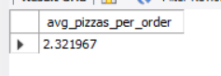
- Analyze the daily trend of total orders, showing the number of orders placed each day.
SELECT
HOUR(order_time) AS order_hour,
COUNT(DISTINCT order_id) AS orders_per_hour
FROM pizza_data
GROUP BY HOUR(order_time)
ORDER BY order_hour;
RESULT-
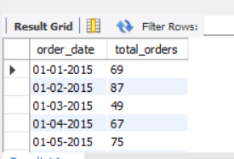
- Analyze the hourly trend of orders, showing the number of orders placed during each hour of the day.
SELECT
HOUR(order_time) AS order_hour,
COUNT(DISTINCT order_id) AS orders_per_hour
FROM pizza_data
GROUP BY HOUR(order_time)
ORDER BY order_hour;
RESULT-
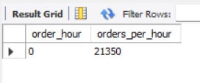
- Calculate the percentage contribution of sales by each pizza category.
SELECT
pizza_category,
SUM(total_price) AS total_sales,
ROUND(
SUM(total_price) * 100.0 /
( SELECT SUM(total_price) FROM pizza_data),
2
) AS sales_percentage
FROM pizza_data
GROUP BY pizza_category
ORDER BY sales_percentage DESC;

RESULT-
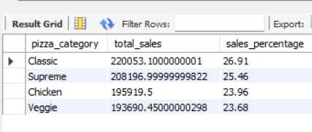

- Find the total number of pizzas sold for each pizzas category.
SELECT pizza_category,
SUM(quantity) AS total_pizzas_sold
FROM pizza_data
GROUP BY pizza_category
ORDER BY total_pizzas_sold DESC;
RESULT-
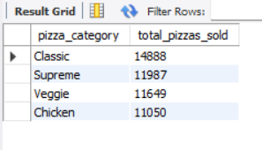
- Top 5 best selling pizzas based on total total quantity sold .
SELECT
pizza_name,
SUM(quantity) AS total_quantity_sold
FROM pizza_data
GROUP BY pizza_name
ORDER BY total_quantity_sold DESC
LIMIT 5;
RESULT-

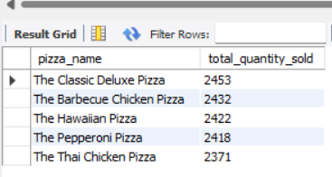
- Bottom 5 least selling pizzas based on total quantity sold.
SELECT
pizza_name,
SUM(quantity) AS total_quantity_sold
FROM pizza_data
GROUP BY pizza_name
ORDER BY total_quantity_sold ASC
LIMIT 5;
RESULT-

