Pratical-MST

Student Name: Pranav Chauhan UID: 24BCY70004
Branch: BE CSE (cyber security) Section/Group: 24AIT_KRG-G2
Semester: 5th Date of Performance: 28/09/2026
Subject Name: ADBMS Subject Code:24CSP-333

Q.1)
--Pranav Chauhan
select d.dept_name , e.emp_name , e.salary
from department d
join employee e
on d.dept_id = e.dept_id
where e.salary>(
SELECT AVG(ee.salary)
FROM employee ee
WHERE ee.dept_id = e.dept_id
)
AND e.dept_id IN (
SELECT dept_id
FROM employee
GROUP BY dept_id
HAVING COUNT(*) >= 3
);

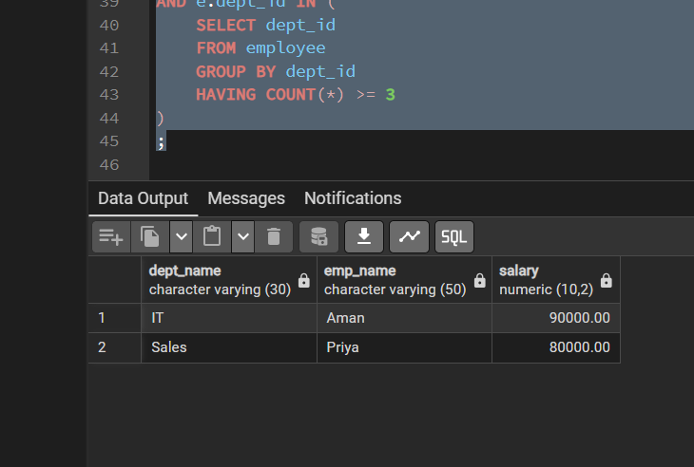

Q.2)
create or replace function bank_tringer()
returns trigger
language plpgsql
as $$
begin

insert into customer_audit (customer_id, customer_name, action, action_time)
value()

END;
$$;
