Q.1) 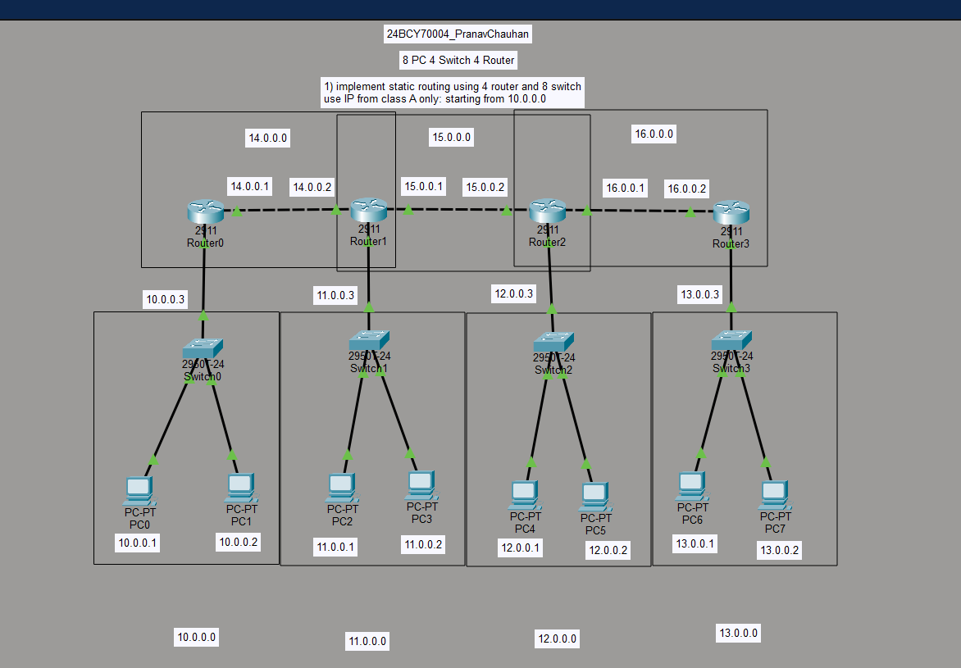

ANS: Steps:
- Get 8 pc , 4 switchs and 4 router
- Connect pc 1 and 2 to switch 1 (using straight cable)
- Connect pc 3 and 4 to switch 2(using straight cable)
- Connect pc 5 and 6 to switch 3(using straight cable)
- Connect pc 7 and 8 to switch 4(using straight cable)
- Connect router 1 to 2 (using cross cable)
- Connect router 2 to 3 (using cross cable)
- Connect router 3 to 4 (using cross cable)
- Assign ip to PCs keep it in class a ( 10.0.0.0 – 13.0.0.0 networks) and gateway
- In each router assign ip to the gigabitEnternet (make 1 network of 2 routers )
- Network for router ( 14.0.0.0 , 15.0.0.0 and 16.0.0.0) also assign ip to its interfaces according to network
- Network for switch (10.0.0.0 , 11.0.0.0 , 12.0.0.0 and 13.0.0.0)
- Now for each router go to static
  - First input = what network it is going to
  - Send input = subnetmask ( 255.0.0.0 for all)
  - 3rd input = through which port ( next router port ip assigen)
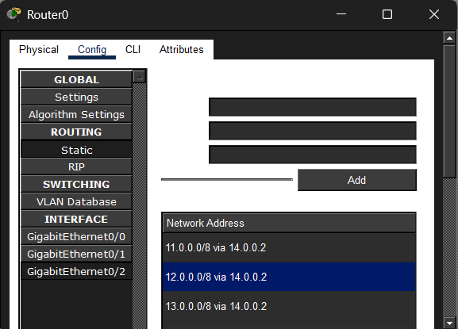
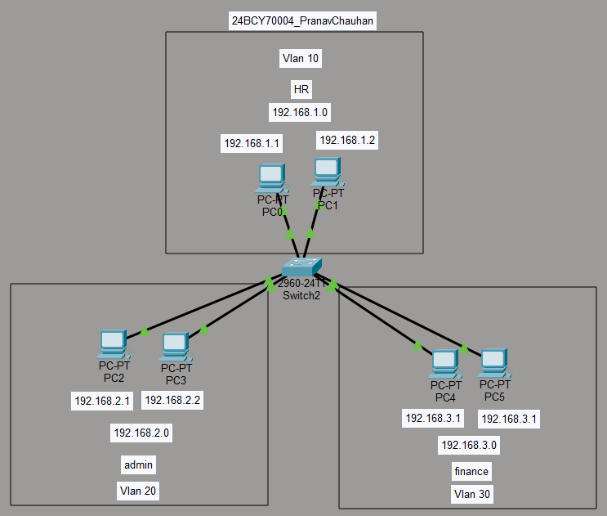

Q.2)
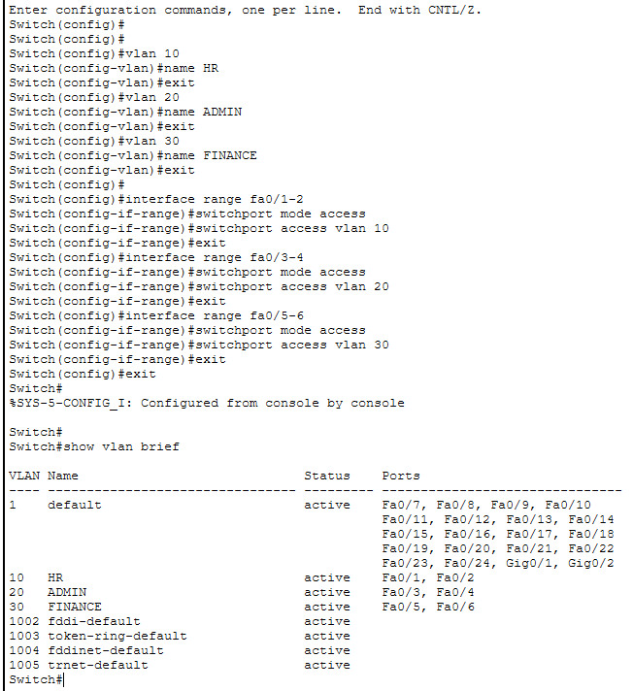
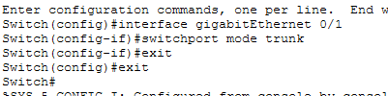

Steps:
- Get 1 switch
- Get 6 PCs
- Assign each pc ip according to its network
- Let pc 1-2 is HR
- Pc 3-4 is ADMin
- Pc 5-6 is Finance
- Connect:
  - fa0/1 & fa0/2 to HR PCs
  - fa0/3 & fa0/2 to ADMIN PCs
  - fa0/5 & fa0/6 to Finance PCs
- Now open switch and then CLI and run cmds given in the screenshots

