BOOLEAN ALGEBRA

AND $⋅$ LAWS

$$A⋅0=0$$

$$A⋅1=A$$

$$A⋅A=A$$

$$A⋅\bar{A}=0$$

OR + LAWS

$$A+0=A$$

$$A+1=1$$

$$A+\bar{A}=1$$

$$A+A=A$$

DE MORGAN’S THEOREM

$$\bar{A+B}=\bar{A}⋅\bar{B}$$

$$\bar{A⋅B}=\bar{A}+\bar{B}$$

NOTE THIS

$$C+AD=\left(C+A\right)⋅\left(C+D\right)$$

PROPERTIES OF BOOLEAN ALGEBRA

Commutative Law:

$$A+B=B+A$$

$$A⋅B=B⋅A$$

Associative Law

$$\left(A+B\right)+C=A+\left(B+C\right)$$

$$A\left(BCD\right)=\left(ABC\right)D$$

Distributive Law

$$A\left(B+C\right)=AB+AC$$

QUESTIONS

1. $Y=\bar{A}B+A\bar{B}+AB$

Solution

$$Y=\bar{A}B+A\left(\bar{B}+B\right)$$

$$Y=\bar{A}B+A$$

$$Y=\left(\bar{A}+A\right)\left(B+A\right)$$

$$Y=1\left(B+A\right)$$

$$Y=A+B$$

2. $Y=\bar{A}\bar{B}C+\bar{A}B\bar{C}+A\bar{B}\bar{C}+A\bar{B}C$

$$Y=\bar{B}C\left(\bar{A}+A\right)+\bar{A}B\bar{C}+A\bar{B}\bar{C}$$

$$Y=\bar{B}C+\bar{A}B\bar{C}+A\bar{B}\bar{C}$$

$$Y=\bar{B}\left(C+A\bar{C}\right)+\bar{A}B\bar{C}$$

$$Y=\bar{B}\left[\left(C+A\right)\left(C+\bar{C}\right)\right]+\bar{A}B\bar{C}$$

$$Y=\bar{B}\left(C+A\right)+\bar{A}B\bar{C}$$

$$Y=\bar{B}C+A\bar{B}+\bar{A}B\bar{C}$$

That’s the end of that question

3. $F=\bar{Y}\bar{Z}+\bar{W}\bar{X}\bar{Z}+\bar{W}\bar{X}\bar{Y}\bar{Z}+Y\bar{Z}$

$$F=\bar{Y}\bar{Z}\left(1+\bar{W}\bar{X}\right)+\bar{W}\bar{X}\bar{Z}+Y\bar{Z}$$

$$F=\bar{Y}\bar{Z}+\bar{W}\bar{X}\bar{Z}+Y\bar{Z}$$

$$F=\bar{Z}\left(\bar{Y}+Y\right)+\bar{W}\bar{X}\bar{Z}$$

$$F=\bar{Z}+\bar{W}\bar{X}\bar{Z}$$

$$F=\bar{Z}\left(1+\bar{W}\bar{X}\right)$$

$$F=\bar{Z}\left(1\right)$$

$$F=\bar{Z}$$

LOGIC GATES

Basic Gates → And, Or, Not

AND.

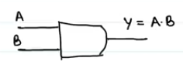

OR

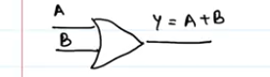

NOT

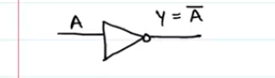

EXOR / XOR → Exclusive Or

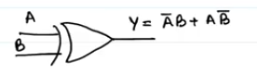

$$A⊕B=\bar{A}B+A\bar{B}$$

You’ll notice that when you make the truth table of an exor gate, you’ll notice that

If inputs are same, output = 0

If inputs are different, output = 1

EXNOR, XNOR. This is the opposite of the exor gate

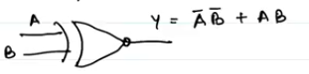

$$\overline{A⊕B}=\overline{\bar{A}B+A\bar{B}}$$

On solving with De Morgan’s theorem, you’ll get

$$\overline{A⊕B}=\bar{A}\bar{B}+AB$$

For the truth that if both inputs are the same, the output will be 1

If the inputs are not the same, output is 0.

UNIVERSAL GATES

These are the NAND and NOR gates.

These are called universal gates because they can be used to construct any other gate as will be seen below

NAND GATE

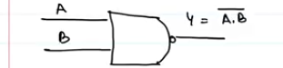

NOR GATE

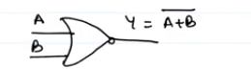

CONSTRUCTION OF GATES USING NAND GATE

AND GATE

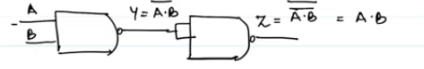

OR GATE BY NAND GATE

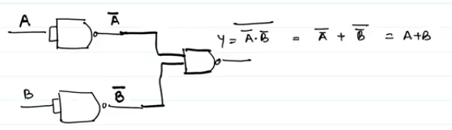

NOT GATE BY NAND GATE

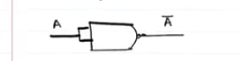

CONSTRUCTING THE GATES USING THE NOR GATE

AND GATE BY NOR GATE

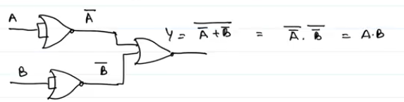

OR GATE WITH NOR GATE

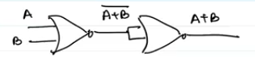

NOT GATE WITH NOR GATE



So those are the gates and solvings