**CHEMICAL KINETICS**

This is the branch of physical chemistry that studies the rate of chemical reactions. The rate of a chemical reaction is defined as the speed at which a reaction proceeds. Different reactions occur at different rates. Some reactions are very fast that may occur within micro seconds. Other reactions may also be very slow that they may occur for months or years. Examples of fast reactions include explosions, combustion, neutralization and collision etc. Examples of slow reactions include decaying, fermentation, rusting, oxidation of diamond and organic reactions.

The rate of a reaction is also defined as the rate of disappearance of the reactant or the rate of appearance of the product. In terms of concentration (volume), the rate of a reaction is defined as the decrease in the concentration of the reactant or an increase in concentration (amount) of the product.

$$A+B→C+D$$

**COLLISION THEORY**

This theory assumes that

There must be collision between the reactant particles for a chemical reaction to occur. There are many of such collisions but a small fraction of them lead to the chemical reaction. The small fraction of collision is called EFFECTIVE COLLISION

The minimum amount of energy in which the reactant particles must possess for a chemical reaction to occur is known as the ACTIVATION ENERGY. This means for a chemical reaction to take place, the energy of the colliding particles must be greater than the activation energy

FACTORS THAT AFFECT THE RATE OF CHEMICAL REACTIONS

These are the factors that determine the speed at which a reaction proceeds

Concentration

Temperature

Catalyst

Surface Area Exposed

Light

Nature of the reactants

Pressure for gaseous reactions

CONCENTRATION OF THE REACTANTS

An increase in the concentration of the reactant increases the frequency of collision which leads to a rapid increase in the reaction rate. This means that reactions occur faster at higher concentration that at a lower concentration. For example, conc. H2SO4 liberates hydrogen faster than dilute H2SO4

The SI unit of a rate of a reaction is $mol{dm}^{−3}s^{−1}$ which is actually the $\frac{concentraion}{time}$.

RATE LAW

This law states that

The rate of a chemical reaction is directly proportional to the concentration of the reactants raised to some powers

$$mA+nB→pC+qD$$

From rate law

$$ConcentrationofA=\left[A\right]$$

$$R∝{\left[A\right]}^{x}{\left[B\right]}^{y}$$

$$R=k{\left[A\right]}^{x}{\left[B\right]}^{y}$$

Here, x is the order of the reaction with respect to A

And y is the order of the order of the reaction with respect to B

Also, $x+y$ is the overall order of the reaction and this determines the rate of the reaction.

Also, $m+n$ is the molecularity of the reaction. Molecularity of a reaction is defined as the addition of the coefficient of the reactions

The molecularity of a reaction is always a whole number and it is determined stoichiometrically

The order of a reaction can either be zero, fraction, percentage or whole number and it is determined experimentally

From

$$R=k{\left[A\right]}^{x}{\left[B\right]}^{y}$$

Here, k in the equation above is the specific rate constant. Its SI unit depends on the overall order of the reaction

$$SIunitofrate=moldm^{−3}s^{−1}$$

Find the SI unit of the specific rate constant of a zero order reaction

$$R∝C^{0}$$

$$R=kC^{0}$$

$$k=\frac{R}{C^{0}}$$

$$k=\frac{mol{dm}^{−3}s^{−1}}{1}$$

The SI unit of k for a zero order reaction is $moldm^{−3}s^{−1}$

The SI unit of k for a first order reaction is

$$R=kC^{1}$$

$$k=\frac{R}{C^{1}}$$

$$k=\frac{moldm^{−3}s^{−1}}{moldm^{−3}}$$

$$k=s^{−1}$$

The SI unit of k for a second order reaction is

$$R=kC^{2}$$

$$k=\frac{R}{C^{2}}$$

$$k=\frac{moldm^{−3}s^{−1}}{{\left(moldm^{−3}\right)}^{2}}$$

$$k=mol^{−1}dm^{3}s^{−1}$$

The SI unit of k for a half order reaction is:

$$R=kC^{\frac{1}{2}}$$

$$k=\frac{R}{C^{\frac{1}{2}}}$$

$$k=\frac{moldm^{−3}s^{−1}}{{\left(moldm^{−3}\right)}^{\frac{1}{2}}}$$

$$k=\frac{moldm^{−3}s^{−1}}{mol^{\frac{1}{2}}dm^{\frac{−3}{2}}}$$

$$k=mol×mol^{\frac{−1}{2}}×dm^{−3}×dm^{\frac{3}{2}}×s^{−1}$$

$$k=mol^{\frac{1}{2}}dm^{\frac{−3}{2}}s^{−1}$$

The SI unit of k for a 0.125 order reaction is mol7/8dm-21/8s-1

The SI unit of k for a 75% order reaction is mol1/4dm-3/4s-1

RATE CURVE

This is the curve of concentration against time. The rate curve actually depends on the order of the reaction

For zero order, parallel to the x axis

For first order, direct graph

For second order , direct then curve to the left.

RADIO ACTIVE REACTIONS

It should be noted that all radioactive decay follow the first order reactions

$$R∝C^{1}$$

$$R=kC$$

From calculus notation

$$\frac{dc}{−dt}=kC$$

$$\frac{dC}{C}=−kdt$$

$$\frac{1}{C}dC=−kdt$$

On integrating both sides

$$\int_{C_{o}}^{C}{\frac{1}{C}dC}=−k\int_{0}^{t}{dt}$$

$${\left[lnC\right]}_{C_{o}}^{C}=−k{\left[t\right]}_{0}^{t}$$

$$InC−C_{o}=−k\left(t−0\right)$$

$$InC−C_{o}=−kt$$

$$In\left(\frac{C}{C_{o}}\right)=−kt$$

At half life

$$C=\frac{C_{o}}{2}∧t=t_{\frac{1}{2}}$$

$$\left(\frac{\left(\frac{C_{o}}{2}\right)}{C_{o}}\right)=−kt_{\frac{1}{2}}$$

$$\left[\frac{C_{o}}{2}×\frac{1}{C_{o}}\right]=−kt_{\frac{1}{2}}$$

$$\left(\frac{1}{2}\right)=−kt_{\frac{1}{2}}$$

$$−0.693=−kt_{\frac{1}{2}}$$

$$0.693=kt_{\frac{1}{2}}$$

$$t_{\frac{1}{2}}=\frac{0.693}{k}$$

K in the equation above is called the decay constant

TEMPERATURE

Most reversible reactions at ordinary temperatures take months or years to attain equilibrium. However, at higher temperature, equilibrium can be achieved within micro seconds. An increase in temperature increases the frequency of collision and change the content of the reaction which leads to a rapid increase in the reaction rate. This means that reactions occur faster at higher temperatures. Generally, for every degree rise is temperature, the reaction rate doubles. Temperature is defined as the measure of the average kinetic energy of a substance

Arrhenius studied the effect of temperature on the reaction rate

From Arrhenius,

$$k=Ae^{\frac{−E}{Rt}}$$

K is the specific rate constant

A is the Arrhenius constant

E is the activation energy

R is the molar gas constant

T is the absolute temperature

From

$$k=Ae^{\frac{−E}{Rt}}$$

Adding In to both sides,

$$ln\left(k\right)=\left(Ae^{\frac{−E}{Rt}}\right)$$

$$ln\left(k\right)=ln\left(A\right)+ln\left(e^{\frac{−E}{Rt}}\right)$$

$$ln\left(k\right)=ln\left(A\right)−\frac{E}{Rt}ln\left(e\right)$$

$$ln\left(k\right)=ln\left(A\right)−\frac{E}{Rt}×1$$

$$ln\left(k\right)=ln\left(A\right)−\frac{E}{Rt}$$

$$ln\left(k\right)=\frac{−E}{Rt}+ln\left(A\right)$$

$$ln\left(k\right)=\frac{−E}{R}∙\frac{1}{t}+ln\left(A\right)$$

In a graph of $ln\left(k\right)$ against $\frac{1}{t}$, the y intercept is $ln\left(A\right)$ while the slope is $\frac{–E}{R}$

CATALYST

A catalyst is a substance that alters the rate of a reaction but remains chemically and quantitatively unchanged at the end of the reaction. A reaction that involves a catalyst is called a catalysis or a catalytic reaction. Substances that improve the efficiency of a catalyst are called promoters while substances that decrease the efficiency of a catalyst are called Inhibitors or enzyme poison.

The basic function of a catalyst in a reaction is to change (or increase) the rate of a reaction by lowering the activation energy

GENERAL CHARACTERISTICS OF CATALYSTS

They alter the rate of reactions

They remain unchanged at the end of the reaction

They are specific in action

They also do not affect the product formed

They have no effect on the position of equilibrium

The efficiency of a solid catalyst can be improved by the increase of its surface area.

SURFACE AREA EXPOSED

An increase in the surface area of the reactant increases the frequency of collision which leads to a rapid increase in the reaction rate. For example, powdered marble (which has a large surface area because its particles are freer and can easily interact) liberates $CO_{2}$ faster than when solid marble when it combines with $HCl$ because of the increase in its surface area. Similarly, sore dust particles of a particular wood burn faster than a log of wood of the same mass.

LIGHT

Some reactions are influenced by the presence of light and they are known as PHOTOCATALYTIC reactions. Examples include

The reaction between hydrogen and chlorine is spontaneous under a bright sunlight but slower under a diffused light

$$H_{2}+Cl_{2}→_{sunlight}2HCl$$

Photosynthesis

$$6CO_{2}+6H_{2}O→C_{6}H_{12}O_{6}+6O_{2}$$

Decomposition of hydrogen peroxide

$$2H_{2}O_{2}→2H_{2}O+O_{2}$$

Substitution reaction between methane and chlorine

$$CH_{4}+Cl_{2}→CH_{2}Cl_{2}+H_{2}$$

PHYSICAL NATURE OF THE REACTANTS

The physical nature of the reactants also plays a significant role in determining the speed of a reaction. For example, when gold is dropped into a solution of HCl, there is no evidence of any reaction

When Iron is dropped into HCl, there is a slow evolution of Hydrogen gas

When zinc is dropped into a solution of HCl, there is a fast evidence of a reaction and hydrogen gas is evolved quickly

PRESSURE

Pressure affects only gaseous reactions. Generally, an increase in pressure increases the frequency of collision which leads to the rapid increase in the reaction rate

For forward reaction,

$$ActivationEnergy=EnergyofActivatedComplex−energyofreactants$$

$$ActivationEnergy=Activatedcomplex\left(highestpoint\right)−reactant$$

$$E=C−r$$

For a backward reaction, the products are now the reactants

$$ActivationEnergy=ActivatedComplex−products$$

$$E=C−p$$

QUESTIONS

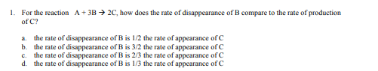

Answer: B

my answer is c



Answer: B

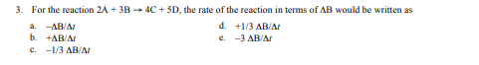

Answer: C

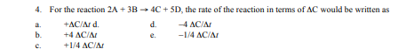

Answer: C

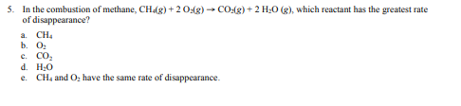

Answer: B

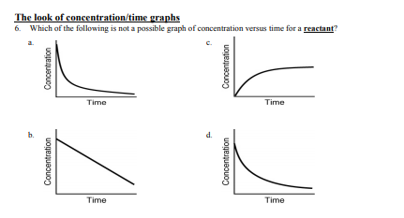

Answer: C

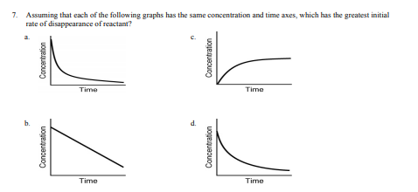

A

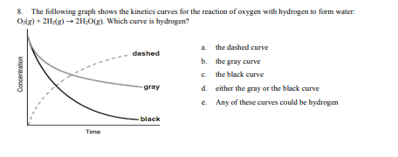

C

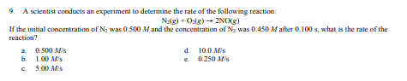

A

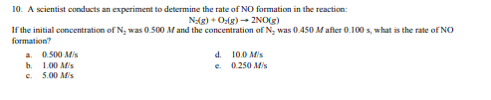

B

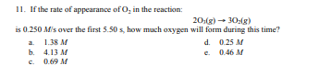

A

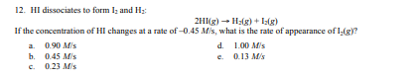

C

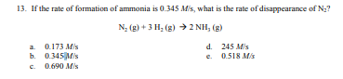

A

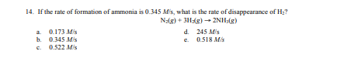

C or E

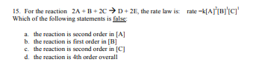

C

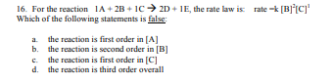

A

Note the following formulae

$$Rateofareaction=rateofdisappearanceofareactant=rateofappearanceofaproduct$$

Given the following equation:

$$2N_{2}O_{5}→4NO_{2}+O_{2}$$

$$Rateofappearanceofoxygen=\frac{FinalConc.−InitialConc.}{Finaltime−InitialTime}$$

$$RateofdisappearanceofN_{2}O_{5}=\frac{FinalConc.−InitialConc.}{Finaltime−InitialTime}$$

The value of the above is going to be negative since it is going to decrease in concentration. To make it positive, a negative sign is put infront of it

$$\frac{−Δ\left[N_{2}O_{5}\right]}{Δt}$$

To be able to cook

Given the equation

$$mA+nB→pC+qD$$

$$\frac{−1}{m}\frac{Δ\left[A\right]}{Δt}=\frac{−1}{n}\frac{Δ\left[B\right]}{Δt}=\frac{1}{p}\frac{Δ\left[C\right]}{Δt}=\frac{1}{q}\frac{Δ\left[D\right]}{Δt}$$

The concentration per time for each element is the rate of appearance or rate of disappearance of the element.

$$2N_{2}O_{5}→4NO_{2}+O_{2}$$

If the rate of formation of $NO_{2}=0.0072molL^{−1}$

$$\frac{1}{4}\frac{Δ\left[NO_{2}\right]}{Δt}=\frac{Δ\left[O_{2}\right]}{Δt}$$

$$\frac{1}{4}\left[0.0072\right]=\frac{Δ\left[O_{2}\right]}{Δt}$$

$$\frac{Δ\left[O_{2}\right]}{Δt}=0.0018$$