TABLE OF CONTENT

Functions

Limits

Continuity and Differentiability

Differentiation:

* Differentiation by first principle
* Differentiating algebraic, exponential, logarithmic functions
* Chain rule, Product rule
* Quotient rule
* Logarithmic Differentiation
* Derivative of inverse trigonometric functions
* L’hopital rule
* Partial Derivatives
* Differentiation in rates
* Maclaurin and Taylor Series
* Motion Problems
* Minimum and Maximum curves
* Curve sketching and sketch fittings
* Series
* Mean Value Theorems

**Text Books:**

Online materials

K.A. Stroud

John Bird

**NOTE THE FOLLOWING:**

Something is said to be defined when it actually has a value

**FUNCTIONS:**

A function could be defined as a relationship of an input x and an output y

, y is the output of the function with x as the input

NB:

1. For it to be a function for any value of x you must get one output
2. Input is the domain of the function while the output is the range

A function represented by “f”, f(x, y)

is an independent variable

is a dependent variable

is interpreted as y is a function of x. is called the value of the function of x

**TEST FOR FUNCTIONS**

1. The vertical line test

In the graph of a function if a straight line is drawn on a value of x and it touches only one part of the graph, then the graph is a function but if not it is not a function. Even if the graph touches one point at zero as long as in any other point of x on the graph, we get two or more values of y, then the expression is not a function

This, is not a function and it does not express a rule that is a function

However,

All the possible input values of x are called the domain. The complete collection of numbers y that correspond to the numbers in the domain is called the range or co-domain of the function.

**DIFFERENCE BETWEEN AN IMAGE AND A VALUE OF A FUNCTION**

The image is the set of all output values it may produce. There can also be an inverse image which is called the pre-image.

4 is the value and also the image since there is only one value in the set.

Example

, then

The value of this function is 0 or this function of x, f(x) is 0

**FINDING THE DOMAINS AND RANGES OF FUNCTIONS**

Consider the function f(x) = 2x – 7. What is the domain (list of all possible values that can be put into a function.

For a linear function like the one above, the domain is negative infinity to positive infinity. This domain is also the same for quadratic equations and polynomial functions

Note the following:

1. The domain of a linear, quadratic or a polynomial is (-infinity, infinity)
2. For a fractional function, the denominator must not equal zero.
3. For a radical (or root) function, the value in the root must be greater than 0
4. If , and , and , then the range of the function will be i.e. you will have to combine the maximum and minimum of the two.

y = , the domain is and the range is 0 <= y <= 1

**EXAMPLES OF FUNCTIONS**

1. Linear functions i.e. the power of x is 1
2. Quadratic functions i.e. the highest power of
3. Cubic
4. Radical or square root function
5. Logarithmic function: This function increases at a decreasing rate
6. Exponential function: This increases at an exponential rate.
7. Trigonometric function (periodic functions; they repeat forever)
8. Absolute value function
9. Rational functions e.g. y = 1/x. The function has a variable in the bottom
10. Polynomial functions: Their graphs vary
11. Multi-variable functions:

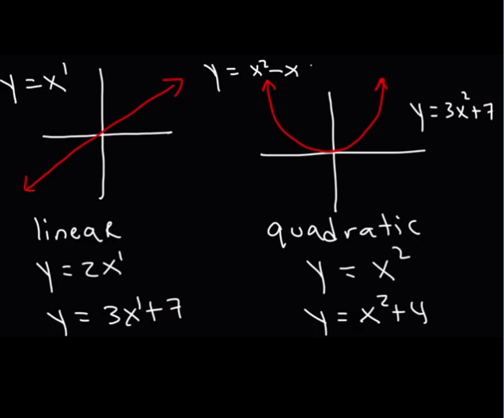

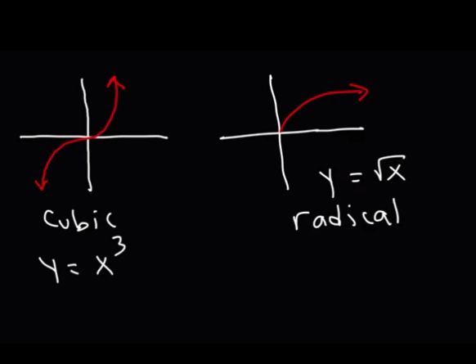

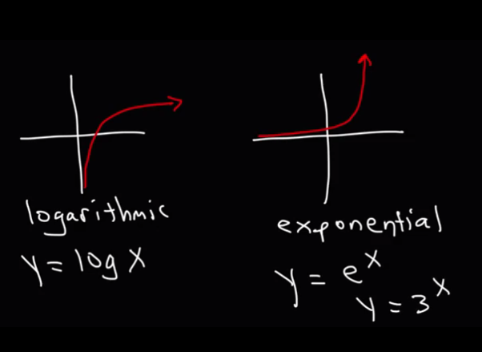

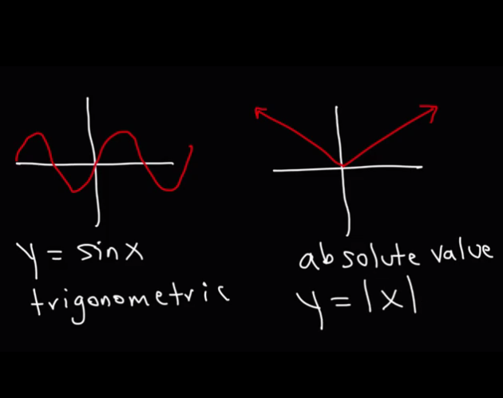

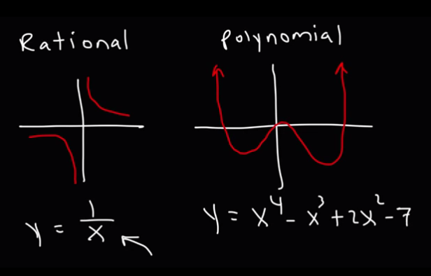

**COMPOSITE FUNCTIONS**

A composite function is a function of a function. A chain of functions can be built when the output of a function forms the input of another function. E.g. and and

Then h is composed of two functions f and g. It is also said is h is a composition of f and g

H = f o g

Note that the order of the composition matters.

F o g is not the same as g o f

Find

Find the functions that composed into

Ans:

Find the functions that composed into

Ans:

To find the inverse of a composite function, we find the inverse of each of the functions

**PERIOD OF A FUNCTION**

The period of a function is an input that is the difference for corresponding repeated values of the function

in radians

The function f(x) = sin x is periodic with the period 2pie because the graph consists of a wave patterns of widths of 2pie

**EVEN AND ODD FUNCTIONS**

For a function, if

then the function is even but if then the function is odd and if then it is neither even nor odd

E.g.

Looking at the function

Since, the function is even

Graphically,

If the shape on the left is equal to the shape on the right then it is even. If the symmetry of the graph is at the origin then it is odd. Odd functions look like inverted images of each other.

For a circular graph, this is not a function even though it passes the even and odd tests but it doesn’t pass the vertical line test.

**EVEN AND ODD PART OF A FUNCTION**

The even part of a function while the odd part is

The exponential function is neither even nor odd but it can be expressed in an even and odd part of a function

**CONTINUITY AND DIFFERENTIABILITY**

Note the following:

1. A differentiable function is one that can be differentiated i.e. the derivative can be found
2. Not all functions that are differentiable might always be continuous.
3. Continuity refers to whether a function is continuous or not
4. Differentiability refers to whether the derivative of a function

is continuous

**HEAVINESS OF A FUNCTION**

The heaviness refers to whether the numerator or the denominator of a function has the highest power of x.

**CONTINUITY**

**CONTINUOUS FUNCTION**

1. A function can be said to be continuous if its domain is an interval like a < x < b and it is continuous at every point of the interval i.e. for every value in the interval, the function is continuous

2. For a continuous function, when a graph is drawn, there is no break in contact between the points.

The graph of a continuous function is a graph that does not break. All the points join. However in a discontinuous function, there is no connection between some of the points

The function f(X) is continuous at “a” if

For example, if we have a function f(x) = x + 2.

Let a = 2,

We sill see that the limit has the same answer as when the parameter of the function is a .

Since both are equal, we have a continuous function

3. A continuous function must have a limit and the function/limit must exist

4. It must have a value

5. It must be differentiable.

6. All of the important functions used in calculus and analysis are continuous except at isolated points. Such points are called points of discontinuity.

7. The point of discontinuity is the point on the function interval that makes the function wrong, undefined or bad.

8. This point is also known to be isolated

**DISCONTINUITY**

Discontinuity is a point in the graph of the function where two parts of the graph do not meet. It is a part of the function where there is not function result.

There are three types of discontinuity:

1. A jump discontinuity: is one in which at a certain point “c” the right part and the left part of the graph do not connect and they start on different parts of the y axis.

One major thing to note is that, this type of discontinuity is usually gotten when the **limit of the function does not exist**.

The right hand limit and the left hand limit both exist but these two limits are not equal meaning that as x approaches the definite value for which we are finding the left hand and the right hand does not exist. In mathematical terms,

If , then

The size of the jump is the distance between the left hand and the right hand limit.

Though jump discontinuities are not common functions, they occur frequently in engineering.

For example in

1. square waves in electrical engineering
2. the sudden discharge of capacitors
3. A hole or a removable discontinuity: is a discontinuity in which there is no major connection but they are joined together. A hole is a removable discontinuity.

One thing to remember is that a hole occurs when the function returns **indeterminate**.

In a removable discontinuity 𝑒𝑥𝑖𝑠𝑡𝑠exists but

This may be because is undefined, or because has the “wrong” value.

The discontinuity can be removed by changing the definition of f(x) at “a” so that its new value there will have a value for.

For example, if , we know that if we do

, we will get .

When you draw the graph of the function, you’ll notice that there is a break in the flow of the graph but the graph can be joined together in some way.

We see that at f(a) which is f(2) we get an indeterminate value or wrong value. However if we redefine the function, we get ,

If we find the limit, as x approaches a = 2,

We will see that

We will also see that the graph will now become continuous and there will be do break or hole in the graph i.e. the hole in the graph becomes filled in

1. Infinite discontinuity: The right part of the point (of “x”) where the discontinuity happens either goes to positive or negative infinity while the left part goes the other way. If the right goes to positive infinity then the left will go to negative infinity

This type of continuity is usually gotten at the point -of x- where the function returns **undefined**. When the function is undefined, a **vertical asymptote** is usually there.Therefore, there is a point of discontinuity at a vertical asymptote.

**What is a vertical asymptote**? For example if we have a function , We know that x cannot equal 2 because we will get undefined so at the point where x = 2, y = undefined and at that point, the graph is a vertical (dotted) line and that line is called the asymptote. So it is said that at x = 2, there is a vertical asymptote. And at that point there is also a discontinuity and the function is not continuous at that point.

**DIFFERENTIABILITY**

Continuity tells us whether a function is continuous or discontinuous. Differentiability on the other hand tells us whether the first derivative of a function is continuous or discontinuous

On a graph, if the graph is smooth, there are no breaks and there is no sharp turn, then the function of the graph is differentiable for any value of x.

If the function is smooth and there are no breaks on the graph but there is a sharp turn (like a v shape), the function of that graph is continuous; however, there is a high chance that it may not be differentiable at the point of that sharp turn.

If the graph starts at “a” and ends at “b”, then the first derivative is continuous on the interval from “a” to “b”

If we look at the function,

You will see that the graph is a V-shaped graph and the slope changes radically from -1 to 1. The slope changes at 0 but there is no slope at 0. That means it is not differentiable at x = 0 and the first derivative is not continuous at x = o

Note that the function itself is continuous because there are no breaks in the graph but is the first derivative continuous?

EXAMPLES:

1. Check if the function is continuous. It is not continuous because its domain is not an interval and it has a single point of discontinuity at x = 0 and at that point there is an infinite discontinuity. Solve and check it out and also check out its differentiability
2. The function
3. The function

The above function is represented as

What this means is that the value of the function is +x when and it is –x when and the value of the function is 0 when the value of x is equal to 0

When we differentiate the values of the functions, we get the above.

Note that we don’t know the derivative (or slope) at x = 0 and we do not have a derivative value at that point. Of course the derivative of 0 but looking at the graph of the main function, we will see that there is no slope of that graph at x = 0

If we plot a graph for the , we will get a jumping . discontinuity.

That means the derivative is not continuous at 0

1. Consider the piece wise function

First let’s check the continuity. For a function to be continuous, we have to check if the left hand and right hand limits (as x approaches 0) are equal

First, what is the limit as x approaches 0 from the left. Since we are approaching from the left, we have to use the equation which is associated with the condition of x < 0. So we use the expression

Note that we used the value in the condition and we didn’t use the condition i.e. we didn’t use a value less than 0 instead we used 0.

Since the left side and the right side are not equal,

That also means the function is not continuous at x = 0and that means the function is not differentiable at x = 0.

To plot the graph, first, we plot the graph of on one side and then we plot a graph of on another side. Now we take the left side of the graph since it goes with the condition and we also take the right side of the graph since it is with the condition. Then we join them together

One way to easily do this is to plug in the values in the given condition into the function expressions and if the values of these function expressions are not the same, then we have a discontinuous function

1. Take a look at the function

After you’ve found the limit, check if the function exists i.e. from the above you look for which of the conditions has an equal to sign. Which in this case is the first one; that means, to check if the function exists, we say:

And since the condition says , the input of the function has to be 1

Since

Then the function exists and it is continuous too at x = 1.

Here, the function is continuous at x = 1 but the first derivative is not continuous at x = 1. Therefore, the function is not differentiable at x = 1.

1. Take a look at this

The function that will be used to test if the function exists will be the second one because that is where the equal to sign exists

, a and b are constants hence find all values of a and b for which is differentiable

For it to be differentiable, it has to be first continuous

For it to be differentiable, has to be continuous

Find all values of the constants a and b for which the function is defined by the function below will be differentiable

**ASYMTOTES**

An asymptote is a point on the graph where the graph never touches.

There are three major types of asymptotes.

1. The vertical asymptote
2. The horizontal
3. The slant

Explanations:

1. Vertical asymptote: This is occurs at the point on the x-axis or a point on the domain where the function of the graph returns undefined.

Equation of the vertical asymptote

1. To find the horizontal asymptote, we need to know whether the equation is top heavy, bottom heavy or the same.

The above equation is bottom heavy

To find the horizontal asymptote, we find the limit as x approaches infinity

Note the following:

1. If an equation is bottom heavy, the horizontal asymptote is 0.
2. If the degree of both numerator and denominator are the same, divide the coeficcients to find the horizontal asymptote
3. If the graph is top heavy, there is no horizontal asymptote
4. To know how the graph looks like, you can just plug in test points.
5. Slant asymptotes. This occurs when the highest power of the numerator is greater than the highest power of the denominator by just 1.

The slant asymptote is usually an equation of a straight line.

The equation of the slant asymptote can be gotten by dividing the numerator by the denominator using long division.

The equation gotten back will be the equation of the asymptote.

But there’s a hole at 2

Domain cannot include -3 and 2

Since the power of the numerator is greater than the power the denominator by just 1, there will be an oblique or slant asymptote

Therefore, the equation of the slant asymptote is given as

**LIMITS**

If we have a function and we say we want to find the limit as x tends to c, written as , what this means is that as we input values either from the right hand side or the left hand side of “c” and we keep getting closer to “c”, the value of that limit will return values closer and closer to the output of the function.

Take for example,

If we input 2 into the function, we get our answer as 0/0 which is indeterminate

If we use a value close to 2, let’s say 2.1, the value of the function will be 4.1

Also, if we use another value, even closer to 2, let’s say 2.01, we will get 4.01 as our answer

So we see that as we get closer to 2, the limit gets closer to 4. We can therefore say as the limit approaches 2, the function of the limit is equal to 4

Rules of limits

If and

1. L’hopital’s rule: This states that when the limit of is **indeterminate**, under certain conditions, it can be obtained by evaluating the limit of the quotient of the derivatives of f and g i.e. . If the result is indeterminate, the procedure is repeated.

Examples

**ONE-SIDED LIMITS**

One sided limits are limits where x approaches a value “a” either from the right of “a” or the left of “a” . This makes the value of x either less than or greater than the value it approaches which in this case is “a”.

**RIGHT HAND LIMITS:**

These are limits that come from the right i.e. they approach the limit from the right thereby making them greater than the limit

This means x approaches “a” from the positive side. Notice the plus (+) sign on a. That means when using values for the limit, we use values to the right of a and . Therefore, x comes from the right of “a”

**LEFT HAND LIMITS**

**EXAMPLES**

**SOLUTION**

Taking a look at the first limit,

We see that it is a right handed limit.

So x approaches 1 from the right; we therefore use values greater than 1 to test.

Let

When x = 1.1 we get a complex number

Taking a look at the negative side,

When x = 0.9

When x = 0.99, y = 0.1411

When x = 0.999, y = 0.0447

We see that as the value of x increases, the value of y decreases and we also see that as the value of x moves closer to one from the left, we keep getting values closer to 0 which was the value of the limit

EXAMPLE 2:

A simple way to do this is as follows

This gives the values as follows:

These two values are the final results of our function limits.

The other way of doing it is by using the left hand and right hand limits:

EXAMPLE 3:

If we put the value of 0, we get which is undefined

For the right sided limit, X > 0.

.

As the value of x increases, the value of y (the function) decreases. Also notice that the farther we get from the origin 0 on the x-axis, we see that as we increase, we keep getting lower values of y which means the values of y will never end and we get an infinite number of values of the function “y”.

Therefore, the answer to

, is

Similarly, the answer to, is

The reason it is negative is because the values of x are to the left of 0 which are always negative values

EXAMPLE 4:

The relationship between the one-sided limits and the usual (two-sided) limit is given by:

(1)

lim 𝑥→𝑎 𝑓 𝑥 = 𝐿 = lim 𝑥→𝑎− 𝑓 𝑥 = 𝐿 𝑎𝑛𝑑 lim 𝑥→𝑎+ 𝑓 𝑥 = 𝐿

In other words, the (two-sided) limit exists if and only if both one-sided limits exist and are equal.

This shows for example that in Examples 2 & 3 above, lim 𝑥→0 𝑓 𝑥 𝑑𝑜𝑒𝑠 𝑛𝑜𝑡 𝑒𝑥𝑖𝑠𝑡.

Caution: Students often say carelessly that

However, this is not. it is simply wrong as the picture for example 3 shows.

By contrast,

Is correct and acceptable terminology

**PRECISE DEFINITION OF LIMITS**

This actually refers to the method or mode of simplification which will give you an answer as x tends to a value

Prove the following by using the precise definition of limits

, we can say this limit is precised when you make use of L’hopital’s rule

, precised with the

QUESTIONS

1. Ans: 4
2. Ans: 27
3. Ans: 1/6
4. Ans: 0
5. : Ans
6. Ans: 31
7. Ans: -1/9
8. Ans: 1/6
9. Ans: -1/16

Solution:

Applying L’hopital rule,

Applying L’hopital’s rule,

Recall that

L’hopital rule: This states that when the limit of is indeterminate, under certain conditions, it can be obtained by evaluating the limit of the quotient of the derivatives of f and g i.e.. If the result is still indeterminate, repeat the procedure till an answer is gotten

**DIFFERENTIATION**

This is the

**DERIVATIVE**

The derivative is a value or expression obtained by differentiating another value or expression in the process of differentiation. The study of all forms of differentiation is called differential.

If we begin with a function and we differentiate it we get a first derivative. If we differentiate the first derivative again, we get the second derivative of the main function and we also get the first derivative of the derived function.

The slope or gradient of a graph at a given point is the derivative of the function at that given point

**SYMBOLS OF DIFFERENTIATION**

The derivative of y is expression as

RULES OF DIFFERENTIATION

1. If you differentiate a constant you get 0
2. If you differentiate a product of a constant and x, you will get the constant.
3. Power rule:

Proof:

Product Rule:

Quotient Rule:

**TRIGONOMETRIC DIFFERENTIATION:**

**DIFFERENTIATION OF INVERSE LOGARITHMIC FUNCTIONS**

Note that

Derivatives of powers of trigonometric functions

**LOGARITHM AND EXPONENTIAL DIFFERENTIATION:**

Note that:

If

CHAIN RULE, DIFFERENTIATION OF COMPOSITE FUNCTIONS

Proof

If

And

If we differentiate

, we get

If we differentiate

, we get

But

And

**DIFFERENTIATION BY FIRST PRINCIPLE**

If

On expanding,

Recall,

**ANOTHER WAY OF REPRESENTING THE FIRST PRINCIPLE**

If we have a function

The derivative can be expressed as

The derivative of the function with respect to x

Here, h is the change in x i.e.

For example, taking the function above, we have

Applying the rule

**A DIFFERENTIABLE FUNCTION**

A differentiable function f(x) is one that has a derivative for every value of x in the domain. Its graph is smooth and continuous.

If f has a derivative at x = a, then f is a continuous function at x = a. A function must be continuous before it can be differentiable

**INTERMEDIATE VALUE THEOREM FOR DERIVATIVES**

If a and b are any two points in an interval on which f is differentiable, then takes on every value between and

That is to say, for example, if and , then, will take on every value between ½ and 3

**PARTIAL DERIVATIVES**

If we are given a function, to find the partial derivative with respect to represented as, we treat every other value as a constant i.e. we view y as a constant

So that is the first derivative with respect to x

Another example

Differentiate

**APPLICATIONS OF DIFFERENTIATION**

1. Maximum and minimum (points of a curve): The minimum or maximum points of a curve are the turning points. At turning points,

Differentiation can be used to calculate the maximum and minimum values of other things other than curves

Note:

1. To obtain the maximum and minimum values of a cubic function, the nature of the function must be identified
2. For a positive cubic function, the smaller value of x gives the maximum value of y (f(x) the function) and the bigger value of x gives the minimum value of y
3. For a negative cubic function, the smaller value of x gives the minimum value of y (f(x) the function) and the bigger value of x gives the maximum value of y
4. When determining the maximum point of a curve, the maximum point is at. The point before has a positive slope and therefore, before the maximum point (or the left side of the maximum point). On the right side of the maximum point, the slope is negative, therefore. The maximum point can therefore be defined as the point where the slope changes from positive to negative.
5. Similarly, the minimum point can be defined as the point where the first derivative of the function (or the gradient of the curve) changes from negative to positive.
6. Slope of a curve: The slope or gradient of a curve can be obtained by differentiating the given function and then substituting the value of x.
7. Equation of a tangent and equation of a normal to a curve: In solving this, you first need to find the gradient of the curve (as explained above). Then you apply the formulae below:

For the equation of a tangent to a curve f(x) at

1. Points of inflection: The point of inflection is a point where a shape of a curve changes from a maximum type to a minimum type. At that point,

For a maximum curve,

For a minimum curve,

1. In curve sketching

**CURVE SKETCHING**

The following steps should be taken when trying to draw curves using differentiation:

1. When given a function to draw a curve, first reduce the function to its simplest form
2. Find the domain of the function
3. Determine the y-intercept (here, x = 0)
4. Determine the x-intercept(s) (here, y = 0)
5. Look for asymptotes. Asymptotes are points where the function is undefined. Curves do not cross asymptotes because there is a discontinuity at that point
6. After drawing the graph, find the (local) minimum and maximum points of the curve
7. Test if the graph is symmetrical about the x or y-axes.
8. Sketch the graph from the above data

EXAMPLES

Sketch the graph of

**QUESTIONS**

Find the derivative of the following functions

**MEAN VALUE THEOREMS**

Find all numbers “c” that satisfy the mean value theorem if it can be applied to f on the closed interval [a, b]

If you have a function f(x) and the graph looks like a “U”, upside down i.e. like an “n”.

The mean value theorem states that:

If f(x) is continuous on the closed interval [a, b] and differentiable on the open interval (a, b), then there’s some number c where

Secant line is a line that touches two points on a curve. In this case, the points are “a” and “b”. The secant line has to be parallel to the tangent line since both have the same slope. The tangent line touches the point at one point (c)

EXAMPLES

1. If [1,5] Answer: c = 3;
2. [1, 5] Answer: c = 2
3. [0, 1] Answer: 8/27
4. , [0, 2]
5. , [-1, 3] Answer c = 0.464 or -6.464 therefore the answer is 0.464
6. , [4, 8], Answer: c = 5

Solutions:

1. Is it continuous on the closed interval [1,5]? Yes it is;

Is it differentiable in the open interval (1,5)? Yes it is

From the mean value theorem,

1. Is it continuous on the closed interval [0,1]? Yes it is

Note that it is not differentiable at 0 but it is differentiable in the open interval (0, 1)

1. The above function is not differentiable at 0

If we find the vertex or x-intercept, we get

So is the function continuous on the closed interval [0, 2]? Yes it is;

Is it differentiable in the open interval (0,2)? No it’s not differentiable

Since it is not differentiable at the vertex, we cannot apply the mean value theorem

4x-5=0

X=5/4

The vertex or x intercept

We cannot apply the mean value theorem to this problem

1. Solve that
2. Is it continuous on the open interval? Yes it is

**ROLLE’S THEOREM**

This theorem states that a function must be continuous on a closed interval [a, b] and must be differentiable on the open interval (a, b) and . If these conditions are met, then there’s going be a number c on the open interval (a, b) such that

Verify that the function satisfies the conditions of Rolle’s Theorem on the given interval. Then find all numbers “c” that satisfy the conclusion of Rolle’s Theorem

, [0, 3] Answer: c = 3/2

, [1, 5] Answer: Rolle’s Theorem doesn’t apply

Answer c = -3 or 2. Since -3 is not in the interval, the answer is 2

Answer: c = 8/3