Deploy NIBE Limited Website on AWS EC2
Step-by-step guide for Amazon Linux 2023 · August 2026

1. What You Already Have
Your EC2 instance is created and you are connected via the AWS browser terminal (EC2 Instance Connect). From your screenshot:
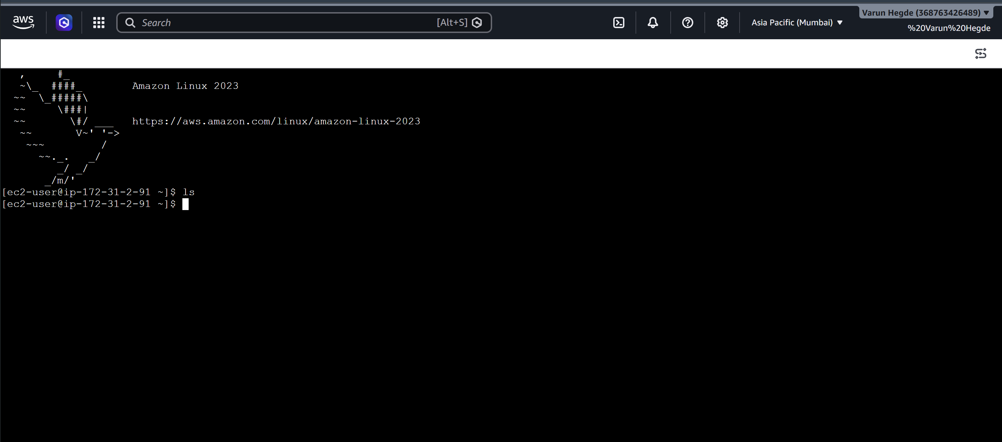
Figure 1. Your EC2 browser session (Amazon Linux 2023, user: ec2-user)
Item | Value from your setup
Operating system | Amazon Linux 2023
Shell user | ec2-user
Region | Asia Pacific (Mumbai) ap-south-1
Private host | ip-172-31-2-91 (internal VPC IP)
Website type | Static HTML/CSS/JS (no Node server required)
Local project folder | D:\Nibe-Limited-main
Important: Amazon Linux uses dnf (not apt). The login user is ec2-user (not ubuntu). Commands below match your OS.

2. Open HTTP/HTTPS in the Security Group
Before the website can load in a browser, the instance security group must allow inbound traffic on ports 80 (HTTP) and 443 (HTTPS).
- In AWS Console, open EC2 → Instances → select your instance.
- Open the Security tab → click the security group link.
- Edit inbound rules → Add rule for each of the following:

Type | Port | Source | Purpose
SSH | 22 | My IP (recommended) | Terminal / SCP access
HTTP | 80 | 0.0.0.0/0 | Public website
HTTPS | 443 | 0.0.0.0/0 | SSL later (optional now)
Save rules. Note your instance Public IPv4 address from the instance summary page (you will use it as the site URL).

3. Install and Start Nginx on the EC2 Instance
In the browser terminal (or SSH session) where you see the ec2-user prompt, run these commands one block at a time.

3.1 Update packages and install Nginx
sudo dnf update -y
sudo dnf install -y nginx unzip
sudo systemctl enable nginx
sudo systemctl start nginx
sudo systemctl status nginx
If status shows active (running), open http://YOUR_PUBLIC_IP in a browser. You should see the default Nginx welcome page. That confirms ports and Nginx work.

3.2 Create the website directory
sudo mkdir -p /var/www/nibe
sudo chown -R ec2-user:ec2-user /var/www/nibe
ls -la /var/www/nibe

4. Upload Website Files from Your Windows PC
Do not upload the node_modules folder. It is only for local image tools and is large. Prefer zipping the site first.

4.1 Create a zip on Windows (PowerShell)
Open PowerShell on your PC and run:
cd D:\Nibe-Limited-main
Get-ChildItem -Force |
Where-Object { $_.Name -notin @('node_modules','.git','nibe-site.zip','scripts','package.json','package-lock.json','vercel.json','NIBE-EC2-Deployment-Guide.docx') } |
Compress-Archive -DestinationPath D:\nibe-site.zip -Force
Get-Item D:\nibe-site.zip
You need the HTML pages (index.html, About_us.html, …), Style.css, Main.js, image-perf.js, and all image/video folders.

4.2 Option A — Upload with SCP (key pair required)
If you have the .pem key file from when the instance was created, use SCP from PowerShell. Replace paths and IP:
# Optional: restrict key permissions (Windows)
icacls "C:\path\to\your-key.pem" /inheritance:r
icacls "C:\path\to\your-key.pem" /grant:r "$($env:USERNAME):(R)"
scp -i "C:\path\to\your-key.pem" D:\nibe-site.zip ec2-user@YOUR_PUBLIC_IP:~/

4.3 Option B — Upload via AWS Systems Manager / S3 (no SCP)
If you do not have the .pem file handy:
- In AWS Console → S3 → Create bucket (or use existing) in ap-south-1.
- Upload D:\nibe-site.zip to the bucket.
- On EC2 (browser terminal), if the instance has an IAM role with S3 read access:
cd ~
aws s3 cp s3://YOUR-BUCKET-NAME/nibe-site.zip .
unzip -o nibe-site.zip -d /var/www/nibe
ls /var/www/nibe/index.html
If aws is not configured or there is no IAM role, attach an instance role with AmazonS3ReadOnlyAccess (or a custom bucket-read policy), or use SCP (Option A).

4.4 Option C — Paste small files only (not recommended for full site)
The full site includes large videos and images. Browser paste is impractical. Use SCP or S3.

4.5 Extract files on EC2 (after zip is on the instance)
cd ~
unzip -o nibe-site.zip -d /var/www/nibe
ls -la /var/www/nibe
# index.html must be directly under /var/www/nibe
test -f /var/www/nibe/index.html && echo OK || echo MISSING_INDEX
If unzip created an extra nested folder (for example /var/www/nibe/Nibe-Limited-main/index.html), move contents up one level:
# Only if files landed in a subfolder
cd /var/www/nibe
ls
# Example fix:
# mv Nibe-Limited-main/* .
# rmdir Nibe-Limited-main

5. Configure Nginx for the NIBE Site

5.1 Create site config
sudo tee /etc/nginx/conf.d/nibe.conf > /dev/null << 'EOF'
server {
listen 80 default_server;
listen [::]:80 default_server;
server_name _;
root /var/www/nibe;
index index.html;
location / {
try_files $uri $uri/ $uri.html =404;
}
location ~* \.(js|css|png|jpg|jpeg|gif|svg|ico|webp|avif|mp4|webm)$ {
expires 30d;
add_header Cache-Control "public";
}
add_header X-Content-Type-Options nosniff;
add_header X-Frame-Options SAMEORIGIN;
add_header Referrer-Policy "strict-origin-when-cross-origin";
}
EOF

5.2 Disable default server conflict (if needed)
# If default.conf also claims default_server, rename it:
sudo mv /etc/nginx/conf.d/default.conf /etc/nginx/conf.d/default.conf.bak 2>/dev/null || true

5.3 Set permissions and reload Nginx
sudo chown -R ec2-user:nginx /var/www/nibe
sudo find /var/www/nibe -type d -exec chmod 755 {} \;
sudo find /var/www/nibe -type f -exec chmod 644 {} \;
sudo nginx -t
sudo systemctl reload nginx

6. Verify the Website
- Copy Public IPv4 from EC2 → Instances.
- Open http://YOUR_PUBLIC_IP in Chrome/Edge.
- Confirm Home page loads (index.html).
- Click About Us, Land Systems, Investors, etc.
- Check that images and videos load (may be slow the first time).
Quick server-side check:
curl -I http://127.0.0.1/
curl -s http://127.0.0.1/ | head -n 20

7. Optional: Custom Domain and HTTPS

7.1 DNS
- Create an A record: yourdomain.com → Public IPv4 of the instance
- Optional: www CNAME → yourdomain.com
If the instance uses a dynamic public IP, allocate an Elastic IP and associate it so the IP does not change after stop/start.

7.2 Free SSL with Let’s Encrypt (Certbot)
sudo dnf install -y certbot python3-certbot-nginx
sudo certbot --nginx -d yourdomain.com -d www.yourdomain.com
sudo systemctl reload nginx
Certbot will adjust the Nginx config for HTTPS. Renewals are typically automatic via a timer/cron installed by the package.

8. Updating the Site Later
- Edit files locally under D:\Nibe-Limited-main.
- Re-zip (excluding node_modules) and upload again via SCP or S3.
- On EC2:
unzip -o ~/nibe-site.zip -d /var/www/nibe
sudo systemctl reload nginx

9. Troubleshooting
Problem | What to check
Browser timeout / no response | Security group: HTTP port 80 open; instance running
Nginx default page still shows | nibe.conf root path; default.conf disabled; reload nginx
403 Forbidden | chmod 755 on folders, 644 on files; SELinux rarely blocks static files
404 on Home | Confirm /var/www/nibe/index.html exists (not nested folder)
Images/videos missing | Folder names with spaces uploaded correctly; case-sensitive paths
SCP Permission denied | User must be ec2-user; correct .pem; SG allows SSH from your IP
dnf / nginx not found | You are on Amazon Linux 2023 — use dnf install nginx
Useful logs:
sudo tail -n 50 /var/log/nginx/error.log
sudo journalctl -u nginx -n 50 --no-pager

10. Checklist Summary
- EC2 instance running (Amazon Linux 2023) — DONE
- Connected as ec2-user — DONE (see Figure 1)
- Security group: SSH + HTTP (+ HTTPS)
- Install Nginx with dnf
- Upload zip of site (no node_modules)
- Extract to /var/www/nibe with index.html at root
- Nginx config root → /var/www/nibe
- Open http://PUBLIC_IP and test all pages
- (Optional) Elastic IP + domain + Certbot SSL

11. Quick Command Cheat Sheet
On EC2 (Amazon Linux 2023):
sudo dnf install -y nginx unzip
sudo systemctl enable --now nginx
sudo mkdir -p /var/www/nibe && sudo chown ec2-user:ec2-user /var/www/nibe
unzip -o ~/nibe-site.zip -d /var/www/nibe
sudo nginx -t && sudo systemctl reload nginx
From Windows (with key):
scp -i "C:\path\to\key.pem" D:\nibe-site.zip ec2-user@YOUR_PUBLIC_IP:~/
End of guide · NIBE Limited static website on AWS EC2
This document was generated for your current instance profile (Amazon Linux 2023 / ec2-user / Mumbai region). Replace YOUR_PUBLIC_IP and key paths with your real values.

