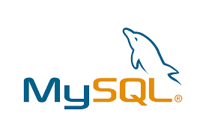

Eureka Server

Database

Database

API

Gateway

3rd Party API

Database

password

email

Crud

Register

login

Register

login

User

Authentication

Service

Favorite

Movie

Service

Recommended

Movie

Service

Feign

Client

Movie

Service