# **Tasks**

**Objective Questions**:

1. What is the total no. of tables present in the data?

**Answer**: There is only one table present in the data.

1. What is the total no. of attributes present in the data?

**Answer:** There are total 35 attributes (Columns) are present in the data.

1. The data consists of some inconsistent and missing values so ensure that the data used for further analysis is cleaned.

* There are no duplicate values found in the dataset but there are some
  + - irrelevant columns so I have hide them for solving the problem statement.
    - Columns name – isWhiteListUser,Queue.
* Created Columns in data like Unique Guru names, rating category.
* Did some extraction on **CreatedAt, UpdatedAt** Column.
* I have taken out **Days** and **Months** from date column.

1. What is the change in daily call volume day by day and also find the average daily call volume.

**For the change in daily call volume day by day I have attached screenshot of table.**

**Formula for average daily call volume over the day by day:**

**AVERAGE(J2:J35)**

**Calculate Total Number of Calls Each Day:**

Use the COUNTIFS function on the callStatus column to determine the total

number of calls for each day.

**=COUNTIFS(data!Q2:Q28028, $G2, data!Z2:Z28028,"<>")**

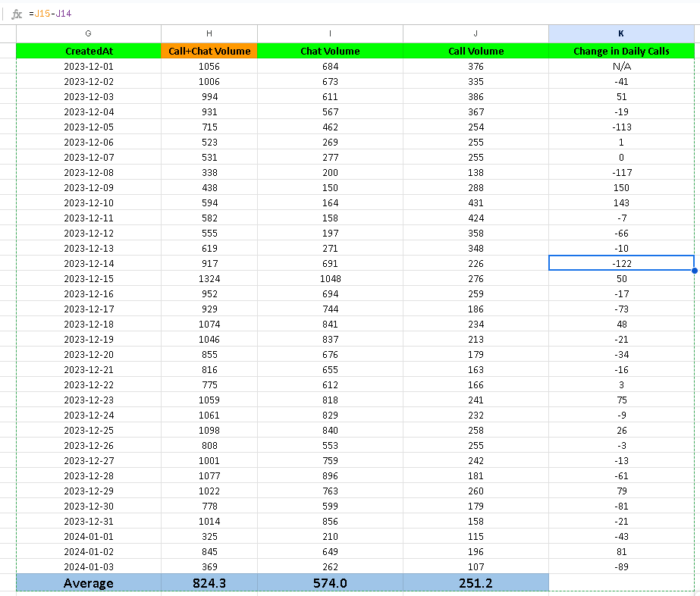

1. Which months experienced the highest and lowest call volumes?

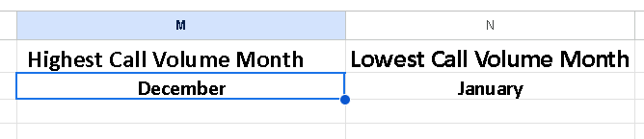

**For highest call month**

**=TEXT(INDEX(G2:G35, MATCH(MAX(J2:J35), J2:J35, 0)), "mmmm")**

**For Lowest call month**

**=TEXT(INDEX(G2:G35, MATCH(MIN(J2:J35), J2:J35, 0)), "mmmm")**

1. What is the total operational cost for that month?

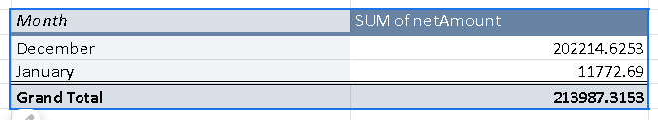

Operation Cost for December 202214.6253 and January 11772.69   
I have Taken net amount for operational cost.

1. What is the average number of calls handled per agent per day?

The average number of calls handled per agent per day = 1.66

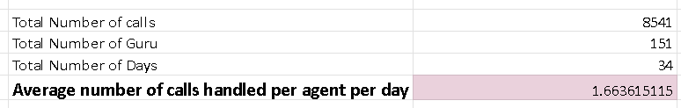

Count of calls/(count of guru id * count of days) **= 1.66**

Calls are handled per agent per day

1. How many repeat callers are there, and what percentage of total calls do they represent?

Total Number of repeat callers(users) = 1282

(Total repeat callers / Total Number of call made by user) * 100

Total Percentage Call of represented by repeated Caller: **57.36%**

**Total unique callers is being calculated from the pivot table using =COUNTIF(O5:O3428,"=1")**

**Total callers is the count of Row Labels column of the pivot table which comes out as 3424**

**Repeat callers is the difference between Total callers & Total Unique Callers which is 1234**

**Total number of calls = 8315**

**Calls done by repeat callers = 5977**

**Total First calls of repeat callers (To be excluded from call percentage calculation) = 1208**

**Percentage of total calls done by repeat callers = 57 %**

1. What are the total sales generated by the call centre for each product category?

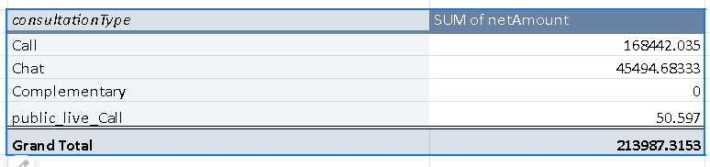  
  
The pivot table shows the total sales generated sales generated by the call centre for each product category.

1. How many calls were made for each user ID and guru ID?

The mentioned pivot tables identify the number of calls done by each user and each guru respectively.

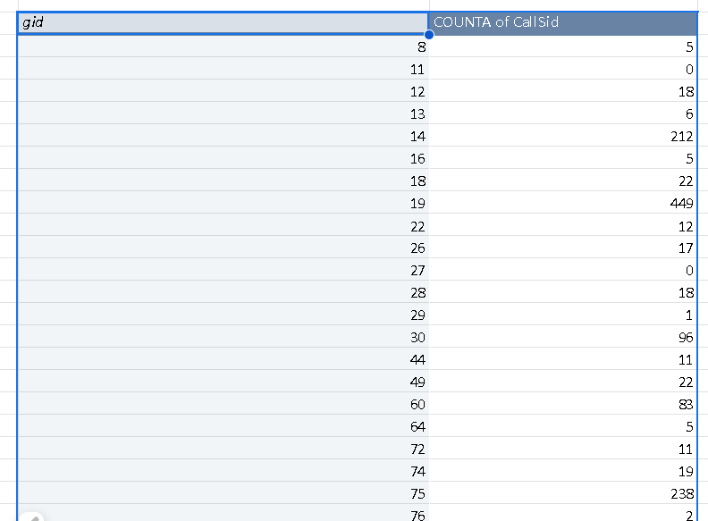 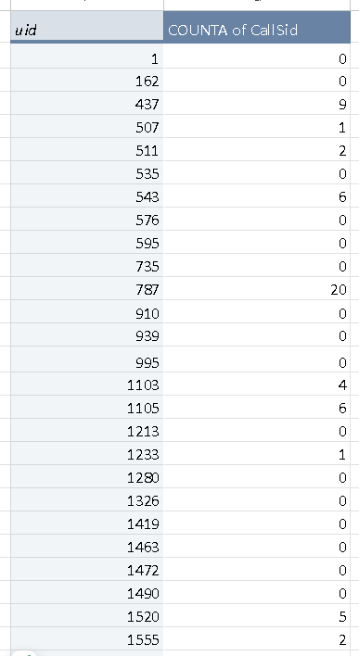

1. What is the correlation between call duration and customer satisfaction?

The correlation coefficient of **-0.041** between **call duration** and **customer satisfaction** indicates:

**Weak Relationship:**

* The correlation is very close to **0**, suggesting there is almost no linear relationship between the two variables.
* Changes in call duration do not consistently correspond to changes in customer satisfaction.

**Negative Direction:**

* The slight negative value indicates that if there is any relationship, it is in the **opposite direction**. For example:
* **Formula Used:**
* **correlation between call duration and customer satisfaction:** **=CORREL(X43:X572,Y43:Y572)**

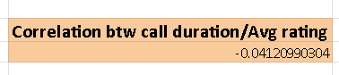

1. Which guru has the highest and lowest customer satisfaction scores?

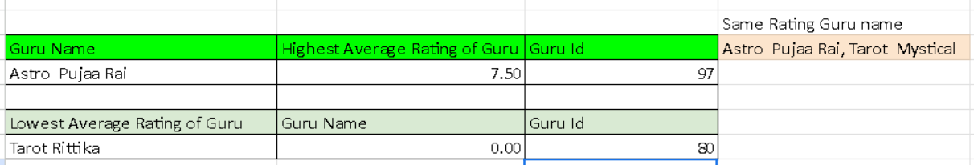

**=INDEX($A$2:$A$152, MATCH(MAX(D2:D152), D2:D152, 0))**This formula will give the highest rated guru

**=INDEX($A$2:$A$152, MATCH(MIN(D2:D152), D2:D152, 0))**

This formula will give lowest rated guru

1. What is the average customer satisfaction score by month?

Created Pivot Table as Month in row and rating as average in value.  
 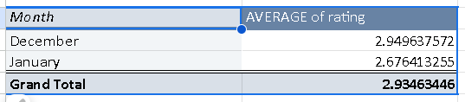

1. How many categorical columns are there in the data? [Search about categorical and continuous data, and try to answer this question]

There are **15 categorical columns** in the dataset which are mentioned below:

chatStatus, consultationType, website, refundStatus, isWhiteListUser, queue, freeCall, freeChat, callChannel, callIvrType, callStatus, astrologerCallStatus, region, userCallStatus, rating

**Subjective Question:**

1. Should the investment be used to hire more agents, improve training programs, or upgrade call center technology?

After analysing the dataset the following findings have been observed:

1. The number of calls received by the call centre is decreasing at an exponential rate indicating low customer retention.

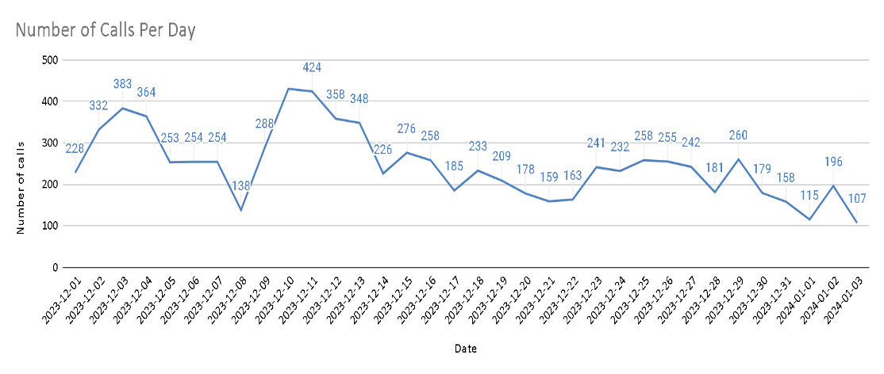

1. The call centre agent distribution is quite ineffective as some of the agents are getting high volume of chat or call requests and some of them are having minimal call/chat requests. This is being analysed by grouping the calls as per the Guru id and count of calls attended in a pivot table and sorting it to get the distribution.

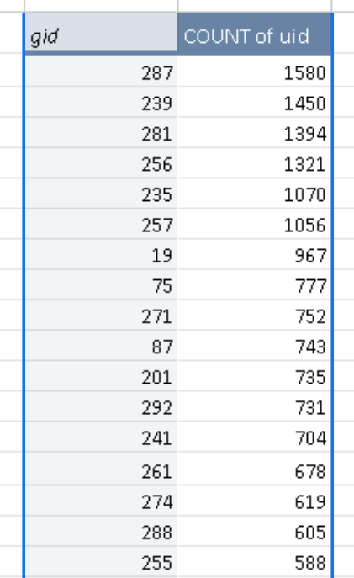

Here we can analyse that some gurus have high traffic while some are having less volume of calls.

1. The quality of the consultations of customers is not satisfactory as in both the calls & chat category only

about 41 % of total consultation is completed and the rest are either incomplete/ busy/ no answer.

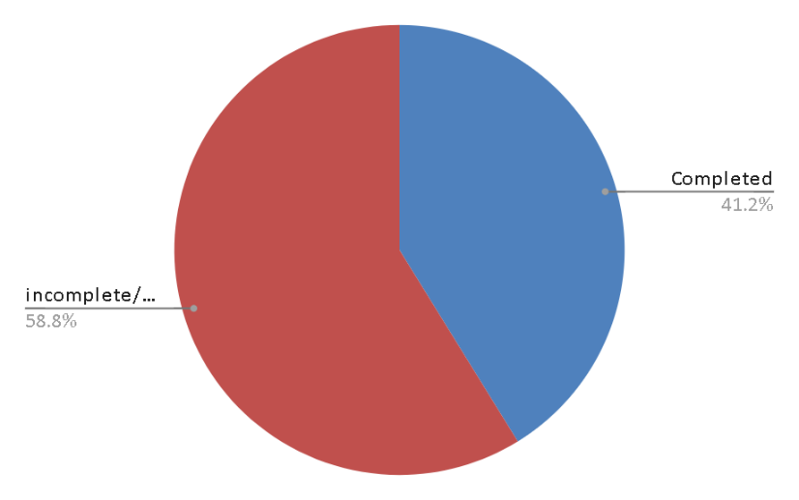

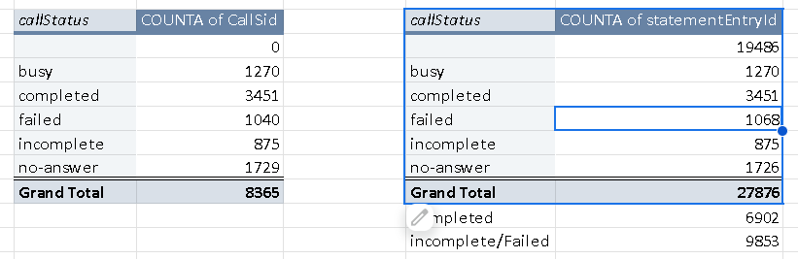

We can identify from the pivot table the number of consultations being completed.

*Recommendations:*

*Some portions of the investment should be done on the following aspects:*

***Technology Upgradation*** *:- Technology of the application and gurukul platform should be enhanced to have a definite distribution of calls/chats among all the gurus seamlessly without dropping the calls. An enhanced call managing infrastructure should be developed.*

***Training Agents****:- Proper structured training sessions should be given to specific agents to improve their customer satisfaction ratings. Training should be done by expert individuals for better quality of gurus enhancing the revenue and number of consultations.*

1. What are the potential risks of each investment option (hiring, training, technology upgrades), and how can they be mitigated?

Name the chart/spreadsheet function you will use for solving the problem.

**Potential Risks of Each Investment Option and Ways to Manage Them**

**Hiring More Agents**

**Risks:**

**Higher Costs:** Adding agents increases salaries and overhead. If call volume doesn’t grow, it could create unnecessary financial pressure.

**Idle Workforce:** Since current agents handle only about 1.84 calls per day, bringing in more people may worsen inefficiency rather than solving the problem.

**Delayed Impact:** Hiring won’t quickly fix deeper issues like poor customer satisfaction or low call volume.

**How to Manage:**

Begin with part-time or temporary hires to test the effect before committing to full-time staff.

Analyze call data to confirm where extra help is really needed (e.g., peak hours or high-demand days).

Use workforce scheduling tools to maximize the efficiency of existing staff before expanding.

**Strengthening Training Programs**

**Risks:**

**Temporary Loss of Capacity:** While in training, agents can’t take calls, which may reduce availability.

**Resistance to Change:** Some agents may be hesitant or uncomfortable adopting new practices.

**Unclear Results:** If training doesn’t address the actual challenges—like first-call resolution—it may not lead to improvements.

**How to Manage:**

Focus training on essential skills such as handling difficult customers and reducing call times.

Blend online modules with live workshops to reduce workflow disruption.

Track post-training metrics (e.g., customer satisfaction, call resolution time) to measure success.

**Upgrading Call Center Technology**

**Risks:**

**High Initial Investment:** Implementing advanced tools (e.g., CRM upgrades, AI solutions) requires significant cost.

**Implementation Difficulties:** Transitioning to new systems may cause technical issues and require time for adjustment.

**Poor Adoption:** Without proper guidance, agents may not fully utilize the new tools, limiting benefits.

**How to Manage:**

Introduce new systems gradually, instead of a full rollout, to identify and resolve problems early.

Engage agents in the decision-making process so the tools meet their needs.

Provide thorough training to ensure proper usage.

Monitor performance metrics (e.g., faster responses, improved customer feedback) to confirm return on investment.

**Functions for Supporting Improvements**

**Function: WHAT-IF Analysis or Goal Seek**

**Use:** Assess how outcomes change with different inputs, such as hiring/training numbers or technology costs. Goal Seek can identify the breakeven point for these investments, providing valuable decision-making data.

**Visualization Tools:**  
**Function: Charts (Bar, Pie, Waterfall, etc.)**

**Use:** Display risks, expenses, and potential returns in a clear, visual format. For instance, a Waterfall Chart can show the step-by-step impact of each investment decision.

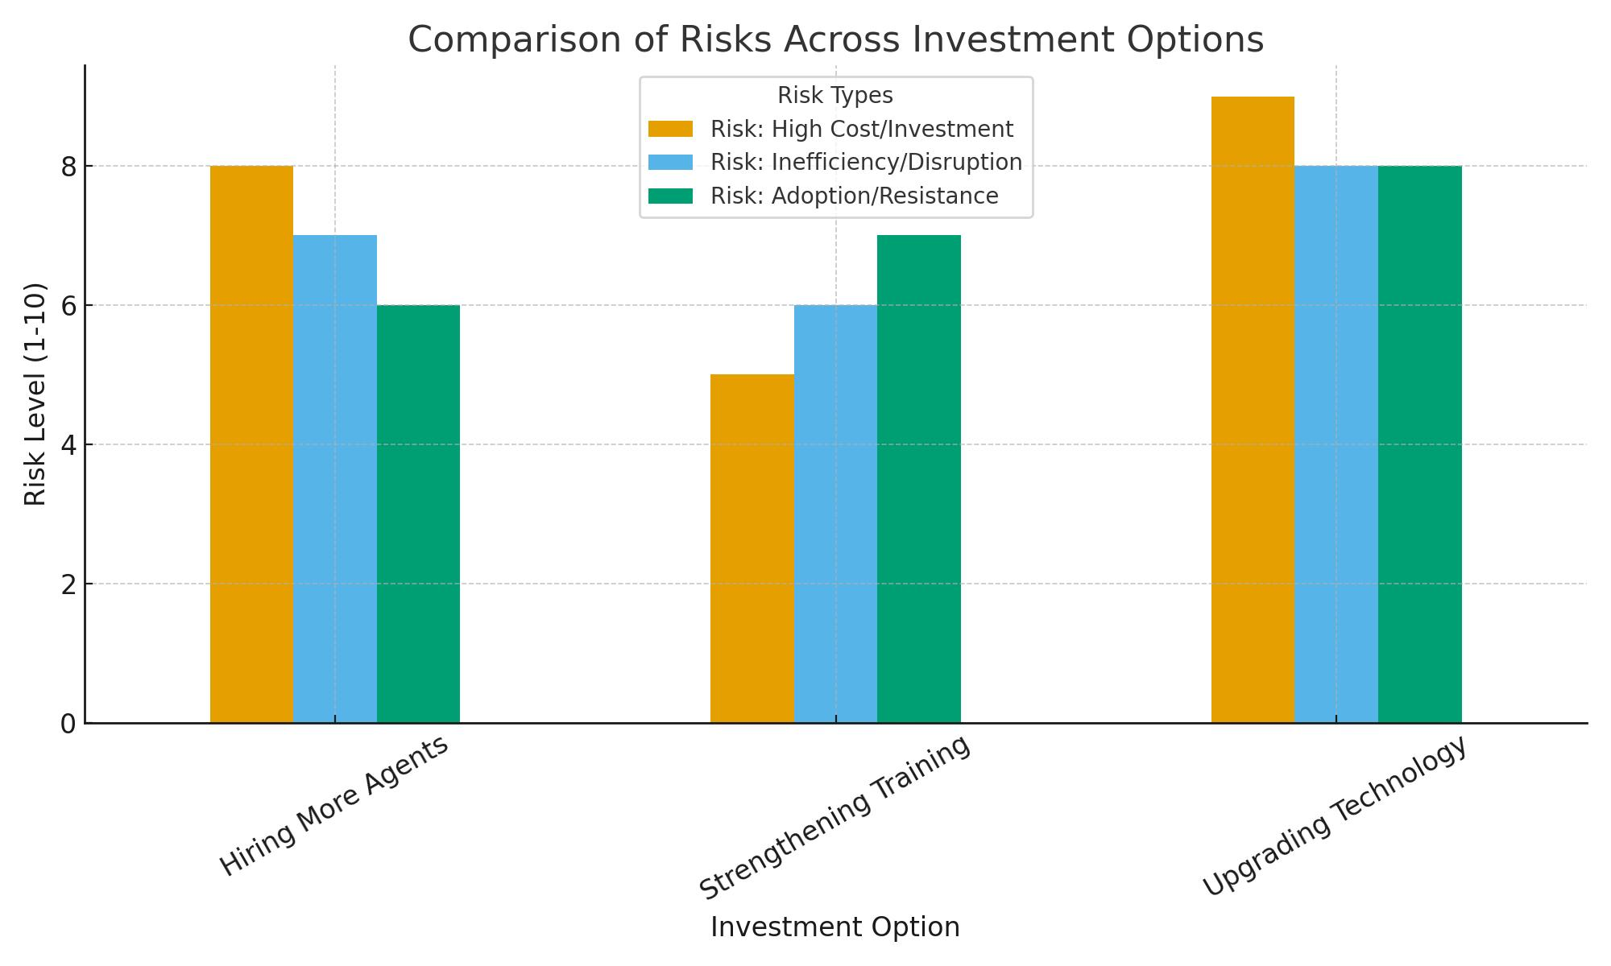

1. How does AstroSage's call center performance compare to AstroGuru's average call volume, customer satisfaction, and agent performance?

Will you use any aggregation function or a visualization here to solve the problem?

The current dataset isn’t sufficient to compare with another organisation.

[AstroGuru Data haven’t been provided]

1. How can the call center improve its handling of peak call periods to ensure high customer satisfaction?

Mention the functionality you will use for giving the suggestions, will it be any aggregated function or a visualization?

Analysing the dataset we could observe that most of the calls are being placed in the time period of 5 AM to 5 PM (6602 calls) which is aggregated to 79.9 % of the total calls.

We used a pivot table to group the calls data by the hourly basis and derived a column chart to analyse the distribution of the calls.

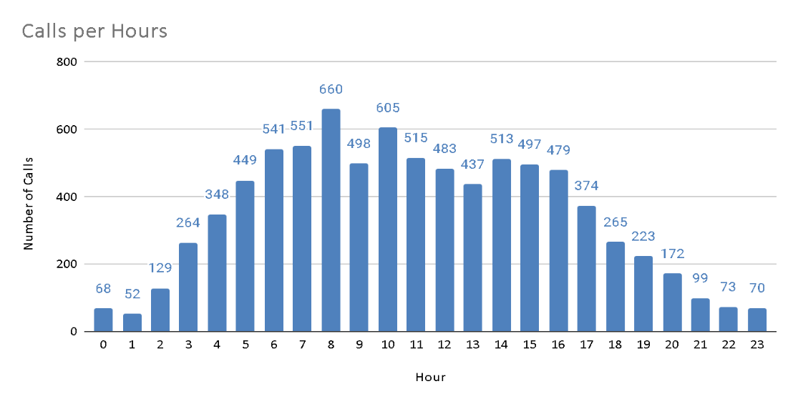

From the analysis it is clear that the peak call periods range from 5 AM till 5PM.

*Recommendations:* The Agent’s shift distribution should be managed to handle calls at the peak time period by assigning 80% of agents into the derived time span. And for the time period other than the peak call hours, the rest 20% of agents were able to handle seamlessly. This would prevent burnouts and stress among the agents and maximum calls could be completed positively impacting the customer satisfaction.

1. Based on historical data, what strategic initiatives should be prioritized to improve efficiency and customer satisfaction?

**Strategic Initiatives for Improving Call Center Efficiency**

**1. Targeted Training for Low-Performing Agents**  
Analysis shows certain agents have high failure rates and low customer ratings. Focused training can reduce failures and improve satisfaction.  
**Action:**

* Identify agents with poor ratings and frequent failures.
* Provide training in communication, problem-solving, and technical skills.
* Measure post-training performance to track effectiveness.

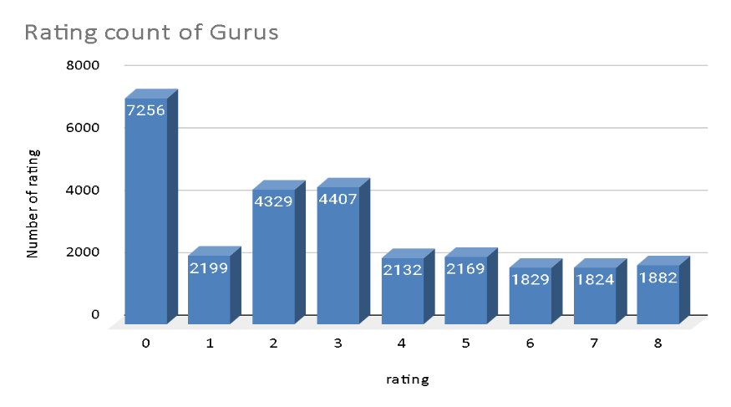

**2. Smarter Call Management & Prioritization**  
Inefficient call routing leads to delays, poor customer experience, and agent misuse. Intelligent routing can resolve this.  
**Action:**

* + Use skill-based routing to connect calls to the right agents.
  + Apply priority queuing for high-value or repeat customers.
  + Update routing rules regularly using performance data.

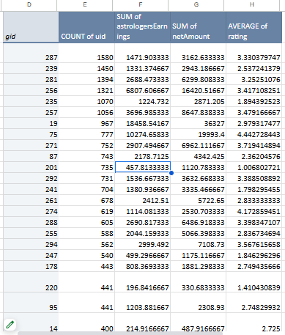

**3. Reduce Failures Through Technology Upgrades**  
Past data shows failures often stem from technical issues. Stronger infrastructure can improve call quality and reliability.  
**Action:**

* Invest in robust communication systems.
* Enhance IVR for handling simple queries.
* Use monitoring tools to detect and fix issues quickly.

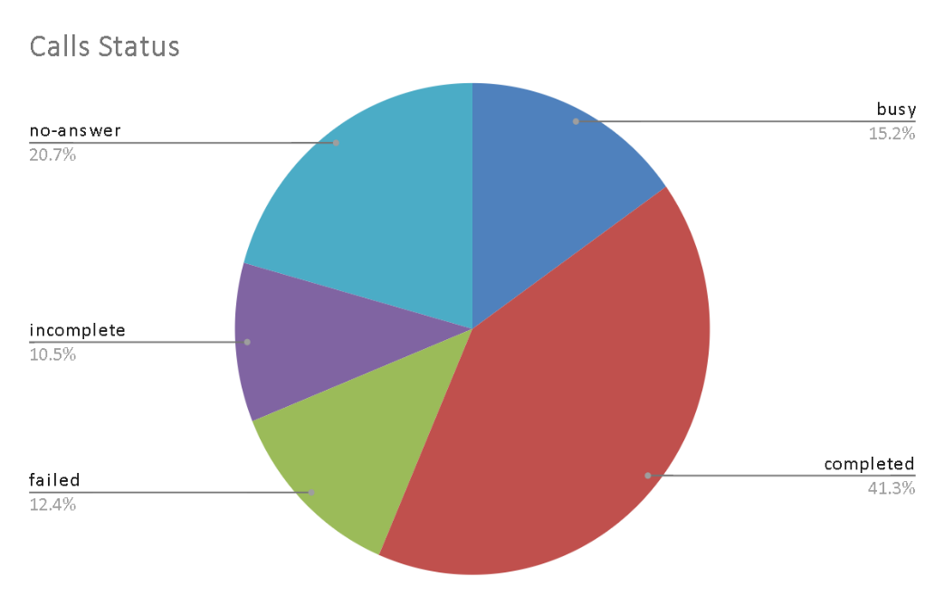

**4. Expand Self-Service Options**  
Customers prefer solving simple queries independently. Stronger self-service reduces peak-hour load.  
**Action:**

* Develop IVR to cover common questions.
* Deploy AI chatbots for routine issues.
* Promote self-service channels to increase adoption.

**Conclusion:**  
By focusing on training, smart routing, technology upgrades, and self-service, the call center can significantly boost efficiency and customer satisfaction.

1. What can be the key factors contributing to high customer satisfaction scores, and how can these be leveraged to improve overall performance?

What is the basis for the suggestions? And mention how you decided if the satisfaction score affects the ratings.

Note: The Satisfaction scores taken into account is the average of rating provided by the customers.

The Key Factors contributing to the high customer satisfaction scores are:

**Interaction with expert agents:**

**Approach:** Agents having high demand and higher expertise contribute to the high customer satisfaction.

Low call volumes: Agents attending less customers enhances the experience of customers gradually providing a better consultation and overall rating. Overburdened agents could provide less efficiency to the customers and their rating drops.

***Performance Improvement strategies:***

To improve the overall performance well trained agents with effectively lower call volumes would provide a better output for the customers.

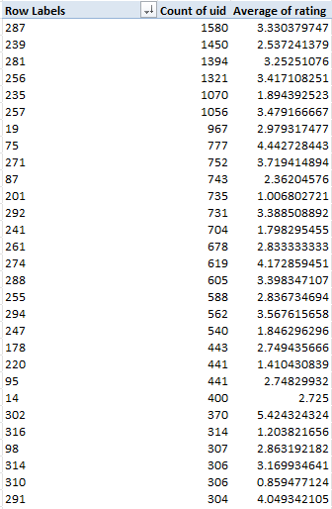

This pivot table shows the performance of the agents and their efficiency in handling the customers. The top agents who handle the most volume of calls is being shown in this part of the table.

The bottom part of the table shows agents showing poor performance with respect to having the number of calls and therefore handling efficiency decreases.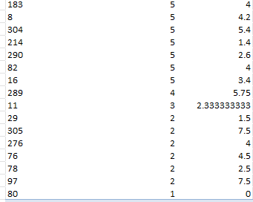

The distribution of interactions to be balanced using prioritising customer requirements to specific agents.

1. How should the call center balance the workload among agents to ensure optimal performance and avoid burnout?

Mention your approach and spreadsheet function for the answer.

Ans :

To improve agent workload distribution and ensure both optimal performance and agent well-being, we can take a data-driven approach based on the metrics we've gathered. Here’s an overview of the approach and how each metric supports balanced scheduling:

**Current Agent Workload Calculation**

**Average Calls Handled per Agent per Day**: We calculated this by taking the total number of calls divided by the product of the total number of agents and days. With this calculation, we found that, on average, each agent handles approximately 1.91 calls per day.

This metric helps set a baseline. By knowing the expected calls per agent, we can identify when agents are handling above or below this average, potentially indicating overwork or underutilization.

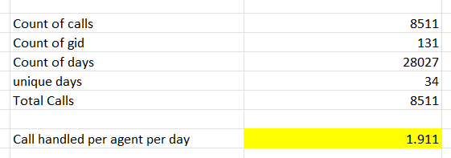

**Identifying High-Demand Periods**

We used pivot tables to determine the call volume and average call duration for each hour of the day. From these, we can see specific peak periods with high call volumes and potentially longer call durations, which may signal more complex issues or slower response times.

**Recommendation**: Schedule more agents during peak hours (e.g., early mornings and late afternoons). This targeted approach ensures that agents aren’t overloaded during busy times, which can lead to burnout and reduced customer satisfaction.

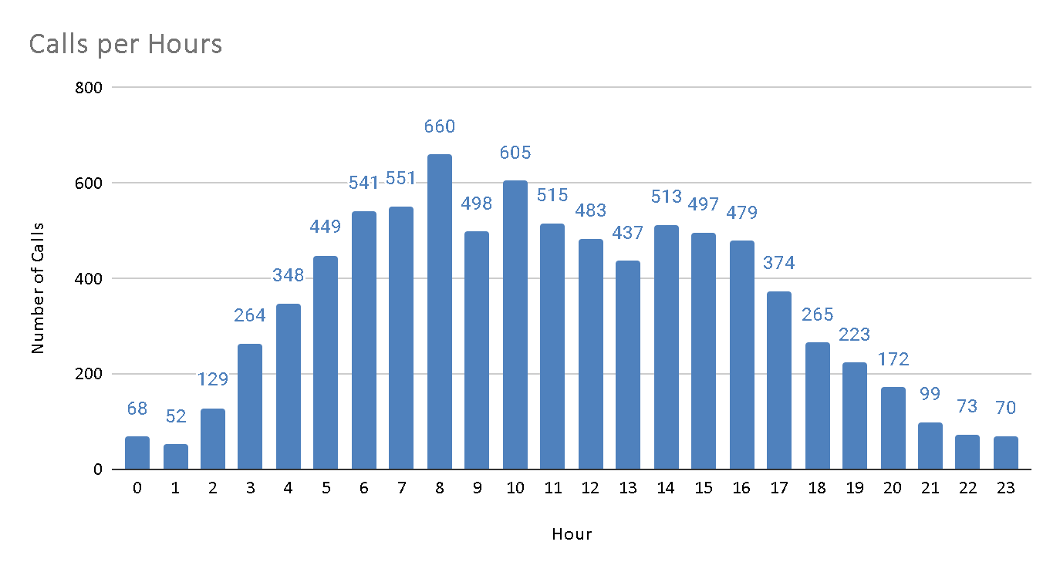

**Distribution of Calls**

The call centre must try and use all the consultants equally to manage the workload by assigning them equal number of calls by assigning calls to them as per the availability, moreover they can also focus on pre-booking model and use effective UI to give users an option to select the consultants to provide better user experience, equalising workload by removing the consultant as soon as they are chosen for a threshold count of bookings.

As shown in the below chart there is an uneven distribution of calls among the consultants.

The Top 10 consultants cover 44% of total calls.

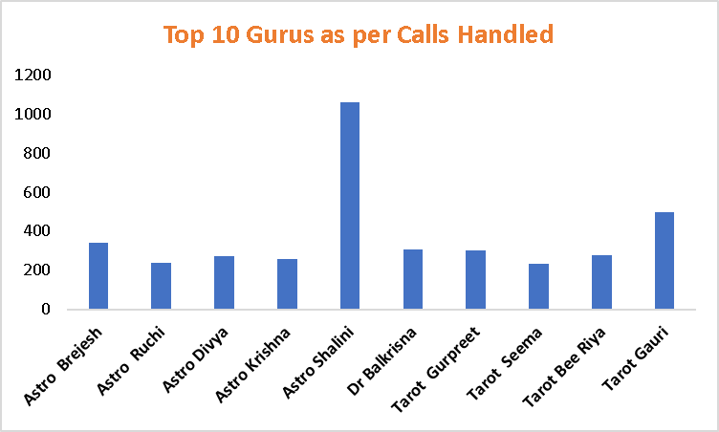

1. What new technologies or tools could be implemented to enhance call center operations and customer service?

Improving call center management and customer relations can be done through the integration of proactive technologies and tools that facilitate management, productivity and customers’ satisfaction. Here are some new technologies and tools that can be implemented:

**AI and Machine learning**

AI-Powered Chatbots: Chatbots powered by artificial intelligence can attend to simple inquiries and customer relations hence lowering call traffic for agents. NLP based chatbots can give appropriate responses like a human and can solve most of the problems without involving a human.

Tool Examples: IBM Watson, Google dialog flow, zendesk answer bot.

**Robotic Process Automation (RPA)**

Task Automation: Some of the activities that could be automated include data input, updating customer databases, and processing of refund. This relieves agents from simple tasks allowing them to manage complicated interactions hence enhancing the efficiency of the services.

Tool Examples: UiPath, Automation Anywhere, Blue Prism are some of the famous companies that provide RPA.

**Cloud-Based Call Center Solutions**

Scalability and Flexibility: Cloud-based call center platforms provide flexibility in that they can be easily customized to provide for growth. These platforms also support remote work, which enhances flexibility in staffing and business operation even in an event of disruption.

Tool Examples: Hence, other telephony solutions such as Amazon Connect, Twilio Flex, and RingCentral.

This section focuses on how Customer Relationship Management (CRM) Integration takes place in the company.

360-Degree Customer View: The integration of the call center with a CRM system helps the agents to work with all the information regarding the customer’s past interactions, orders, and preferences. It results in more appropriate service delivery since clients are treated individually as they are.

Tool Examples: Some of the popular CRM systems include, Salesforce, HubSpot CRM, Microsoft Dynamics 365.

1. What metrics should be included in the final dashboard to comprehensively view call center performance and guide investment decisions?

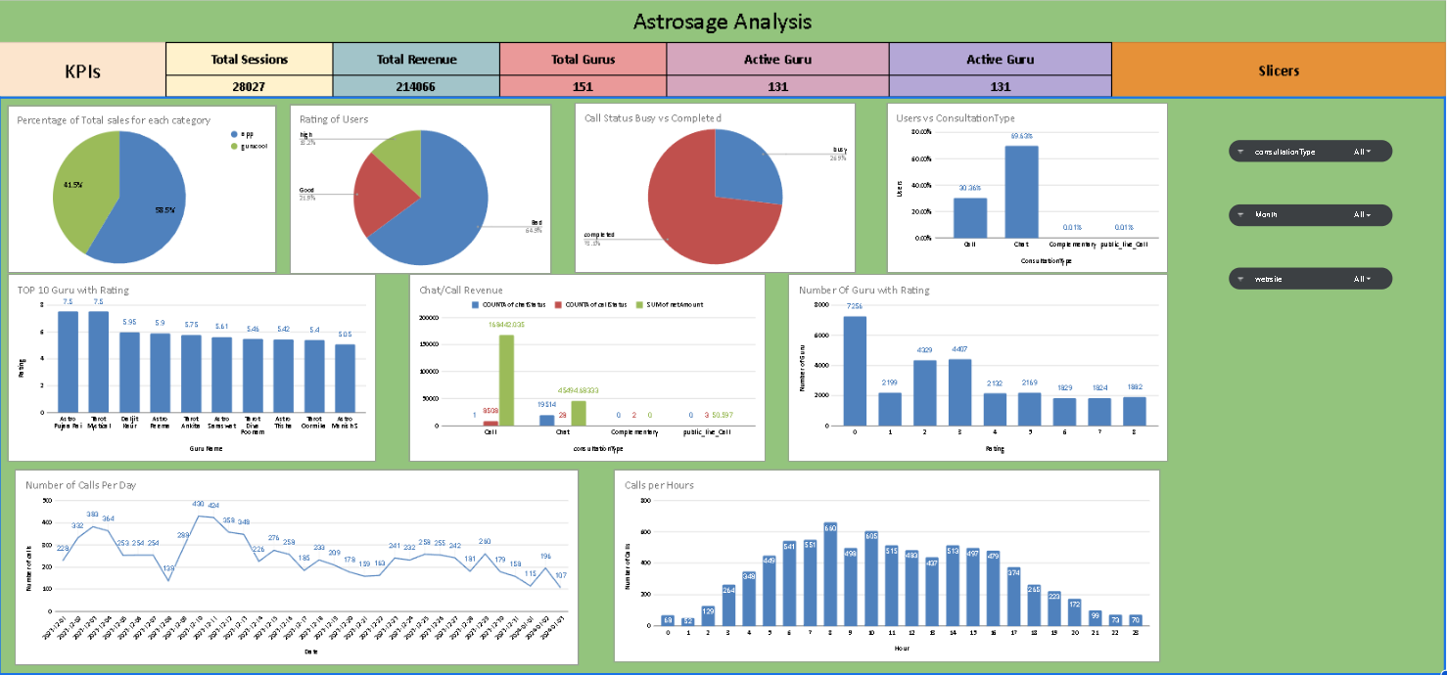

Metrics that can be included in the final dashboard to optimize the business and identify any underlying issues can be:

Filters:

1. Consultation Type Filter
2. Platform Filter(website or app)
3. Month Filter

Metrics on which these filters act upon are:

* Total Revenue Generated: This shows the total revenue of the business from all of its activities. This can be filtered out to gauge the income from different consultation types(call, chat or both) as well as from different platforms(app, website or both). It is an important metric to gauge the overall performance.
* Total active gurus/agents: Another important metric that measures the workforce available to serve the customers. This can also be filtered through the provided filter options.
* Total Active Users: This visualizes the daily activity of users on different platforms(app, gurucool,etc.). It can be an important metric to measure the number of users coming to the business daily. It can give an overview of the performance of business and any changes occuring.
* Daily activity on Astrosage: This chart visualizes the trend of overall daily activity on the Platform(all) and can be filtered via the available filters to view the specifics of the business.
* Users v/s Revenue: It gives an overview of the total users and the revenue generated by different consultation types(eg. Call, chat,etc). It can be used to analyze the income from activity of users of different consultation preferences and the revenue/income generated from them.
* Platform Activity Overview: This gives the percentage distribution of the activity on various consultation preferences(chat, call,etc.). It gives an overview of the type of consultation preferred by the users.
* Call Volumes across hours: This is a very important metric that shows the peak call hours to determine which time period maximum calls were being done. This metric shows a distribution of call volumes in the whole span of 24 hrs.
* Consultation Status: This metric provides an accumulated status of consultations which are completed and compares it with the failed statuses.
* Rating vs Count of gurus : This metric visualises the ratings and the distribution of number of gurus as per the rating.
* Top 10 Guru with their names

1. How would you allocate a 1 crore rupee investment to optimize operational efficiency, enhance customer satisfaction, and boost profitability, and what analysis-based recommendations would you offer to support this?

[you have to give bullet pointers to answer this question]

The budget of 1 Crore could be allocated / distributed for the recommended strategies as per the following:

***Technology Upgradation:*** Technology Infrastructure upgradation requires huge amounts to be invested upon for smooth operational convenience. Cloud Data centres would help to manage customer data efficiently. CRM tools would be used by employees for a better customer service approach and better overview of customers to the agents. More specialisations and developments in the application would attract more customers to the application.

Overall expenditure for the Technology could be roughly 40 Lakh Rs.

***Training & Development:*** Training and development of the existing Agents would create a positive impact on the Customers as more customers would have a higher satisfaction score due to the expert consultation. Training of agents along with retention bonuses for the agents would cost the organisation around 30 Lakh Rs.

***Implementing New Technologies:***Implementing new AI chatbot and Machine Learning features in the application and Dashboard would resolve the agents burnout and the free consultation would be done by AI Chatbot relieving the overburdened agents and saving resources.

Implementation of AI would cost the organisation around 20 Lakh Rs. for the subscriptions and commercial licences.

***Marketing & Advertisements:***The organisation should spend an amount of 10 Lakh Rs. from the budget to improve brand value against its competitors by channelling various marketing campaigns and indulging people to use their platform for better astrology recommendations. Valuable feedback to be taken from customers in the form of surveys and continuously improving the strategies for better outreach.