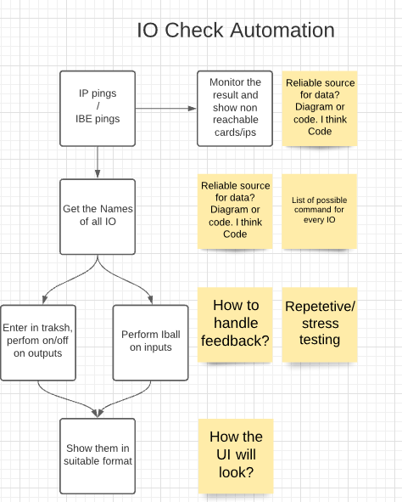
- Ping the IBE cards
- See whats Io is on them
- Iball Inputs
- On/of outputs
- Store results in a file
- Looks for diagram for details

