A PROJECT REPORT ON

**“UNDERWATER PICK AND PLACE ROBOT”**

**SUBMITTED TO**



MAHARASTRA STATE BOARD OF TECHNICAL EDUCATION

IN THE FULLFILMENT OF THE REQUIRMENT FOR THE FINAL YEAR DIPLOMA IN COMPUTER ENGINEERING

**SUBMITTED BY**

ANKITA KHEDEKAR 152333

SHUBHAM VENGURLEKAR 152328

SHUBHAM RANE 152313

RAHUL SOGAM 152326

**UNDER THE GUIDANCE OF:**

Ms. SONAL PANSARE

DEPARTMENT OF COMPUTER ENGINEERING

SARDAR VALLABHBHAI PATEL POLYTECHNIC

I.C. COLONY, LINK ROAD, BORIVALI(W)

MUMBAI-400103

2015-2016

**Sardar Vallabhbhai Patel Polytechnic**



Certificate

THIS IS TO CERTIFY THAT THE PROJECT “UNDERWATER PICK AND PLACE ARM” IS SATISFACTORIALY CARRIED OUT IN LABORATORY/INDUSTRY AND HENCE RECORDED IN THIS PROJECT REPORT IS THE BONAFIDE WORK OF GROUP: 05 OF THIRD YEAR DIPLOMA COURSE IN COMPUTER ENGINEERING DURING THE ACADAMIC YEAR 2015-2016 IN A SATISFACTORY MANNER AS PER CURRICULAM LAID DOWN BY M.S.B.T.E. MUMBAI.

GROUP LEADER: ANKITA KHEDEKAR

GROUP MEMBERS: SHUBHAM VENGURLEKAR

SHUBHAM RANE

RAHUL SOGAM

SONAL PANSARE SUNNY SALL SUNNY SALL

Project Guide HOD Principal

ACKNOWLEDGEMENT

We would like to take this opportunity to express our sincere thanks and gratitude to honourable head of department Prof. Sunny Sall for all his help and concern. The successful completion of this project was made by his able guidance and co-operation only without which the task would never have been completed.

We also own our deep gratitude towards our extremely helpful and supportive Project guide Ms. Sonal Pansarefor leading and directing us at every step of project. We would like to thanks her for being so understanding, invaluable help and for his crucial role in the completion of our project.

We are greatly indebted to management of our institute and express appreciation and thanks to our principle Prof. Sunny Sall, for co-ordination showing keen interest and providing necessary facilities in completing project report.

Finally, we extend our thanks and deep sense of respect for all professors of Sardar Vallabhbhai Patel Polytechnic for leading us every step of the way.

PREFACE

This report presents the research, finding and recommendations, resulting from the project Underwater Pick and Place arm. The objective was to give the complete information about how the robot work under water.

The project is very useful for those who want to know about the underwater arm.

This robot is controlled via two separate remote controllers one for vehicle body and one for robotic arm. The vehicle body have 6 mini submersible pumps and arm contains 5 servo motors.

In the last, we greatly acknowledge & express our gratitude to our group guide Ms.Sonal Pansare and our HOD Sunny Sir and all group members.

THE TEAM

For a project to be successful it is necessary for the group to be absolutely co-operative and pen minded. And after spending two years together we know what are the groups going to be like. We did not had any questions when it came to the selection of our team. We know team work is going to play a massive role as this is not a small task to complete.

The team is selected and fortunately we all are much excited to work together. Our team has one of the best understanding of all and the talent in members. We all have good efficiency in some or other fields.

**Ms. Sonal Pansare (Group Guide)**

**Ankita Khedekar (Group Leader)**

**Shubham Vengurlekar**

**Shubham Rane**

**Rahul Sogam**



**MS. SONAL PANSARE (GROUP GUIDE)**

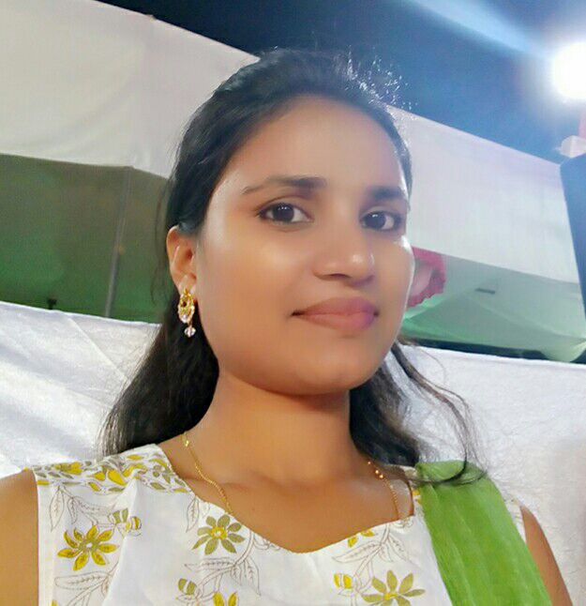

As the very successful student a fair amount of hand is of the teacher that of a student, similarly our Group Guide helped us a lot in making the project successful. Though she has very friendly nature which helped us in achieving our goals. In spite of having a very busy schedule she helped us in every building block of our project. She is very down to earth person.

**QUALIFICATION:** B.E. in computers.

**UNIVERSITY:** Mumbai University.

**CLASS:** First Class with Distinction

**FAVORITE SUBJECTS:** Data Structure, Robotics, Advance Microprocessor.

**ANKITA KHEDEKAR (GROUP LEADER)**

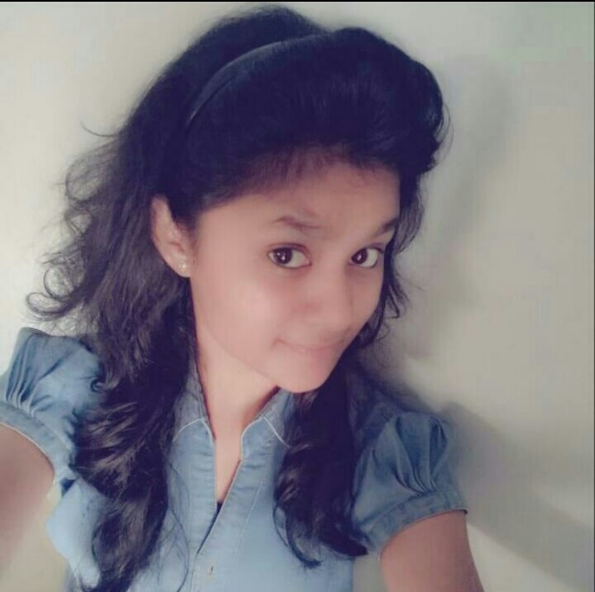

As a group leader she has handled this project and the members of the project in a very successful manner and has proved to be a very effective group leader. She has tried to unite the members during the crisis.

She had distributed all the work in such way that every type of job is rotated among the members so that everyone gets equal experience in all kind of work, be it programming, testing, debugging, etc.

She equally took participants in the following activities:

* Assembling
* Testing
* Debugging & Troubleshooting
* Planning
* Feasibility Study
* Collection of information

**SHUBHAM VENGURLEKAR**



He decided the future scope and he decided the feasibility report of this project and he also helped in designing models for project. He was more responsible for software coding and interfacing with user. He suggested and applied more careful modification. The took part in software coding. He was more responsible for designing various aspect of the project.

He equally took part in following activities:

* Documentation
* Designing
* Coding
* Algorithm and Flowchart
* Planning
* Feasibility Report

**SHUBHAM RANE**

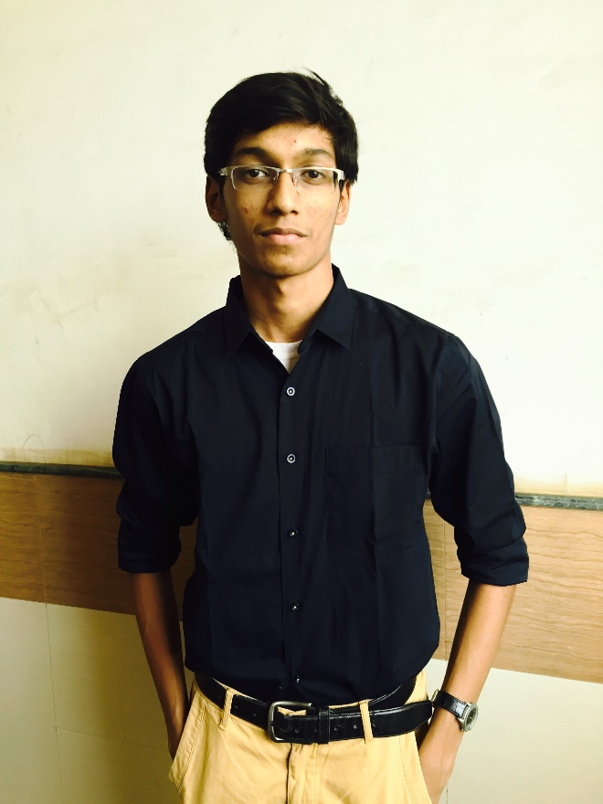

Project presentation point of view he has worked out on the physical appearance of the project, he gave creative idea to modify the code. He helped group leader in printout work and deciding the future scope of the project. He helped in presentation of documentation using various software.

He equally contributed in sectors of:

* Designing
* Testing
* Assembling
* Algorithm & Flowchart
* Feasibility Report
* Future Development

**RAHUL SOGAM**



As the work was divided equally he involved himself in the requirement documentation using “MICROSOFT OFFICE 13”. He was like the right hand of leader, very smart with the instant solutions to many problems. He was the person with a good humour and make us laugh us whenever there is tension.

He equally took part in the following:

* Collection of information
* Documentation
* Coding
* Debugging and Troubleshooting
* Feasibility Report
* Future Scope

INDEX

|  |  |  |  |
| --- | --- | --- | --- |
| SR. NO. | TOPIC | | Pg. No. |
| 1. | INTRODUCTION | | 14 |
| 2. | LITERATURE REVIEW   * History * Existing System | | 16 |
| 3. | REQUIREMENTS AND TECHNOLOGIES   * Hardware Requirements * Software Requirement | | 18 |
| 4. | FEASIBLITY   * Technical feasibility * Operational feasibility | | 20 |
| 5. | DESIGN AND CONSIDERATIONS   * Mode of Operation * System Description * Design Considerations * Electric Circuit * Voltage Regulation * Interface | | 22 |
| 6. | PERFORMANCE EVOLUTION AND TESTING   * Unit Testing * Integration Testing | | 35 |
| 7. | APPLICATION | | 37 |
| 8. | CONCLUSION AND FUTURE SCOPE | | 39 |
| 9. | | BIBLIOGRAPHY & REFFERENCE | 42 |

**ABSTRACT**

The design analysis of Underwater Remote Controlled “Pick and Place” Robotic Vehicle has been presented in this paper. This Remotely operated vehicles (ROV) help oceanographers study parts of the ocean that are too dark, too cold, or too deep for human divers. Build a real underwater ROV, and take a video showing how you control it while it's underneath water.

We are trying to make a mechanical arm with all its basic applications which can be also useful underwater that is we can search, locate, and pick or place it on another location underwater.

This arm will able to pick and place object which cannot handled or not accessible to human body which are beneath the water, as it is underwater the arm and its other parts will be fully waterproof.

**Keyword:** ROV, Oceanographers

**CHAPTER - 01**

**Introduction**

This Underwater Pick and Place arm is of type ROV, which will be controlled by two wired remote controllers from which one remote controller is for Robot body and another is for Robotic arm. Also the robot is divided in two main bodies, one is main body which is a framework which is moving robotic body from one place to another place and second one is robotic arm which is used to pick and place objects from one place to another place.

A certain problems associated with building a Underwater robotic vehicle with robotic arm. Firstly, the problem of integrating the units to form a working machine which can work fully submersed in water. Secondly, using the right actuator (pneumatic, stepper motor, RC servo etc). Thirdly, choice of right material (wood, plastic, acrylic) and last but not the least the balancing the weight of robotic body in water and making its framework resistant to jerks and waves of water.

In the work, a miniature Underwater robotic vehicle with four degree of freedom a robotic arm is designed.it is also intended that structure of the robot should be simple to facilitate easy adaptation and upgrading. The housing is designed to create three distinct layers within the RCRV to separate elements of the robot, thus leaving space to add more devices in future. The middle layer will contain the electronics and its connections.

**CHAPTER - 02**

**Literature Review**

**History**

Robots have their historical past though they came into existence only in 1962 when Unimation Inc. USA introduced the first servo controlled industrial robots. Early development during back to 500B.C. shows that the Egyptians, Indians, Chinese and Romans build many automatic puppets which imitate the movement of animals and birds.

**Existing System**

Now days there are already many pick and place arms available and developed by various industries and countries. These pick and place arms are used for various purposes like for industrials application, scientific research sector, medical field, for defence applications. The basics behind these pick and place arms is all the same just there is a difference between in components, material, soft wares, micro controllers or micro-processors used as per the requirement of task.

The basics are that, there is one or more robotic arms having special tool holder at its one end and another end resting on a surface if it is a moving then its base is resting on a mobile vehicle and if not moving then resting on a fixed surface.

**CHAPTER - 03**

**Requirements and Technologies**

In this machine several motors, pump joints etc. are used also for making its prototype interface the software part is introduced.

As the project is hardware based the its requirements and soft wares used are stated as follows:

**Hardware Requirements:**

* DC motors
* Mini submersed water pumps
* Acrylic pipes
* Silicon glue
* 6-8 Button Remote Controls (2 pieces)
* Power supply adapters
* Connecters
* Standard robotic arm
* Shouldering iron

**Software Requirements:**

* JAVA

The java is used for making the prototype interfacing of the ROV for giving idea that how its interfacing can be done in future. It is done using basic java .awt package and with the help of some event handling features.

**CHAPTER NO: 04**

**Feasibility Report**

**TECHNICAL FEASIBILITY**

* Needs a full tub of water to move the robot.
* 2 AC power supply points of 240V.

**OPERATIONAL FEASIBILITY**

The staff members are willing to operate, use & support the proposed system. There will be only one person to operate on the proposed system. Which does not require any specialized technical skills in the absence of that person another person can take over the operations as and when required any time of the day and will able to work as the regular worker as the operation carried out to be very simple

**CHAPTER - 05**

**Design and Considerations**

This section will describe the functions of various units of work and various algorithms/approaches during its development.

**Mode of operation**

When the operator issues a command from the remote control to the robotic vehicle all necessary tasks will be carried out by sending signals to its respective electrical channels. The electric motor response will depend on the type of command issued; and the direction, speed and motion of the motor is regulated.

The rotation of the powered motor moves the affected links connected to the motor and this in effect affects the movement of robotic arm.

**System Description**

The robotic arm has four degree of freedom. It is made up of various links forming an open chain. The arrangement of these links depends on the adopted design. The arm has rotating base which rests on upper region of vehicle. The arm terminates with the gripper or a specialized tool holder; it has four degrees of freedom. The first three links of the arm form the body and which helps to place the tool holder at desired position at the location inside the environment. The fourth link is used for the gripper’s grab and drop operation. For the purpose of analysis, the robotic arm is made up of joints which are named as elbow, shoulder, and base. The preliminary sketch from which the detailed design was made is based on the sketch.

**End Effector**

This is gripper to whose operation is to grip and outgrip the objects to be lifted or moved. The connected to the horizontal rotating servo motor.

**Elbow**

This is joint between end effector and shoulder; it has one degree of freedom actuated by RC servo motor. It can rotate to about 180-degree (by design).

**Shoulder**

This is a joint between base and elbow, this joint has one degree of rotation which is actuated by servo motor. It can rotate about 180-degree horizontal axis.

**Base**

This is joint between robotic arm and vehicle; it has one degree of freedom which is actuated by a DC motor connected to gear in link. The DC motor is similar to that used in the shoulder but different gear arrangement. The base rotates about full 360 degrees. The base is platform on which the arm stands and carries the weight of the arm which in turns determine maximum load the robotic are can lift. the circuit board and wiring and other attachments are fixed to the base.

**Design Considerations**

The following were put into considerations in the design process.

1. Electrical actuators DC servo are chosen instead of hydraulic and pneumatic actuators because of the little power requirements and its light weight which is suitable for design.
2. The material which are used for the design will be light in weight so as the reduce the weight concentration on the base and shoulder.
3. Hollow acrylic pipes are used to design the framework of the vehicle body, this extremely reduced the weight of the body which is very useful for the vehicle while it is underwater.
4. The silicon is used for sealing and waterproofing of the desired parts, circuits, joints and materials of the whole ROV.
5. The detachable floaters are used for robot’s toggle operation which can be over the water or under the water.
6. Materials used for the fabrication were locally sourced from available materials.

**Electric Circuits**

The circuits include components for supplying power to the system, controlling the electric power to the system, controlling electric motors.

There are two different connections of motors one for vehicle motors and another one for arm motors:

For vehicle body, there are 6 mini submersed water pumps which are paired in group of 2-2.

One pair is used to move vehicle body forward, second one is used for moving vehicle body backward, and third pair is used for rotating purpose.

For arm, there are 5 servo DC motors, from this each one motor is for gripper, elbow, base and 2 for shoulder respectively.

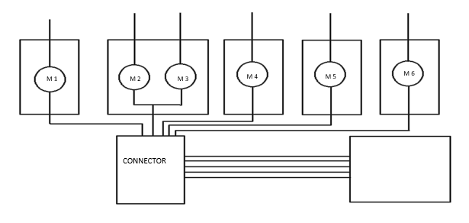

INPUTE: 100V-240V~50/60Hz

OUTPUT: DC 5V 1000 mA

Fig. Vehicle Body

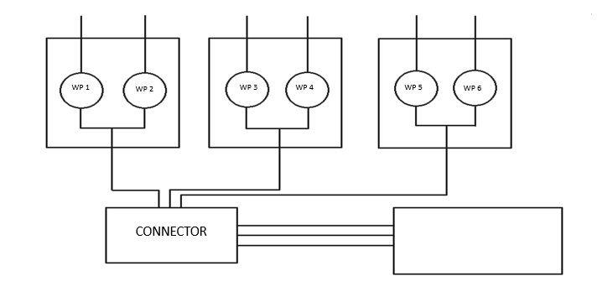

INPUTE: 100V 240V ~ 50/60Hz 0.6A

OUTPUT; 12V 2A

Fig. Robotic Arm

**Voltage Regulation**

Under this topic the voltage regulation and distribution of power supply is shown:

Mainly there are two power supply given to this machine one is for arm and one is for vehicle body. The two power adapter are given one of 5V for arm and one of 12V vehicle body.

This voltage is distributed to the motors and water pumps through the power connectors.

**Interface:**

This topic is added to give idea about how its interfacing can be done in future.

Its coding is done in java using some basic java packages like .awt, awt.event. In this topic, it is shown that how systems will be shown on interface if we want to use it on large commercial basis, how its controller will be, at least which buttons it should contain, if we want to recover the robot from the water or want to find its current location, to know its path, which featured can be handled by operator and which are only reserved for admin.

**Coding :**

import java.awt.*;

import java.awt.event.*;

class Shark1 implements ActionListener,KeyListener

f1.add(b1); // shark 1.1

f1.add(b2); // shark 1.2

f1.add(b3); // shark 1.3

m2.add(mi1);

m8.add(mi8);

mb1.add(m2);

mb1.add(m8);

f1.setMenuBar(mb1);

f2.add(l6);

f2.add(b5); // ^

f2.add(b7); // <

f2.add(b8); // v

f2.add(b9); // >

f2.add(l7);

f2.setMenuBar(mb2);

m4.add(mi4);

m4.add(mi2);

mb2.add(m4);

f2.add(b11); // grab

f2.add(b13); // rotate ri8

f2.add(b15); // arm up

f2.add(b17); // wrist up

f2.add(b12); // relese

f2.add(b14); // rotate left

f2.add(b16); // arm down

f2.add(b18); // wrist down

f4.add(l12);

f4.add(ta3);

f4.add(l5);

f4.add(ta1);

f4.add(b21);

f4.add(l9);

f4.add(b23);

f4.add(ta2);

f4.add(b22);

m7.add(mi6);

m7.add(mi7);

mb4.add(m7);

f4.setMenuBar(mb4);

f5.add(l10);

f5.add(tf5);

f5.add(l11);

f5.add(tf6);

f5.add(b24);

m9.add(mi9);

mb5.add(m9);

f5.setMenuBar(mb5);

m10.add(mi10);

mb6.add(m10);

f6.setMenuBar(mb6);

f6.add(l1);

f6.add(tf1);

f6.add(l2);

f6.add(tf2);

f6.add(l3);

f6.add(tf3);

f6.add(l4);

f6.add(tf4);

f6.add(b25);

f7.add(b26);

f7.add(b27);

f7.add(b28);

b1.addActionListener(this); // shark 1.1

mi1.addActionListener(this);

mi2.addActionListener(this);

mi3.addActionListener(this);

mi4.addActionListener(this);

mi5.addActionListener(this);

mi6.addActionListener(this);

mi7.addActionListener(this);

b26.addActionListener(this);

b9.addKeyListener(this);

b7.addKeyListener(this);

b5.addKeyListener(this);

b8.addKeyListener(this);

f1.setSize(250,300);

f2.setSize(300,250);

f4.setSize(450,500);

f5.setSize(250,225);

f6.setSize(300,400);

f7.setSize(250,300);

f1.setVisible(true);

ta2.setVisible(false);

b22.setVisible(false);

tf6.setEchoChar('*');

f1.setLayout(new FlowLayout());

f2.setLayout(new FlowLayout());

f4.setLayout(new FlowLayout());

f5.setLayout(new FlowLayout());

f6.setLayout(new FlowLayout());

f7.setLayout(new FlowLayout());

}

public void actionPerformed(ActionEvent e)

{

if(e.getSource()==b1)

{

f5.setVisible(true);

}

if(e.getSource()==b25)

{

s5=tf1.getText();

s6=tf2.getText();

s7=tf3.getText();

s8=tf4.getText();

ta3.append(s5+"\n");

ta3.append(s6+"\n");

ta3.append(s7+"\n");

ta3.append(s8+"\n");

}

if(e.getSource()==b26)

{

f6.setVisible(true);

}

}

public void keyPressed(KeyEvent ke)

{

int key= ke.getKeyCode();

switch(key)

{

case KeyEvent.VK_RIGHT:

ta1.append("BODY MOVED RIGHT \n");

ta2.append("MOVE BODY TO LEFT \n");

break;

case KeyEvent.VK_LEFT:

ta1.append("BODY MOVED LEFT \n");

ta2.append("MOVE BODY TO RIGHT\n");

break;

case KeyEvent.VK_UP:

ta1.append("BODY MOVED FORWARD \n");

ta2.append("MOVE BODY BACKWARDS \n");

break;

case KeyEvent.VK_DOWN:

ta1.append("BODY MOVED BACKWARD \n");

ta2.append("MOVE BODY FORWARD\n");

break;

case KeyEvent.VK_Q:

ta1.append("OBJECT GRABBED \n");

break;

case KeyEvent.VK_A:

ta1.append("OBJECT RELEASED \n");

break;

case KeyEvent.VK_W:

ta1.append("ARM ROTATED RIGHT \n");

break;

case KeyEvent.VK_S:

ta1.append("ARM ROTATED LEFT \n");

break;

case KeyEvent.VK_E:

ta1.append("ARM LIFTED UP \n");

break;

case KeyEvent.VK_D:

ta1.append("ARM LIFTED DOWN \n");

break;

case KeyEvent.VK_R:

ta1.append("WRIST UP \n");

break;

case KeyEvent.VK_F:

ta1.append("WRIST DOWN \n");

break;

}

}

public void keyReleased(KeyEvent ke){}

public void keyTyped(KeyEvent ke){}

public static void main(String args[])

{

Shark1 x = new Shark1();

}

}

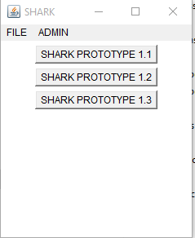 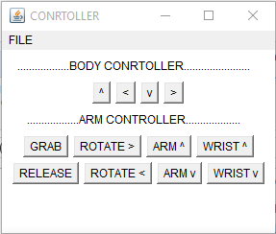

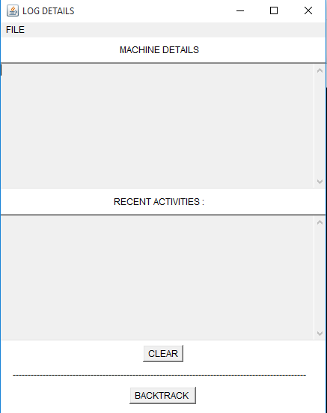

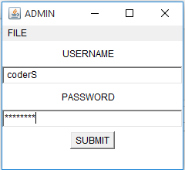 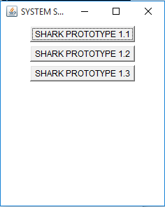

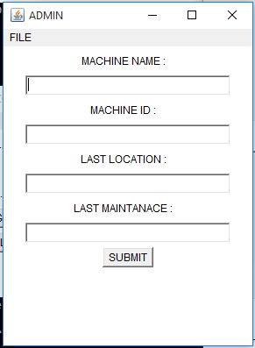

**CHAPTER - 06**

**Performance Evolution and Testing**

**Unit Testing**

Firstly, we tested each component that was going to be used in the system individually. Like testing of water pumps, servo motors, connectors, end effector etc.

The points we discovered during this unit testing phase was that the robotic arm and its body was not able to move with the help of only one water pump because the weight of body was not bearable for only one water pump to move body in forward or backward or for rotating purpose. Here we have decided to make pairing of motors and combining in them in pair of 2-2. Then the 2 major parts are made a vehicle body and robotic arm. Are individual testing of these two parts is done first in dry and in submersed conditions both. Here these both worked successfully.

**Integration Testing**

In integration testing the robotic arm is fixed on vehicle body and the power supply connectors are fixed too the water proofing is done with the help of silicon glue.

After the waterproofing of all the circuits and motors when the whole robotic vehicle is tested in water the functions and features which are to be there were working perfectly but the new problem raised was of weight balancing of robot in submersed condition.

Due to deducted weight of body in water, the weight of vehicle got dis-balanced hence the extra weight is placed where it was needed. Hence floaters are also there which are easily detachable from vehicle body as per requirement.

**Performance evolution**

After the testing when we realized its unevenly distributed weight factor we placed some extra weight on opposite side of arm i.e. its back side. Due to this the ROV got balanced and it was ready for all the operations which were not possible without its balanced weight.

**CHAPTER NO.07**

**Applications**

**Applications:**

In this topic the applications and the fields where it can be implemented are discussed.

Due to the advantage of working in water or any fluid, with some future modifications this robot has limitless applications from oil mining to space research.

This technology can be applicable in following fields:

1. Oceanography
2. Deep under water research
3. Defence application (Especially Navy)
4. Space research
5. Wetland and Wasteland research
6. Above water research

In applications where there is water stated, it is not necessary that it should be water, this machine is able to work in or above any liquid or fluid.

**CHAPTER - 08**

**Conclusion and Future scope**

**Future scope:**

In this section the future modifications and enhancements that can be done are discussed over here:

* Camera:

When the camera and its embedded circuitry is mounted on vehicle body this ROV can be used more effectively for under water research and surveillance purpose.

* GPS:

When this ROV is connected to GPS this vehicle can be located from outside the water or from anywhere through satellite connectivity.

* Upward Forcing pumps:

Like previously explained in electric circuit of vehicle body have 6 water pumps moving it, for future improvement more 2 pumps will be added on it which will pump water in opposite direction which is downward direction to push ROV in upward direction towards surface.

**Conclusion:**

The design of underwater remote controlled robotic Vehicle has been completed. A prototype was build and confirmed functional. This system would make it easier for man to unrivalled the risk of handling dangerous and hazardous in its present environment and workplace. Complex and complicated duties would be achieved faster and more accurately with this design.

**CHAPTER NO: 9**

**Bibliography And References**

**BIBLIOGRAPHY AND REFERENCES**

1. www.electronicprojects.com
2. [www.mkElectikindia.com](http://www.mkElectikindia.com)
3. Magazines-electronics for you
4. <http://seminarprojects.org/t-pick-and-place-robot>
5. [www.wikipedia.com](http://www.wikipedia.com)
6. www.ecropose.com

**TECHMANIA 2016**

WINNERS

(1st Rank in Project Competition Think-Quest)

