FoxxOwl

A Synopsis Submitted

in Partial Fulfillment of the Requirements

for the Degree of

# Bachelor Of Computer Applications

by

# Siddharth Bisht

**Jatin Khadia**

**Devanshi Dogra**

under the guidance of

**Ms. Komal Dhingra**

COMPUTER DEPARTMENT

INTEGRATED INSTITUTE OF TECHNOLOGY

SEC-9, DWARKA, DELHI

# Nov, 2021

**Table of Contents**

1. Introduction

2. Motivation

3. Related Work

4. Objectives Of The Work

5. Technical Details

6. Hardware and software requirement specifications

7. Future Scope

8 .Conclusion

9. ER Diagram

10. Screen-shorts

:

**Synopsis**

1. **Introduction**

There has been a demand for a product , an application which can solve the problem of mock tests , sample papers for the different different government and non government project.

The current trend of research on ed-Tech startup shows us that there is no specific application that solves this problem Several variants of these application are not focused on this . The current project is is to study and develop how these exam web and mobile application works so that we can build them in our forthcoming future .

1. **Motivation**

Motivation goes here -

Our country has too many of government exams and the craze for it is too much but in the ed – tech market in this digital age too there is no stable application by which the aspirants can practice for the exams. In the modern era of 2021 the aspirants have to go to the local market and ask for the books for the preparation and mock exam of that particular government exam. Therefore we felt like there is a need for such application in the market .This is a pain point of many that we can see around us.

1. **Related work**

Before starting this project our team has made many different google forms to know the need for this project and if something like this is required in the market or not.

Other then that we had previously observed people to go to the local book store and ask for the sample paper books and wait until its available and also finding the papers is also tough since too many sites takes extra permission and shows non relevant ads.

1. **Objectives of the work**

The objective of this project is to make a well focused web application (maybe a demo for this time and upgraded version in the future and mobile application too) so that the aspirants can find all the sample paper and mock exam papers at one place without suffering through the whole internet and make a business model in the future out of it.

**5. Technical Details**

This project is mainly developed using HTML , CSS , JavaScript , JSON.

We are gonna develop API to fetch data ( Questions and choices ) from the JSON file and are going to use external API’s for external data too. Some CSS frameworks will also be used for the beauty of the front-end. The score of the users performance will be calculated and stored using the local storage

**6.Hardware and Software Requirement Specifications**

Write hardware and software requirement specifications.

The hardware required for the project are our team members own laptops for programming and WiFi router for remote work since we all are in different cities. Many software are used for the communication and development as follows -

1. Zoom – for planning and discussing about the project and connecting virtually through video calls our team used Zoom application which is also used in the tech industry for the same.

2. Slack – for the communication in the form of texts and images and also for data sharing except the code we used slack and we could use other applications too but we choose it during a discussion because it is also used in the industry.

3. Visual Studio Code – for the real work to be done that is programming we used the IDE called visual studio code . The two main reasons to choose this IDE only over the others are

a. We used it before in our college therefore we are comfortable in it.

b. It is widely used in the industry .

This software gave us support by its vast extensions some of them are

Live Server (main feature hot reload)

Prettier (format the code in ES6 the industry standard )

4. Git Bash – for the use of terminal for the Linux commands since 1 of our teammate uses Linux Operating System (Ubuntu) and it is beneficial to use these commands over windows commands (commands of Windows Power shell etc ) since again because of industry standards – most of the startups in India provide mac book to their developers , the terminal of which also works on Linux commands and other companies also suggest to use Linux over windows at least for Command Line Interface.

5. Git Hub – To deploy and share our code , it has many features like making branches and work separately together . To take the snapshot of that particular instant of the code for the future and other features like staging area , commit , clone and a remote code sharing system.

1. **Future Scope**

The MVP version the project and its corresponding later versions can be used by the aspirants so that instead of finding papers in the whole web they can simply use a single website and study and practice without distractions .

1. **Conclusion**

This project is made with the idea of having a web application where the aspirants can practice with the sample papers of their particular exam.

**7 . ER Diagram For FOXXOWL**

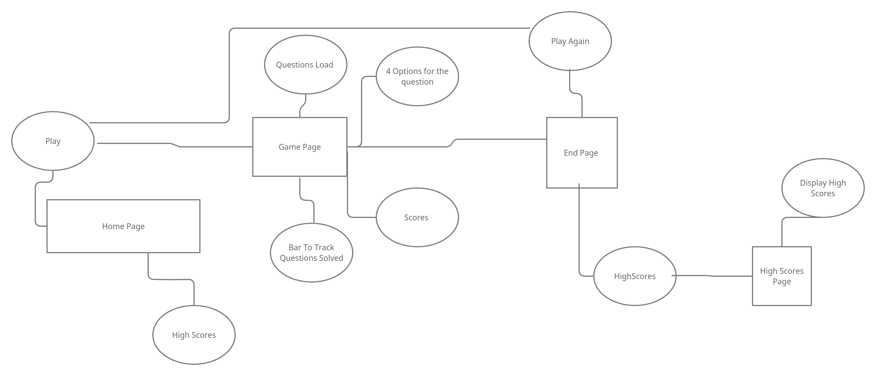

**8. Screen-shorts**

Mobile :-

