Core_Java_Question_Answer

1).Who developad java programming Language.
Ans--:Java is a computer programming language. Java was created by James Gosling in 1990
2).What is java so popular.
Ans--:Java is so popular is the platform independence. Programs can run on several different types of computer; as long as the computer has a Java Runtime Environment (JRE) installed, a Java program can run on it.
3).What is platform independent.
Ans--:Java is a platform independent language meaning we run the same code on multipal platform java achive the JVB and byte code java convert the programming langugage code in to byte code byte code is the platform independent can be run of the any process.
4).What is byte code.
Ans--:Byte Code in java is a set of instructionfor the java vartual machain . Byte code is a platform independent code

The JVM, which is part of the Java Runtime Environment, interprets the bytecode and converts it to machine language specific to the intended platform.
Systax--:
Byte a=10;
System.out.println(a) ;

5).Compare JDK vs JRE vs JVM.
Ans--:JDK(Java development kit) is the tool neccessary to compile document and java program the jdk completely includes jre.
Ans--:JRE(Java runtime envarnment) is a runtime Envarnment which emplement jvm provides all class libraries and other file the jvmuse to run time.
Ans--:JVM(Java Virtual machain)is an the abstract machin. It is a Spicification that provide runtime envanmentin which java byte code can be executed.

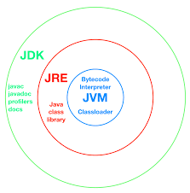

6).What is Token How many type.
Ans--:Token is a smallest element of a program that is a identifiy TOKEN--:Keyward, Identifiy, Operator, Seprator, Itteral;
7).Define the datatype and its type,
Ans--:Data type in java represent the size and deffrent value can be stored in a varible a java type is a set of value and operation defined other value,
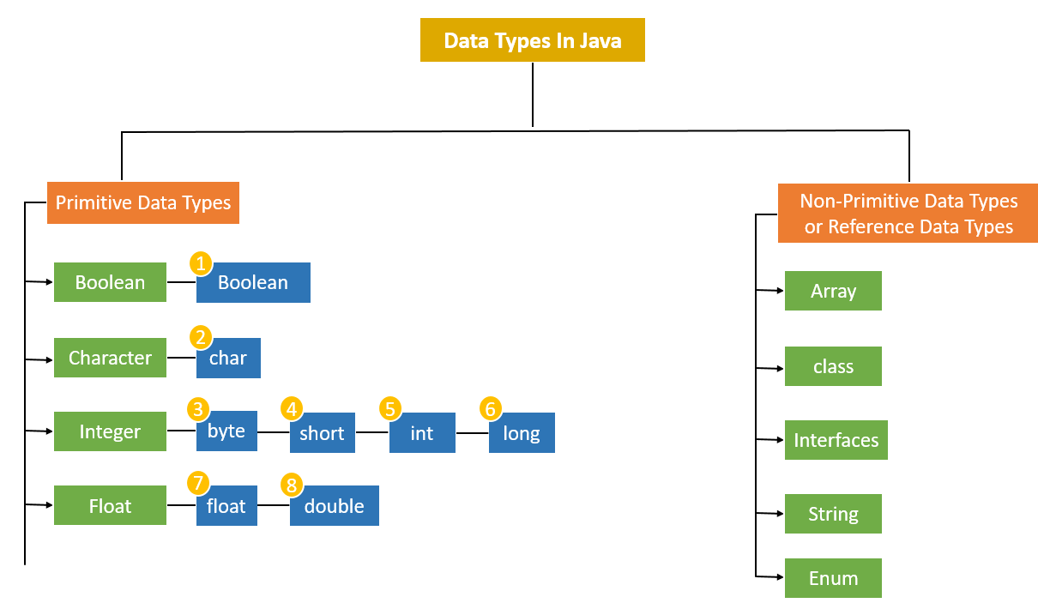
8).What are deffirent type of operator,
Ans--:Operators in Java are the special type of tokens in Java which when coupled with entities such as variables or constants or datatypes result in a specific operation such as addition, multiplication or even shifting of bits.

https://data-flair.training/blogs/java-operators/
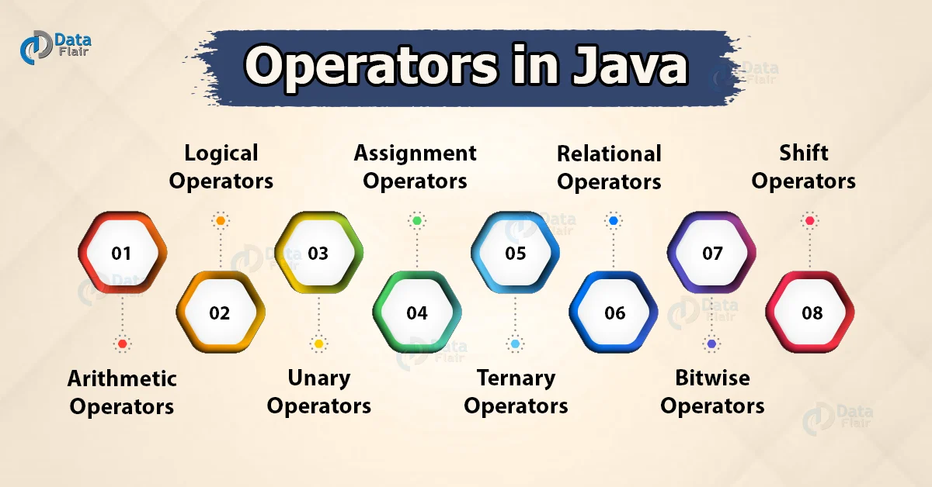

9).What is casting,
Ans--:Casting mense one value ko dusri value ko exchange do it as known as casting
They are two type casting,
Widening Casting(automatically) - converting a smaller type to a larger type size
byte->short->char->int->long->float->doubl
Narrowing Casting(manually) - converting a larger type to a smaller size type
double->float->long->int->char->short->byte

10).What is implicit casting,
Ans--:The process is the converting one type is varivle an object they can not change the value but they will be exchange variable value ,
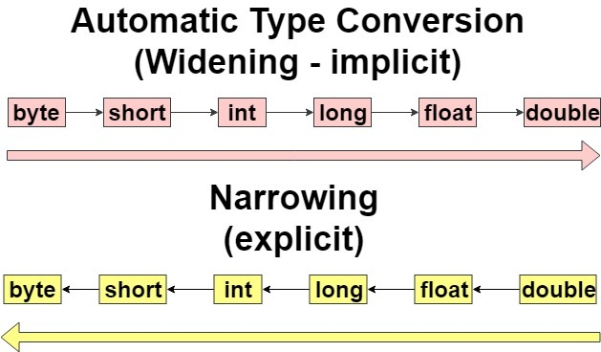
11).What is Explicit casting,
Ans--:Explicit is a difined of the variable and they can be forced anothe variable exe-:int=a;
they can we put float is a force float(a);
12).What is array and diffrent type of array,
Ans--:Array is the collection of the similar data type and contiguas of the memory location.
They are type of array,
Single Dimensional Array.
in Java is a collection of similar types of elements stored at contiguous memory locations
MultiDimensional Array.
multidimensional arrays are stored in tabular form (in row and culam)
13).Explain the array class method.
Ans--:This class provides static methods to dynamically create and access Java arrays. It consists of only static methods and the methods of Object class.
15).What is jugged Array,
Ans--:Jagged Arrays are special types of Multidimensional arrays which have variable number of columns. It is an array of arrays where each element is an array and can be of a different size.
14).Diffirent b/w length and length(),
Ans--:
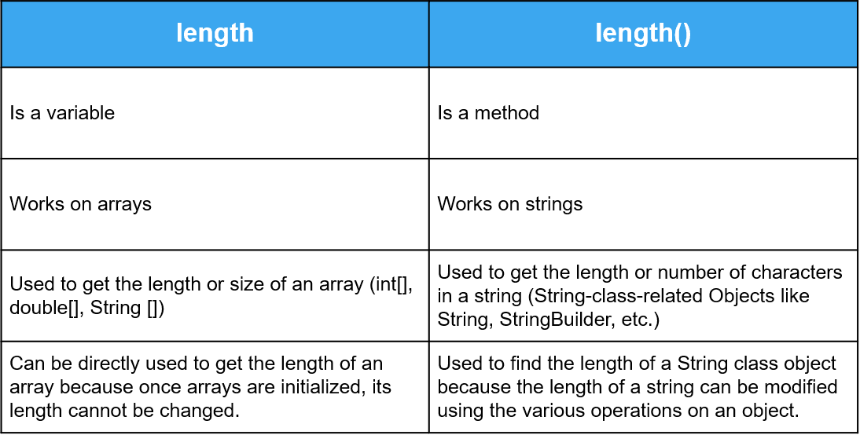
16).What is class,
Ans--:class is a group of objects which have common properties. It is a template or blueprint from which objects are created.

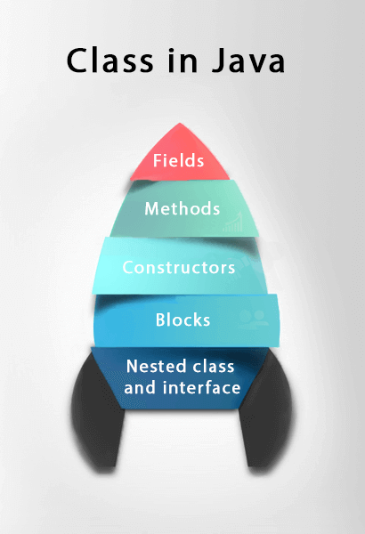

17).What is object,
Ans--:Object is areal ward entitythat has state and behavior is known as an object,
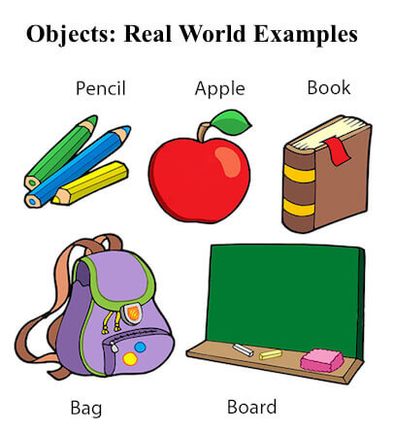

18).what is a state of object,
Ans--:The state or attributes are the built in characteristics or properties of an object. For example, a T.V has the size, colour, model etc.
19).What is behiver of an object,
Ans--:The behavior or operations of an object are its predefined functions. For example, a T.V. can show picture , change channels,
20).What is different type of variable in java.
Ans--:There are three types of variables in Java:Local, Instance, and Static.
Local varible-:local varible id defined method body,,Instance--:instance varible is a defined class ke andar.
21).What are different type of method in java,
Ans--:There are two types of methods in Java:Predefined Method.User-defined Method.
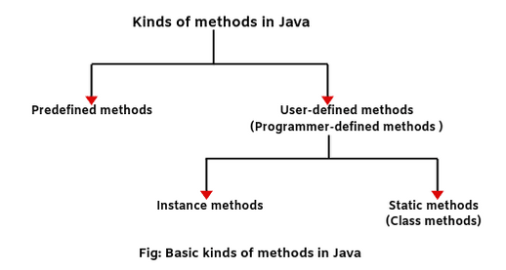

22).Explain Inheritance with Exemple
Ans--:Inheritance in java is a machainsum in which one object and query all property and behaviour of a prent object,
23).What is method overloading,
Ans--:Method overloading is method method overloading declare in a class ,As name same and different argument and perameter,
24).Method overriding,
Ans--:Declaring a method in the subclass which already exists there in the parent class is known as method overriding. When a class is inheriting a method from a superclass of its own, then there is an option of overriding the method provided it is not declared as final.
25).Can you achive method overriding on static method,
Ans--:
26).What is Upcasting,
Ans--:Upcasting is the typecasting of a child object to a parent object. Upcasting can be done implicitly. Upcasting gives us the flexibility to access the parent class members but it is not possible to access all the child class members using this feature.
27).What is method hiding,
Ans--:Method hiding can be defined if a sub class difined a static method with the same signature as a static method in the super class.in the such case in the method of the subclass hide the one of the super class,the machainsum as known as the method hiding,
28).Can supr class refrence variable hold an obj on sub class,
Ans--:
29).Multipal inheriatance allow in java.
Ans--:Java supert multipal inheriatance the ablity of a class to implement more then one interface
30).What is Constructors,
Ans--:A constructor in Java is a special method that is used to initialize objects. The constructor is called when an object of a class is created.Java cannot be abstract, static, final or synchronized and these modifiers are not allowed for the constructor.
31).What is a default Constructors,
Ans--:Default Constructord is a constructor that has either no parameter all the parameter have default value if there is no constructor class compiler autometically create difault constructor,
32).How do you Super class Constructor from sub class Constructor,
Ans--:
33).What is use of the This(),
Ans--:This key ward is used to refer to courent object thought which the method is called this() is call is constructor frome the other of the class,.
34).Is a super class constructor called even when one is no explict call from a sub class constructor,
Ans--:
35).What is polymorphism,
Ans--:Polymorphism is a one performence task is diffrent way As known as the polymorphism.

36).What is use of the instance of operator in java,
Ans--:
37).What is encapsulation,
Ans--:Encapsulation is defined as tha Warpping up of data under a single unit.it is the machainsum that baind together code and tha data,
38).What is a interface,
Ans--:The interface in Java is a mechanism to achieve abstraction. There can be only abstract methods in the Java interface, not method body. It is used to achieve abstraction and multiple inheritance in Java.
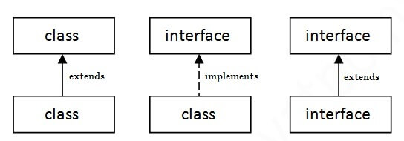
39).How do you define an interface,
Ans--:The interface keyword is used to declare a special type of class that onlycontains abstract method,
41).How do you implement interface,
Ans--:Declare a class that implements an interface you include an implements clause in the class declaration.your class can implement more then one interface,
interface Demo{
void print();
}
class A1 implement Demo{
public void print(){
System.out.println(“hello”);
}
public static void main(String args[]){
A1 obj = new A1();
obj.print();
}
}

40).What else u know about interface
Ans--:Interface is a shared boundary across which two or more separate components of a computer system exchange information.
42).can you extend interface
Ans--:An interfacecan extend other interface just as a class subclass or extend another class where a class can extend only one other class an interface can extend only number of interface,

43). Can a class extend multipul interface;
Ans--:A class can extend only one class but implement many interface An interface can extend another interface can extend another interface in a similar way as a class can extend another class.

Abstract methods are those types of methods that don't require implementation for its declaration.
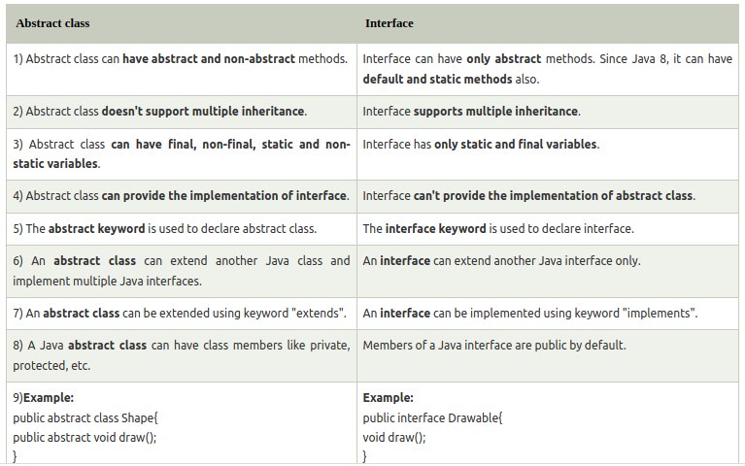
.

49).What is inner class.
Ans--:Inner class is a defined inside of the another class

//object create inner class ka
Outer.Inner a=new Outer().Inner();
50).Static inner class.
Ans--:Ststic inner class is a nested class which is a ststic member of the outer it can be accessed without instantiating the outer class using other static member.

Exemple--:
class Outer{
class Inner{
void run(){
System.out.println(“hello”);}}}
class main{
psvm(){
outer.Inner A=new Outer().Inner();
A.run();
}}

equal contain check; contain same true
== refrence check; same refrence, same location sem true

51).What is a inner class.
Ans--:Inner class in java is difined as the class that is declared inside the another class.
52).Local inner class.
Ans--:Local inner class is the inner class that are defined inside a block.genearly a block is a method body.
53).What is a anonymous class.
Ans--:Anonymous class must be defined in side a another class is know as the anonymous inner class.
class Polygon {
public void display() {
System.out.println("Inside the Polygon class");
}
}

class AnonymousDemo {
public void createClass() {

// creation of anonymous class extending class Polygon
Polygon p1 = new Polygon() {
public void display() {
System.out.println("Inside an anonymous class.");
}
};
p1.display();
}
}

class Main {
public static void main(String[] args) {
AnonymousDemo an = new AnonymousDemo();
an.createClass();
}
}
https://oodlescoop.com/tutorials/java/string-programs;jsessionid=C9016A47400322AD6AEBEDBCEEC4DBFD---:Stringpro
54).What is default class modifiers
Default access modifier means we do not explicitly declare an access modifier for a class, field, method, etc.
55).What is a private access modifires
Ans--:private access modifire is tha accessible only withen the class.for example, we have created two classes A and Simple. A class contains private data member and private method. We are accessing these private members from outside the class, so there is a compile-time error.
56).What is default and acces modifire
Ans--:access modifiers are used to set the accessibility (visibility) of classes, interfaces, variables, methods, constructors, data members, and the setter methods.
For example, class Animal {
public void method1() {
...}
private void method2() {
...}
}
57).What is default package acces modifire
Ans--:We do not explicitly declare an access modifier for a class, field, method, etc.
58).What is protected acces modifire
Ans--:
59).What is public acces modifire.
Ans--:public access modifier is the direct opposite of the private access modifier. A class, method or variable can be declared as public and it means that it is accessible from any class. Public access modifier can be likened to a public school where anyone can seek admission and be admitted
60).What acces type of varibles can be accessed from a class in same package,
Ans--:Variables, methods, and constructors, which are declared protected in a super class can be accessed only by the subclasses in other package or any class within the package of the protected members' class.
61).What acces type of varibles can be accessed from a class in dffrent package,
Ans--:
62).What acces type of varibles can be accessed from a Sub class in same package,
Ans--:
63).What is acces type of varibles can be accessed from a sub class in diffrent package,
Ans--:Variables, methods, and constructors, which are declared protected in a superclass can be accessed only by the subclasses in other package or any class within the package of the protected members' class.
64).Wtha is use of final modifire on a varible
Ans--:The final modifier keyword makes that the programmer cannot change the value anymore. The actual meaning depends on whether it is applied to a class, a variable, or a method.

65).What is use of final modifire on a class
Ans--:The final modifier keyword makes that the programmer cannot change the value anymore. The actual meaning depends on whether it is applied to a class, a variable, or a method.

Afinalclass cannot have subclasses. An example:
public final class MathConstants {
...
}
65).What is use of final modifire on a method
Ans--: final modifier keyword makes that the programmer cannot change the value anymore.
66).What is final Argument,
Ans--:final keyword is used with a variable of primitive data types such as int, float, etc)the value of the variable cannot be changed
67).What is atatic varible,
Ans--:Static variables are, essentially, global variables. All instances of the class share the same static variable.
NOT--:A static int variable remains in memory while the program is running
68).Should default be the last case Switch Statement,
Ans--:The default statement doesn't have to come at the end. It may appear anywhere in the body of the switch statement. A case or default label can only appear inside a switch statement. The type of switch expression and case constant-expression must be integral.
69).What is an enhance for loop
Ans--:The for-each loop is used to iterate through elements of arrays and collections (like ArrayList). It is also known as the enhanced for loop.
70).what are the default value in array
Ans--:
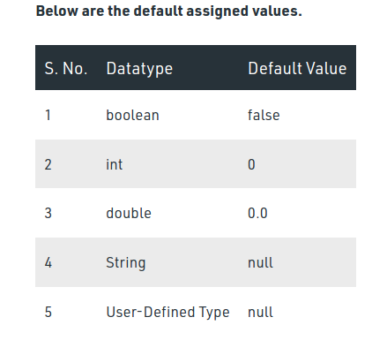

71).How many ways are there to read input through the keyboard?
Ans--:
72).Diffrent b/w Final and finaly and finalize in java,
Ans--:The final, finally, and finalize are keywords in Java that are used in exception handling. Each of these keywords has a different functionality. The basic difference between final, finally and finalize is that the final is an access modifier, finally is the block in Exception Handling and finalize is the method of object class.
73).What are the Wapper calsses,
Ans--:Wrapper class is a class whose object wraps or contains primitive data types.
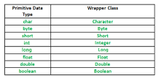
74).What do we need Wapper Classes.
Ans--:wrapper classes in java can be used when it is required to use the primitive types as objects. Moreover, wrapper classes also contain methods that unwrap the object and return the data type. The classes only handle objects in java. util package.
75).int a= 10;
Ans--:
76).Integer l=a;//autoboxing
Ans--:
77).
Ans--:
78).What is casting,
Ans--:Type casting is when you assign a value of one primitive data type to another type. In Java, there are two types of casting: Widening Casting (automatically) - converting a smaller type to a larger type size. byte -> short -> char -> int -> long -> float -> double.
79).What is string imutable,
Ans--:The string is immutable means that we cannot change the object itself, but we can change the reference to the object.The string is made final to not allow others to extend it and destroy its immutability
public class ImmutableStrings {
public static void main(String[] args) {
testmethod();
}
private static void testmethod() {
String a = "a";
System.out.println("a 1-->" + a);
a = "ty";
System.out.println("a 2-->" + a);
}
}
80).What are String value stored in memory
Ans--:Strings are stored on the heap area in a separate memory location known as String Constant pool. String constant pool: It is a separate block of memory where all the String variables are held. String str1 = "Hello"; directly, then JVM creates a String object with the given value in a String constant pool.
81). What is the difference b/w String and StringBuffer and StringBuilder classes
Ans--:A thread-safe, mutable sequence of characters. A string buffer is like a String, but can be modified. At any point in time it contains some particular sequence of characters, but the length and content of the sequence can be changed through certain method calls.
String buffers are safe for use by multiple threads.
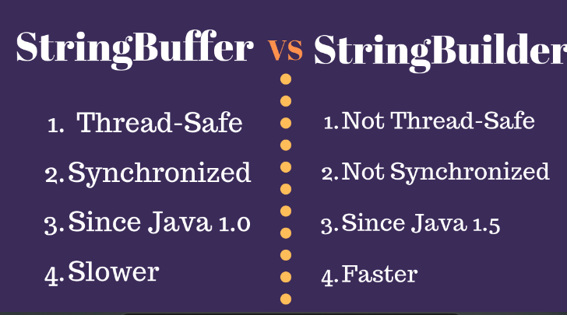
82). Explain about toString() method
Ans--:Tostring method in built is a method and java that the return value of the string format.
83). What is the use of equals method in java
Ans--:Equal is a refrence check(Seme location and same name);
84). What is the use of hashCode() method
Ans--:The hashCode() method is defined in Java Object class which computes the hash values of given input objects. It returns an integer whose value represents the hash value of the input object.
85). How do you print contents of an Array
Ans--:Array is the collection of the similar data type of the continous of the memmory location.
86).What is d/w c++ and java,
Ans--:C++ is only a compiled language while Java is both compiled and interpreted.

87).What is a role of classloder in java
Ans--:ClassLoader is a part of the Java Runtime Environment that dynamically loads Java classes into the Java Virtual Machine. The Java run time system does not need to know about files and file systems because of classloaders.
88).What is deffrent Wrapper class instance.
Ans--:Wrapper Class a class whose object wraps or contains primitive data types
89).Creating the Wrapper class
Ans--:
90).What is out Boxing.
Ans--:Autoboxing is the automatic conversion that the Java compiler makes between the primitive types and their corresponding object wrapper classes.
91).What is advantage of auto boxing,
Ans--:Autoboxing and unboxing lets developers write cleaner code, making it easier to read. The technique lets us use primitive types and Wrapper class objects interchangeably and we do not need to perform any typecasting explicitly
92).
Ans--:
93).Utility and method class,
Ans--:utility class is a class that defines a set of methods that perform common, often re-used functions. Most utility classes define these common methods under static (see Static variable) scope. Examples of utility classes include java.
94).
Ans--:
95).What is coupling,
Ans--:Coupling is nothing but the dependency of one class on the other. If one object in a code uses the other object in the program, it is called loose coupling in Java. In coupling, two classes or objects collaborate and work with each other to complete a pre-defined task.
96).What is cohesion,
Ans--:Cohesion in Java is the Object-Oriented principle most closely associated with making sure that a class is designed with a single, well-focused purpose
97).Why should you alway use block around if statement,
Ans--:
Without curly brackets,you could accidentally write a semicolon after the IF-statements. The semicolon is a valid, empty statement, which will be "execute" instead of the actual (intended) one.

98).How do you loop around an array usingenhence for loop
Ans--:loop through the array elements with the for loop, and use the length property to specify how many times the loop should run.
99).What is compare to array
Ans--:A simple way is to run a loop and compare elements one by one. Java provides a direct method Arrays.equals() to compare two arrays.
100).What is Enum,
Anss--:An enum is a special "class" that represents a group of constants

