googletest ref sheet (2013-03-18)

Links
http://code.google.com/p/googletest/
http://code.google.com/p/googletest/wiki/Documentation

Basic test
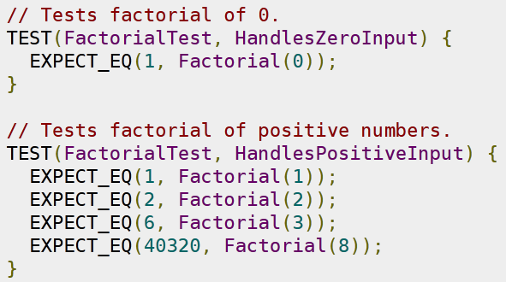
Test names
- NO UNDERSCORES
- prefix name with DISABLED_ to disable it

Runner
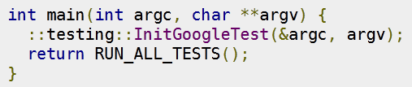
Exec flags
(no flags) : runs all tests.
--help
--gtest_list_tests list available tests
--gtest_filter=* Also runs all tests. (match all)
--gtest_filter=FooTest.* Runs everything in test case FooTest
--gtest_filter=*Null*:*Constructor* Runs any test whose full name contains either "Null" or "Constructor"
--gtest_filter=-*DeathTest.* Runs all non-death tests
--gtest_filter=FooTest.*-FooTest.Bar Runs everything in test case FooTest except FooTest.Bar
--gtest_also_run_disabled_tests also run DISABLED_ tests
--gtest_repeat=1000 repeat test 1000 times (useful for 'random' errors)
--gtest_repeat=-1 repeat forever
--gtest_break_on_failure stop on first failure with a breakpoint (useful in combination with --gtest_repeat)
--gtest_shuffle to check if tests are really independant (used pseudo-random seed will be displayed)
--gtest_random_seed=SEED to repeat a failed shuffled test
--gtest_catch_exceptions=0 disable unexpected exceptions catching, very useful in debug

Good debug flags : (when trying to find and correct errors)
--gtest_catch_exceptions=0 --gtest_break_on_failure --gtest_also_run_disabled_tests --gtest_shuffle

Assertions : Fatal assertions will stop the current unit test while nonfatal allow it to continue and catch multiple failures at once
⇨ Use fatal only when subsequent expectations depends on this one
Nonfatal (use them first) | Fatal (only when needed) | Verifies :
Basic assertions
EXPECT_TRUE(condition); | ASSERT_TRUE | condition is true
EXPECT_FALSE(condition); | ASSERT_FALSE | condition is false
Binary comparison
EXPECT_EQ(expected, actual); | ASSERT_EQ | expected == actual  please note the correct order of args
EXPECT_NE(val1, val2); | ASSERT_NE | val1 ≠ val2
EXPECT_LT(val1, val2); | ASSERT_LT | val1 < val2
EXPECT_LE(val1, val2); | ASSERT_LE | val1 ≤ val2
EXPECT_GT(val1, val2); | ASSERT_GT | val1 > val2
EXPECT_GE(val1, val2); | ASSERT_GE | val1 ≥ val2
C string comparison
EXPECT_STREQ(expected_str, actual_str); | ASSERT_STREQ | the two C strings have the same content
EXPECT_STRNE(str1, str2); | ASSERT_STRNE | the two C strings have different content
EXPECT_STRCASEEQ(expected_str, actual_str); | ASSERT_STRCASEEQ | the two C strings have the same content, ignoring case
EXPECT_STRCASENE(str1, str2); | ASSERT_STRCASENE | the two C strings have different content, ignoring case
Exception assertions
EXPECT_THROW(statement, exception_type); | ASSERT_THROW | statement throws an exception of the given type
EXPECT_ANY_THROW(statement); | ASSERT_ANY_THROW | statement throws an exception of any type
EXPECT_NO_THROW(statement); | ASSERT_NO_THROW | statement doesn't throw any exception
Predicate assertions (for better error messages)
EXPECT_PRED1(pred1, val1); | ASSERT_PRED1 | pred1(val1) returns true
EXPECT_PRED2(pred2, val1, val2); | ASSERT_PRED2 | pred2(val1, val2) returns true
EXPECT_PRED_FORMAT1(pred_format1, val1); | ASSERT_PRED_FORMAT1 | pred_format1(val1) is successful
EXPECT_PRED_FORMAT2(pred_format2, val1, val2); | ASSERT_PRED_FORMAT2 | pred_format2(val1, val2) is successful
Floating-point comparison
EXPECT_FLOAT_EQ(expected, actual); | ASSERT_FLOAT_EQ | the two float values are almost equal
EXPECT_DOUBLE_EQ(expected, actual); | ASSERT_DOUBLE_EQ | the two double values are almost equal
EXPECT_NEAR(val1, val2, abs_error); | ASSERT_NEAR | the difference between values doesn't exceed the given absolute error
Windows HRESULT assertions
EXPECT_HRESULT_SUCCEEDED(expression); | ASSERT_HRESULT_SUCCEEDED | expression is a success HRESULT
EXPECT_HRESULT_FAILED(expression); | ASSERT_HRESULT_FAILED | expression is a failure HRESULT
Type assertions
::testing::StaticAssertTypeEq<T1, T2>();
Death tests
EXPECT_DEATH(statement, regex`); | ASSERT_DEATH | statement crashes with the given error
EXPECT_DEATH_IF_SUPPORTED(statement, regex`); | ASSERT_DEATH_IF_SUPPORTED | if death tests are supported, verifies that statement crashes with the given error; otherwise verifies nothing
EXPECT_EXIT(statement, predicate, regex`); | ASSERT_EXIT | statement exits with the given error and its exit code matches predicate

Custom failure messages :
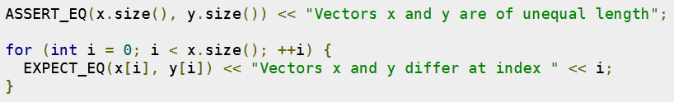
Brought to you by Offirmo
www.offirmo.net

To the extent possible under law, Offirmo has waived all copyright and related or neighboring rights to googletest reference sheet.

TODO : fixtures
TODO : Predicate Assertions for Better Error Messages
TODO : Teaching Google Test How to Print Your Values
TODO : Value-Parameterized Tests
TODO : Type-Parameterized Tests

Google Test http://code.google.com/p/googletest/issues/detail?id=38

Printing instructions :

- Don't print this page and subsequent pages
- Print in color if possible (color is information, color increases information density)
- Ask your print manager to NOT RESIZE or FIT the content (especially adobe reader which tend to do that)
- print in recto/verso "across short size"

After printing :
- Fold along the lines
- Share !
- Send me a token of appreciation for my hard work (facebook like, paypal, etc.)
- Contribute

http://code.google.com/p/googletest/wiki/FAQ#Why_should_not_test_case_names_and_test_names_contain_underscore

