Report

On

Web Hosting

COHDSE182f006 – S. M. Lagamuwa

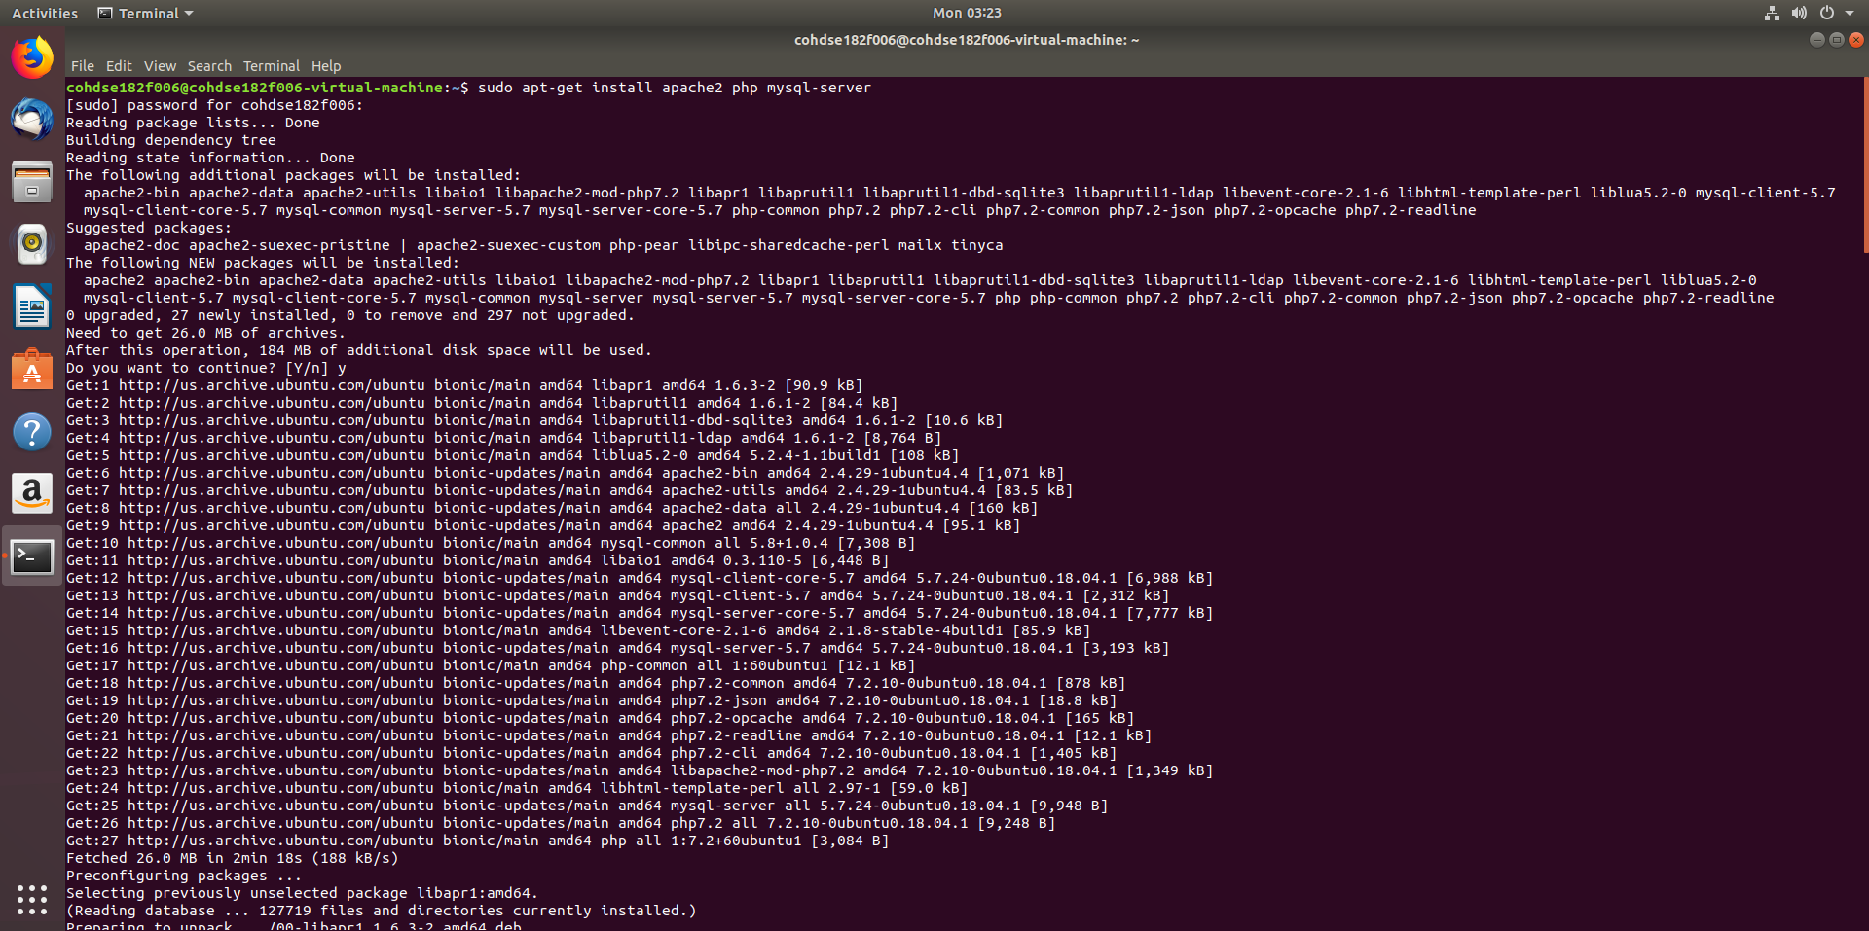

This diagram shows installing of apache2 , php and mysql-server in the ubuntu OS

* sudo apt-get install apache2 php mysql-server

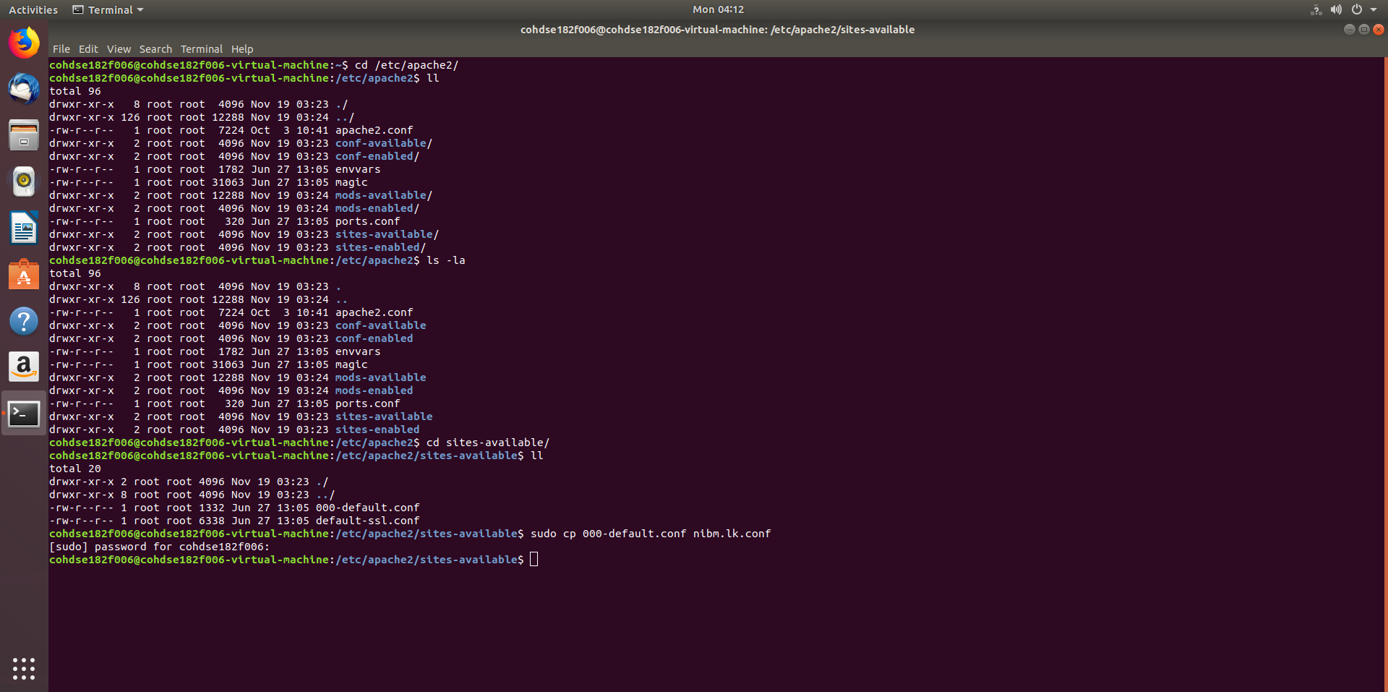

In here a copy of the default server configuration file is made as nibm.lk.conf in the folder at /etc/apache2/sites-available

* sudo cp 000-default.conf nibm.lk.conf

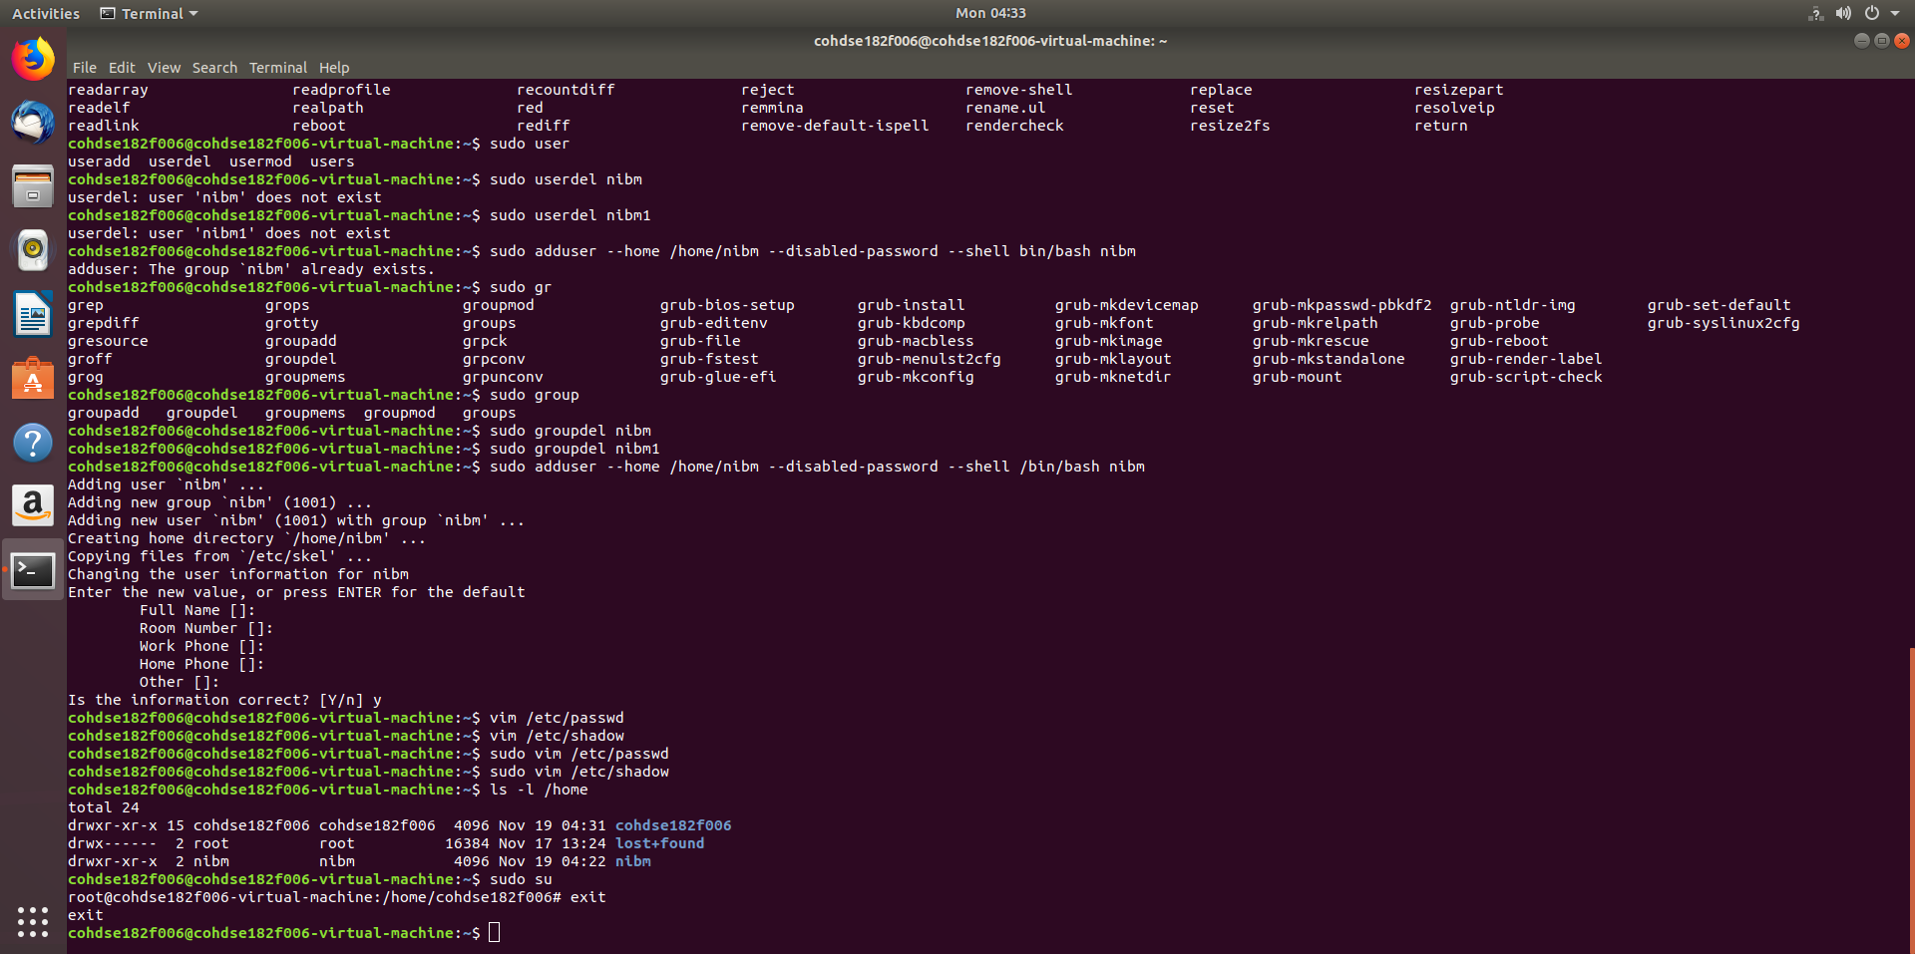

Now a new user without a legal password is formed. The password is disabled to enhance security to the server

* sudo adduser --home /home/nibm --disabled-password --shell /bin/bash nibm

The new user is accessed through the root user

* sudo su
* su – nibm

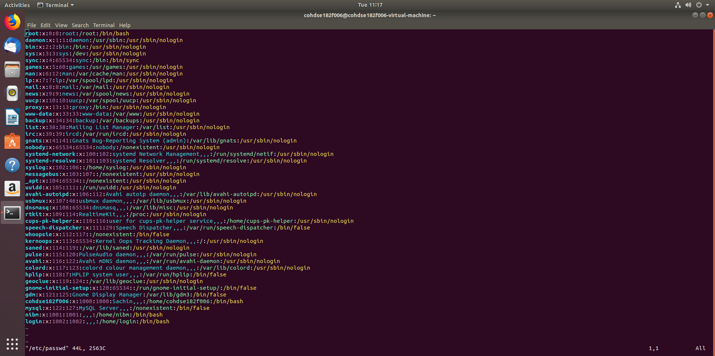

/etc/passwd file

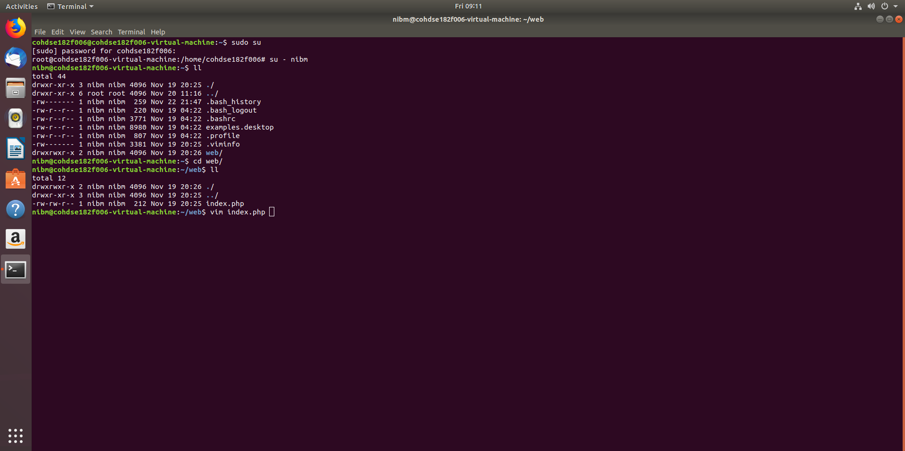

Here a directory called ‘web’ is created to keep the files that the server is hosting

Eg: html,php,js

* mkdir web

In the web directory the file index.php is created to hold the first web page

* vim index.php

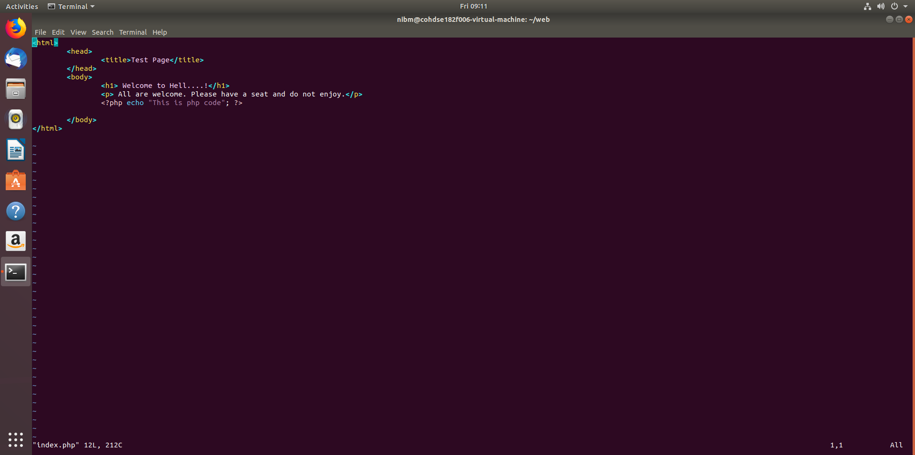

index.php file

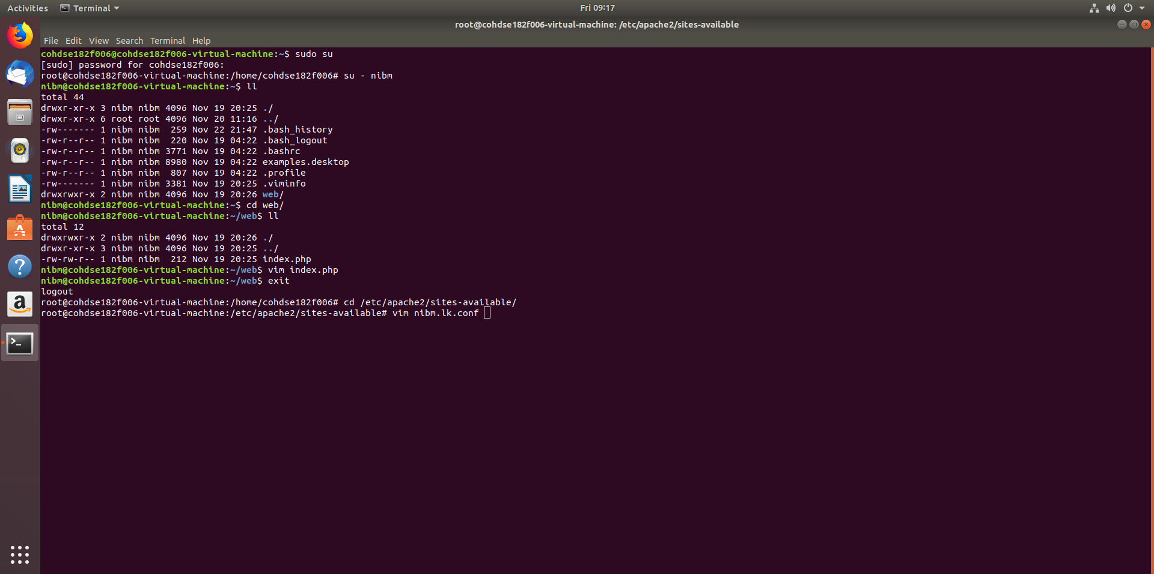

Now log out to the root user and go to directory /etc/apache2/sites-available/ and display the nibm.lk.conf file that we copied earlier.

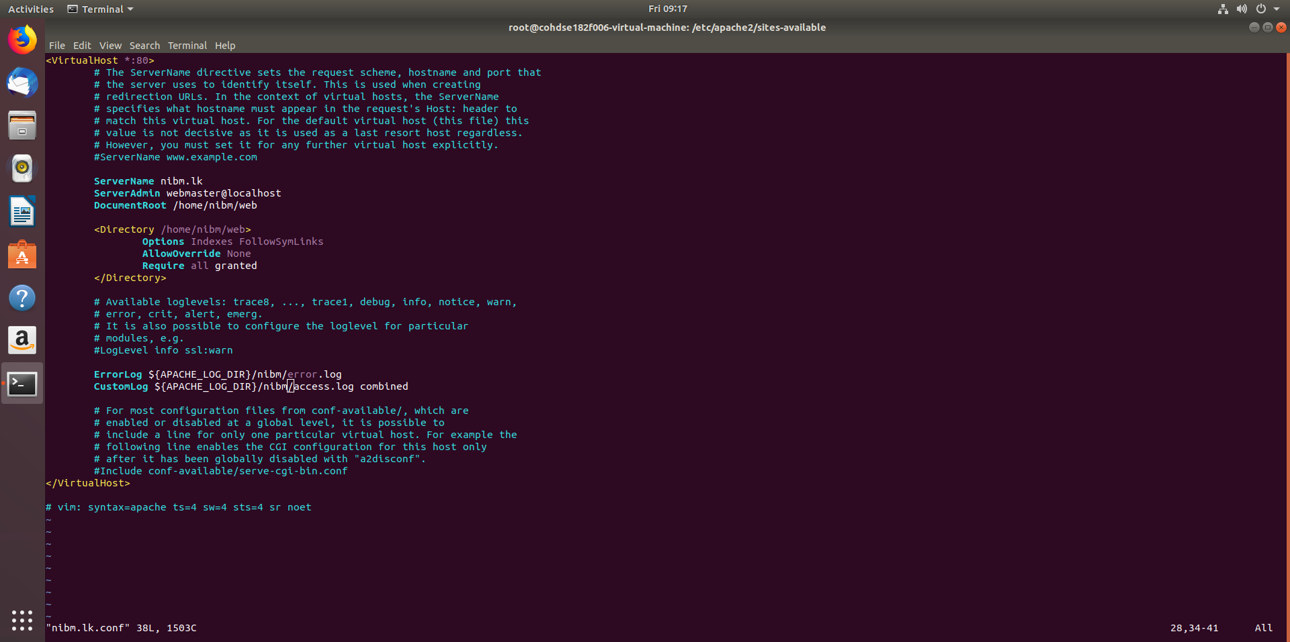

In here Add

ServerName nibm.lk

ServerAdmin webmaster@localhost

DocumentRoot /home/nibm/web

<Directory /home/nibm/web>

Options Indexes FollowSymLinks

AllowOverride None

Require all granted

</Directory>

ErrorLog ${APACHE_LOG_DIR}/nibm/error.log

CustomLog ${APACHE_LOG_DIR}/nibm/access.log combined

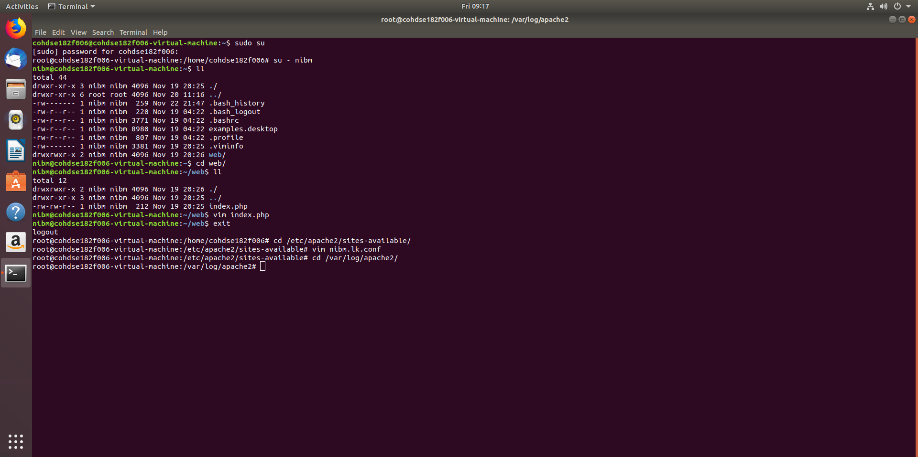

Now go to /var/log/apache2/

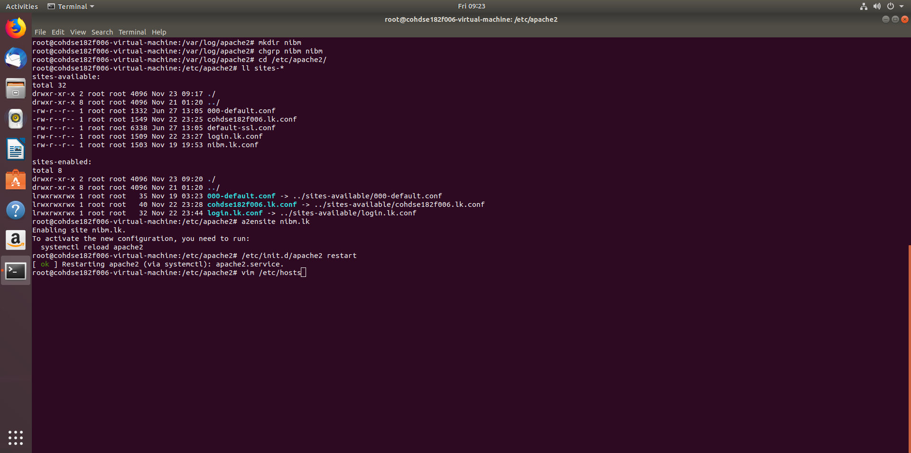

Make a directory named ‘nibm’ and change group to ‘nibm’

* mkdir nibm
* chgrp nibm nibm

Now go to /etc/apache2/ and enable nibm.lk website

* a2ensite nibm.lk

Now restart the apache service

* /etc/init.d/apache2 restart

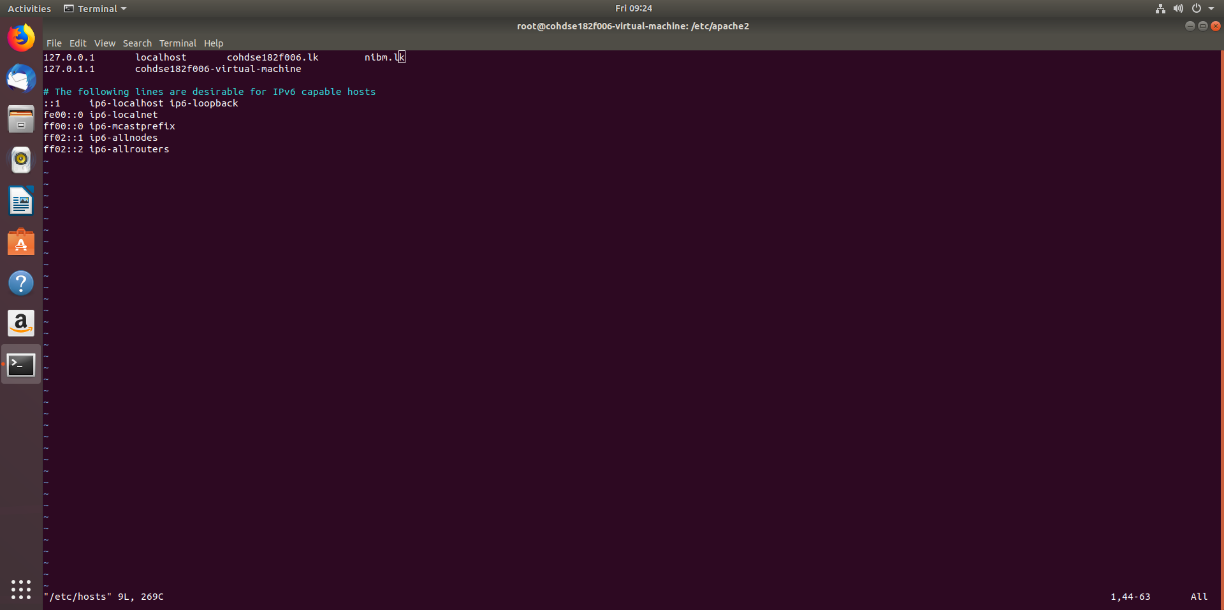

Assign IP for nibm.lk

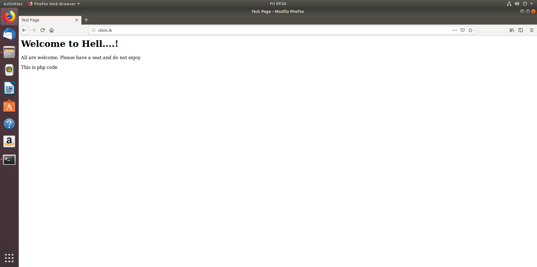

Run nibm.lk in web browser