Major HW 3 – Regression

Orad Barel, 311288203, [oradbarel@campus.technion.ac.il](mailto:oradbarel@campus.technion.ac.il)

Ofir Manor, 316084623, [ofir.manor@campus.technion.ac.il](mailto:ofir.manor@campus.technion.ac.il)

**Q1.**

**Q2.**

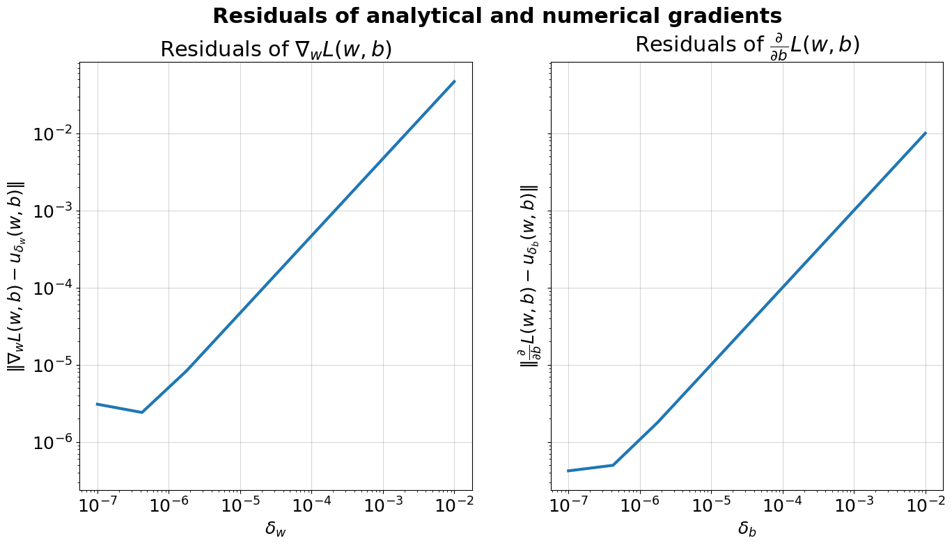

**Q3.**

We see here that from the most part (excluding ), the higher the learning rate, the faster the descent of the loss is. This makes sense because small learning rates create a slow gradient descent, so that we arrive at the minimum of the loss only after a great number of iterations. As for we can see that the loss is divergent after a few iterations, the large “jumps” that occur do not allow the gradient descent to arrive at a minimal loss.

Our best learning rate (the one that achieved the minimal validation loss) is . It does not make sense to increase the number of gradient steps as it seems to achieve this minimum before step 1500 and slightly diverge around the minimum.

**Q4.**

|  |  |  |  |
| --- | --- | --- | --- |
| Model | Section | Train MSE | Valid MSE |
|  |  | Cross Validated | |
| Dummy | 2 | -105.82 | -106.19 |

**Q5.**

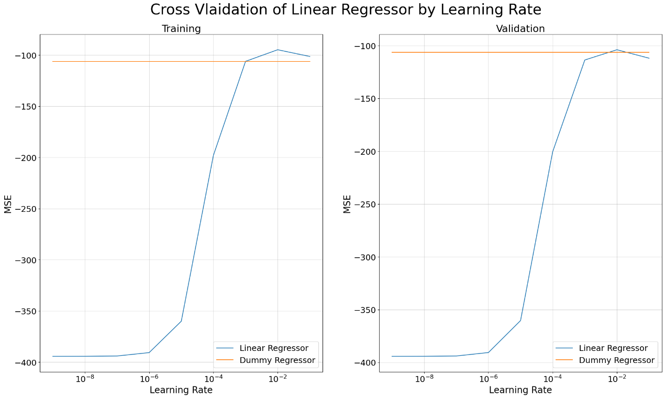

|  |  |  |  |
| --- | --- | --- | --- |
| Model | Section | Train MSE | Valid MSE |
|  |  | Cross Validated | |
| Dummy | 2 | -105.82 | -106.19 |
| Linear | 2 | -94.77 | -103.8 |

**Q6.**

Depends on the model. The dummy model, that always uses the average contamination level, would not change. The average stays the same regardless of any normalization we did to the features.

The Linear Regressor will change. This model uses SGD in order to find the minimal loss. SGD is sensitive to the values of the features. The partial derivative of a feature which holds “larger” (as in far greater or far lesser) data points than other features will pull the SGD stronger in its direction, thus making it more prominent, even if it’s data is less indicative of our target.

**Q7.**

We found that the optimal and it achieves a validation loss of -98.25

**Q8.**

|  |  |  |  |
| --- | --- | --- | --- |
| Model | Section | Train MSE | Valid MSE |
|  |  | Cross Validated | |
| Dummy | 2 | -105.82 | -106.19 |
| Linear | 2 | -94.77 | -103.8 |
| Lasso Linear | 3 | -96.25 | -98.25 |

**Q9.**

|  |  |
| --- | --- |
| Feature | Coefficient |
| sugar_levels | 2.121 |
| PCR_01 | 1.875 |
| PCR_05 | 0.372 |
| num_of_siblings | 0.362 |
| household_income | 0.178 |

**Q10.**

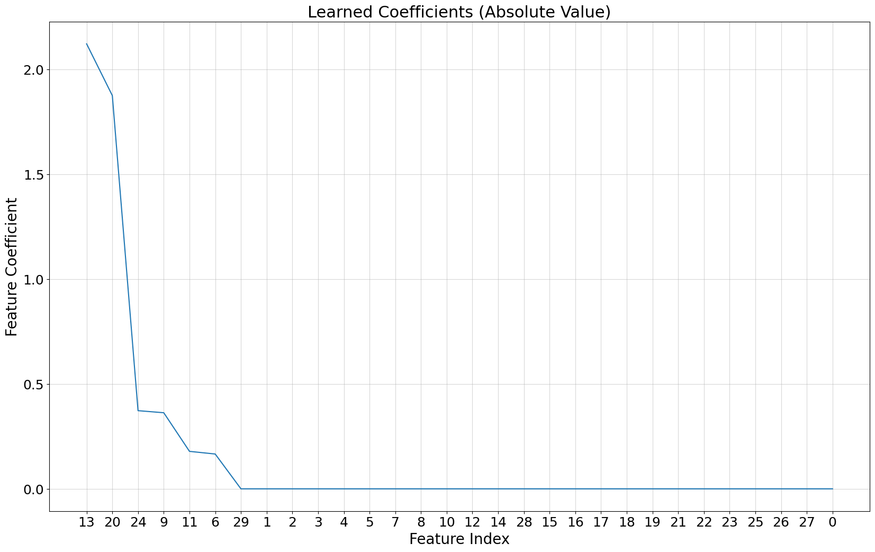

**Q11.**

As we saw in the tutorial, lasso (which uses regularization) causes a sort of “variable selection”. The magnitude of the coefficient gives us an idea of the effect the feature has on finding our target, the features with larger (absolute) coefficient will be more prominent in our model for predicting the target.

**Q12.**

Yes, had we chosen not to normalize the features the training performance of Lasso would have changed. Features who in their original scale is smaller from the others would have far greater regularization in order to compensate. This would mean that for said features the regularization has greater importance than the data, while for others their regularization would remain minimal. This changes the training performance of the model.

**Q13.**

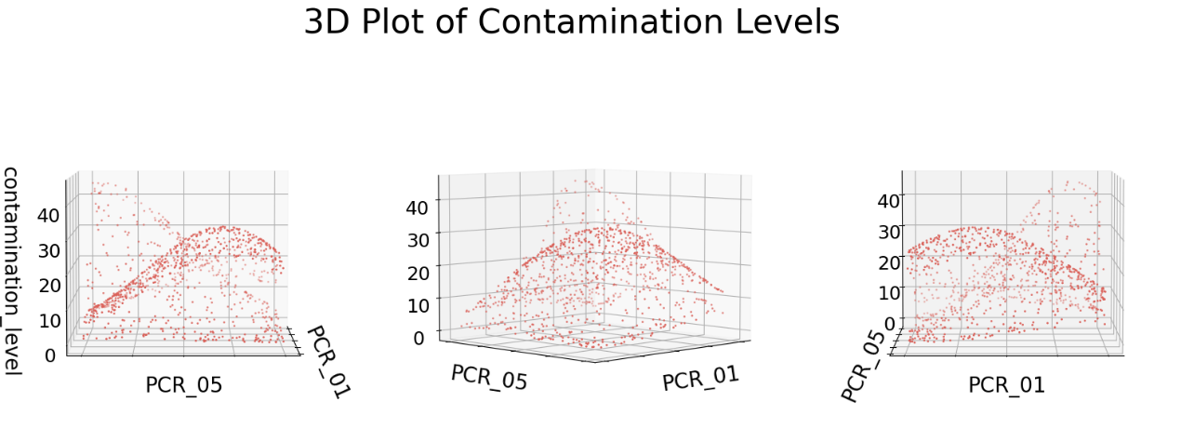

From this visualization, we can understand that the contamination levels are distributed in a mostly of parabolic manner through PCR_01 and PCR_05, but with a large amount of noise. When we look at the bivariate analysis of them, we see that still a certain parabolic nature returns, where most contamination levels can be found on some parabolic line. This means our model should be able to hypothesize the target on a parabolic plane, unlike the "flat" planes our Linear regressor and Lasso modeled.

**Q14.**

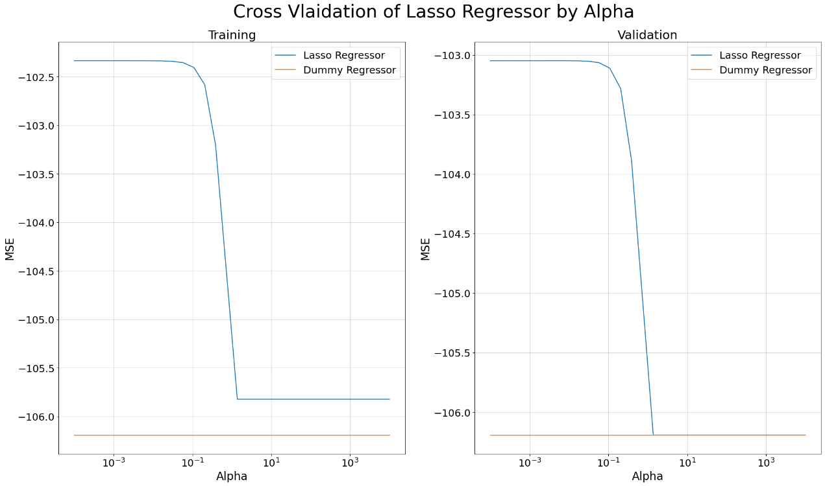

Using only PCR_01 and PCR_05 as features we found that the optimal .

It achieves a validation loss of -103.04.

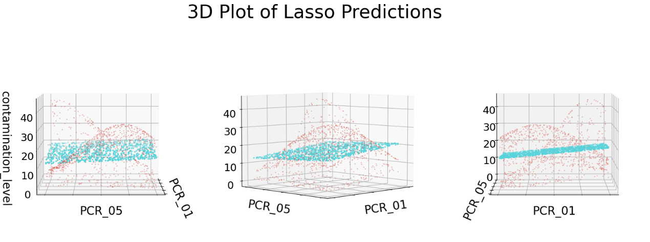**Q15.**

**Q16.**

After 2nd degree polynomial mapping, many of our “new” features are of a second degree () and seeing as how these features have already been normalized earlier, most of them lie between 1 and -1. Thus, after mapping them, all those that did not equal 1 or -1 will now lie much closer to 0. This will create a non-evenly distributed scattering of datapoint as there will be small patched at 1 and -1, and a larger patch near 0. This new distribution could harm the learning process as it creates artificial “islands” that could falsely give more information.

**Q17.**

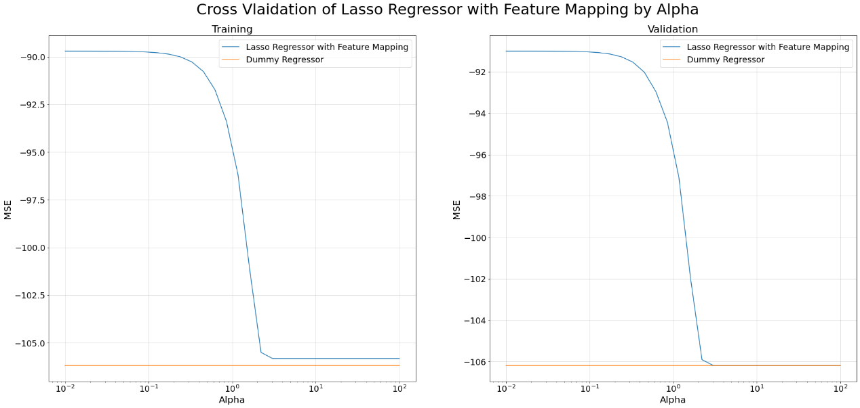

We found that the optimal and it achieves a validation loss of .

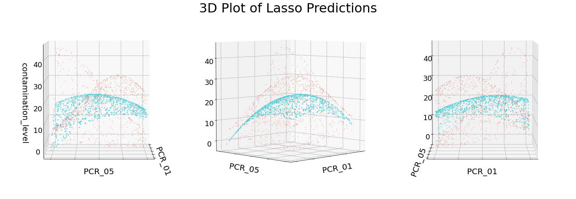**Q18.**

**19.**

We have found that after feature mapping, out model was able to better hypothesize our target variable. We can see from the plot, that our predictions are placed on a parabolic plane, which (from a human eye perspective) is far closer to the actual distribution of the contamination level with respect to of PCR_01 and PCR_05. We have also seen that the error has reduced by over 10% after our feature mapping (while the regularization strength remained similar). All of this goes to show us that regularization is not enough to improve our model, but feature mapping adds necessary data to allow our models to predict with greater accuracy.

**20.**

For our Random Forest model we decided to transform features PCR_01 and PCR_05 with the 3rd degree polynomial transformation and sugar_levels with the RBF transformation with transformation. To decide on these features and their respective transformations we first looked at a univariate analysis of our features with respect to the contamination levels. We found that these three features showed some curvature, so we decided to test different feature mappings on then (using cross validation and taking the transformations that led to the best validation score).

**21.**

We have seen that RBF mapping divides the feature space into “bubbles” of high concentration. A random forest, which is uses decision trees, can achieve greater entropy loss when the division of a feature which isn’t linearly separable can be made more separable through RBF. We can expect the training loss to become nearly zero, as said “bubbles” can be learned efficiently, and also the validation error to decrease.

**22.**

A Random Forest selects only a few features each time and finds how well their combination can predict our target. This means that we do not have to do manual feature selection, as the random forest will explore on its own which combinations provide the most data and give that selection the most weight. It also combines several models, allowing for greater flexibility.

23.