Appendix A. Supplementary methods, data and results
The environmental footprint of the Danish health care system: supply-chain origins and geographical displacement
Ofir Eriksen and Albert Kwame Osei-Owusu
This appendix documents the analytical framework, data sources, system boundaries and calculations behind the environmental footprint of the Danish health care system reported in the main article, so that each result can be traced to its inputs and reproduced. The travel calculations are also provided as a spreadsheet in Appendix B.

Methods
The analysis covers five impact categories: climate change, material extraction, blue water consumption, land use and waste generation. By applying a methodology consistent with previous international studies while using Danish data and system boundaries, this study provides a systemic perspective on the environmental impacts associated with Danish health care and the activities that drive them. Health care is defined here as:
‘Health and social care services (including residential care and elder care), pharmaceutical and other medical products, and therapeutic appliances and equipment.’
This definition aligns with the System of Health Accounts (SHA) [1] and ensures comparability with previous health care footprint studies. The system boundary covers the direct emissions of the health care industries, as reported in Statistics Denmark's own accounts, and the indirect impacts that arise along global supply chains.
The three reference years form a comparison, not a time series. Running the same code for 2016, 2019 and 2022 measures how far the result depends on the vintage of the underlying accounts. The runs cannot be read as a series for two reasons: the 2022 run uses a different background table from the other two, and the 2019 table reports the Danish health industry at less than half its national-accounts size, so the 2019 run uses the 2016 table instead. The three results, and a decomposition of the differences between them, are reported under Reference years and the background model below. Expenditure is expressed in the current prices of each year, so the 2022 headline needs no deflator; the change between the 2016 and 2019 runs, which share a background, includes price change as well as volume change.

Model and notation
The model is EXIOBASE version 3.8.2, industry by industry for 2022, with 49 regions and 163 industries, giving $n=7,987$ region-industry nodes, and $k=5$ reported indicators, with the Danish sea-transport reallocation described below. Matrices are set in bold upper case, vectors in bold lower case, scalars and indices in italics, and a hat diagonalises a vector. The objects, with their dimensions and the names the code uses, are:
- $Z$ ($n×n$), inter-industry transactions in million euros at basic prices, and $x$ ($n$), gross output (code: Z, x)
- $A$ ($n×n$), technical coefficients, and $L$ ($n×n$), the Leontief inverse (code: A, L)
- $F$ ($1,113×n$), environmental extensions in physical units, and $C$ ($k×1,113$), characterisation factors (code: R, Q)
- $B$ ($k×n$), characterised direct intensities (code: B)
- $y_{H}$ ($n$), Danish health care demand, and $d$ and $g^{BU}$ ($k$), the operational and bottom-up terms (code: Ystim, Hstim)

Danish regional treatment
Denmark is retained as an explicit region within the EXIOBASE regional structure, which allows Danish health care demand to be traced through both domestic production and international supply chains without altering the balance of the system. The Netherlands is also a separate region in EXIOBASE and in the code inherited from Steenmeijer and colleagues; it is reported inside Europe.

Core equations
The technical coefficients, Leontief inverse and characterised direct intensities are
$A=Z{\hat{x}}^{−1}, L={\left(I−A\right)}^{−1}, B=CF{\hat{x}}^{−1}$ (A.1)
where $I$ is the identity matrix. Health care demand combines the three expenditure categories:
$y_{H}=a_{h}E^{s}+\sum_{g∈\left\{p,a\right\}}{\left(κ^{g}E^{g}w^{g}+m^{g}\right)}$ (A.2)
Health care services, $E^{s}$, enter through $a_{h}$, the column of $A$ for the Danish health and social work industry, so that expenditure is traced through the goods and services that industry buys; value added carries no pressure and is not part of the vector. Pharmaceuticals ($p$) are mapped to Chemicals n.e.c. and appliances ($a$) to Medical, precision and optical instruments. The good itself is distributed over supplying regions $r$ in proportion to Danish final demand for that product $j\left(g\right)$ in EXIOBASE,
$w_{r}^{g}=\frac{y_{r,j\left(g\right)}^{DK}}{\sum_{s}{y_{s,j\left(g\right)}^{DK}}}$ (A.3)
and $κ^{g}$ is the share of each category that is the good, net of the distribution margins $m_{t}^{g}$ earned by the Danish motor-trade (45), wholesale (46) and retail (47) industries, which $m^{g}$ places at those industries (see Valuation and distribution margins):
$κ^{g}=1−\frac{1}{E^{g}}\sum_{t∈\left\{45,46,47\right\}}{m_{t}^{g}}$ (A.4)
The footprint of each indicator is
$f=BLy_{H}+d+g^{BU}$ (A.5)
where $d$ is the health sector's own operational term, taken for climate change and waste generation from Statistics Denmark's accounts and for the other three indicators from the direct intensity of the Danish health industry scaled to $E^{s}$, and $g^{BU}$ holds the bottom-up terms. Because $LA=L−I$, the model term of the services vector is the industry's full multiplier net of its own direct intensity,
$BLa_{h}E^{s}=\left(M_{·h}−B_{·h}\right)E^{s}, M=BL$ (A.6)
which holds in the published run to $3×{10}^{−12}$ kt CO₂e: the model term is purely upstream, and the operational term does not overlap it. For one indicator with direct intensities $b$, the pressure arising at producing node $i$ and the pressure driven by purchased product $j$ are two marginals of one total,
$e_{i}=b_{i}{\left(Ly_{H}\right)}_{i}, p_{j}=y_{H,j}{\left(bL\right)}_{j}, \sum_{i}{e_{i}}=\sum_{j}{p_{j}}=bLy_{H}$ (A.7)
which give the sector and region cuts and the activity cut respectively. The share of the Danish national consumption-based footprint, which includes households' direct emissions $h_{k}^{DK}$, is
$λ_{k}=\frac{f_{k}}{b_{k}Ly^{DK}+h_{k}^{DK}}$ (A.8)
with the national final demand $y^{DK}$ on the same corrected background and characterisation. The health care vector is built from Danish accounts and superimposed on the model rather than carved out of EXIOBASE's Danish final demand, so the share compares two estimates on one background rather than partitioning one total.

System boundary
For pharmaceuticals and therapeutic appliances, expenditure is allocated to the corresponding EXIOBASE sectors and distributed across supplying regions according to the sourcing patterns observed in Danish final demand. This step reflects the international supply chains of these products and assigns impacts according to the geographical origin of production.
A Dutch study [2] found that representing pharmaceuticals by Chemicals n.e.c. may overestimate pharmaceutical-specific impacts for material extraction and greenhouse gas emissions, the only two categories it assessed. A life cycle assessment of penicillin treatments found toxicity-related categories to be the largest after normalisation [3].
On SNAC-EXIOBASE, which separates pharmaceuticals from Chemicals n.e.c. and assumes domestic sourcing, the same study [2] found the indirect footprint of Dutch health care in 2014 to be about 60% lower for material extraction and 10% lower for greenhouse gases. The pharmaceuticals and chemical products group also carries more than pharmaceuticals, including chemical purchases made by health care services and possibly other activities.
The error margin of using Chemicals n.e.c. therefore varies by impact category and allocation structure. No correction factor is applied to the headline, and results for pharmaceuticals are interpreted as indicative of chemically intensive supply chains rather than of pharmaceutical production alone; the effect of a pharmaceutical-specific intensity is reported as a sensitivity case (see Sensitivity).

Health care final demand
(i) Health care services include the delivery of health services by hospitals, outpatient clinics, general practitioners and other health care providers, covering labour-intensive clinical activities as well as associated institutional services; (ii) pharmaceutical products and other medical products include the manufacturing and upstream supply of pharmaceuticals, vaccines, diagnostic reagents, consumables and other chemically based medical products used in prevention, diagnosis and treatment; and (iii) therapeutic appliances and equipment comprise medical devices and durable equipment such as diagnostic imaging equipment, surgical instruments, implants and other specialised medical technologies.
The purposes and transactions summed for each category in 2022, from Statistics Denmark's input-output table (sheets CP and IO, industry rows only) [4], were:

- Health care services, 37,552 million euros: household consumption (3110) of out-patient care services (06200), hospital services (06340) and retirement homes and day-care centres (13302); consumption by non-profit institutions serving households (NPISH, 3130) of hospitals (06300) and retirement homes (13302); marketed individual government consumption (3141) of out-patient care services (06200); and non-market individual government consumption (3142) of out-patient care services (06200), hospitals (06300), other hospital services (06400) and retirement homes (13302). The service columns contain no trade deliveries.
- Pharmaceutical products and other medical products (06112), 1,950 million euros: household consumption (3110) and marketed individual government consumption (3141), of which 791 million euros are distribution margins.
- Therapeutic appliances and assistive products (06134), 1,094 million euros: household consumption (3110) and marketed (3141) and non-market (3142) individual government consumption, of which 596 million euros are distribution margins.
The two NPISH columns for hospitals (06300) and retirement homes (13302) are both delivered by industry 880000 and carry the same value within each table: 2,420,768 thousand kroner in 2022 and 2,298,963 thousand in 2016. The values are used as published; in 2022 each is 0.9% of services expenditure and the two together 1.7%.

Values are converted from Danish kroner (DKK) to million euros at the annual average rate of Danmarks Nationalbank for the reference year: 7.4452 DKK/EUR for 2016, 7.4661 for 2019 and 7.4396 for 2022.

Valuation and distribution margins
Statistics Denmark's input-output table records purchases at basic prices; VAT and other product taxes are separate rows and are excluded here. A basic-price column for a good bought by a final user nevertheless contains the distribution margin on that good, recorded as a delivery from the trade industry that earned it. In 2022, margins were 790.7 million euros of the 1,950.3 million spent on pharmaceuticals (40.5%: wholesale 352.0, retail 436.1, motor trade 2.7) and 595.8 million of the 1,094.4 million spent on therapeutic appliances (54.4%: wholesale 207.0, retail 388.0, motor trade 0.8). The good itself is mapped to its manufacturing sector and the margins to the Danish EXIOBASE trade industries, as in Eqs. (A.2) and (A.4), so that the expenditure total is preserved and each part is charged at its own intensity. Mapping each whole column to the manufacturing sector instead would add 491 kt CO₂e (11.5%) to the climate footprint, 765 kt to material extraction, 20.7 Mm³ to blue water consumption, 735 km² to land use and 38 kt to waste generation. The 2019 supply-use table records the same margins as trade-service rows, and the 2016 and 2019 runs are treated identically.
Included from the bottom-up analysis:

- anaesthetic gases, including nitrous oxide (N₂O), and pressurised metered-dose inhalers (pMDIs)
- private travel (employee commuting, and patient and visitor travel)

Excluded:
- gross fixed capital formation (infrastructure and durable equipment)

EXIOBASE integration
The three expenditure categories are mapped to EXIOBASE sectors as follows (Fig. A.1):
- HC.1 to HC.9 (excluding HC.5) represented by Health and social work
- HC.51 represented by Chemicals n.e.c.
- HC.52 represented by Medical, precision and optical instruments

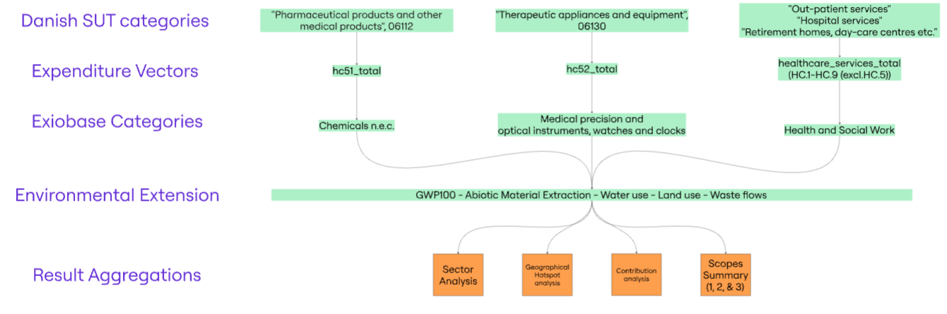
Fig. A.1. Integration of Danish input-output tables with EXIOBASE in five steps: (i) summarising Danish health care expenditures, (ii) aggregating them into SHA-based categories, (iii) mapping these to corresponding EXIOBASE sectors, (iv) combining them with environmental extensions in the edited code base of Steenmeijer and colleagues, and (v) aggregating outputs into sectoral, geographical and contribution analyses, as well as a scope-based summary.

Bottom-up terms
Two kinds of bottom-up term are used. The anaesthetic gases and inhaler propellants are Danish primary data, characterised on IPCC AR6 GWP100 values [5,6] and added to climate change only. Employee commuting and patient and visitor travel are built from the Danish National Travel Survey [7] and valued at the Dutch emission intensity per person-kilometre [8]; both travel terms carry four of the five indicators, all but waste generation, for which the Dutch inventory records no value.

Anaesthetic gases
Medical nitrous oxide is taken from Denmark's National Inventory Document [9], category 2.G.3.a, which reports 38 tonnes of N₂O per year for 2013 to 2024, estimated from average sales in 2005 to 2012 and covering hospital, dental and veterinary use as well as minor non-medical uses; all of it is attributed to health care here, so the term is an upper bound. Volatile anaesthetic agents are read from the Register of Medicinal Product Statistics of the Danish Health Data Authority [10] (ATC N01AB, entire country, all sectors): 2,400 litres of sevoflurane, 181 of desflurane and 15 of isoflurane sold in 2022. The anaesthetic term is
$G_{anae}=W_{N_{2}O}{GWP}_{N_{2}O}+\sum_{a}{V_{a}ρ_{a}ε_{a}{GWP}_{a}}$ (A.9)

where $W_{N_{2}O}$ is the mass of nitrous oxide, $V_{a}$ the volume of agent $a$ sold, $ρ_{a}$ the specific gravity at 20 °C (sevoflurane 1.5203, desflurane 1.4651, isoflurane 1.5019) [11], $ε_{a}$ the fraction exhaled rather than metabolised (0.95 for sevoflurane, 1 otherwise) [12], and GWP the AR6 100-year values: N₂O 273, sevoflurane 195, desflurane 2,590 and isoflurane 539 [5,6]. The result is 10.37 kt CO₂e for nitrous oxide and 1.37 kt for the volatile agents, 11.75 kt in total. Medical nitrous oxide, 10.07 kt CO₂e on the AR5 value of 265 used in Statistics Denmark's DRIVHUS accounts, is subtracted from their direct-emissions figure before this term is added, so that it is not counted twice.

Inhaler propellants
Propellant emissions from pressurised metered-dose inhalers are taken from the F-gas inventory of the Danish Environmental Protection Agency [13], which estimates emissions from the sales of each product and its propellant content per dose, with half released in the year of sale and half in the year after. For 2022, the inventory reports 9.1 kt CO₂e from HFC-134a and 2.5 kt from HFC-227ea, 11,619 tonnes of CO₂ equivalents in total, on the GWPs of its Appendix 1 (1,430 and 3,220, the AR4 values). The emitted mass of each gas is recovered from those contributions and restated on AR6:
$G_{pMDI}=\sum_{g}{\frac{G_{g}^{AR4}}{{GWP}_{g}^{AR4}}{GWP}_{g}^{AR6}}$ (A.10)

which gives 12.55 kt CO₂e on GWPs of 1,530 for HFC-134a and 3,600 for HFC-227ea [6]. The comparison years use the same inventory series: 5.0 tonnes of HFC-134a and 0.7 tonnes of HFC-227ea in 2019 [14], giving 10.17 kt; and 5.5 tonnes of HFC-134a in 2016 [15], with 0.61 tonnes of HFC-227ea imputed at the 90 to 10 split reported for 2019 [16], giving 10.61 kt on the same factors. The manufacture of the inhalers is already included in the input-output component through pharmaceutical expenditure and is not added again.

Private travel
The Dutch inventory of Steenmeijer and colleagues [8] gives the life-cycle impacts of travel, namely the direct emissions and the indirect impacts of fuel supply and vehicle manufacture, but records no waste. Both Danish travel terms scale that inventory by an activity ratio, and Appendix B gives the calculations in full.

Employee commuting

Employee commuting is estimated from Danish activity data. The Danish National Travel Survey [7] reports the distance travelled to the workplace per resident per day; because the survey assigns a trip home the purpose of the stay from which it returns, the figure counts both legs of the journey. The distance is scaled to a full year and to the survey population, allocated to health care by its share of hours worked in the national accounts [17], and valued at the life-cycle emission intensity per person-kilometre of the Dutch commuting inventory [8]:
$G_{c}=δ_{w}×365×P_{6+}×s_{h}×η_{c}$ (A.11)
where $δ_{w}$ is 9.3 km per person per day in 2022 (9.7 in 2016 and 9.2 in 2019) [7]; $P_{6+}$ is 5,499,115 residents aged 6 and over, the survey population; $s_{h}$ is 0.1278, the ratio of hours worked in hospital activities (860010), medical and dental practice activities (860020) and residential care activities (870000), plus the elder care share $α$ = 0.3092 of social work activities without accommodation (880000), to all hours worked in 2022 [17]; and $η_{c}$ is 0.1862 kg CO₂e per person-kilometre, the Dutch inventory's 573.43 kt over 3,080 million person-kilometres, all modes including cycling and walking [8]. Health care commuting is therefore 2,386 million person-kilometres and 444.2 kt CO₂e in 2022. The other indicators scale with the same activity ratio:

$I_{c,k}=I_{c,k}^{NL}×\frac{G_{c}}{G_{c}^{NL}}$ (A.12)
where $I_{c,k}^{NL}$ is the Dutch commuting impact in indicator $k$ and $G_{c}^{NL}$ = 573.43 kt CO₂e, so that the ratio is 0.7746. The Dutch inventory counts one commuting trip per working day [8], which halves its total but not its intensity per person-kilometre, because emissions and distance are counted on the same trips; the intensity can therefore be applied to the Danish survey distance, which counts both legs.

Comparability assumptions
The Dutch intensity carries the Dutch modal split, which is broadly similar to the Danish one: cars and other road vehicles carry 83% of Danish workplace kilometres in 2022 [7], and cars and mopeds carry 77% of Dutch commuting kilometres in 2016 [18]. Denmark's higher car share and its higher share of electric cars act in opposite directions on the intensity, and further modal disaggregation was not pursued.

Patient and visitor travel
Patient and visitor travel reflects the use of health care rather than workforce attendance, and the Danish National Travel Survey [7] measures it: the survey reports travel for social and health purposes (table 15, 'Social/sundhed', covering visits to doctors, hospitals and job centres) at 0.8 km per person per day in 2022 among residents aged 6 and over. Because the survey folds visits to patients into visits to family and friends, the visitor share is the one imported parameter: the ratio of visitor to patient travel in NHS England, 0.29 to 1.23 Mt CO₂e [19]. The term and its four non-climate indicators are
$G_{PV}=\left(1+ν\right) δ·365·P·η, g_{PV,k}=g_{PV,k}^{NL}\frac{G_{PV}}{G_{PV}^{NL}}$ (A.13)

where $δ=0.8$ km per person per day, $P=5,499,115$ residents aged 6 and over, $η=0.1328$ kg CO₂e per person-kilometre, the composite intensity of the Dutch inventory [8] (358.64 kt over 2.70 billion person-kilometres), $ν=0.236$, and $G_{PV}^{NL}=358.64$ kt. Patient travel is 213.2 kt and visitor travel 50.3 kt, 263.6 kt CO₂e in total.

Data sources and inputs
The travel terms draw on:
- the commuting and patient and visitor travel inventories of Steenmeijer and colleagues [8]
- Statistics Netherlands mobility statistics, for the modal comparison [18]
- the Danish National Travel Survey of the DTU Center for Transport Analytics [7]
- Statistics Denmark's hours worked by industry and input-output tables [4,17], and the NHS England carbon footprint, for the visitor share [19]
The travel statistics used are:
- distance per person per day by purpose, and the population aged 6 and over
- distance per person per day by purpose and mode
- hours worked by industry

Uncertainties and limitations
Three sources of uncertainty remain in the travel terms. First, the Dutch intensities per person-kilometre are for 2016 and assume a vehicle fleet and modal split comparable with the Danish ones, while the Danish share of electric cars is rising. Second, allocating commuting by hours worked assumes that health care staff travel as far per hour worked as the average worker. Third, the visitor share of patient and visitor travel is transferred from NHS England.

Parameter uncertainty: Monte Carlo simulation
Parameter uncertainty is propagated by Monte Carlo simulation with 100,000 draws at a fixed seed. Reported 95% uncertainty intervals run from the 2.5th to the 97.5th percentile of the simulated values. The footprint of each indicator is additive in six groups of inputs, the input-output component, the operational term and four bottom-up terms, and each group carries a lognormal multiplier with a median of one:
$\tilde{f}=\sum_{q}{θ_{q}f_{q}}, lnθ_{q}∼N\left(0,σ_{q}^{2}\right), σ_{q}=ln{GSD}_{q}$ (A.14)
so that the draws are centred on the deterministic estimate rather than displaced from it. The input-output coefficients carry a shared factor calibrated to a coefficient of variation of 8.35%, the relative standard deviation of the Danish health care footprint in Lenzen and colleagues [20] (their table SI 7.1). The geometric standard deviations of the other five terms are 1.10 for the operational term from the national accounts, 1.15 for inhaler propellants, 1.25 for employee commuting, 1.30 for anaesthetic gases and 1.40 for patient and visitor travel: tightest for values read from a national account and widest for the term with a transferred component. Employee commuting and patient and visitor travel are drawn with a correlation of 0.8, because both rest on the same travel survey and the same Dutch inventory; in a check with 20,000 draws, the 95% interval is 3,715 to 4,972 kt at a correlation of 0, 3,690 to 5,003 kt at 0.5 and 3,672 to 5,027 kt at 0.8. Because the model is additive, the first-order variance shares [21] follow in closed form rather than from the draws:
$S_{q}=\frac{Var\left(θ_{q}f_{q}\right)}{Var\left(\tilde{f}\right)}, S_{cov}=\frac{2Cov\left(θ_{c}f_{c},θ_{v}f_{v}\right)}{Var\left(\tilde{f}\right)}$ (A.15)
and the covariance of the two travel terms is reported as its own share, so that the shares sum to 100%. For the 2022 climate footprint, the input-output parameters account for 69.6% of the variance, patient and visitor travel for 7.9%, employee commuting for 9.0% and their covariance for 13.4%; the three remaining terms together account for 0.12%.
Two consequences follow. First, the width of the reported intervals is largely a property of the multi-regional input-output data and not of the Danish primary data, so better national data on anaesthetic gases and inhaler propellants would not narrow them, and removing all travel uncertainty would narrow them by only about a sixth. Second, the ranking of contributors is more precisely determined than their levels, because the shared input-output factor cancels in a ratio: pharmaceuticals and chemical products hold rank one in 96.6% of draws, while their level spans 982 to 1,358 kt CO₂e.
Choices that are decisions rather than measurement error are reported as sensitivity cases beside the interval, not folded into it. The most important of these is the mapping of pharmaceutical expenditure: on a pharmaceutical-specific intensity rather than on Chemicals n.e.c., the median climate footprint falls to 3,547 kt CO₂e, below the parametric 95% interval of 3,675 to 5,029 kt. This single modelling choice therefore moves the estimate further than all six parameter groups together do.

Sensitivity
Against the headline of 4,267 kt CO₂e, the sensitivity cases give the following results. A pharmaceutical-specific intensity in place of Chemicals n.e.c. gives a median of 3,547 kt (16.9% lower); charging distribution margins at the manufacturing intensity gives 4,758 kt (11.5% higher); a sea-transport target share between 0.05 and 0.15 gives 4,245 to 4,397 kt; widening the boundary to include childcare gives 4,994 kt, and removing elder care gives 3,462 kt; endogenising capital on the matrices of Södersten and colleagues [22] raises the input-output and operational component by 21.2%; the GWP revision moves the input-output component between 4.7% lower (SAR) and 0.3% higher (AR5); and a correlation of 0 rather than 0.8 between the two travel terms narrows the interval from 3,672 to 5,027 kt to 3,715 to 4,972 kt (20,000 draws).

Quality assurance
Every run ends with a consistency audit, published with the results. It checks the input-output identities, $Ax+y=x$ and $L\left(I−A\right)=I$ to ${10}^{−10}$; that the producing-node and purchased-product cuts each sum to the footprint; that the scope partition plus the self-supply loop returns the total, 4,265.07 kt plus 1.81 kt equals 4,266.88 kt; that 97 characterised categories reconcile with their detail to ${10}^{−13}$; that the input-output climate component agrees across the ten tables that carry it; that each of the thirteen model variants reproduces its headline from its own background; that the sea-transport sensitivity reproduces the published total at the applied share; and that every result file has a lineage record naming its script, equations, inputs and method.

Data, code and software
The materials required to reproduce the analysis are in the project repository (github.com/Ofir2025/envr-footprint-healthcare-Dk2025): the Python modules implementing the Danish model, the extraction of the Danish input-output tables, the SHA-to-EXIOBASE concordance, the bottom-up inputs, the figure code and a lineage record naming, for every result file, the script, equations, inputs and published method behind it. An earlier version of the code is archived as release v1.0.1 (DOI: 10.5281/zenodo.21493995); the version reported here is to be archived as a new version of the same Zenodo record (concept DOI: 10.5281/zenodo.20542389).
EXIOBASE version 3.8.2 is openly licensed (CC BY-SA 4.0) [23] and Statistics Denmark's tables are public; both are obtained from their providers, and the repository records their identifiers and retrieval dates.
The analysis was implemented in Python 3.14.4 with pandas 3.0.2, NumPy 2.4.4, SciPy 1.17.1 and Matplotlib 3.10.9, and the figures were drawn in R 4.5.2. A single script, scripts/run_pipeline.py, runs every analysis stage in dependency order and ends with the consistency audit described under Quality assurance.

Scope 1, 2 and 3 greenhouse gas emissions
The greenhouse gas footprint is partitioned following the Greenhouse Gas (GHG) Protocol [24] as applied to input-output models by Hertwich and Wood [25]. Scope 1 comprises the direct emissions of the health and social care industries from Statistics Denmark's DRIVHUS accounts [17], with medical nitrous oxide netted out, plus the anaesthetic gases. Scope 2 comprises the emissions from generating the electricity, steam and hot water the health sector buys, traced through transmission and distribution within the energy block:
$S_{2}=b_{E}L_{EE}y_{E}, L_{EE}={\left(I_{EE}−A_{EE}\right)}^{−1}$ (A.16)
where $E$ indexes the electricity, steam and hot-water nodes in all 49 regions and $y_{E}$ is the health sector's own first-tier purchase of them. The OECD first-tier convention [26] gives 72.1 kt, and the cradle-to-gate convention of Hertwich and Wood, which adds the fuel supply behind generation, 75.0 kt, against 73.3 kt here. Scope 3 comprises the remainder of the footprint, including inhaler propellants and employee commuting. Patient and visitor travel falls outside the GHG Protocol's reporting boundary and is reported separately, as in NHS England [19]. Because EXIOBASE allocates emissions to producing sectors rather than to the organisation in control, the model alone would place the fuel burned in ambulances in the transport sector; reading Scope 1 from DRIVHUS returns those emissions to the health sector.
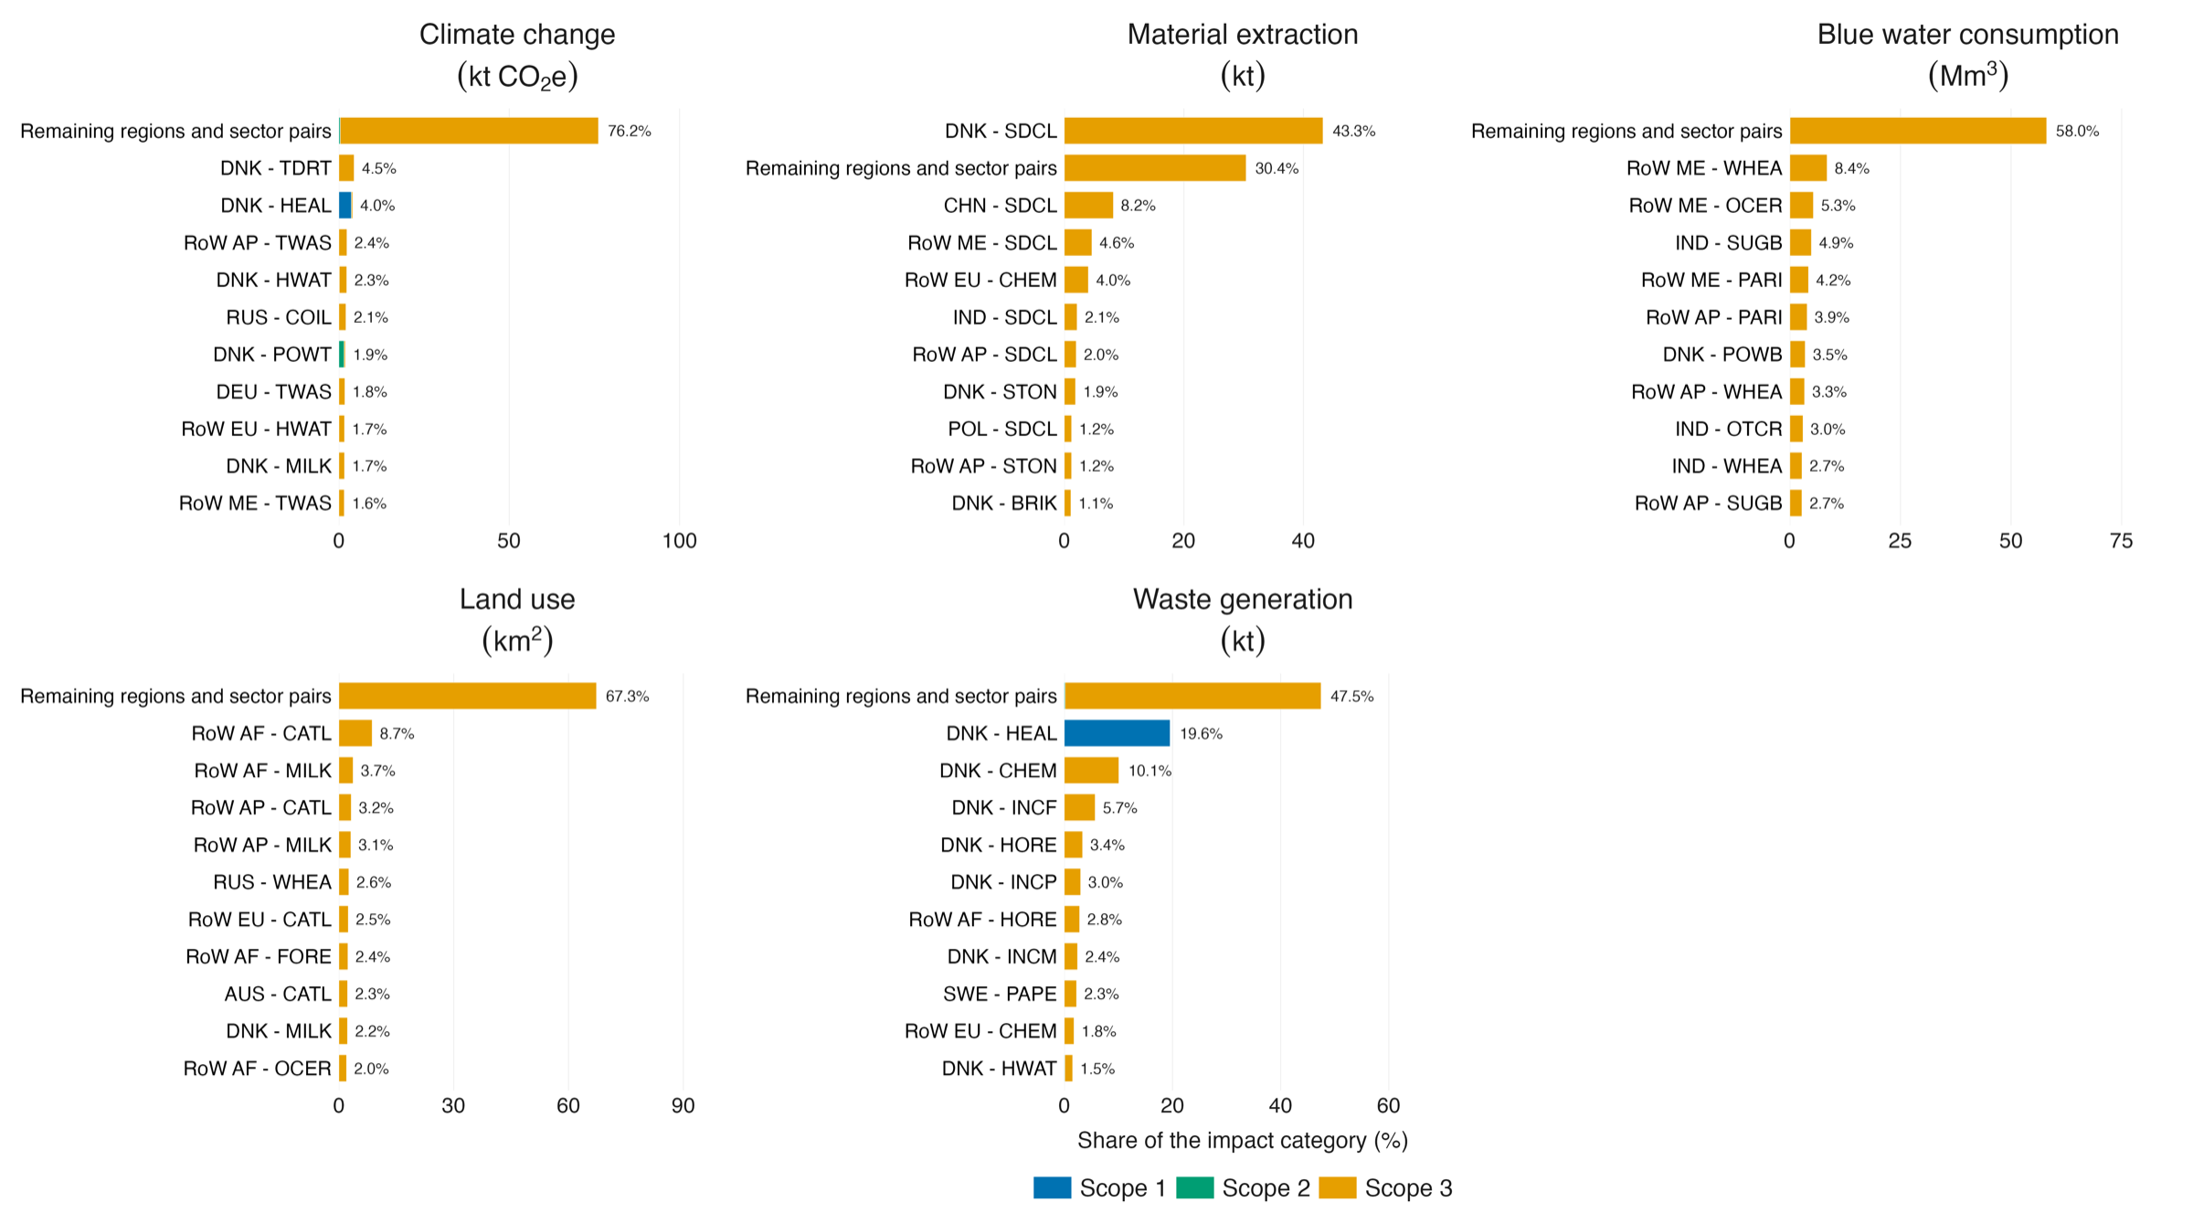
Fig. A.2. The ten largest producing region-by-industry pairs in each impact category, coloured by GHG Protocol scope, Danish health care, 2022. DNK-HEAL, the Danish health and social care industry itself, is the only Scope 1 node of any size; Danish electricity transmission and heat supply carry Scope 2, patient and visitor travel lies outside the protocol, and the remaining pairs sit in Scope 3. Region codes are ISO3 for individual countries and RoW AF, RoW AM, RoW AP, RoW EU and RoW ME for the EXIOBASE rest-of-world regions. Scope 1 comprises the DRIVHUS direct emissions plus anaesthetic gases; Scope 2 is purchased electricity and heat; Scope 3 includes upstream supply chains, inhaler propellants and employee commuting; patient and visitor travel is shown separately.
The partition covers 4,265 kt CO₂e: Scope 3 accounts for 3,797 kt (89.0%), Scope 1 for 131 kt (3.1%), Scope 2 for 73 kt (1.7%) and patient and visitor travel, outside the protocol's boundary, for 264 kt (6.2%). The 1.8 kt difference from the headline of 4,267 kt is the health sector's own self-supply loop, removed to avoid double counting (see Double counting). Fig. A.2 shows the ten largest producing region-by-industry pairs in each category, coloured by scope.

Results
Tables A.1 to A.5 give the results in greater detail.
Table A.1 presents absolute environmental impacts associated with Danish health care consumption in 2022, disaggregated by activity group. Results are reported for five impact categories: climate change, material extraction, blue water consumption, land use and waste generation. The contributions are shown for nine activity groups.
Table A.1. Environmental impacts of Danish health care in 2022 by activity group, in absolute units.
Activity group | Climate change (kt CO₂e) | Material extraction (kt) | Blue water consumption (Mm³) | Land use (km²) | Waste generation (kt)
Food and food services | 434 | 140 | 20 | 1,581 | 34
Heat and electricity | 74 | 30 | 0 | 15 | 1
Private travel | 708 | 32 | 0 | 2 | 0
Medical, electrical equipment and machinery | 115 | 105 | 1 | 74 | 5
Operational impacts | 131 | 0 | 0 | 0 | 43
Pharmaceuticals and chemical products | 1,154 | 1,451 | 37 | 1,332 | 63
Services | 792 | 412 | 11 | 727 | 31
Transport | 567 | 129 | 2 | 178 | 8
Other | 293 | 1,198 | 2 | 208 | 36
Private travel comprises employee commuting and patient and visitor travel; operational impacts are the health sector's own direct emissions and waste generation. Values are rounded independently, so rows and columns may not sum exactly.

Table A.2 is a hotspot analysis, presenting the absolute environmental impacts associated with Danish health care consumption in 2022, disaggregated by producing sector group. The impacts are distributed over seven sector groups plus an eighth aggregated group, ‘Other’.
Table A.2. Environmental impacts of Danish health care in 2022 by producing sector group, in absolute units.
Producing sector group | Climate change (kt CO₂e) | Material extraction (kt) | Blue water consumption (Mm³) | Land use (km²) | Waste generation (kt)
Agricultural sector | 528.6 | 40.3 | 63.5 | 4,071.6 | 44.1
Electricity sector | 358.5 | 7.7 | 3.2 | 1.8 | 11.7
Fossil fuel industry | 567.6 | 14.2 | 0.1 | 1.4 | 10.7
Mining of minerals and metals | 99.7 | 2,983.7 | 0.0 | 0.4 | 0.3
Operational impacts | 131.2 | 0.0 | 0.0 | 0.0 | 42.8
Pharmaceutical and chemical industry | 322.1 | 220.7 | 5.4 | 0.6 | 43.0
Transport | 664.9 | 21.6 | 0.0 | 4.2 | 2.3
Other | 1,594.4 | 210.0 | 2.6 | 37.7 | 66.3
Values are rounded independently, so rows and columns may not sum exactly.

Table A.3 reports the absolute environmental impacts of Danish health care in 2022, disaggregated by the world region in which the impacts occur. The indirect impacts of private travel, from fuel supply and vehicle manufacture, are not included, because the Dutch inventory quantifies them without a producing region: 288 kt CO₂e, 32 kt of material extraction, 0.2 Mm³ of blue water and 2 km² of land, so the columns sum to the totals less these amounts.
Table A.3. Environmental impacts of Danish health care in 2022 by producing world region, in absolute units.
Producing region | Climate change (kt CO₂e) | Material extraction (kt) | Blue water consumption (Mm³) | Land use (km²) | Waste generation (kt)
Denmark | 1,339 | 1,673 | 4 | 373 | 115
Africa | 166 | 76 | 4 | 875 | 13
America | 239 | 128 | 6 | 448 | 8
Asia and Pacific | 712 | 620 | 32 | 943 | 24
Europe | 1,254 | 748 | 10 | 1,284 | 59
Middle East | 269 | 221 | 19 | 193 | 2
The Netherlands is included in Europe. Values are rounded independently, so rows and columns may not sum exactly.

Table A.4 reports the health care footprint alongside the national consumption-based footprint and health care's share of it for each of the five impact categories, calculated with Eq. (A.8). The national totals include households' direct emissions and are computed on the same corrected background and characterisation.
Table A.4. The health care footprint, the Danish national consumption-based footprint and health care's share of it, 2022.
Impact category | Health care footprint | National consumption footprint | Health care share of national consumption footprint (%)
Climate change (kt CO₂e) | 4,266.88 | 77,240.62 | 5.52
Material extraction (kt) | 3,498.28 | 53,925.07 | 6.49
Blue water consumption (Mm³) | 74.78 | 1,276.05 | 5.86
Land use (km²) | 4,117.69 | 99,442.88 | 4.14
Waste generation (kt) | 221.09 | 10,586.42 | 2.09

Table A.5 compares health care purchases from two supply-chain sector groups with the greenhouse gas intensity of those purchases, calculated as each group's footprint divided by its expenditure. Health care buys almost as much from transport as from chemicals, 1,637 against 1,668 million euros, but the chemical purchases carry about twice the intensity, 0.68 against 0.35 kt CO₂e per million euros. The difference between the two groups' contributions therefore lies in intensity rather than in the amount purchased.
Table A.5. Expenditure and greenhouse gas intensity of health care purchases from the chemicals and transport sector groups, 2022.
Sector group | Expenditure (million euros) | Greenhouse gas intensity (kt CO₂e per million euros)
Chemical products (purchased) | 1,668 | 0.68
Transport | 1,637 | 0.35
Chemical products comprise Chemicals n.e.c. and the other chemical sectors.

The Danish sea-transport reallocation
EXIOBASE places 73.6% of Danish sea and coastal water transport output in Danish intermediate use in the 2022 table, whereas Statistics Denmark's own domestic input-output table puts the figure at 6.5%. The gap is a modelling artefact rather than a feature of the Danish economy: Danish-flagged shipping sells its services overwhelmingly abroad, and treating that output as an input to domestic industries loads international shipping emissions onto every Danish purchaser, health care among them. The excess is reallocated to exports, preserving the row and column balances of the Danish block, with the target share φ read from the Danish table for the background year in use: 0.0774 for the 2016 table, which the 2016 and 2019 runs share, and 0.0651 for the 2022 table. As an external check, the same procedure applied to the 2019 table returns 0.0931, matching the 9% that Rørmose Jensen and Iliev report for water transport in the Danish national-accounts input-output table for that year, against 74% in EXIOBASE [27]. The correction releases 11,954 million euros of output in the 2022 table.
For every Danish industry $j$, the delivery coefficient of the sea-transport row is rescaled so that deliveries to Danish industries equal the target share $φ$ of the row's output $x_{wt}$, and the released output is assigned to exports:
$a_{wt,j}^{φ}=a_{wt,j}\frac{φ x_{wt}}{\sum_{k∈DK}{z_{wt,k}}}, j∈DK$ (A.17)
The effect on this study is large. On the uncorrected 2022 background, the transport sector group carries 34.1% of the health care climate footprint and the total is 5,688 kt CO₂e; on the corrected background, transport carries 15.6% and the total is 4,267 kt. The same correction lowers the Danish national consumption-based footprint from 86.3 to 77.2 Mt CO₂e. A sensitivity grid over the target share from 0.05 to 0.15 is published with the results; across that range the climate footprint moves between 4,245 and 4,397 kt, so the finding depends not on the precise value of the share but only on its being far below the share EXIOBASE implies.

Direct operational emissions and waste
The health sector's own emissions and waste are read from Statistics Denmark's DRIVHUS emission accounts and AFFALD waste accounts by industry [17], for human health activities, residential care and the elder care share of social work, because the model allocates operational emissions to supplying sectors and would understate them. The elder care share, 0.3092 in 2022, is taken from each year's input-output table and applied to both accounts, so that the emission and waste boundaries match. Medical nitrous oxide (38 tonnes, or 10.07 kt CO₂e on the AR5 value of 265 that the accounts use) is netted out of the DRIVHUS figure before the bottom-up anaesthetic term is added, and the health sector's own self-supply loop, 1.8 kt CO₂e, is removed from the scope partition so that it is not counted twice.

Double counting
Each risk of overlap between the input-output component and the other terms is tested numerically, and the ledger is published with the results. First, the services vector is the Danish health and social work industry's purchase column, so the model term excludes the industry's own emissions; Eq. (A.6) holds to $3×{10}^{−12}$ kt, and the DRIVHUS term does not overlap it. Second, through its purchases from itself, the industry's own direct emissions arise once inside the model term, 1.8 kt CO₂e, which is removed from the scope partition. Third, medical nitrous oxide is netted out of the DRIVHUS figure before the anaesthetic term is added. Fourth, inhaler propellants are released at patients' homes and booked to household direct emissions, which the health care footprint does not read, while the manufacture of the inhalers enters through pharmaceutical expenditure; only the release is added. Fifth, employee commuting and patient and visitor travel are household consumption, outside the providers' purchase column, and their indirect part covers fuel supply and vehicle manufacture for private travel, which the input-output component does not contain. Sixth, the pharmaceutical component consists of retail and marketed government purchases, and the services column's own purchase of chemicals is a separate channel of 3.5 million euros.

Greenhouse gas emissions by scope, in further detail
Scope 1, Scope 2 and Scope 3 are defined under Scope 1, 2 and 3 greenhouse gas emissions above, with patient and visitor travel reported as its own category rather than folded into Scope 3. Of the 4,265 kt CO₂e the partition covers, Scope 3 accounts for 3,797 kt (89.0%), Scope 1 for 131 kt (3.1%), Scope 2 for 73 kt (1.7%) and patient and visitor travel for 264 kt (6.2%). Applied to the other four categories, the partition places 99.6% or more of material extraction, blue water consumption and land use in Scope 3; waste generation is the exception, with 19.6% in Scope 1. Fig. A.3 ranks the producing region-by-industry pairs behind Scope 3, and Fig. A.4 the producing sectors behind Scope 2.
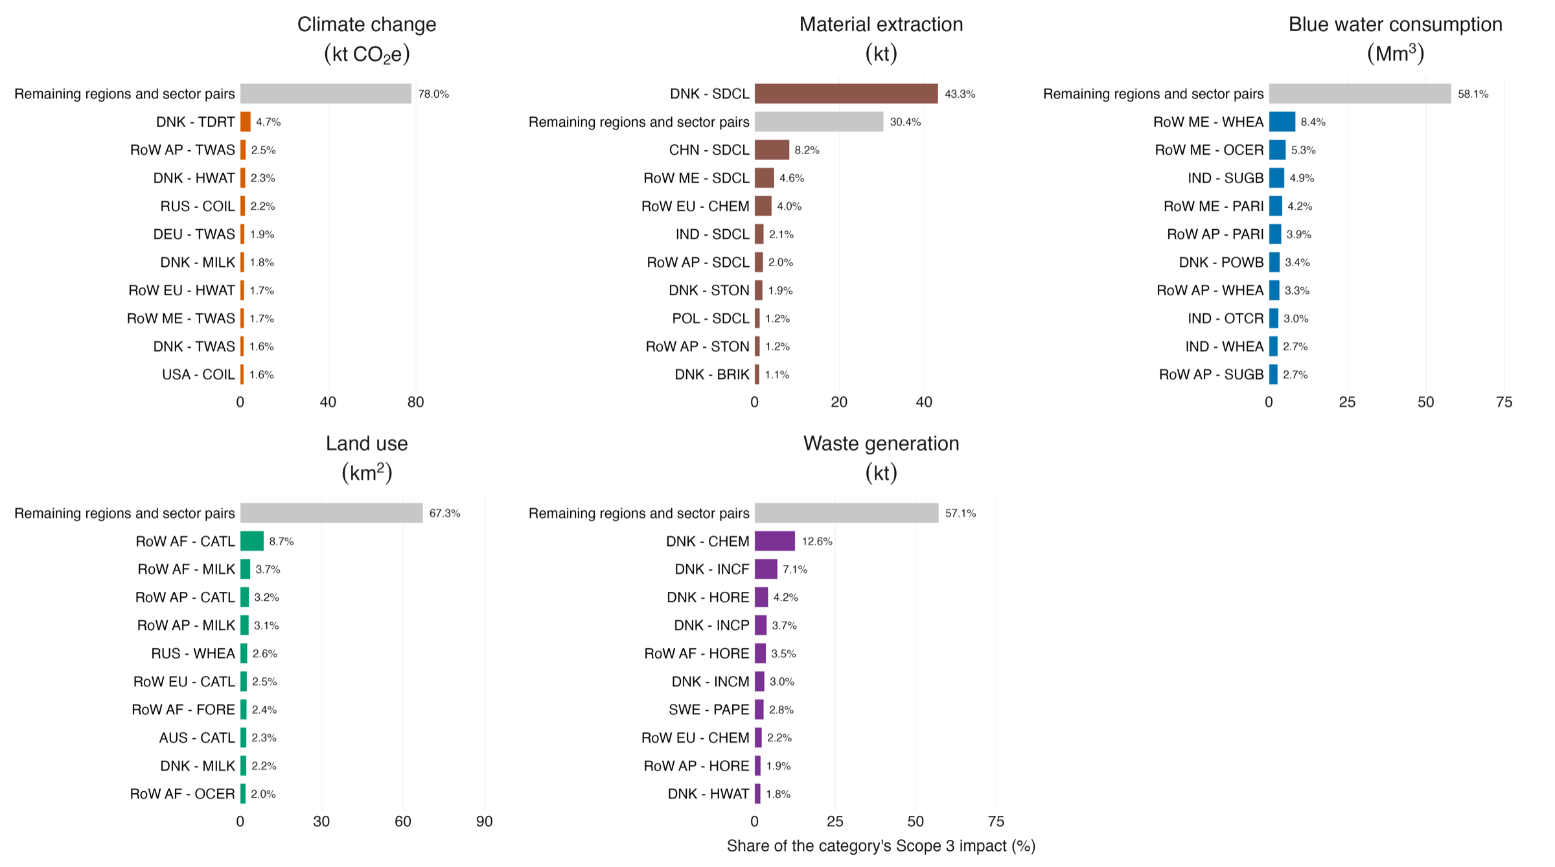
Fig. A.3. The ten largest producing region-by-industry pairs behind Scope 3 greenhouse gas emissions associated with Danish health care in 2022. Bars are ranked by contribution and labelled with their share of Scope 3.
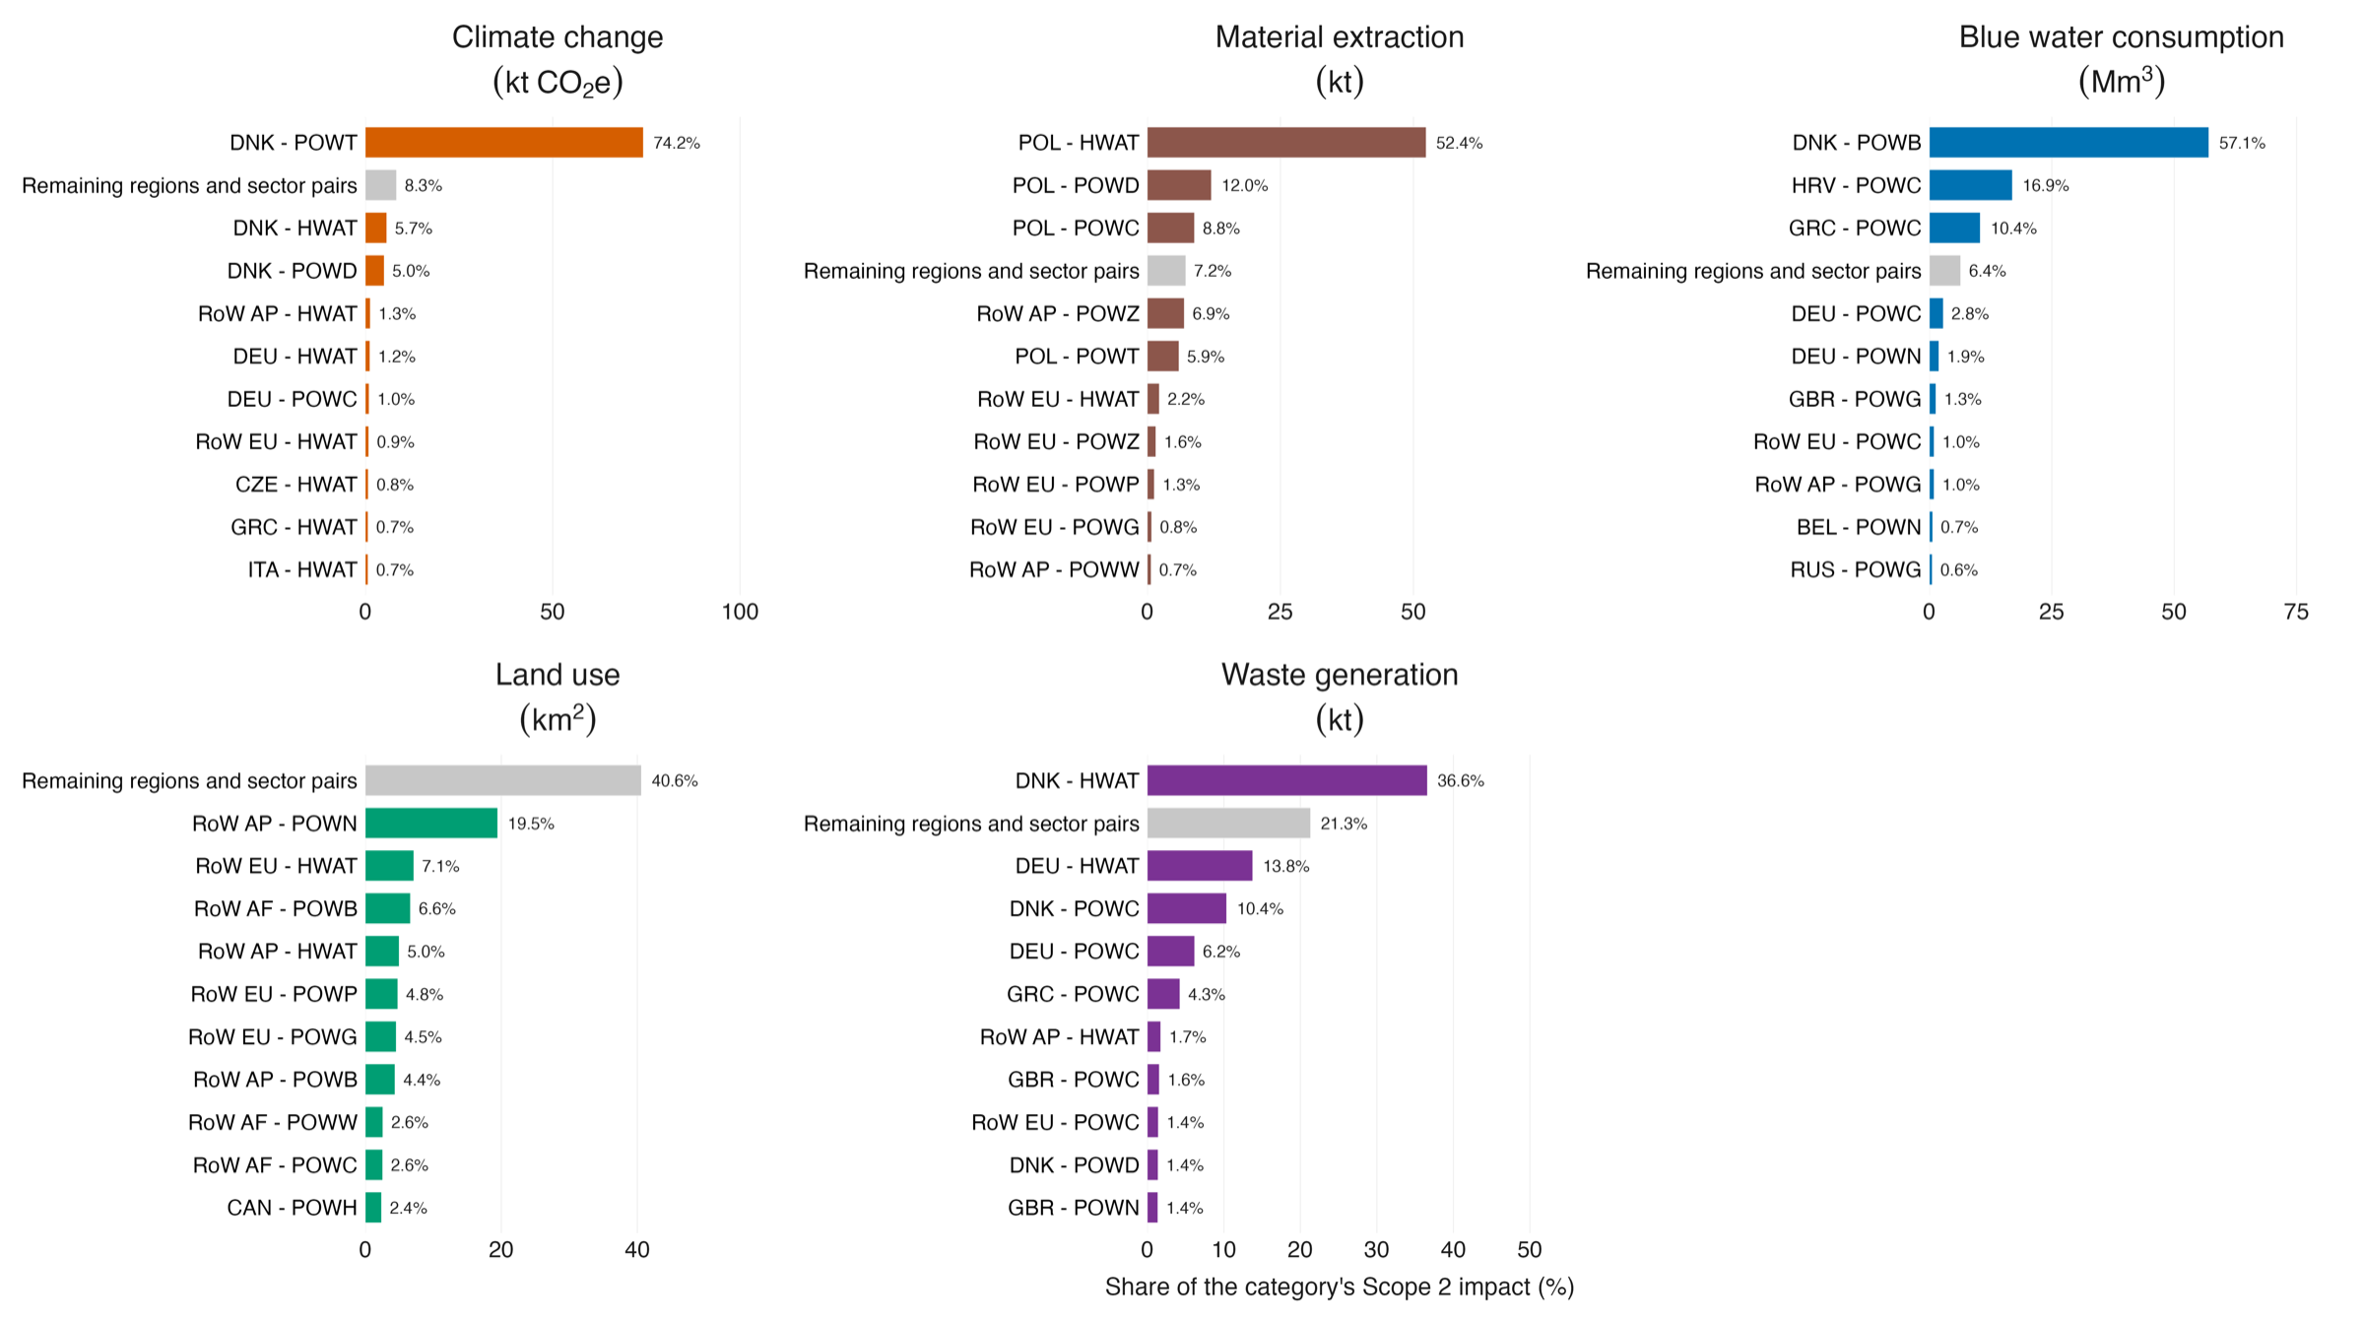
Fig. A.4. The producing sectors behind Scope 2 greenhouse gas emissions, that is, the electricity, steam and hot water purchased by the Danish health and social care industries in 2022.

Contributions in absolute and per-person terms
The main text reports contributions as shares of each impact category, the form in which the five categories can be compared with one another. Table A.1 gives the same decomposition in absolute units, and Fig. A.5 gives it per person, using the Danish population of 5,873,420 in 2022. Per-person values are the form most readily compared with other national studies, which more often than not report on that basis.
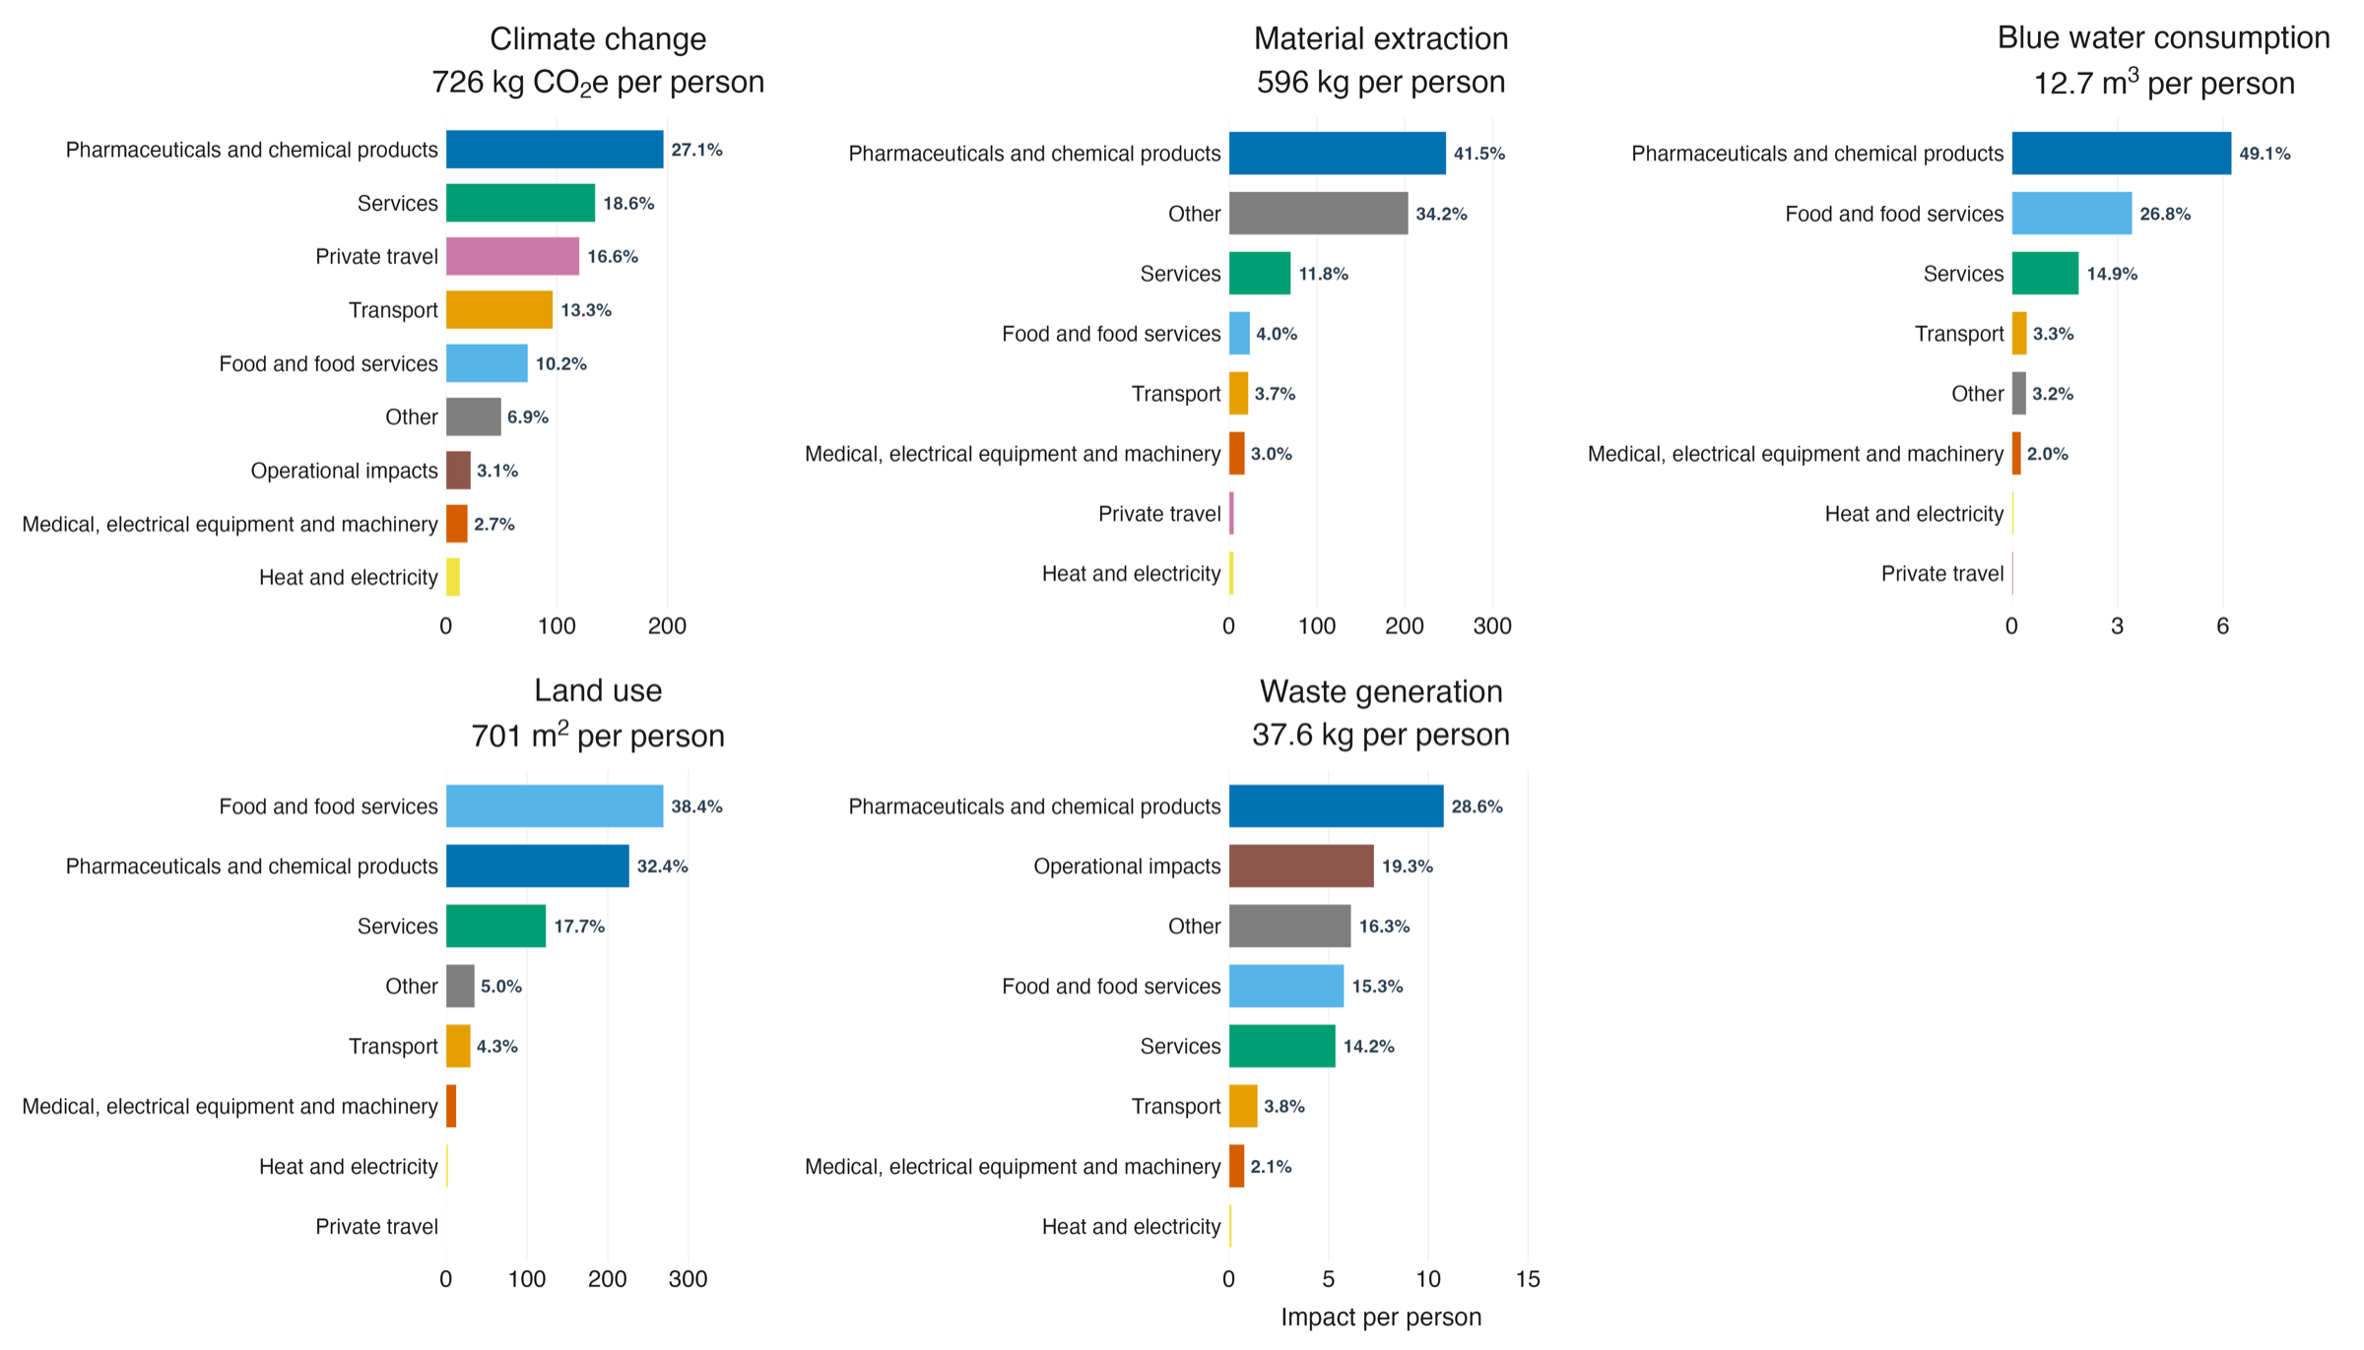
Fig. A.5. Contribution of each activity group to the five impact categories per person, Danish health care, 2022.

Geographical origin
The geographical decomposition allocates each unit of impact to the region in which it physically occurs along the supply chain, rather than to the region from which the product was bought. The operational term, the anaesthetic gas and inhaler propellant terms and the direct emissions of private travel arise in Denmark; the indirect impacts of travel have no producing region in the Dutch inventory, so Fig. 1C of the main text, Table A.3 and Fig. A.6, which resolves each region by producing sector group, leave them out. The Netherlands is reported inside Europe.
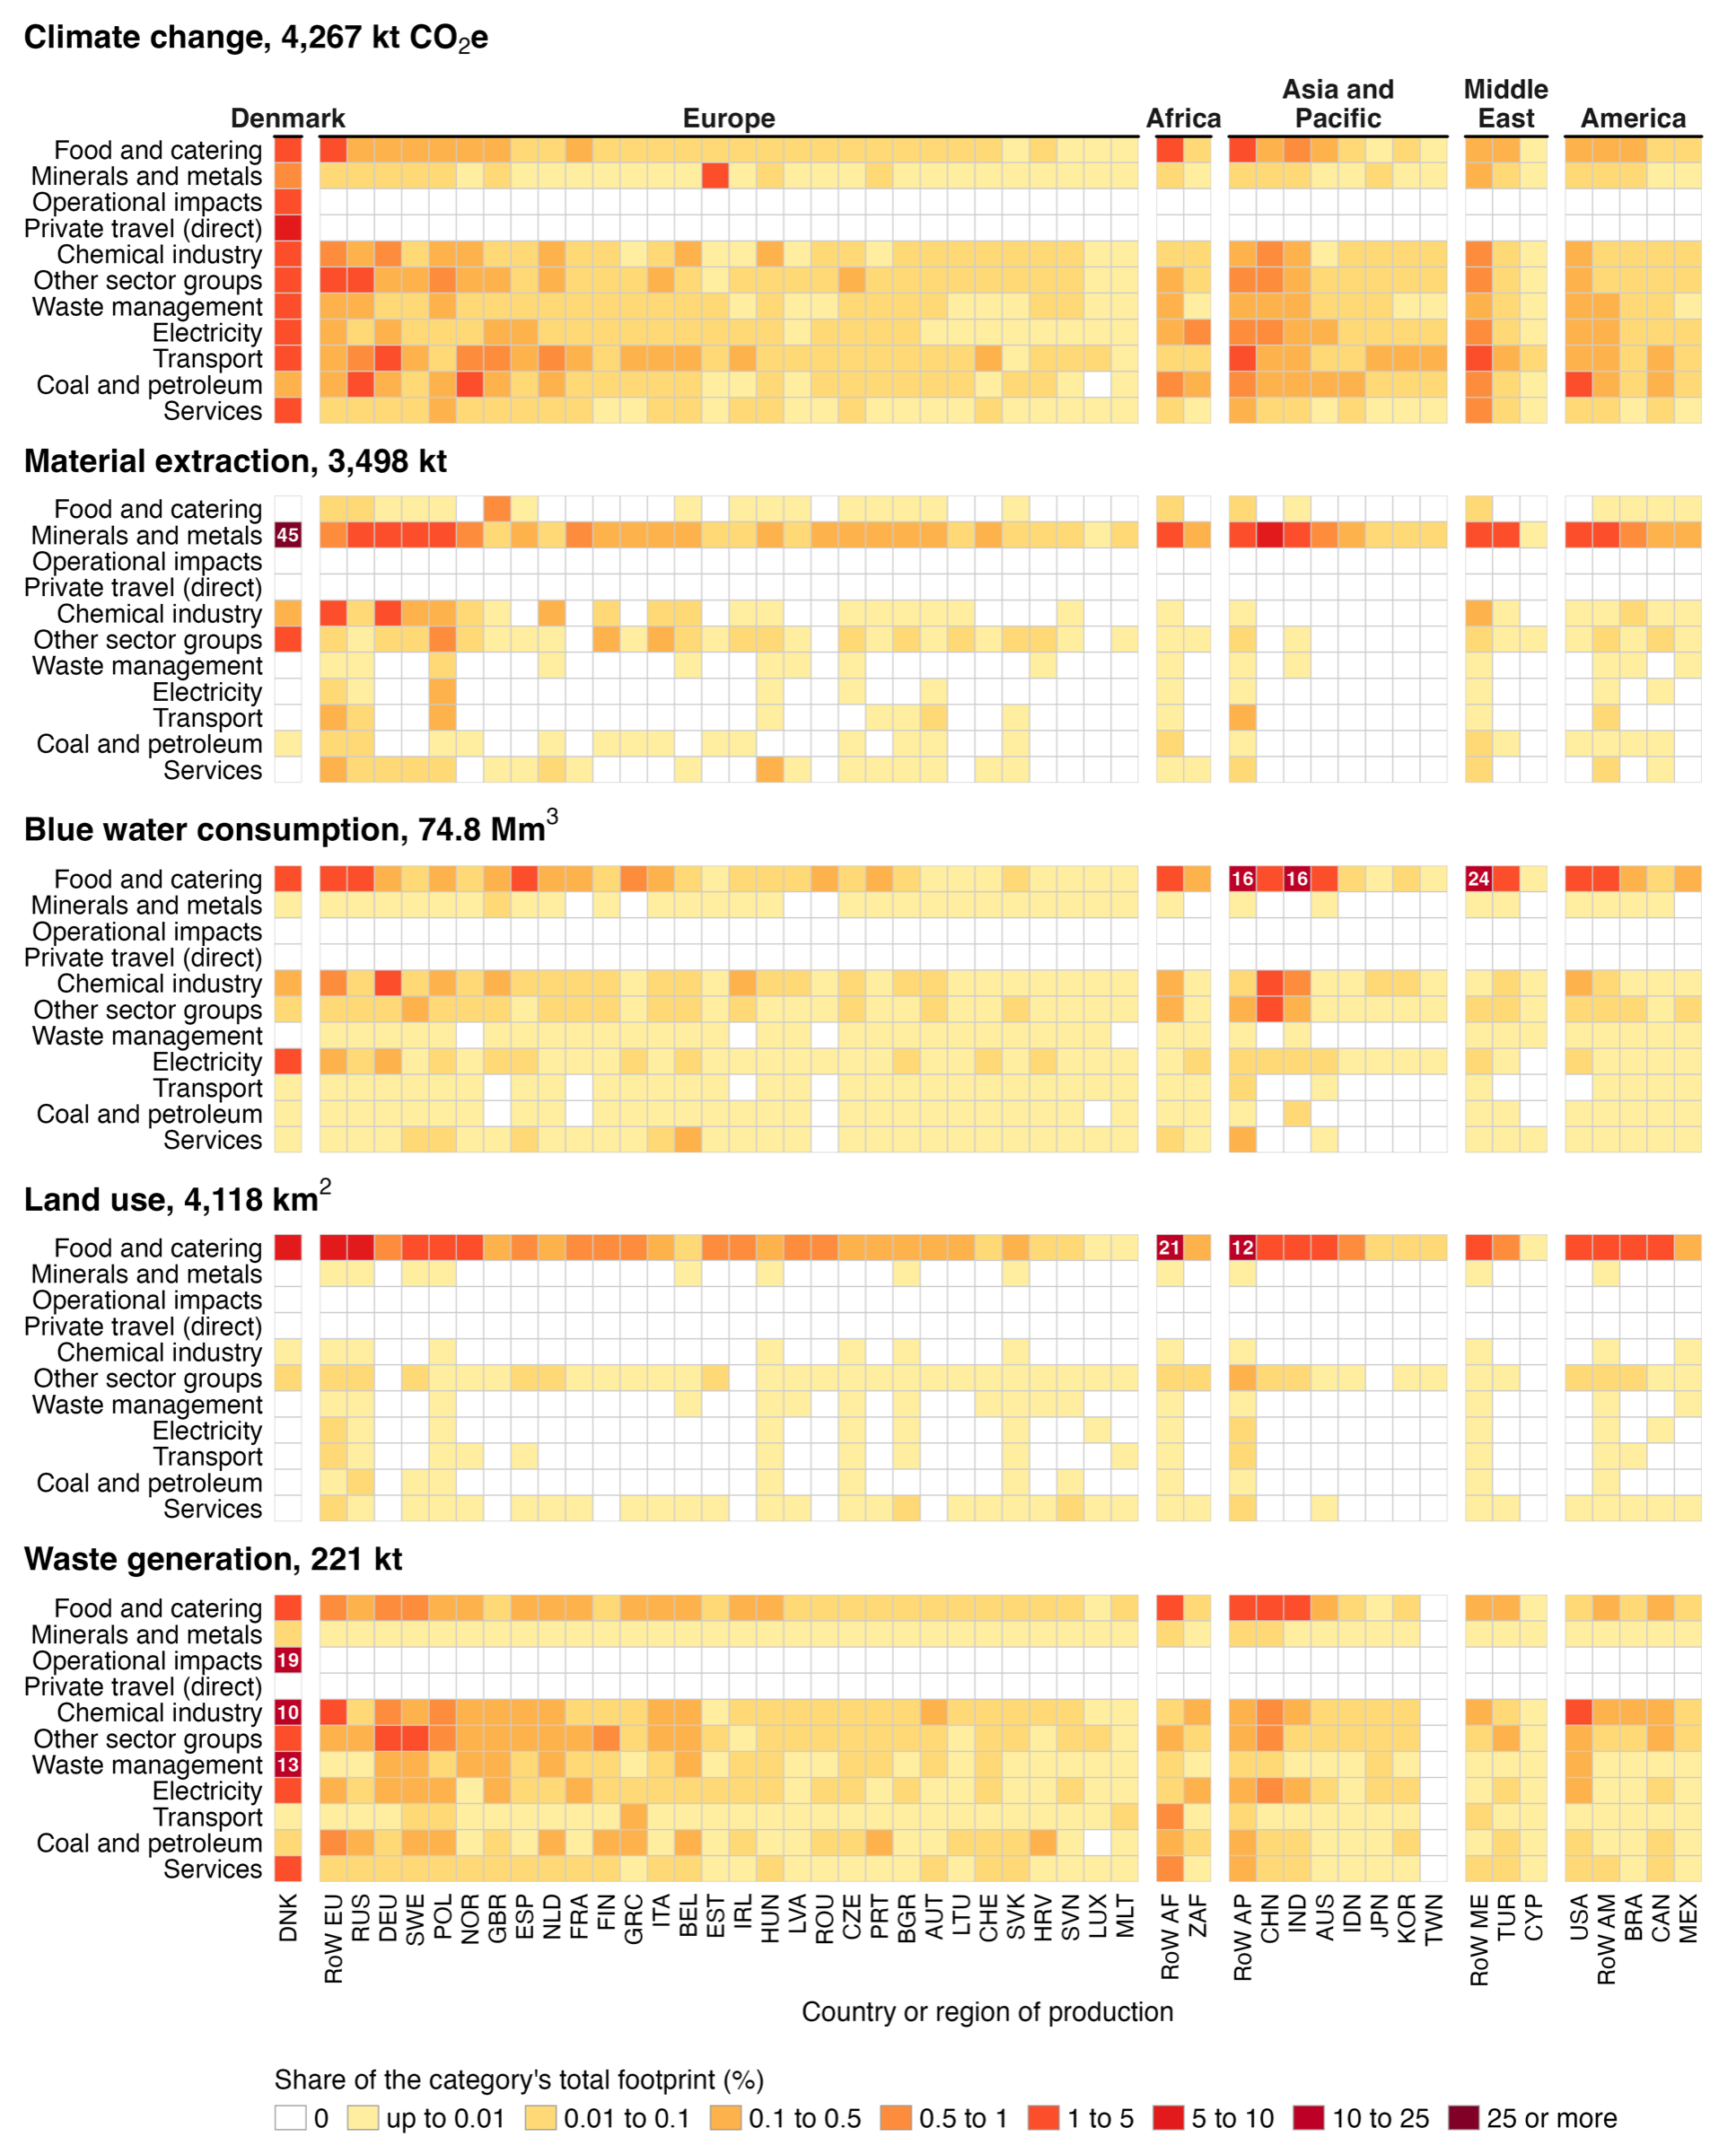
Fig. A.6. Environmental impacts associated with Danish health care in 2022 by country or region of production (columns) and producing sector group (rows), for the five impact categories. Each cell is a share of the category's total footprint, given in the panel title; white cells have no footprint. Region codes are as in Fig. 2 of the main text. Private travel (direct) is the vehicle emissions of commuting and patient and visitor travel; its supply chains have no country of production and are not shown (6.7% of climate change, under 1% of each other category).

Reference years and the background model
The analysis year is 2022. The same code was run for 2016 and 2019 to show how sensitive the result is to the reference year, but the three results form a comparison, not a time series, for two reasons. First, version 3.8.2 has a two-year gap in the Danish health block. The output of the health and social work industry is 37,163 million euros in 2016 and 38,298 million in 2017, falls to 17,590 million in 2018 and 18,646 million in 2019, and returns to 42,834 million in 2020 and 43,955 million in 2022. Where a Danish national-accounts figure exists for comparison, the table agrees with it to within 3% in 2016 and in 2022 but reaches only 48% of it in 2019. Because health care demand in this study is scaled onto that industry's own intermediate structure, a 2019 run on the 2019 table would scale a demand vector roughly twice the size of the industry it is supposed to come from. The 2019 run therefore uses the 2016 background, as does the 2016 run. The defect is specific to a release rather than to a year: versions 3.9.x and 3.10.x report 2019 within 15% of the national accounts but put 2022 at 70% and 36% of it, which is why version 3.8.2 is used here. Second, the 2022 run uses the 2022 background, so the step from 2019 to 2022 changes the technology structure and the satellite accounts at the same time as demand.
Read with that caveat, the comparison is informative (Figs. A.7 and A.8). Between 2016 and 2019, with the background held constant, health care expenditure rises from 33,430 to 35,271 million euros in current prices and the five categories rise by between 1.5% and 5.9%: the climate footprint from 3,809 to 3,996 kt CO₂e, material extraction from 2,431 to 2,574 kt, blue water consumption from 45.1 to 47.7 Mm³, land use from 2,859 to 3,020 km² and waste generation from 227 to 230 kt. Between 2019 and 2022, expenditure rises by a further 15.1%, to 40,597 million euros, and the categories diverge: climate change +6.8%, material extraction +35.9%, blue water consumption +56.8%, land use +36.3% and waste generation −4.0%. The divergence arises largely from the background model. A group-level decomposition (Fig. A.9) shows the net climate increase of 271 kt to be the sum of a 657 kt rise in pharmaceuticals and chemical products, which grows because the chemicals block is larger in the 2022 table; falls of 231 kt in transport and 171 kt in the residual group; and a net rise of 17 kt across the remaining groups. Fig. A.10 traces the climate footprint from the uncorrected 2016 estimate to the corrected 2022 estimate.
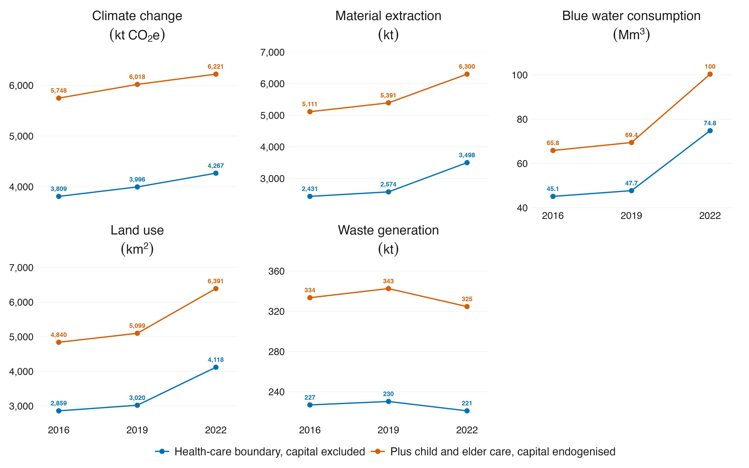
Fig. A.7. The Danish health care footprint in each of the three reference years for the five impact categories, all computed on the corrected background with the same code.
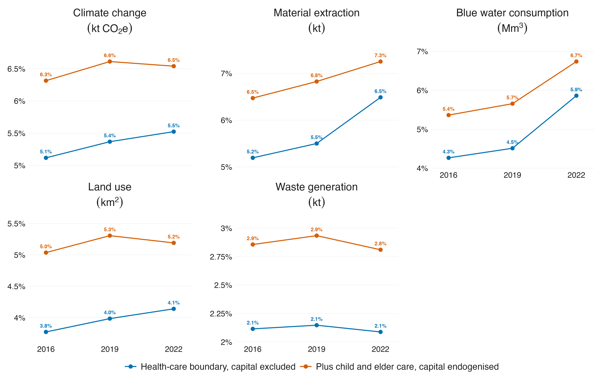
Fig. A.8. The Danish health care footprint in each of the three reference years as a share of the Danish national consumption-based footprint for each impact category.
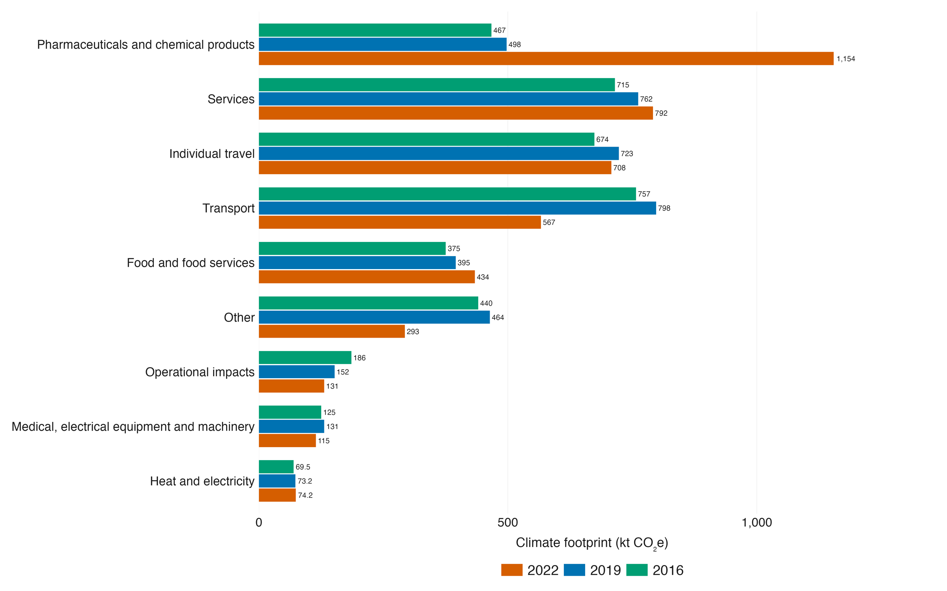
Fig. A.9. Activity-group composition of the climate footprint in each reference year, showing where the divergence between 2019 and 2022 is located.
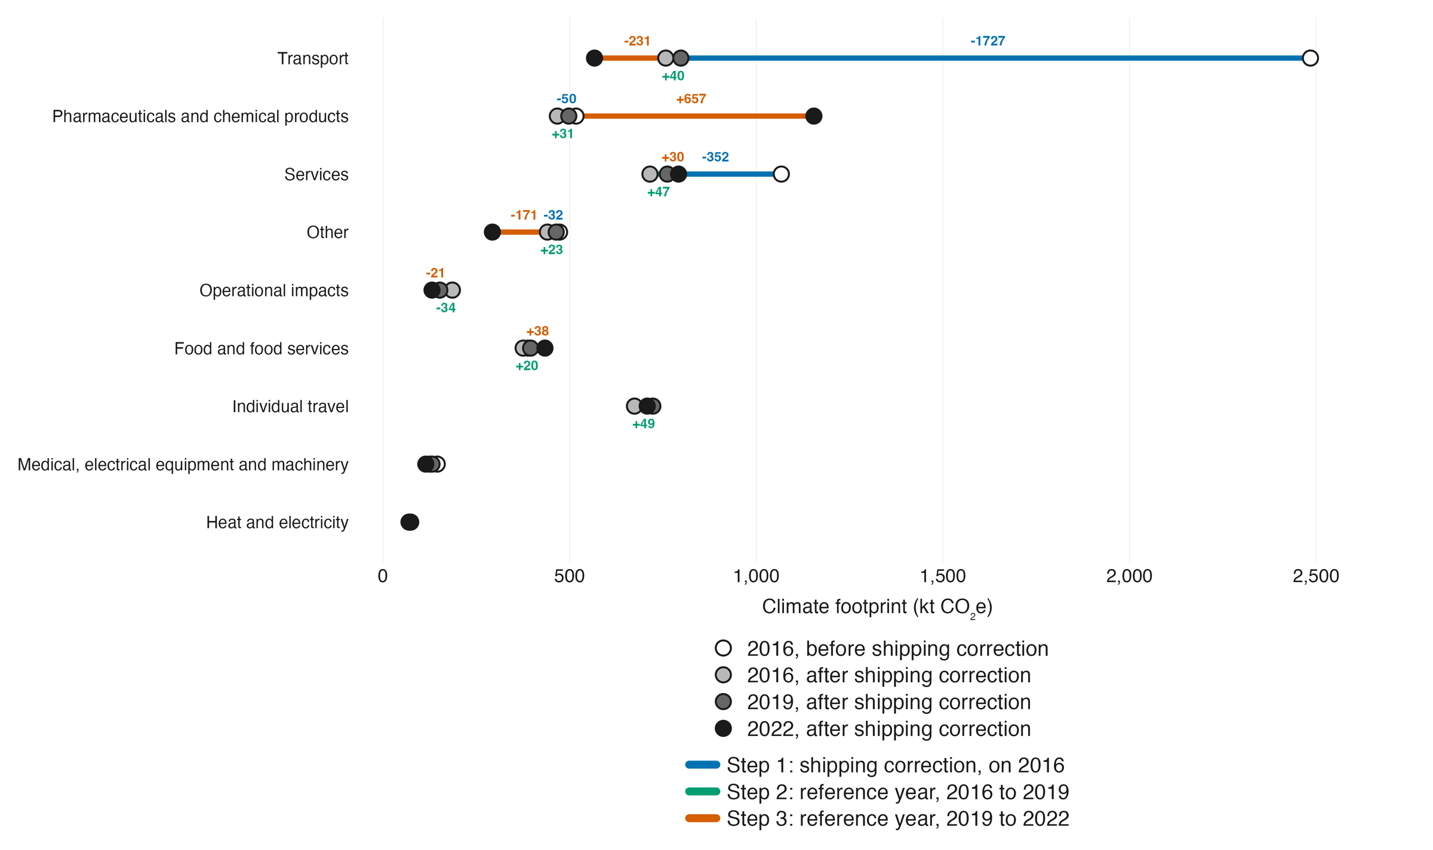
Fig. A.10. The climate footprint from the uncorrected 2016 estimate to the corrected 2022 estimate, in three steps: the sea-transport correction, the change from 2016 to 2019 demand, and the change from 2019 to 2022 demand and background. Labels are given for steps of 20 kt CO₂e or more.

Gross fixed capital formation
Capital is excluded from the headline, following the treatment in the Dutch template [8]; Pichler and colleagues, Eckelman and Sherman, and Malik and colleagues include health investment [28,29,30], so their totals are not directly comparable. Excluding capital nonetheless has a measurable effect. Three capital treatments were computed on the input-output component with the operational term, 3,535 kt CO₂e. Adding the consumption of fixed capital of the Danish health and residential care industries as an exogenous service flow raises it to 4,070 kt, an increase of 15.1%. Endogenising capital into the Leontief inverse on the published matrices of Södersten and colleagues [22],
$L^{K}={\left(I−\left(A+K\right)\right)}^{−1}, K=\overline{K}{\hat{x}}^{−1}$ (A.18)
raises it to 4,286 kt, an increase of 21.2%, and raises material extraction by 38.9%, blue water consumption by 12.5% and land use by 22.5%; a full endogenisation built from each region's own capital formation raises the climate figure by 23.0%. Excluding capital therefore places the estimate about a fifth lower for climate change and nearly two-fifths lower for material extraction.

The global-warming-potential revision
The study characterises greenhouse gases on IPCC AR6 GWP100 values, in the input-output component [31] and in the bottom-up terms alike. The choice moves the input-output component by about 5%: the same physical emissions give 3,254 kt CO₂e on SAR, 3,294 kt on TAR, 3,347 kt on AR4, 3,425 kt on AR5 and 3,415 kt on AR6. AR5 and AR6 are within 0.3% of one another, and studies characterised on AR4, including several of the comparators used here, sit about 2% below an AR6 accounting of the same emissions. A residue of 126 kt of pre-aggregated hydrofluorocarbons and perfluorocarbons in the EXIOBASE satellite accounts cannot be restated on a different revision and is reported unchanged in every case.

Producing region by industry
Resolving the producing sector and the producing region jointly, rather than one at a time, identifies the specific nodes that carry each impact category; shares are taken of the input-output component. The main text reports the twenty largest pairs, which show that four of the five categories are concentrated in identifiable nodes and climate change is not. Quarrying of sand and clay carries 64% of material extraction across the twenty largest pairs, the Danish node alone 43%; cattle farming and raw milk together carry 31% of land use; irrigated wheat, rice and sugar cultivation carry 34% of blue water consumption; and Danish chemicals production and Danish waste incineration carry 27% of waste generation. For climate change, the largest single pair, Danish retail trade, which carries the distribution margins on pharmaceuticals and therapeutic appliances, accounts for 4.7%, and 67.4% of the footprint lies outside the twenty largest pairs.

Validation against published Danish footprints
The Danish national consumption-based climate footprint computed in this study, 77.2 Mt CO₂e for 2022, is higher than Eurostat FIGARO's 57.4 Mt [32], Statistics Denmark's AFTRYK 62.9 Mt [33], and Schmidt and Merciai's EXIOBASE-based 73.9 Mt for 2016 [34]. The separation is by model family rather than by year: national-accounts-based estimates sit below EXIOBASE-based estimates for Denmark. For health care, matching Schmidt and Merciai's sector boundary, which includes childcare, and their capital treatment moves this study's figure from 4.27 to 6.14 Mt CO₂e, 1.046 t per person, against their 6.1 Mt and 1.07 t per person for 2016: 0.7% higher in total and 2.3% lower per person. Their model is consequential and ours is attributional, and their year is 2016, so the comparison checks order of magnitude and structure rather than the figure itself. Fig. A.11 shows the steps from the headline to the matched figure.
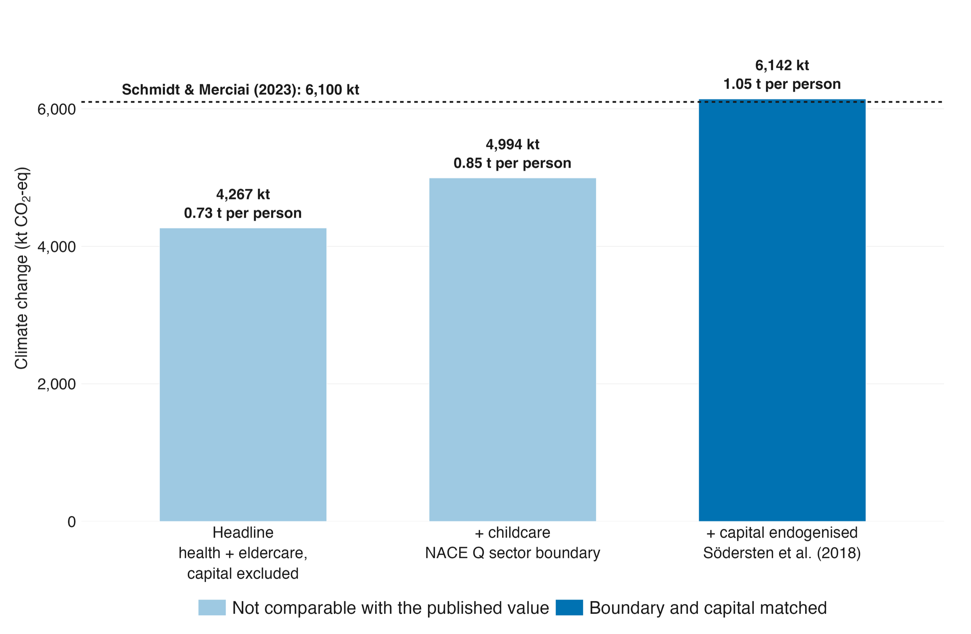
Fig. A.11. From this study's headline to a figure comparable with that of Schmidt and Merciai, in two steps: matching the sector boundary, then matching the capital treatment.

Parameter uncertainty, in figures
Figs. A.12 to A.16 present the Monte Carlo results described above. They are the evidence for three statements in the main text: that the intervals are set by the input-output data rather than by the Danish primary data, that the ranking of contributors is far more precisely determined than their levels, and that the estimate does not rest on the bottom-up proxies.
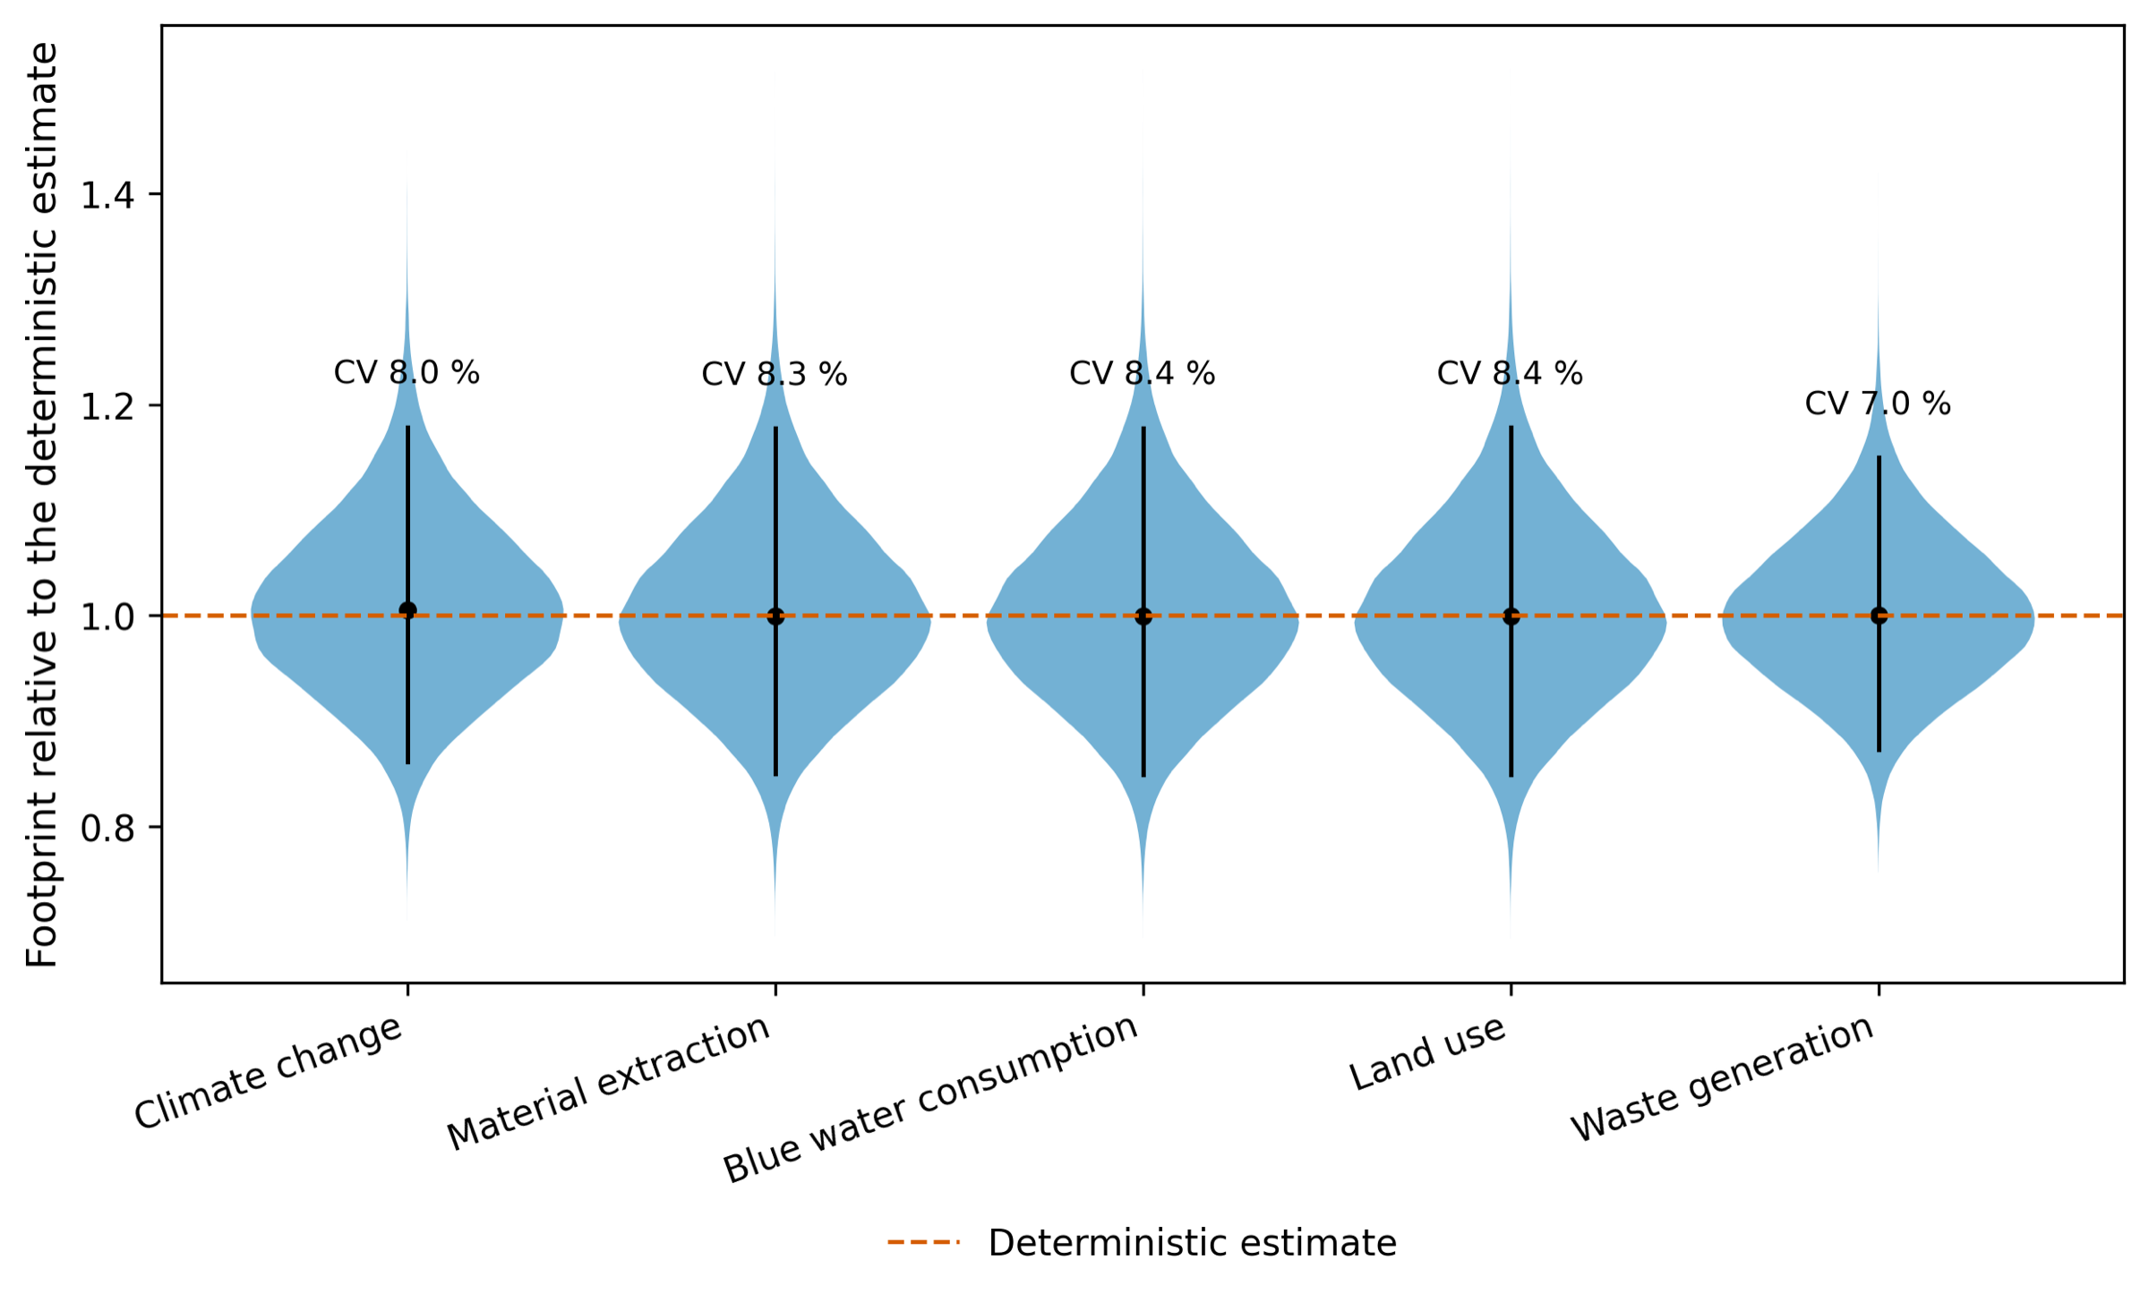
Fig. A.12. The simulated distribution of each impact category, 100,000 draws, with the deterministic estimate and the 95% interval marked. The distributions are shown on their own scales because the categories differ by orders of magnitude.
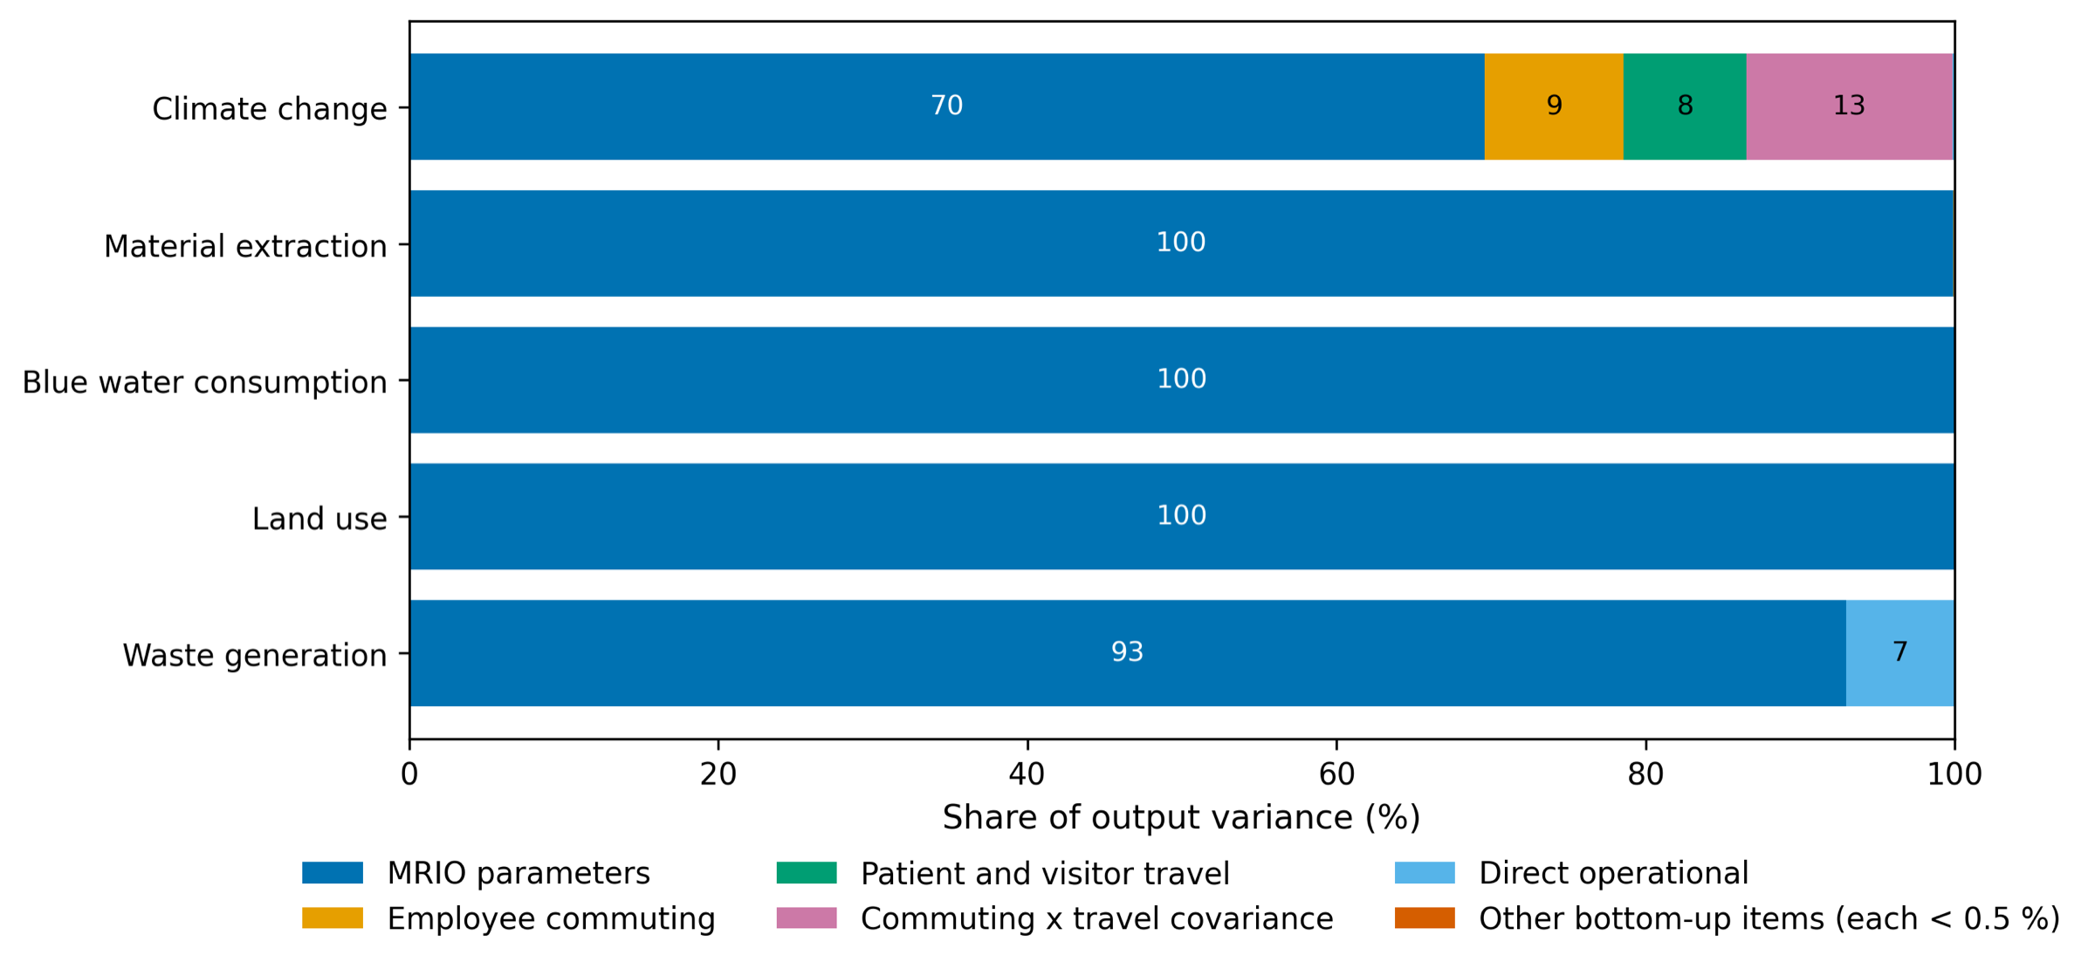
Fig. A.13. First-order variance shares by parameter for each impact category, with the covariance of employee commuting and patient and visitor travel carried as its own term so that the decomposition sums to 100%.
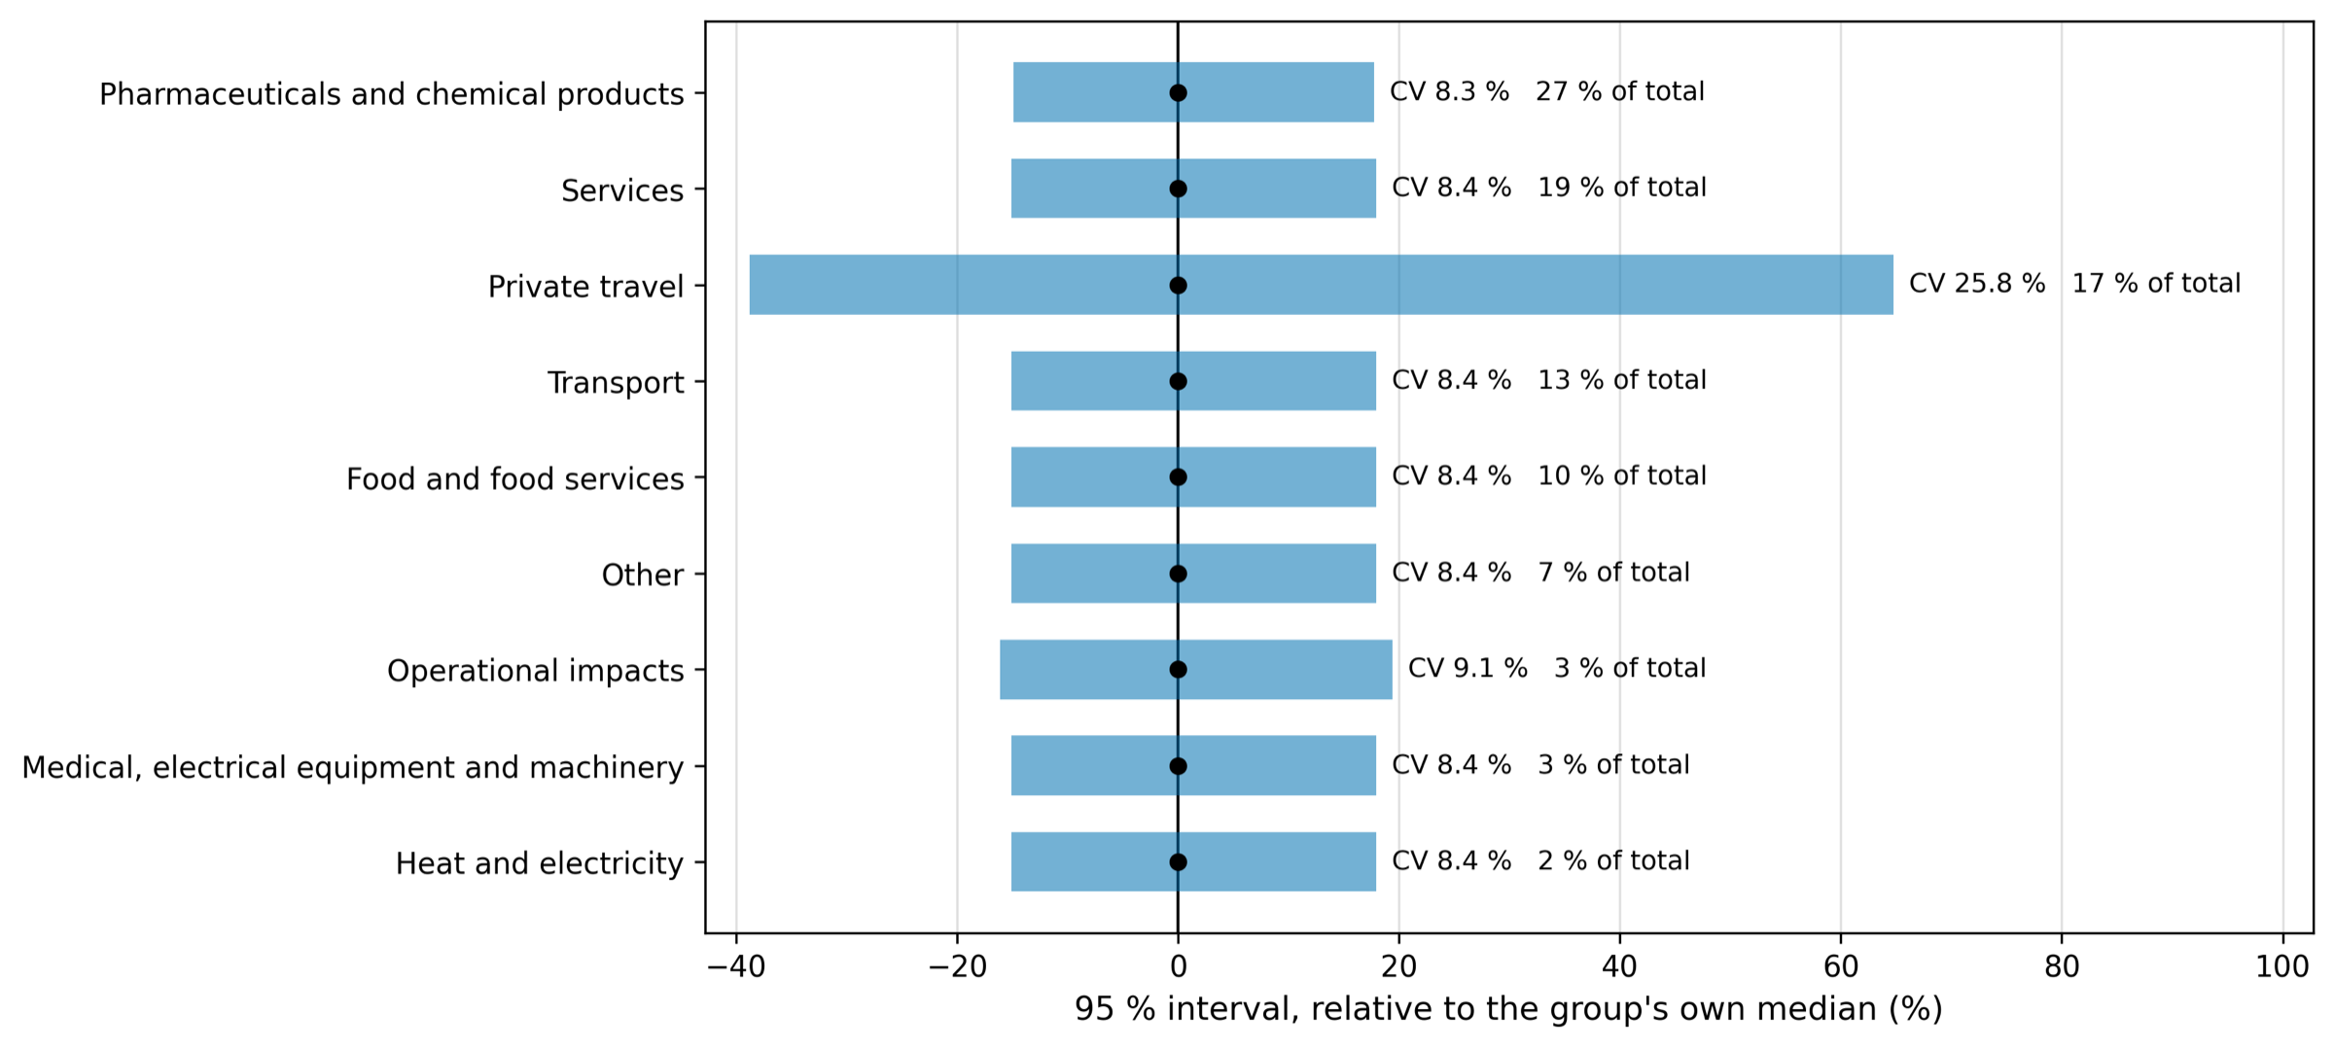
Fig. A.14. The climate contribution of each activity group with its 95% interval, ordered by share. Private travel is the only group whose coefficient of variation, 25.8%, is materially above the 8.3% to 9.1% the input-output data impose on the other groups.
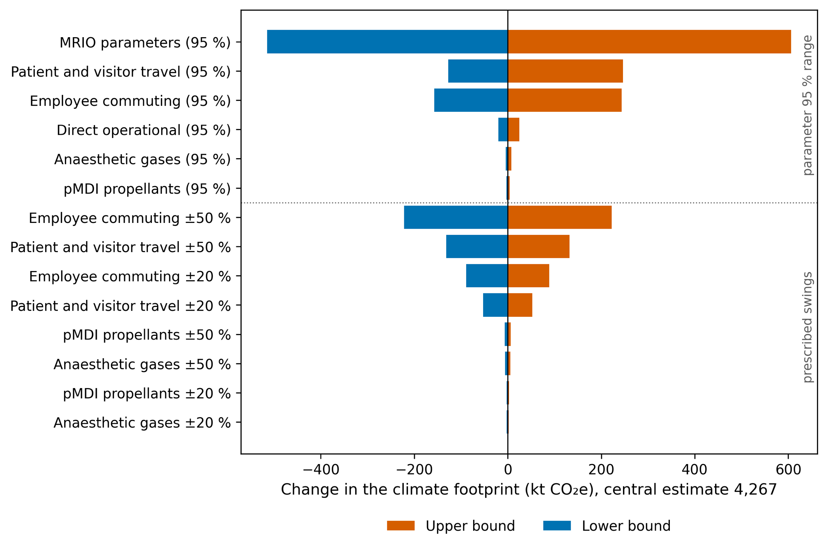
Fig. A.15. The effect on the climate footprint of moving one parameter at a time to the ends of its own interval, with all others held at their medians.
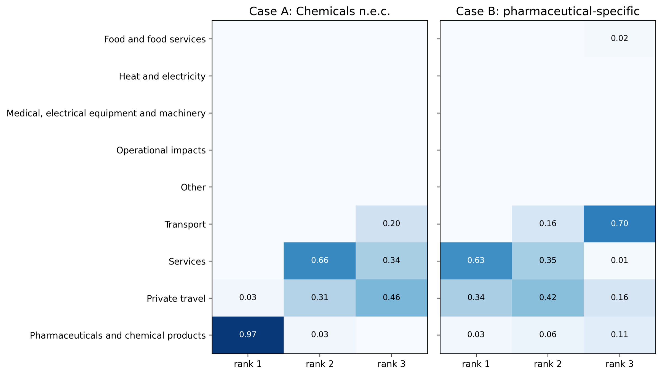
Fig. A.16. The probability that each activity group holds rank one, two or three in the climate footprint across the 100,000 draws. Pharmaceuticals and chemical products hold rank one in 96.6% of draws under the chemicals mapping.

References
[1] OECD, Eurostat, World Health Organization, A System of Health Accounts 2011: Revised Edition, OECD Publishing, Paris, 2017. https://doi.org/10.1787/9789264270985-en.
[2] R.H. Hagenaars, An investigation into the carbon and material footprint of the Dutch consumption of pharmaceuticals, MSc thesis, Industrial Ecology, Delft University of Technology and Leiden University, 2022. https://resolver.tudelft.nl/uuid:6256cb61-eab8-4c4c-bd3a-07ff8e709219 (accessed 14 September 2026).
[3] R.W.F. Olsen, K.B. Johansen, F. Ayivee, S. Gislason, S.A. Pedersen, C. Cimpan, The greener prescription: life cycle environmental impact of oral and IV penicillin treatments, Sustain. Chem. Pharm. 50 (2026) 102346. https://doi.org/10.1016/j.scp.2026.102346.
[4] Statistics Denmark, Input-output tables 2016 and 2022, 117 industries, current prices; supply and use tables 2019 [datasets], Statistics Denmark, Copenhagen, 2025. https://www.dst.dk/en/Statistik/emner/oekonomi/nationalregnskab/input-output (accessed 7 September 2026).
[5] P. Forster, T. Storelvmo, K. Armour, W. Collins, J.-L. Dufresne, D. Frame, D.J. Lunt, T. Mauritsen, M.D. Palmer, M. Watanabe, M. Wild, H. Zhang, The Earth's energy budget, climate feedbacks, and climate sensitivity, in: V. Masson-Delmotte, P. Zhai, A. Pirani, S.L. Connors, C. Péan, S. Berger, N. Caud, Y. Chen, L. Goldfarb, M.I. Gomis, M. Huang, K. Leitzell, E. Lonnoy, J.B.R. Matthews, T.K. Maycock, T. Waterfield, O. Yelekçi, R. Yu, B. Zhou (Eds.), Climate Change 2021: The Physical Science Basis. Contribution of Working Group I to the Sixth Assessment Report of the Intergovernmental Panel on Climate Change, Cambridge University Press, Cambridge and New York, 2021, pp. 923–1054. https://doi.org/10.1017/9781009157896.009.
[6] C. Smith, Z.R.J. Nicholls, K. Armour, W. Collins, P. Forster, M. Meinshausen, M.D. Palmer, M. Watanabe, The Earth's energy budget, climate feedbacks, and climate sensitivity supplementary material, in: V. Masson-Delmotte, P. Zhai, A. Pirani, S.L. Connors, C. Péan, S. Berger, N. Caud, Y. Chen, L. Goldfarb, M.I. Gomis, M. Huang, K. Leitzell, E. Lonnoy, J.B.R. Matthews, T.K. Maycock, T. Waterfield, O. Yelekçi, R. Yu, B. Zhou (Eds.), Climate Change 2021: The Physical Science Basis. Contribution of Working Group I to the Sixth Assessment Report of the Intergovernmental Panel on Climate Change, IPCC, 2021. https://www.ipcc.ch/report/ar6/wg1/downloads/report/IPCC_AR6_WGI_Chapter07_SM.pdf (accessed 14 September 2026).
[7] H. Christiansen, O. Baescu, The Danish National Travel Survey: Annual Statistical Report for Denmark for 2022, data version TU0622v1, DTU Center for Transport Analytics, Technical University of Denmark, Kongens Lyngby, 2023. https://orbit.dtu.dk/en/publications/the-danish-national-travel-survey-annual-statistical-report-for-d-2/ (accessed 14 September 2026).
[8] M.A. Steenmeijer, J.F.D. Rodrigues, M.C. Zijp, S.L. Waaijers-van der Loop, The environmental impact of the Dutch health-care sector beyond climate change: an input–output analysis, Lancet Planet. Health 6 (2022) e949–e957. https://doi.org/10.1016/S2542-5196(22)00244-3.
[9] O.-K. Nielsen, M.S. Plejdrup, M. Winther, M. Nielsen, S. Gyldenkærne, M.H. Mikkelsen, R. Albrektsen, K. Hjelgaard, P. Fauser, H.G. Bruun, G. Levin, T.A. Andersen, S.L. Tougaard, L.S.H. Arendal, V.K. Johannsen, T. Nord-Larsen, L. Vesterdal, I. Stupak, N. Scott-Bentsen, L. Baunbæk, M.G. Hansen, Denmark's National Inventory Document 2026: Emission Inventories 1990-2024, Submitted under the United Nations Framework Convention on Climate Change and the Paris Agreement, Scientific Report from DCE, Danish Centre for Environment and Energy, No. 706, Aarhus University, Aarhus, 2026. https://pure.au.dk/portal/en/publications/denmarks-national-inventory-document-2026-emission-inventories-19/ (accessed 14 September 2026).
[10] Danish Health Data Authority (Sundhedsdatastyrelsen), medstat.dk: sales of medicines by ATC code, N01AB halogenated hydrocarbons, entire country, all sectors, 2016-2022 [dataset], Register of Medicinal Product Statistics, 2026. https://medstat.dk/en (accessed 7 September 2026).
[11] M.J. Laster, Z. Fang, E.I. Eger, Specific gravities of desflurane, enflurane, halothane, isoflurane, and sevoflurane, Anesth. Analg. 78 (1994) 1152–1153. https://doi.org/10.1213/00000539-199406000-00022.
[12] E.D. Kharasch, M.D. Karol, C. Lanni, R. Sawchuk, Clinical sevoflurane metabolism and disposition. I. Sevoflurane and metabolite pharmacokinetics, Anesthesiology 82 (1995) 1369–1378. https://doi.org/10.1097/00000542-199506000-00008.
[13] Danish Environmental Protection Agency, T.S. Poulsen (Ed.), Danish consumption and emission of F-gases in 2022, Environmental Project No. 2255, The Danish Environmental Protection Agency, Odense, 2024. https://www2.mst.dk/Udgiv/publications/2024/01/978-87-7038-582-4.pdf (accessed 14 September 2026).
[14] Danish Environmental Protection Agency, Danish consumption and emission of F-gases in 2019, Environmental Project No. 2161, The Danish Environmental Protection Agency, Odense, 2021. https://www2.mst.dk/Udgiv/publications/2021/02/978-87-7038-274-8.pdf (accessed 14 September 2026).
[15] Danish Environmental Protection Agency, T.S. Poulsen (Ed.), Danish consumption and emission of F-gases, Environmental Project No. 1979, Miljøstyrelsen, Copenhagen, 2018. https://www2.mst.dk/Udgiv/publications/2018/02/978-87-93614-62-8.pdf (accessed 14 September 2026).
[16] J. Vestbo, K. Press-Kristensen, Translated impact on carbon footprint from choice of inhaled therapy: a Danish scenario, Eur. Respir. J. 62 (2023) 2300856. https://doi.org/10.1183/13993003.00856-2023.
[17] Statistics Denmark, DRIVHUS: Greenhouse gas accounts (in CO2 equivalents) by industry and type of emission; AFFALD01: Waste generation by industry and waste category; NABB117: Employment (117-grouping), hours worked by industry [datasets], StatBank Denmark, 2025–2026. https://www.statbank.dk/DRIVHUS, https://www.statbank.dk/AFFALD01 and https://www.statbank.dk/NABB117 (accessed 7 and 14 September 2026).
[18] Statistics Netherlands (CBS), Personenmobiliteit; vervoerwijzen en reismotieven, regio's, 2010-2017 [Personal mobility; modes of travel and travel purposes, regions], table 83500NED [dataset], StatLine, 2018. https://opendata.cbs.nl/statline/#/CBS/nl/dataset/83500NED/table (accessed 14 September 2026).
[19] I. Tennison, S. Roschnik, B. Ashby, R. Boyd, I. Hamilton, T. Oreszczyn, A. Owen, M. Romanello, P. Ruyssevelt, J.D. Sherman, A.Z.P. Smith, K. Steele, N. Watts, M.J. Eckelman, Health care's response to climate change: a carbon footprint assessment of the NHS in England, Lancet Planet. Health 5 (2021) e84–e92. https://doi.org/10.1016/S2542-5196(20)30271-0.
[20] M. Lenzen, A. Malik, M. Li, J. Fry, H. Weisz, P.-P. Pichler, L.S.M. Chaves, A. Capon, D. Pencheon, The environmental footprint of health care: a global assessment, Lancet Planet. Health 4 (2020) e271–e279. https://doi.org/10.1016/S2542-5196(20)30121-2.
[21] I.M. Sobol', Global sensitivity indices for nonlinear mathematical models and their Monte Carlo estimates, Math. Comput. Simul. 55 (2001) 271–280. https://doi.org/10.1016/S0378-4754(00)00270-6.
[22] C.-J.H. Södersten, R. Wood, E.G. Hertwich, Endogenizing capital in MRIO models: the implications for consumption-based accounting, Environ. Sci. Technol. 52 (2018) 13250–13259. https://doi.org/10.1021/acs.est.8b02791.
[23] K. Stadler, R. Wood, T. Bulavskaya, C.-J. Södersten, M. Simas, S. Schmidt, A. Usubiaga, J. Acosta-Fernández, J. Kuenen, M. Bruckner, S. Giljum, S. Lutter, S. Merciai, J.H. Schmidt, M.C. Theurl, C. Plutzar, T. Kastner, N. Eisenmenger, K.-H. Erb, A. de Koning, A. Tukker, EXIOBASE 3 [dataset], Zenodo, version 3.8.2, 2021. https://doi.org/10.5281/zenodo.5589597.
[24] World Resources Institute, World Business Council for Sustainable Development, The Greenhouse Gas Protocol: A Corporate Accounting and Reporting Standard, revised ed., World Resources Institute and World Business Council for Sustainable Development, Washington, DC and Geneva, 2004. https://ghgprotocol.org/corporate-standard (accessed 14 September 2026).
[25] E.G. Hertwich, R. Wood, The growing importance of scope 3 greenhouse gas emissions from industry, Environ. Res. Lett. 13 (2018) 104013. https://doi.org/10.1088/1748-9326/aae19a.
[26] C. Doucet, M. Lioussis, N. Yamano, M. Mueller, Measuring greenhouse gas emissions in the health sector: a new approach to model GHG emissions combining (JHAQ) health expenditure data and the multi-regional inter-country input-output (ICIO) tables, OECD Health Working Papers No. 184, OECD Publishing, Paris, 2025. https://doi.org/10.1787/4d15c6ef-en.
[27] P. Rørmose Jensen, B. Iliev, Compilation of a consumption based greenhouse gas account for Denmark using coupled models, Technical report for Eurostat, grant no. 101022790, Statistics Denmark, Copenhagen, 2022. https://www.dst.dk/Site/Dst/SingleFiles/GetArchiveFile.aspx?fi=868742149393&fo=0&ext=kvaldel (accessed 14 September 2026).
[28] P.-P. Pichler, I.S. Jaccard, U. Weisz, H. Weisz, International comparison of health care carbon footprints, Environ. Res. Lett. 14 (2019) 064004. https://doi.org/10.1088/1748-9326/ab19e1.
[29] M.J. Eckelman, J. Sherman, Environmental impacts of the U.S. health care system and effects on public health, PLoS One 11 (2016) e0157014. https://doi.org/10.1371/journal.pone.0157014.
[30] A. Malik, M. Lenzen, S. McAlister, F. McGain, The carbon footprint of Australian health care, Lancet Planet. Health 2 (2018) e27–e35. https://doi.org/10.1016/S2542-5196(17)30180-8.
[31] Institute of Environmental Sciences (CML), Leiden University, Characterisation factors for the EXIOBASE 3 satellite accounts, characterisation_DESIRE version 3.4, 25 May 2018, adapted [dataset], distributed in the model repository of Steenmeijer et al., 2022. https://github.com/rivm-syso/envr-footprint-healthcare (accessed 14 September 2026).
[32] Eurostat, Greenhouse gas emission footprints (in CO2 equivalent, FIGARO application), env_ac_ghgfp [dataset], Eurostat, Luxembourg, 2026. https://ec.europa.eu/eurostat/databrowser/view/env_ac_ghgfp/default/table (accessed 7 September 2026).
[33] Statistics Denmark, AFTRYK1: Climate footprint (experimental statistics) by type of use, emitting industries, emitting countries and time [dataset], StatBank Denmark, 2026. https://www.statbank.dk/AFTRYK1 (accessed 14 September 2026).
[34] J. Schmidt, S. Merciai, Technical report: GHG emissions from Danish consumption 2016, causal link between consumption and GHG emissions, 2.-0 LCA consultants for CONCITO, Aalborg, 2023. https://concito.dk/files/media/document/Bilagsrapport%201_GHG%20emissions%20from%20Danish%20consumption%202016.pdf (accessed 14 September 2026).

