Abstract

Background
Health care systems are essential for maintaining and improving human health, yet delivering care relies on energy and materials that generate environmental impacts extending across global supply chains. These impacts harm human health and are not captured by facility-level assessments, highlighting the need for systemic analysis.
Methods
We quantified the environmental impacts associated with delivering health care in Denmark in 2019 using a hybrid approach that combines environmentally extended multi-regional input-output analysis with selected bottom-up estimates. Health care demand was constructed using Danish supply-use tables and linked to global supply chains to assess five impact categories: climate change, material extraction, blue water consumption, land use, and waste generation.
Findings
Danish health care was responsible for an estimated 4,815 kt CO₂e (5·6% of national greenhouse gas emissions), 2,601 kt of material extraction (5·5%), 47 million cubic metres (Mm³) of blue-water consumption (4·3%), 2,753 km² of land use (3·6%), and 840 kt of waste (3·6%). Transport was the largest contributor to greenhouse gas emissions, while pharmaceuticals, chemicals, and food-related supply chains were key drivers of other impacts. A considerable proportion of impacts, particularly water consumption and land use, occurred outside Denmark and Europe. By tracing health care demand through international supply chains, the analysis identifies environmental impacts that are geographically displaced from the delivery of care and quantifies their upstream origins, which are not captured by facility-level or other production-based assessments.
Interpretation
Although direct emissions are likely underestimated by our method, these findings indicate that environmental impacts associated with Danish health care are largely driven by indirect and geographically displaced supply-chain activities. The results show that the environmental footprint of health care cannot be fully characterised from activities occurring within health care facilities or national borders. Mitigation efforts therefore need to extend beyond health care facilities to address transport, procurement, pharmaceutical supply, and food systems, including impacts embodied in internationally sourced goods and services.

The environmental impacts of the Danish health care system: supply-chain origins and geographical displacement of impacts

Research in context
Evidence before this study
Previous studies have used facility-level, process-based, and input-output approaches to quantify the environmental impacts of health care, primarily focusing on greenhouse gas emissions and highlighting the importance of supply-chain impacts. Input-output and hybrid approaches have increasingly enabled assessment of indirect impacts across health care supply chains, including impacts occurring outside the health care sector and across national borders. However, these approaches have been applied to a limited number of national health care systems, and there remains a need for country-specific assessments that combine consumption-based accounting with detailed national health care expenditure data and selected bottom-up estimates.

Added value of this study
This study provides a consumption-based assessment of the Danish health care system using a hybrid input-output approach that links Danish health care demand to global supply chains and combines economy-wide estimates with selected bottom-up data. The approach quantifies environmental impacts across five impact categories and identifies the sectors and geographical regions in which impacts associated with Danish health care occur. Results estimate that health care contributes approximately 3·6-5·6% of national environmental impacts across the five categories, with (upstream- and direct) transport, pharmaceuticals & chemicals, and food-related supply chains accounting for substantial shares of the footprint.

Implications of all the available evidence
Reducing the environmental impacts of health care requires action both within health care facilities and across the global supply chains on which they depend. Our findings show that substantial environmental impacts associated with health care arise from activities upstream of health care delivery and, for some impact categories, occur predominantly outside Denmark and Europe. This means that reducing the environmental footprint of health care will require attention to the supply chains through which care is delivered, including procurement of pharmaceuticals, chemicals, food, and transport services, alongside measures to reduce direct impacts within health care facilities.

Introduction
Health care systems are essential components of societal infrastructure, maintaining and improving public health through prevention, diagnosis, and treatment. However, delivering health care services relies on energy, materials, transport, and complex supply chains, generating environmental impacts that extend beyond national borders and contribute to risks for human health and wellbeing ^{1,2}. Recent assessments indicate that health care systems contribute a significant share of national and global environmental impacts, particularly with respect to greenhouse gas emissions ³⁻⁵. In Europe, including Denmark, health care systems operate within broader policy frameworks that prioritise climate change mitigation and sustainability while simultaneously facing increasing demand for health care services. Aligning health care service delivery with climate and sustainability objectives therefore represents a key challenge, as reductions in direct emissions must be complemented by improved understanding of indirect and supply‑chain‑related environmental impacts ^{2,4}.
During the recent two decades, increasing attention has been directed towards the environmental impacts of health care, mostly in relation to climate change ^{6,7}, but also with regards to other impacts such as resource use and waste generation ⁴. Early assessments commonly focused on direct emissions from health care facilities or specific clinical activities, whereas subsequent input-output and hybrid studies have incorporated indirect impacts associated with the wider supply chains required to deliver health care ^{3,5,7-9}. These approaches demonstrate that a substantial share of health care's environmental impacts arise upstream, beyond the physical boundaries of health care facilities and, in many cases, across international supply chains. These environmental effects cause harm to human populations ² and have been identified as a growing threat to human wellbeing ¹⁰. The health impacts of climate change and environmental degradation are distributed unevenly, with populations that contribute relatively little to global emissions often experiencing disproportionate adverse effects ^{1,2}. This uneven distribution is increasingly recognised as both an environmental and governance challenge. The WHO framework for environmentally sustainable health systems argues that health systems should reduce their environmental impacts across the full spectrum of activities required to deliver care, including procurement and supply-chain processes. Similarly, the recent Earth Commission report emphasises that environmental sustainability cannot be separated from considerations of justice, arguing that environmental impacts and their associated harms are often distributed unevenly across populations, regions, and generations¹¹. Similar patterns of spatially decoupled environmental impacts have been documented in other global supply chains, where trade links consumption in one region to environmental pressures in another. These perspectives suggest that understanding the environmental impacts of health care requires attention not only to the magnitude of impacts, but also to where they occur and who is exposed to their consequences¹². The uneven distribution further highlights the importance of addressing environmental impacts associated with health care delivery, particularly in high-income countries, where health care expenditure is high; Denmark, for example, spent 9·4% of gross domestic product (GDP) on health care in 2024 according to an OECD report¹³.
In Denmark, recent policy-oriented assessments have quantified the environmental footprint of the health sector. They estimate that Danish health care contributes on the order of 5 to 6% of national greenhouse gas emissions, while a broader institutional report outlines key emission sources, including energy use, procurement, pharmaceuticals, and transport, but without a complete consumption-based accounting framework ^{8,9}. These assessments have been influential in shaping national discussions and have highlighted the importance of procurement and other indirect sources of emissions. However, they do not provide a comprehensive consumption-based assessment of environmental impacts across multiple categories, nor do they examine the geographical distribution of those impacts across international supply chains. As a result, the extent to which environmental pressures associated with Danish health care are displaced beyond national borders remains insufficiently characterised.

Other studies have reported that a majority of the environmental impacts of health care systems occur outside the physical boundaries of hospitals and clinics ^{3,5}. Direct emissions (particularly in countries with low carbon intensive energy infrastructure) from on‑site energy use and medical activities represent only a fraction of the total impact ^{5,14}, while a substantial share arises upstream in the supply chain that provides pharmaceuticals, medical equipment, energy, transport services, construction, and other supporting activities ⁵. This pattern is also observed in Danish regional assessments of health care emissions, where a regional report attributed approximately 70% of greenhouse gas emissions to the procurement of goods and services ¹⁵. The region covers other areas additional to health care, and is therefore not directly comparable, but it reinforces the central role of supply chains in determining and reducing the health care footprint.
Environmental impacts can be assessed using different analytical approaches depending on the scope of interest. Process‑based life cycle assessment (LCA) provides detailed, bottom‑up estimates and has been widely applied in health care to evaluate specific products and clinical activities ¹⁶, but is currently unfeasible to apply to complex sectors due to the myriad of complexity and data requirements. Environmentally extended multi‑regional input‑output analysis (EE‑MRIO) ¹⁷ provides a top‑down, consumption‑based framework that captures impacts across global supply chains at the sector level, making it well suited for system‑wide assessment, and complementary to LCA ¹⁸. Whereas process-based LCA provides detailed estimates for individual products or activities, EE-MRIO captures the indirect environmental impacts associated with the wider economic activity required to meet health care demand, including impacts occurring in other sectors and countries¹⁸. Hybrid approaches combine these strengths by using input-output analysis to capture economy-wide supply-chain impacts while incorporating bottom-up estimates for activities that are not adequately represented in monetary input-output accounts¹⁹. In the context of health care, this combination allows system-wide supply-chain impacts to be quantified while retaining more detailed estimates for specific activities that may be incompletely captured by input-output data.
Previous studies have applied environmentally extended input-output and hybrid approaches to assess the environmental impacts of national and multi‑regional health care systems ^{3,7}. These studies show that health care contributes between 4% (UK ⁵) and 10% (US ²⁰) of national greenhouse-gas emissions, with the Netherlands at 7·3% ¹⁹ and the global average between 4·4 and 4·6% ^{4,8}. These studies underline the importance of system‑wide approaches for understanding where environmental impacts arise within health care systems.
Despite an increasing number of studies on health care’s environmental impacts, geographical coverage remains limited ^{4,7}. National health care systems differ in organisation, energy supply, procurement patterns, and reliance on imports, which means that results from one country cannot be transferred directly to another ^{3,7,19}. Hybrid approaches have been developed, which combine MRIO‑based estimates with bottom‑up calculations for specific activities that are not well represented in monetary accounts, such as anaesthetic gases and private travel ¹⁹. To our knowledge, no comprehensive assessment of the environmental impacts of the Danish health care system using an Environmentally Extended Input Output (EEIO) or hybrid framework combined with Danish health care expenditure data has been published. Such an assessment allows the environmental footprint of Danish health care to be quantified across multiple impact categories while tracing the sectors and geographical regions in which the associated impacts occur.

This study addresses this gap by assessing the environmental impacts of the Danish health care system using an environmentally extended multi‑regional input‑output framework combined with selected bottom‑up data sources. By linking Danish health-care demand to global supply chains, we quantify five environmental impact categories and identify the sectors and geographical regions in which associated impacts occur. In doing so, we provide insight into the magnitude of health-care-related environmental impacts and highlight the extent to which those impacts are geographically displaced beyond the regions in which health-care services are consumed. We found that Danish health care was responsible for 4,815 kt CO₂e (5·6% of national emissions) in 2019, with transport-related activities contributing with approximately half of the greenhouse gas emissions and pharmaceutical and chemical products dominating material extraction, blue-water consumption and waste generation. A significant portion of impacts occurred outside Denmark and Europe.
Methods
We applied an environmentally extended multi-regional input-output (EE‑MRIO) analysis supplemented with bottom-up estimates for selected emission sources. The term “hybrid” is used in a limited sense, as the bottom-up components are added to the model results and do not constitute an integrated hybrid life cycle assessment framework. Health care demand was represented using expenditure data from Danish supply-use tables, structured in accordance with the System of Health Accounts ²¹. The analysis is based on EXIOBASE v3.7 (reference year 2016; euros at basic prices). Danish health care expenditure data for 2019 were aligned to this price system without explicit deflation, as the analysis focuses on structural relationships and relative contributions rather than time-series comparability, avoiding additional uncertainty from sector-specific deflators. Results should therefore be interpreted as indicative of the 2019 health care structure represented within a 2016 price system. Differences in price-base treatment relative to other studies, such as PPP-adjusted USD ³ and sector-specific deflation²⁰ should be considered when comparing results.
The model was based on Steenmeijer et al. ¹⁹ and implemented using their publicly available Python code, with adaptations to Danish input data and parameters. The ‘other’ category was disaggregated to improve interpretability, as it represented a large share of greenhouse gas emissions.
Health care expenditure data for 2019 were retrieved from Danish supply-use tables and aggregated into three categories ²²: health care services; pharmaceuticals and other medical non-durable goods; and therapeutic appliances and equipment. These were mapped to EXIOBASE sectors as follows: health care services to Health and Social Work; pharmaceuticals and medical products to Chemicals n.e.c.; and therapeutic appliances to Medical precision and optical instruments (appendix A p 1). For health care services, expenditure was represented using the inter-industry structure of the Danish Health and Social Work sector in EXIOBASE, by extracting and scaling the intermediate use column to match total expenditure, thereby approximating upstream supply-chain structure. For example, expenditure associated with ambulance transport is traced to upstream activities such as vehicle manufacturing, fuel supply, insurance, and other related services, thereby capturing indirect environmental impacts along the supply chain.
Environmental impacts were calculated using EXIOBASE v3.7 ^{18,23}, which enables health care expenditure to be traced through domestic and international supply chains using a consumption-based framework. Upstream impacts were quantified using the Leontief inverse ¹⁷ and environmental extensions translating monetary flows into impact intensities. Within this framework, transport is represented as a service sector (NACE H), capturing freight, logistics, and service-related transport. Activities driven by household behaviour (eg, commuting and patient or visitor travel) are not allocated to health care final demand and are therefore excluded from the MRIO results. These were instead included through bottom-up estimates and treated as conceptually distinct from supply-chain transport captured in the top-down analysis. Gross Fixed Capital Formation (GFCF) associated with health care infrastructure was excluded, meaning impacts from capital goods and infrastructure are not captured. Pharmaceutical expenditure was mapped to Chemicals n.e.c., distributing impacts across upstream sectors rather than as a distinct pharmaceutical sector, which limits the ability to isolate pharmaceutical-specific impacts.
Inclusion of bottom-up data
Emission sources not captured within the MRIO system boundary were included through bottom-up calculations. These comprised Nitrous Oxide (N₂O) anaesthetic gas use, pressurised Metered-Dose Inhalers (pMDIs), and private travel associated with delivering health care (employee commuting and patient and visitor travel). These additions extend the system boundary by capturing health care-related activities arising from household behaviour and were treated as additive complements to the MRIO results.
Data on N₂O purchases were available for the Region of Southern Denmark and were scaled to national level based on Danish birth rates, as its primary use in hospitals is pain relief during labour²⁴⁻²⁶. Emissions were converted to carbon dioxide equivalents (CO₂e) using the IPCC GWP100 emission factor ^{1,27}. Because N₂O is also used in other clinical settings, this extrapolation should be interpreted as a proxy estimate rather than a direct measure. Emissions from pMDIs were estimated using a dose-based scaling approach based on Steenmeijer et al. ^{19,28}, due to lack of detailed Danish data (appendix A p 4-5).
Private travel emissions were estimated using scaling ratios applied to Dutch health care travel emissions ¹⁹. Commuting emissions were adjusted based on the number of health care employees ^{29,30}, average working hours ^{31,32}, and commuting distance ^{33,34}. Patient and visitor travel was scaled using health care workforce ratios combined with a distance adjustment factor reflecting differences in travel behaviour between Denmark and the Netherlands (appendix A p 5-7, and appendix B).
Uncertainty was not propagated quantitatively, as the analysis aims to provide system-level insight into environmental hotspots. Several estimates rely on proxy assumptions (eg, scaling factors for N₂O, pMDIs, and private travel), and results should therefore be interpreted as indicative of relative contributions rather than precise values.
Impact assessment
Environmental impacts were characterised at midpoint level using ReCiPe 2016 (H) ³⁵ for greenhouse gas emissions, land use, and blue water consumption, and the DESIRE FP7 method ³⁶ for abiotic material extraction and waste generation. Indicators were assessed at the midpoint level and expressed in physical units: greenhouse gas emissions (kt CO₂e), material extraction (kt), blue water consumption (Mm³), land use (km²), and waste generation (kt). Further details, including data availability and scope 1–3 calculations, are provided in the appendix A (p 6-8).
Role of the funding source
This study received no dedicated external or commercial funding; it was supported by the authors’ institutions and ultimately by Danish public funds.
No funder had any role in the study design; in the collection, analysis, or interpretation of data; in the writing of the report; or in the decision to submit the paper for publication. The corresponding author had full access to all study data and had final responsibility for the decision to submit for publication.
Results
Results are presented across five environmental impact categories. The overall environmental footprint of Danish health care is reported in absolute terms and as a share of national impacts, followed by analyses of activity contributions, sectoral origins, and geographical distribution.

Delivering health care in Denmark was associated with environmental impacts across all five assessed impact categories, accounting for between 3·6% and 5·6% of the national consumption-based totals. Greenhouse gas emissions were estimated at 4,815 kt CO₂e., corresponding to approximately 5·6% of total Danish consumption-based emissions. Per capita, that is roughly 0·83 t CO₂e per person per year. Material extraction amounted to 2,601 kt (5·5%), blue water consumption to 47 Mm³ (47 million cubic metres; 4·3%), land use to 2,753 km² (3·6%), and waste generation to 840 kt (3·6% of total Danish waste). National totals are derived from EXIOBASE and therefore reflect a consumption-based accounting framework including emissions embodied in international supply chains. A substantial share of the environmental impacts associated with health care delivery was attributed to indirect and upstream activities that support health care delivery.

 | Basic price  expenditure,  million euros | Climate change,  kilotonnes of CO₂e  equivalent | Material extraction,  kilotonnes | Blue water  consumption,  Mm³ | Land use, km² | Waste generation,  kilotonnes
Total | 25,857 (100·0%) | 4,815 (100·0%) | 2,601 (100·0%) | 47 (100·0%) | 2,753 (100·0%) | 840 (100·0%)
Top-down
Health care services | 23,221 (89·8%) | 3,294 (68·4%) | 1,309 (50·3%) | 27 (58·2%) | 1,884 (68·4%) | 562 (66·8%)
Pharmaceuticals and  chemical products | 1,735 (6·7%) | 756 (15·7%) | 1,132 (43·5%) | 17 (36·8%) | 755 (27·4%) | 221 (26·3%)
Medical appliances | 901 (3·5%) | 181 (3·8%) | 135 (5·2%) | 2 (4·7%) | 113 (4·1%) | 57 (6·8%)
Bottom-up
Release of anaesthetic gases | N/A | 10 (0·2%)
Release of  propellants from  pressurised metered-dose  inhalers | N/A | 35 (0·7%)
Private travel |  | 540 (11·2%) | 25 (0·9%) | 0 (0·4%) | 2 (<0·1%) | N/A
Commuting | N/A | 312 (6·5%) | 13 (0·5%) | 0 (0·2%) | 1 (<0·1%) | N/A
Patients & Visitors | N/A | 228 (4·7%) | 12 (0·4%) | 0 (0·2%) | 1 (<0·1%) | N/A
Table 1: Basic-price health care expenditure (million euros) and associated environmental impacts in Denmark in 2019, expressed across five impact categories: climate change (kt CO₂e), material extraction (kt), blue water consumption (Mm³), land use (km²), and waste generation (kt). Results combine top-down EE‑MRIO estimates (EXIOBASE v3.7) with bottom-up contributions for anaesthetic gases, pressurised metered-dose inhalers, and private travel (commuting and patient/visitor travel). Percentages indicate contributions relative to total health care impacts. Values may not sum exactly due to rounding.

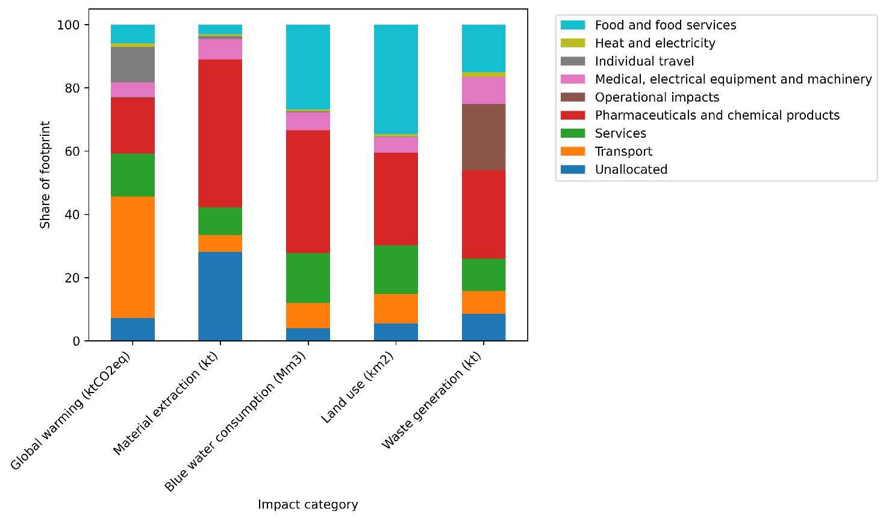
Figure 1: Activity contributions of environmental impacts associated with Danish health care in 2019, combining EXIOBASE v3.7 results (top-down EE‑MRIO analysis) with bottom-up estimates for anaesthetic nitrous oxide, pressurised metered-dose inhalers (pMDIs), and private travel (commuting and patient & visitor travel). The EXIOBASE “other” category was disaggregated to distinguish transport activities. Scope 1–3 classifications are not shown due to overlap across categories and methodological inconsistencies in hybrid accounting. Total climate footprint: 4,815 kt CO₂e.

When disaggregated by expenditure category, health care services accounted for 3294 kt CO₂e, representing just above two thirds of total greenhouse gas emissions. Direct emissions captured through bottom‑up data, from nitrous oxide and pMDIs, constituted nearly 1% of total greenhouse gas emissions. Additional bottom-up estimates for commuting and patient and visitor travel accounted for 540 kt CO₂e, corresponding to approximately 11% of total greenhouse gas emissions. Among the remaining expenditure categories captured through the MRIO model, transport services were the largest contributor, accounting for 39% of MRIO-derived greenhouse gas emissions.

The largest contributor to three of the five impact categories was pharmaceuticals and chemical products, with a contribution of 47% of material extraction, 39% of blue water consumption, and 28% of waste generation. Food and food services was the largest contributor to land use (35%), followed by pharmaceuticals and chemical products (29%). Food and food services was the second highest contributor to blue water consumption (27%), which is in line with previous studies ^{4,19}. Estimates for pharmaceuticals and chemical products should be interpreted cautiously, as aggregation within EXIOBASE may lead to overestimation of greenhouse gas emissions and material footprint associated with this category ³⁷ (appendix A p 2-3). The contribution analysis is visualised in figure 1.

Sector contributions across impact categories

Sector contributions represent the upstream economic sectors where environmental impacts physically occur (figure 2), as traced through the multi-regional input-output model. This reflects the final origin of impacts along supply chains rather than the sector where expenditure occurs.

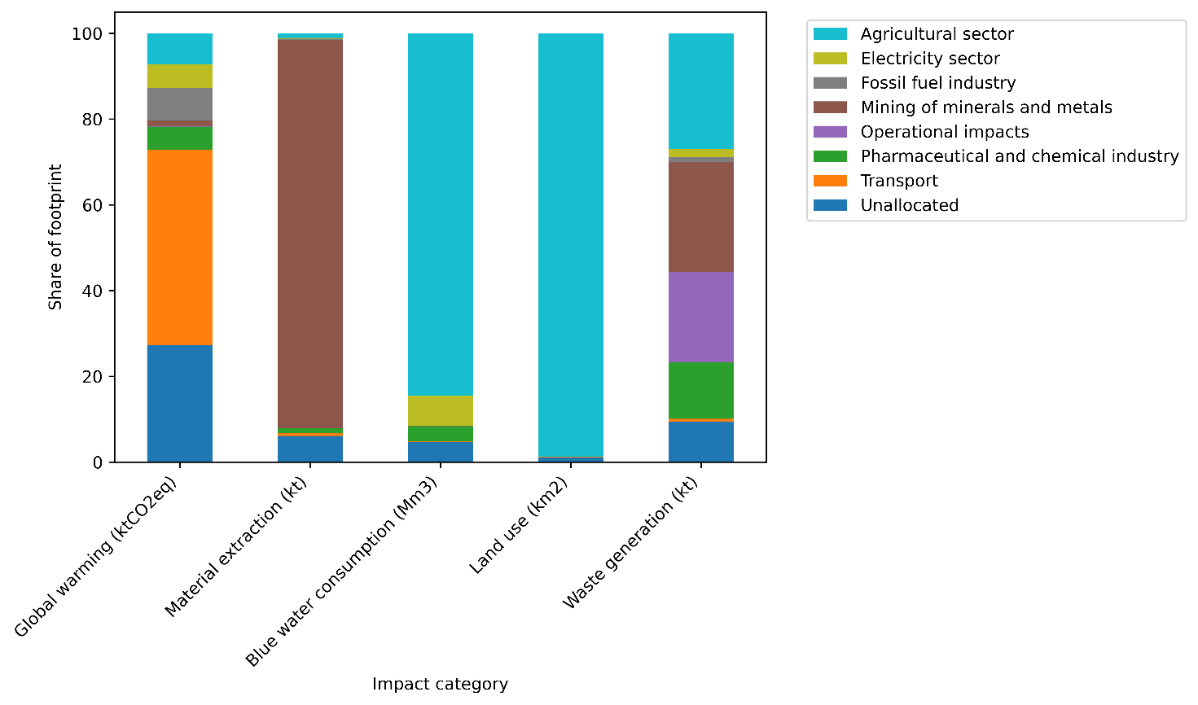
Figure 2: Sectoral contributions to environmental impacts associated with Danish health care delivery in 2019. Impacts are attributed to the producing sectors where environmental impacts occur along global supply chains. Five impact categories are shown: climate change (kt CO₂e), material extraction (kt), blue water consumption (Mm³), land use (km²), and waste generation (kt).

For greenhouse gas emissions, the transport sector accounted for the largest share (46%). This reflects transport services within the economic system and excludes household travel added through bottom-up estimates. Mining of minerals and metals accounts for nearly all of material extraction (91%), while the agricultural sector accounts for the vast majority of blue water consumption (85%) and virtually all of the land use (99%). An estimated 79% of waste generation appears to occur outside of facilities.

Geographical distribution of impacts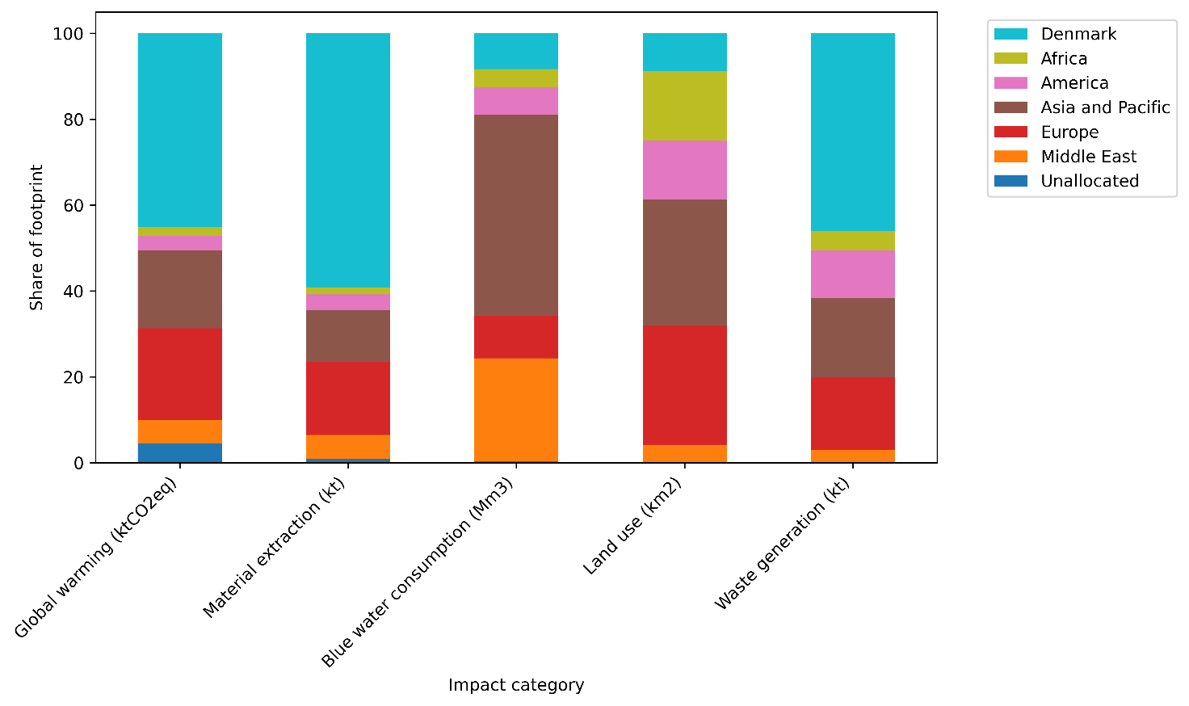
Figure 3: Geographical distribution of environmental impacts associated with Danish health care delivery in 2019. Impacts are allocated to regions where they physically occur along global supply chains. Impact categories include climate change (kt CO₂e), material extraction (kt), blue water consumption (Mm³), land use (km²), and waste generation (kt). (The Netherlands was retained as a separate region to ensure consistency with the underlying data structure and to avoid overlap or double counting during regional aggregation.)

Figure 3 shows the geographical distribution of impacts. Roughly 45% of greenhouse gas emissions were traced to activities occurring within Danish borders, primarily associated with transport, services, pharmaceuticals, and food. Material extraction was also partly domestic (59%). In contrast, the majority of blue water consumption occurred in Asia and the Pacific and in the Middle East, with Denmark and Europe together accounting for approximately 18%. Land use was similarly concentrated outside Europe, with Denmark accounting for less than 9% and Europe for approximately 28%. A substantial share of waste generation occurs within Denmark (approximately 46%), while the remainder is distributed across international supply chains.

Estimates of scope 1, 2, and 3 greenhouse gas emissions were not interpreted due to methodological limitations.
Discussion
This study provides a systemic assessment of the environmental impacts of Danish health care using a hybrid environmentally extended input–output framework complemented with selected bottom-up data. Health care was associated with a range of 3·6 to 5·6% of nationally induced impacts.
The estimated Danish health care footprint of 5·6% of national greenhouse gas emissions sits within the lower-to-middle range of values reported internationally, including approximately 10% in the United States, 7% in Australia, 7·3% in the Netherlands, 4% in the United Kingdom, between 4·4 and 4·6% globally ^{4,5,8,19,20,38}. In per-capita terms, Danish health care emissions correspond to approximately 0·83 t CO₂e per person per year, placing Denmark in the upper-middle of the OECD distribution. This is higher than the global average of approximately 0·6 t CO₂e per capita, but substantially lower than the United States (approximately 1·5 t CO₂e per capita), and far above low-income contexts such as India (approximately 0·06 t CO₂e per capita)^{3,8}.
Three structural factors likely explain Denmark’s position. Firstly, the Danish electricity system is comparatively low-carbon, which reduces indirect (scope 2) emissions relative to more fossil-based systems such as those in the United States and Australia. Secondly, health care accounts for a smaller share of national economic output in Denmark than in the United States, limiting the overall scale of demand-driven emissions. Thirdly, and in the opposite direction, Denmark is a relatively wealthy country. Together, these factors suggest that Denmark’s footprint is not anomalous, but consistent with both the structure of its energy system and its level of health care expenditure.
A key finding is that environmental impacts are predominantly driven by indirect and upstream activities rather than on-site clinical processes. Transport-related activities account for approximately half of total greenhouse gas emissions when combining supply-chain transport, health care services (eg, ambulances and helicopters), and private travel. While transport is recognised as part of health care emissions in previous studies, it is typically embedded within broader supply-chain categories and not identified as a dominant driver. The magnitude observed here reflects the consistent aggregation of transport-related activities across system boundaries, suggesting that transport may play a more prominent role than is commonly highlighted. It may also partly be explained by the organisation of health care and eldercare services in Denmark, which rely heavily on mobility and decentralised service delivery.
More broadly, transport and chemically intensive supply chains represent the largest contributors across impact categories, indicating that environmental pressures are shaped by the systems that enable health care delivery rather than core clinical processes.
The contribution of pharmaceuticals and chemical products should be interpreted with caution. Previous studies indicate that pharmaceuticals may have lower environmental impacts per euro than the broader Chemicals n.e.c. sector (18, 35) , suggesting that their contribution to greenhouse gas emissions and material extraction may be overstated. Although pharmaceuticals appear as a major contributor in the activity analysis, their impacts are distributed across multiple upstream sectors in the sectoral analysis, including chemicals, agriculture, and mining.As a result, the contribution of pharmaceutical supply chains cannot be isolated directly, limiting interpretation of pharmaceuticals as a distinct environmental hotspot and reducing the ability to identify pharmaceutical-specific mitigation opportunities.

The geographical distribution of impacts highlights substantial displacement of environmental pressure. Blue-water consumption and land use occur predominantly outside Europe, particularly in Asia and the Pacific and the Middle East; regions that include areas of water stress. This finding demonstrates that environmental impacts associated with delivering health care in Denmark occur in regions geographically separated from the delivery and consumption of care. Similar patterns of spatially decoupled environmental impacts have been observed in other globally traded supply chains, where consumption in one region drives environmental pressures elsewhere through international production networks. From a sustainability perspective, such displacement is important because environmental burdens are not experienced uniformly across locations. The Earth Commission has argued that environmental sustainability should be evaluated not only in relation to biophysical limits, but also in relation to fairness in the distribution of environmental harms and access to resources¹². Although our analysis does not assess local social or health consequences directly, the concentration of water- and land-intensive activities outside Denmark suggests that a substantial portion of environmental pressures associated with Danish health care are borne by populations geographically distant from the beneficiaries of health-care services.
. Waste generation showed a more domestic profile, although a substantial share still originates from upstream processes rather than from on-site clinical activities.
From a policy perspective, the dominance of supply-chain-related impacts implies that mitigation must extend beyond health care facilities to procurement, transport, and upstream production systems. In Denmark, centralised procurement actors and EU regulatory frameworks provide potential leverage points for integrating environmental criteria into supply chains. These findings align with previous assessments identifying procurement, pharmaceuticals, and transport as key emission sources^{9,39}. Because many environmental impacts occur outside Danish borders, reducing the environmental footprint of health care requires not only domestic action through procurement and planning decisions, but also engagement with the international supply chains through which those impacts arise.

Limitations
Several limitations should be noted. Direct operational emissions are likely underestimated because sector-specific environmental extensions were not updated with Danish national accounts. Gross fixed capital formation was excluded, meaning impacts associated with infrastructure and equipment are not captured.
Bottom-up estimates rely on proxy assumptions, including the use of births to estimate national nitrous oxide consumption and cross-country scaling for pMDIs and private travel. These introduce uncertainty, particularly where national differences in clinical practice or transport behaviour exist. In addition, the EXIOBASE baseline reflects a 2016 economic and technological structure and therefore does not capture recent developments such as transport electrification ^{40,41}, which may influence current emission profiles.
Although combining top-down and bottom-up approaches introduces methodological inconsistencies, this approach improves coverage of emission sources and provides system-level insight into impact drivers. Results should therefore be interpreted as indicative of structural patterns rather than precise estimates. Overall, the findings highlight the importance of addressing indirect and geographically displaced impacts, indicating that effective mitigation strategies must target transport, supply chains, and procurement in addition to health care operations.
Conclusion
This study provides a systemic assessment of the environmental impacts associated with delivering health care in Denmark using a hybrid environmentally extended input‑output framework complemented by selected bottom‑up calculations. The results show that Danish health care contributes between approximately 3·6% and 5·6% of national environmental impacts across five assessed categories. For greenhouse gas emissions, this corresponds to a per-capita consumption of approximately 0·83 t CO₂e.
Climate change impacts are primarily associated with health care services, which includes a large portion of transport activities, whereas material extraction, blue water consumption, land use, and waste generation are dominated by upstream supply‑chain processes, particularly from pharmaceuticals and chemical products, food‑related activities, and international production systems. A substantial share of environmental impacts occurs outside Denmark and Europe, highlighting the geographically displaced nature of health care‑related environmental impacts.
The inclusion of bottom‑up data for nitrous oxide, pressurised metered‑dose inhalers, and private travel improves coverage of emission sources that are not sufficiently represented in input‑output databases. Nevertheless, the analysis remains subject to limitations related to temporal mismatches in data sources, proxy‑based estimates, pharmaceutical-related inaccuracies, and the exclusion of gross fixed capital formation.
Overall, the findings suggest that efforts to reduce the environmental impacts of delivering health care services must extend beyond direct emissions and facility‑level interventions and address transport, supply chains, and consumption patterns associated with health care delivery.

AI Statement
The authors used large language models (primarily Microsoft Copilot) to assist with grammar, spelling, language clarity, and code comprehension. AI tools were used to help interpret and explain existing code and to support programming tasks. All AI-generated suggestions, text revisions, and coding outputs were critically reviewed, validated, and, where appropriate, modified by the authors. The authors take full responsibility for all analyses, code, results, interpretations, and conclusions presented in the manuscript

References

1. Intergovernmental Panel on Climate Change. Climate Change 2023: Synthesis Report: IPCC, 2023.
2. Romanello M, Napoli CD, Green C, et al. The 2023 report of the Lancet Countdown on health and climate change: the imperative for a health-centred response in a world facing irreversible harms. Lancet 2023; 402(10419): 2346-94.
3. Pichler P-P, Jaccard IS, Weisz U, Weisz H. International comparison of health care carbon footprints. Environmental Research Letters 2019; 14(6).
4. Lenzen M, Malik A, Li M, et al. The environmental footprint of health care: a global assessment. Lancet Planet Health 2020; 4(7): e271–79.
5. Tennison I, Roschnik S, Ashby B, et al. Health care's response to climate change: a carbon footprint assessment of the NHS in England. Lancet Planet Health 2021; 5(2): e84-e92.
6. Braithwaite J, Smith CL, Leask E, et al. Strategies and tactics to reduce the impact of healthcare on climate change: systematic review. BMJ 2024; 387: e081284.
7. Andrieu B, Marrauld L, Vidal O, Egnell M, Boyer L, Fond G. Health-care systems' resource footprints and their access and quality in 49 regions between 1995 and 2015: an input-output analysis. Lancet Planet Health 2023; 7(9): e747-e58.
8. Karliner J, Slotterback S, Boyd R, Ashby B, Steele K. Health care’s climate footprint: how the health sector contributes to the global climate crisis and opportunities for action: Health Care Without Harm, 2019.
9. Danish Regions. The Danish regions’ strategy for sustainable hospitals, 2024.
10. Intergovernmental Science-Policy Platform on Biodiversity and Ecosystem Services. Global Assessment Report on Biodiversity and Ecosystem Services: Summary for Policymakers: IPBES, 2019.
11. World Health Organization. Environmentally sustainable health systems: a strategic document. Copenhagen, 2017.
12. Gupta J LD, Rockström J, Qin D, Stewart-Koster B, Rocha JCR, et al. A just world on a safe planet: a Lancet Planetary Health–Earth
Commission report on Earth-system boundaries,
translations, and transformations. Lancet Planet Health 2024; 8(10): e813-e73.
13. Organisation for Economic Co-operation and Development. Health at a Glance 2025: OECD, 2025.
14. Rodriguez-Jimenez L, Romero-Martin M, Spruell T, Steley Z, Gomez-Salgado J. The carbon footprint of healthcare settings: A systematic review. J Adv Nurs 2023; 79(8): 2830-44.
15. Region Midtjylland. Klimaregnskab 2020 for Region Midtjylland: Region Midtjylland, 2021.
16. Jonathan Drew, Sean D Christie, Daniel Rainham, Chantelle Rizan. HealthcareLCA: an open-access living database of health-care environmental impact assessments. Lancet Planet Health 2022; 6: e1000–12.
17. Leontief W. Environmental repercussions and the economic structure: an input-output approach. Review of Economics and Statistics 1970; 52(3): 262-71.
18. Stadler K, Wood R, Bulavskaya T, et al. EXIOBASE 3: Developing a Time Series of Detailed Environmentally Extended Multi‐Regional Input‐Output Tables. Journal of Industrial Ecology 2018; 22(3): 502-15.
19. Steenmeijer M, Rodrigues J, Zijp M, Waaijers-van der Loop S. The environmental impact of the Dutch health-care sector beyond climate change: an input–output analysis. Lancet Planetary Health 2022; 6(12): e949-e57.
20. Eckelman MJ, Sherman J. Environmental Impacts of the U.S. Health Care System and Effects on Public Health. PLoS One 2016; 11(6): e0157014.
21. Organisation for Economic Co-operation and Development, Eurostat, World Health Organization. A System of Health Accounts 2011 (Revised): OECD, 2017.
22. Statistics Denmark. DK Umat 2019 supply-use table. Copenhagen: Statistics Denmark, 2024.
23. Merciai S, Schmidt J. Methodology for the Construction of Global Multi‐Regional Hybrid Supply and Use Tables for the EXIOBASE v3 Database. Journal of Industrial Ecology 2017; 22(3): 516-31.
24. Obling ML PS. Inhalationsanæstetika:klimaeffekt ogreduktionsmuligheder. Medicindk 2026.
25. Anesthesiologists ASo. Nitrous Oxide. (Year unknown, but after 2019). https://www.asahq.org/about-asa/governance-and-committees/asa-committees/committee-on-obstetric-anesthesia/nitrous-oxide (accessed 10-06-2026.
26. Region Hovedstaden. Pregnant women given climate-friendly nitrous oxide at Hvidovre Hospital. 2023. https://www.regionh.dk10-06-2026).
27. Intergovernmental Panel on Climate Change. Climate Change 2007: The Physical Science Basis. Cambridge: Cambridge University Press; 2007.
28. Vestbo J, Press-Kristensen K. Translated impact on carbon footprint from choice of inhaled therapy: a Danish scenario. Eur Respir J 2023; 62(3).
29. Statistics Netherlands. Employment in health and social care. The Hague: CBS, 2016.
30. Statistics Denmark. Employment in health and social services. Copenhagen: Statistics Denmark, 2019.
31. Eurostat. Actual and usual hours of work. Luxembourg: European Commission, 2019.
32. Statistics Denmark. Labour Force Survey: actual weekly working hours. Copenhagen: Statistics Denmark, 2019.
33. Christiansen H, Baescu O. The Danish National Travel Survey: Annual Statistical Report 2019. Copenhagen: Technical University of Denmark, 2020.
34. Statistics Netherlands. Mobility by mode and purpose. The Hague: CBS, 2016.
35. Huijbregts MAJ, Steinmann ZJN, Elshout PMF, Stam G VF, Vieira M, et al. ReCiPe2016: a harmonised life cycle impact assessment method at midpoint and endpoint level. Int J Life Cycle Assess 2017; 22: 138–47.
36. van Bree T, Slob A. DESIRE Report: FP7 / European Commission, 2016.
37. Hagenaars RH. An investigation into the carbon and material footprint of the Dutch consumption of pharmaceuticals. Leiden, The Netherlands: Delft University of Technology; Leiden University; 2022.
38. Malik A, Lenzen M, McAlister S, McGain F. The carbon footprint of Australian health care. Lancet Planetary Health 2018; 2(1): e27–e35.
39. World Health Organization. Transitioning to a Sustainable Healthcare Sector: WHO, 2024.
40. Statistics Denmark. Stock of motor vehicles. 2026.
41. Denmark M. Nu er der 400.000 elbiler i Danmark. 2025. https://mobility.dk/nyheder/nu-er-der-400-000-elbiler-i-danmark/ (accessed 10-06-2026.

Declaration of interests
We declare no competing interests.
Data sharing
This study draws on publicly available data sources. EXIOBASE v3.7 is openly available at https://www.exiobase.eu, and the Danish supply-use tables are available from Statistics Denmark. The analysis adapts the openly available model code of Steenmeijer and colleagues. Processed input data, intermediate results, and the bottom-up calculations underlying the reported estimates are provided in appendix A and appendix B; further details are available from the corresponding author on reasonable request.

