fSupplementary appendix
The Geographical Displacement of Healthcare’s Environmental impacts: A Danish Input-Output Study
This document provides technical descriptions of the analytical framework, data sources, system boundaries, and calculations used to quantify the environmental footprint of the Danish healthcare system (Main article). Its purpose is to facilitate transparency, traceability, and reproducibility of the results reported in the accompanying journal manuscript. Each section provides further details for reviewers and other readers to be able to dive into a more detailed version of methodology and results for a more thorough interpretation.
Methods
The analysis covers five impact categories: climate change, material extraction, blue water consumption, land use, and waste generation. By applying a methodology consistent with previous international studies while using Danish data and system boundaries, this study provides a systemic perspective on the environmental impacts associated with Danish healthcare and the activities that drive them. Healthcare in this scope is defined as:
“Health and social care services (including residential & elder care), pharmaceutical & other medical products, and therapeutic appliances & equipment.”
This definition aligns with the System of Health Accounts ¹ and ensures comparability with previous healthcare footprint studies. The system boundary includes some, but not all, direct emissions from healthcare activities and indirect impacts arising along global supply chains.
A timeseries was considered to analyse the expenditure over time. However, the environmental impacts are already estimated based on rough estimates. Adding a detailed version of expenditure introduces the risk of making it seem like the results are very accurate and can be traced over several years. However, the same anchor would be used for all the datasets, namely the 2016 EXIOBASE dataset. Another challenge is assessing how much inflation has affected the prices of products and services. Government and central bank money printing has increased dramatically over the recent decade, while official inflation estimates remains a politically disputed topic. This makes it difficult to accurately determine whether potentially increased spending is based on increased consumption or from an increase in reported prices.
MRIO Database
The applied MRIO system is based on EXIOBASE version 3.7 (49 regions; 163 industries), with monetary supply-use and input-output tables; environmental extensions for industries and final demand; and a characterization system for multiple impact categories. The background scripts load and serialize the following core objects, that are used for the calculations:
- A = Technical coefficients matrix
- Y = Final demand matrix
- R = Environmental extensions for industries and products
- H = Final-demand (consumption-based) satellite (EXIOBASE naming)
- Q = characterization matrices assembled to quantify five impact categories (GWP100, abiotic material extraction, water use, land use, and waste flows).
Danish regional treatment
Denmark was retained as an explicit individual region within the EXIOBASE regional structure. This allowed Danish healthcare demand to be traced through both domestic production and international supply chains without altering the internal balance of the MRIO system. The original codebase also keeps the Netherlands explicit, which was deemed safest to leave un-altered for the calculations. All non-DK and non-NL regions follow the standard EXIOBASE aggregation.
Construction of the Leontief system
The Leontief inverse is calculated as:

$L=(I-A)^{-1}$ (A1)
where $I$ is the identity matrix and $A$ is the technical coefficient matrix.
Total output $x$ is computed as:

$x=L⋅y$ (A2)
where $y$ is the vector of aggregated final demand.
The inter-industry transaction matrix $Z$ is reconstructed as:

$Z=A⋅diag(x)$ (A3)
All matrices ($A$, $L$, $x$, $Z$) were stored as serialized background objects to ensure numerical consistency across analyses.

System Boundary
For pharmaceuticals and medical durables, expenditure was allocated to the corresponding EXIOBASE sectors and distributed across supplying regions based on sourcing patterns observed in Danish final demand. This step reflects the international supply chains of these products and assigns impacts according to the geographical origin of production.
A Dutch study ² found that using chemicals n.e.c to represent pharmaceuticals may lead to an overestimation of pharmaceutical-specific impacts for material extraction and greenhouse gas emissions, while other impact categories were excluded from their study. However, a recent case study on penicillin has shown, that normalised to milli-person equivalents, the largest contribution to environmental effects from pharmaceuticals are toxicity-related effects ³.
Hagenaars ² found that the total environmental impacts from Dutch healthcare was 61% lower for material extraction and 11% lower for greenhouse gas emissions, when adjusting the pharmaceutical expenditure to an exiobase category closer aligned with pharmaceuticals instead of the ‘Chemicals n.e.c’ category. Meanwhile, the aggregation of pharmaceuticals and chemical products represent more than pharmaceuticals; it also represents emissions from healthcare services and possibly other activities.
In summary, the error margin for using chemicals n.e.c varies by impact category and allocation structure and cannot be robustly quantified within the present framework. Consequently, no quantitative correction factor was applied, and results related to pharmaceuticals are interpreted as indicative of chemically intensive supply chains rather than pharmaceutical-specific production alone.

Healthcare final demand in further detail
(i) Healthcare services include the delivery of health services by hospitals, outpatient clinics, general practitioners, and other healthcare providers, covering labour intensive clinical activities as well as associated institutional services, (ii) Pharmaceutical products and other medical products includes the manufacturing and upstream supply of pharmaceuticals, vaccines, diagnostic reagents, consumables, and other chemically based medical products used in prevention, diagnosis, and treatment, and (iii) Therapeutic appliances and equipment, which comprise medical devices and durable equipment such as diagnostic imaging equipment, surgical instruments, implants, and other specialised medical technologies.
The following is a list of expenditures from the Danish SUT (2019) that were summed for each of the three expenditure categories:

Healthcare services:
Household consumption, Transaction code 3110)
    - Out-patient services, 06200
    - Hospital services, 06300
    - Retirement homes, day-care centres etc., 12401
Marketed individual government consumption, Transaction code 3141
    - Out-patient services, 06200
Non-market individual government consumption,Transaction code 3142
    - Out-patient services, 06200
    - Hospital services, 06300
NPISH, Transaction code 3130
    - Retirement homes, day-care centres etc., 12401
Pharmaceutical products and other medical products:
Household consumption (Transaction code 3110)
    - Pharmaceutical products and other medical products, Transaction code 06112
Marketed individual government consumption, Transaction code 3141
    - Pharmaceutical products and other medical products, Transaction code 06112
Therapeutic appliances and equipment
Household consumption, Transaction code 3110
    - Therapeutic appliances and equipment, 06130
Marketed individual government consumption, Transaction code 3141
    - Therapeutic appliances and equipment, 06130
Non-market individual government consumption, Transaction code 3142
    - Therapeutic appliances and equipment, 06130

Values were converted from DKK to Millions of Euro (MEUR) at an exchange rate of 7·45 DKK/EUR
Included from the Bottom-up analysis

Nitrous Oxide (N₂O) and pressurised metered-dose inhalers (pMDIs)
Private travel (commuting, and patients and visitors)

Excluded:
GFCF (infrastructure and durable equipment)

Exiobase integration
The three expenditure categories were classified to corresponding EXIOBASE sectors
- HC.1-HC.9 (excl.HC.5) represented by Health and Social Work
- HC.51 represented by Chemicals n.e.c
- HC.52 represented by Medical precision and optical instruments

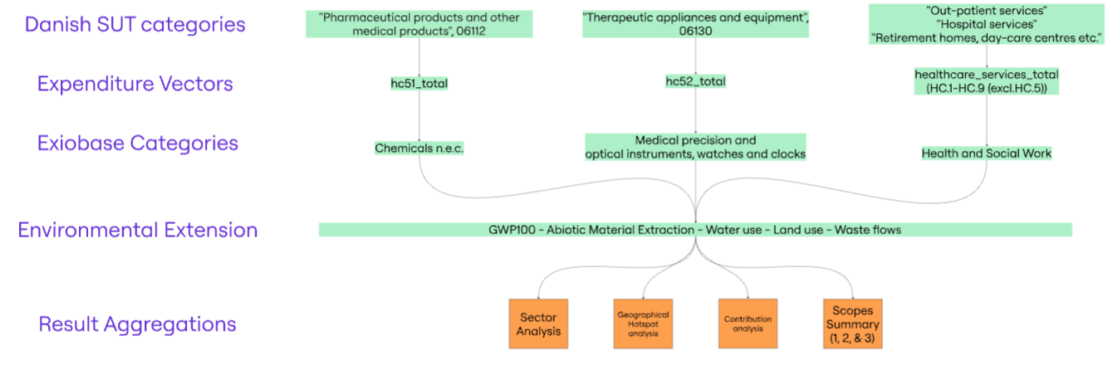
Figure A1: Integration of Danish Supply–Use Tables with EXIOBASE in five steps: (i) summarising Danish healthcare expenditures, (ii) aggregating them into SHA-based categories, (iii) mapping these to corresponding EXIOBASE sectors, (iv) combining with environmental extensions using Steenmeijer et al.’s edited code base, and (v) aggregating outputs into sectoral, geographical, and contribution analyses, as well as a scope-based summary.
Direct emissions
To integrate bottom‑up estimates, two different approaches were used. For most categories (pMDIs and transport), Danish values were obtained by scaling Dutch estimates from Steenmeijer et al. using activity‑based ratios. In contrast, nitrous oxide emissions were first calculated directly from Danish data and then converted into a scaling factor relative to the Dutch value. This conversion was necessary because the computational framework applies Danish adjustments by scaling a Dutch baseline dataset across all impact categories; therefore, all inputs must be expressed as multiplicative factors rather than absolute values.
Nitrous Oxide
Data available: Number of births in the Region of Southern Denmark, total number of births in Denmark, and amount of N₂O purchased by the former. The difference in number of births was applied as a ratio to estimate the amount of N₂O purchased on a national level. Uncertainties depend on whether the usage of N₂O is equally distributed across Denmark and whether number of births can function as a proxy for amount of N₂O purchased. We based the assumption on childbirth being the primary usage of N₂O.
The ratio was calculated based on the total number of births in Denmark divided by the number of births in the region of southern Denmark, which was thereafter multiplied with the amount of N₂O purchased by the Region of Southern Denmark. Finally, the greenhouse gas emissions in carbon dioxide equivalents (CO₂e) were calculated by multiplying N₂O emissions with its respective emission factor ⁴.
$\text{Total Danish N₂O impacts}=\frac{\text{National births}}{\text{Regional births}}x Regional N₂O purchased x N₂O emission factor$ (A4)

Regional births (Region South): 11,095
National births (Denmark): 58,438
Regional N₂O purchased (Region South): 6,063·42 kg
Ratio:
$\text{Ratio}=\frac{\text{National births}}{\text{Regional births}}=\frac{\text{58,438}}{\text{11,095}}≈5.267$ (A5)

Scaled national N₂O:
$\text{National N₂O usage }= Regional N^{2}O purchased x Ratio=6,063x5.267≈31,936kg$ (A6)
Converted to GWP (CO₂eq):
$\text{National N₂O usage x Emission factor = 31,936 kg N₂}\text{O x}\text{ GWP100 factor (298) ≈ 9.52 kt }\text{CO₂e}$ (A7)

Dutch value (from Steenmeijer et al.,): 14·2 kt CO₂e
$Final scaling factor=\frac{Danish National emissions from nitrous oxide}{\text{Dutch National emissions from nitrous oxide}}=\frac{9.52}{\text{14.2}}=0.67$ (A8)

National N₂O emissions were estimated at approximately 9·52 kt CO₂e. Compared with the Dutch estimate of 14·2 kt CO₂e, this corresponds to a scaling factor of 0·67.
pMDIs
Steenmeijer et al. ⁵ quantified pMDI-related greenhouse gas emissions for the Netherlands in 2016 at 76·9 kt CO₂e (GWP100), based on national pharmaceutical consumption data and life-cycle emission factors for inhaler propellants. Defined daily doses (DDD) were used as the harmonised unit of comparison, as this metric reflects actual therapeutic use and avoids confounding from differences in actuation counts or inhaler formats. According to Dutch national pharmaceutical statistics underlying Steenmeijer et al., approximately 62 million pMDI DDD were dispensed in the Netherlands in 2016. Correspondingly, Danish national pharmacy dispensation data indicate that approximately 28 million pMDI DDD were dispensed in Denmark in 2019 ⁶.
It was assumed that pMDI emissions scale proportionally with Defined Daily Doses (DDDs) dispensed, therefore the ratio between the number of pMDI DDDs dispensed in Denmark relative to the Netherlands was calculated to estimate these emissions ⁵. An additional assumption was that Steenmeijer et al. excluded bottom-up calculations of emissions from alternative inhaler types (e.g. dry-powder inhalers), because their contribution is substantially lower than that of pMDIs ⁶. Thus, total impacts from pMDIs were calculated as follows:
$\text{Total Danish }\text{pMDI}\text{ emissions}=\frac{\text{Danish pMDI DDD}}{\text{Dutch }\text{pMDI}\text{ DDD}}x Dutch pMDI DDD emissions$ (A9)
Despite Denmark having a substantially higher dry-powder inhaler (DPI) uptake than the Netherlands, scaling emissions by pMDI DDD - rather than population size or disease prevalence - was considered the most appropriate method for cross-country adjustment. Applying a ratio based on relative pMDI use (28/62 ≈ 0·45) to the Dutch pMDI footprint yields an estimated Danish pMDI emission of approximately 34·6 kt CO₂e.
This estimate aligns closely with independent Danish calculations by Vestbo & Press-Kristensen (2023), who estimated approximately 31 kt CO₂-equivalents from pMDI use using pharmacy dispensation data and propellant-specific emission factors. Minor differences are attributable to methodological choices, including the global warming potential time horizon (GWP20 vs. GWP100) and assumptions regarding propellant composition. Overall, the convergence of estimates supports the robustness of the dose-based scaling approach.
Private travel (Further details in Appendix B)
A scaling-based approach was used to estimate emissions from private travel associated with healthcare provision in Denmark. This approach adapts Dutch estimates from Steenmeijer et al. to Danish conditions while ensuring internal consistency and avoiding the use of heterogeneous life cycle inventory data.
Commuting emissions
Danish commuting emissions were estimated by scaling Dutch healthcare commuting emissions using ratios that reflect differences in workforce size, working hours, and commuting distances:
$Dk commuting emissions=\frac{Dk Health employees}{\text{NL Health employees}}x\frac{\text{Dk Work hours}}{\text{NL Work hours}}x\frac{\text{Dk Daily mileage}}{\text{NL Daily mileage}}x NL commuting emis.$ (A10)
Input parameters were:
Number of healthcare employees:
Denmark (2019): 524,000
Netherlands (2016): 1,220,750
Average weekly working hours:
Denmark (2019): 34·4 hours
Netherlands (2016): 29·2 hours
Average daily commuting distance per person:
Denmark (2019): 8·5 km
Netherlands (2016): 7·88 km
Applying these ratios:
$Dk/NL commuting ratio=\frac{524000}{\text{1220750}}x\frac{\text{34.4}}{\text{29.2}}x\frac{\text{8.5}}{\text{7.88}}x 0.545$ (A11)

Thus, Danish commuting emissions in 2019 were estimated to be approximately 0·545 (54·5%) of Dutch commuting emissions in 2016.
Comparability assumptions
The modal distribution of transport for commuting was found to be similar between Denmark in 2019 ⁷ and the Netherlands 2016 ⁸, based on national travel survey data. Although differences exist (e.g., higher car use but also higher share of electric vehicles in Denmark), these were considered to partially offset each other, and further modal disaggregation was not pursued.
Patient and visitor travel
Patient and visitor (P&V) travel reflects healthcare demand rather than workforce attendance. Therefore, emissions were scaled using the number of healthcare employees as a proxy for system size.
Danish P&V travel emissions were estimated by scaling Dutch emissions using two factors: (i) the relative size of the healthcare workforce and (ii) differences in travel distances:
$Dk P\&V travel emis.=\frac{Dk Health employees}{\text{NL Health employees}}x\frac{\text{Dk commute + Dk errands + Dk GP }}{\text{NL commute + NL errands + NL GP}}x NL P\&V travel emis.$ (A12)
The following deconstructs this formula in steps to simplify the logic of the calculation.
The employee ratio was calculated as:
$Employee ratio=\frac{Dk Health employees}{\text{NL Health employees}}=\frac{524000}{\text{1220750}}=0.429$ (A13)
Calculating the difference in travel behaviour in this category was more complicated than for commuting. Observed differences in travel distances across key categories were:
Commuting: approximately 8% higher in Denmark
Total travel (all purposes): approximately 29% higher
Service and errand-related travel: approximately 40% higher
Because none of these categories are perfectly aligned with patient and visitor travel, a central heuristic scaling factor was derived as the unweighted mean of these differences:
$Scaling factor=\frac{8\%+29\%+40\%}{\text{3}}\text{≈26\%}$ (A14)
This factor reflects a compromise between precision and robustness and is not intended as a statistical uncertainty bound.
Multiplying employee ratio with the distance adjustment:
$Dk P\&V tranvel emissions=\text{0.429 x 1.26}≈0.541$ (A15)
Thus, Danish patient and visitor emissions in 2019 were estimated to be approximately 0·54 (54%) of Dutch emissions in 2016.
Data sources and input
Data used in the scaling procedure were obtained from:
Steenmeijer et al. (background documentation)
Statistics Netherlands (CBS) mobility datasets
The Danish National Travel Survey (Technical University of Denmark)
Statistics Denmark (employment and labour force data)
Key travel indicators included:
Average trip length and total travel distances
Commuting distances by purpose and mode
Modal split and travel time by transport mode
Uncertainties and limitations
Several sources of uncertainty are associated with the scaling approach. First, data for Denmark in 2019 and the Netherlands in 2016 are not temporally aligned. Second, the assumption that the number of patients and visitors scale proportionally with healthcare employment may not fully capture differences in healthcare utilisation patterns. Third, the use of a heuristic distance scaling factor simplifies complex differences in travel behaviour and infrastructure.
Data availability
Materials required to reproduce the analysis are available in a public repository (Zenodo DOI: 10.5281/zenodo.20542390). These include the modified Python scripts implementing the Danish model, Danish Supply-Use Table extraction and preprocessing scripts, the SHA-to-EXIOBASE concordance, bottom-up datasets (nitrous oxide, pMDIs, and private travel), and figure-generation code, along with documentation describing the modelling workflow.
The analysis relies on EXIOBASE v3.7 and Danish national accounts data from Statistics Denmark, which are subject to licensing and access restrictions and must be obtained independently. All other data generated or analysed during this study are included in the repository.
The analysis was implemented in Python (v3.11.7) using pandas (v2.1.4), numpy (v1.26.4), and matplotlib (v3.8.0). The model implementation corresponds to repository release v1.0.1 (DOI: 10.5281/zenodo.21493995).
Scope 1, scope 2, and scope 3 of greenhouse gas emissions
A Scope 1-3 decomposition of greenhouse gas emissions was conducted by combining the EEIO framework with the bottom-up estimates. Scope 1 was defined as direct emissions from Danish healthcare service sectors, supplemented with bottom-up estimates of anaesthetic gases and pMDIs. Scope 2 includes emissions from electricity, gas, and heat supply induced by healthcare demand. Scope 3 was calculated as the residual and includes all upstream supply-chain emissions.
Due to the structure of EXIOBASE, emissions are allocated to producing sectors rather than to the sector exercising operational control. As a result, activities such as transport are represented as upstream services, and associated fuel emissions (from ambulances, helicopters, etc.) are attributed to the transport sector rather than to healthcare service delivery. Consequently, Scope 1 is structurally underestimated and Scope 3 correspondingly overestimated, mainly because all travel-related emissions are included within Scope 3.
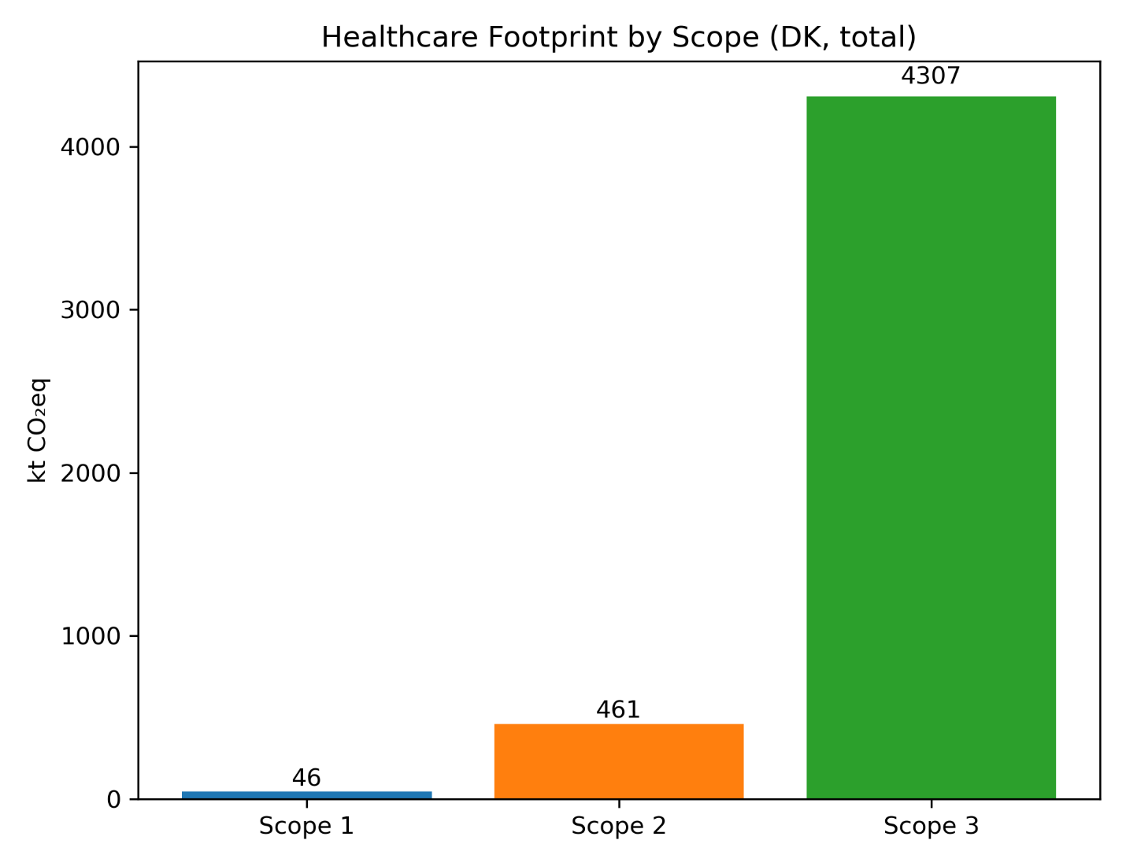 Figure A2: Greenhouse gas emissions associated with Danish healthcare provision in 2019 disaggregated by Scope 1, Scope 2, and Scope 3 (kt CO₂e), using an EE‑MRIO framework (EXIOBASE v3.7) supplemented with bottom-up estimates. Scope 1 includes direct emissions from healthcare services and bottom-up additions (anaesthetic gases and pMDIs), Scope 2 includes emissions from electricity and heat supply, and Scope 3 includes upstream supply-chain impacts and private travel. Due to the MRIO accounting structure, the majority of operational emissions are attributed to supplying sectors, resulting in a significant underestimation of Scope 1 and corresponding overestimation of Scope 3.
The Scope 1-3 decomposition shows that emissions associated with Danish healthcare are mostly Scope 3 (4307 kt CO₂e), followed by Scope 2 (461 kt CO₂e), while Scope 1 contributes a minor share (46 kt CO₂e). Private travel-related emissions are included within Scope 3. Diagnostics showed that only 3% of scope 1 emissions originated from the EEIO data, grossly underestimating emissions from fuels used in ambulances, medical helicopters, and refrigerant leakage; while the rest of the 97% were from the bottom-up data. The low contribution of Scope 1 reflects the allocation structure of the EEIO framework rather than the absence of direct operational emissions.
Results
The following tables show the results in greater detail.
Table A1 presents absolute environmental impacts associated with Danish healthcare consumption in 2019, disaggregated by consumption category. Results are reported for five impact categories: climate change, material extraction, blue water consumption, land use, and waste generation. The table illustrates the magnitude of contributions across nine activities:
Contribution | Global warming (ktCO2eq) | Material extraction (kt) | Blue water consumption (Mm3) | Land use (km2) | Waste generation (kt)
Food and food services | 287 | 80 | 12 | 952 | 127
Heat and electricity | 52 | 14 | 0 | 24 | 12
Individual travel | 540 | 25 | 0 | 2 | 0
Medical, electrical equipment and machinery | 224 | 170 | 3 | 137 | 71
Operational impacts | 11 | 0 | 0 | 0 | 176
Pharmaceuticals and chemical products | 850 | 1215 | 18 | 806 | 236
Services | 651 | 229 | 7 | 425 | 85
Transport | 1855 | 139 | 4 | 258 | 61
Unallocated | 345 | 730 | 2 | 150 | 72

Table A2 is a Hotspot analysis, presenting absolute environmental impacts associated with Danish healthcare consumption in 2019, disaggregated by upstream sector. Results are reported across five impact categories, distributed upon 7 sectors, including an eighth aggregated sector named ‘other’:
Hotspot | Global warming (ktCO2eq) | Material extraction (kt) | Blue water consumption (Mm3) | Land use (km2) | Waste generation (kt)
Agricultural sector | 350·2 | 27·1 | 39·4 | 2717·5 | 226·6
Electricity sector | 265·2 | 5·0 | 3·2 | 1·1 | 16·6
Fossil fuel industry | 362·7 | 7·8 | 0·0 | 0·9 | 9·6
Mining of minerals and metals | 59·5 | 2353·8 | 0·0 | 0·3 | 215·2
Operational impacts | 10·9 | 0·0 | 0·0 | 0·0 | 175·9
Pharmaceutical and chemical industry | 260·8 | 32·1 | 1·7 | 0·4 | 111·6
Transport | 2193·5 | 15·6 | 0·0 | 3·0 | 5·5
Unallocated | 1311·8 | 159·1 | 2·2 | 30·0 | 79·3

Table A3 provides absolute environmental impacts associated with Danish healthcare consumption in 2019, disaggregated by geographical region where impacts occur. Results are reported across five impact categories, distributed across eight regions. The Netherlands were retained as a separate region to ensure consistency with the underlying data structure and to avoid overlap or double counting during regional aggregation:
Region | Global warming (ktCO2eq) | Material extraction (kt) | Blue water consumption (Mm3) | Land use (km2) | Waste generation (kt)
Denmark | 2174 | 1540 | 4 | 242 | 387
Africa | 96 | 40 | 2 | 443 | 37
America | 164 | 95 | 3 | 379 | 94
Asia and Pacific | 874 | 313 | 22 | 808 | 155
Europe | 1028 | 444 | 5 | 765 | 143
Global | 220 | 25 | 0 | 2 | 0
Middle East | 259 | 144 | 11 | 113 | 25
Unallocated | 220 | 25 | 0 | 2 | 0

Table A4 reports the healthcare footprint alongside national consumption totals and healthcare’s share of national impacts for each of the five categories.
 | Healthcare footprint | National consumption footprint | Healthcare share of national consumption footprint (%)
Global warming (ktCO2eq) | 4814·69 | 85752·01 | 5·61
Material extraction (kt) | 2600·56 | 47233·92 | 5·51
Blue water consumption (Mm3) | 46·54 | 1070·44 | 4·35
Land use (km2) | 2753·15 | 76743·82 | 3·59
Waste generation (kt) | 840·18 | 23288·34 | 3·61

Table A5 compares healthcare expenditure for selected consumption categories with greenhouse gas emission intensities of related supply chain sectors. Although expenditure on pharmaceuticals and chemical products exceeds that of transport, transport-related activities exhibit a higher emission intensity per monetary unit and ultimately contribute more to total emissions. This contrast reflects the decoupling between final demand and the distribution of environmental impacts across supply chains. The comparison also serves as a consistency check to support the interpretation of transport as a dominant emission source.
Category | Expenditure (MEUR) | Emission intensity (kt CO₂e per MEUR)
Pharmaceuticals and Chemical products | 1,685 | 0·43 (based on chemicals n.e.c.)
Transport | 969 | 1·17

References
1. Organisation for Economic Co-operation and Development, Eurostat, World Health Organization. A System of Health Accounts 2011 (Revised): OECD, 2017.
2. Hagenaars RH. An investigation into the carbon and material footprint of the Dutch consumption of pharmaceuticals. Leiden, The Netherlands: Delft University of Technology; Leiden University; 2022.
3. Olsen RWF, Johansen KB, Ayivee F, Gislason S, Pedersen SA, Cimpan C. The greener prescription: Life cycle environmental impact of oral and IV penicillin treatments. Sustainable Chemistry and Pharmacy 2026; 50.
4. Intergovernmental Panel on Climate Change. Climate Change 2023: Synthesis Report: IPCC, 2023.
5. Steenmeijer M, Rodrigues J, Zijp M, Waaijers-van der Loop S. The environmental impact of the Dutch health-care sector beyond climate change: an input–output analysis. Lancet Planetary Health 2022; 6(12): e949-e57.
6. Vestbo J, Press-Kristensen K. Translated impact on carbon footprint from choice of inhaled therapy: a Danish scenario. Eur Respir J 2023; 62(3).
7. Christiansen H, Baescu O. The Danish National Travel Survey: Annual Statistical Report 2019. Copenhagen: Technical University of Denmark, 2020.
8. Statistics Netherlands. Mobility by mode and purpose. The Hague: CBS, 2016.

