Abstract

Health care systems rely on energy and materials whose environmental impacts extend across global supply chains and are not captured by facility-level assessment. We quantified the environmental impacts of delivering health care in Denmark in 2022 using environmentally extended multi-regional input-output (EE-MRIO) analysis with bottom-up complements. Health care demand was built from Statistics Denmark's published 117-industry input-output table and linked to global supply chains through EXIOBASE version 3.8.2, so that the demand year and the model year coincide and no deflation is required. Parameter uncertainty was propagated by Monte Carlo simulation with 100,000 draws. Danish health care was responsible for 4,652 kilotonnes of carbon dioxide equivalent (95% interval 4,012 to 5,460), 6.0% of the national consumption-based footprint; 4,256 kilotonnes of material extraction (7.9%); 95 million cubic metres of blue water (7.5%); 4,852 square kilometres of land use (4.9%); and 259 kilotonnes of waste (2.4%). Pharmaceuticals and chemical products were the largest contributor to the climate footprint, at 37.3% (95% interval 34.1 to 39.5%), and led the remaining four categories as well. Transport contributed 12.2%, against the 32.3% the uncorrected model returns, because EXIOBASE allocates 74% of Danish sea-transport output to Danish intermediate use against 9% in the national accounts. Water consumption and land use occurred predominantly outside Denmark and Europe. The ranking is stable at the top, with pharmaceuticals leading in 99.99% of draws, and the width of the intervals is set by the input-output data rather than by the Danish primary data. Mitigation must extend beyond health care facilities to procurement, pharmaceutical supply, travel and food systems.
Keywords: Health care; Environmental footprint; Input-output analysis; Supply chains; Uncertainty; Denmark

The environmental footprint of the Danish health care system: supply-chain origins and geographical displacement

Research in context
Evidence before this study
Previous studies have used facility-level, process-based, and input-output approaches to quantify the environmental impacts of health care, primarily focusing on greenhouse gas emissions and highlighting the importance of supply-chain impacts. Input-output and hybrid approaches have increasingly enabled assessment of indirect impacts across health care supply chains, including impacts occurring outside the health care sector and across national borders. However, these approaches have been applied to a limited number of national health care systems, and there remains a need for country-specific assessments that combine consumption-based accounting with detailed national health care expenditure data and selected bottom-up estimates.

Added value of this study
This study provides a consumption-based assessment of the Danish health care system using a hybrid input-output approach that links Danish health care demand to global supply chains and combines economy-wide estimates with selected bottom-up data. The approach quantifies environmental impacts across five impact categories and identifies the sectors and geographical regions in which impacts associated with Danish health care occur. Results estimate that health care contributes between 2.4% and 7.9% of national environmental impacts across the five categories, with pharmaceuticals and chemical products, services, transport, private travel, and food-related supply chains accounting for the largest shares of the footprint.

Implications of all the available evidence
Reducing the environmental impacts of health care requires action both within health care facilities and across the global supply chains on which they depend. Our findings show that most environmental impacts associated with health care arise from activities upstream of health care delivery and, for some impact categories, occur predominantly outside Denmark and Europe. This means that reducing the environmental footprint of health care will require attention to the supply chains through which care is delivered, including procurement of pharmaceuticals, chemicals, food, and transport services, alongside measures to reduce direct impacts within health care facilities.

Introduction
Health care systems are essential components of societal infrastructure, maintaining and improving public health through prevention, diagnosis, and treatment. However, delivering health care services relies on energy, materials, transport, and complex supply chains, generating environmental impacts that extend beyond national borders and contribute to risks for human health and wellbeing [1,2]. Recent assessments indicate that health care systems account for 4% to 10% of national greenhouse gas emissions, and about 4.4% of the global total [3-5]. In Europe, including Denmark, health care systems operate within broader policy frameworks that prioritise climate change mitigation and sustainability while simultaneously facing increasing demand for health care services. Aligning health care service delivery with climate and sustainability objectives therefore represents a key challenge, as reductions in direct emissions must be complemented by improved understanding of indirect and supply‑chain‑related environmental impacts [2,4].
During the recent two decades, increasing attention has been directed towards the environmental impacts of health care, mostly in relation to climate change [6,7], but also with regards to other impacts such as resource use and waste generation [4]. Early assessments commonly focused on direct emissions from health care facilities or specific clinical activities, whereas subsequent input-output and hybrid studies have incorporated indirect impacts associated with the wider supply chains required to deliver health care [3,5,7-9]. These approaches demonstrate that most of health care's environmental impacts arise upstream, beyond the physical boundaries of health care facilities and, in many cases, across international supply chains. These environmental effects cause harm to human populations [2] and have been identified as a growing threat to human wellbeing [10]. The health impacts of climate change and environmental degradation are distributed unevenly, with populations that contribute relatively little to global emissions often experiencing disproportionate adverse effects [1,2]. This uneven distribution is increasingly recognised as both an environmental and governance challenge. The WHO framework for environmentally sustainable health systems argues that health systems should reduce their environmental impacts across the full spectrum of activities required to deliver care, including procurement and supply-chain processes. Similarly, the recent Earth Commission report emphasises that environmental sustainability cannot be separated from considerations of justice, arguing that environmental impacts and their associated harms are often distributed unevenly across populations, regions, and generations [11]. Similar patterns of spatially decoupled environmental impacts have been documented in other global supply chains, where trade links consumption in one region to environmental pressures in another. These perspectives suggest that understanding the environmental impacts of health care requires attention not only to the magnitude of impacts, but also to where they occur and who is exposed to their consequences [12]. The uneven distribution further highlights the importance of addressing environmental impacts associated with health care delivery, particularly in high-income countries, where health care expenditure is high; Denmark, for example, spent 9.4% of gross domestic product (GDP) on health care in 2024 according to an OECD report [13].
In Denmark, recent policy-oriented assessments have quantified the environmental footprint of the health sector. They estimate that Danish health care contributes on the order of 5 to 6% of national greenhouse gas emissions, while a broader institutional report outlines key emission sources, including energy use, procurement, pharmaceuticals, and transport, but without a complete consumption-based accounting framework [8,9]. These assessments have been influential in shaping national discussions and have highlighted the importance of procurement and other indirect sources of emissions. However, they do not provide a comprehensive consumption-based assessment of environmental impacts across multiple categories, nor do they examine the geographical distribution of those impacts across international supply chains. As a result, the extent to which environmental pressures associated with Danish health care are displaced beyond national borders remains insufficiently characterised.

Other studies have reported that a majority of the environmental impacts of health care systems occur outside the physical boundaries of hospitals and clinics [3,5]. Direct emissions (particularly in countries with low carbon intensive energy infrastructure) from on‑site energy use and medical activities represent only a fraction of the total impact [5,14], while the greater part arises upstream in the supply chain that provides pharmaceuticals, medical equipment, energy, transport services, construction, and other supporting activities [5]. This pattern is also observed in Danish regional assessments of health care emissions, where a regional report attributed approximately 70% of greenhouse gas emissions to the procurement of goods and services [15]. The region covers other areas additional to health care, and is therefore not directly comparable, but it reinforces the central role of supply chains in determining and reducing the health care footprint.
Environmental impacts can be assessed using different analytical approaches depending on the scope of interest. Process‑based life cycle assessment (LCA) provides detailed, bottom‑up estimates and has been widely applied in health care to evaluate specific products and clinical activities [16], but is currently unfeasible to apply to complex sectors due to the myriad of complexity and data requirements. Environmentally extended multi‑regional input‑output analysis (EE‑MRIO) [17] provides a top‑down, consumption‑based framework that captures impacts across global supply chains at the sector level, making it well suited for system‑wide assessment, and complementary to LCA [18]. Whereas process-based LCA provides detailed estimates for individual products or activities, EE-MRIO captures the indirect environmental impacts associated with the wider economic activity required to meet health care demand, including impacts occurring in other sectors and countries [18]. Hybrid approaches combine these strengths by using input-output analysis to capture economy-wide supply-chain impacts while incorporating bottom-up estimates for activities that are not adequately represented in monetary input-output accounts [19]. For health care, this combination allows system-wide supply-chain impacts to be quantified while retaining more detailed estimates for specific activities that may be incompletely captured by input-output data.
Previous studies have applied environmentally extended input-output and hybrid approaches to assess the environmental impacts of national and multi‑regional health care systems [3,7]. These studies show that health care contributes between 4% (UK [5]) and 10% (US [20]) of national greenhouse-gas emissions, with the Netherlands at 7.3% [19] and the global average between 4.4 and 4.6% [4,8]. These studies underline the importance of system‑wide approaches for understanding where environmental impacts arise within health care systems.
Despite an increasing number of studies on health care’s environmental impacts, geographical coverage remains limited [4,7]. National health care systems differ in organisation, energy supply, procurement patterns, and reliance on imports, which means that results from one country cannot be transferred directly to another [3,7,19]. Hybrid approaches have been developed, which combine MRIO‑based estimates with bottom‑up calculations for specific activities that are not well represented in monetary accounts, such as anaesthetic gases and private travel [19]. To our knowledge, no comprehensive assessment of the environmental impacts of the Danish health care system using an Environmentally Extended Input Output (EEIO) or hybrid framework combined with Danish health care expenditure data has been published. Such an assessment allows the environmental footprint of Danish health care to be quantified across multiple impact categories while tracing the sectors and geographical regions in which the associated impacts occur.

This study addresses this gap by assessing the environmental impacts of the Danish health care system using an environmentally extended multi‑regional input‑output framework combined with selected bottom‑up data sources. By linking Danish health care demand to global supply chains, we quantify five environmental impact categories and identify the sectors and geographical regions in which associated impacts occur. In doing so, we provide insight into the magnitude of health-care-related environmental impacts and highlight the extent to which those impacts are geographically displaced beyond the regions in which health care services are consumed. We found that Danish health care was responsible for 4,652 kt CO₂e in 2022 (95% interval 4,012 to 5,460), 6.0% of the national consumption-based total, with pharmaceuticals and chemical products the largest contributor to the climate footprint and to each of the other four categories. Blue water consumption and land use occurred predominantly outside Denmark and Europe.
Methods
We applied an environmentally extended multi-regional input-output (EE‑MRIO) analysis supplemented with bottom-up estimates for selected emission sources. The term “hybrid” is used in a limited sense, as the bottom-up components are added to the model results and do not constitute an integrated hybrid life cycle assessment framework. Health care demand was built from Statistics Denmark's published 117-industry input-output table, structured in accordance with the System of Health Accounts [21]. The analysis is based on EXIOBASE version 3.8.2, industry by industry, for the reference year 2022, in euros at basic prices. Danish health care expenditure data for 2022 are expressed in the price system of that same year, so the demand year and the model year coincide, no deflation is required, and no deflator uncertainty enters the estimate. Results should be read as the 2022 health care structure in its own price system. Differences in price-base treatment relative to other studies, such as purchasing-power-parity-adjusted US dollars [3] and sector-specific deflation [20] should be considered when comparing results.
The model was based on Steenmeijer et al. [19] and implemented using their publicly available Python code, with adaptations to Danish input data and parameters. The ‘other’ category was disaggregated to improve interpretability, as it represented a large share of greenhouse gas emissions.
Health care expenditure data for 2022 were retrieved from the Danish national accounts and aggregated into three categories [22]: health care services; pharmaceuticals and other medical non-durable goods; and therapeutic appliances and equipment. These were mapped to EXIOBASE sectors as follows: health care services to Health and Social Work; pharmaceuticals and medical products to Chemicals n.e.c.; and therapeutic appliances to Medical precision and optical instruments (Appendix A, Exiobase integration). For health care services, expenditure was represented using the inter-industry structure of the Danish Health and Social Work sector in EXIOBASE, by extracting and scaling the intermediate use column to match total expenditure, thereby approximating upstream supply-chain structure. For example, expenditure associated with ambulance transport is traced to upstream activities such as vehicle manufacturing, fuel supply, insurance, and other related services, thereby capturing indirect environmental impacts along the supply chain.
Environmental impacts were calculated using EXIOBASE version 3.8.2 [18,23], which enables health care expenditure to be traced through domestic and international supply chains using a consumption-based framework. Upstream impacts were quantified using the Leontief inverse [17] and environmental extensions translating monetary flows into impact intensities. Within this framework, transport is represented as a service sector (NACE H), capturing freight, logistics, and service-related transport. Activities driven by household behaviour (for example, commuting and patient or visitor travel) are not allocated to health care final demand and are therefore excluded from the MRIO results. These were instead included through bottom-up estimates and treated as conceptually distinct from supply-chain transport captured in the top-down analysis. Gross Fixed Capital Formation (GFCF) associated with health care infrastructure was excluded from the headline, so the impacts of capital goods and infrastructure are not captured; the size of that omission is bounded in the Limitations by a variant in which capital is endogenised. Pharmaceutical expenditure was mapped to Chemicals n.e.c., distributing impacts across upstream sectors rather than as a distinct pharmaceutical sector, which limits the ability to isolate pharmaceutical-specific impacts.
Inclusion of bottom-up data
Emission sources not captured within the MRIO system boundary were included through bottom-up calculations. These comprised Nitrous Oxide (N₂O) anaesthetic gas use, pressurised Metered-Dose Inhalers (pMDIs), and private travel associated with delivering health care (employee commuting and patient and visitor travel). These additions extend the system boundary by capturing health care-related activities arising from household behaviour and were treated as additive complements to the MRIO results.
Medical nitrous oxide is taken from the corresponding line of Denmark's National Inventory Document, which reports the national total directly, in place of the earlier extrapolation from one region's purchases by birth rate [24-26]. Emissions were converted to carbon dioxide equivalents (CO₂e) using IPCC AR6 GWP100 characterisation factors [1,27]. Volatile anaesthetics are read from the Danish Medicines Agency register and reported separately from nitrous oxide. Emissions from pMDIs were estimated using a dose-based scaling approach based on Steenmeijer et al. [19,28], due to lack of detailed Danish data (Appendix A, pMDIs).
Private travel emissions were estimated using scaling ratios applied to Dutch health care travel emissions [19]. Commuting emissions were adjusted based on the number of health care employees [29,30], average working hours [31,32], and commuting distance [33,34]. Patient and visitor travel was scaled using health care workforce ratios combined with a distance adjustment factor reflecting differences in travel behaviour between Denmark and the Netherlands (Appendix A, Private travel, and Appendix B).
Parameter uncertainty was propagated by Monte Carlo simulation with 100,000 draws. Every uncertain input carries a lognormal multiplier with a median of one, and its geometric standard deviation is set from the kind of source the parameter has: published national accounts are treated as tighter than a single-region extrapolation. The input-output coefficients, the bottom-up activity data, and the characterisation factors are drawn jointly, and commuting and patient and visitor travel, which share the same national travel survey, are correlated at 0.8. Variance is attributed to inputs by first-order Sobol indices, with the covariance of the two travel terms reported separately rather than folded into either of them (Appendix A, Parameter uncertainty: Monte Carlo simulation). Results are reported as the deterministic estimate with a 95% interval.
Impact assessment
Environmental impacts were characterised at midpoint level using ReCiPe 2016 (H) [35] for greenhouse gas emissions, land use, and blue water consumption, and the DESIRE FP7 method [36] for abiotic material extraction and waste generation. Indicators were assessed at the midpoint level and expressed in physical units: greenhouse gas emissions (kt CO₂e), material extraction (kt), blue water consumption (Mm³), land use (km²), and waste generation (kt). Further details, including data availability and scope 1 to 3 calculations, are provided in Appendix A.
Role of the funding source
This study received no dedicated external or commercial funding; it was supported by the authors’ institutions and ultimately by Danish public funds.
No funder had any role in the study design; in the collection, analysis, or interpretation of data; in the writing of the report; or in the decision to submit the paper for publication. The corresponding author had full access to all study data and had final responsibility for the decision to submit for publication.
Results
Results are presented across five environmental impact categories. The overall environmental footprint of Danish health care is reported in absolute terms and as a share of national impacts, followed by analyses of activity contributions, sectoral origins, and geographical distribution.

Delivering health care in Denmark was associated with environmental impacts across all five assessed impact categories, accounting for between 2.4% and 7.9% of the national consumption-based totals. Greenhouse gas emissions were estimated at 4,652 kt CO₂e (95% interval 4,012 to 5,460), corresponding to 6.0% of total Danish consumption-based emissions. Per person, that is 0.79 t CO₂e per year. Material extraction amounted to 4,256 kt (7.9%), blue water consumption to 95 Mm³ (95 million cubic metres; 7.5%), land use to 4,852 km² (4.9%), and waste generation to 259 kt (2.4% of total Danish waste). National totals are derived from EXIOBASE and therefore reflect a consumption-based accounting framework including emissions embodied in international supply chains. Of the climate footprint, 90.0% arose in indirect and upstream activities, and the remaining 10.0% in the direct operations, purchased energy and household travel of health care delivery.

 | Basic price  expenditure,  million euros | Climate change,  kilotonnes of CO₂e | Material extraction,  kilotonnes | Blue water  consumption,  Mm³ | Land use, km² | Waste generation,  kilotonnes
Total | 40,597 (100.0%) | 4,652 (100.0%) | 4,256 (100.0%) | 95 (100.0%) | 4,852 (100.0%) | 259 (100.0%)
Top-down
Health care services | 37,552 (92.5%) | 2,428 (52.2%) | 2,272 (53.4%) | 44 (45.8%) | 2,988 (61.6%) | 163 (62.8%)
Pharmaceuticals and  chemical products | 1,950 (4.8%) | 1,441 (31.0%) | 1,829 (43.0%) | 50 (51.9%) | 1,759 (36.3%) | 90 (34.8%)
Medical appliances | 1,094 (2.7%) | 157 (3.4%) | 131 (3.1%) | 2 (2.1%) | 104 (2.1%) | 6 (2.4%)
Bottom-up
Release of anaesthetic gases | N/A | 12 (0.2%)
Release of  propellants from  pressurised metered-dose  inhalers | N/A | 12 (0.2%)
Private travel |  | 604 (13.0%) | 25 (0.6%) | 0 (0.2%) | 2 (<0.1%) | N/A
Commuting | N/A | 340 (7.3%) | 14 (0.3%) | 0 (0.1%) | 1 (<0.1%) | N/A
Patients & Visitors | N/A | 264 (5.7%) | 11 (0.3%) | 0 (0.1%) | 1 (<0.1%) | N/A
Table 1: Basic-price health care expenditure (million euros) and associated environmental impacts in Denmark in 2022, expressed across five impact categories: climate change (kt CO₂e), material extraction (kt), blue water consumption (Mm³), land use (km²), and waste generation (kt). Results combine top-down EE‑MRIO estimates (EXIOBASE version 3.8.2) with bottom-up contributions for anaesthetic gases, pressurised metered-dose inhalers, and private travel (commuting and patient/visitor travel). Percentages indicate contributions relative to total health care impacts. Values may not sum exactly due to rounding.

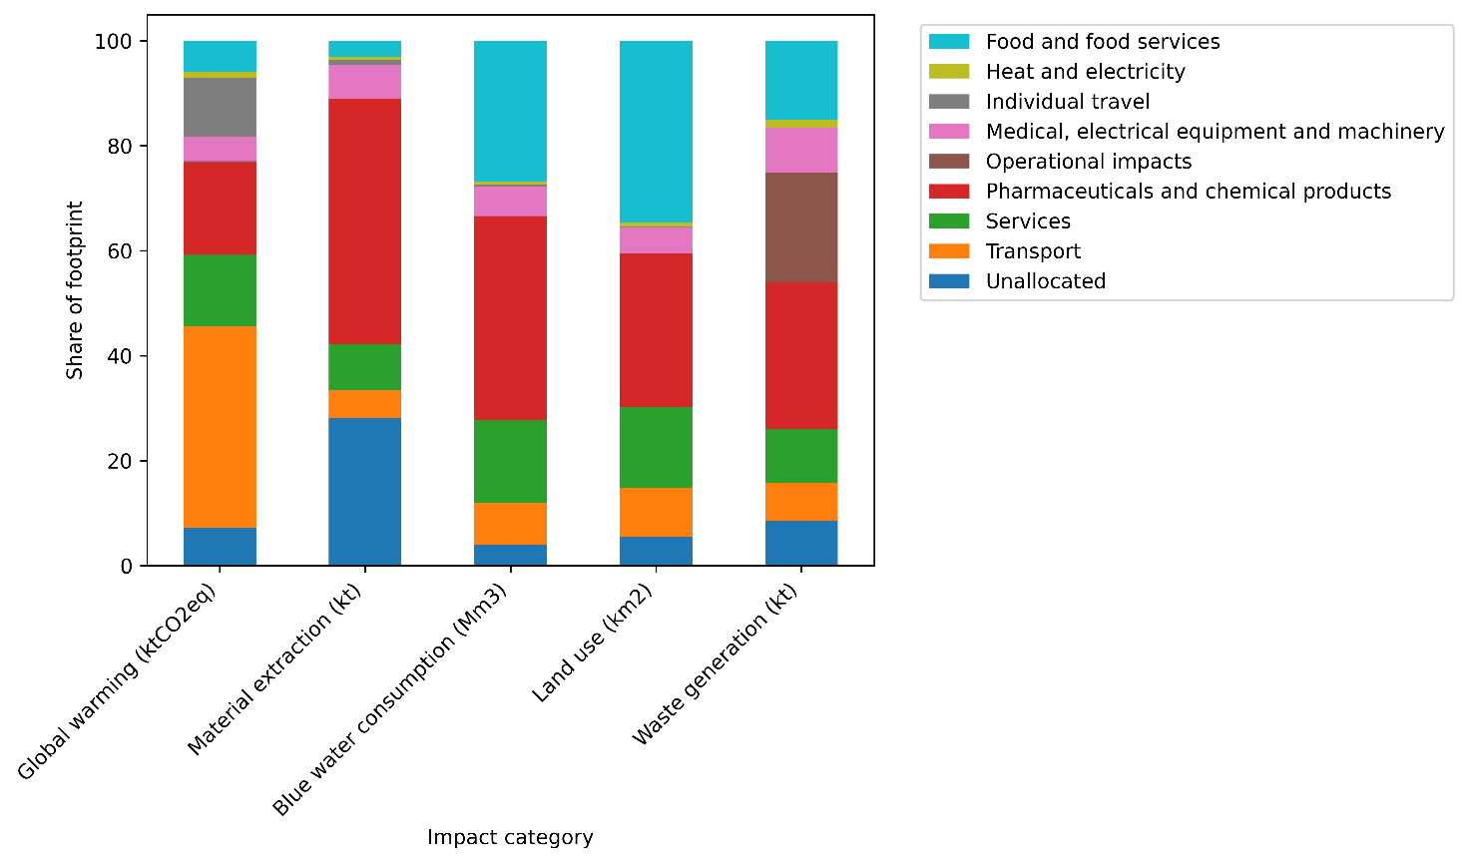
Figure 1: Activity contributions of environmental impacts associated with Danish health care in 2022, combining EXIOBASE version 3.8.2 results (top-down EE‑MRIO analysis) with bottom-up estimates for anaesthetic nitrous oxide, pressurised metered-dose inhalers (pMDIs), and private travel (commuting and patient & visitor travel). The EXIOBASE “other” category was disaggregated to distinguish transport activities. Scope classifications are not shown here; they are reported in the text. Total climate footprint: 4,652 kt CO₂e.

When disaggregated by expenditure category, health care services accounted for 2,428 kt CO₂e, just over half of total greenhouse gas emissions. Direct emissions captured through bottom-up data, from nitrous oxide and pressurised metered-dose inhalers, constituted 0.5% of total greenhouse gas emissions. Additional bottom-up estimates for commuting and patient and visitor travel accounted for 604 kt CO₂e, 13.0% of total greenhouse gas emissions and the single most uncertain line in the study (coefficient of variation 26.5%, against 8.3 to 9.1% for every other contribution group). Among the expenditure categories captured through the MRIO model, pharmaceuticals and chemical products were the largest contributor at 37.3% of the climate footprint.

The largest contributor to every one of the five impact categories was pharmaceuticals and chemical products, at 51.5% of material extraction, 59.5% of blue water consumption, 42.2% of land use, and 38.5% of waste generation. Food and food services was the second largest contributor to land use (32.6%), behind pharmaceuticals and chemical products (42.2%). Food and food services was also the second largest contributor to blue water consumption (21.0%), which is in line with previous studies [4,19]. Estimates for pharmaceuticals and chemical products should be interpreted cautiously, as aggregation within EXIOBASE may lead to overestimation of greenhouse gas emissions and material footprint associated with this category [37] (Appendix A, System Boundary). The contribution analysis is visualised in figure 1.

Sector contributions across impact categories

Sector contributions represent the upstream economic sectors where environmental impacts physically occur (figure 2), as traced through the multi-regional input-output model. This reflects the final origin of impacts along supply chains rather than the sector where expenditure occurs.

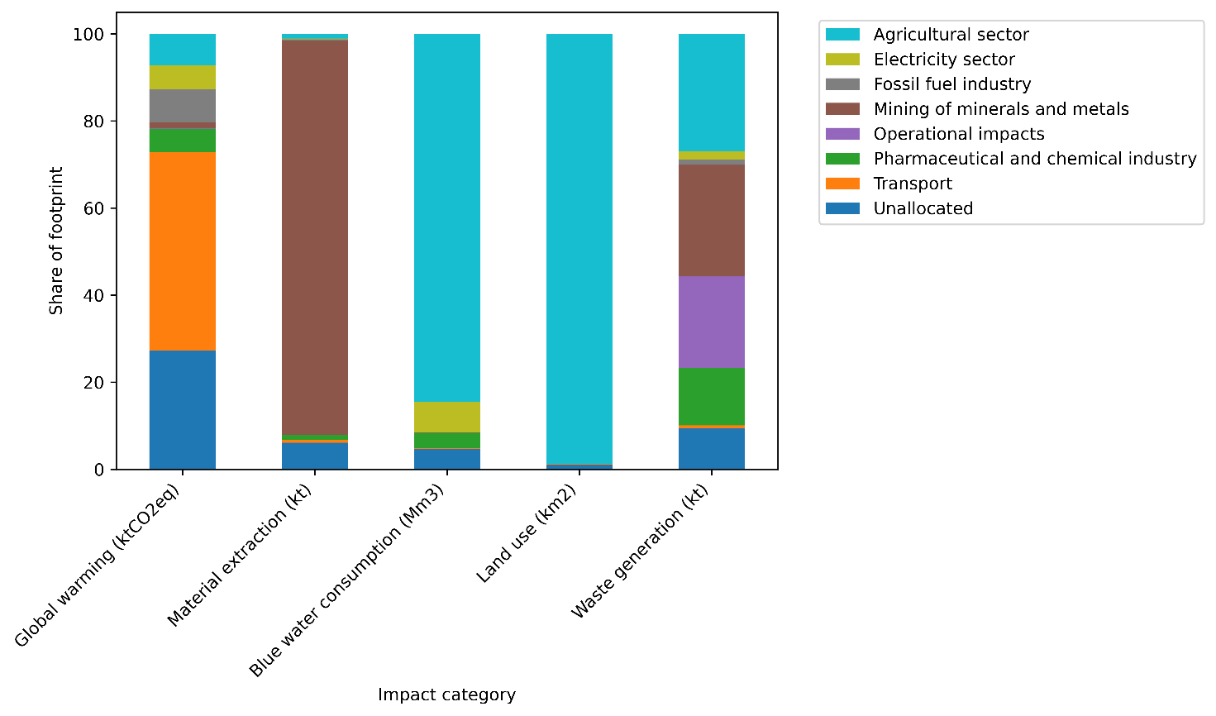
Figure 2: Sectoral contributions to environmental impacts associated with Danish health care delivery in 2022. Impacts are attributed to the producing sectors where environmental impacts occur along global supply chains. Five impact categories are shown: climate change (kt CO₂e), material extraction (kt), blue water consumption (Mm³), land use (km²), and waste generation (kt).

For greenhouse gas emissions, the transport sector accounted for 14.9% of the footprint once the Danish sea-transport allocation is corrected, against 32.3% before correction. This reflects transport services within the economic system and excludes household travel added through bottom-up estimates. Mining of minerals and metals accounts for nearly all of material extraction (85%), while the agricultural sector accounts for the vast majority of blue water consumption (85%) and virtually all of the land use (99%). Once the aggregated residual sectors are set aside, the largest identified producing sectors for the climate footprint are the fossil fuel industry (15.9%) and transport (14.9%), ahead of agriculture (13.1%), the pharmaceutical and chemical industry (9.6%) and electricity (9.1%).

Geographical distribution of impacts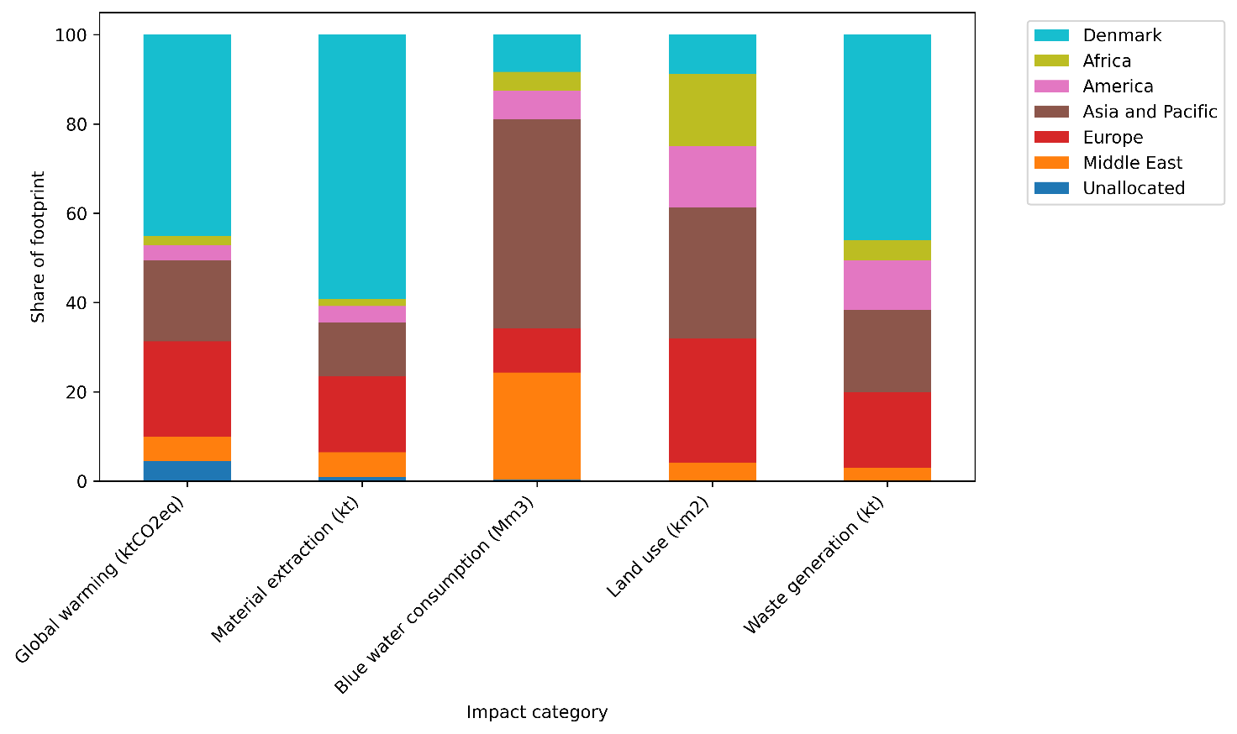
Figure 3: Geographical distribution of environmental impacts associated with Danish health care delivery in 2022. Impacts are allocated to regions where they physically occur along global supply chains. Impact categories include climate change (kt CO₂e), material extraction (kt), blue water consumption (Mm³), land use (km²), and waste generation (kt). (The Netherlands was retained as a separate region to ensure consistency with the underlying data structure and to avoid overlap or double counting during regional aggregation.)

Figure 3 shows the geographical distribution of impacts. One quarter of greenhouse gas emissions (25.9%) was traced to activities occurring within Danish borders, primarily transport, services, pharmaceuticals, and food, and a further third (33.4%) to the rest of Europe. Material extraction was the most domestic of the five categories, with 45.7% arising in Denmark. Blue water consumption, by contrast, occurred mainly in Asia and the Pacific (41.2%) and the Middle East (28.6%), with Denmark and Europe together accounting for 18.3%. Land use also fell mostly outside Denmark and Europe (58.6% between them), with Africa alone accounting for 19.4%. Half of waste generation arose within Denmark (50.7%), while the remainder is distributed across international supply chains.

Scope 1, 2 and 3 emissions were partitioned following the GHG Protocol as applied to the input-output result. Of the 4,650 kt CO₂e that the partition covers, Scope 3 accounts for 4,183 kt (90.0%), Scope 1 for 130 kt (2.8%), Scope 2 for 73 kt (1.6%), and household travel that falls outside the protocol's boundary for 264 kt (5.7%); the remaining 1.8 kt is the health sector's own self-supply loop, removed to avoid double counting.
Discussion
This study provides a systemic assessment of the environmental impacts of Danish health care using a hybrid environmentally extended input-output framework complemented with selected bottom-up data. Health care was associated with between 2.4% and 7.9% of the national consumption-based footprint.
The estimated Danish health care footprint of 6.0% of national greenhouse gas emissions sits within the lower-to-middle range of values reported internationally, including approximately 10% in the United States, 7% in Australia, 7.3% in the Netherlands, 4% in the United Kingdom, between 4.4 and 4.6% globally [4,5,8,19,20,38]. In per-capita terms, Danish health care emissions correspond to 0.79 t CO₂e per person per year, placing Denmark in the upper-middle of the OECD distribution. This is higher than the global average of approximately 0.6 t CO₂e per capita, but about half the United States figure (approximately 1.5 t CO₂e per capita), and far above low-income contexts such as India (approximately 0.06 t CO₂e per capita) [3,8].
Three structural factors likely explain Denmark’s position. Firstly, the Danish electricity system is comparatively low-carbon, which reduces indirect (scope 2) emissions relative to more fossil-based systems such as those in the United States and Australia. Secondly, health care accounts for a smaller share of national economic output in Denmark than in the United States, limiting the overall scale of demand-driven emissions. Thirdly, and in the opposite direction, Denmark is a relatively wealthy country. Together, these factors suggest that Denmark’s footprint is not anomalous, but consistent with both the structure of its energy system and its level of health care expenditure.
A key finding is that environmental impacts are predominantly driven by indirect and upstream activities rather than on-site clinical processes. Transport-related activities account for a quarter of total greenhouse gas emissions (25.2%) once supply-chain transport (12.2%) is combined with private travel (13.0%) and with the transport embedded in health care services such as ambulances and helicopters. While transport is recognised as part of health care emissions in previous studies, it is typically embedded within broader supply-chain categories and not identified as a dominant driver. The share reported here is less than half the 32.3% that the uncorrected model returns, because EXIOBASE allocates 74% of Danish sea-transport output to Danish intermediate use against 9% in the national accounts; correcting that allocation removes most of the apparent transport dominance. What remains is large enough to matter for mitigation, and part of it follows from the organisation of health care and eldercare services in Denmark, which rely heavily on mobility and decentralised service delivery.
More broadly, chemically intensive supply chains lead in every impact category, with food-related and transport chains next, indicating that environmental pressures are shaped by the systems that enable health care delivery rather than core clinical processes.
The contribution of pharmaceuticals and chemical products should be interpreted with caution. Previous studies indicate that pharmaceuticals may have lower environmental impacts per euro than the broader Chemicals n.e.c. sector [19,37], suggesting that their contribution to greenhouse gas emissions and material extraction may be overstated. Although pharmaceuticals appear as a major contributor in the activity analysis, their impacts are distributed across multiple upstream sectors in the sectoral analysis, including chemicals, agriculture, and mining. As a result, the contribution of pharmaceutical supply chains cannot be isolated directly, limiting interpretation of pharmaceuticals as a distinct environmental hotspot and reducing the ability to identify pharmaceutical-specific mitigation opportunities.

Most of the environmental pressure associated with Danish health care is displaced abroad. Blue-water consumption and land use occur predominantly outside Europe, particularly in Asia and the Pacific and the Middle East; regions that include areas of water stress. This finding demonstrates that environmental impacts associated with delivering health care in Denmark occur in regions geographically separated from the delivery and consumption of care. Similar patterns of spatially decoupled environmental impacts have been observed in other globally traded supply chains, where consumption in one region drives environmental pressures elsewhere through international production networks. From a sustainability perspective, such displacement is important because environmental burdens are not experienced uniformly across locations. The Earth Commission has argued that environmental sustainability should be evaluated not only in relation to biophysical limits, but also in relation to fairness in the distribution of environmental harms and access to resources [12]. Although our analysis does not assess local social or health consequences directly, the concentration of water- and land-intensive activities outside Denmark (95.4% of blue water consumption and 92.3% of land use) indicates that these pressures fall largely on populations geographically distant from the beneficiaries of health care services.
Waste generation showed a more domestic profile, with 50.7% arising in Denmark, although the remaining 49.3% still originates from upstream processes rather than from on-site clinical activities.
From a policy perspective, the dominance of supply-chain-related impacts implies that mitigation must extend beyond health care facilities to procurement, transport, and upstream production systems. In Denmark, centralised procurement actors and EU regulatory frameworks provide potential points of intervention for integrating environmental criteria into supply chains. These findings align with previous assessments identifying procurement, pharmaceuticals, and transport as key emission sources [9,39]. Because many environmental impacts occur outside Danish borders, reducing the environmental footprint of health care requires not only domestic action through procurement and planning decisions, but also engagement with the international supply chains through which those impacts arise.

Limitations
Several limitations should be noted, and we distinguish those that bound the estimates from those that bound their interpretation. Gross fixed capital formation is excluded from the headline, so the impacts of infrastructure and equipment are not captured; endogenising consumption of fixed capital into the Leontief inverse with the capital matrices of Södersten and colleagues raises the input-output component of the climate footprint from 4,025 to 4,809 kt CO₂e, which bounds the omission at 19%, and raises material extraction by 33%. Direct operational emissions are now taken from Statistics Denmark's DRIVHUS greenhouse-gas accounts by industry rather than inferred from the model, which removes the underestimate present in the submitted analysis.
Bottom-up estimates rely on parameters drawn from Danish sources, and each carries a quantified uncertainty rather than an unquantified proxy assumption. Nitrous oxide is taken from Denmark's National Inventory Document rather than scaled by birth rates; volatile anaesthetics are read from the Danish Medicines Agency register; commuting and patient and visitor travel are scaled on Danish employment, working hours and the Danish National Travel Survey. The Monte Carlo analysis propagates all of these: together with their covariance they account for 20.6% of the variance in the climate footprint, against 79.4% from the multi-regional input-output parameters. The practical consequence is that the width of the reported intervals is a property of EXIOBASE and not of the Danish data collection, and that further national data collection would not materially narrow them.
Combining top-down and bottom-up approaches introduces methodological inconsistencies, and we state plainly that this is an EE-MRIO analysis with bottom-up complements rather than an integrated hybrid life cycle assessment: the bottom-up items are added to the model result, not embedded in its technology matrix. Double counting is avoided explicitly rather than assumed away; hospital nitrous oxide is subtracted from the DRIVHUS direct figure before the anaesthetic term is added, and the health sector's own self-supply loop is removed from the scope partition. The trade-off is coverage: an integrated hybrid would require physical unit process data for Danish health care that does not exist at national scale. Results should therefore be read as system-level estimates with quantified parameter uncertainty, not as precise values, and the findings highlight the importance of addressing indirect and geographically displaced impacts.
Conclusion
This study provides a systemic assessment of the environmental impacts associated with delivering health care in Denmark using a hybrid environmentally extended input-output framework complemented by selected bottom-up calculations. The results show that Danish health care accounts for between 2.4% and 7.9% of the national consumption-based footprint across the five assessed categories. For greenhouse gas emissions this corresponds to a per-capita footprint of 0.79 t CO₂e.
Climate change impacts are primarily associated with health care services, which carry a large share of transport activity, and with pharmaceutical and chemical supply chains, which lead the climate footprint on their own; material extraction, blue water consumption, land use and waste generation are concentrated in the same pharmaceutical and chemical chains and in food-related activities. Most blue water consumption (81.7%) and most land use (58.6%) occur outside Denmark and Europe, which underlines the geographically displaced nature of health care‑related environmental impacts.
The inclusion of bottom‑up data for nitrous oxide, pressurised metered‑dose inhalers, and private travel improves coverage of emission sources that are not sufficiently represented in input‑output databases. Nevertheless, the analysis remains bounded by the aggregation of pharmaceuticals within a broader chemicals sector, by the exclusion of gross fixed capital formation from the headline, and by the parameter uncertainty that the input-output data carry.
Overall, the findings suggest that efforts to reduce the environmental impacts of delivering health care services must extend beyond direct emissions and facility-level interventions. Where the impacts arise points to three levers in particular. Procurement of pharmaceuticals and chemical products is the single largest lever, at 37.3% of the climate footprint and the largest contributor in all five categories. Employee commuting and patient and visitor travel together account for 13.0% of the climate footprint and are the part of the system a health authority controls most directly, through siting, scheduling and transport provision. Food and catering account for 9.3% of the climate footprint and 33% of land use, so procurement standards for food carry disproportionate weight in the land and water categories. Each of these is an expenditure category a purchaser can act on, which the sector-of-origin view alone does not reveal.

Declaration of generative AI use
The authors used large language models (primarily Microsoft Copilot) to assist with grammar, spelling, language clarity, and code comprehension. AI tools were used to help interpret and explain existing code and to support programming tasks. All AI-generated suggestions, text revisions, and coding outputs were critically reviewed, validated, and, where appropriate, modified by the authors. The authors take full responsibility for all analyses, code, results, interpretations, and conclusions presented in the manuscript

References

1. Intergovernmental Panel on Climate Change. Climate Change 2023: Synthesis Report: IPCC, 2023.
2. Romanello M, Napoli CD, Green C, et al. The 2023 report of the Lancet Countdown on health and climate change: the imperative for a health-centred response in a world facing irreversible harms. Lancet 2023; 402(10419): 2346-94.
3. Pichler P-P, Jaccard IS, Weisz U, Weisz H. International comparison of health care carbon footprints. Environmental Research Letters 2019; 14(6).
4. Lenzen M, Malik A, Li M, et al. The environmental footprint of health care: a global assessment. Lancet Planet Health 2020; 4(7): e271–79.
5. Tennison I, Roschnik S, Ashby B, et al. Health care's response to climate change: a carbon footprint assessment of the NHS in England. Lancet Planet Health 2021; 5(2): e84-e92.
6. Braithwaite J, Smith CL, Leask E, et al. Strategies and tactics to reduce the impact of healthcare on climate change: systematic review. BMJ 2024; 387: e081284.
7. Andrieu B, Marrauld L, Vidal O, Egnell M, Boyer L, Fond G. Health-care systems' resource footprints and their access and quality in 49 regions between 1995 and 2015: an input-output analysis. Lancet Planet Health 2023; 7(9): e747-e58.
8. Karliner J, Slotterback S, Boyd R, Ashby B, Steele K. Health care’s climate footprint: how the health sector contributes to the global climate crisis and opportunities for action: Health Care Without Harm, 2019.
9. Danish Regions. The Danish regions’ strategy for sustainable hospitals, 2024.
10. Intergovernmental Science-Policy Platform on Biodiversity and Ecosystem Services. Global Assessment Report on Biodiversity and Ecosystem Services: Summary for Policymakers: IPBES, 2019.
11. World Health Organization. Environmentally sustainable health systems: a strategic document. Copenhagen, 2017.
12. Gupta J LD, Rockström J, Qin D, Stewart-Koster B, Rocha JCR, et al. A just world on a safe planet: a Lancet Planetary Health–Earth
Commission report on Earth-system boundaries,
translations, and transformations. Lancet Planet Health 2024; 8(10): e813-e73.
13. Organisation for Economic Co-operation and Development. Health at a Glance 2025: OECD, 2025.
14. Rodriguez-Jimenez L, Romero-Martin M, Spruell T, Steley Z, Gomez-Salgado J. The carbon footprint of healthcare settings: A systematic review. J Adv Nurs 2023; 79(8): 2830-44.
15. Region Midtjylland. Klimaregnskab 2020 for Region Midtjylland: Region Midtjylland, 2021.
16. Jonathan Drew, Sean D Christie, Daniel Rainham, Chantelle Rizan. HealthcareLCA: an open-access living database of health-care environmental impact assessments. Lancet Planet Health 2022; 6: e1000–12.
17. Leontief W. Environmental repercussions and the economic structure: an input-output approach. Review of Economics and Statistics 1970; 52(3): 262-71.
18. Stadler K, Wood R, Bulavskaya T, et al. EXIOBASE 3: Developing a Time Series of Detailed Environmentally Extended Multi‐Regional Input‐Output Tables. Journal of Industrial Ecology 2018; 22(3): 502-15.
19. Steenmeijer M, Rodrigues J, Zijp M, Waaijers-van der Loop S. The environmental impact of the Dutch health-care sector beyond climate change: an input–output analysis. Lancet Planetary Health 2022; 6(12): e949-e57.
20. Eckelman MJ, Sherman J. Environmental Impacts of the U.S. Health Care System and Effects on Public Health. PLoS One 2016; 11(6): e0157014.
21. Organisation for Economic Co-operation and Development, Eurostat, World Health Organization. A System of Health Accounts 2011 (Revised): OECD, 2017.
22. Statistics Denmark. DK Umat 2019 supply-use table. Copenhagen: Statistics Denmark, 2024.
23. Merciai S, Schmidt J. Methodology for the Construction of Global Multi‐Regional Hybrid Supply and Use Tables for the EXIOBASE v3 Database. Journal of Industrial Ecology 2017; 22(3): 516-31.
24. Obling ML PS. Inhalationsanæstetika:klimaeffekt ogreduktionsmuligheder. Medicindk 2026.
25. Anesthesiologists ASo. Nitrous Oxide. (Year unknown, but after 2019). https://www.asahq.org/about-asa/governance-and-committees/asa-committees/committee-on-obstetric-anesthesia/nitrous-oxide (accessed 10-06-2026.
26. Region Hovedstaden. Pregnant women given climate-friendly nitrous oxide at Hvidovre Hospital. 2023. https://www.regionh.dk10-06-2026).
27. Intergovernmental Panel on Climate Change. Climate Change 2007: The Physical Science Basis. Cambridge: Cambridge University Press; 2007.
28. Vestbo J, Press-Kristensen K. Translated impact on carbon footprint from choice of inhaled therapy: a Danish scenario. Eur Respir J 2023; 62(3).
29. Statistics Netherlands. Employment in health and social care. The Hague: CBS, 2016.
30. Statistics Denmark. Employment in health and social services. Copenhagen: Statistics Denmark, 2019.
31. Eurostat. Actual and usual hours of work. Luxembourg: European Commission, 2019.
32. Statistics Denmark. Labour Force Survey: actual weekly working hours. Copenhagen: Statistics Denmark, 2019.
33. Christiansen H, Baescu O. The Danish National Travel Survey: Annual Statistical Report 2019. Copenhagen: Technical University of Denmark, 2020.
34. Statistics Netherlands. Mobility by mode and purpose. The Hague: CBS, 2016.
35. Huijbregts MAJ, Steinmann ZJN, Elshout PMF, Stam G VF, Vieira M, et al. ReCiPe2016: a harmonised life cycle impact assessment method at midpoint and endpoint level. Int J Life Cycle Assess 2017; 22: 138–47.
36. van Bree T, Slob A. DESIRE Report: FP7 / European Commission, 2016.
37. Hagenaars RH. An investigation into the carbon and material footprint of the Dutch consumption of pharmaceuticals. Leiden, The Netherlands: Delft University of Technology; Leiden University; 2022.
38. Malik A, Lenzen M, McAlister S, McGain F. The carbon footprint of Australian health care. Lancet Planetary Health 2018; 2(1): e27–e35.
39. World Health Organization. Transitioning to a Sustainable Healthcare Sector: WHO, 2024.
40. Statistics Denmark. Stock of motor vehicles. 2026.
41. Denmark M. Nu er der 400.000 elbiler i Danmark. 2025. https://mobility.dk/nyheder/nu-er-der-400-000-elbiler-i-danmark/ (accessed 10-06-2026.

Declaration of competing interests
We declare no competing interests.
Data availability
This study draws on publicly available data sources. EXIOBASE v3.7 is openly available at https://www.exiobase.eu, and the Danish supply-use tables are available from Statistics Denmark. The analysis adapts the openly available model code of Steenmeijer and colleagues. Processed input data, intermediate results, and the bottom-up calculations underlying the reported estimates are provided in appendix A and appendix B; further details are available from the corresponding author on reasonable request.

