**Assignment 4**

**Ofir Gilad & Max Brener**

**2 Tasks:**

**1. CIFAR-10 classification:**

*The tutorial results:*

Example images:

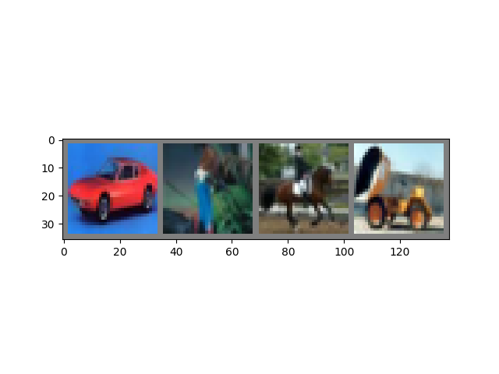

car bird horse truck

Training results:

[1, 2000] loss: 2.215  
[1, 4000] loss: 1.924  
[1, 6000] loss: 1.725  
[1, 8000] loss: 1.616  
[1, 10000] loss: 1.546  
[1, 12000] loss: 1.471  
[2, 2000] loss: 1.400  
[2, 4000] loss: 1.378  
[2, 6000] loss: 1.355  
[2, 8000] loss: 1.345  
[2, 10000] loss: 1.311  
[2, 12000] loss: 1.264  
Finished Training

Test results:

**Ground Truth:** cat, ship, ship, plane

**Predicted:** cat, ship, ship, plane

Accuracy of the network on the 10000 test images: 54.3 %

Accuracy for class: plane is 67.9 %  
Accuracy for class: car is 57.2 %  
Accuracy for class: bird is 47.1 %  
Accuracy for class: cat is 12.2 %  
Accuracy for class: deer is 51.1 %  
Accuracy for class: dog is 63.3 %  
Accuracy for class: frog is 51.4 %  
Accuracy for class: horse is 65.4 %  
Accuracy for class: ship is 64.0 %  
Accuracy for class: truck is 63.4 %

Explanation:

The CIFAR-10 dataset contains 60,000 32x32 color images in 10 classes, with 6,000 images per class.   
The CNN architecture consists of two convolutional layers, followed by a max pooling layer.   
Two fully connected layers then map the extracted features to the 10 output classes.   
The training process involved iterating over the training dataset in batches, performing forward and backward passes to calculate the loss and updating the model's parameters accordingly.  
After training, the model was evaluated on the test set to measure its performance.   
The overall accuracy and per-class accuracy were calculated.

**2. Deconvolutional Model:**

*The task results:*

Accuracy of the network on the 10000 test images: 47.63 %

3 Example images and their reconstruction:

**3. Latent Representations Analysis:**

*The task results:*

Explanation:

For the first convolutional layer, setting five channels to zero at a time, we observed varying contributions to the image's structure. Some channels retained edges and textures, indicating their role in capturing low-level features.

For the second convolutional layer, focusing on three channels, the reconstructions highlighted the main object of the image's class. This suggests these channels capture higher-level semantic features.

Overall, we saw the following things:

* The first layer channels preserved basic structural details, with each channel contributing differently.
* The second layer channels revealed class-specific patterns, indicating they capture more abstract and meaningful features.
* This demonstrates a hierarchy in the model's feature abstraction, with lower layers focusing on fundamental visual elements and higher layers on complex, class-specific details.