**15/01/2025**

**Oderda UV Crosslinked films report**

This report summarizes the results of the samples received from Oderda.

**Samples Tested:**

1. Trail 1 – no crossitol
2. Trail 2 – 3% crossitol
3. Trail 3 - 5% crossitol

**Test plan:**

1. UV radiation of 2.5 J/cm2 and 3.5 J/cm2 for sheets with 3% and 5% crossitol respectively.
2. Uv-Vis analysis to identify the crossitol before and after UV radiation to identify the chemical reaction.
3. FTIR analysis to identify the crossitol before and after UV radiation to identify the chemical reaction.
4. Creep Test to identify thermal stability of the sheet. The analysis performed at the following conditions:

|  |  |  |
| --- | --- | --- |
| **Test Conditions** | **Value** | **Unit** |
| Oil temperature | 135 | °C |
| Weight | 50 | gr |
| 𝐿0 of the sample | 2 | cm |
| Time limit of the test | 180 | sec |

**Table 1.** Creep test conditions.

**Results**:

**Figure 2** shows the results of FTIR analysis performed on sheets before and after UV radiation. Two types of sheets were tested, containing 3% and 5% crossitol by weight, and were UV radiated with 2.5 and 3.5 J/cm², respectively. The peaks of crossitol dispersed in the sheet and analyzed before UV radiation were marked in circles (1740 cm⁻¹, 1660 cm⁻¹, and 1600 cm⁻¹). We can see that after UV radiation was applied to the sheet, the peaks at 1660 cm⁻¹ and 1600 cm⁻¹ disappeared, indicating a chemical reaction took place during the UV radiation. Those peaks with 1740 cm⁻¹ peak corresponds to the carbonyl (C=O) stretching which indicate on conversion of this group to C-OH during the crosslinking reaction.

A

B

Sheet without corssitol

Sheet with 5%wt. corssitol

Sheet with 5%wt. corssitol after UV radiation

Sheet without corssitol

Sheet with 3%wt. corssitol

Sheet with 3%wt. corssitol after UV radiation

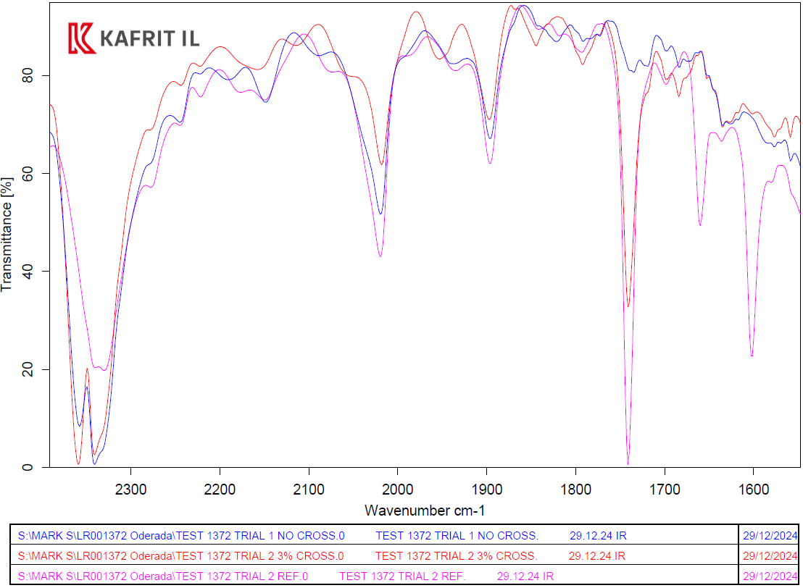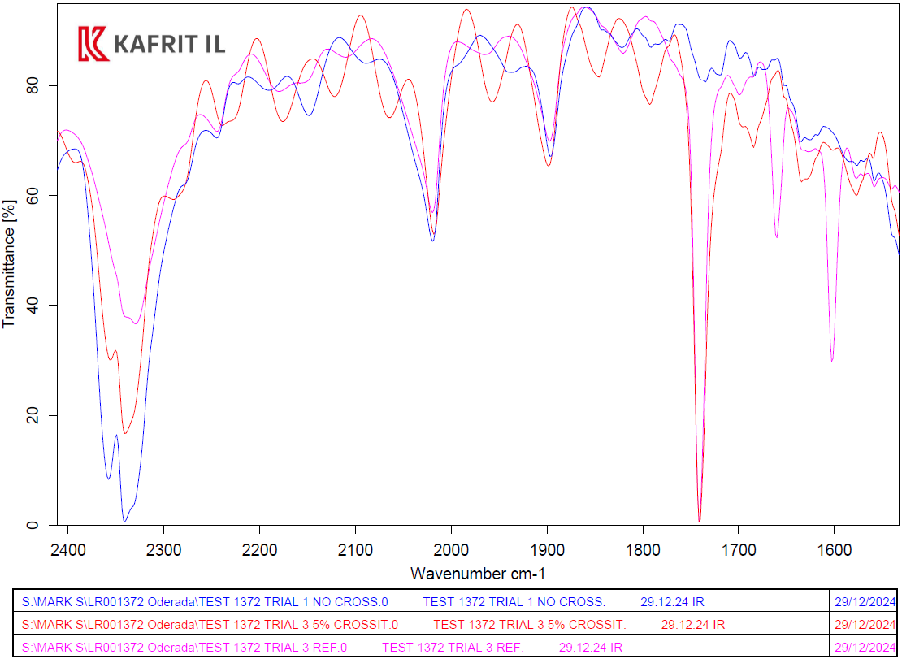

**Figure 1.** FTIR spectroscopy analysis performed on were performed on two types of sheets which contain (a) 3 %wt. and (b) 5 %wt of crossitol before and after UV radiation.

**Figure 2**shows the results of UV-Vis analysis performed on sheets before and after UV radiation. Two types of sheets were tested, containing 3% and 5% crossitol by weight, and were UV radiated with 2.5 and 3.5 J/cm², respectively. The dashed line marks the location of crossitol, which should be spotted at 285 nm, as seen in the sheet before crosslinking (**Figure 1**). In the sheets after UV radiation, we can see the disappearance of the crossitol peak, indicating sufficient UV radiation and a complete crosslinking reaction of the crossitol.

**Figure 2.** Uv-Vis transmittance analysis in a range of 200-500nm were performed on two types of sheets which contain 3%wt. and 5%wt. of crossitol (a) before and (b) after UV radiation.

B

A

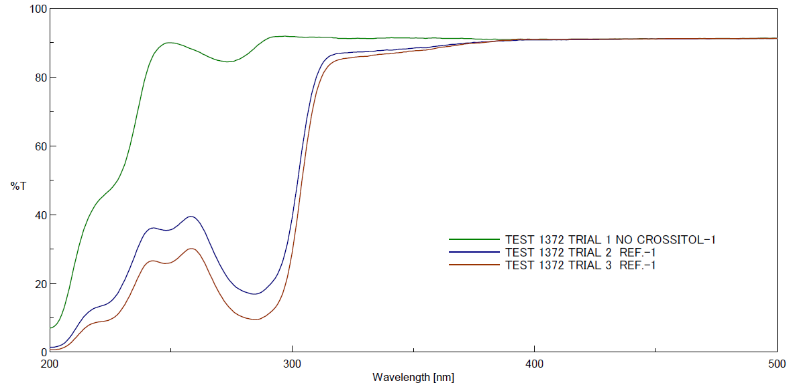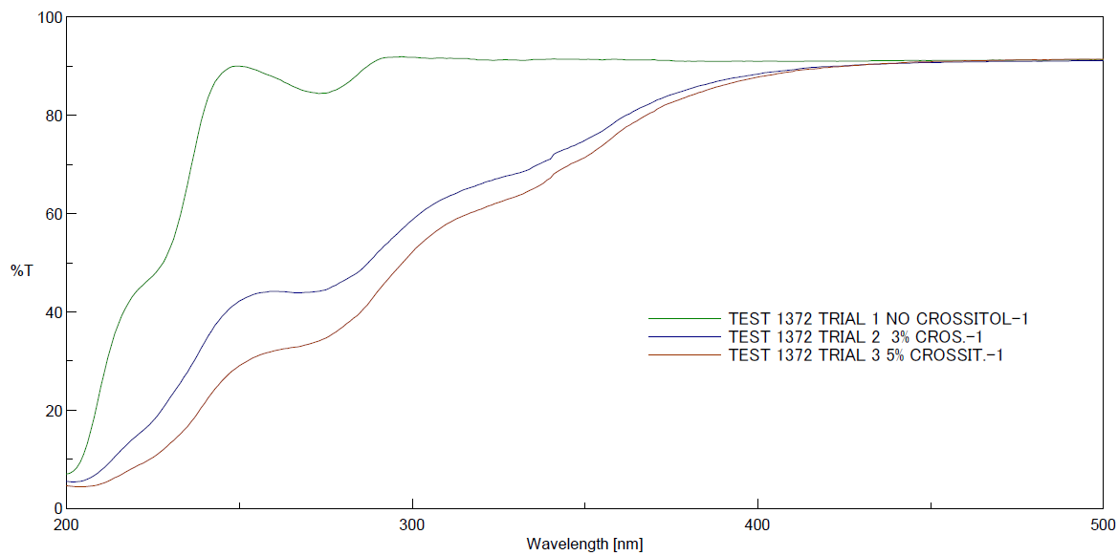

Crossitol

Creep tests were performed and the results summarized in **table 2** and demonstrated in **figure 3** showed that sheet without crossitol had rapid creep failure after a split of a second, while sheets containing crossitol didn’t reach to a total failure. We also can see that sheet with higher crossitol concentrationsת had higher heat stability leading to lower plastic deformation by reducing ΔL values.

**Table 2.** Creep test

|  |  |  |  |  |  |
| --- | --- | --- | --- | --- | --- |
| sample No | Sample Description | Energy Dose (j/cm2) | Creep Time Avg. (sec)* | L Avg. (cm) | ΔL (cm) |
| Trial 1 | No Crossitol | 0 | 0.5 | none | none |
| Trial 2 | 3%wt. Crossitol | 2.5 | 180 | 6.5 | 4.5 |
| Trial 3 | 5%wt. Crossitol | 3.5 | 180 | 3.5 | 1.5 |

* The test stopped after 180 sec, when no change occurred in the sheet length with time.

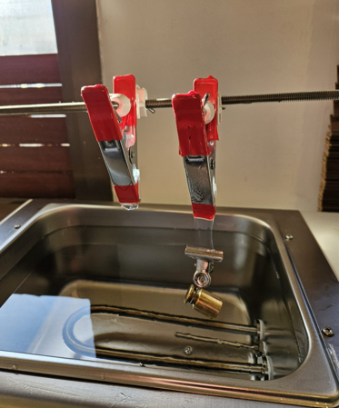

5%wt. Crossitol Film

No Crossitol Film

After 180 sec

**Figure 3.** Demonstration of the creep test as performed in our facilities for sheets without and with 5%wt. of crossitol.