**Physical properties summary: Samples 1, 2, 7, 6.1, 6.2 and 6.3.**

Foamed samples 1, 2, 7, 6., 6.2 and 6.3:

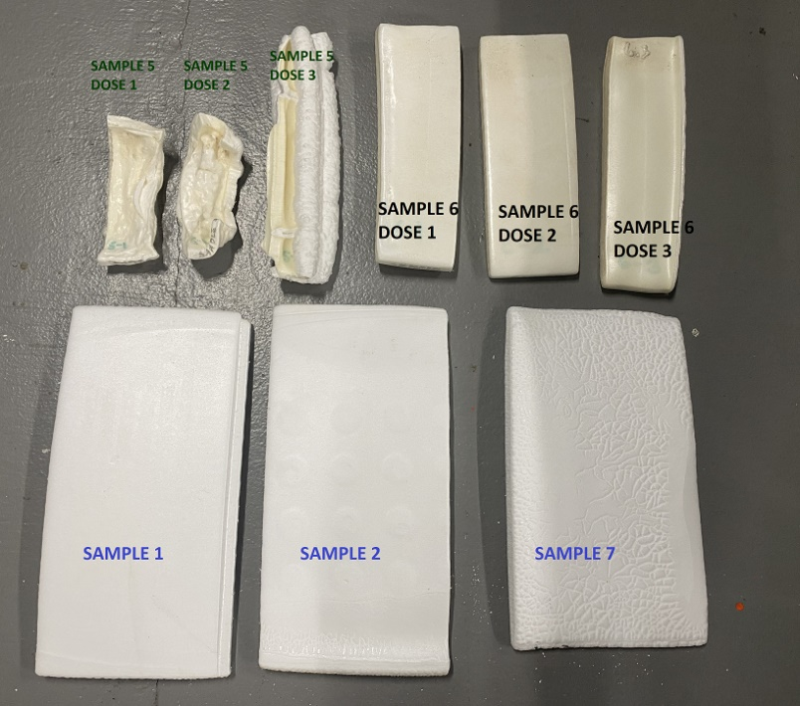

Physical properties:

|  |  |  |  |  |  |  |  |  |  |  |  |
| --- | --- | --- | --- | --- | --- | --- | --- | --- | --- | --- | --- |
| **Sample description** | **Material** | **%** | **Sub-sample no** | **S/S density (kg/m3)** | **C/C density (kg/m3)** | **Tensile  (kPa)** | **EaB (%)** | **Modulus** | **Cell size  (mm)** | | |
| **Top** | **Middle** | **Bottom** |
| **Sample 1 - Zotefoams ref Crosslinked with peroxide** | **LDPE  Peroxide** | **90% 10%** | **1** | **19.8** | **19.5** | **335.4** | **109.1** | **0.7** |  | **0.30** |  |
| **Sample 2 - negative ref Addition of carrier polymer only Crosslinked with peroxide** | **LDPE  LDPE Ipetene 320 Peroxide** | **80% 10% 10%** | **2** | **20.8** | **19.6** | **347.5** | **111.7** | **0.7** |  | **0.25** |  |
| **Sample 6 Crosslinker only 4 SAMPLES** | **LDPE  CROSSITOL** | **80% 20%** | **6.1.** | **21.3** | **19.1** | **268.2** | **81.9** | **0.7** | **0.25** | **0.26** | **0.26** |
| **6.2.** | **22.5** | **20.7** | **351.7** | **72.7** | **0.8** | **0.25** | **0.27** | **0.24** |
| **6.3.** | **25.3** | **30.7** | **134.1** | **130.3** | **0.7** | **0.22** | **0.23** | **0.23** |
| **Sample 7 - negative ref Addition of carrier polymer only Crosslinked with peroxide** | **LDPE  LDPE Ipetene 320 Peroxide** | **60% 30% 10%** | **7** | **20.6** | **19.3** | **327.5** | **115.5** | **0.7** |  | **0.26** |  |