Crossitol PH-2

Provided by Prof. Boris Gorelik, MOBIChem

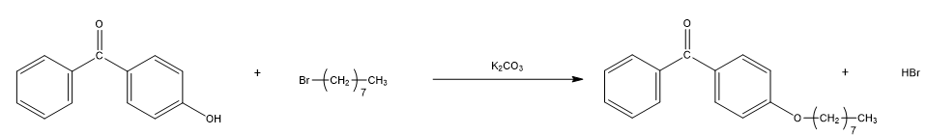

* PH2 (patent pending) technology is a family of additives masterbatch for Polyolefin crosslinking by reaction with UV energy source.
* The main purpose of PH-2 is to initiate cross linking reactions in polyolefins (LDPE, HDPE, EVA, etc.).
* PH2 is a photoinitiator, with long hydrophobic tail to enable the molecule to be less migrative. It has one side group -O-(CH2)7-CH3 that responsible for compatibility with PE.
* PH-2 responds to UV irradiation at wavelength 280 nm, open C=O bond to free radical that creates the crosslinking.
* Handling and Storage in cooled conditions otherwise it can turn to agglomerates.
* Melt temp is 42˚c

**Applications**

* An application of PH-2 in polyolefin's made films results in high stability of melt during inflation of sleeve while production of oriented polyolefins.
* PH-2 also can be used to give rise to high cross-linking density in polymer pipes used for transportation of hot water

**Cross-linking measurement**

* In the case photo-initiator leads to formation in polymer matrix two-dimensional network. Degree of cross-linking can be assessed by measuring creep time of irradiated film at 135C. Creep time of 12sec-15sec reflects cross-linking density being able to stabilize sleeve of polyolefin while inflating by compressed air.
* In the case degree of cross-linking can be expressed in gel fraction formed in irradiated polymer. Amount of gel fraction is to be higher than 65%. Quantity of gel fraction in irradiated polymer can be found by extraction of soluble part of polymer in appropriate solvent (usually xylene) at boiling temperature of used solvent.

**Additive impurities**

* In order to determine additive impurities and their concentrations in the photo-initiator we have to conduct HPLC-MS analysis