**Communication Defined**

The word communication is derived from the Latin word, *communis,* which means *common***.** Communication is concerned with all the ways in which information and ideas are exchanged and shared. Communication is the process of transferring information from a sender to a receiver with the use of a medium in which the communicated information is understood by both sender and receiver. It is a process that allows organisms to exchange information by several methods. In its simplest form communication is the use of words to describe and convey a message or give information to another person. We communicate using language as a code to share information, ideas and feelings.

The word communication has been variously defined by scholars according to their persuasion. These arrays of definitions, notwithstanding, are pertinent to the affront. Barnard (1938) defined communication as‘ the means by which people are linked together in an organisation to achieve a common purpose." To Hoy and Miskel (1982) communication refers to the behavior that conveys the desired meaning of a message to two or more parties to the message. While Anderson (1972, p5) defined it as a dynamic process by which an individual, consciously or unconsciously affects the cognitions of another through materials or agencies used in symbolic ways. Communication, as Kimbrough and Nunnery (1988) posited, may be “regulative” characterised by task - related may directions and feedback between superiors and subordinates. Communication can also be conceived of as “Innovative” dealing with means and ends of bringing about change".

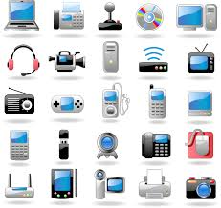

Source: educationwithfun.com

Okwo (1995) supports Thompson’s (1979) opinion that communication is “an interactive process involving the design of ideas, messages, information or data and their dissemination in an attempt to effect a change in a person’s behaviour or to persuade him to act in a particular or predetermined manner” communication may take place between individuals or organizations and that process modifies the behaviour of both the sender and the receiver

Communicationcan can be defined as the process of transmitting information and common understanding from one person to another (Keyton, 2011). Communication is the given of understandable information or message and the receiving and understanding involve to the point that the receiver is able to respond by appropriate action or inaction. Communication is the means by which we share our reality with others, it is the mechanism through which human relation exist and develop. It is the process by which an individual that is the communicator transmit stimuli usually verbal symbols to modify the behavior of the other individual that is the receiver. Also it is the process which involves the transmission of properly conceived and encoded facts, ideas, views, thought, opinions, messages, feelings, or information among individuals organizations or systems via appropriate means such as face to face conversation, letters, reports, memoranda, drawings, designs, posters, telephone calls, e-mails, minutes of meetings invoices, photography, symbols, models etc.

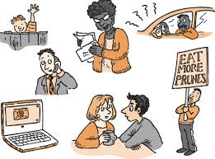

Source: educationwithfun.com

**Attributes of communication**

From our discussion about communication, we can point out some attributes. The most prominent ones are:

1. It is a process which is identifiable.
2. This process is dynamic.
3. Tt is interactive and it involves continuous interaction between the sender and the receiver.
4. There is always a purpose in communication and the purpose of communication may br classified as persuasive, educative, informative, entertaining and instrumental.

**ASSIGNMENT:**

1. Define communication in your own words.
2. Identify the attributes of communication.