**Forms of Communication**

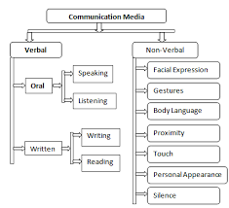

Source: Bartol and Martin (2015**)**

**Written Communication:** In the form of emails,letters, reports, memos and various other documents.

**Oral Communication**: This is either face-to-face or over the phone/video conferencing, etc.

A third type of communication, also commonly used but often underestimated is **Non-verbal communication**, which is by using gestures or even simply body movements that are made. These too could send various signals to the other party and is an equally important method of communication.

Oral communication refers to all communication that is face - to - face. The communicator and communicate either talk to each other in understandable language or through the medium of the telephone. This type of communication is unwritten. The classroom teacher finds this type of communication very useful it is the major medium of communication with his class. It is also found to be a very effective means of teaching as it uses questions and answer for communication is in respect of physically disabled or impaired student who are deaf or hard hearing.

Written communication is another type of communication prevalent in school. This is another common medium of communication. The teacher uses this often as he writes on the blackboard major summaries or objectives in his lesson. He also uses it to reinforce what he has orally communicated for meaningful effect and retention by students. Written communication is often regarded as official communication in the form of letters, Memos and circulars. An effective classroom teacher usually combines oral and written.

Visual communication is another type of communication refers to communication between the sender and the receiver through pictures, images or symbols. In communicating with children, visual communication is often relevant as is evident in many children's books. Pictures, symbols, and shapes arouse the imagination of children who though, cannot read the wordings of the pictures and shapes. Still or motion pictures without sound are also examples of visual communication. By seeing these pictures, images and symbols, associations are made by students in relation to lesson being taught. Visual materials reinforce classroom instruction of the teacher and consequently effective arouse the imagination of children who though, cannot read the wordings of the pictures and shapes.

Non verbal communication or kinetic communication refers to body signals or gestures which convey meaning to the receiver. Body movements using the hand, facial expressions, nose the eye, the legs and even the lips are illustrative of kinetic communication. In United States cultural parlance, this type of communication has long been in use effective. The student may use their eyes, nodding of the head or even shuffling of legs to indicate to a teacher that he is either boring them, and therefore ineffective or that they don't like his mannerisms or lesson proper. Whichever use the student make of this, the classroom teacher should be conversant with this kind of communication in order to devise appropriate strategies for neutralising the negative ones through adaptation of preferable behaviour. Kinetic communication has been found more useful for teaching the dumb and deaf students.

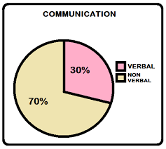

Source: Bartol and Martin (2015)

Classroom communication can be either effective or ineffective. It is effective when the intended message to the student is received, understood and responded to. The effectiveness of the teacher is a contingency of whether what is taught has been understood by the students. An illustration of an ineffective classroom teacher is that of a history teacher who came to his class loaded with high sounding English words and without finding out the reading level and communication ability of his form three students, he went on to deliver his lesson. Half way into his lecture, he paused to ask them whether they understood what he said thus far, and the entire class shouted 'Yes Sir'. Naturally, at the end of the second lecture contact with the teacher and the same experience occurred, the students matched to the principal's class to protest and request for another history teacher. This type of teacher obviously failed to communicate with his class students and was therefore ineffective. He merely talked at the class rather than to the student.

The effective classroom teacher must be able to introduce his lesson appropriately after taking time to prepare his lesson. He must adopt his lesson and examples to the level of the class and must allow time for questions for the students and from the students. Above all, language must be clearly understood. In addition to taking time to prepare lesson, choosing appropriate lesson materials and illustrative diagrams, choice of appropriate language and allowing time for questions and answer by the students, he must adopt a specific strategy. Effective classroom communication can be achieved through giving group assignments, organizing classroom debates, organizing the class into task force and through questioning method. In suggesting these four strategies, Ehiametalor (1985: 164)remarked that "an effective classroom teacher is that teacher who deliberately plans classroom instruction to facilitate interaction.

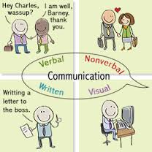

Source: Bartol and Martin (2015)

**Assignment:**

1. Explain two types of communication.
2. Explain the values of effective communication in classroom.