**Barriers to Effective Classroom Communication**

At any point in the communication process a barrier can occur. Barriers keep us from understanding other’s ideas and thoughts. Barriers can appear at any point of the communication loop. They are distortions which may prevent the achievement of teaching and learning goals. The barriers tend to minimize learning.

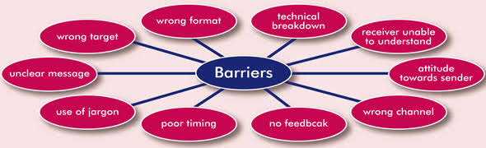

Source: Keizer, (2010)

Barriers are fatigue, poor listening skills, attitude toward the sender or the information, lack of interest in the message, fear, mistrust, past experiences,negative attitude, problems at home, lack of common experiences, and emotions. Examples of external barriers include noise, distractions, e-mail not working, bad phone connections, time of day, sender used too many technical words for the audience, and environment. Barriers keep the message from getting through. When communicating, watch out for barriers. Monitor the actions of the receiver. Watch her body language; check to make sure the message the receiver receivedis the one sent—ask questions and listen.

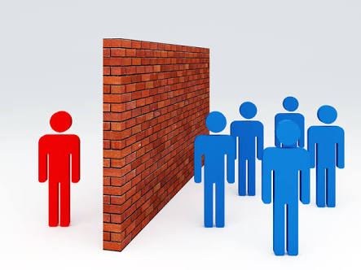

Source: (Krapp, 2011)

**NOISE**: - many communication theorists recognize the negative effect of noise on communication that is why they included it in the communication process.

Noise in communication refers to any disturbance, distortion, obstacle or hindrance that tampers with the free flow of the message, its interpretation and comprehension. Noise is anything that interfere with any stage of the communication process, there are different types of noise.

1. Physical noise:- human being talking i.e. noise from outside the class, discomfort in the classroom, anything that disturb free flow of a lesson, mannerism.

2. Emotional and psychological noise:- this is from any emotional hatred for the subject, anxiety, negative pre-conceived ideas depressed conditions of the learner, family problems, hunger.

3. Environmental noise:- industries.

4. Linguistic noise: - this relates to language incompetency of the teacher, wrong use of words or sentences that can make the meaning of the message to be loss, mispronunciation and wrong interpretation of message.

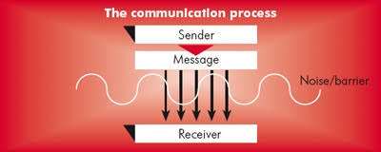

Source: Panikka: (2011)

**Physical Barriers**

Any number of physical distractions can interfere with the effectiveness of communication, including a telephone call, drop-in visitors, distances between people, walls, and static on the radio. People often take physical barriers for granted, but sometimes they can be removed. For example, an inconveniently positioned wall can be removed. Interruptions such as telephone calls and drop-in visitors can be removed by issuing instructions to a secretary. An appropriate choice of media can overcome distance barriers between people.

**Semantic Barriers**

The words we choose, how we use them, and the meaning we attach to them cause many communication barriers. The problem is semantic, or the meaning of the words we use. The same word may mean different things to different people. Words and phrases such as *efficiency, increased productivity, management prerogatives,* and *just cause* may mean one thing to a school administrator, and something entirely different to a staff member.

Technology also plays a part in semantic barriers to communication. Today's complex school systems are highly specialized. Schools have staff and technical experts developing and using specialized terminology. The staff and technical experts can understand, and if people do not understand the words, they cannot understand the message.

**Psychosocial Barriers**

Three important concepts are associated with psychological and social barriers: fields of experience, filtering, and psychological distance (Antos, 2011)). *Fields of experience* include people's backgrounds, perceptions, values, biases, needs, and expectations. Senders can encode and receivers decode messages only in the context of their fields of experience. When the sender's field of experience overlaps very little with the receiver's, communication becomes difficult. *Filtering* means that more often than not we see and hear what we are emotionally tuned in to see and hear. Filtering is caused by our own needs and interests, which guide our listening. Psychosocial barriers often involve a *psychological distance* between people that is similar to actual physical distance. For example, the school administrator talks down to a staff member, who resents this attitude, and this resentment separates them, thereby blocking opportunity for effective communication.

Successful communication by school administrators is the essence of a productive school organization. However, as discussed previously, communications do break down. Several communication theorists (Abrell, 2004; Auer, 2011; Larson, 2011; Shettleworth, 2010; Weiss, 2011) have focused on the major areas where failures in communication most frequently occur. The following are the major areas where communication breakdowns most frequently occur in schools:

• ***Sincerity.*** Nearly all communication theorists assert that sincerity is the foundation on which all true communication rests. Without sincerity—honesty, straightforwardness, and authenticity—all attempts at communication are destined to fail.

• ***Empathy.*** Research shows that lack of empathy is one of the major obstacles to effective communication. Empathy is the ability to put one's self into another's shoes. The empathetic person is able to see the world through the eyes of the other person.

• ***Self-perception.*** How we see ourselves affects our ability to communicate effectively. A healthy but realistic self-perception is a necessary ingredient in communicating with others.

• ***Role perception.*** Unless people know what their role is, the importance of their role, and what is expected of them, they will not know what to communicate, when to communicate, or to whom to communicate.

• ***Efforts to distort the message.*** Pitfalls in communication often occur in our efforts—both consciously and unconsciously—to distort messages.

• ***Images.*** Another obstacle to successful communication is the sender's image of the receiver and vice versa. For example, on the one hand, school administrators are sometimes viewed as not too well informed about teaching, seen as out of touch with the classroom, and looked on as paper shufflers. On the other hand, some school administrators view teachers as lazy, inconsiderate of administrative problems, and unrealistic about the strengths and weaknesses of their students.

**Assignment**

Have you ever been talking to someone and they misunderstand whatyou were saying? Why do you think happens? List other types of barrier and share your experiences.

Discussion

1. How many of us got confused and just “quit” listening? Why?

2. Why was communication so difficult to follow?

3. Why was it difficult to comprehend in a class and why communication cannot ensure complete understanding?

4. How can we make our communication efforts more effective?