Republic of the Philippines
City of Lipa

BARANGAY STO. NIÑO
OFFICE OF THE BARANGAY CHAIRMAN
Tel. No:(043) 774-1560 / email: brgystonino0411@gmail.com
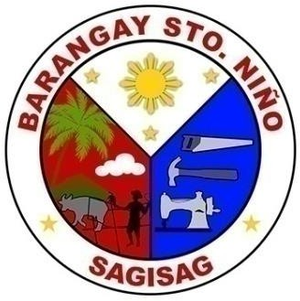
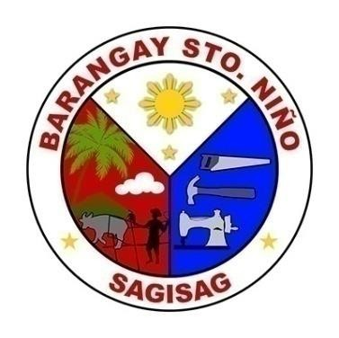
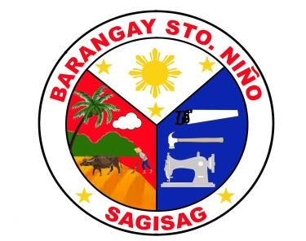

CHAIRMAN:
+++INS chairman.name+++
+++INS chairman.position+++
+++INS chairman.description+++

COUNCILORS:
+++FOR councilor IN councilors+++
HON. +++INS $councilor.name+++
+++INS $councilor.description || ''+++
+++END-FOR councilor+++

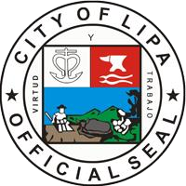
Justified Persevering Leadership

BARANGAY CLEARANCE

TO WHOM IT MAY CONCERN:

This is to certify that +++INS fullName+++, +++INS age+++ years old is personally known to me to be a law-abiding citizen and has no derogatory / criminal records filed in this barangay.

Issued upon request of the above-named person, this +++INS currentDate+++ , at Barangay Sto Niño, Lipa City, for whatever purpose this may legally serve.

NOT VALID W/OUT DRY SEAL

